Weather Symbols

Duration: 1, 50 min class session

Background Information:
This lesson occurs at the beginning of a Kindergarten Weather Unit and follows the 5 E Lesson format. Students will be making and sharing weather observations for several weeks. Inorder to begin making observations, students need to be able to identify and describe seven basic weather symbols to share their weather observations. To help students review these weather symbols, students will use a Bee-Bot to follow and create algorithms. Blue-Bots, Program and Go Mice, and other simple computing devices can be used in place of a Bee-Bot. If using something other than a Bee-Bot, changes to the Bee-Bot mat may be necessary to accommodate your computing device. Students should already have a working knowledge of how to use the computing device you choose. In this case, students already have a background working with the Bee-Bots.

Lesson Standards:
Science: K.ESS2-1: Use and share observations of local weather conditions to describe patterns over time.
Computer Science: 2.AP.A.01: With guidance, identify and model daily processes by creating and following algorithms (sets of step-by-step instructions) to complete tasks (e.g., verbally, kinesthetically, with robot devices, or a programming language).

Lesson Objective:
Students will:
- Identify and describe seven weather symbols.
- Communicate what weather symbol should be used at five different points in the book Storm is Coming! By Hether Tekavec.
- Follow algorithms to identify weather symbols
- Create an algorithm to share what weather symbol communicates the weather at the end of the book.

Materials:
- 1 - Copy of the book Storm is Coming! By Heather Tekavec (Can use the video if book is not available) and/or
- Video of the book Storm is Coming! (YouTube Video)
- A projector to show the video
- Internet access
- 1 - Bee-Bot per student or group of two students
- 1 - Bee-Bot Mat per group of four students (make ahead of time) - Appendix A
- 1 - Weather Symbols Poster - Appendix B
- 1 - Storm is Coming Bee-Bot Activity (can be digital) - Appendix C
- 1 - Weather Symbols Pre-Test per student (can be digital) - Appendix D
- 1 - Weather Symbol Quiz per student (can be digital) - Appendix E
- White board with markers or chart paper with markers for class timeline.

Lesson:
Engage:
Give students an opportunity to take the Pre-Lesson Activity. Tell students to do their best. After students have completed the assessment. Read/show students the book Storm is Coming! By Heather Tekavec. Take time to ask questions about the book as you read or stop the video to ask questions. At the end of the book using the protocol of your choice (drawing sticks etc.) ask students:
- How did Farmer know that a storm was coming? He was listening to the radio and heard a weather report.
- Where did the animals go to get away from the storm? Farmer took them to the barn.
- Why did the cat sleeping in the barn wake up from her nap? She woke up because of all of the noise the animals were making as they came into the barn.
- What did the animals think Storm was? They weren’t quite sure. They thought it could be a human or another animal.
- Why did the animals think that storm was coming? The sky got dark, there was lightning, and thunder.
- Did the animals think Storm had come?
- How did the animals know that storm was gone? The rain stopped and the sun came out.
- What did cat do when the storm was over? She went back to sleep.
- What do you do when there is a storm? Answers will vary.

Explore:
Tell students: Does anyone know what a timeline is? Give students time to think about what a time line is. At the end of the time, call on anyone with their hand up. You are right! A timeline is a way to order events. Let’s make a timeline of the storm. I have written some statements. Read the statements below to the class.
Animals go to the barn
Farmer hears that a storm is coming
Animals hear rain tapping on the roof, sky is flashing, and thunder rolls
The animals leave the barn and go out into the sunshine
The sky grows very dark and the wind begins to blow

Say: Is this the order of the story, of the storm? Give students time to answer. Then say: I don’t think so either. Let’s put the statements in order of the story of the storm. What do you think happened first? Lead the class in putting the statements in order according to the book. Use questioning as you model putting the statements in order of the story.

Farmer hears that a storm is coming
Animals go to the barn
The sky grows very dark and the wind begins to blow
Animals hear rain tapping on the roof, sky is flashing, and thunder rolls
The animals leave the barn and go out into the sunshine

Explain:
Say: Great job! Thanks for helping me put the statements in order. This makes me think. Meteorologists (scientists who study the weather) use symbols to represent the weather. Why do you think they would use symbols? Wait for a moment then ask the kids to turn and talk to their elbow buddy as to why meteorologists use symbols to represent the weather? Then, using the protocol of your choice, call on students to share why they think meteorologists use symbols to represent weather. Say: You are exactly right! Meteorologists use symbols to communicate about the weather because they show a lot of information in a very easy way. Let’s take a look at five weather symbols meteorologists use to describe the weather. Show students the weather symbols cards and ask them what they think they mean.


Sunny Partly Cloudy Cloudy Rainy

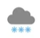
Thunder storms Windy Snowy

Continue the Discussion: I am wondering what symbol would go with each part of our timeline. Let’s use the Bee-Bots to find out! Let’s work with our elbow buddy. In a minute, not right now, you will be given a Bee-Bot, a mat, and some algorithms. You will program your Bee-Bot using the algorithms given to you to find out what symbol would be used during the first four entries of our timeline. When you get to the end, raise your hand.

Using protocols for passing out and using technology, give each team of students a Bee-Bot, a mat and their handout. Do the first statement with the kids. Model how to make a prediction, program the Bee-Bot, and communicate the answer. Remind students that Bee-Bot starts on the green flag pointing up to the top of the mat.

I think you are ready to program the Bee-Bots on your own. Remember, what are you supposed to do when you get to the end of the handout? Right, raise your hand.

Have students try the next one on their own. Walk around the room monitoring to make sure students understand how to predict, program, and communicate.

Go on to the next page.
Elaborate:
As students finish programming their Bee-Bots and begin raising their hands, give them the next thing to do. They are to write and test an algorithm to get the Bee-Bot to the symbol that shows the symbol for the last event on the timeline - the sunny sky. Students will use arrows to show how the Bee-Bot will get to the Sunny Sky symbol. If students make a mistake, have them debug their program by writing it on their handout and testing it again.

When students finish, they should put their Bee-Bots away. If you have students who are able to help others as student tutors, allow them to do that while you wait for the class to finish.

Evaluate:
Students complete the Weather Symbol Quiz.

Appendix A:
How to Make a Bee-Bot Map for the Storm is Coming Bee-Bot Activity

Directions: Using a sheet of butcher paper 36 in x 36 in, draw a grid that has squares that are 6 in x 6 in.

1.

2. Choose the five weather symbols from the book Storm is Coming.

Sunny, cloudy, thunder storm, wind and partly cloudy

3. Make one copy of each weather symbol and tape it into a square. Make sure that all of the edges
are taped down. The squares below are not equal due to the size of the graphics. Your mat will
have equal squares. The green flag is start.

 |  | 
 |  |  |  | 
 |  |  |  |  | 
 |  |  | 
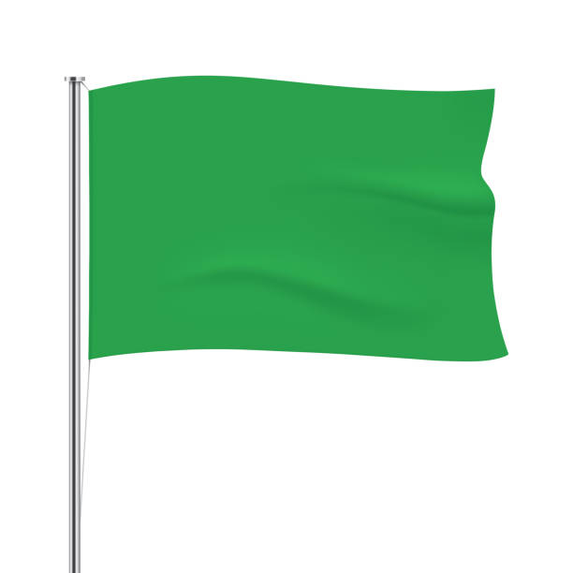

Appendix B
Weather Symbols


Sunny Weather Partly Cloudy Cloudy


Rainy Weather Thunderstorms Windy


Snowy Weather

Appendix C
Name: _________________________

Storm is Coming Bee-Bot Activity

Directions: Using the algorithm below, program the Bee-Bot to discover which weather symbol should be used at each step of the Storm is Coming Timeline.

- Farmer hears that a storm is coming.

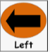



- The animals go to the barn.





- The sky grows very dark and the wind begins to blow.






- The animals hear rain tapping on the roof, sky is flashing, and thunder rolls.






- At the end of the story, the animals leave the barn and go out into the sunshine.
The symbol for sunshine is
 Create your own algorithm using the arrows below to get Bee-Bot from the Green flag to the sun symbol. When you are finished writing down your code, test it.

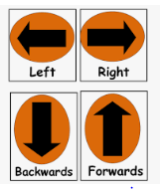

Appendix D
Weather Symbols Pre-Test

Directions: Circle the symbol described in each statement.

- Circle the symbol that shows windy weather.

- Circle the symbol that shows rainy weather.

- Circle the symbol that shows sunny weather.


- Study the Bee-Bot Map below. Following the algorithm provided, what color flower does Bee-Bot go to? The green flag is start.

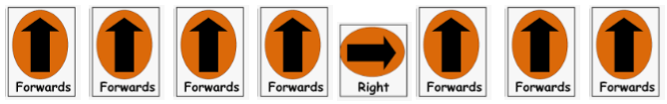






Appendix E
Weather Symbols Quiz

Directions: Circle the symbol described in each statement.
- Circle the symbol that shows windy weather.


- Circle the symbol that shows rainy weather.


- Circle the symbol that shows sunny weather.


- Study the Bee-Bot Map below. Following the algorithm provided, what color flower does Bee-Bot go to? The green flag is start.








