Micro:bit: How bright is it really?
 | Engage
 | Light Sensors

 | Explore
1. Read aloud Running on Sunshine: How Does Solar Energy Work? by
Carolyn Cinami DeCristofano (or another book about solar energy)
2. Discuss how the intensity of the sunlight can potentially affect solar powered devices.
3. Explore micro:bit

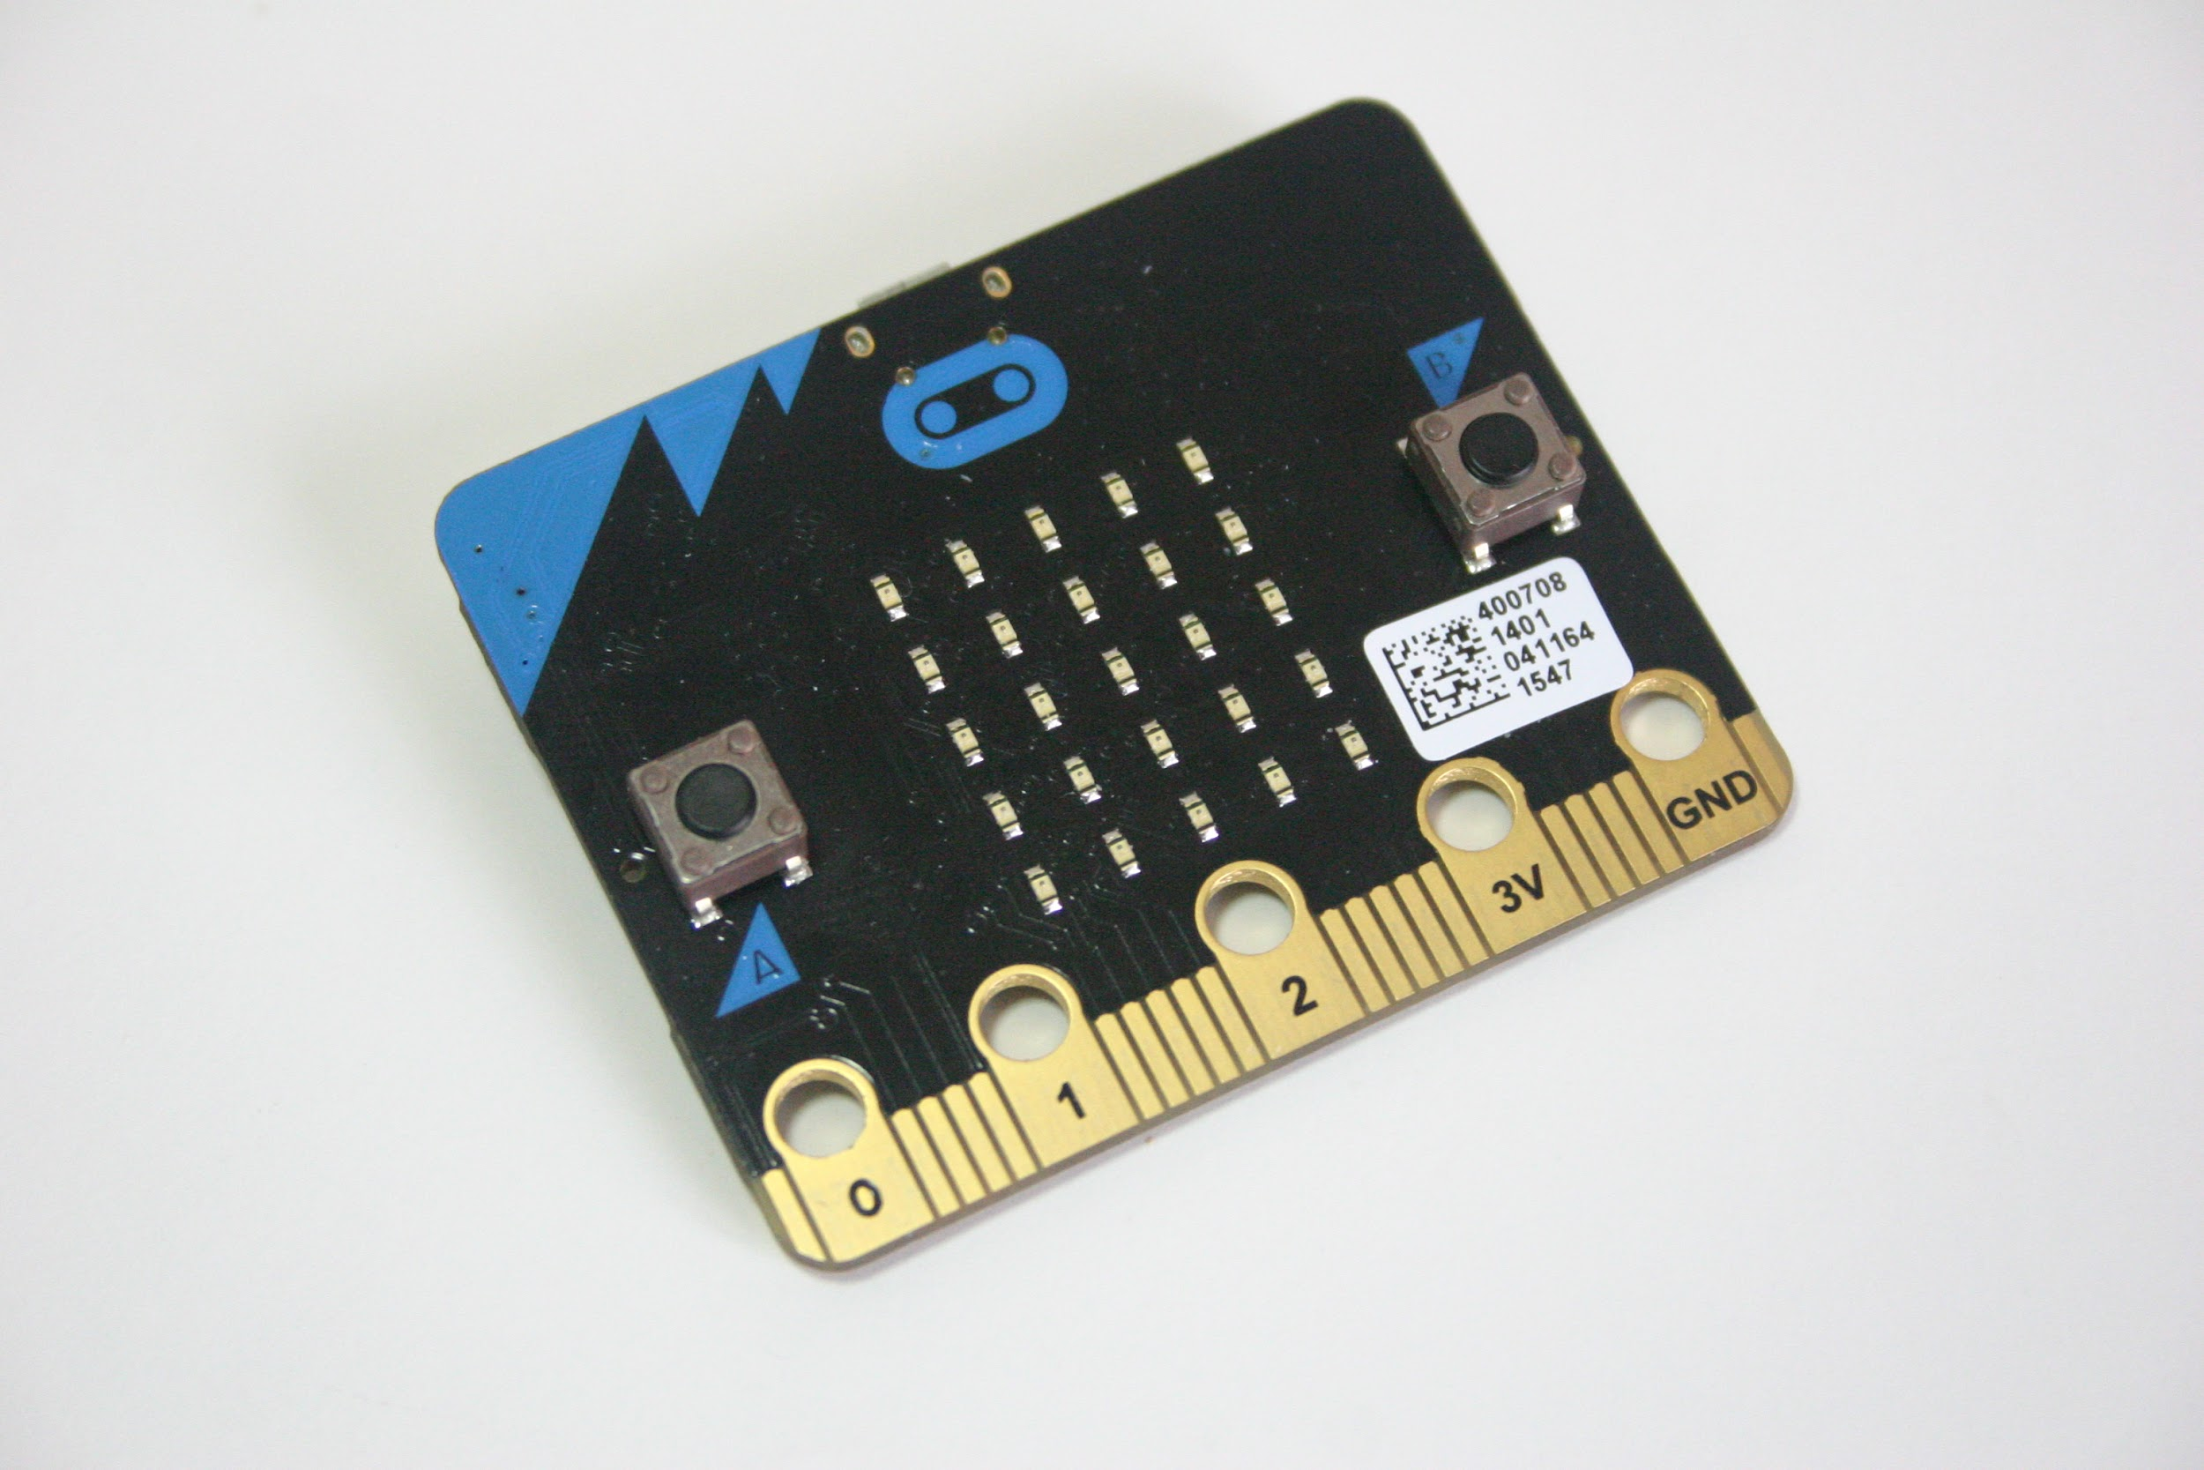 | Explain
- Discuss input/output/hardware/software as it applies to micro:bits
- Ask students how they could create a sensor that would show the amount of energy coming from the sun.
- Introduce the Sunlight Sensor activity for micro:bit Sunlight Sensor

 | Apply
 | Students will program the micro:bit to sense the light.

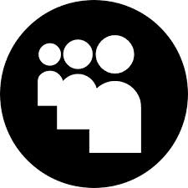 | Share
 | You have 3 minutes to share your sensor with one of your classmates.

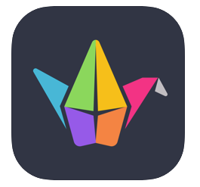 | Reflect
Go to your class Padlet
Share:
How you could use micro:bit as a learner.
How you could use micro:bit to showcase your learning.
Anything else you want to share with your teacher about these apps.

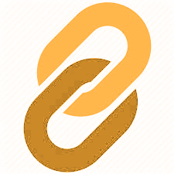 | Extend
Show a different picture, like a moon or star, when it’s dark.
Show an animated sun when light falls on your micro:bit.
Turn this project into a night-light by making it light up the micro:bit’s display when it goes dark.
Choose another activity: Night Light or Light Alarm

