Svalbarði Water - The World’s Most Expensive Water

Duration: Four, 50 minute class periods

Background Information:
This lesson is the third lesson in a 5th Grade Water Unit. This unit is taught during the Hydrosphere portion of the 5th Grade Biosphere Unit. On day one, students completed a pre-assessment (Ideas about the Percentage of Water Reservoirs on Earth - Appendix A), Then students were introduced to the hook - Svalbarði water being the most expensive bottled water in the world. It costs $50 for a 16 oz bottle of water. They watched a short video as to how it is gathered by ship and then students generated questions as to why this water is so expensive and whether or not it is worth it. Students have determined that there are five major reservoirs of water on Earth. They are: oceans, lakes, rivers, ground water, and ice (glaciers and icebergs). They have determined the compositions of these reservoirs: Oceans are composed of salt water, lakes, rivers, and groundwater are primarily fresh water, and ice and snow is made up of glaciers and are composed of freshwater. However, they are not sure about icebergs. The question came up about Icebergs and whether or not they are made of salt water. Students designed and carried out a laboratory activity to determine whether or not icebergs are composed of salt water. They determined that icebergs are composed of fresh water.

Lesson Standards:
Science: 5.ESS.2-2: Describe and graph the amounts of percentages of water and fresh water in various reservoirs to provide evidence about the distribution of water on Earth.
Computer Science: 5.DA.IM.01: Use data to highlight or propose relationships, predict
outcomes, or communicate an idea.

Lesson Objectives:
Students will:
- Research to determine the amount of percentages of water and fresh water in various reservoirs on Earth.
- Make predictions about the relative sizes of the reservoirs of water.
- Use a spreadsheet (Microsoft Excel) to create a data table, bar graph and a pie chart.
- Use peer feedback to refine a computer artifact (data table and graphs)
- Use the graphs to make predictions about what could happen to Earth’s water as the climate changes.

Possible Student Misconceptions:
- Fresh water is the most abundant form of water on the Earth.
- Ground water is the least abundant form of water on the Earth.

Materials:
- 1 Computing Device (laptop, smartphone, Chromebook, tablet, or computer) per student
- A projector to show the lesson slides and a YouTube Video
- Lesson Slides (coming later)
- Internet access
- Spread Sheet (Microsoft Excel, Apple Numbers, etc.)
- Pre-Lesson Assessment - (Ideas about the Percentage of Water Reservoirs on Earth - Appendix A)
- Activity handout - Digital or hardcopy (See Appendix B)
- Data table and Graph Rubric - Digital or Hardcopy (See Appendix C)
- Exit Ticket (Appendix D)
- Sticky notes - three per group
- Writing device - one per student
- Website - How Svalbaroi Produces Water (Youtube Video - queued and ready to go to avoid questionable advertisements)
- Wikipedia Chart - Water Distribution on Earth

Day 1
Engagement: (10 min)
1, Engage Students by saying: Who remembers what we learned in our last class? Give students time to think. Then, using the protocol of your choice (drawing sticks with student names on them, random name generator, pull names out of a hat, etc.) Call on students to answer the question.
Say: Exactly! We were introduced to Svalbarði Water - the most expensive bottled water on Earth. Then we began to think about why it is so expensive. We decided that we needed some information as to what a reservoir is before we could move forward in our investigation. We learned that there are five major reservoirs of water on Earth. Can anyone remember what they are and what kind of water they contain? Again, using the protocol of your choice, call on students to list them and describe them.
Say: You guys are sooooo smart! The five reservoirs are: oceans, rivers, lakes, groundwater
and ice and snow. Oceans are composed of salt water. Rivers, lakes, andground water are
usually fresh water. It depends upon where it is in relationship to oceans, swamps, other bodies of salt water. You said that ice and snow are made up of glaciers and icebergs, and that they are made up of fresh water. How do you know? Turn and talk to your neighbor. Give students time to discuss the salt water ice cube activity they performed during the last class. Then, using the protocol of your choice, call on students to answer the question.
Say: That’s right! When water freezes, the salt is left behind. Icebergs and glaciers are made
up of fresh water. As a result, the water near the North and South Poles is saltier than in other
areas of the ocean.

2. Introduce today’s lesson by saying: As we discovered yesterday, Svalbarði water is the most expensive water in the world. Svalbarði is selling polar iceberg water for over $50 per 16 oz bottle. The company is found in the Svalbarði Islands of the northernmost city in the world. The islands are a part of Norway and are situated halfway between mainland and the north pole. To see how they produce the water watch this short video.

How Svalbaroi Produces Water

According to Svalbarði unlike most water labeled glacier water: “Iceberg water has never touched ground. After originally falling from the sky as snow and compacting into a glacier, it has stayed as ice for potentially thousands of years.” Svalbarði water was frozen in a glacier.

Why do you think Svalbarði expensive? Working in groups of four, come up with three ideas as to why Svalbarði is so expensive. Your group will be given three sticky notes to write one idea on each sticky note. You have two minutes. Be prepared to share out.

After two minutes (more or less) have each group share one idea on their sticky note. Go around the room grouping similar ideas. Push them to propose that it is so expensive because there aren’t very many glaciers. Once that idea has been proposed, go with it.

Say: How do you know that there aren’t very many glaciers? How could we find that out? Allow students to come up with different ideas as to how they could find out. Push them to the idea that they could research it.

Exploration: (40 min)
Engage the class by saying: When in doubt, research. While we are finding out about how much glacier ice there is, let’s go ahead and find out how much ocean, river, lake, and ground water there is too. Go to our Science Class in Canvas and access your digital notebook. You will notice that there is a data table that looks like the one below. Show the data table.

Reservoir | Guess  (1 largest, 5 smallest) | Percent  Total Water | Ranked  (1 largest, 5 smallest)
Groundwater
Ice & Snow (Icebergs)
Lakes
Oceans
Rivers
Other

You will also have access to a Wikipedia Chart. Show the Wikipedia Chart. Be sure to follow
the directions when you are filling out the chart. You may work together with your elbow
buddy, but each person needs to fill out their own chart. Also, don’t worry about filling out the
percentage for “Other” until tomorrow. We will go over how to fill it out during our next class.
Give students instructions as to how to access the data table either digitally or as a hard copy.
See Appendix A.

After students have had a chance to research and fill out the data table, pull the group together
as a whole group to end the class. Let students know that they will need to be ready to
discuss the data in their data table in the next science class.

 At the end of the day before the next science time, collect student computing devices and
make sure that they are fully charged. If that is not possible, make sure that you have a
means for students to charge their device during the next science time. Also, you might need
an extra set of hands for the next class. Ask another teacher, a district support technology
person, or the technology person for your building to help you for the next three classes. They
can help students log on, launch the program and troubleshoot any issues that may arise.

Day 2
Start Class: (5 min)
Engage Students by saying: Who remembers what we learned in our last class?
Give students time to think. Then, using the protocol of your choice (drawing sticks with
student names on them, random name generator, pull names out of a hat, etc.) Call on
students to answer the question. Say: You guys have a great memory! We wondered why
Svalbarði water water is the most expensive water in the world. We wondered if one of the
reasons why it was so expensive is because iceberg water is so rare. To find out, we
researched the percentage of freshwater found in the five reservoirs and created a data table.
What did the data tell us? Lead a class discuss of the data, what the data means, and what
they learned about the percentage of the different reservoirs.

Explanation: (45 min)
- Discussing the Data:
Begin the conversation: What were some of your guesses as to the relative sizes of the
reservoirs? Give students an opportunity to think. Then, using the protocol of your choice, call
on students to share their initial impressions as to the relative sizes of the reservoirs. As
students share their thinking, have them give their rationale. This should be a time of open
sharing. Thank you for sharing your thoughts. You all had some really interesting ideas and
reasoning for your ideas.

Ask: Before we discuss the percentages of water in the water reservoirs, we need to fill in the percentage of the Other reservoir. Does anyone have any ideas about how to figure out what percent the Other is? Give students an opportunity to think. Then, using the protocol of your choice, call on students to share. Push students to come up with the idea that the Percent Total Water Column should equal 100%. Once that has been determined, have students find the percentage by adding all of the other reservoirs together and then subtracting them from 100. You should get an answer that is 0.036919. Let students know that this number represents all of the other types of water reservoirs not represented in your data table.

Continue the data discussion: What are the actual sizes and percentages of water in the reservoirs? Did this surprise you? Give students an opportunity to think. Then, using the protocol of your choice, call on students to share their initial impressions as to the relative sizes of the reservoirs. As students share their thinking, create a classroom data table either on the board, chart paper, etc. Have students give their rationale and have the class come to consensus about what goes in the data table. Say: Again, thank you for sharing your ideas with us. You all have had some very interesting ideas and thoughts about the data you researched. I have another question, what are some of the problems with presenting data in a data table? Give students an opportunity to think. Then, have students turn and share their ideas with their elbow partner. After an appropriate amount of time, using the protocol of your choice, call on students to share their initial impressions as to the relative sizes of the reservoirs. As students share their thinking, have them give their rationale. This should be a time of open sharing.

Ask: You raise some really good problems with showing data in a data table. It isn’t as visual. It takes a lot more time to determine which reservoirs were the largest and any other relationships there might be in the data. What might be another way to display our data so that it is easier to read and we might see some relationships? Give students an opportunity to think. After an appropriate amount of time, using the protocol of your choice, call on students to share their answers. Continue the Data Conversation: I agree. A graph would be a great next step. How could we go about creating a graph? Give students an opportunity to think. After an appropriate amount of time, using the protocol of your choice, call on students to share their answers. Say: True, we could use our data tables to create a graph with a pencil and some graph paper like you did last week in math. How would you share it with the entire class and other scientists around the world? Give students an opportunity to think. After an appropriate amount of time, using the protocol of your choice, call on students to share their answers. Remark: I agree that you could use your phone or your iPad to take a picture of the graph and then upload it into a document and share the document. Great idea! I want to remind you that you are not allowed to use your phone during school. Also, what if I told you that the camera function on your iPad has been disabled. What would you do now? Again, give students an opportunity to think. After an appropriate amount of time, using the protocol of your choice, call on students to share their answers. Say: You are right. We will have to create a graph using a laptop. We are going to learn how to use a spreadsheet to create our graph. We are going to use Microsoft Excel to do this.

- Creating a Spreadsheet using Apple Numbers.
Teacher Note: Students have had experience with graphs and data tables in math in the previous weeks. They understand that a data table has an X column and a Y column and that these columns determine how information is graphed. They have also learned when to use a line graph, a bar graph, and a pie chart. If students do not have this background, you may need to give them a brief lesson about graphing. It should be a review of material previously taught. Most math curriculum has students graphing in Grade 4.

Instruct students to get out their computing device. In our case we are using Laptops that have Microsoft Excel on them. We are using Excel because it is the program I am most familiar with. You can use the spreadsheet you prefer. As a result, the instructions below might vary. I have included links to the instructions to some of spreadsheets below.

AppleWorks Spreadsheets: iWork-Numbers
Open Office Tutorials: Flash tutorials for all Open Office software
Microsoft Excel: Free online audio tutorial

Once students have collected and logged in to their computing device and launched Excel, walk around the room to make sure that everyone is ready to go. Also, share your computer screen with the class so that they can work with you step by step.

Tell Students: It looks like everyone has logged in to their computer and has launched Excel. Great job! What are we going to graph? Give students an opportunity to think. After an appropriate amount of time, using the protocol of your choice, call on a student to share what we are going to graph. You are right. We are going to graph the data we collected about the percentage of water each reservoir has on the Earth. We created a class data table earlier. Let’s use that.

Lead students to create the data table in Excel in terms of a(n):
- What needs to be graphed (percentage of water and the reservoir)
- Which column should be the X and the Y column - think about what the graph would look like (Percentage vs Reservoir. Reservoir is the X and Percentage is the Y)
- Label the columns
- Fill in the columns
- Discuss why some of the numbers are different than what you entered. This has to do with formatting long numbers smaller than one

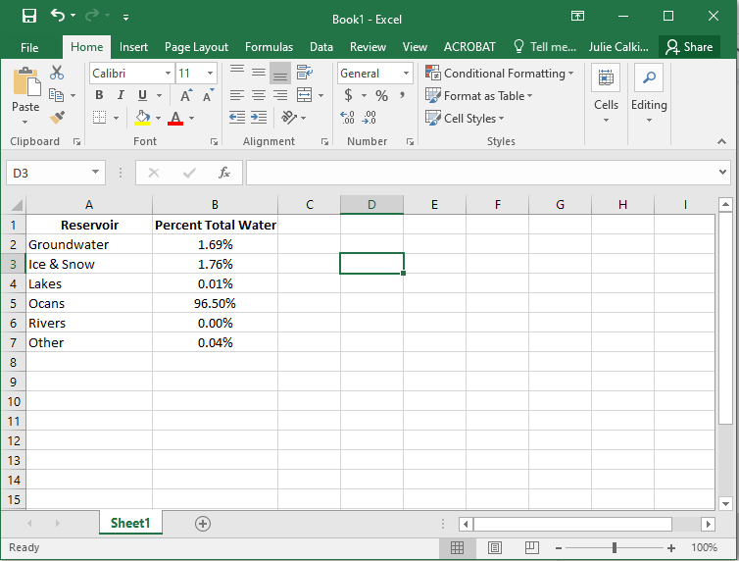

Explain: This next step will show you why using a spreadsheet to make a graph is a great
way to go. Highlight the data table and then click on the insert tab as I am showing you on the
Screen.

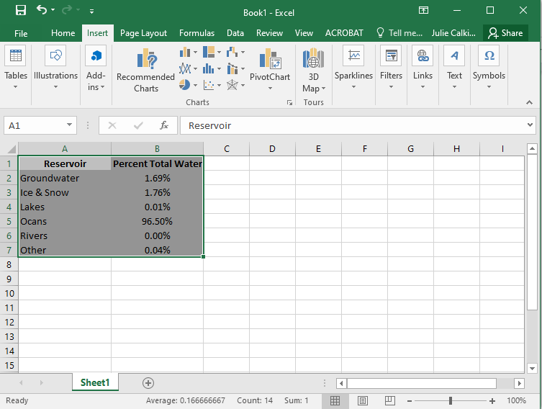

Now choose the Insert tab and click on Recommended Charts. Choose the Clustered Column
and click OK.

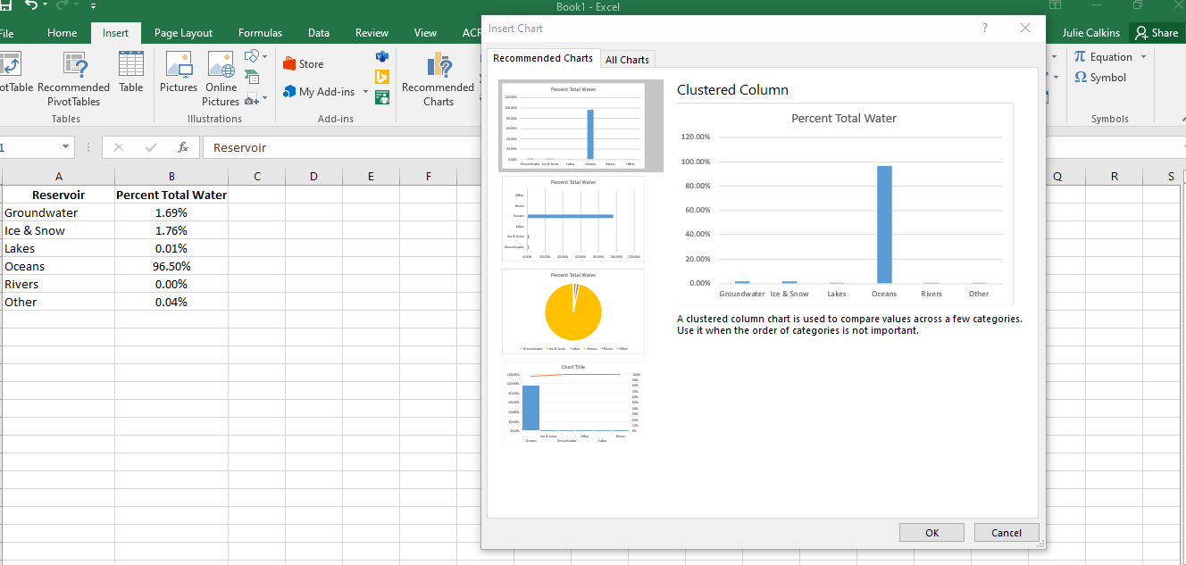

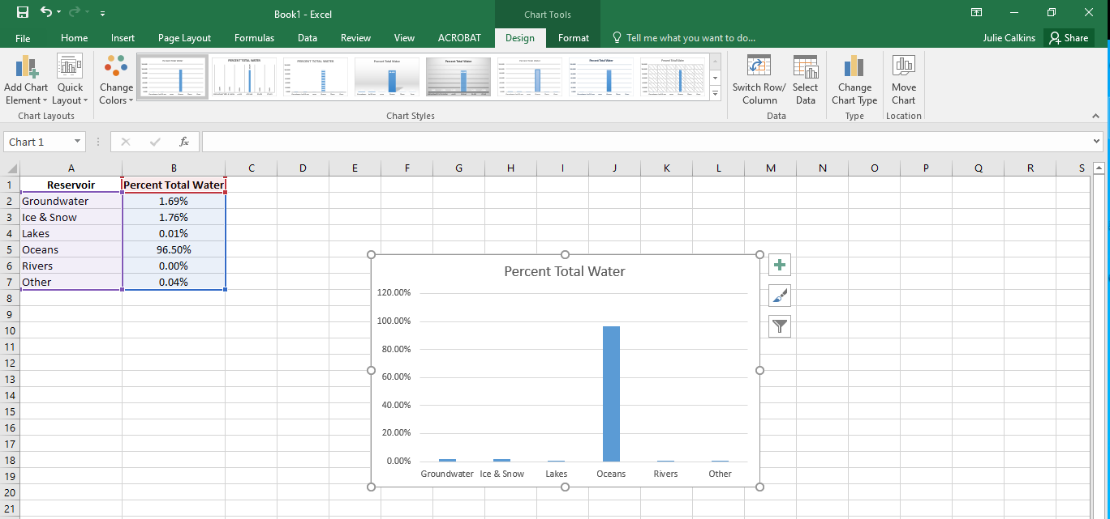

Have students save their work in their digital folders. Then inform students that the next time they have science they will finalize their graphs and data tables and then answer questions that will lead them through analyzing the data they have collected.

Day 3
Start Class: (10 min)
Begin Students by saying: Who remembers what we learned in our last class?
Give students time to think. Then, using the protocol of your choice (drawing sticks with
student names on them, random name generator, pull names out of a hat, etc.) Call on
students to answer the question. Say: You guys have a great memory! We created a data
table and a graph using Excel. We felt that organizing our data into a graph would give us a
better feel for the relative percentages of water reservoirs, help us find more relationships
between the data, and help us find out the amount of icebergs. The amount of icebergs could
be a factor in how expensive Svalbarði water is. The less there is, the more precious the
resource. Have students get their computing devices, log in, and access their digital folder
with their work from the previous class.

Spreadsheets Day 2: (40 min)
- Give students access to the graph and data table rubric (See Appendix B). Have students
work independently to determine whether or not their graph and data meet the criteria for data
tables and graphs. When the class seems to have finished evaluating their data table and
graph, pull the class back together to discuss what is missing. Lead the class in a discussion
about what is missing or incorrect.
Missing or incorrect items:
- Data table doesn’t have a title
- The Percent Total Water column doesn’t have a percent sign in (). The % sign is after each entry. This is ok, but make sure students understand one or the other.
- Graph doesn’t have a title
- X axis is not labeled
- Y axis is not labeled

- After the class discussion, work with students to correct these problems and to transfer their artifacts to the Activityhandout (See Appendix A) or to a new document.
- At the end of class, have students save their work to their digital folder. Most students should have their data table ready for the next class. For those who are not finished, or missed science time, utilize the tech support to help students who are absent or need more help at the beginning of the next class.

Day 3:
Begin Class: (5 min)
Begin Class Students by saying: Who remembers what we learned in our last class?
Give students time to think. Then, using the protocol of your choice (drawing sticks with
student names on them, random name generator, pull names out of a hat, etc.) Call on
students to answer the question. Say: You guys have a great memory! We created a data
table and a graph using Excel, and then we worked with our graphs and data table to make
sure that they met the criteria for graphs and data tables by using the rubric. Then we moved
them to a new document or to our activity. Today, we are going to take our graphs and use
them to determine relationships and to figure out another reason why Svalbarði water is so
expensive. Have students get their computing devices, log in, and access their digital folder
with their work from the previous class.

Elaboration: (40 min)
Say: Today you will work in teams of two to analyze the data you created and to determine
whether or not the amount of icebergs could be a factor in why Svalbarði water is so
expensive. You will have the rest of the class time to work. Tomorrow, we will we will come
together to make sense of our findings. Have students use their digital data table and graph to
answer the questions on the handout (See Artifact A). If the handout is digital, students should
have added their digital artifacts into the designated space. If the students are using a hard
copy of the handout, have them reference their digital artifacts. These can be printed out, or
Displayed on the screen.

When there is about 5 minutes of class time left, say: We have about five minutes of class left.
Next time we will come together to discuss what we discovered and answer our question.
Then you will complete a short exit ticket. Have students put save work into their digital
folders, put computing devices away. If students had hard copies of Appendix A, give them
instructions as to what to do with them until the next class.

Day 4
Begin Class: (10 min)
Say: Who remembers what we learned in our last class?
Give students time to think. Then, using the protocol of your choice (drawing sticks with
student names on them, random name generator, pull names out of a hat, etc.) Call on
students to answer the question. Say: Perfect! We used our data table and graph to answer
analyze data and to determine whether or not the amount of icebergs may have anything to do
with why Svalbarði water is so expensive. I informed you that we would make sense of our
ideas today as a class and that you would fill out a short exit ticket at the end of our time
together. Have students get their computing devices, log in, and access their digital folder for
with their work from the previous class.

Evaluation: (40 min)
Review their thoughts from the handout they completed. Lead the class in a discussion about
what reservoir is the largest, which one is the smallest, how scarcity can drive costs, and any
other ideas that come up during the class discussion. At the end of the class, have students
complete the Exit Ticket (Post Test). This is how they will be evaluated for this activity.

Appendix A
Ideas about the Percentage of Water Reservoirs on Earth

Directions: Carefully read the questions below. Then answer them to the best of your ability in the space provided.

- The Earth is called the Blue Planet because…
________________________________________________________________

________________________________________________________________

________________________________________________________________

- Most of the Earth’s water is located in…

_______________________________________________________________

_______________________________________________________________

- Explain what it means when hydrologists say that “The earth has an abundance of water, but unfortunately, only a small percentage (about 0.3%) is even useable by hymans.” (www.ngwa.org)

________________________________________________________________
________________________________________________________________

________________________________________________________________

________________________________________________________________

________________________________________________________________

Go on to the next page.

Directions: Read the text below. Then answer Questions 4 and 5.
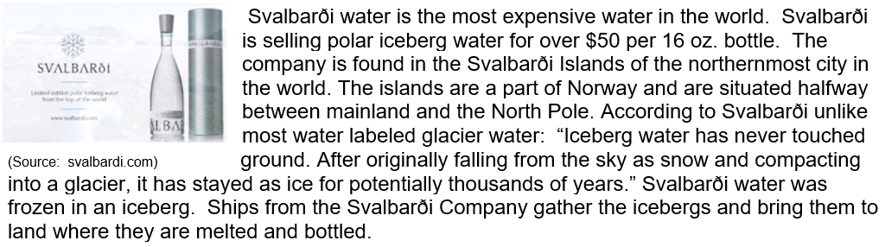

- Why is Svalbarði water the most expensive water in the world?

________________________________________________________________

________________________________________________________________

________________________________________________________________

________________________________________________________________

________________________________________________________________

- How might climate change affect the amount of water on Earth?

________________________________________________________________

________________________________________________________________

________________________________________________________________

________________________________________________________________

________________________________________________________________

Appendix B
Name: ____________________

Svalbarði Water - The World’s Most Expensive Water Handout

Directions: Follow the directions below and answer the questions in the space provided.
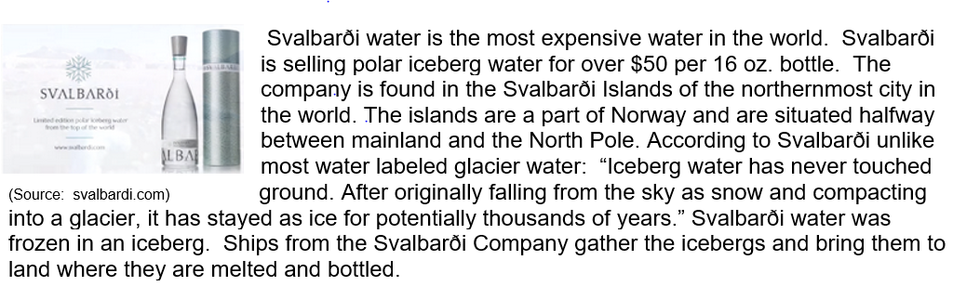

During class one idea as to why Svalbarði water is one of the most expensive in the world is because icebergs are scarce. There aren’t many of them. To test his theory, we decided to do some research. Use the Wikipedia Chart to determine the percentage of total fresh water.

- Before you begin your research, fill out the first column of the data table below by ranking the water reservoirs of Earth from largest (1) to smallest (5). Remember, this is just a guess. There are no wrong answers.

Reservoir | Guess  (1 largest, 5 smallest) | Percent  Total Water | Ranked  (1 largest, 5 smallest)
Groundwater
Ice & Snow (Icebergs)
Lakes
Oceans
Rivers
Other

- Use the Wikipedia Chart to fill out the Percent Total Water Column.

- Now rank the reservoirs using the actual data.

- What did you learn by looking at the Percent Total Water data?

___________________________________________________________________________

___________________________________________________________________________
- Look at the graph you produced. What is the largest reservoir? The smallest reservoir? Be sure to use data from the data table to support your claim.

___________________________________________________________________________

- Does there appear to be a lot of icebergs? Explain.

___________________________________________________________________________

- Most of the water on the planet is not useable. The following table includes the percentage of freshwater reservoirs on the planet.

Reservoir | Total Freshwater (%)
Ice and Snow (Icebergs) | 69
Lakes | 0.3
Rivers | 0.0061
Groundwater | 30
Other | 0.6939

- Comparing the percentage of total freshwater found in icebergs to the other freshwater reservoirs, is there a shortage of icebergs? Explain.

___________________________________________________________________________
___________________________________________________________________________

___________________________________________________________________________

___________________________________________________________________________

___________________________________________________________________________

- Why do you think Svalbarði is the most expensive water in the world?

___________________________________________________________________________

___________________________________________________________________________

___________________________________________________________________________

- How might climate change affect the amount of water in Earth’s reservoirs?

___________________________________________________________________________
___________________________________________________________________________

___________________________________________________________________________

___________________________________________________________________________

___________________________________________________________________________

Appendix C
Data Table and Graphs Rubric
Data Table Rubric

Elements of a Data Table | 0 | 1 | 2 | 3 | 4
Data Table | Missing three criteria for a three, or demonstrates no understanding of a data table, or missing. | Missing two of the criteria for a three | Missing one of the criteria for a three | - Neatly constructed, organized  - Makes good use of space.  - Does not break across a page. | Data table exceeds the the criteria of a three.
Title | Missing three criteria for a three, or demonstrates no understanding of a data table title | Title is missing two criteria for a three. | Title is missing one of the criteria for a three. | - Title is clearly written and shows the data collected.  - Title has the Independent (X) Variable.  - Title has the Dependent (Y) Variable. | Title exceed the criteria of a three.
Heading for the Independent Variable Column (X) | Missing three criteria for a three, or demonstrates no understanding of a data table heading for the independent (X) variable | Heading for the Independent (X) Variable is missing two of the criteria for a three. | Heading for the Independent (X) Variable is missing one of the criteria for a three. | - The Independent (X) Variable is represented in the left column  - The units are in metric  - The units are clearly indicated in parenthesis | Heading exceeds the criteria of a three.
Dependent Variable Column (Y) | Missing three criteria for a three, or demonstrates no understanding of a data table heading for the dependent (Y) variable | Heading for the Dependent (Y) Variable is missing two of the criteria for a three. | Heading for the Dependent (Y) Variable is missing one of the criteria for a three. | - The Dependent (Y) Variable is represented in the left column  - The units are in metric  - The units are clearly indicated in parenthesis | Heading exceeds the criteria of a three.
Data Presentation |  |  |  | - Data appears in the correct column.  - Data is is centered in the cell  - Decimal points align dow a column

Graphing Rubric

Elements of a Graph | 0 | 1 | 2 | 3 | 4
Graph | Missing three elements of a three, or demonstrates no understanding of constructing a graph | Missing two of the elements for a three. | Missing one the elements for a three. | - Correct graph chosen for the data  - Neatly constructed, organized and makes good use of space.  - Does not break across a page. | Graph clearly exceeds the criteria for a three
Title | Missing three elements of a three, or demonstrates no understanding of titling a graph | Missing two of the elements for a three. | Missing one the elements for a three. | - Describes the information with in the graph  - Independent Variable (X) is in the title  - Dependent Variable (Y) is in the title | Title clearly exceed the criteria for a three
Independent (X) Variable Axis | Missing three elements of a three, or demonstrates no understanding of labeling the X axis | Missing two of the elements for a three. | Missing one the elements for a three. | - The horizontal axis  - Clearly labeled  - Includes units (if appropriate) | X Axis clearly exceeds the criteria for a three
Dependent (Y) Variable Axis | Missing three elements of a three, or demonstrates no understanding of labeling the Y axis | Missing two of the elements for a three. | Missing one the elements for a three. | - The vertical axis  - Clearly labeled  - Includes units (if appropriate) | Y Axis clearly exceeds the criteria for a three
Key - If more than two lines appear on a graph or it is impossible to label X axis. | Missing three elements of a three, or demonstrates no understanding of labeling the Y axis | Missing two of the elements for a three. | Missing one the elements for a three. | - Clearly titled  - All elements are listed  - All elements have a symbol | Key clearly exceeds the criteria for a three

Appendix D
Is Svalbarði the Most Expensive Water on Earth?
Exit Ticket

Directions: Carefully read the questions below. Then answer them to the best of your ability in the space provided.

- The Earth is called the Blue Planet because…
________________________________________________________________

________________________________________________________________

________________________________________________________________

- Most of the Earth’s water is located in…

_______________________________________________________________

_______________________________________________________________

- Explain what it means when hydrologists say that “The earth has an abundance of water, but unfortunately, only a small percentage (about 0.3%) is even useable by hymans.” (www.ngwa.org)

________________________________________________________________
________________________________________________________________

________________________________________________________________

________________________________________________________________

________________________________________________________________

Go on to the next page.

- Why is Svalbarði water the most expensive water in the world?

________________________________________________________________

________________________________________________________________

________________________________________________________________

________________________________________________________________

________________________________________________________________

- How might climate change affect the amount of water on Earth?

________________________________________________________________

________________________________________________________________

________________________________________________________________

________________________________________________________________

________________________________________________________________

