The Glaciers Are Shrinking?!

Duration:

Background Information:
This activity was adapted from the World of Science “The Shrinking Glaciers of Glacier National Park” Assessment for 4 - ESS2-1. The resulting activity is designed to provide students with an opportunity to demonstrate proficiency with Wyoming Science Content and Performance Standard 4-ESS2-1. This standard deals with weathering and erosion. Students will use the phenomenon of the Grinnell Glacier located in Glacier National Park in Montana as the foundation to explain why the glacier is shrinking and how it is weathering and eroding this area of the park. Students will work in groups of two and groups of four students.

Lesson Standards:
Science: 4-ESS2-1: Make observations and/or measurements to provide evidence of the effects of weathering or the rate of erosion by water, ice, wind, or vegetation.

Computer Science: 5.DA.IM.01: Use data to highlight or propose relationships, predict
outcomes, or communicate an idea.

Lesson Objectives:
Students will:
- Identify evidence to determine whether or not the glaciers in Glacier National Park are shrinking.
- Make observations to provide evidence of the effects of weathering or the rate of erosion by ice.
- Make measurements to provide evidence of the effects of weathering or the rate of erosion by ice.
- Use data to highlight and propose relationships, predict outcomes, or communicate why the Grinnell Glacier is shrinking and how it is weathering and eroding the ground under it.

Possible Student Misconceptions:
- Glaciers do not move.
- If glaciers do move, they “bulldoze” the ground under them.

Materials:
- 1 Computing Device (laptop, smartphone, Chromebook, tablet, or computer) per student
- Projector to show the Phenomenon and other items in the digital folder.
- Student access to Air Drop or to Canvas
- Access to the Glacier Simulation Website.
- Glacier Video (YouTube)
- Appendix A: Phenomenon Document
- Post it notes.
- Appendix B: Grinnell Glacier Article
- Appendix C: Response Questions to Grinnell Article
- Appendix D: Glacier Experiment
- Appendix E: Glacier Quiz

Day 1:

Engage (10 min):
Show students the picture of Grinnell Glacier taken in 1938 and in 2019 (Appendix A). This photo can be projected, photocopied and handed out to groups of students, or uploaded in the Weathering and Erosion Digital file. Students should be asked to study the photos and write down three things they notice about the pictures and three things that they notice about the pictures. They will then share with a partner, with their group of four, and then with the class. As students share what they notice and wonder with the class, group their post it notes into similar notices and wonderings.

Explore (15 min):
During the Engage portion of the lesson, push students to wonder why the Grinnell Glacier changed size and what was all of the loose rock about. In this section of the lesson plan, students will explore why the glacier is shrinking. Give students the Grinnell Glacier Reading (Appendix B). Then, using the reading strategy of your choice, have students read the article and and answer the response questions (Appendix C). Have students get ready to participate in a class discussion about the article. Push students to answer a few of the wonderings they had during the Engage portion of the lesson. Help students ask how does gravity cause a glacier to move?

Explain (30 min):
HAve students work on the Glaciers Experiment (Appendix D). Have students Download Legacy Java Version. You may need to walk students through logging on the the simulation and how to explore it.



If students are unable to use the simulation, they can gather evidence from this Glacier Simulation Video.

After students have completed the simulation, have them work in pairs, groups of four, or as a whole group to answer the questions. If time permits, host a class discussion as to why the Grinnell Glacier is shrinking.

Day 2:
Elaborate (20 min):
You may need to take more time with the simulation before entering into the Elaborate. There is still one question that has not been answered. That is what is all of the rocks and stuff and how did they get there?

Show the Glacier Video linked above.

Discuss with students how the rocks move by erosion and abrasion.

Evaluate (30 min)
Give students the Glacier Quiz as an exit ticket to demonstrate their learning of glaciers.

Appendix A
Grinnell Glacier 1938 to 2019

Phenomenon
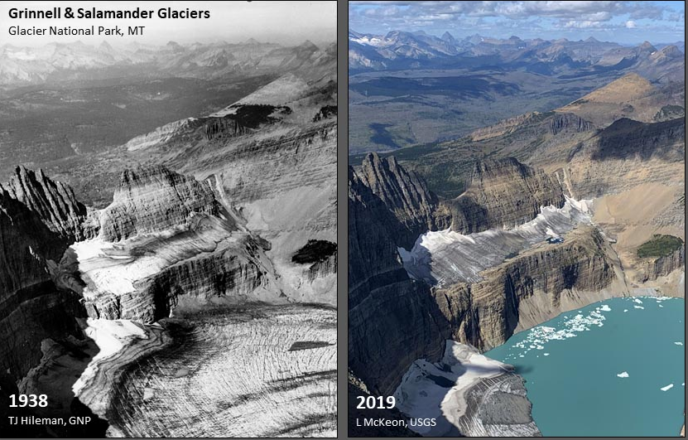

Appendix B
Grinnell Glacier Article
Glacier National Park, MT


Source: https://www.usgs.gov/media/images/grinnell-glacier-1938-2019-glacier-national-park

Glaciers are masses of ice that are so big they move under the influence of gravity. They grow when winter snow accumulation exceeds summer melting. They retreat when melting exceeds snowfall.
A glacier can not be smaller than 25 acres. If the ice and snow mass is smaller than 25 acres, it does not move and stays still. Glaciers do not stay still. They move. Many years of snow accumulation presses the bottom layers of snow into ice. Under the huge weight of the snowpack (usually 100ft thick or more), the ice becomes sticky and allows the glacier to slide downhill. The appearance of large cracks is evidence that the glacier moves. Glaciers don't "bulldoze" landscape as much as they melt and re-freeze, plucking material from areas and moving it to other areas, like downhill conveyor belts.

The Grinnell Glacier in Glacier National Park is estimated to be at least 7,000 years old and was at its largest size during the mid-1800s, during the Little Ice Age. For thousands of years, the glacier naturally cycled through times of advance and retreat. The glacier started to retreat when a warming trend happened between 1966 and 2005. The Grinnell Glacier lost almost 40 percent of its acreage. Glaciologists (scientists who study glaciers) have predicted that if carbon dioxide level increase at a worst-case scenario, all the glaciers in the park, including Grinnell, will disappear by the year 2030

Appendix C
Response Questions
Grinnell Glacier Article

Directions: Read the Grinnell Glacier Article. Then, answer the questions below.

- What is a glacier? ___________________________________________________________

__________________________________________________________________________

- Do glaciers move? Explain. ___________________________________________________

__________________________________________________________________________

__________________________________________________________________________

- According to the article, what is causing the Grinnell Glacier to melt? ___________________

___________________________________________________________________________

___________________________________________________________________________

___________________________________________________________________________

___________________________________________________________________________

- When will the glaciers of Glacier National Park be gone? What might affect this date?

___________________________________________________________________________

___________________________________________________________________________

___________________________________________________________________________

___________________________________________________________________________

Appendix D
Glacier Experiment

Procedure:

- Open up the PhET Glaciers simulation (http://phet.colorado.edu/en/simulation/glaciers). Be sure to click on the white arrow and then choose “Download Legacy Java Version.

- Take some time to explore this simulation for five minutes. Use the tools in the toolbox and play with the air temperature and the average snowfall and the speed.

- What phenomenon will you be investigating.

- What is the purpose of this investigation? _________________________________________

___________________________________________________________________________

Observe what happens to the glacier as you adjust different things in the simulation. Record your observations in the table below.

Action | Glacier Movement | Maximum Thickness
Trial 1  Decrease the average annual snowfall | ___ Advances  ___ Retreats  ___ None | ___ Increases  ___ Decreases  ___ No Change
Trial 2  Increase the average annual snowfall | ___ Advances  ___ Retreats  ___ None | ___ Increases  ___ Decreases  ___ No Change
Trial 3  Decrease the air temperature | ___ Advances  ___ Retreats  ___ None | ___ Increases  ___ Decreases  ___ No Change
Trial 4  Increase the air temperature | ___ Advances  ___ Retreats  ___ None | ___ Increases  ___ Decreases  ___ No Change

6. Draw a model of how increasing and decreasing the average snowfall affected the glacier.

7. Draw a model of how increasing and decreasing the air temperature affected the glacier.

8. Based upon what you have figured out, why is the Grinnell Glacier shrinking?

Appendix E
Glacier Quiz

Directions: Answer the questions below.

- Are the glaciers in Glacier National Park changing size? Explain.

- How do glaciers weather and erode the ground they cover? Use drawings and/or words.

