Instructions

Convert the following algorithms into pseudocode using the methods shown in class. Use this link to access the presentation.
- Make sure to include the proper indentation to show dependencies.
- Use the highlight feature for any variables. This will help with tracking.

1. | Pseudocode | Blocky Algorithm
On Start |  | 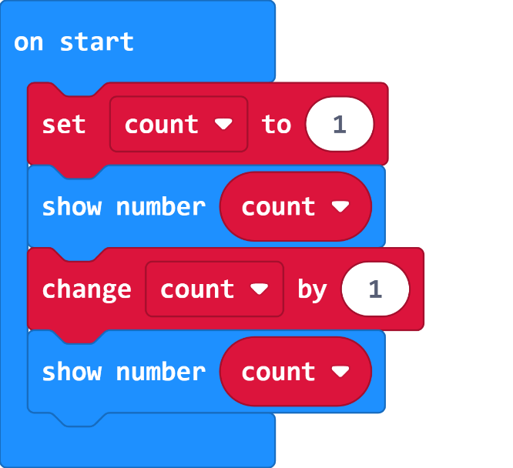

2. | Pseudocode | Blocky Algorithm
Forever |  | 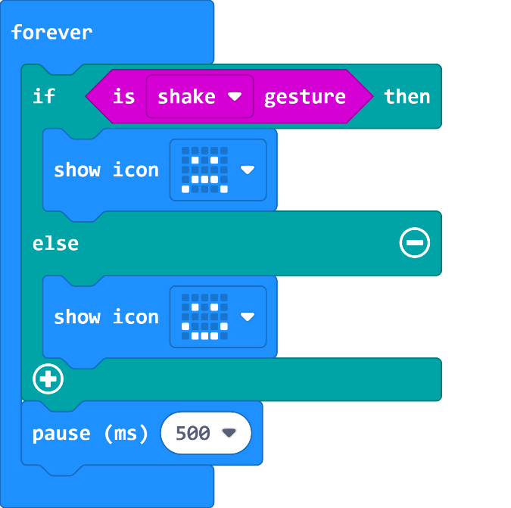

3. | Pseudocode | Blocky Algorithm
On Start |  | 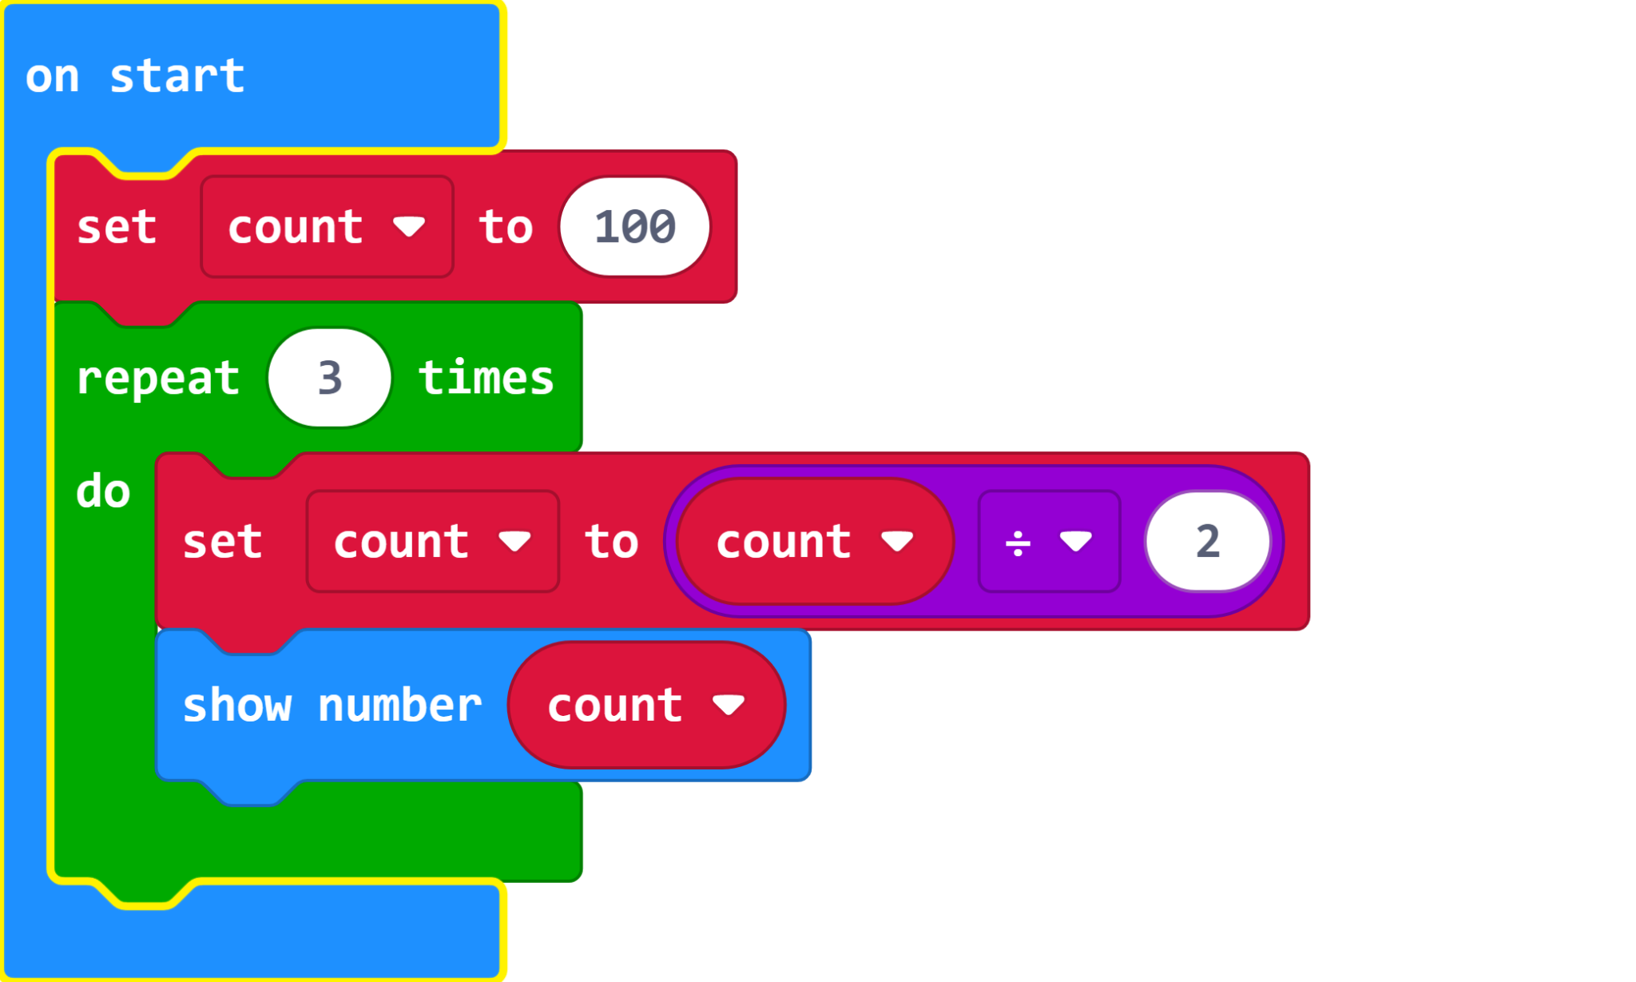

4. | Pseudocode | Blocky Algorithm
On Start  Forever |  | 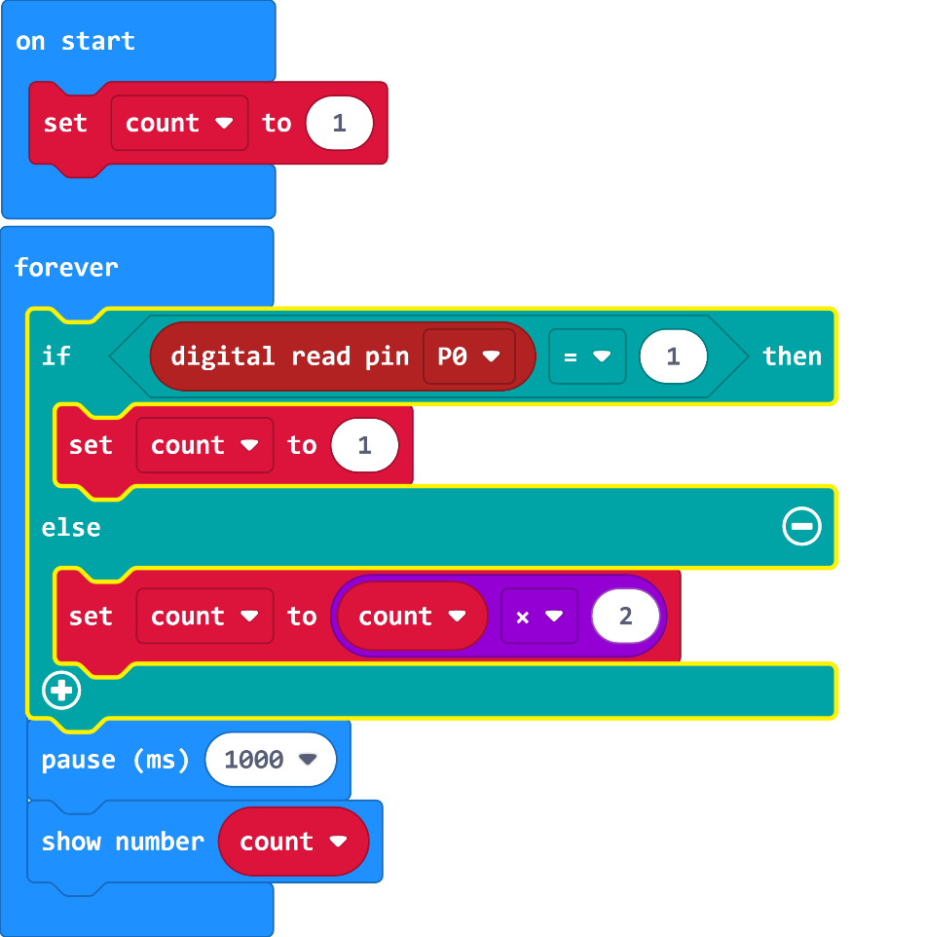

5. | Pseudocode | Blocky Algorithm
Forever |  | 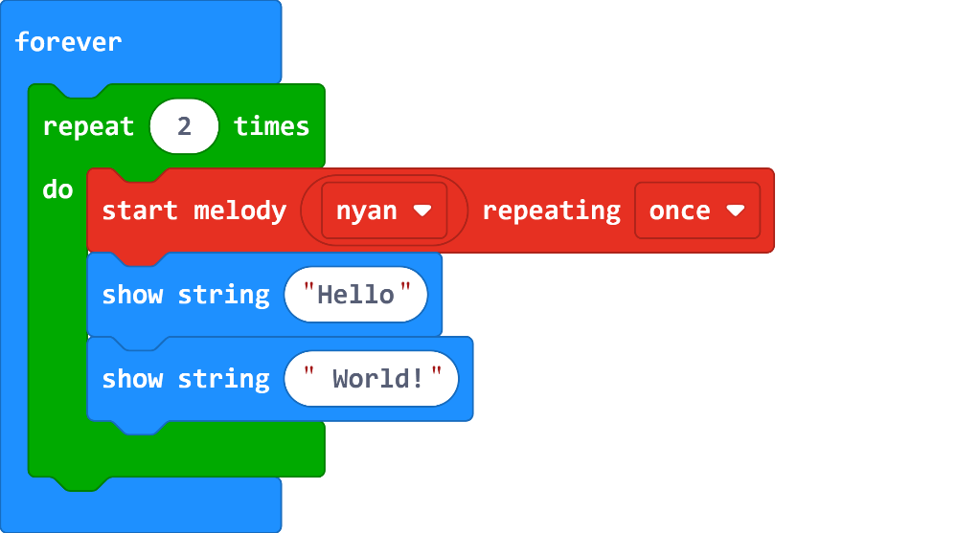

6. | Pseudocode | Blocky Algorithm
Forever |  | 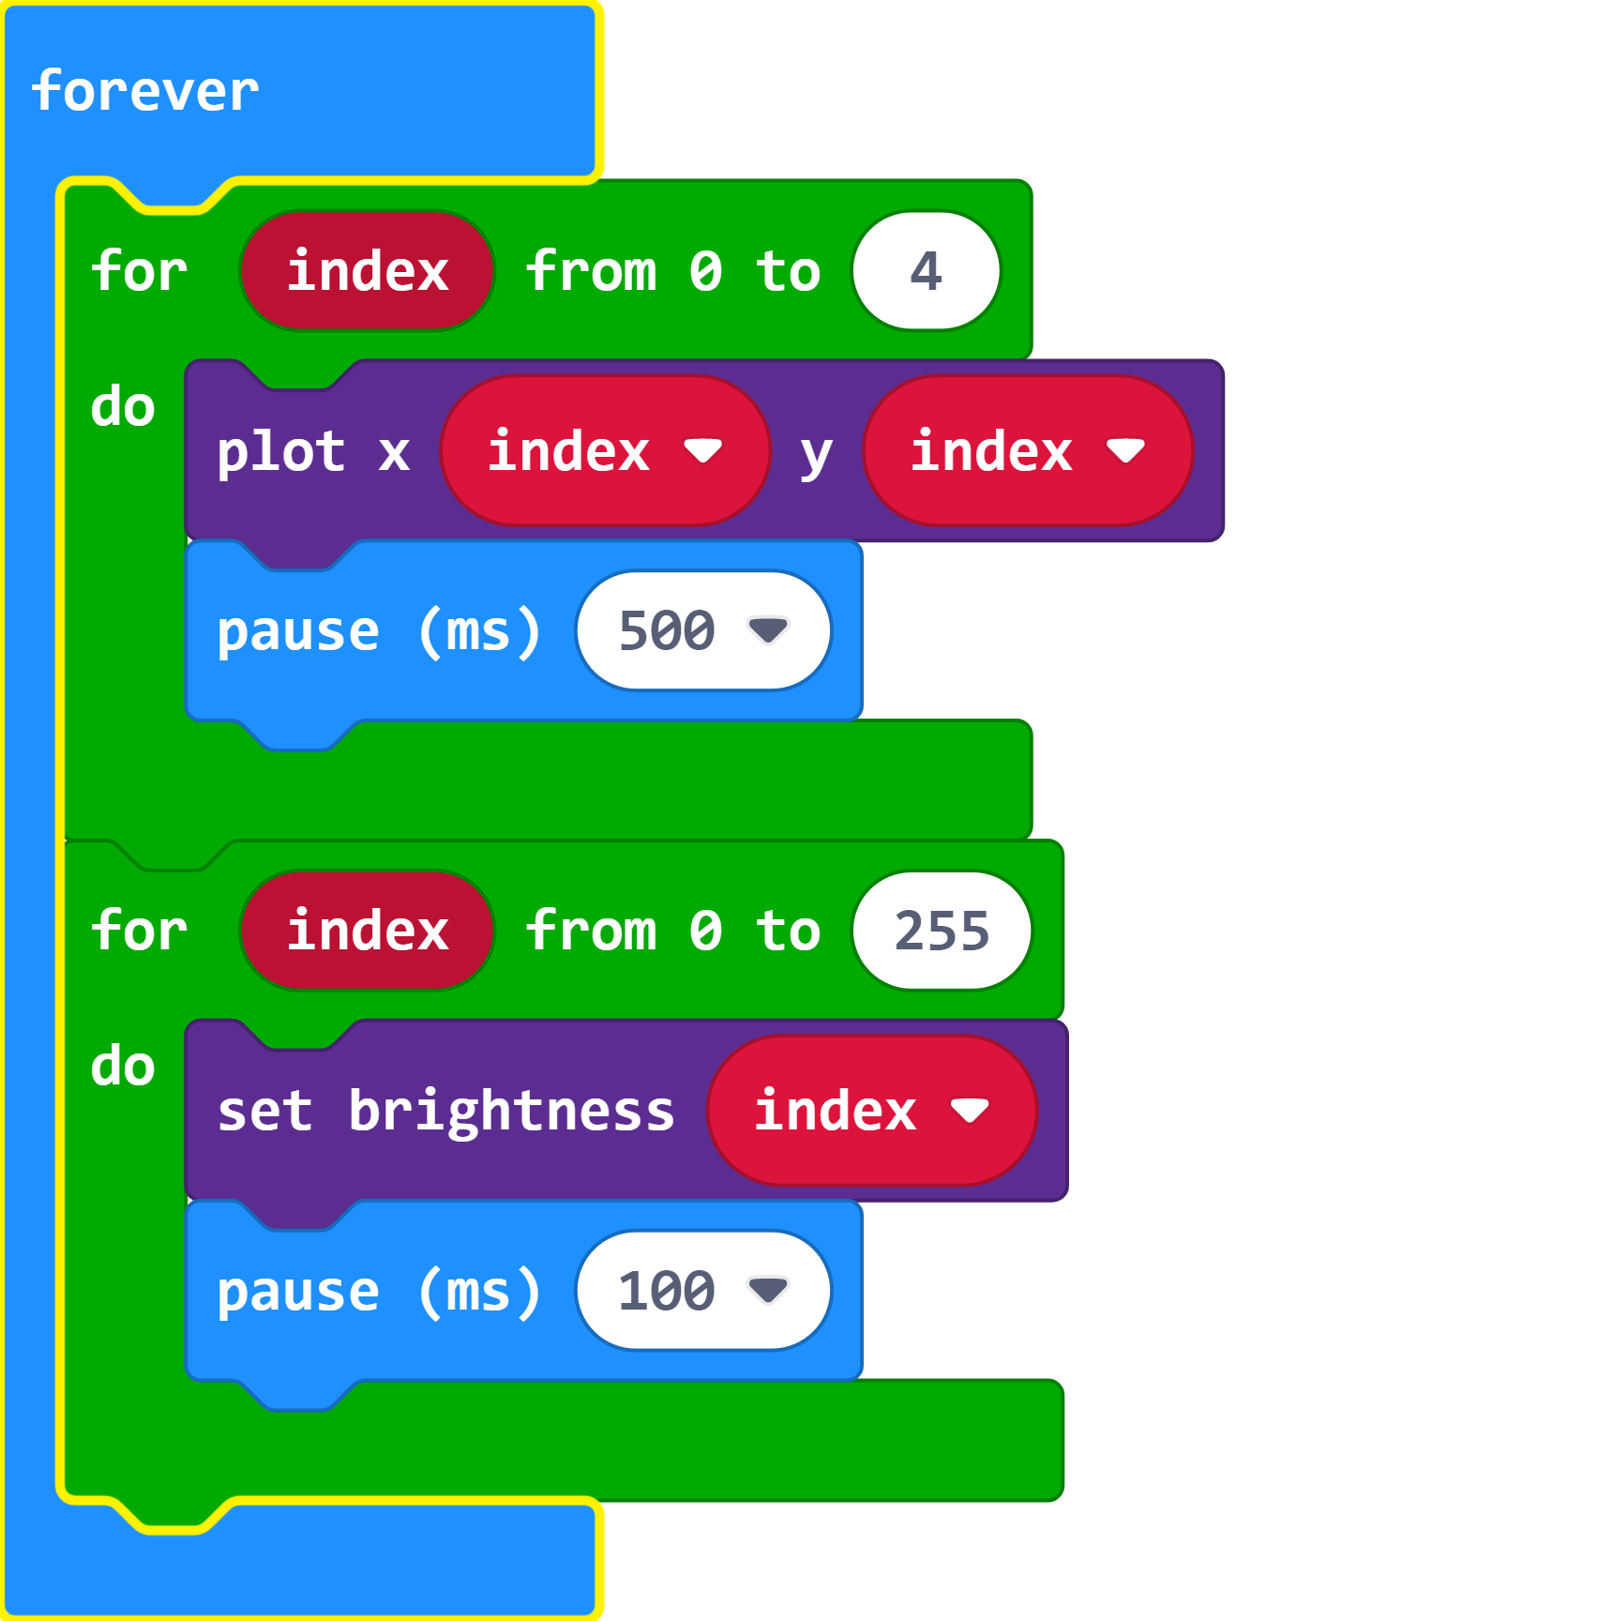

7. | Pseudocode | Blocky Algorithm
On button B pressed  On button A pressed  Forever |  | 