Using Microbits to help students visualize the stage of Mitosis. |  | Biology  High School  2021 spring semester

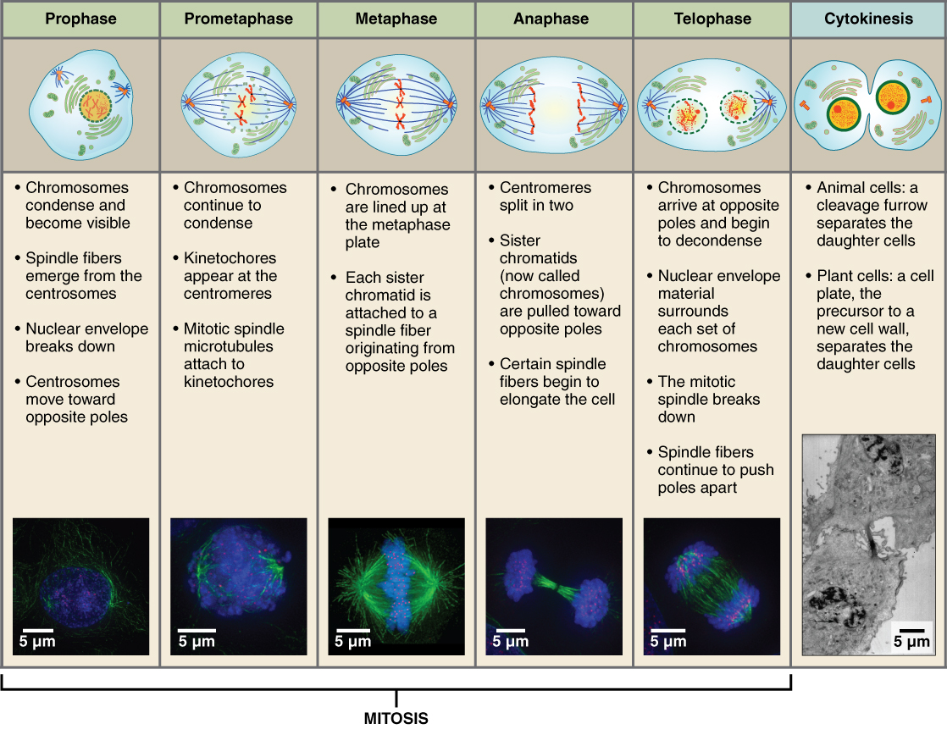
Image taken from: https://s3-us-west-2.amazonaws.com/courses-images-archive-read-only/wp-content/uploads/sites/198/2014/10/21040002/0331_Stages_of-_Mitosis_and_Cytokinesis1.jpg
Students will use this lesson after they have reviewed the stage of Mitosis from reading CK12.org Mitosis and completed the Kinestic activity for Mitosis.

Standards:  WYCSTA Standards: CS.T, L1.AP.PD.01 and AP.A  WYScience Standards HS-LS1-4, MS-ETLS1-1, MS-ETLS1-2WYELA Standard SL.11-12.5  ISTE 5a, 5b, 5c.  NGSS HS-LS2-4, LS2-A, ETS1-B.  Learning Targets:  - Students will demonstrate the phases of mitosis.  - In multicellular organisms, individual cells grow and then divide via a process called mitosis, thereby allowing the organism to grow.  - Use a model based on evidence to illustrate the relationships between systems or between components of a system.  Criteria for Success/SWBAT:  - Student programs their own visual representation of mitosis.  - The stages of mitosis correspond to the correct name and order of the stages of mitosis.  Catch:  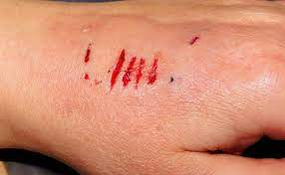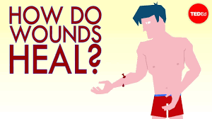  How does the skin heal itself on a molecular level?  Pretest Questions:  - When you cut your hand, how does the wound heal. Can you explain what happens to the cut on a molecular level?  - What do you remember about mitosis?  - How does the body create new cells?  Objectives:  Students will study the process of mitosis. Once they have an understanding of the names and stages of mitosis, they will use a Microbit to create a program that names and images of the different stage of mitosis.  Evaluation:  Students will be given a pre-assessment to see if they have any misconceptions mitosis.  They will learn how to use a Microbit to program the stages of Mitosis.  Finally, students will be given a post-assessment to see if their misconceptions have been addressed.  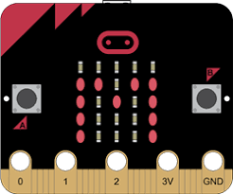M is for Mitosis! |  | Materials  Below are the materials for each student.  - 1 Microbit  - Computer, i-Pad or Chromebook  - MakeCode (internet program)  - Diagram showing the stage of Mitosis

Lesson Schedule with Review Strategies embedded in green:
Pre-test Questions (5-10 minutes):
- When you cut your hand, how does the wound heal. Can you explain what happens to the cut on a molecular level?
- What do you remember about mitosis?
- How does the body create new cells?

Identify any misconceptions in pre-test questions or conversations with students. Such as:

Misconceptions in Mitosis Taken from : https://grade11ubiology.weebly.com/misconceptions.html
Misconception 1
"The chromosome number is doubled in the prophase of mitosis and halved in the anaphase of mitosis."
The Facts
In anaphase, the spindle separates the two sister chromatids (not chromosomes) of each chromosome and moves them to opposite spindle poles.
Overcoming Misconception 1
Comparing video simulations / animations of the phases to see the clear process. Clarifying terminology for students.
Misconception 2
"Interphase is the "resting phase" of mitosis."
The Facts
Interphase is actually a growth phase. In interphase, the cells grows and replicates its DNA before undergoing mitosis (M phase) and cytokinesis.
Overcoming Misconception 2
Demonstrate through multiple microscope slides that interphase is very critical – and busy – phase of cell cycle.
Misconception 3
"Mitosis produces two new identical daughter cells."
The Facts
Mitosis divides the nucleus. Cell division occurs during cytokinesis.
Overcoming Misconception 3:
Referring back to the Cell Cycle following instruction on Mitosis to consolidate the entire process of cell division may remind students that mitosis is only one of three phases in cell division.
The teacher should introduce meiosis instruction by discussing the difference between asexual reproduction and sexual reproduction. The teach could follow meiosis instruction with instruction on spermatogenesis and oogensis to further stress that this is a process that occurs in reproductive cells only.
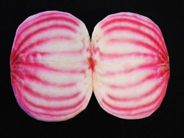

Pre-Assessment (10 minutes): All students will be given a pre-assessment (examples of assessment questions are listed at the bottom of this lesson) and will be required to submit a lab journal during this activity.
Identify any misconceptions in pre-assessment questions.

Introduction (10 minutes):

Use an entrance ticket to check for understanding and misconceptions.

Microbit (5-10 minutes) First review or teach students how to animate objects using Microbits. Students will also need makecode in order to program the Microbit. Go over the animated animals Microbit program and then have students program different shape and letters in the Microbit makecode. Once students are able to program different object and have letters appear on their screen, continue to the next step.
Monitor students’ progress and ask questions.
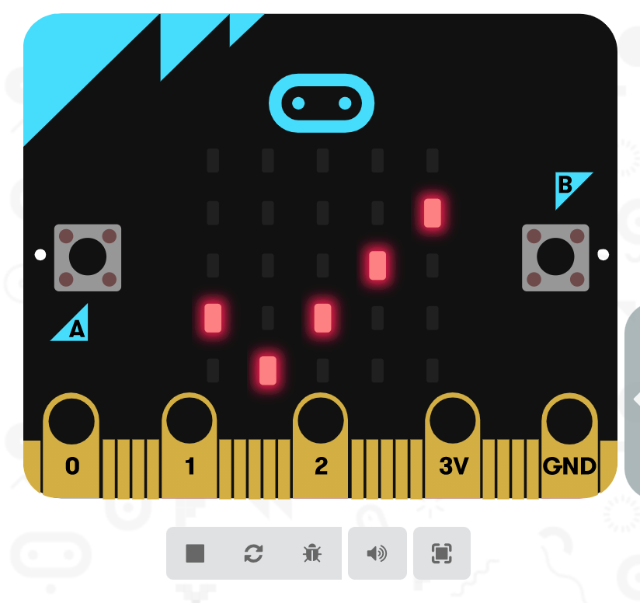

Program a Microbit that displays the names and stages of mitosis (30 minutes). Students will develop ideas for their display, check in with the teacher as they build the program. Potential ideas for criteria:
The word mitosis displays across the screen.
The stages are shown in order with the correct image.
The stages are animated as the Microbit displays the images.

Post-test questions (15 minutes): Every student will be given a post-test questions, post-assessment (assessment and test questions can be combined to one form), lab journals and lab write ups will be collected.
- When you cut your hand, how does the wound heal. Can you explain what happens to the cut on a molecular level?
- What do you remember about mitosis?
- How does the body create new cells?
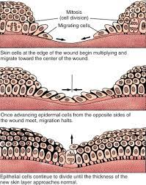
Pre/Mid/Post-Assessment Questions:
- Why is it important to understand the stages of mitosis?
- List the stages of mitosis.
- Does mitosis only help heal wound in the body or does it have more uses? If mitosis has more uses in the body give two more examples.
- Explain if interphase is or isn’t a stage of mitosis.
- Explain if the Microbit helped you understand the stages of mitosis.

Special thanks to Dr. Mike Borowczak, Dr. Andrea Burrow, and the Graduate Students from The College of Engineering and Applied Science at the University of Wyoming. H meter e Our Choices by: Popularity | Title | All Around Favorites | Recent Additions
PRODUCT CENTERS
Power Resource Center

