Using Microbits to measure conductivity of metallic, ionic and covalent bonds. |  | Physical Science  High School (9th Grade)  2021 spring semester

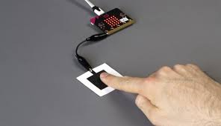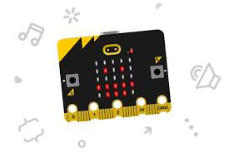

Standards:  WYCSTA Standards: CS.T, DA.CVT, DA.IM, and AP.A  WYScience Standards HS- PS1-3  WYELA Standard WHST.9.12  WY Mathematics Standard 6.SP.A.2  NGSS HS-PS2-4.  Learning Targets:  HS-PS1-3. Plan and conduct an investigation to gather evidence to compare the structure of substances at the macroscopic scale to infer the strength of electrical forces between particles. (Wyoming Science Standard)  Criteria for Success/SWBAT:  - Observe the conductivity strength between different types of bonds, metallic, ionic and covalent.  - Program a Microbit to test the electrical conductivity of different materials.  - Students draw their own conclusion from their experiment.  Catch:  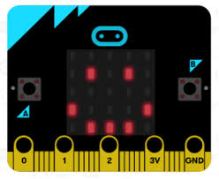 + 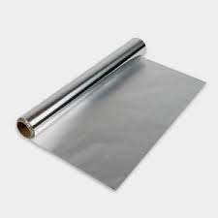  = 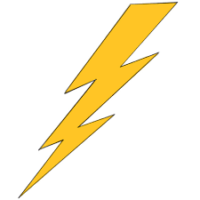  Pretest Questions:  - Make a prediction of which materials will conduct energy causing the Microbit to turn on.  - Does it make a difference if the material is in water, will it conduct?  Objectives:  Students will investigate and design an experiment that explores the natural world using microprocessors. They will study the phenomenon of conductivity. Students will create an experiment that uses Microbit, probes and different material that do or don’t conduct. They will program a Microbit to either light up for strong, low or no conductivity. Students can then evaluate the difference between metallic, ionic and covalent bonds.  Evaluation:  Students will be given a pre-assessment to see if they have any misconceptions about how materials conduct.  They will learn how to use a Microbit for determining the amount a material can conduct.  Then, students will create an experiment to determine the conductivity between different types of bonds.  Finally, students will be given a post-assessment to see if their misconceptions have been addressed.  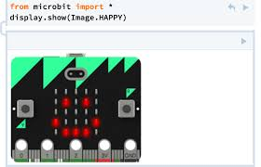 |  | Materials  Groups can be as small as one or as large as four students. Below is material for each group.  - 1 Microbit  - Computer, i-Pad or Chromebook  - MakeCode (internet program)  - Battery Pack for Microbit  - Alligator clips  - Materials such as aluminum, steel, graphite, wood, salt, sugar, glass, baking soda, coke, Gatorade, etc.

Lesson Schedule with Review Strategies embedded in green:
Pre-test Questions (5-10 minutes):
- Name the 3 types of chemical bonding.
- Complete the following table to the best of your ability. Add additional materials you would like the students to test.
Material | Will this material conduct? | What type of chemical bond is this material?
Steel
Air

- Make a prediction explaining how a microprocessor (processing part of the computer), such as Microbit, can determine if a material can conduct energy.
Identify any misconceptions in pre-test questions or conversations with students.

Pre-Assessment (10 minutes): All students will be given a pre-assessment (examples of assessment questions are listed at the bottom of this lesson). and will be required to submit a lab journal during this investigation.
Identify any misconceptions in pre-assessment questions.

Introduction (10 minutes): Periodic table and how to identify metallic, ionic and covalent bonds and why they conduct. This could include “Atomic Hook-Ups - Types of Chemical Bonds: Crash Course Chemistry #22” either from YouTube or Edpuzzle. This can be given to the students as homework.

Use an entrance ticket to check for understanding and misconceptions of the introduction.

Microbit (20 minutes) Students make a working Microbit that measures the conductivity of different materials. Each group or student will need 2-gator clips, Microbit and a Chromebook. They will use the following link to build a working electrical conductor https://microbit.org/lessons/electrical-conductors-making-tester/
Monitor students’ progress and ask questions.

Create write up for experiment (30 minutes). Students will develop an idea for an experiment, discuss their idea with the teacher and then if the teacher approves the idea for the experiment, the student will write-up the design for the experiment. Ideas for design experimental rubric can be found at www.rcampus.com. Students may need to be guided/reminded to record the material tested, conductivity rate and type of chemical bond.
Possible data table. These materials can be from the laboratory or what the students have at home.
Material tested | Conductivity rate | Type of chemical bond
Salt
Distilled water
Tap water
Salt added to water
Copper

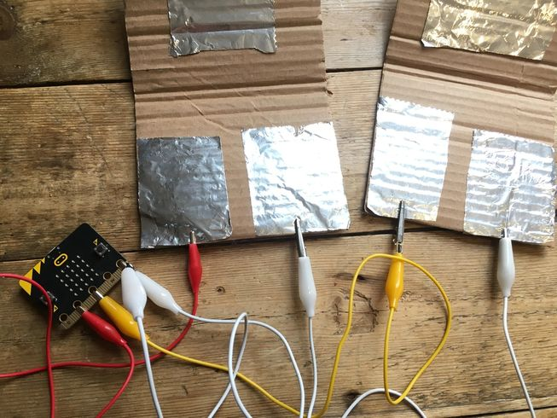

Lab write up (50 minutes). Give students time to write up their lab experiment and have students proof read each other’s report. Ideas for lab rubric can be found at www.rcampus.com.

Post-test questions (15 minutes): Every student will be given a post-test questions, post-assessment (assessment and test questions can be combined to one form), lab journals and lab write ups will be collected.
- Draw the flow of energy using a battery, Microbit, 2-gator clips and a piece of metal.
- Why do metals conduct and nonmetal don’t?
- Why doesn’t salt conduct but when it is added to distilled water, it does conduct?
- Explain if the Microbit helped you determine the type of chemical bond for every material tested.

Pre and Post Assessment Questions:
1) In your own words, explain why some materials conduct and other don’t.
2) If more material is used, will this cause the Microbit to show that this material conducts?
3) Explain why water conducts sometime and not others.
4) Explain if your diet should consist of all three types of chemical bonds, metallic, covalent and ionic bonds?

- Use the periodic table and explain the graph listed below.
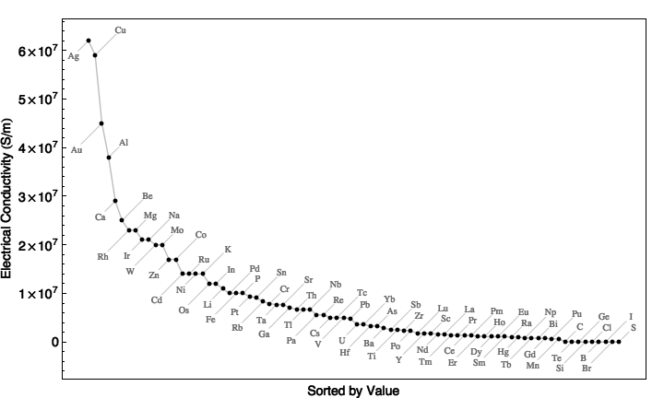
Graphed copied from http://rebeldigger.blogspot.com/2014/03/periodic-table-by-electrical.html
4

Special thanks to Dr. Mike Borowczak, Dr. Andrea Burrow, and the Graduate Students from The College of Engineering and Applied Science at the University of Wyoming. H meter e Our Choices by: Popularity | Title | All Around Favorites | Recent Additions Resource Center

