

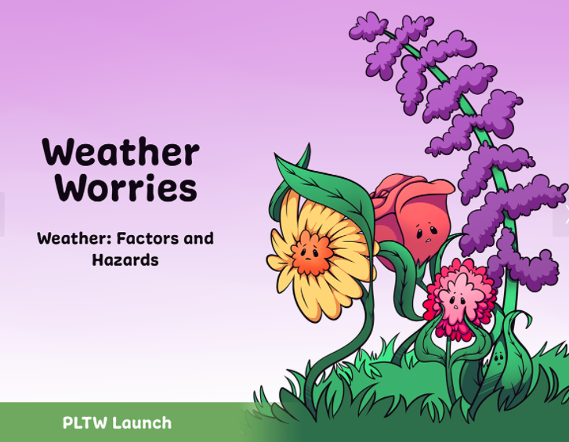

Student Name: _________________
Teacher Name: _________________

Activity 1: Weather Factors
Introduction
Have you ever described the weather to a family member or a friend? What words do you use to describe weather? In this activity, you will explore descriptions of the factors of weather. Also, you will learn how to read two weather tools: a rain gauge and a thermometer.

Weather stations:
Record this week’s weather
Day 1 | Day 2 | Day 3
Temperature: ________  Wind Speed: _________  Wind Direction: ______  Rain amount: ________  Clouds: _____________  ___________________ | Temperature: ________  Wind Speed: _________  Wind Direction: ______  Rain amount: ________  Clouds: _____________  ___________________ | Temperature: ________  Wind Speed: _________  Wind Direction: ______  Rain amount: ________  Clouds: _____________  ___________________

Part 1: Introduction to Weather presentation
Weather: __________________________________________________________
__________________________________________________________________
Three weather factors:
__________________________________________________________________
Meteorologist: __________________________________________________________________
__________________________________________________________________
Precipitation: _______________________________________________________
___________________________________________________________________
Examples of precipitation: _____________________________________________
Rain Gauge: ________________________________________________________
__________________________________________________________________
__________________________________________________________________
Temperature: _______________________________________________________
___________________________________________________________________
Wind: ____________________________________________________________
__________________________________________________________________
Why is collecting weather data important?
__________________________________________________________________
__________________________________________________________________
Why do meteorologists collect weather data?
__________________________________________________________________
__________________________________________________________________

Weather tools:

Activity 1: Weather Factors
Conclusion Questions

- How do the three weather factors impact your local area?
_____________________________________________________________________________________________________________________________________________________________________
_____________________________________________________________________________________________________________
- Why is it important for meteorologists to collect weather data? Support your claim with evidence.
_____________________________________________________________________________________________________________________________________________________________________
_____________________________________________________________________________________________________________
_____________________________________________________________________________________________________________
_____________________________________________________________________________________________________________

Activity 2: Weather and Climate

Welcome back, meteorologists! In this activity, you will continue your exploration of weather as you learn about two new weather tools: a wind sock and an anemometer. You will use the four weather tools to collect daily weather data in your PLTW Launch Logs.
As you continue to explore weather, you will consider how weather impacts climate. You will explore five climate zones and learn how they are different.
Weather stations:
Record this week’s weather
Day 1 | Day 2 | Day 3
Temperature: ________  Wind Speed: _________  Wind Direction: ______  Rain amount: ________  Clouds: _____________  ___________________ | Temperature: ________  Wind Speed: _________  Wind Direction: ______  Rain amount: ________  Clouds: _____________  ___________________ | Temperature: ________  Wind Speed: _________  Wind Direction: ______  Rain amount: ________  Clouds: _____________  ___________________

What is Climate?

Climate Zones

Activity 2: Weather and Climate
Conclusion Questions

- Describe how weather and climate are connected.
________________________________________________________________________________________________________________________________________________________________________________
__________________________________________________________
- If you could live in any climate zone, which climate zone would you choose? Why would you choose this climate zone? _________________________________________________________________________________________________________________________________________________________________________________
___________________________________________________________
___________________________________________________________

Activity 3: Weather Hazards
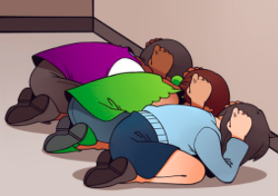
Tornadoes, hurricanes, and tsunamis are weather-related hazards. Have you ever prepared for a weather hazard, such as practicing a tornado or earthquake drill? Why is it important to prepare?
In this activity, you will expand your understanding of weather to learn about weather-related hazards. You will identify the weather factors that are present in specific hazards.

Finally, you will deepen your understanding of weather-related hazards through simulations.
Weather stations:
Record this week’s weather
Day 1 | Day 2 | Day 3
Temperature: ________  Wind Speed: _________  Wind Direction: ______  Rain amount: ________  Clouds: _____________  ___________________ | Temperature: ________  Wind Speed: _________  Wind Direction: ______  Rain amount: ________  Clouds: _____________  ___________________ | Temperature: ________  Wind Speed: _________  Wind Direction: ______  Rain amount: ________  Clouds: _____________  ___________________

Weather-Related Hazards Presentation
Weather-related hazards: _____________________________________________
___________________________________________________________________
Eight (8) Common Weather-Related Hazards

What do the eight common weather-related hazards have in common?
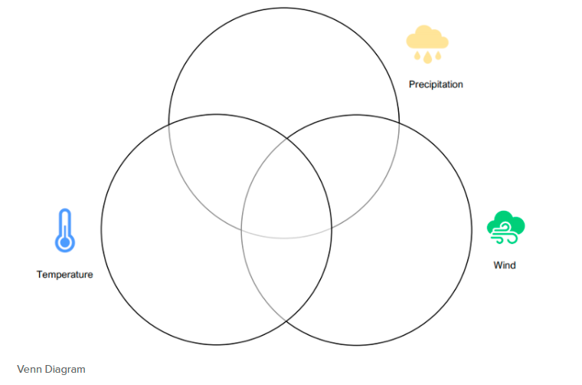

Activity 3: Weather Hazards
Conclusion Questions

- What weather-related hazards are common in your local area? Which of the three weather factors are involved with those weather-related hazards?
_______________________________________________________________________________________________________________________________________________________________________________________
_____________________________________________________________
_____________________________________________________________
- How do weather-related hazards impact the world?
_______________________________________________________________________________________________________________________________________________________________________________________
_____________________________________________________________
_____________________________________________________________

Project: Flooding

By now, your weather calendar should contain lots of data. How can you represent and interpret this data to identify trends? You can graph it! In this project, you will graph the temperature data to show change over time.
Then, you will use the scientific inquiry process to investigate the effect of water on Earth materials. You will explore how water flows through different materials and make a connection between permeability and flooding.
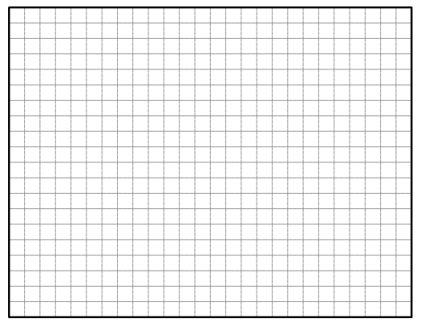
Part 1: GRAPH IT!

PART 2: Introduction to Flooding
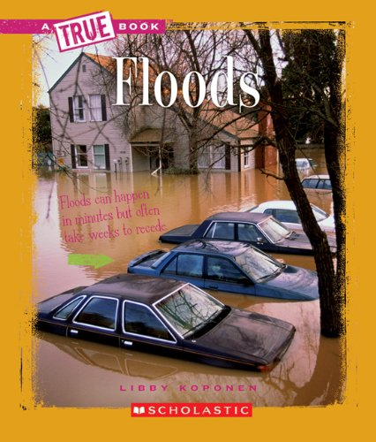
Reflect on the following questions:
- Why do floods occur?
- Why do you think people live near rivers or oceans?
- What steps can be taken to stop the effects of flooding?
- How does flooding affect a town and its residents?
- What are some ideas for how people can prepare for a possible flood?

Discuss with your group.

_______________________________________________________________________________________________________________________________________________________________________________________
_____________________________________________________________
_____________________________________________________________
_______________________________________________________________________________________________________________________________________________________________________________________
_____________________________________________________________
_____________________________________________________________

PART 3: Soil Investigation
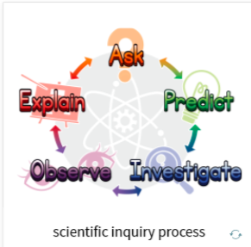
ASK:
How do different Earth materials allow water to pass through them?
_______________________________________
_______________________________________
_______________________________________
EXPLORE/Predict:
Which soil will allow more water to pass through? Which soil will allow the least amount of water to pass through?

___________________________________________________________________________________________________________________________________________________________________________
- INVESTIGATE (Sketch the set up and explain)

___________________________________________________________________________________________________________________________________________________________________________
- OBSERVE (Sketch and write down your observations)

_____________________________________________________________
_____________________________________________________________
_____________________________________________________________
- EXPLAIN
Which material allowed the greatest amount of water to flow through or permeate?

_____________________________________________________________
_____________________________________________________________
_____________________________________________________________
_____________________________________________________________
_____________________________________________________________
_____________________________________________________________
Project: Flooding Conclusion Questions
- How do Earth materials affect the impact of flooding? Support your answer with evidence from this project.

___________________________________________________________________________________________________________________________________________________________________________
________________________________________________________

- In the Introduction Story: Weather Worries, we learned that Suzi’s grandma does not live near a body of water. How can her local area experience a flash flood? Support your answer with evidence.
_____________________________________________________________________________________________________________________________________________________________________
_____________________________________________________________________________________________________________________________________________________________________

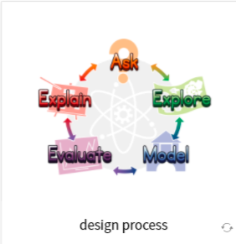
Problem: Hazardous Conditions Ahead!

You have learned about the three weather factors: precipitation, temperature, and wind. You also investigated climate zones and weather-related hazards. Now, you will use what you have learned to sketch, build, test, and reflect on a solution that reduces the impact of a flood.

Ask
What is the need or want we are trying to fulfill?
_____________________________________________________________________________________________________________________________________________________________________
_______________________________________________________
CRITERIA | CONSTRAINTS
Explore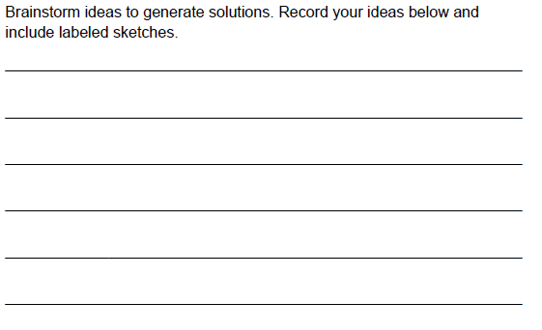

Model
Include a sketch of your group’s final design below.

Evaluate
The strengths of my model are ____________________________________
_____________________________________________________________
_____________________________________________________________
The weaknesses of my model are __________________________________
_____________________________________________________________
_____________________________________________________________
To improve my model I could ____________________________________
_____________________________________________________________
_____________________________________________________________

Explain
- Was your design able to withstand the flood? Support your answer with the evidence you recorded in your Launch Log.

_____________________________________________________________
_____________________________________________________________
_____________________________________________________________
_____________________________________________________________

- List two changes you would make to improve the design. Why do you think these changes would improve your model?

_____________________________________________________________
_____________________________________________________________
_____________________________________________________________
_____________________________________________________________

- In this problem, you designed a solution that reduces the impact of a flood in a specific area. How would your model work in a different region of the world? Why do you think that?

_____________________________________________________________
_____________________________________________________________
_____________________________________________________________
_____________________________________________________________

