What are the Chances?
Overview:
Students will learn basic coding skills while creating a tool for generating random “coin flips” using the Micro:bit.
Target Grade Level: 6-8
Target Subject: Computer Science, Math
Note for Educators: This lesson will also work with younger students who are studying probability.
Materials:
- Micro:bits
- Materials for recording flip results – This could be paper/pencil, spreadsheet, or additional coding of the Micro:bit to record results.
Coding:
Begin by choosing and adding an Input block. This example uses On Button A pressed:
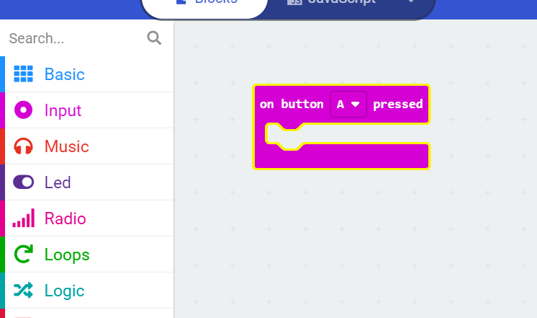
Add a Show Icon block to indicate a flip:
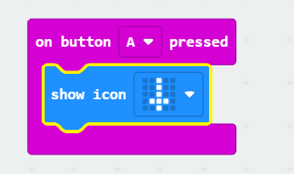
Add an If-Else block from the Logic tray.
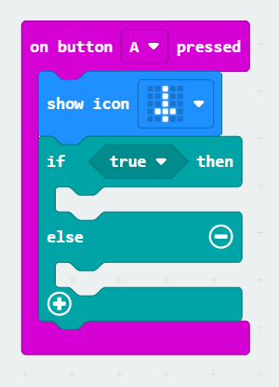
Within the If line, replace True with Pick Random True or False, which is found in the Math tray.
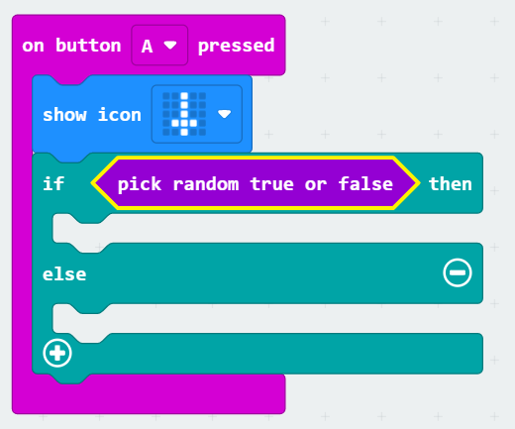
Insert Show icon blocks within If and Else. They will serve as visual representations of Heads and Tales. The order does not matter.
