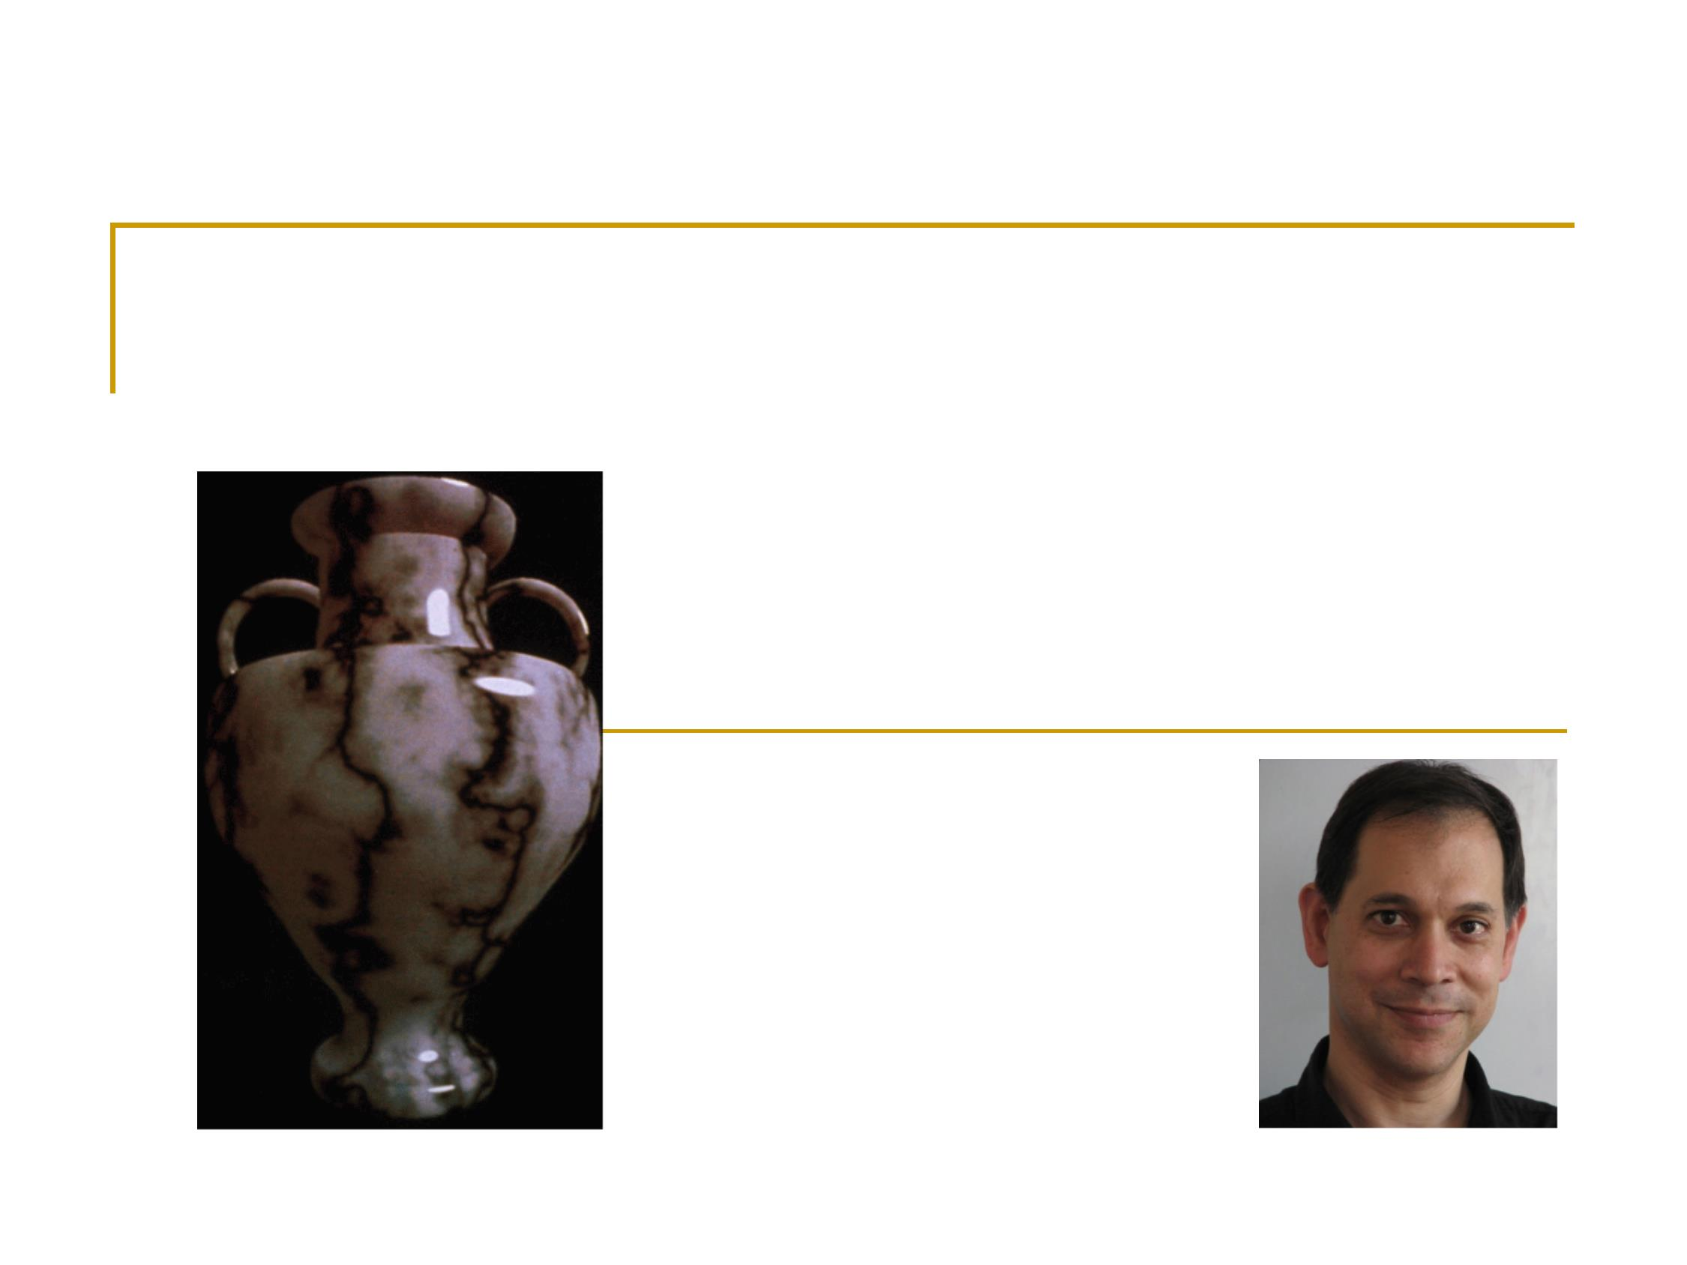
Ken Perlin
Perlin Noise

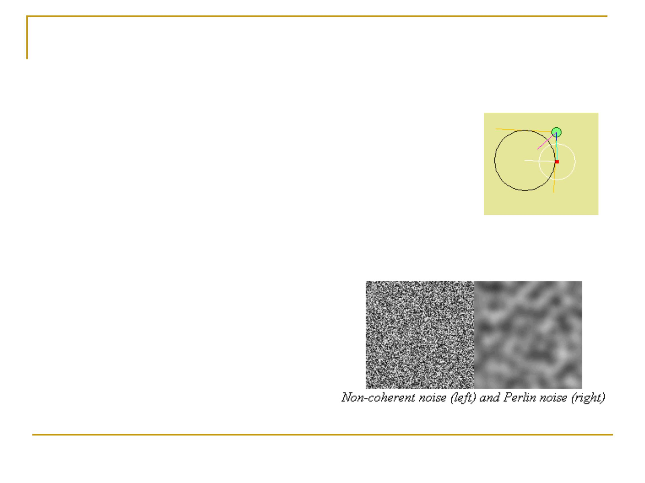
Introduction
Many people have used random number
generators in their programs to create
unpredictability, making the motion and
behavior of objects appear more natural
But at times their output can
be too harsh to appear
natural.
The Perlin noise function
recreates this by simply
adding up noisy functions at
a range of different scales.
Fall 2012
n
n
2
Wander is also an
application of noise
n

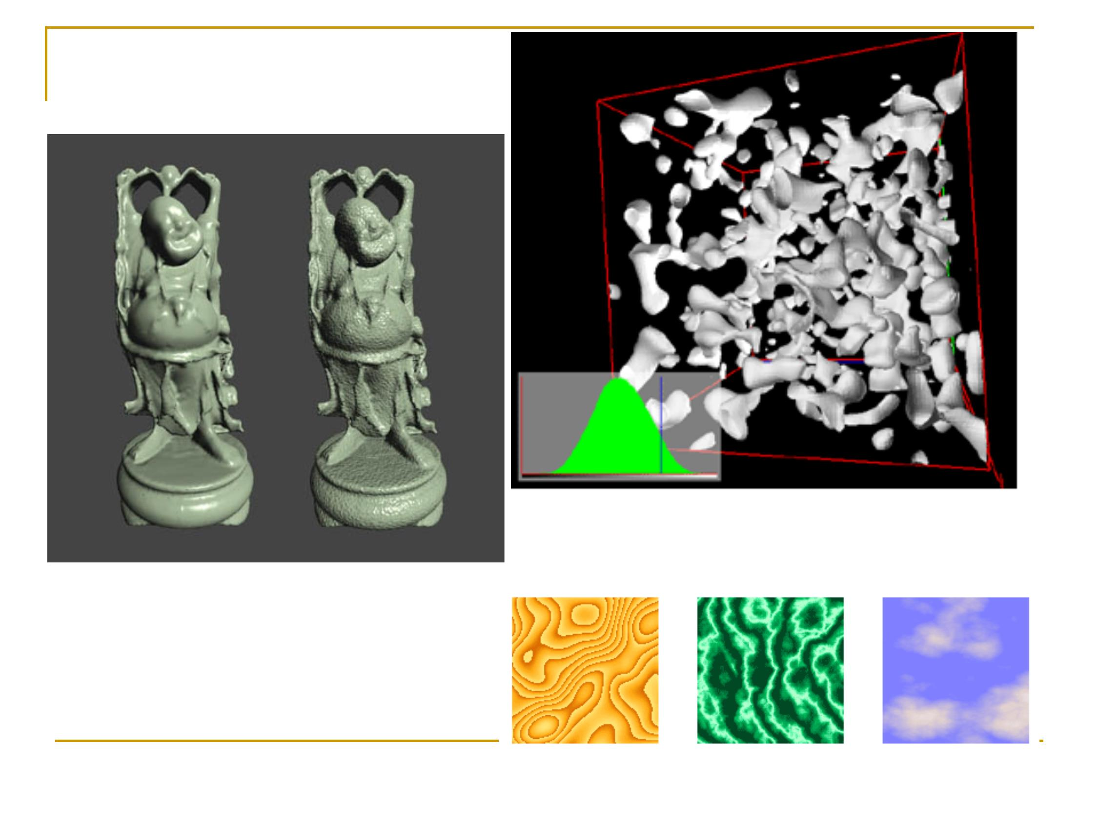
Gallery
3D Perlin Noise
Procedual bump map
Fall 2012
3

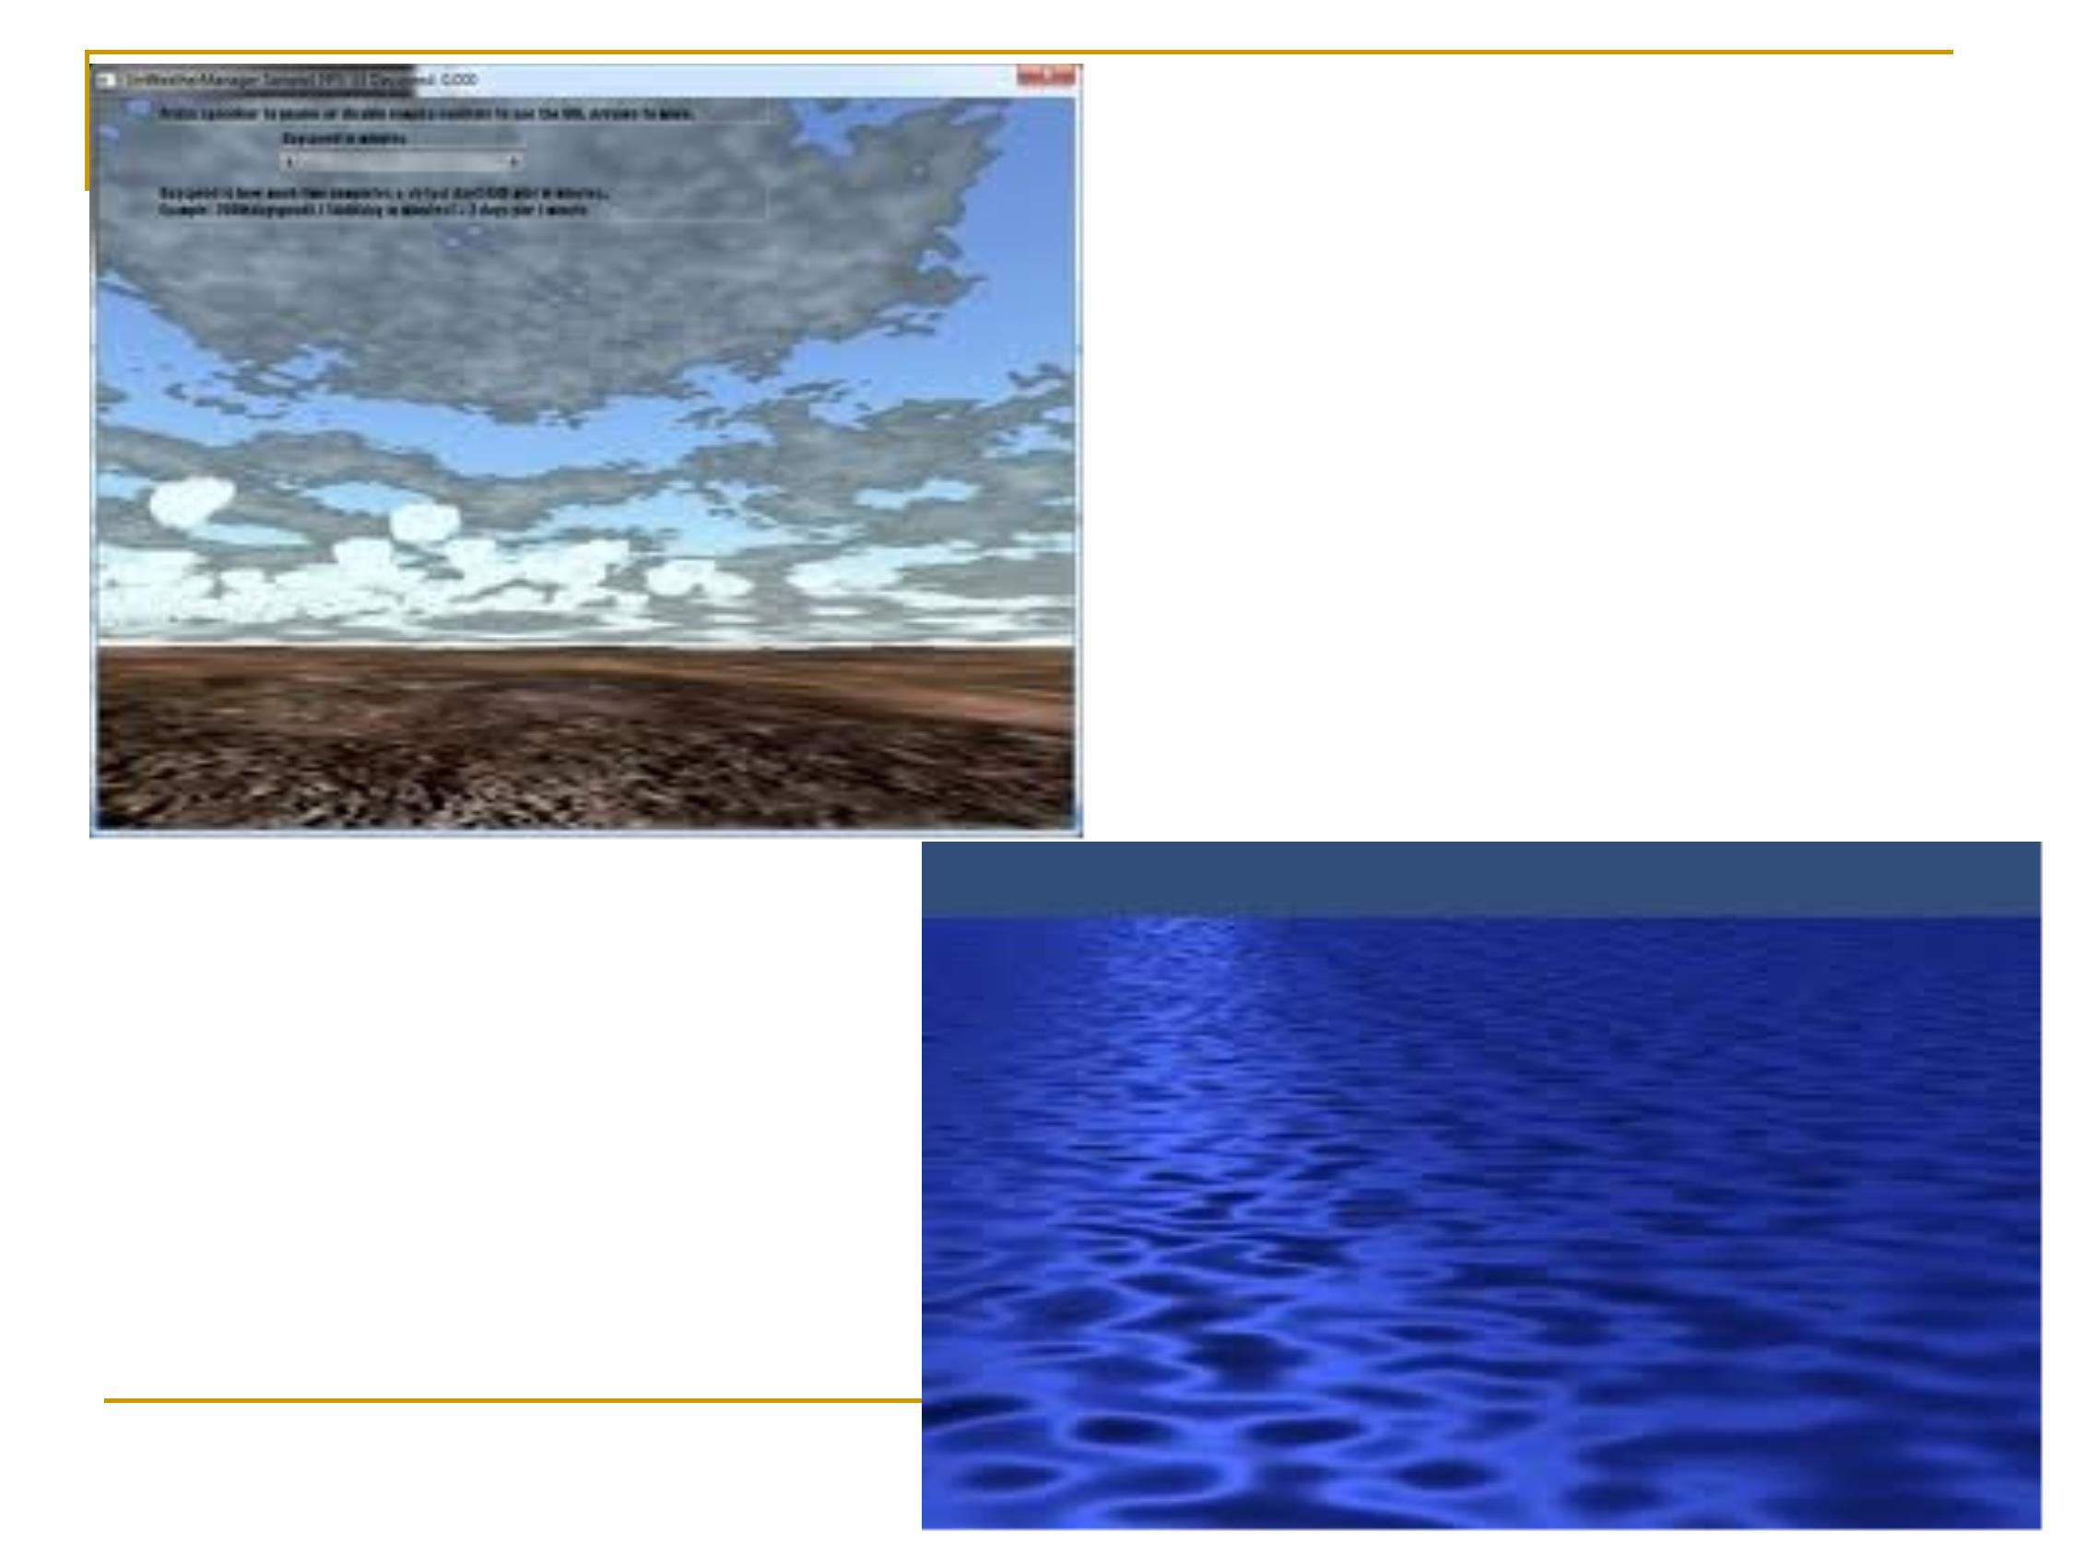
Fall 2012
4

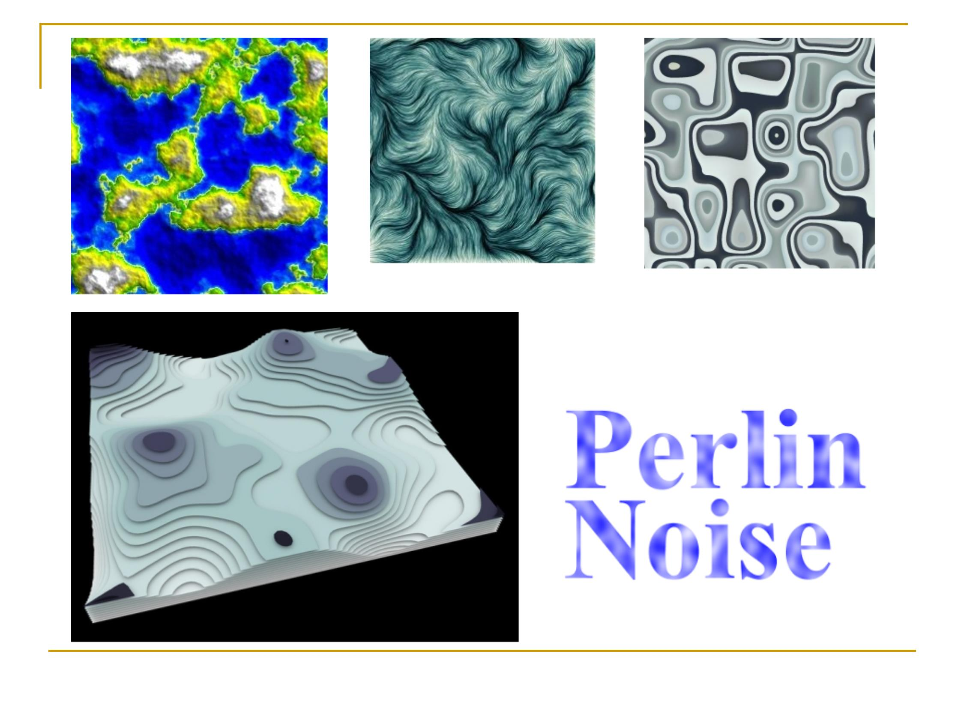
Fall 2012
5

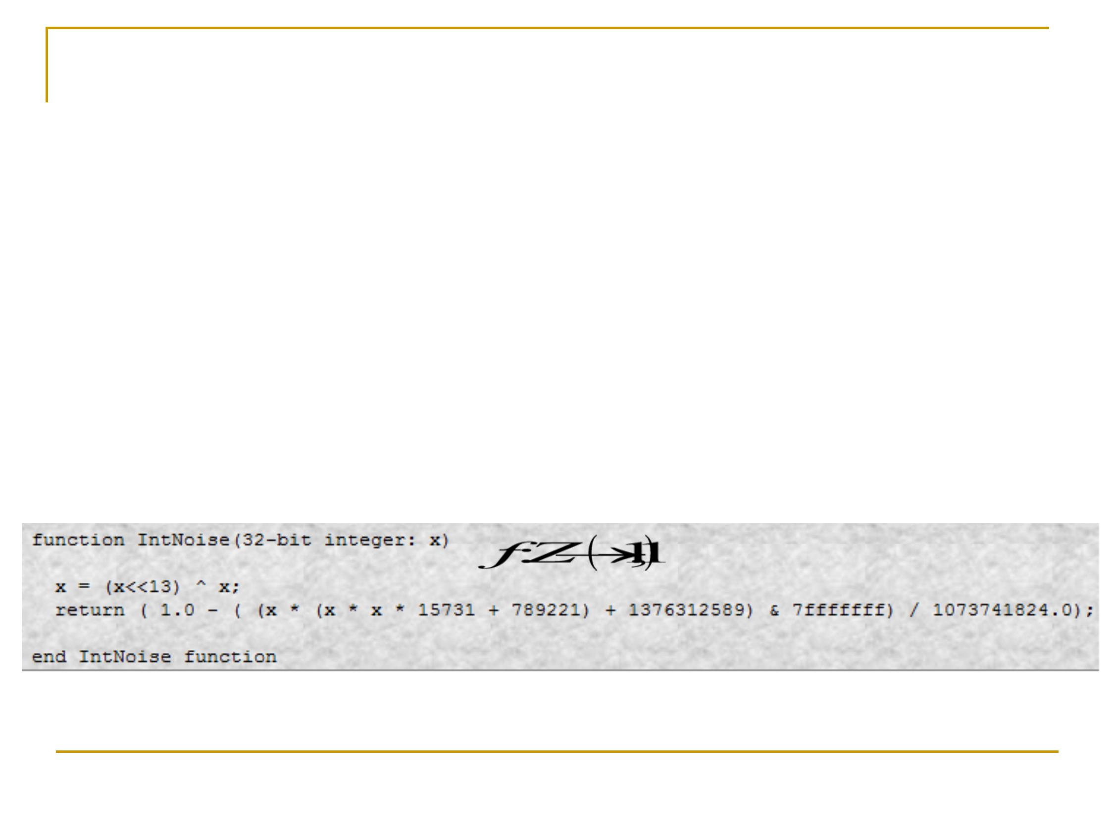
Noise Functions
n
n
A noise function is essentially a seeded
random number generator.
It takes an integer as a parameter (seed), and
returns a random number based on that
parameter.
Fall 2012
6

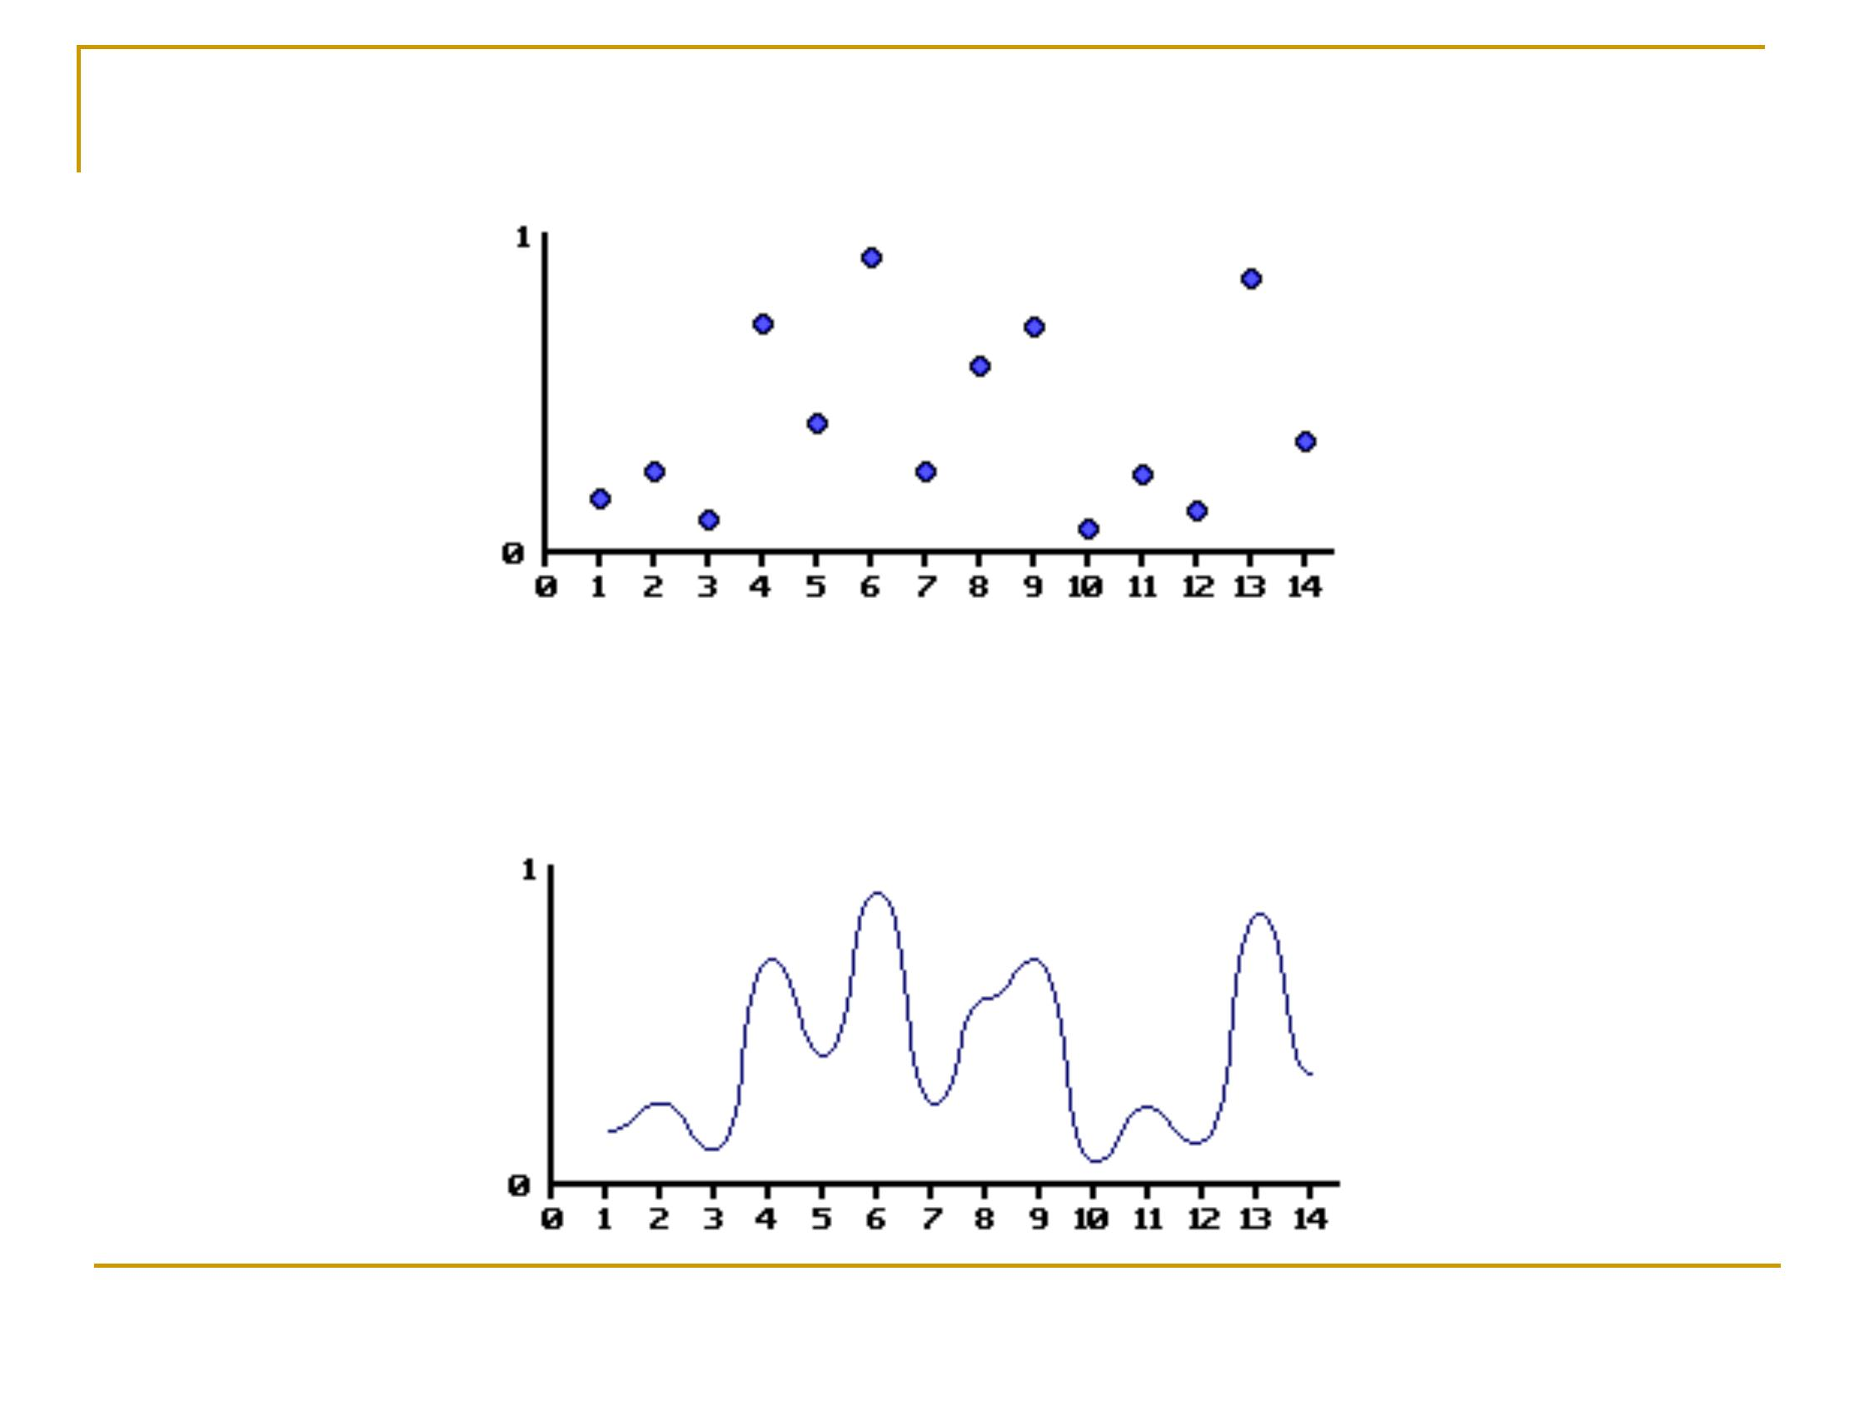
7
Example
After interpolation …
Fall 2012

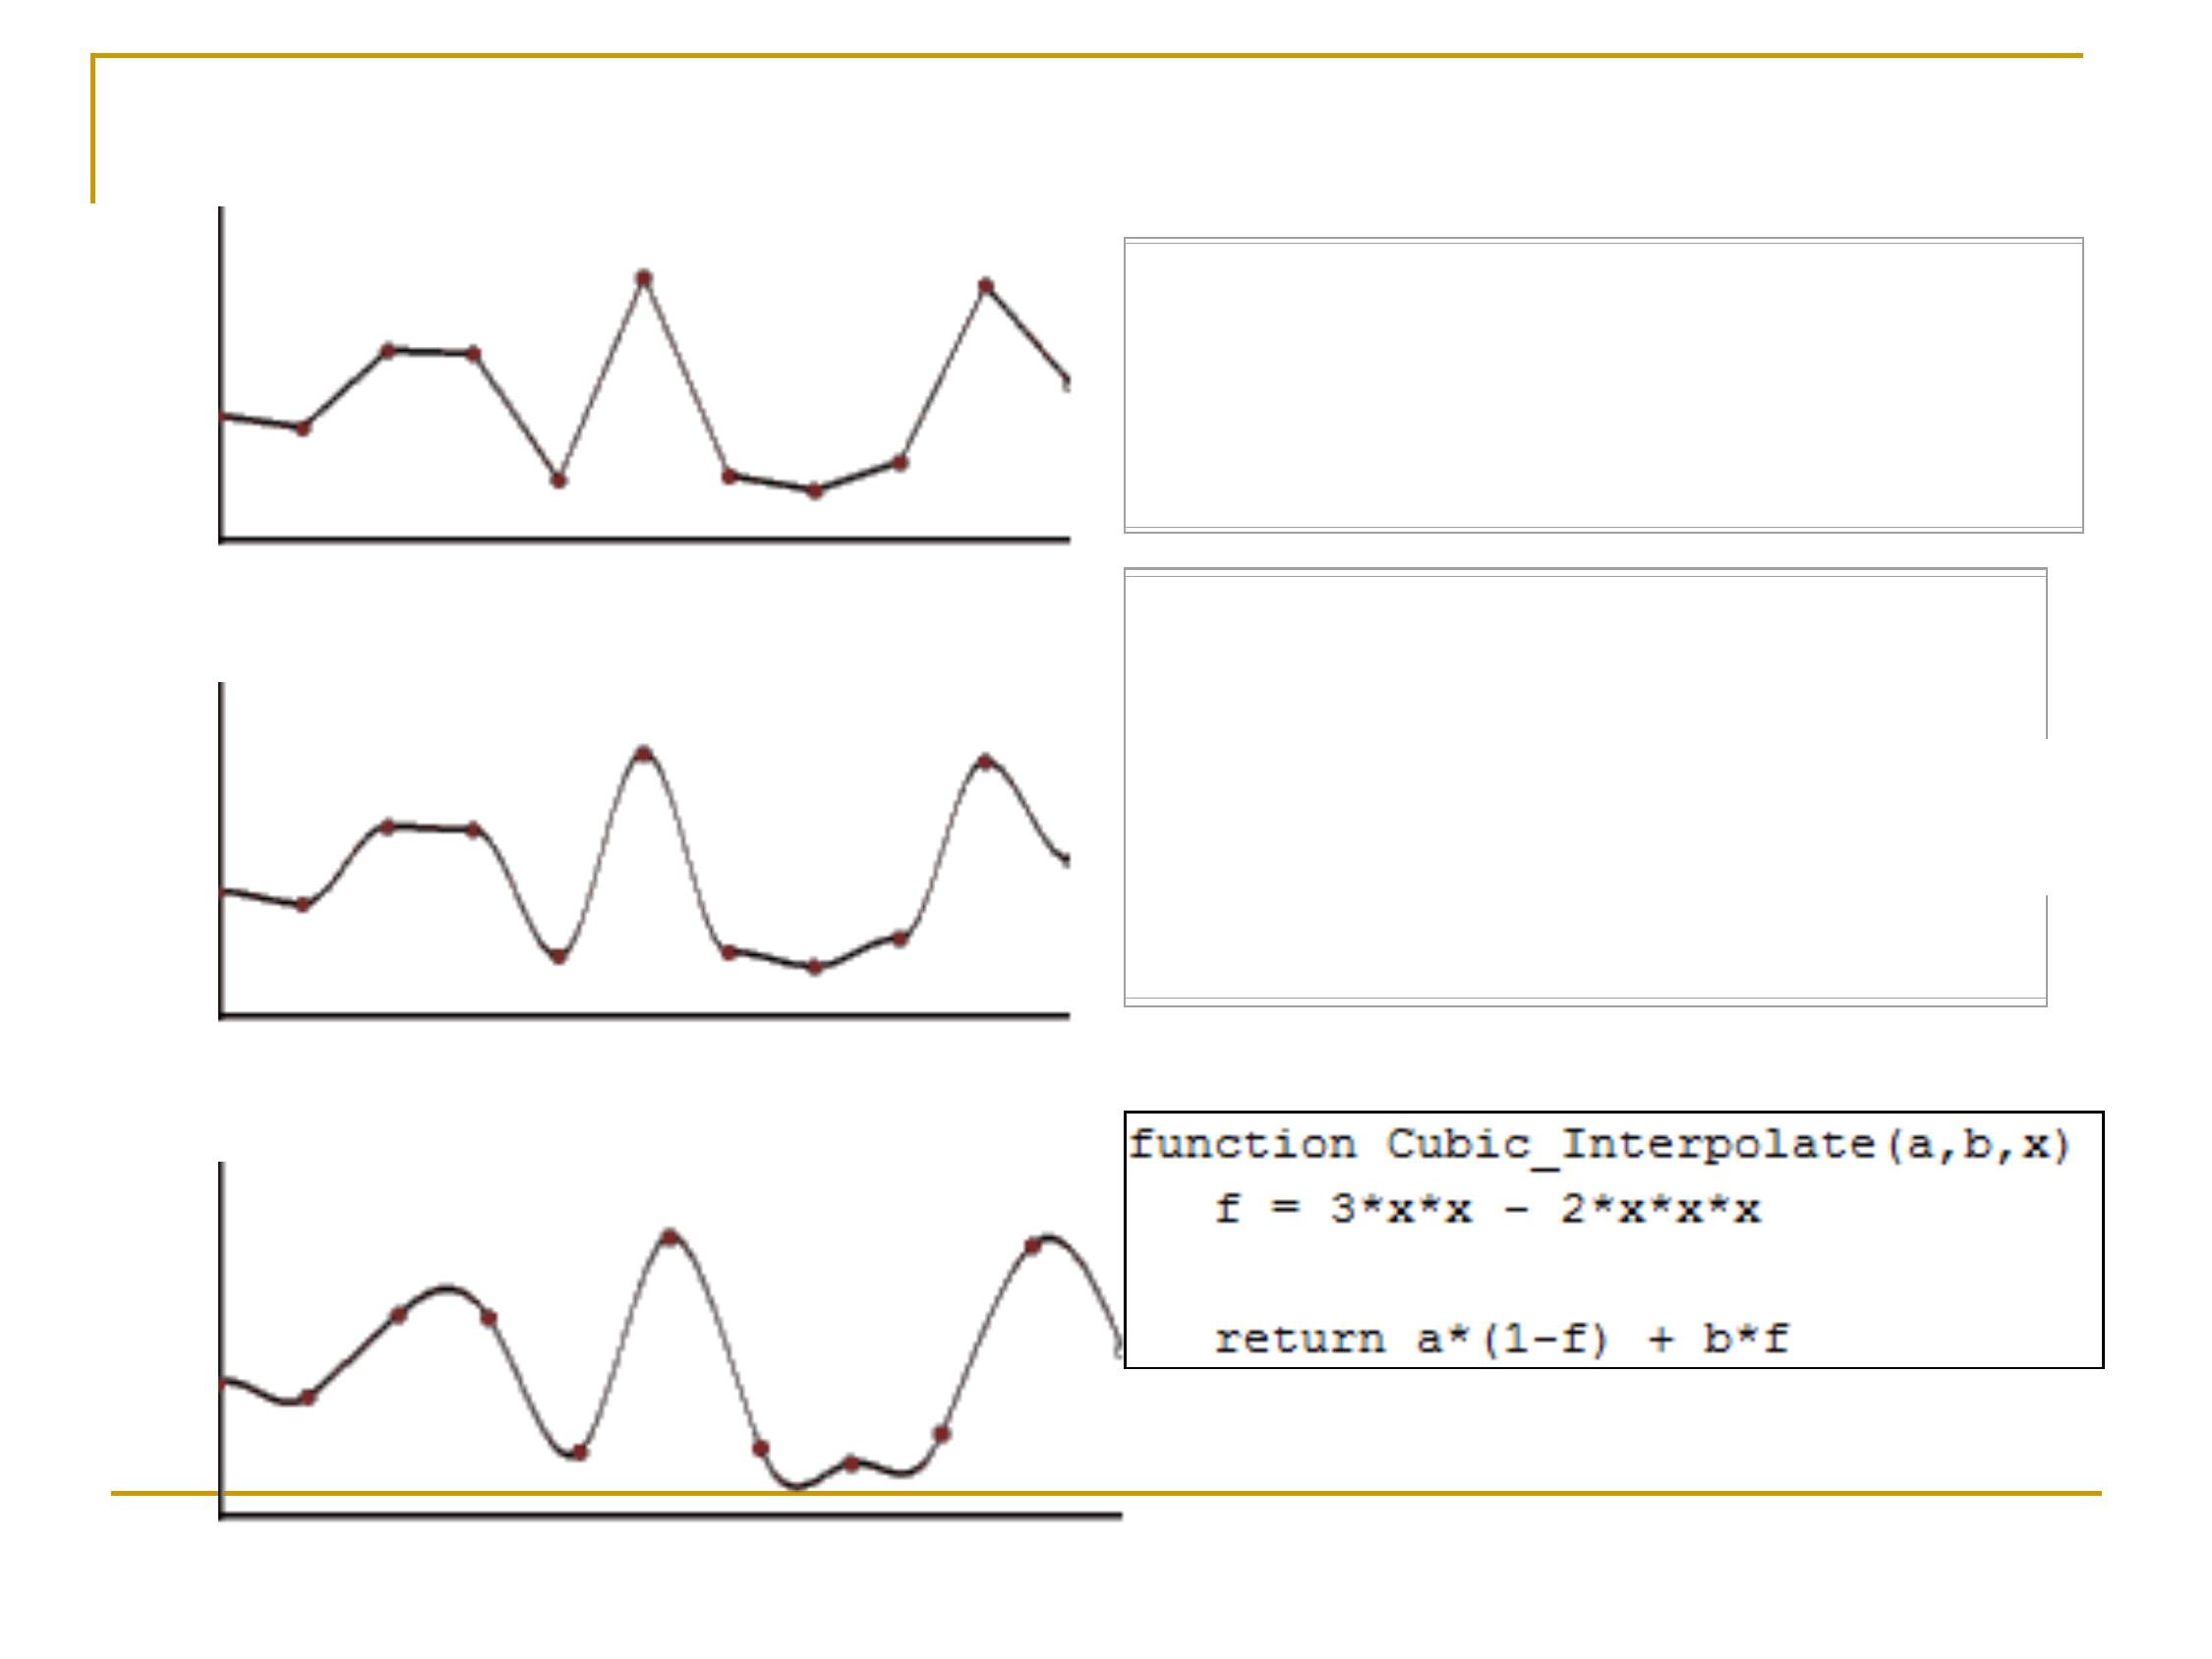
Interpolation
n Linear Interpolation
n Cosine Interpolation
function Linear_Interpolate(a, b, x)
return a*(1-x) + b*x
function Cosine_Interpolate(a, b,
x)
ft = x * 3.1415927
f = (1 - cos(ft)) * .5
return a*(1-f) + b*f
x = 0, ft = 0, f = 0
x = 1, ft = p, f = 1
n
Cubic Interpolation
Fall 2012
8

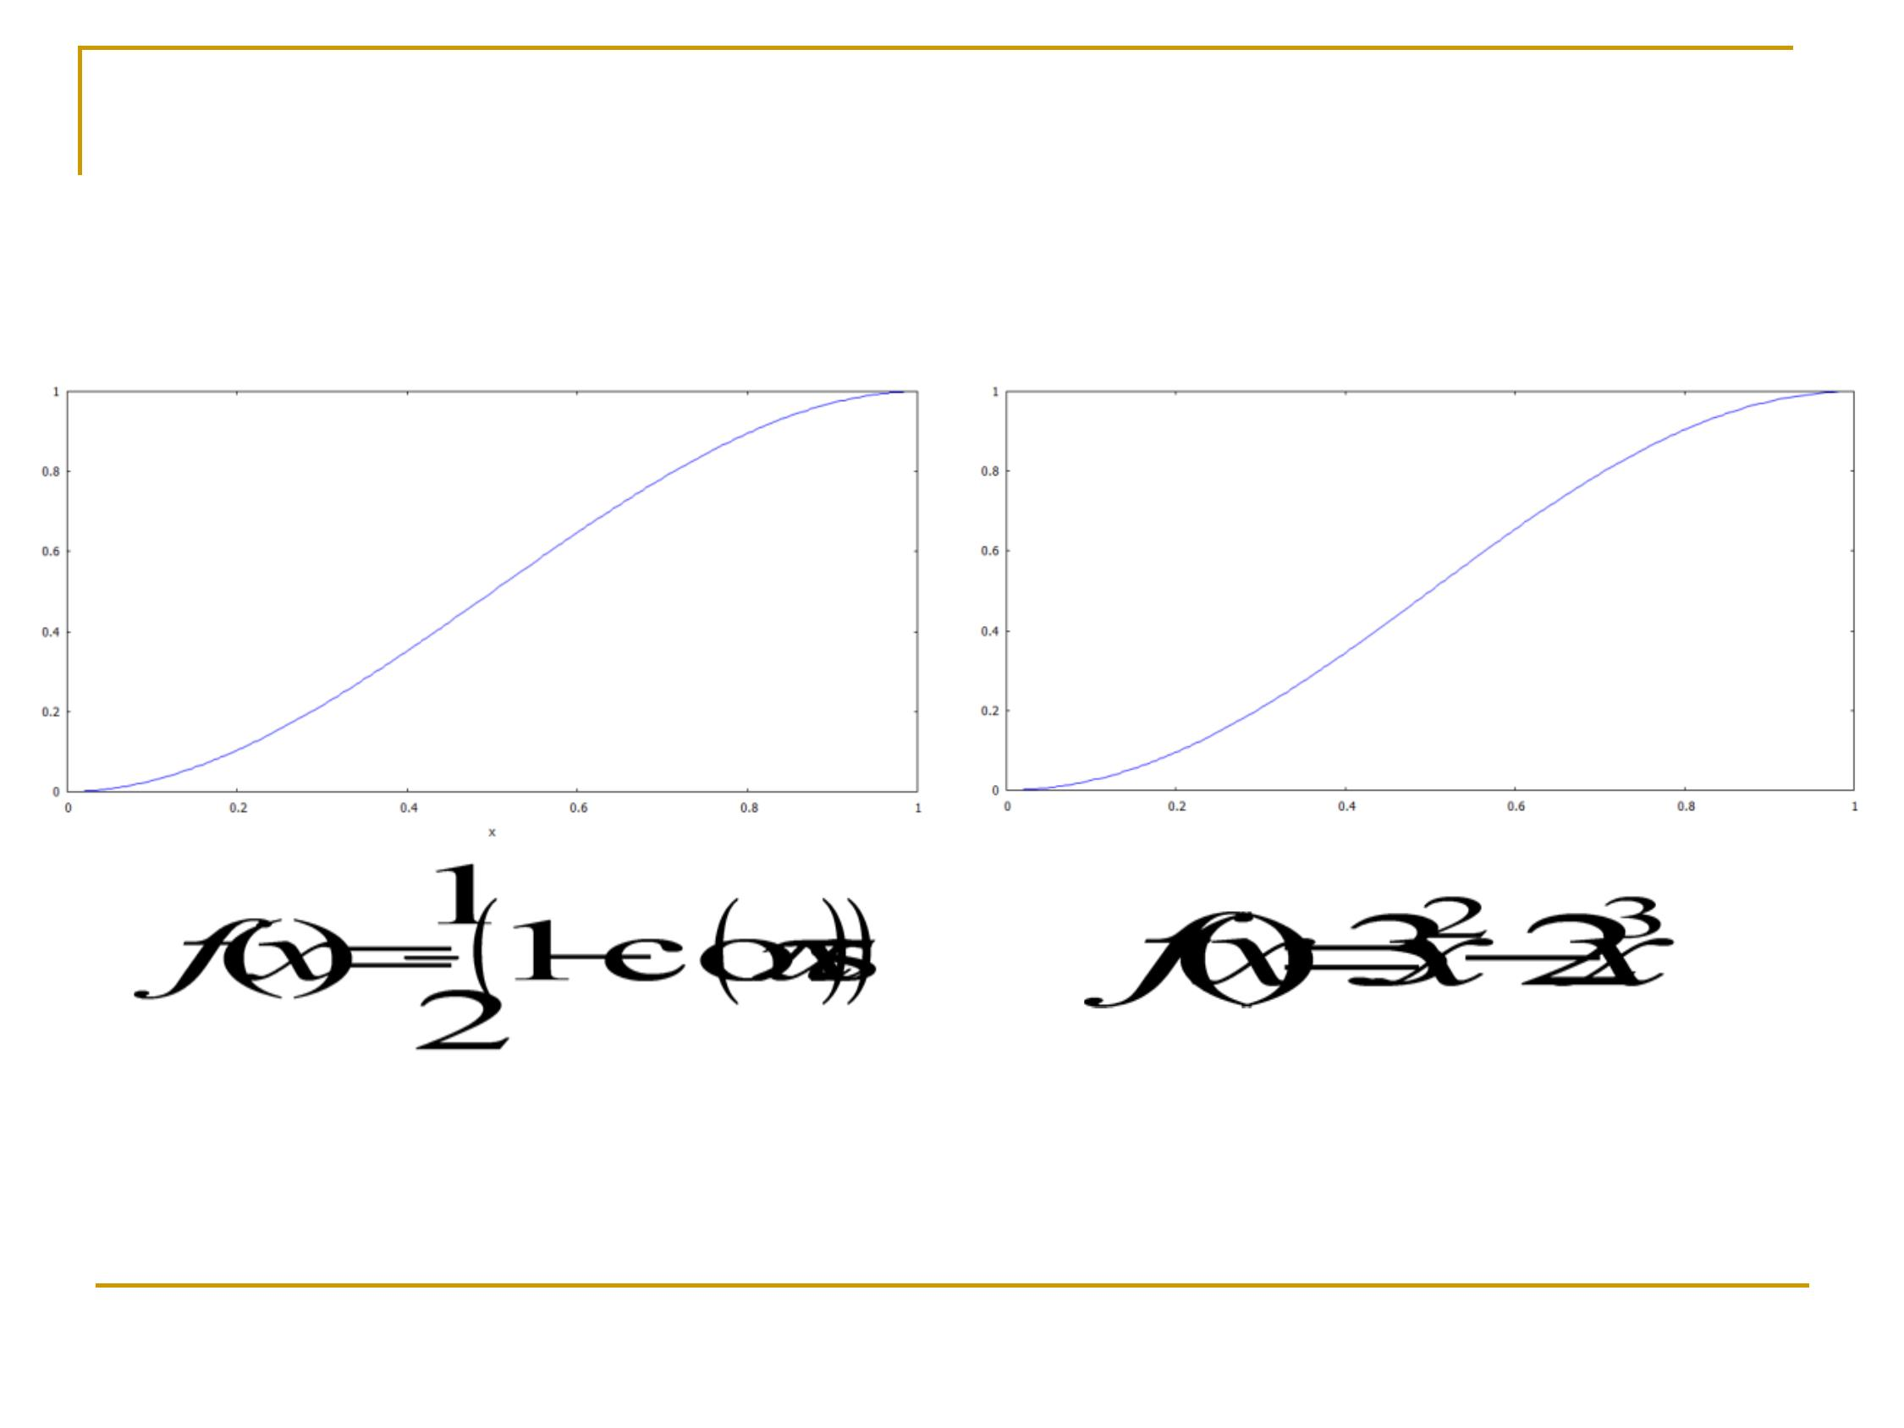
Interpolation
Similar smooth interpolation
with less computation
Fall 2012
9

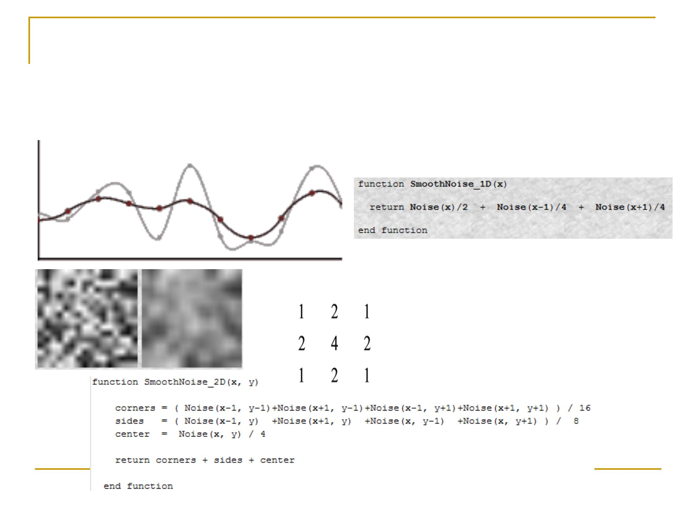
Smoothed Noise
n
Apply smooth filter to the interpolated noise
Fall 2012
10

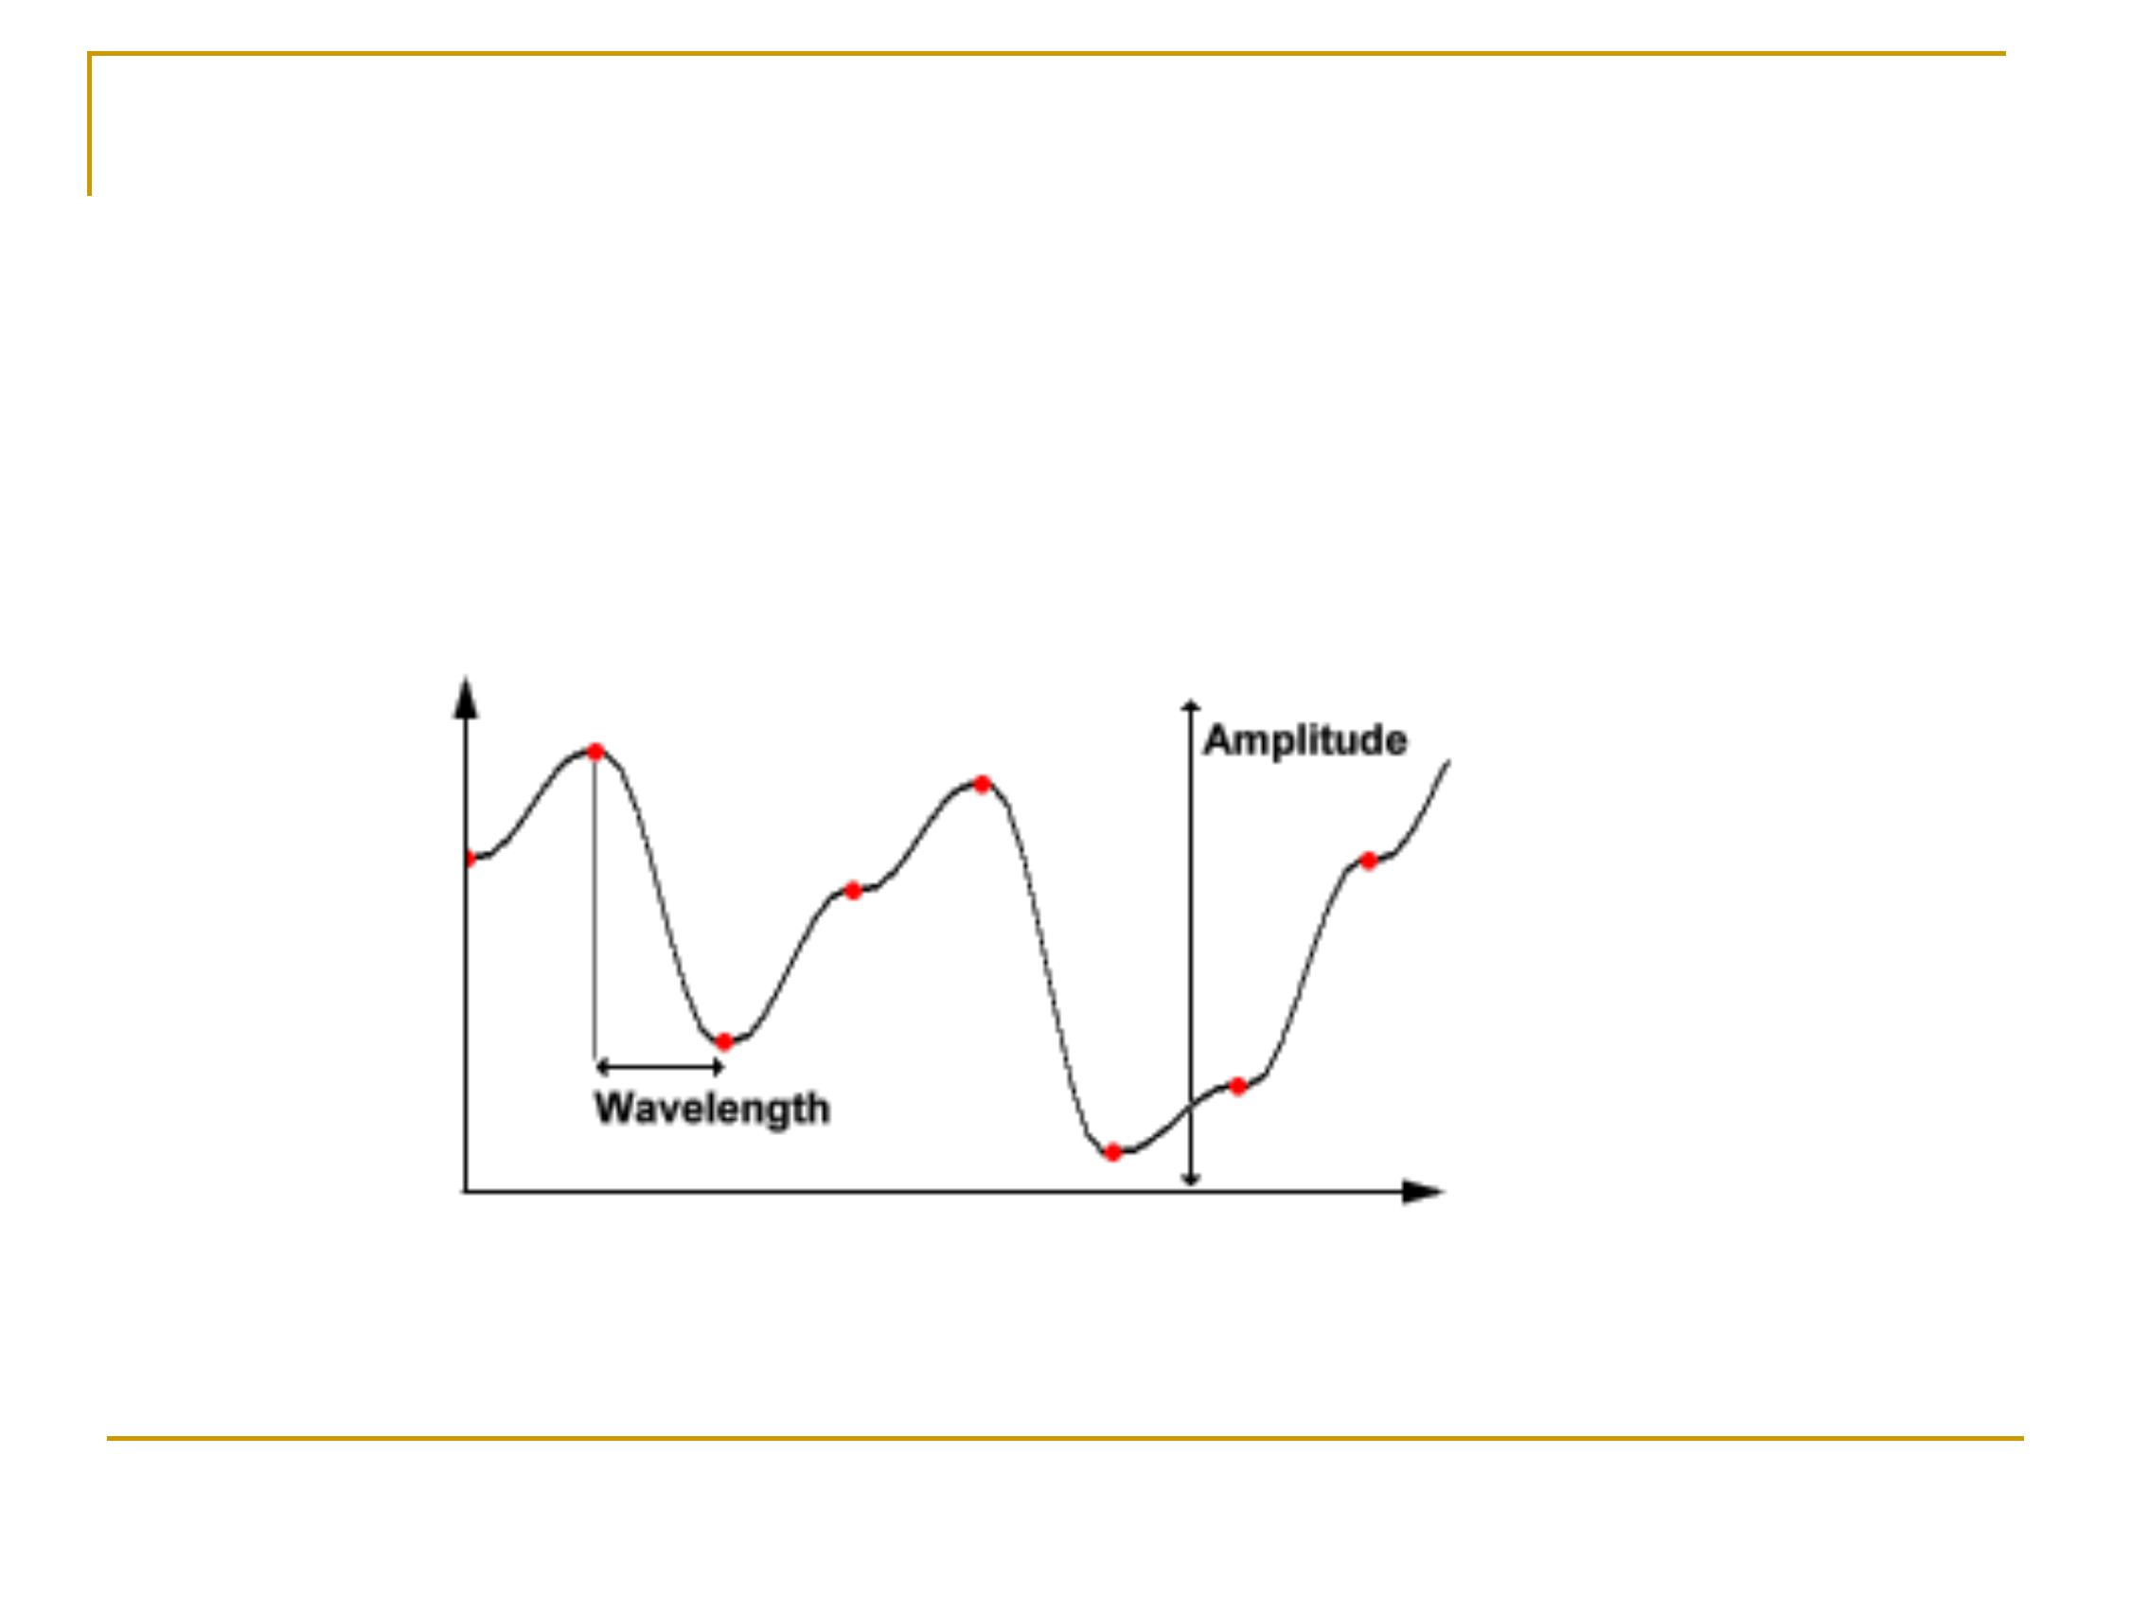
Amplitude & Frequency
n
The red spots indicate the random values
defined along the dimension of the function.
n
frequency is defined to be 1/wavelength.
11
Fall 2012

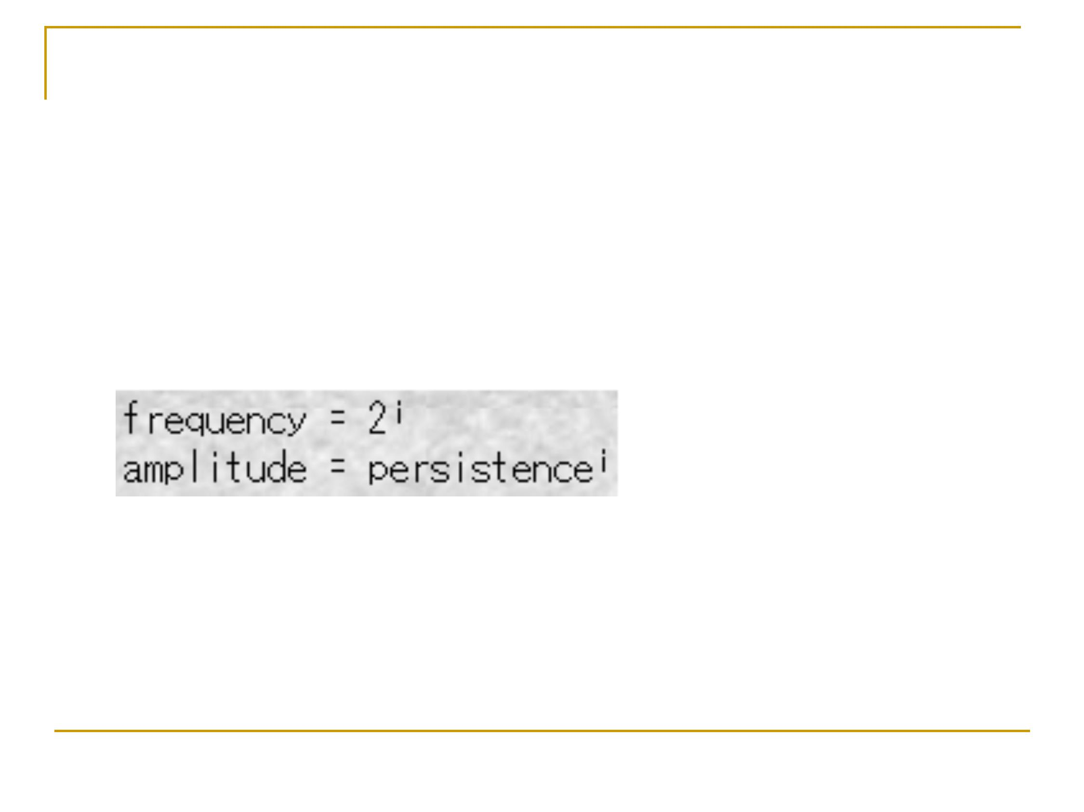
Persistence
n You can create Perlin noise functions with different
characteristics by using other frequencies and
amplitudes at each step.
Fall 2012
12

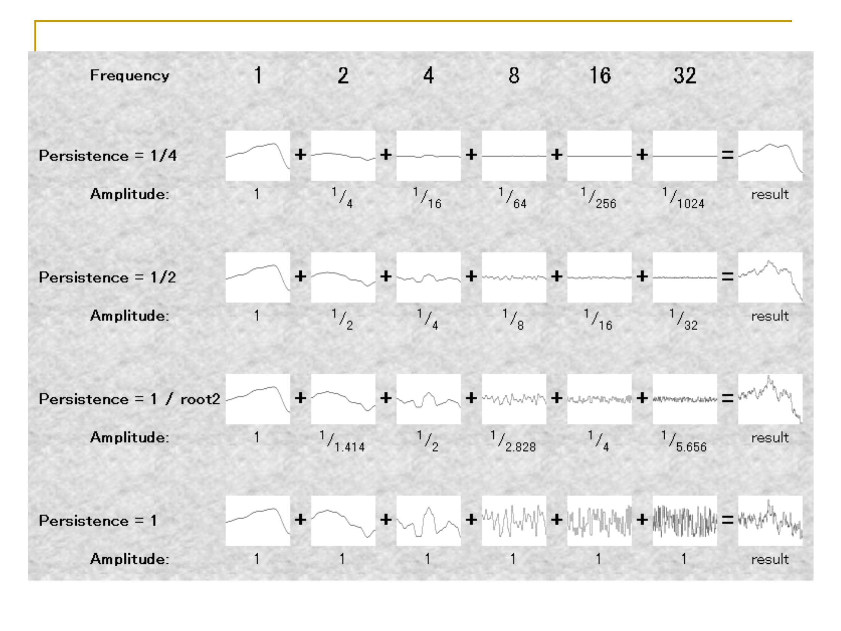
Fall 2012
13

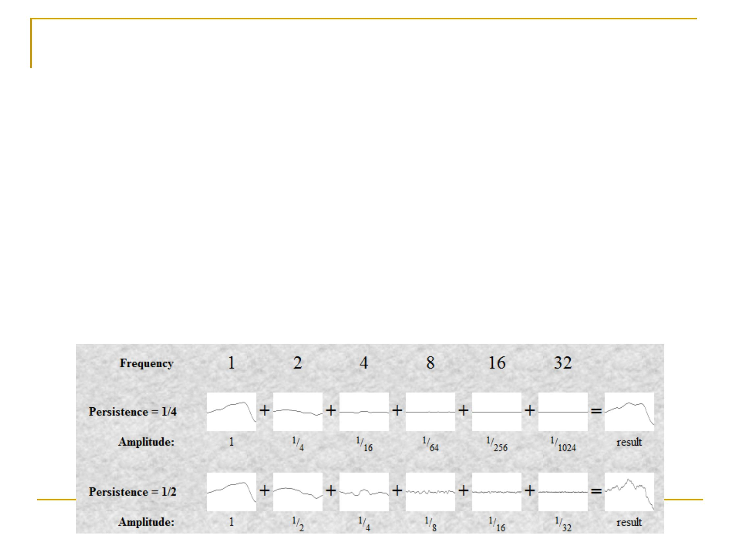
n
Add them all together to create a nice noisy
function.
Fall 2012
14
Idea similar to fractal, Fourier series, …
Creating the Perlin Noise
Function
q
Take lots of such smooth functions, with
various frequencies and amplitudes
n

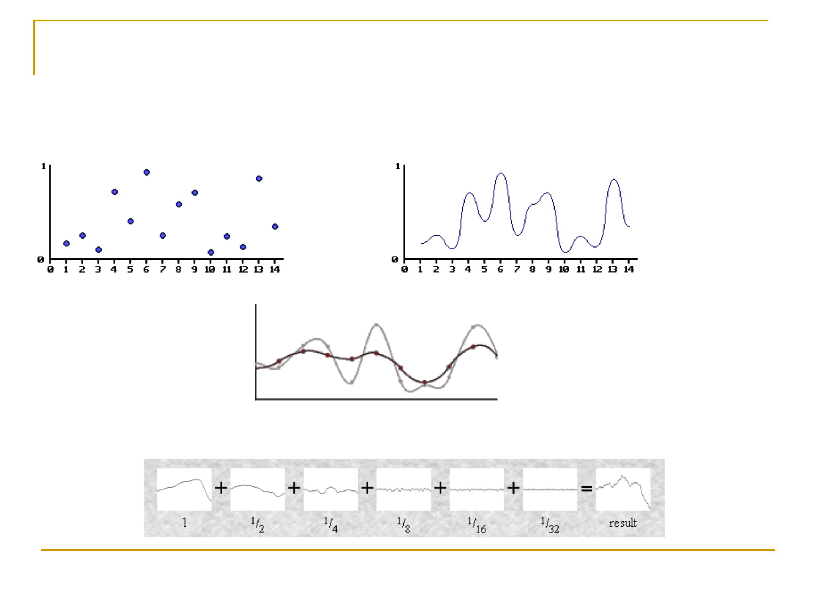
Pseudo random value at integers
Cubic interpolation
Smoothing
Sum up noise of different frequencies
Fall 2012
15
Perlin Noise (1D) Summary

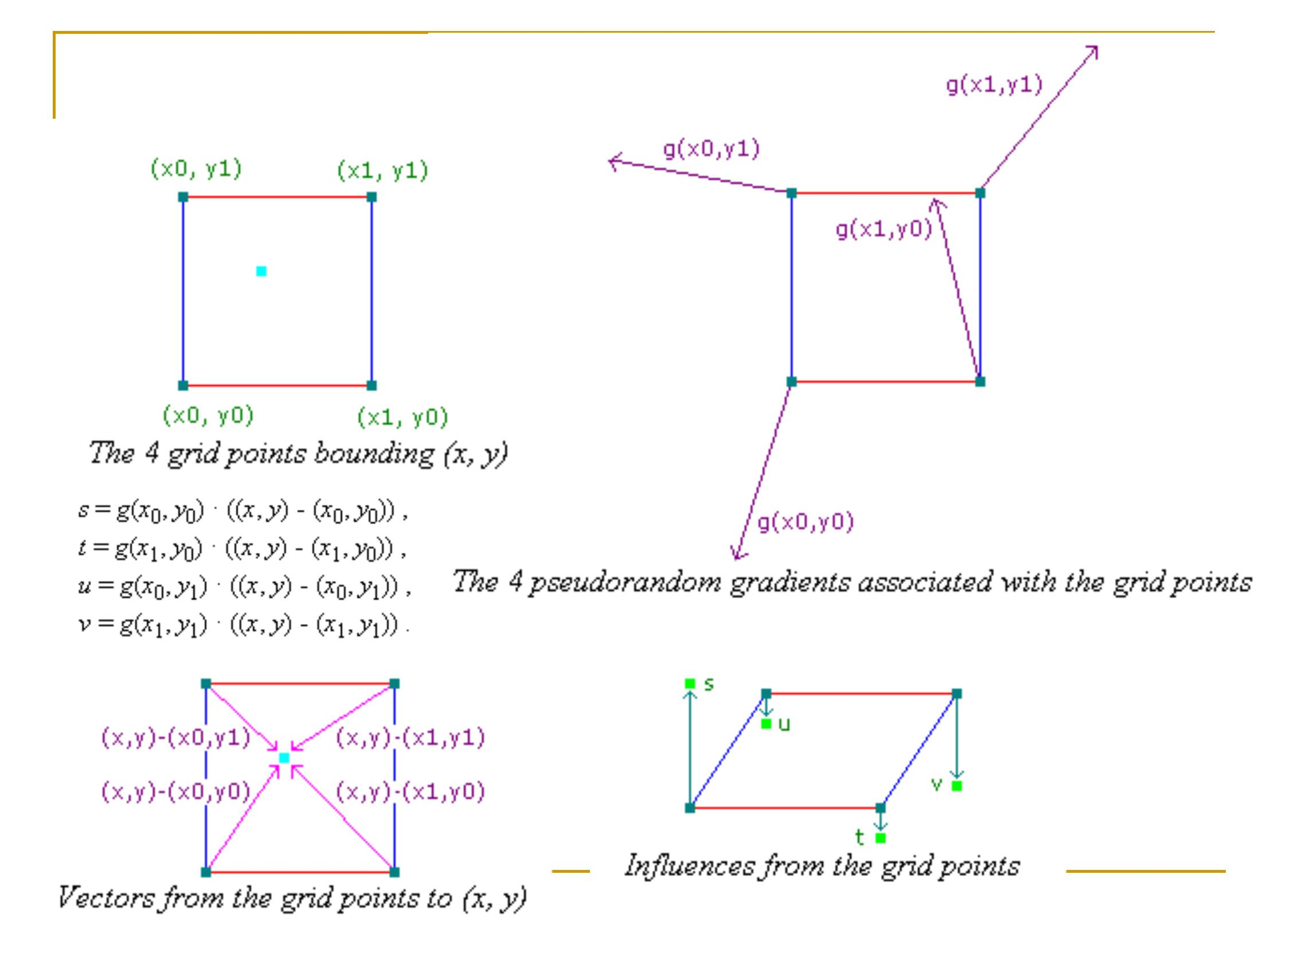
Fall 2012
Perlin Noise (2D)
16

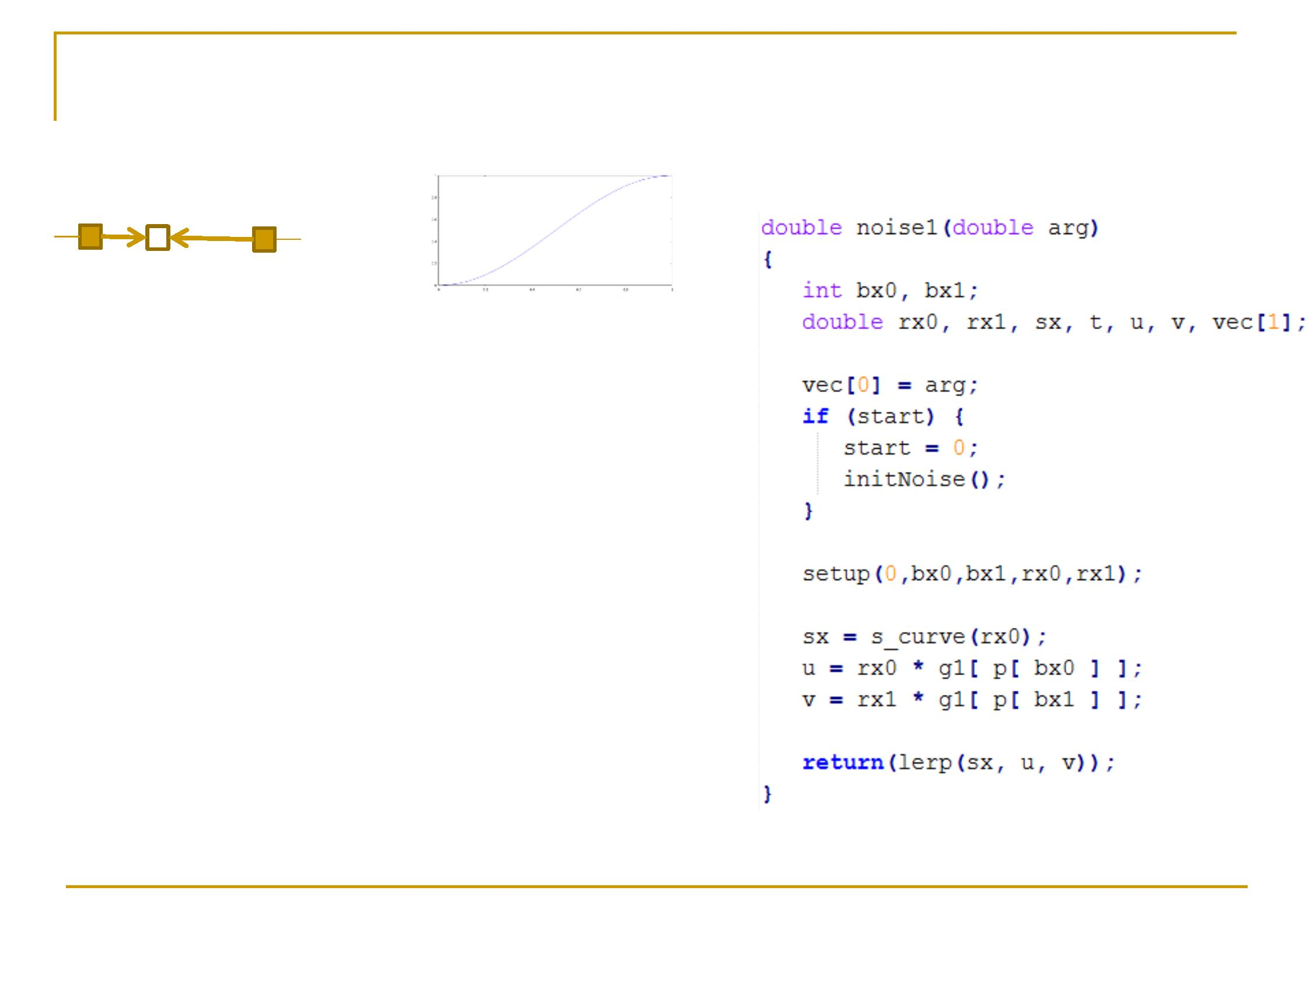
17
Fall 2012
4. Find two function values at both ends of bracket:
rx0*g1[bx0], rx1*g1[bx1] as u, v
5. Linearly interpolate u,v with sx
noise (arg) = u*(1-sx) + v*sx
Perlin Noise (1D)
Here we explain the details
of Ken’s code
rx0
rx1 (= rx0 - 1)
arg
bx0
bx1
1. Construct a [-1,1) random number array g[ ] for
consecutive integers
2. For each number (arg), find the bracket it is in,
[bx0,bx1)
We also obtain the two fractions, rx0 and rx1.
3. Use its fraction t to interpolate the cubic spline
(sx)

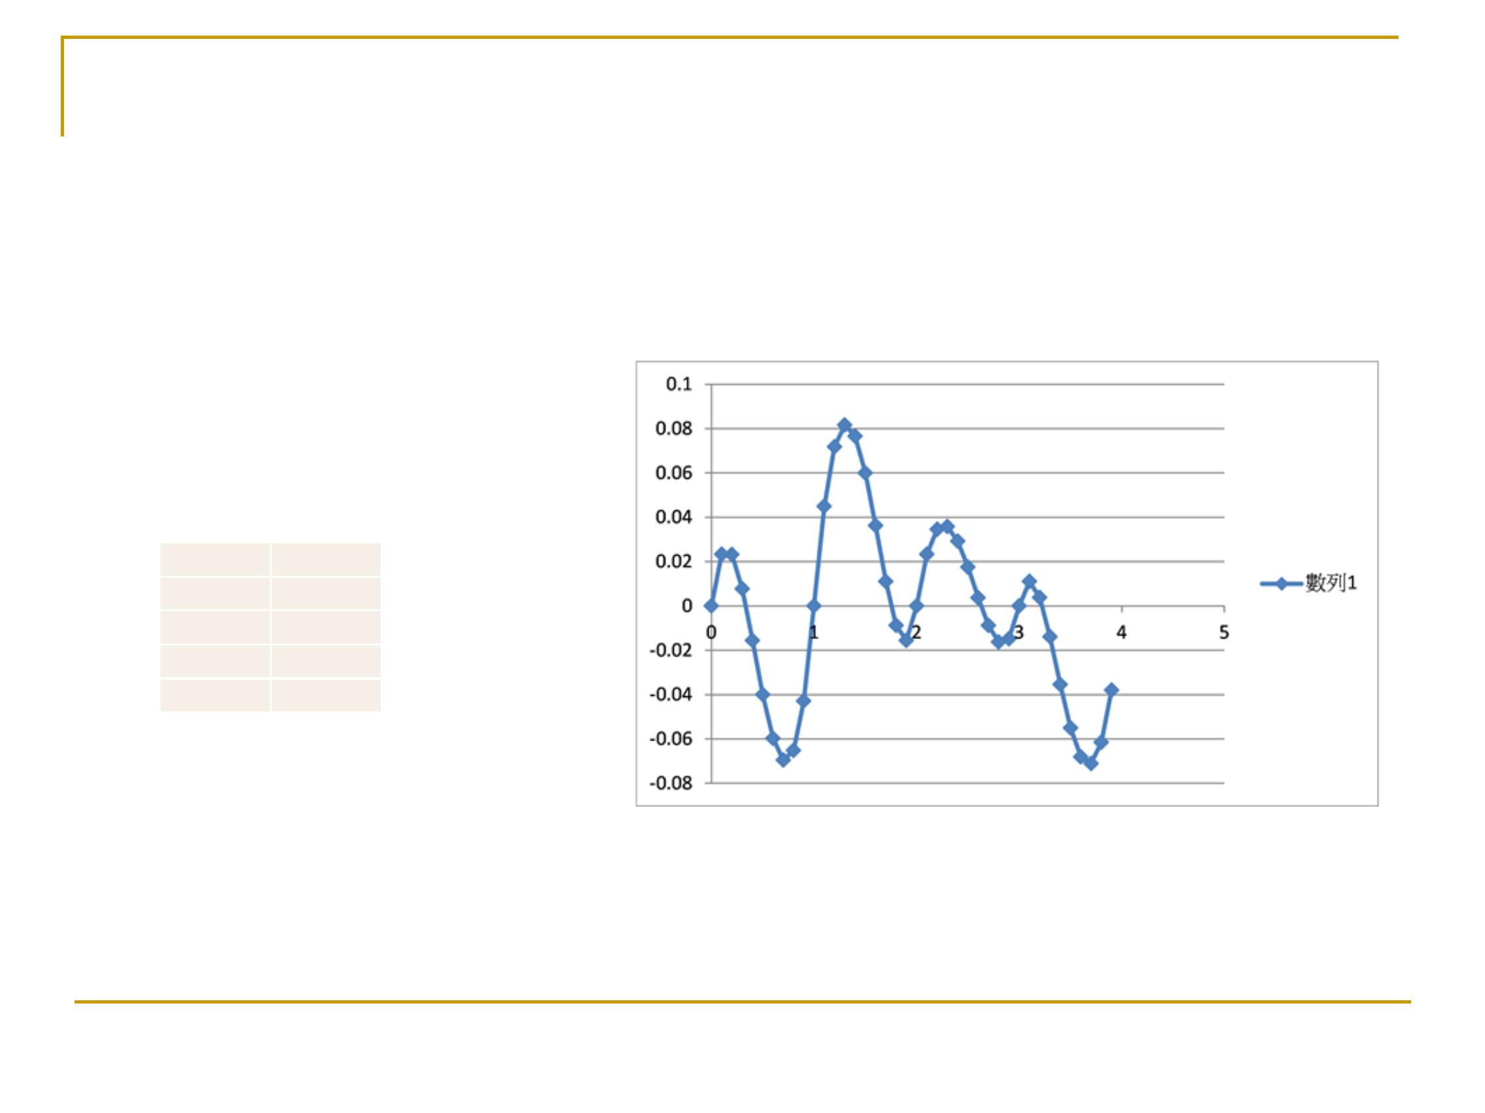
Note: zero values at integers
The “gradient” values at integers
affects the trend of the curve
g0
g1
g2
g3
g4
0.38
0.54
0.3
0.23
0.45
Fall 2012
18

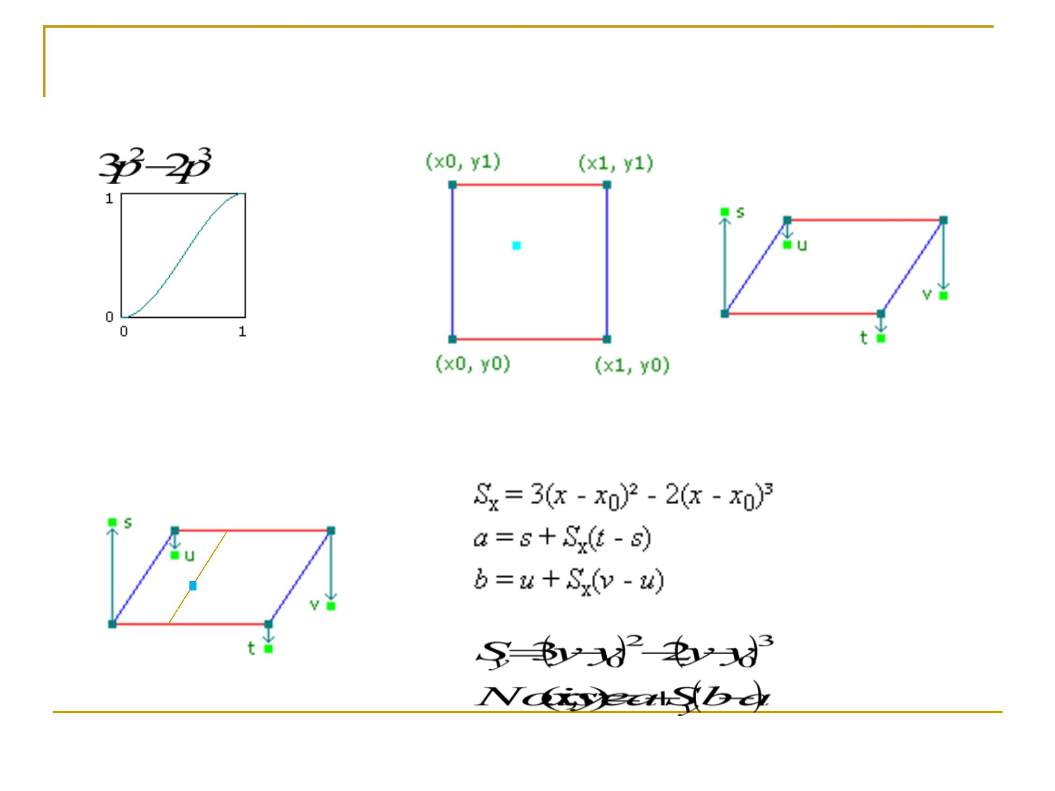
19
Interpolation:2D
p
Interpolant
Bilinear interpolation
a
Fall 2012

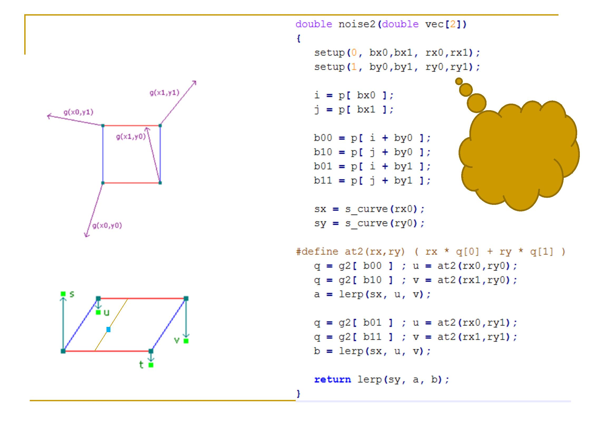
Ken’s noise2( )
a
Fall 2012
20

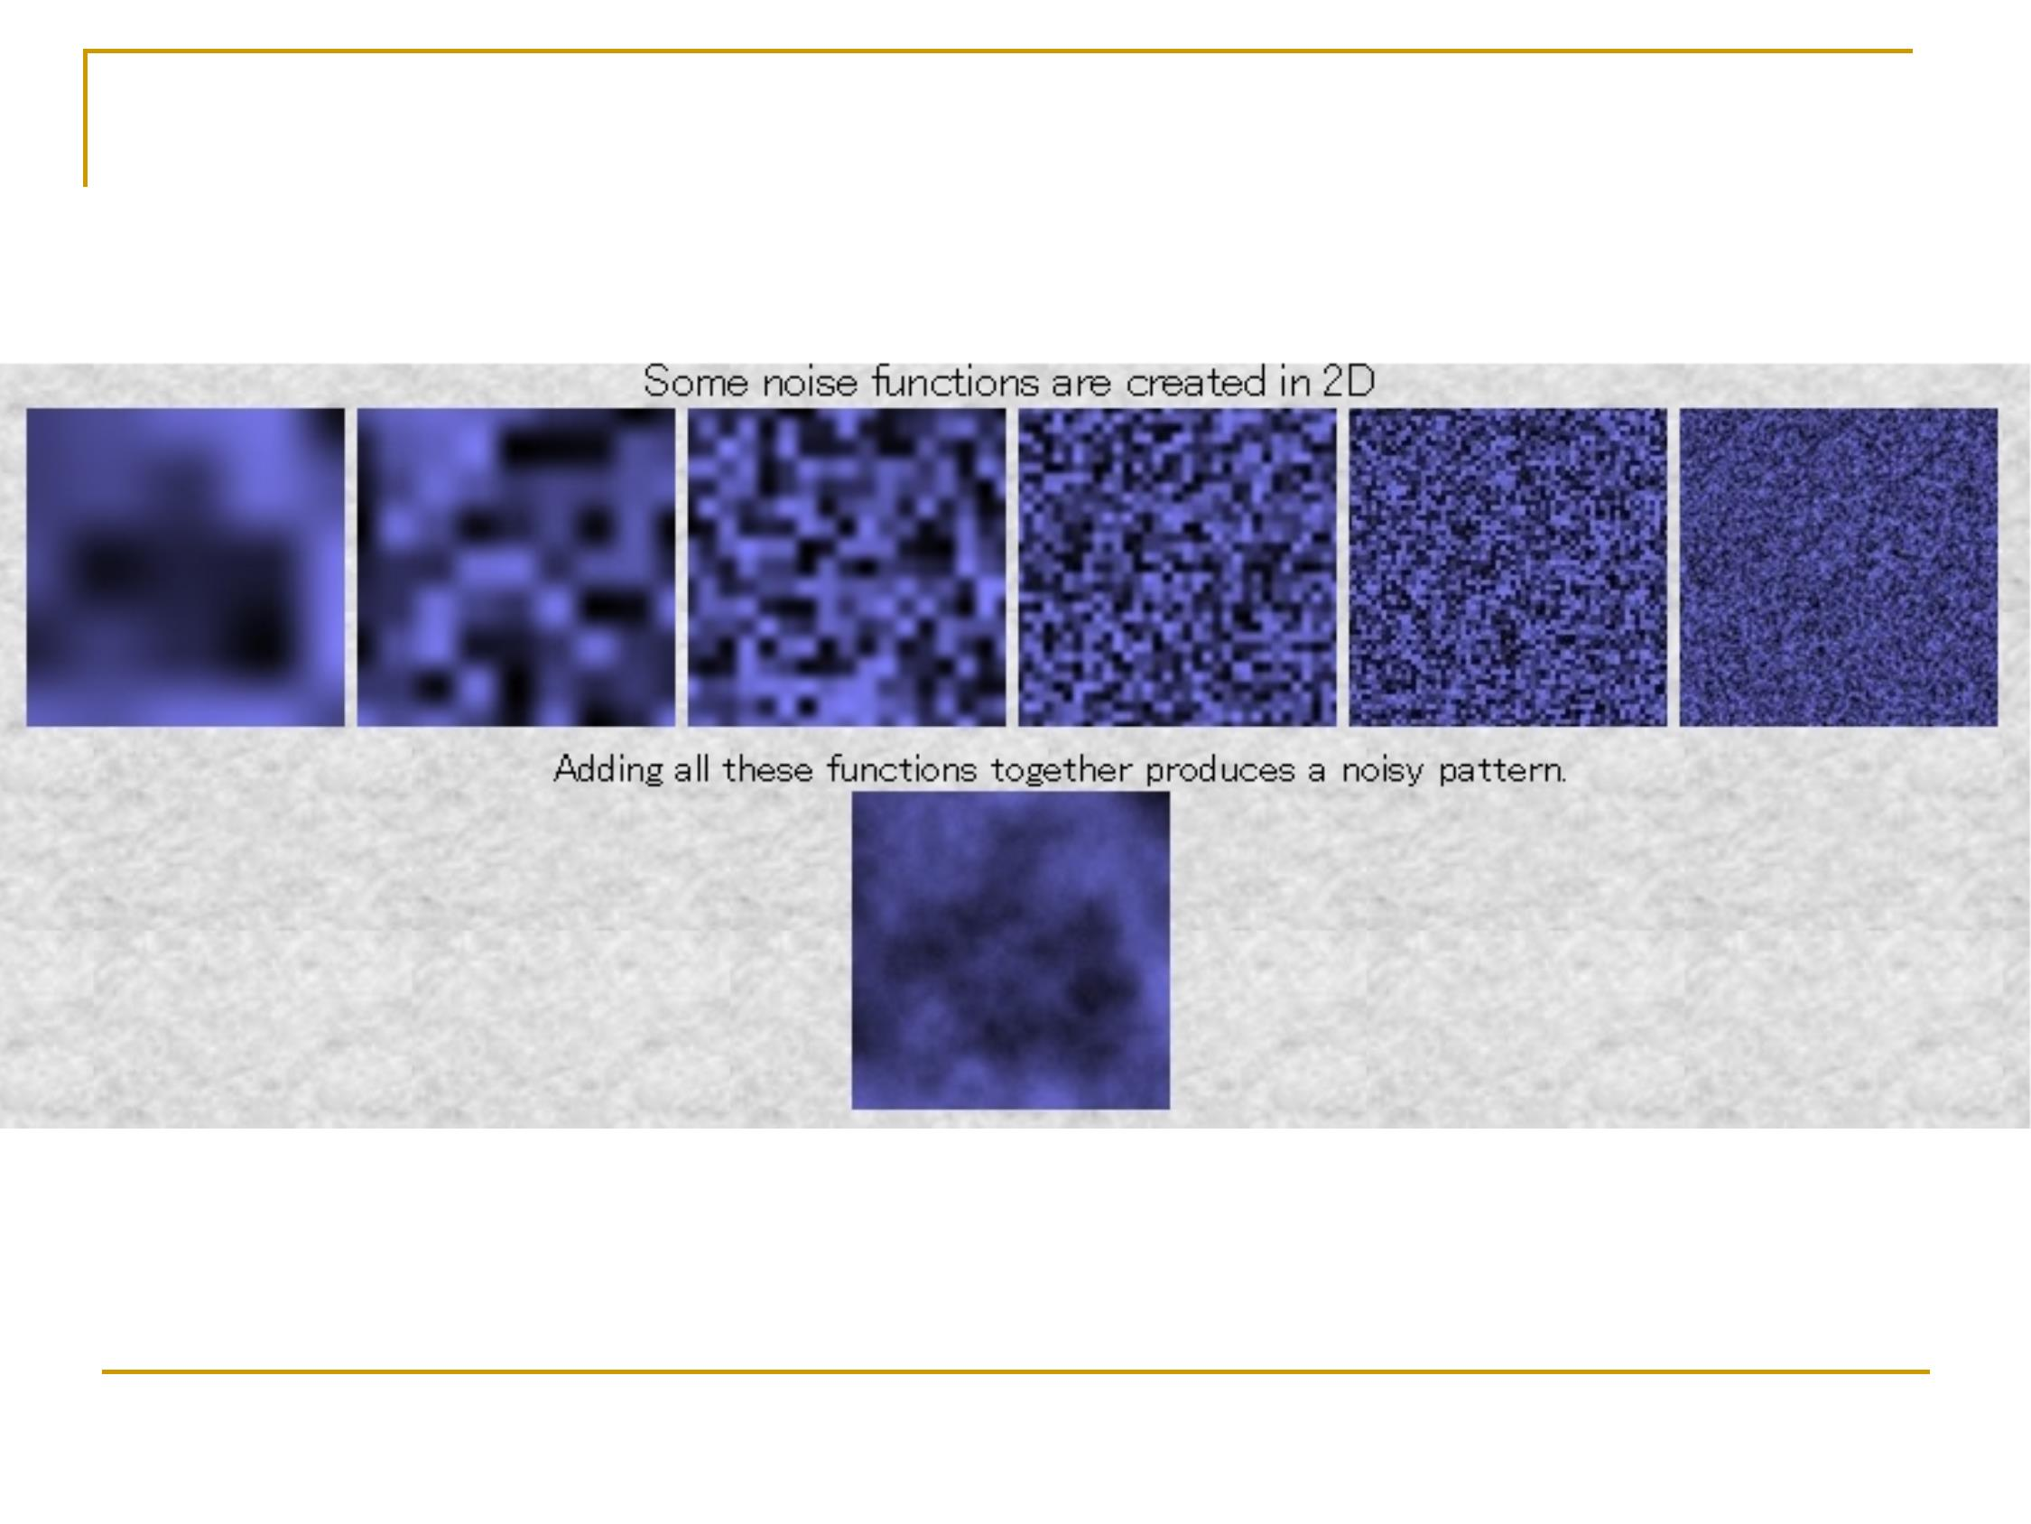
2 dimensions
Fall 2012
21


22
Using noise functions
n
n
n
n
Sum up octaves
Sum up octaves using sine functions
Blending different colors
Blending different textures
Fall 2012

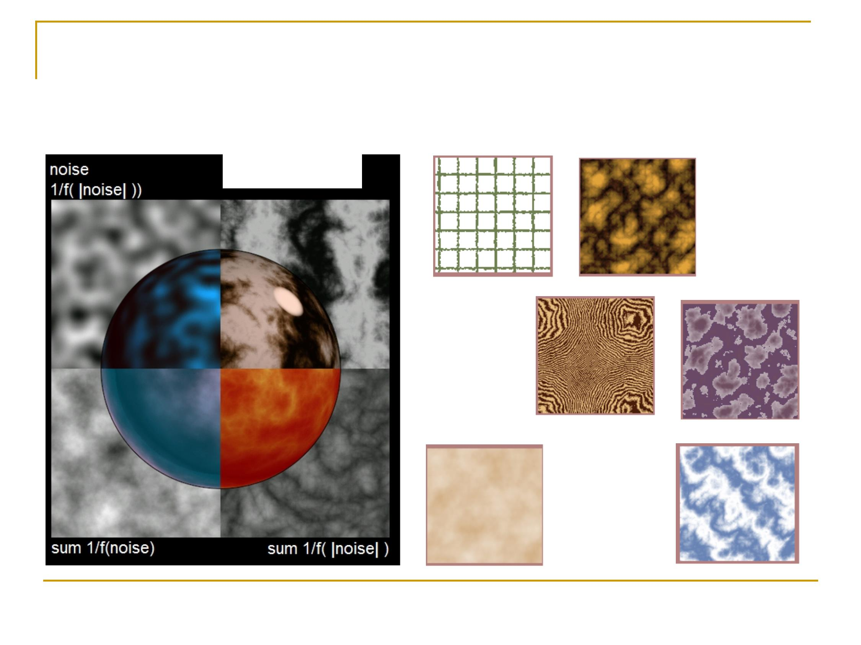
Other Usage of Noise Function
(ref)
sin(x + sum
Fall 2012
23

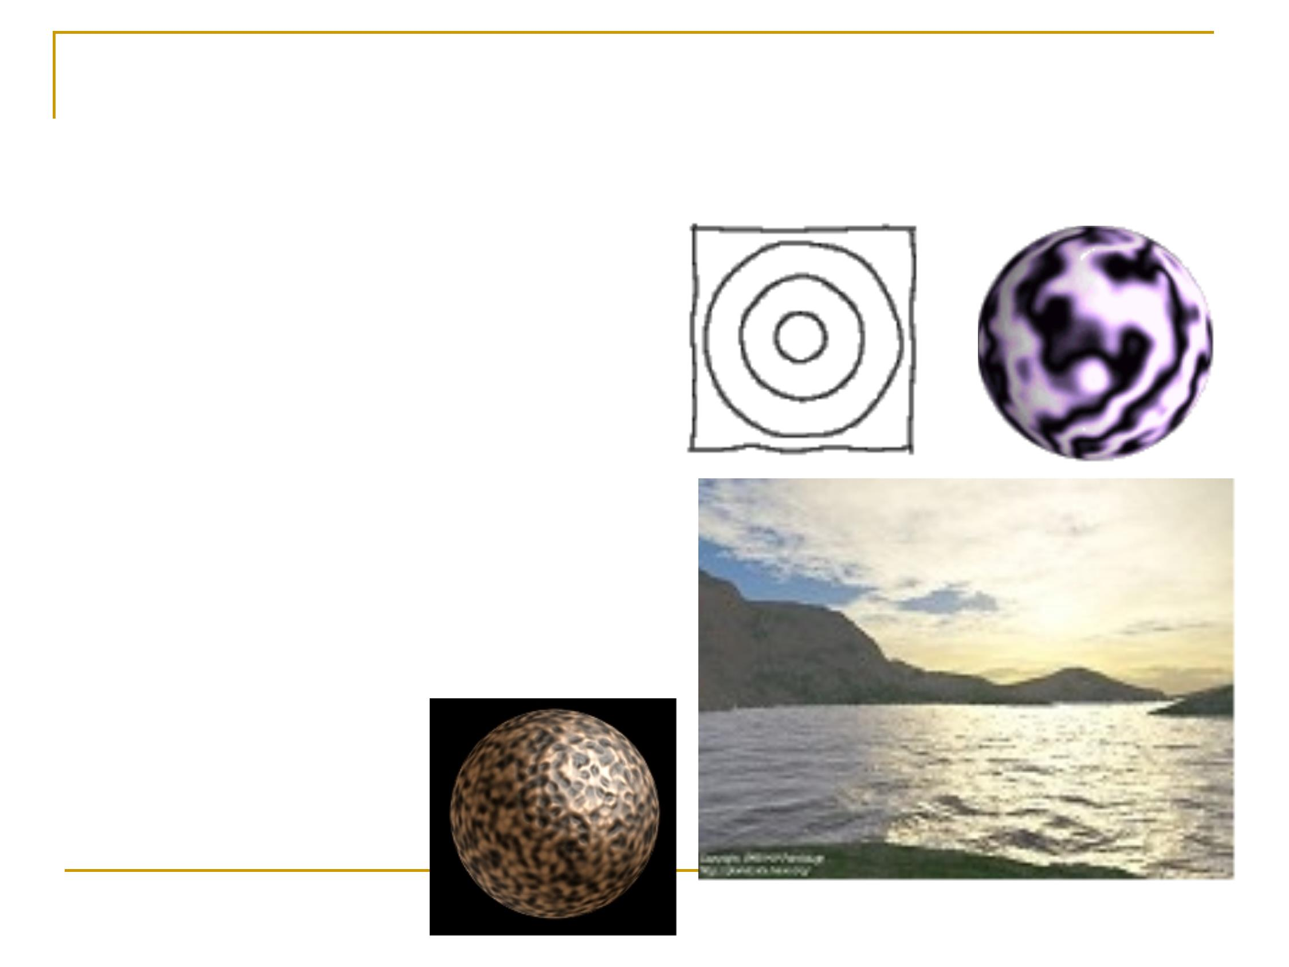
24
Applications of Perlin Noise
n 1 dimensional :
Controlling virtual beings,
drawing sketched lines
n 2 dimensional :
Landscapes, clouds,
generating textures
n 3 dimensional :
3D clouds, solid textures
Fall 2012

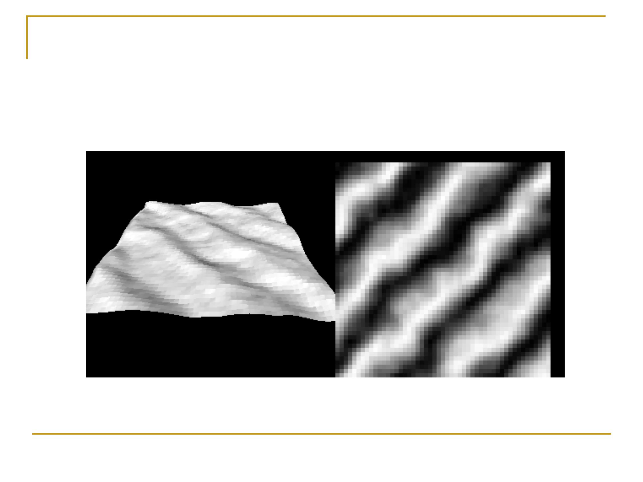
2D Noise: texture and terrain
Fall 2012
25

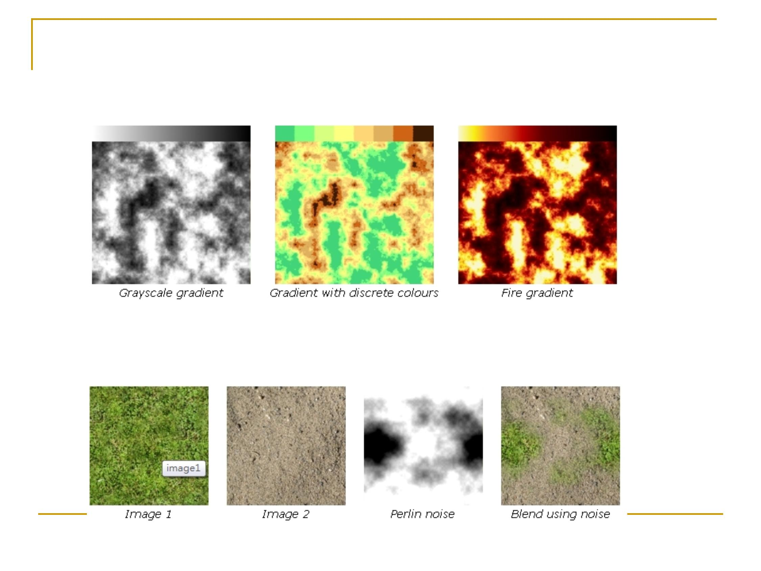
Use Perlin Noise in Games (ref)
Texture generation
Texture Blending
Fall 2012
26

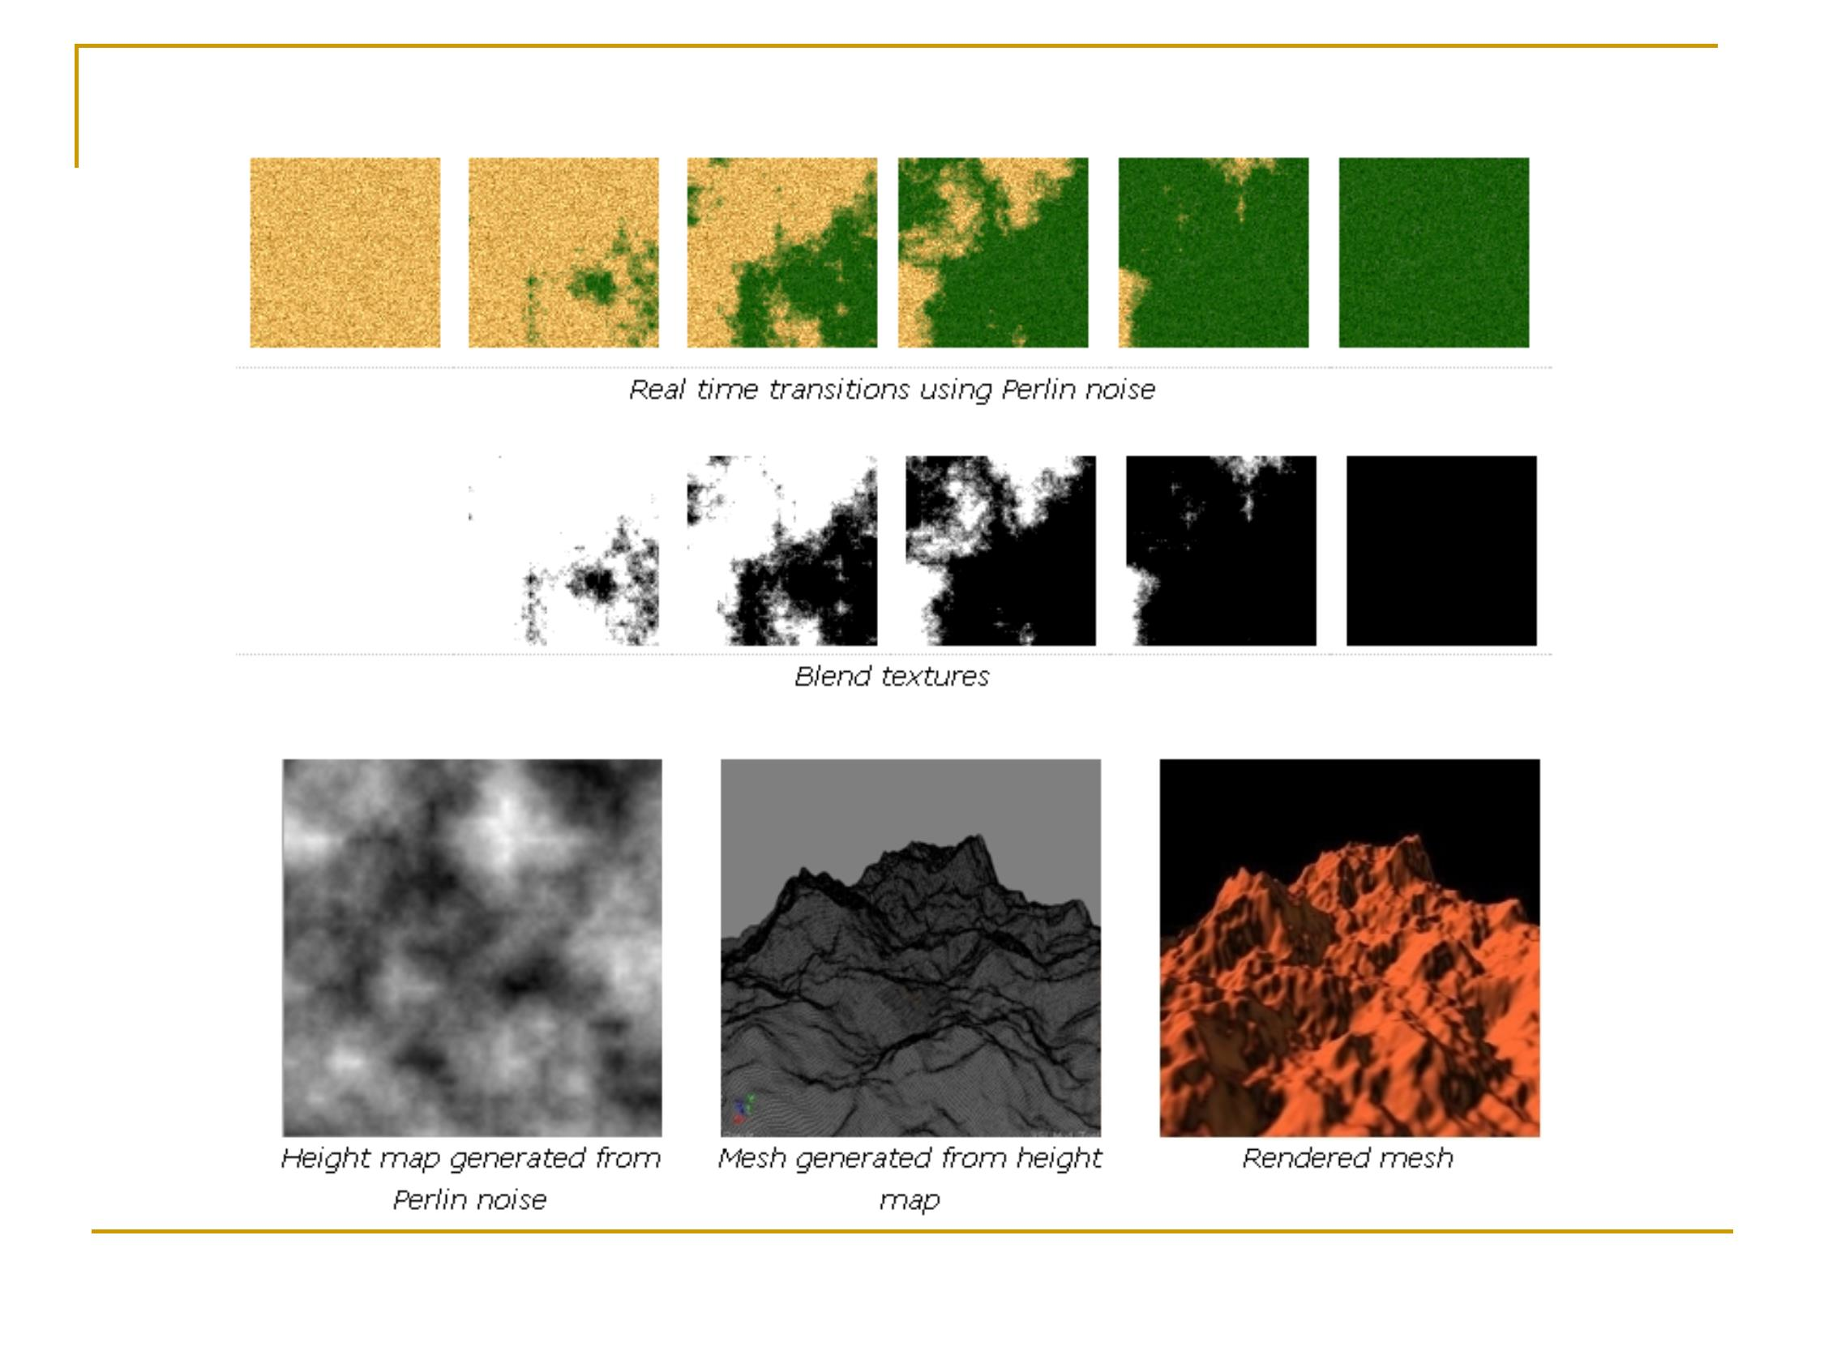
Animated texture blending
Terrain
Fall 2012
27

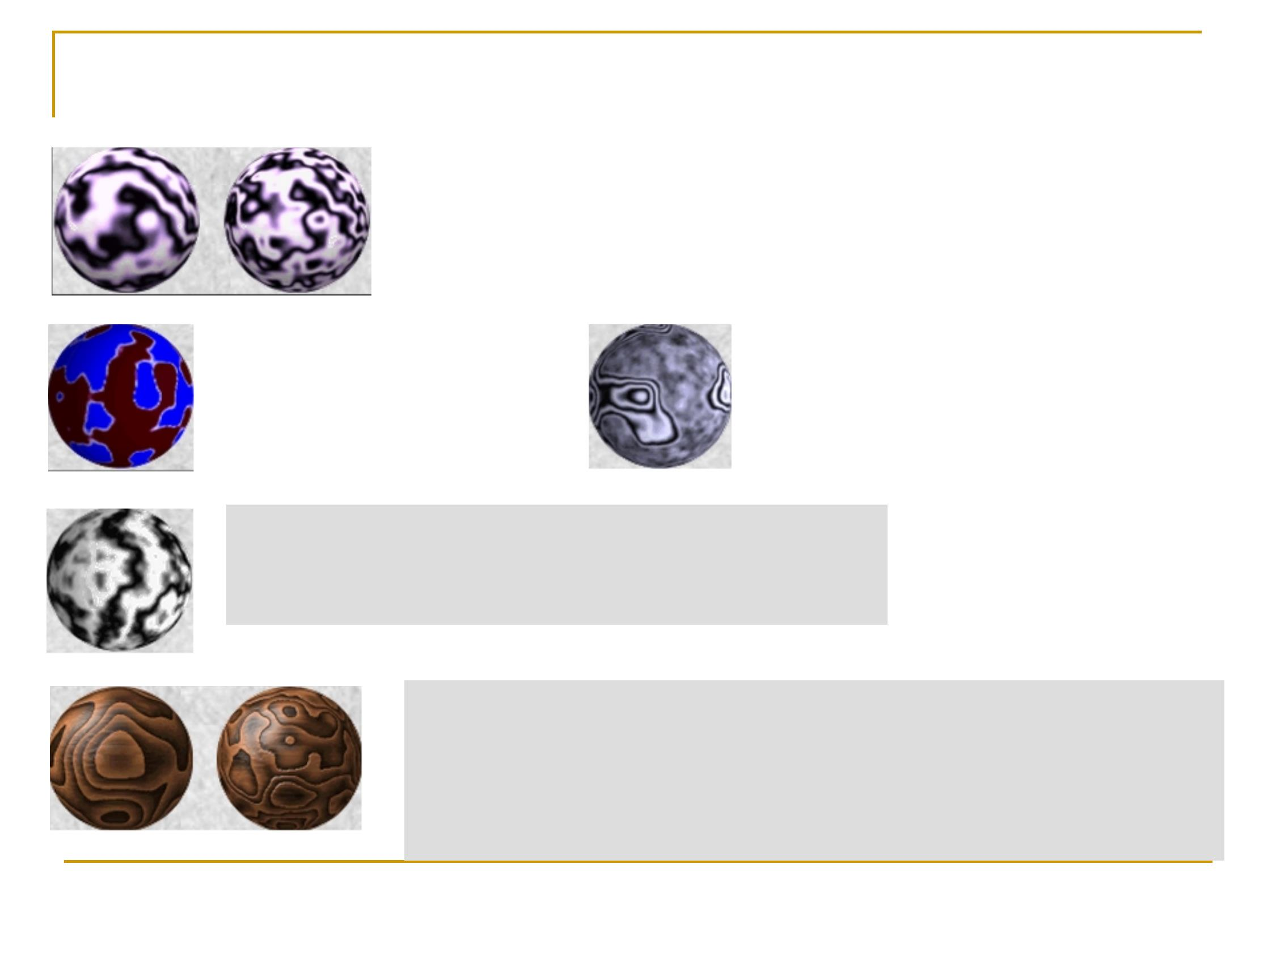
Variations (ref)
Standard 3 dimensional perlin noise. 4 octaves,
persistence 0.25 and 0.5
mixing several Perlin functions
create harder edges by
applying a function to the
output.
marbly texture can be made by using a Perlin
function as an offset to a cosine function.
texture = cosine ( x + perlin(x,y,z) )
Very nice wood textures can be defined. The grain is defined
with a low persistence function like this:
g = perlin(x,y,z) * 20
grain = g - int(g)
Fall 2012
28

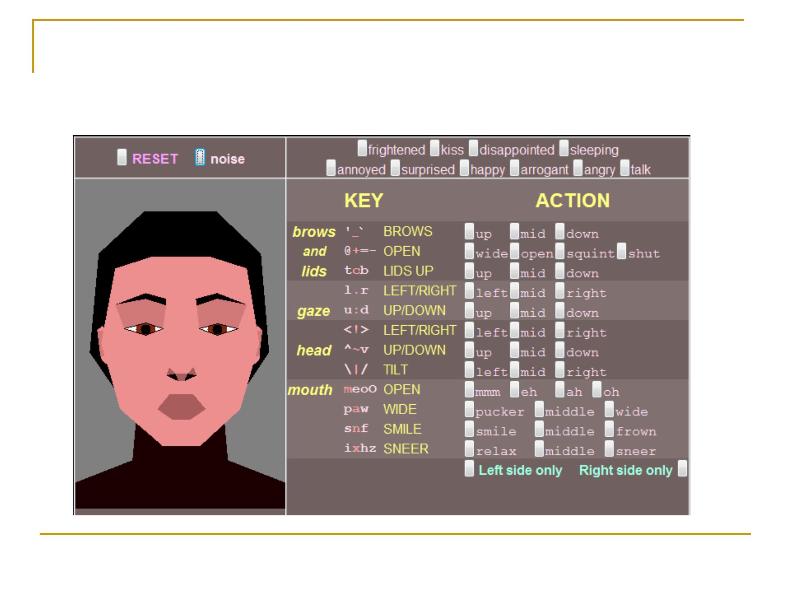
29
Noise in facial animation
Math details
Fall 2012

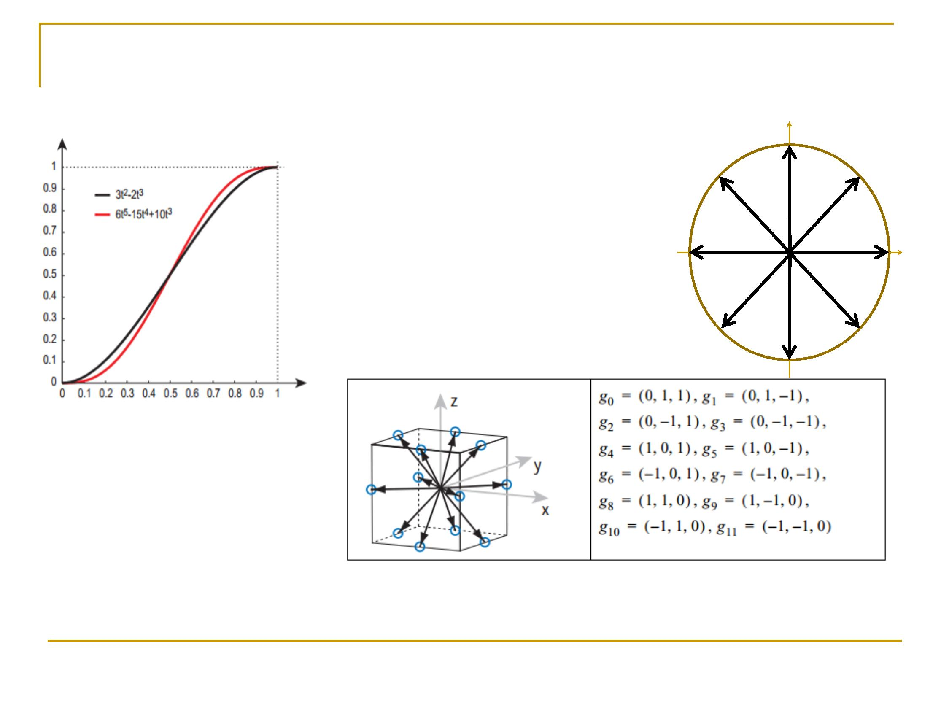
Simplex Noise (2002_{M})_{ore efficient computation!}
New Interpolant
Picking Gradients
Fall 2012
30

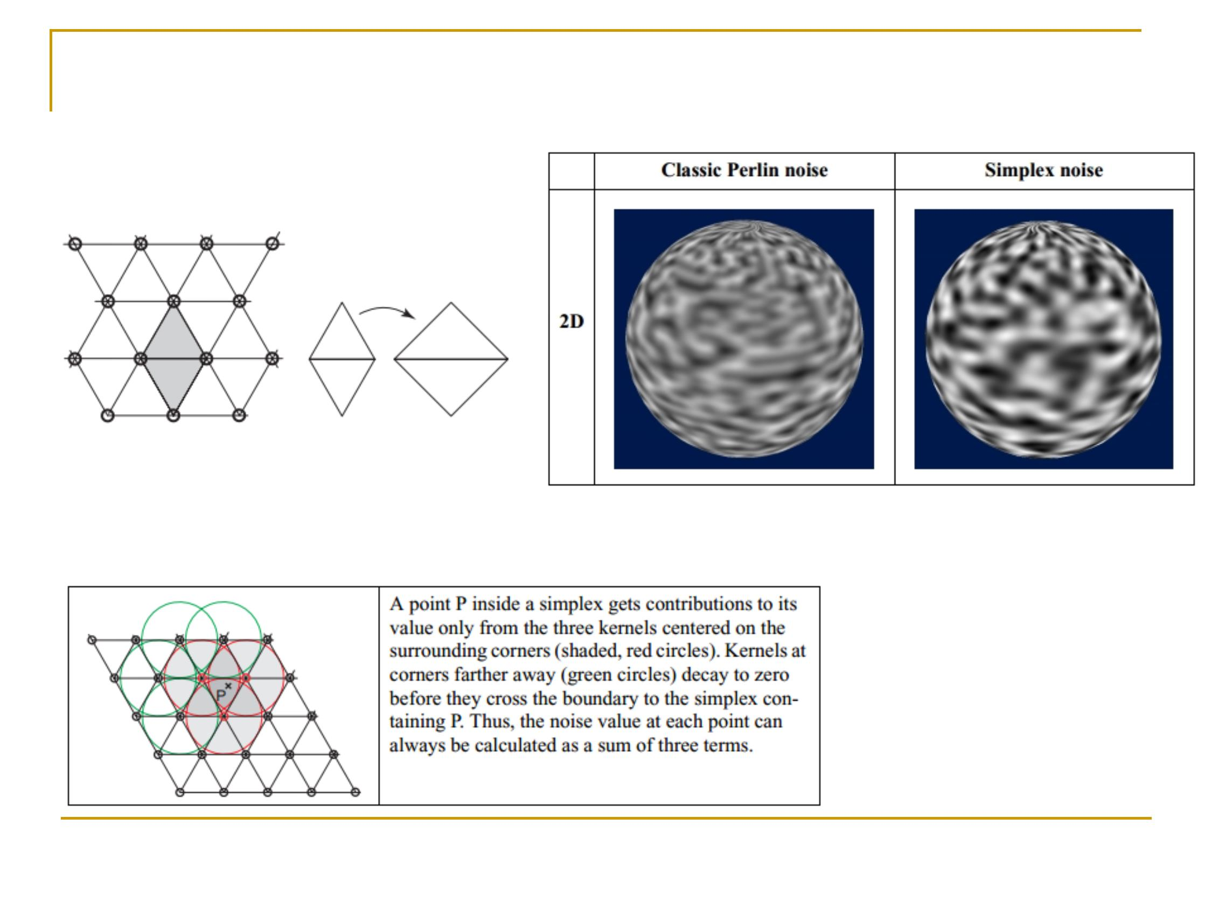
Simplex Noise (cont)
Simplex Grid
Moving from interpolation to summation
(more efficient in higher dimension noise)
Fall 2012
31

Classical noise implementation ref
Making noise (Perlin)
Perlin noise math FAQ
How to use Perlin noise in your games
Simplex noise demystified
Fall 2012
32
Perlin noise (Hugo.elias)
References
n
n
n
n
n
n

Project Options
n
n
n
n
n
Experiment with different noise functions
1D noise: NPR sketch
2D noise: infinite terrain
3D noise: clouds
Application to foliage, plant modeling
Fall 2012
33

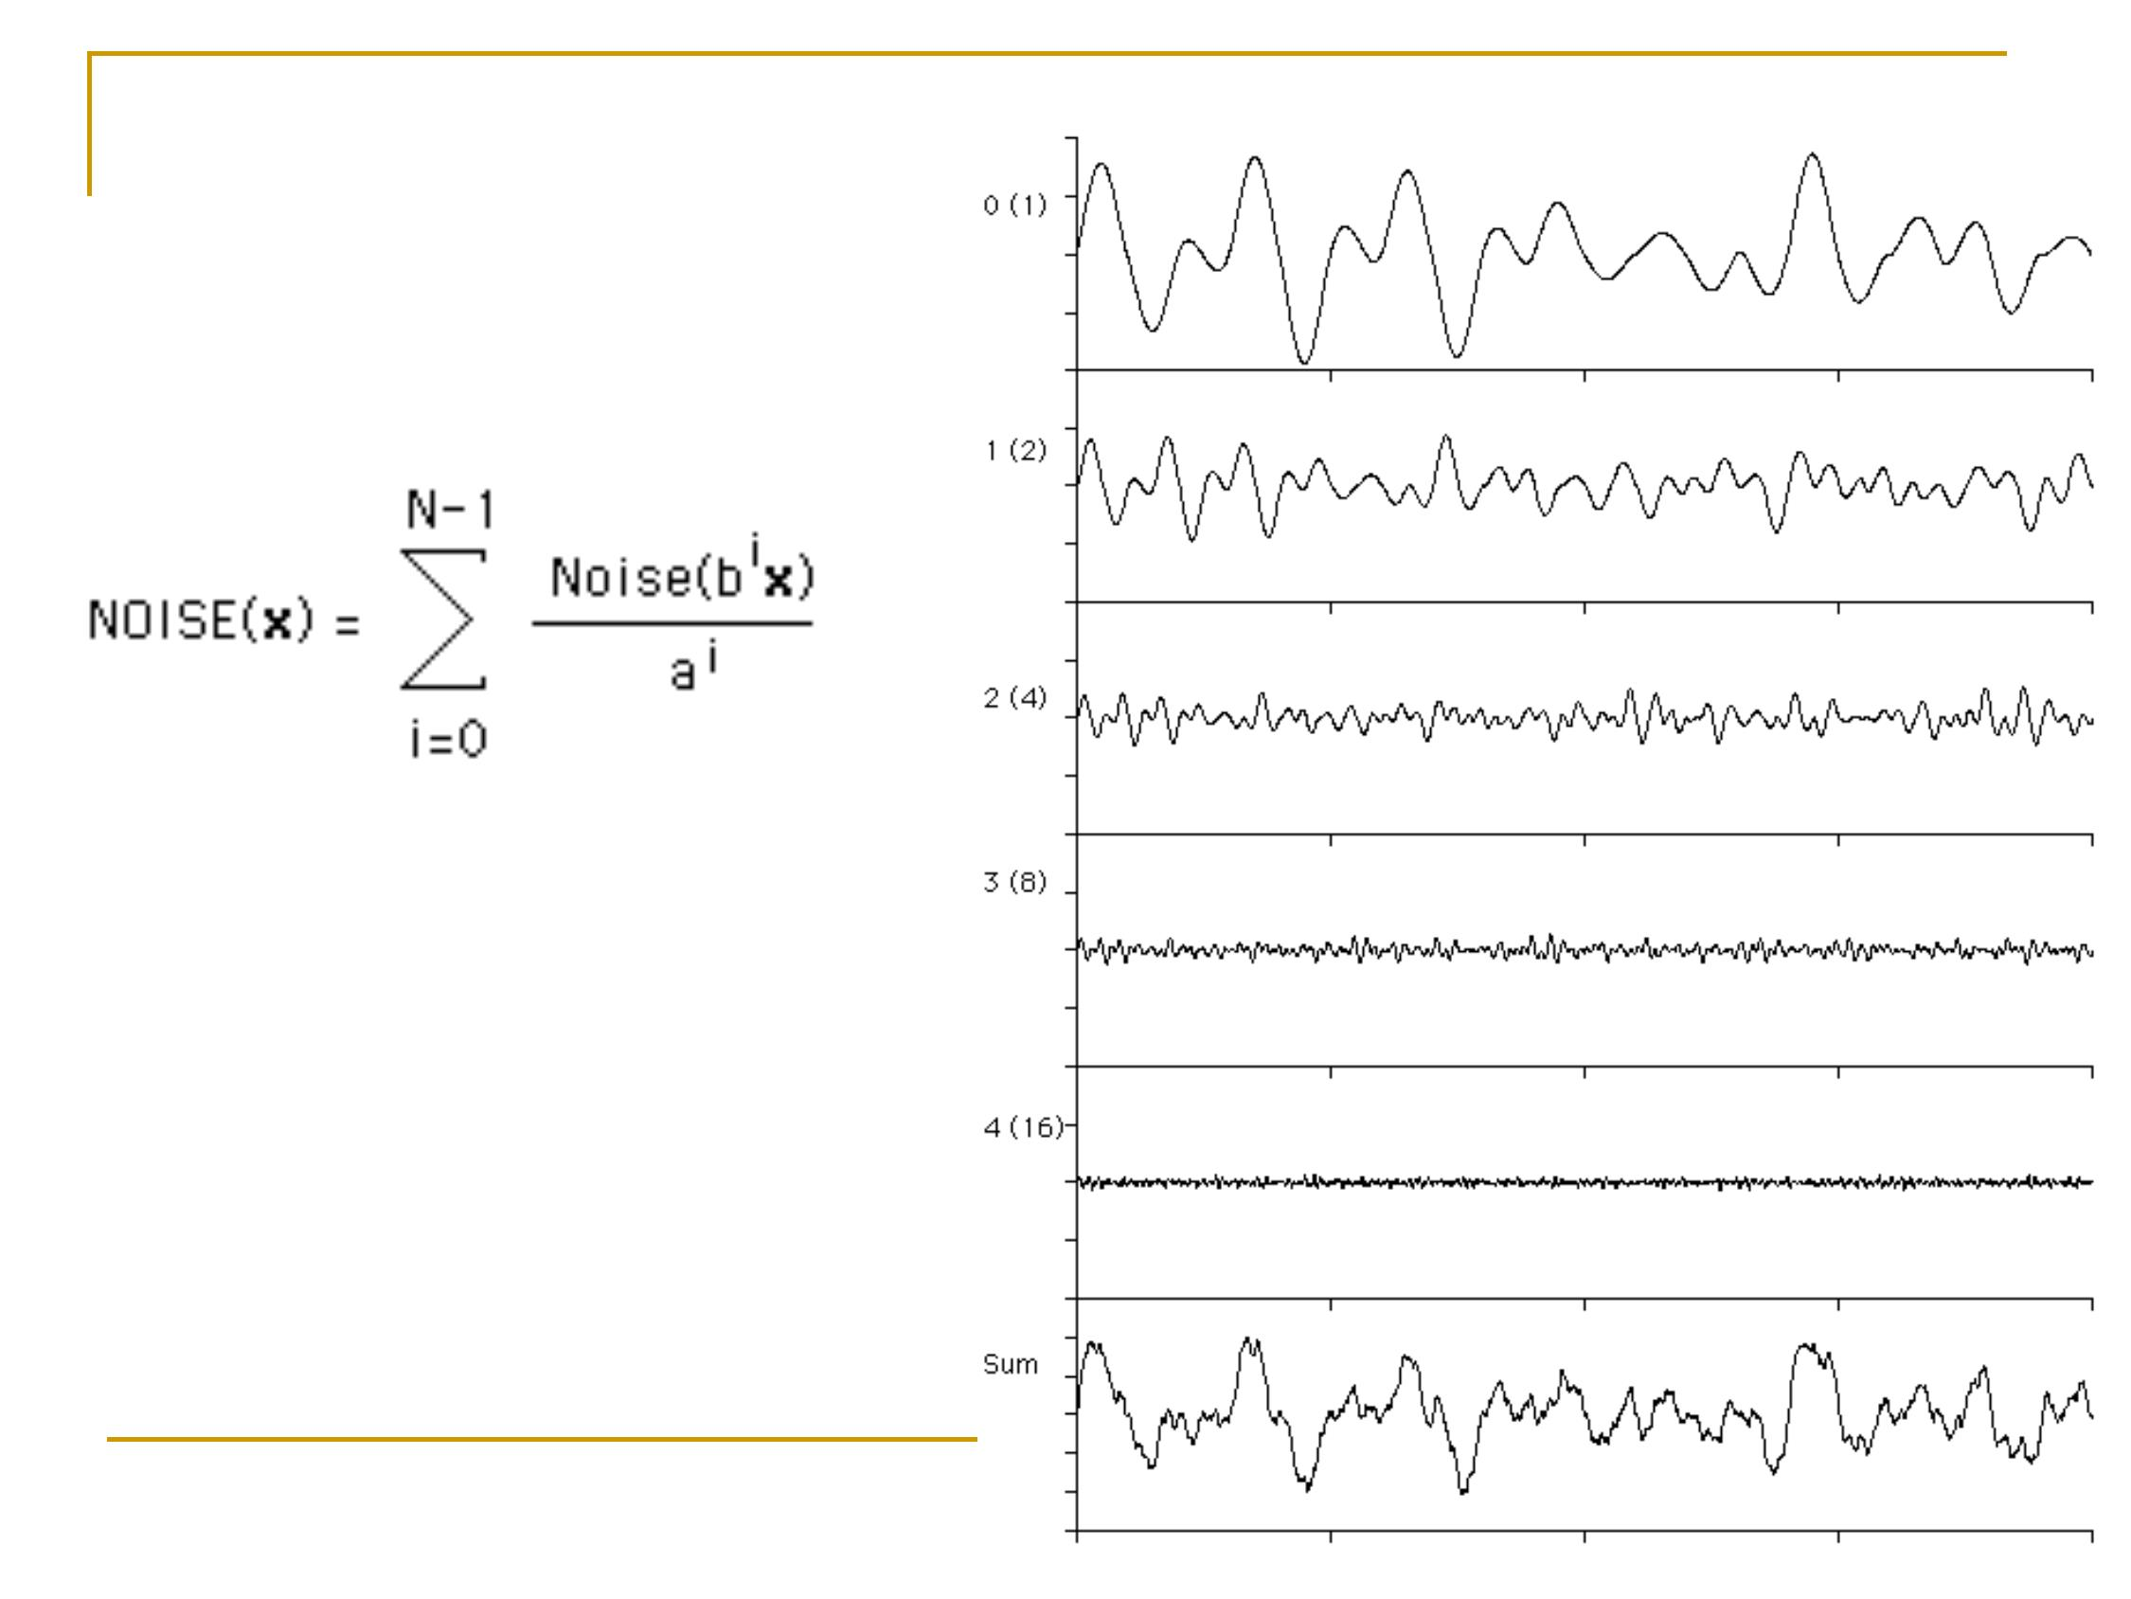
Alternate formula
Fall 2012
34

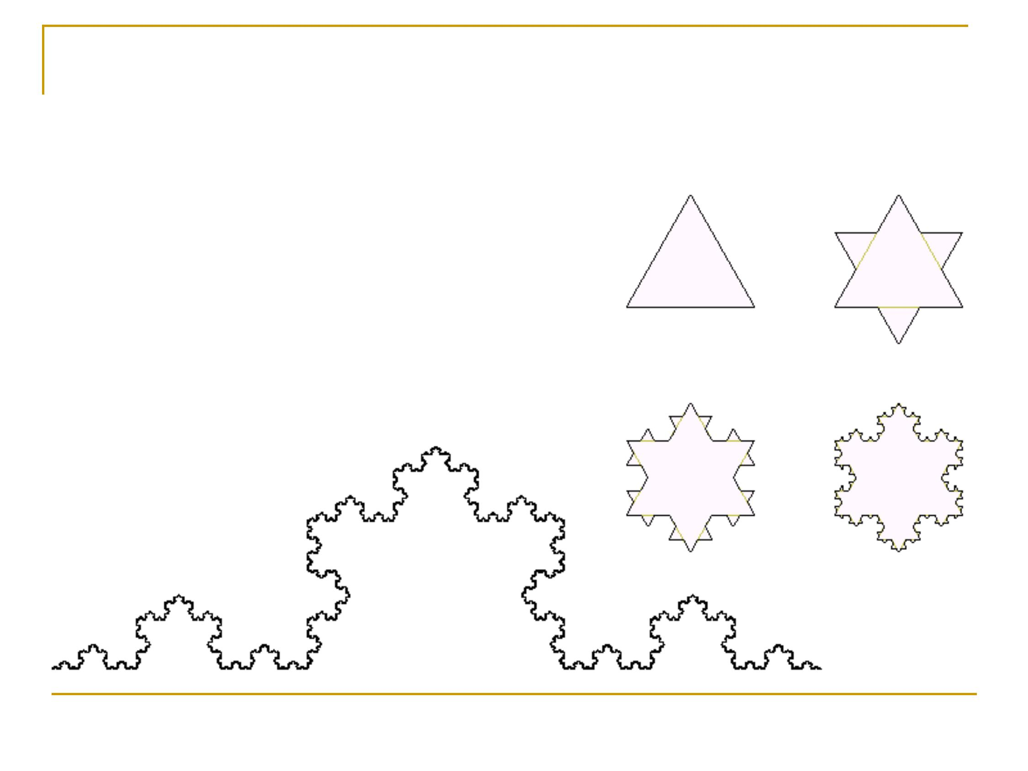
Fractal Geometry (Koch)
Koch curve
Fall 2012
35

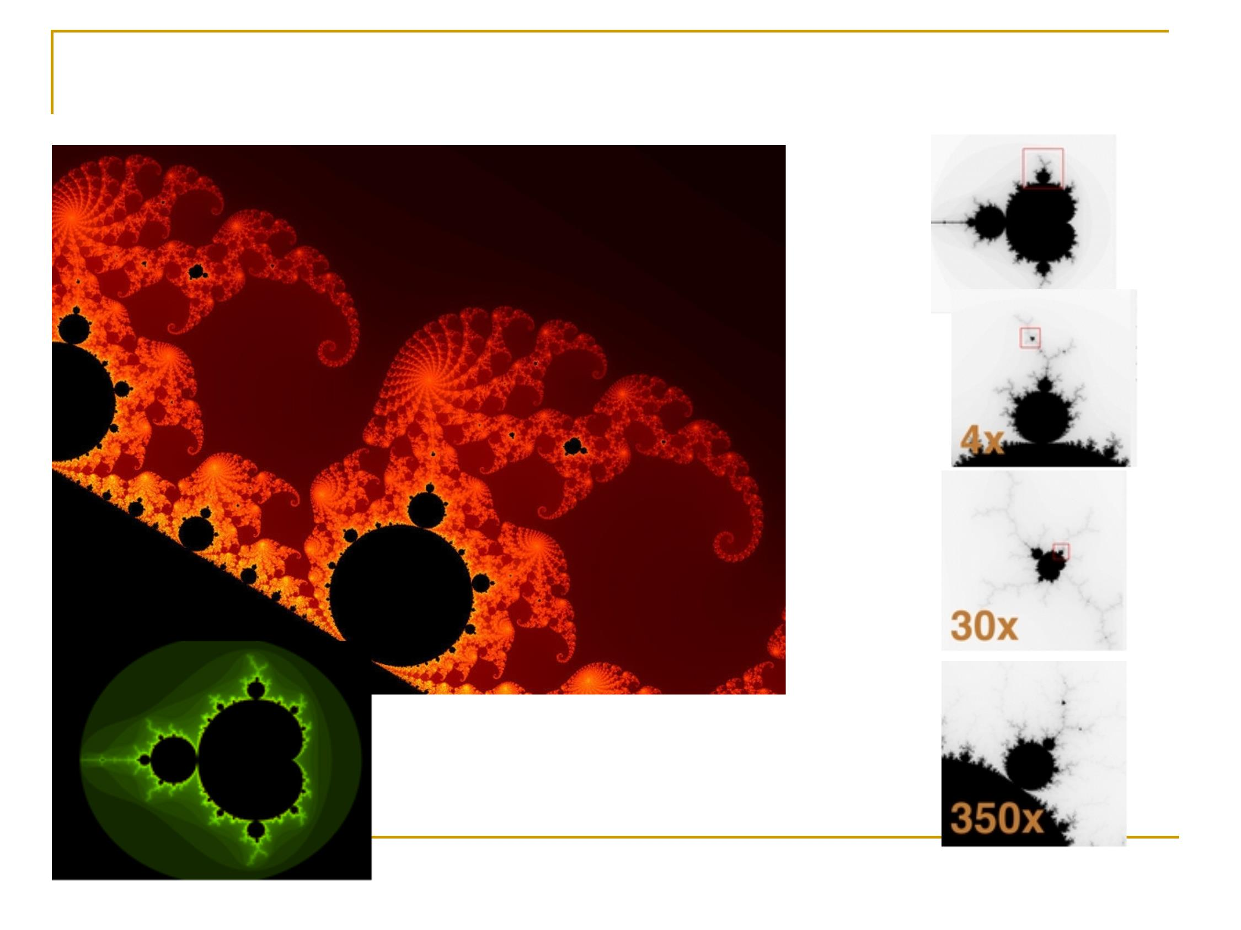
Fractal Geometry (Mandelbrot
set)
Fall 2012
36

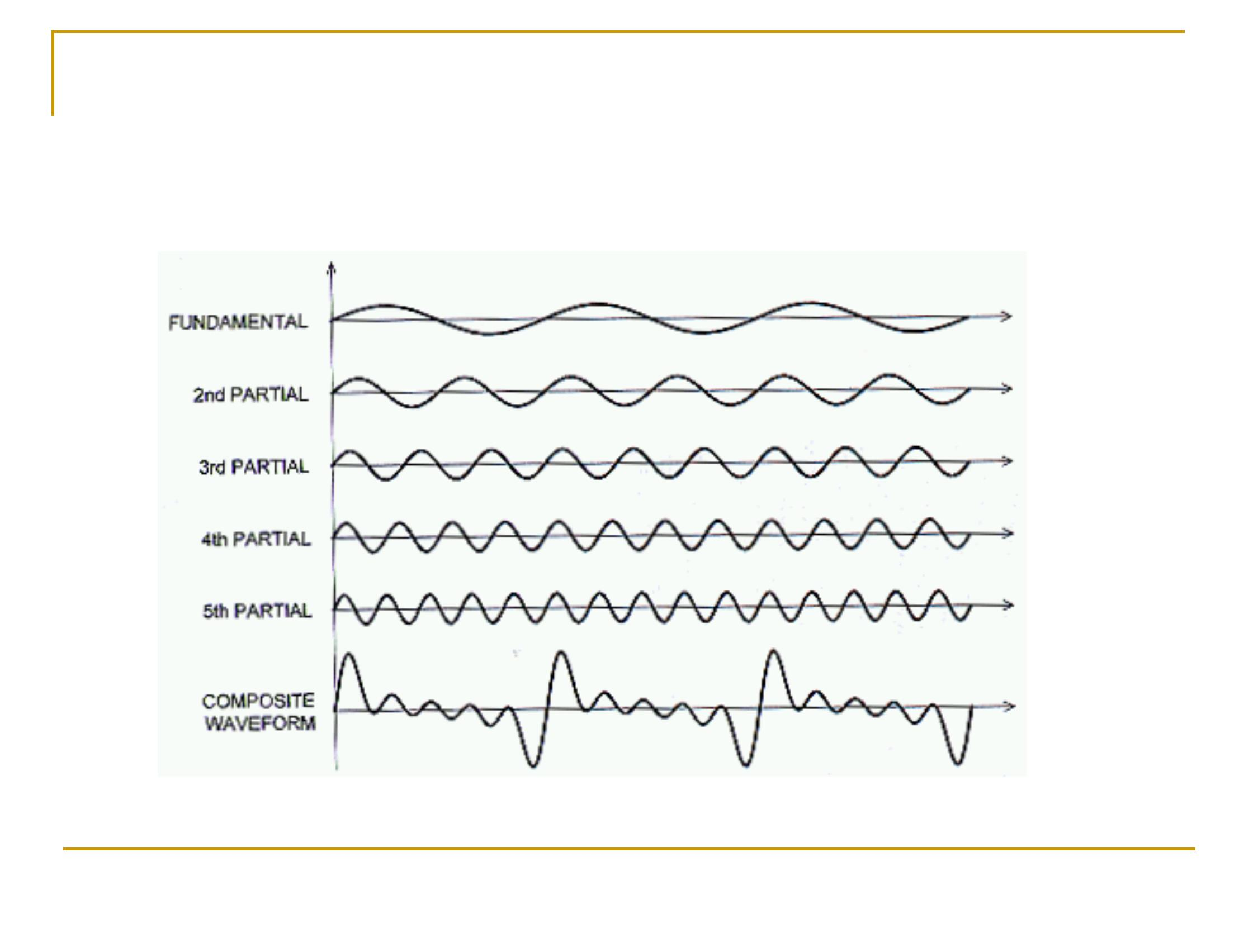
Fourier Analysis
Fall 2012
37

