Craig Harris
harricra@oregonstate.edu
Project 4: Keytime Animation
Video Link

Description: Using Blender, I modeled a ping pong paddle and a ping pong table. I brought those into OpenGL and set a starting position such that it looked as though the two paddles were ready two swing at a ping pong ball on opposite sides of the table. I set the colors within OpenGL and each object has just that one color as I haven’t played with textures yet. A light is set to be above the ping pong ball.

Using the Keytimes class, I set up the Keytime objects, init’d them, and set up the keytimes such that the animation looks like the ping pong paddles volley the ball a couple time until one paddle pulls a sneak shot, the other paddle attempts to throw its paddle but misses. The light using keytimes to follow the z coordinate of the ball along the table. The gluLookAt eye position rotates based on keytimes so that we are always look from the side of the paddle currently hitting the ball. When the ball is hit, it briefly turns red and transition back to white. When a paddle hits the ball, that paddle’s red or blue saturation maxes out (depending which paddle it is). When paddle is not in its hitting animation, it is wavering along the x, y, z axis.

Note that I modified the keytimes class so that I could add a parameter “linear” so that no slope would be added to the generated keytimes if desired. This is used on the ball movement.

Animated Quantities: Noted here are all the quantities fulfilling the requirements along with 8 additional quantities to fulfill the extra credit criteria. Each of these quantities have at least 6 keytimes.
- Light position Z (required lighting)
- Lookat Eye Position Z (required viewing)
- Ping Pong Ball X (required positioning)
- Ping Pong Ball Color (one quantity affecting the G and B fields) (required color)
- Ping Pong Ball, Y, Z, Ping Pong Paddle (#1) X, Y (4 more quantities of choice)
- Ping Pong Paddle (#1) Z, Rotation, Color, Ping Pong Paddle (#2) X, Y, Z, Rotation, Color (E.C. Fulfillment)

Screen Shots:
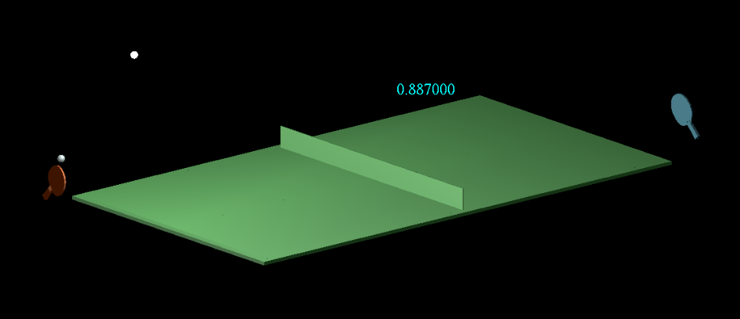
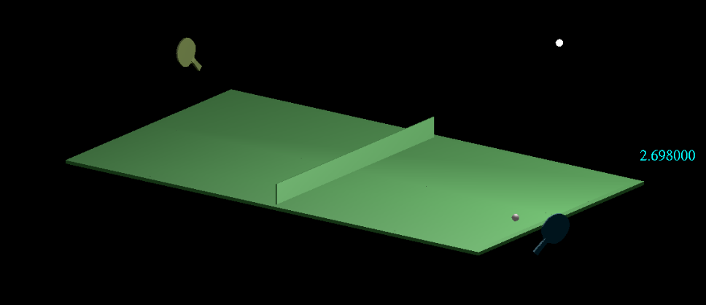

Tell us what convinces you that your animation is indeed doing what you set it up to do.
- The animation is a decent attempt at doing as described in the first section. Some of the bounces don’t look very real but maybe there was some spin on the ball. Basically the ball looks like it’s getting hit by swinging paddles and bouncing along the table.
Keytime values for each quantity: It is OK just to include the lines of code that set them
