Craig Harris
harricra@oregonstate.edu
Project Final: Legend of Zelda Link to the Past, Opening Title Animation
Video Link

- Text From Proposal
My final project will be a recreation of the opening title of the 1991 video game The Legend of Zelda: A Link to the Past. The original opening title can be viewed here (0:03 to 0:23, specifically). My interpretation will not try to imitate the pixelated look, but have a high resolution with sharp edges. Getting this looking really great is not a small undertaking at my current skill level, but a working project which utilizes many of topics learned in this class is doable within one week.

Class topics and their possible utilization:
- Keytimes will be crucial in handling the events such as the triangles’ rotations and final position, the sword dropping, and the sparkles glinting on the “Zelda” text.
- OpenGL lighting will be used to light the objects.
- Textures could be utilized on the castle and hills in the background.
- At the time of writing, I haven’t done anything with shadows or shaders but I would like to utilize both. The shadows will help to create the feeling of depth (especially around the “Z” and the sword). A shader could be utilized in the water portion at the lower half of the frame— maybe by mirroring the top part of the background and running it through a shader to give it a “watery” effect.

Timeline (Very Rough):
- Day 1: Create and import rough draft 3D models of triangles, sword, castle, background, text using Blender. Mostly for location purposes.
- Day 2: Add lighting and carve out the keytimes.
- Day 3: Add shadows.
- Day 4: Add textures.
- Day 5: Add shader for water effect.
- Day 6: Update blender models and import.
- Day 7: Polishing.

- What You Actually Did for Your Project
Generally, I did what was described in the proposal: I recreated the opening title of The Legend of Zelda: A Link to the Past in OpenGL.
- I modeled the triforce piece, text, sky, and sparkles from scratch. I pulled in and modified the models for the sword and castle. The mountain terrain, hills terrain, and water are all created within the code.
- Textures were applied to the sky and castle.
- Coloring and lighting is mostly handled through the vertex and fragment shaders.
- Models’ movement is all handled using Keytimes objects.
- Some additional lighting effects (gleam on the sword, specifically) utilizes Keytimes as well.
- The water movement is handled in the vertex, geometry, and fragment shaders.

- How your project differs from what you proposed, and why
- There were several methods I had hoped to implement but ran out of time. Most notably, my final product does not include shadows or reflections on the water.

- (optional) Any impressive cleverness you want us to know about
- I’m not sure this is “clever” or just “hacky”: The biggest hurdle was getting the water to look “watery”. To do this, I created a flat plane made of triangle strips and applied a pseudo-random y variable to each vertex based its x and z position and the animation time. The real trouble came from getting the lighting to look correct. As it was, each triangle had three vertices with identical normals perpendicular to the triangle’s plane. This made the triangles clearly visible in the render. After many attempts, I ended up learning how to use the geometry shader (not covered in this class) to get the average normal for each vertex’s shared triangle. I’m not sure this is the most efficient method, but it is working.

- What you learned from doing this project (i.e., what you know now that you didn't know when you started)
- Before starting this project, I didn’t quite understand shaders. Especially the geometry shader, which was not covered in the class.
- I learned more about the parameters for glOrtho and glPerspective to get the window property 16:9
- I learned a lot about texturing, and texturing using shaders.
- Using Blender to edit/create the models had many learning moments.

- Some images that are especially representative of what you did

Triforce pieces rotating in
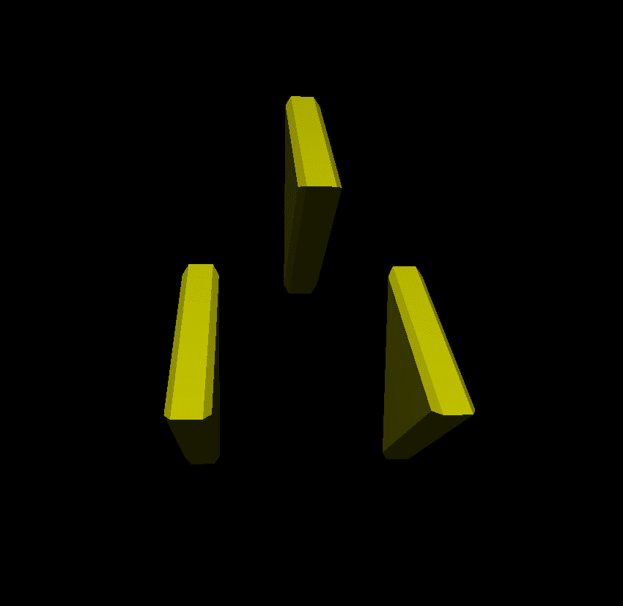

Flashing effect – The screen background goes R->G->B-> Black a couple times for impact when the sword drops
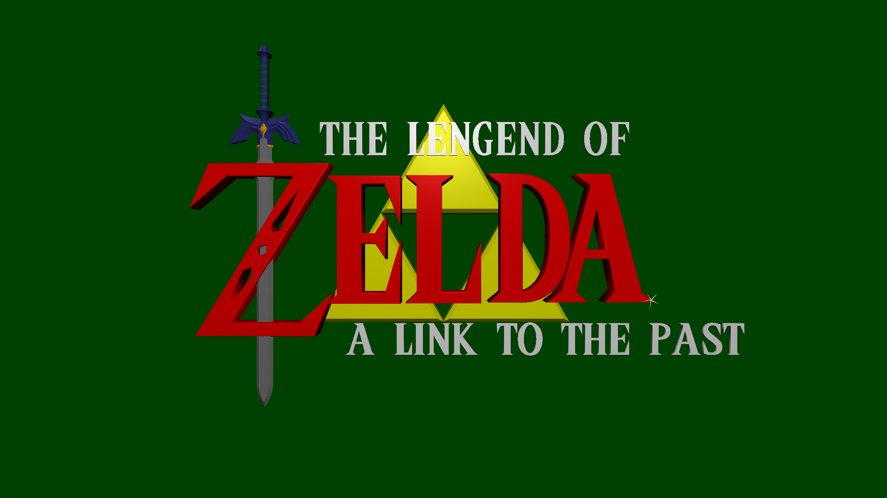

Final Shot
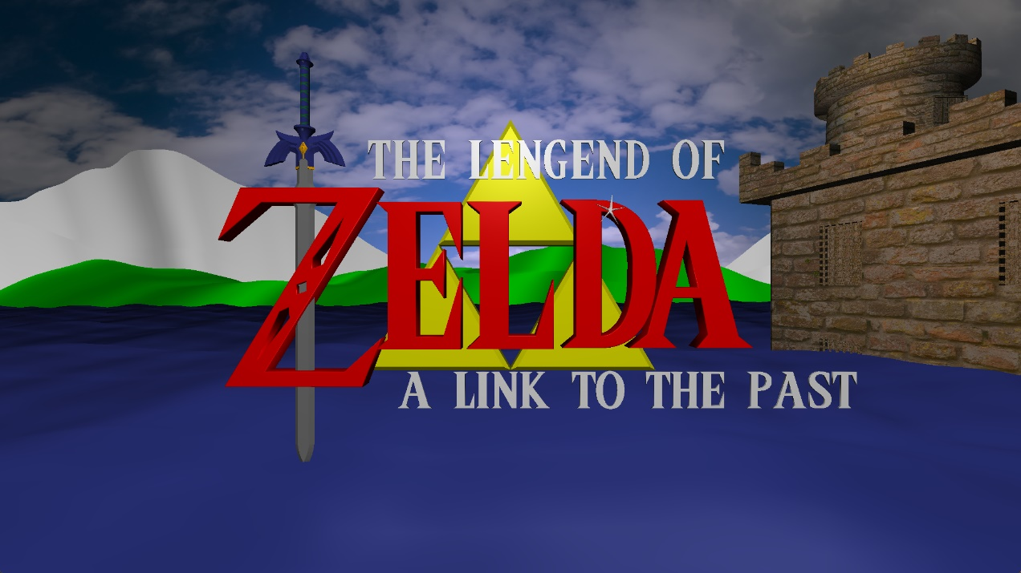

Sparkles


Gleam on sword – It’s difficult to grab a screenshot but watch for a light running down the blade.
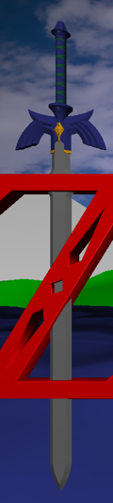

Mountain, Hill, Water, Sky
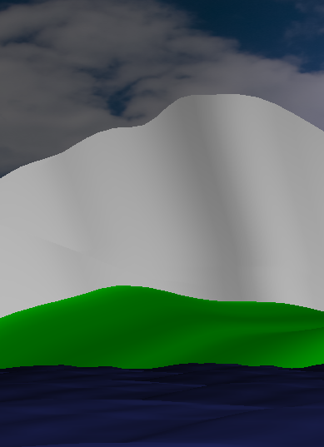

- Improvements for next Iteration
- Utilize more textures (color textures, normal textures, displacement textures)
- Implement shadows.
- Implement water reflections.
- Implement water refraction.
- Textures for castle and sky should fit theme of the rest of the objects.

