Craig Harris
harricra@oregonstate.edu
Project 4: Cube Mapping Reflective and Refractive Bump-mapped Surfaces
Video Link

Description: The vertex displacement and noise bump map features of project 3 are present in this iteration. The lighting is removed and replaced with the cube mapping technique which allows for the quad to act as a refractor and/or a reflector. In another shader, the same textures that are used for the cube map are applied to quads placed as walls/floor/ceiling so that the reflections/refractions on the object have context. The refractions/reflections do not rely on the walls being present. The reflection and refractions interact with the displacement and the bump mapping as one would expect in a real object. This is done by taking into account the eye vector, the normal vector, and the index of refraction. Note that in the video, you will see a uIndexOfRefraction variable. This is used in the refract function as refract(eye, normal, 1. / uIndexOfRefraction). So from the perspective of the viewer, the refraction is as if the light passes through air, and the object has uIndexOfRefraction. This is the reciprocal of how the spec outlines the behavior but is also functionally correct for this particular scenario.

Screen Shots:

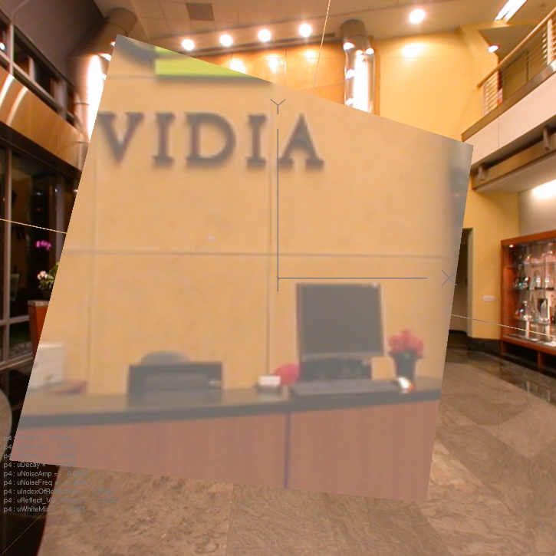
Refraction, No Vertex Displacement, No Noise

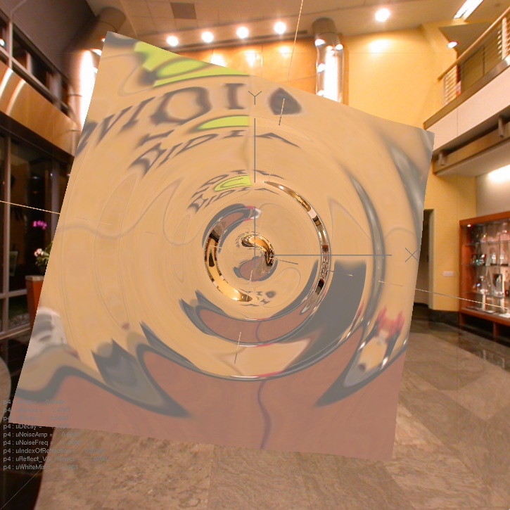
Refraction, Vertex Displacement, No Noise (some total internal reflection)

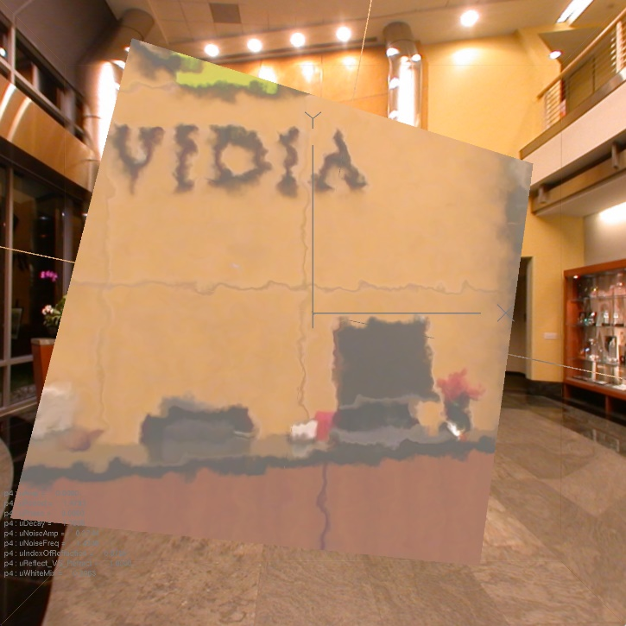
Refraction, No Vertex Displacement, Noise

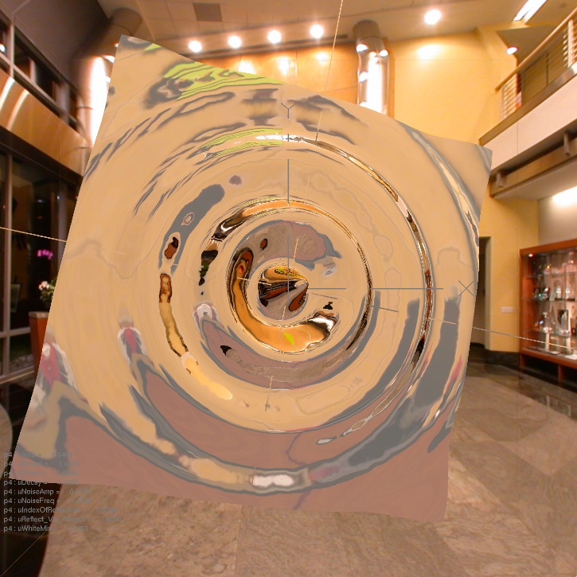
Refraction, Vertex Displacement, Noise (some total internal reflection)

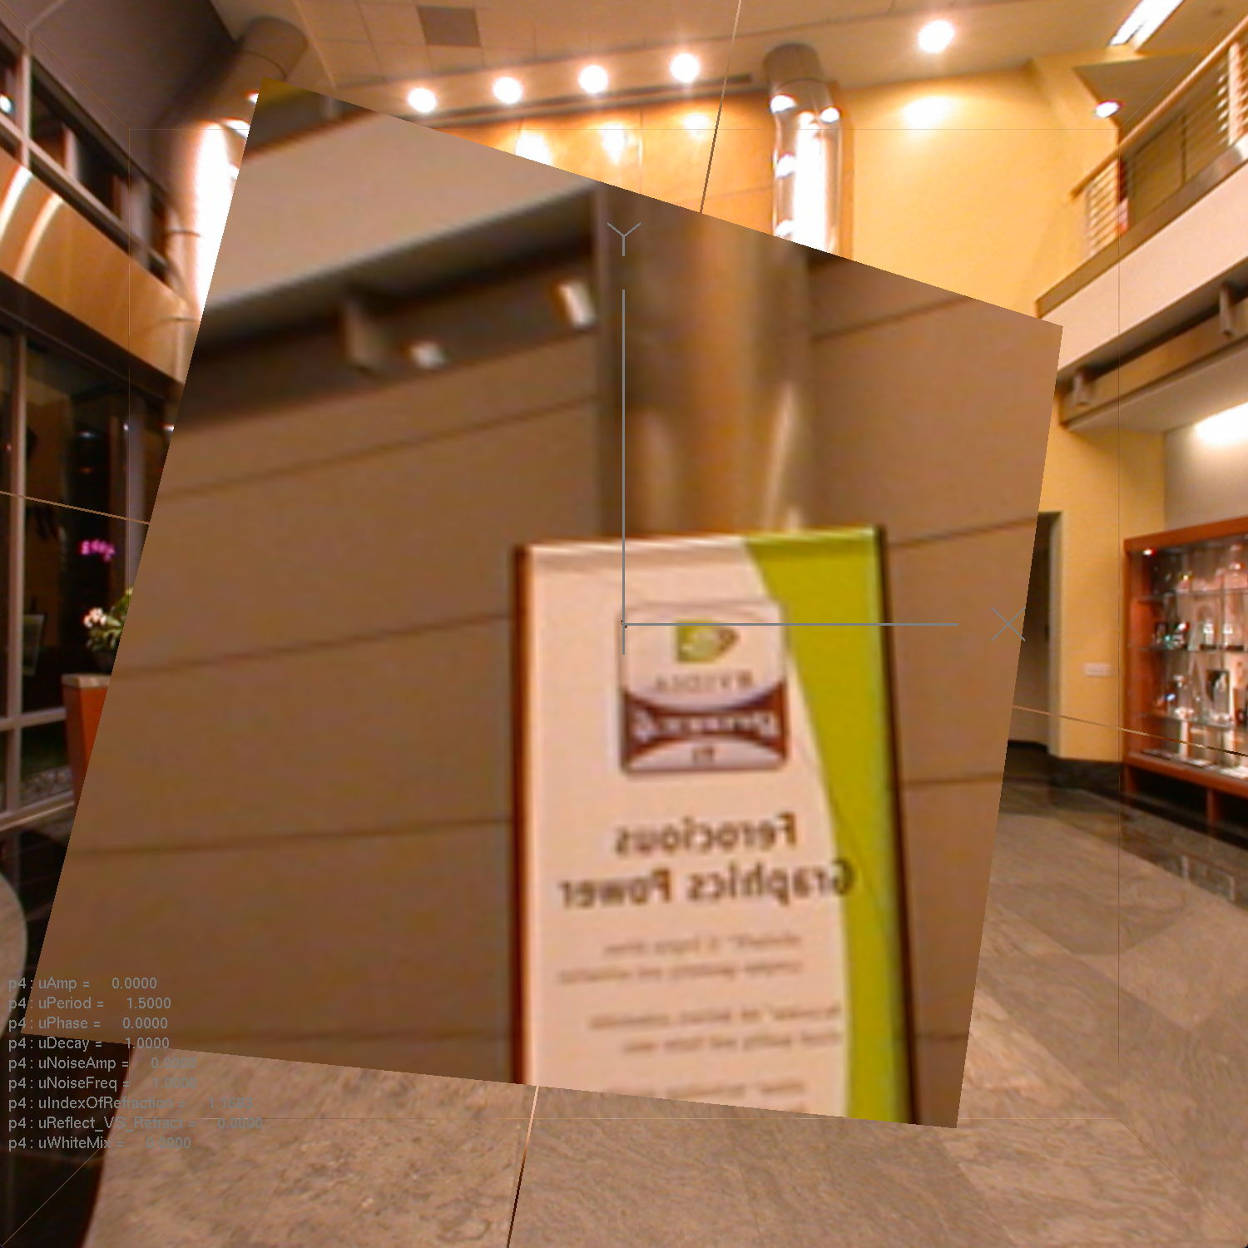
Reflection, No Vertex Displacement, No Noise

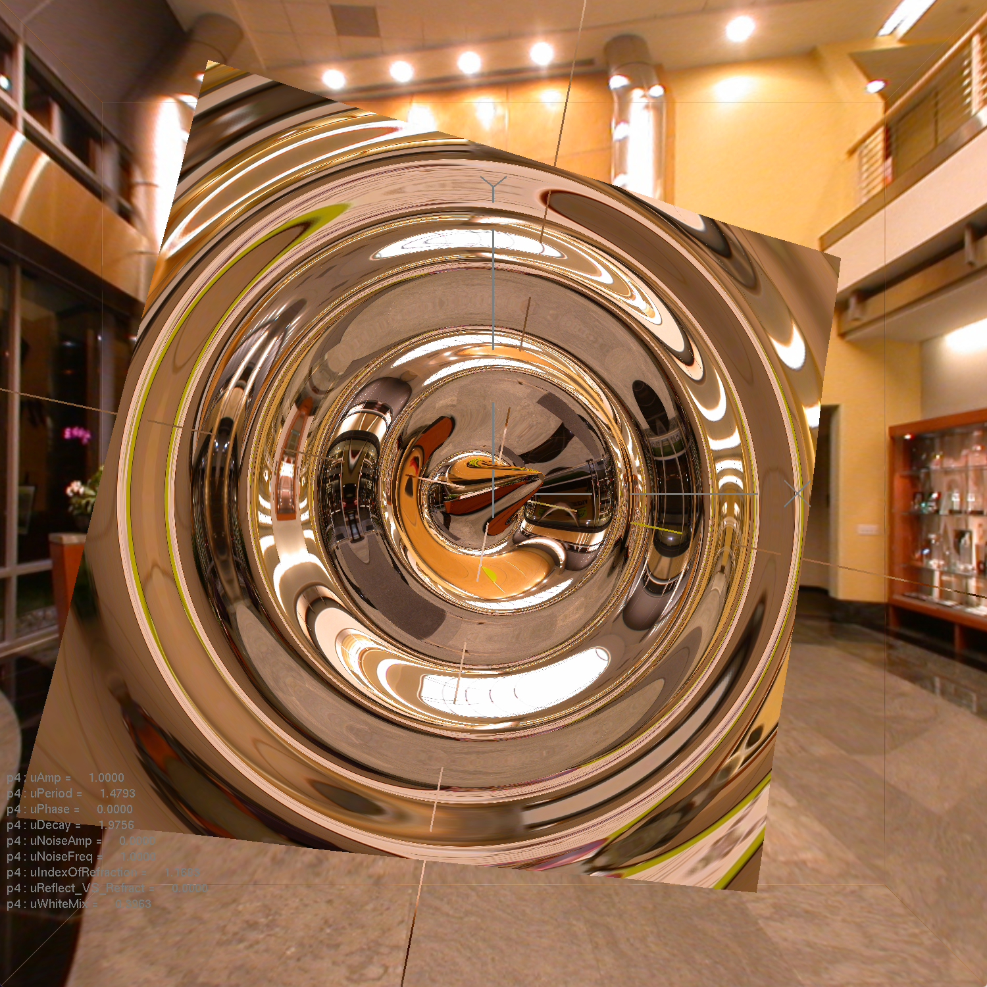
Reflection, Vertex Displacement, No Noise

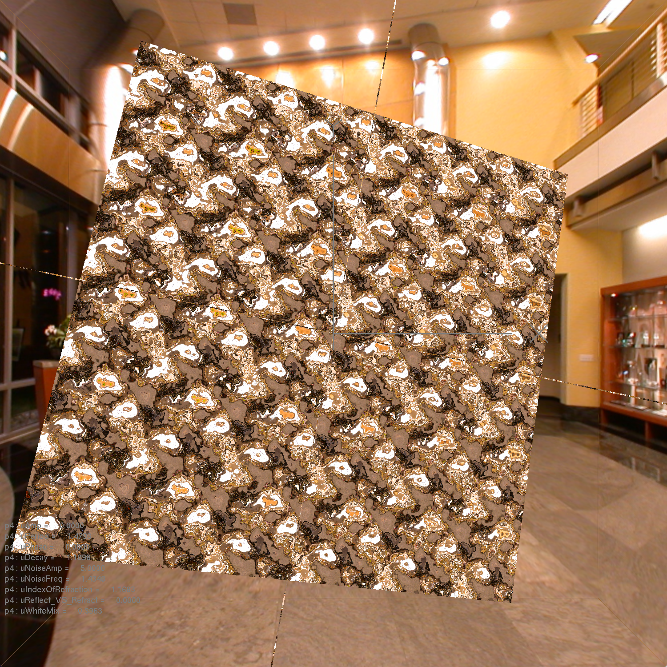
Reflection, No Vertex Displacement, Noise

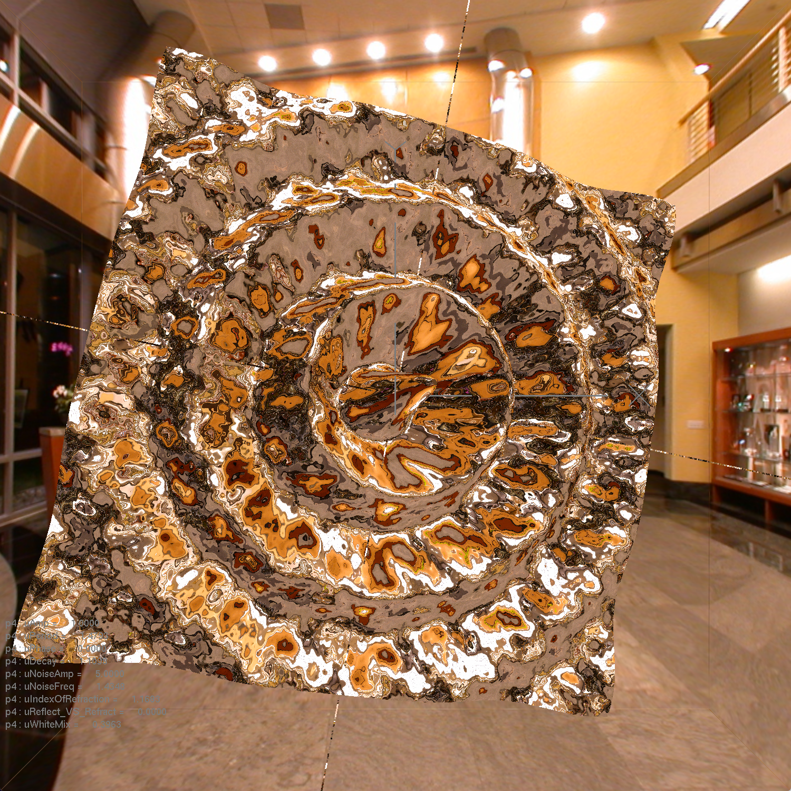
Reflection, Vertex Displacement, Noise

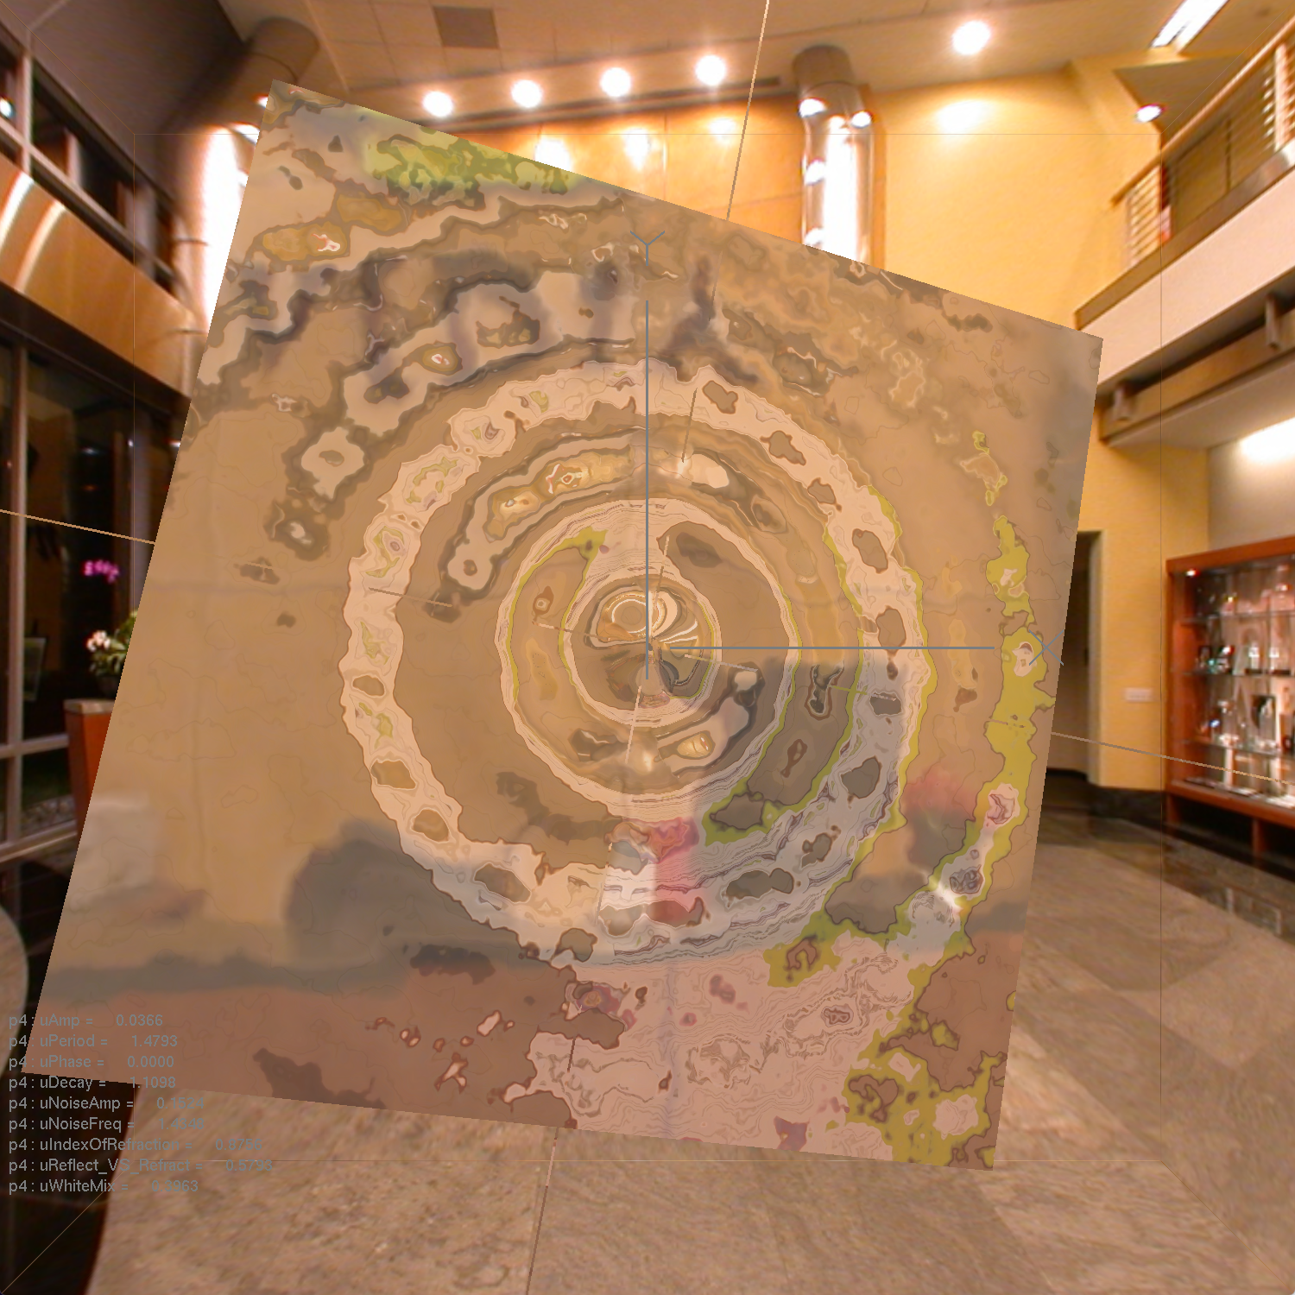
Reflection mixed with Refraction, Vertex Displacement, Noise

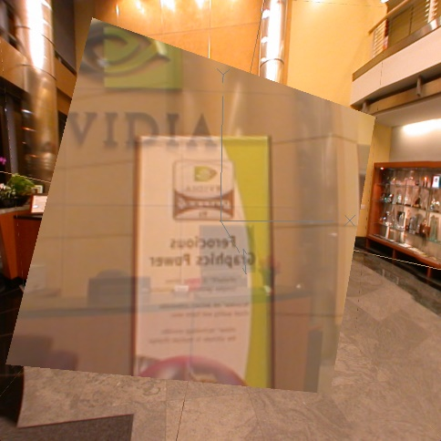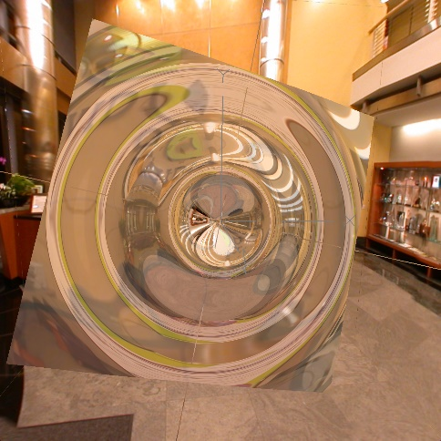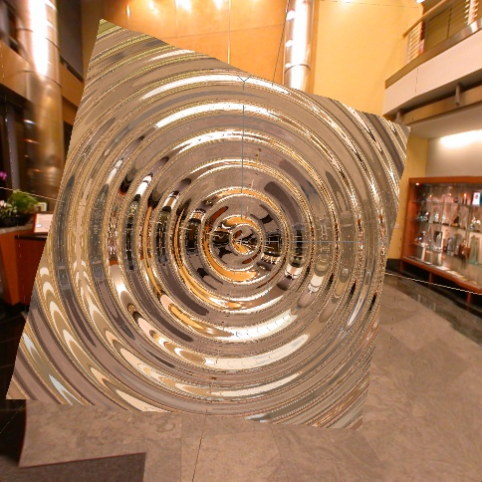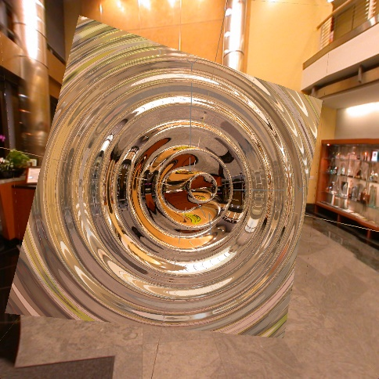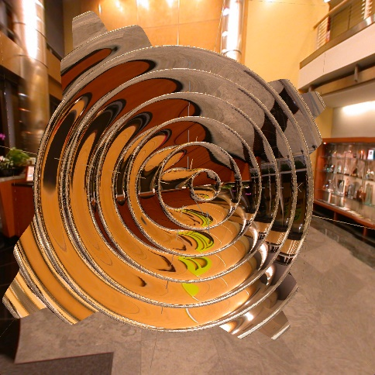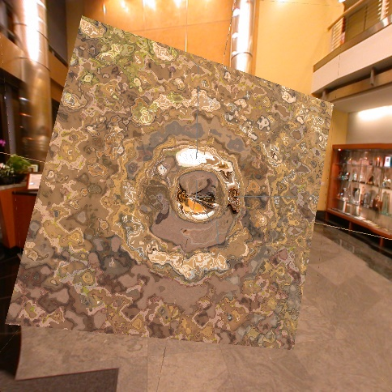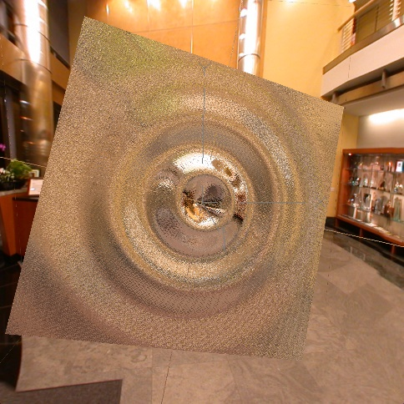
Different values for wave amplitude, period, decay, and noise amplitude and frequency.

