Craig Harris
harricra@oregonstate.edu
Final Project: Chladni Plate Simulation
Video Link

A copy of the accepted proposal is at the end of this document.

Description:
- I began by rewriting the sample.cpp to use GLFW. I wanted to be able to use a GUI slider to quickly experiment with the different variables and could not get that working with glut.
- In the code, several shader storage buffer objects (SSBOs) are set up to represent the sand particles. These hold data such as color, rotation, velocity, and position. The simulation in the linked video uses 128*128*128 = 2,097,152 particles which are updated every frame.
- A quad is set up to represent the plate that the particles will bounce on.
- The plate shader colors the quad with fragment lighting with the ability to toggle showing the Chladni resonances with color and bump mapping.
- The sand compute shader updates each sand particle by checking if the particle intersects with the plate or if it should continue falling. If it intersects with the plate, the normal is used to calculate a standard reflective bounce vector, the amplitude of the resonance and the direction of the normal at the hit position are used to calculate a Chladni resonant vector. These two vectors are added together as the new velocity of the particle. Gravity is applied on each frame as well.
- The sand render shader takes the particles positions as vertices, uses a geometry shader to turn them into cubes, then the fragment shader calculates the per fragment lighting,
- These shaders are set up with uniform variables allowing for the user to change the size of the plate, choose whether to show the Chladni resonance amplitudes (with color and bump maps), change the sand particle size, and modify the N and M inputs to the Chladni function
  - 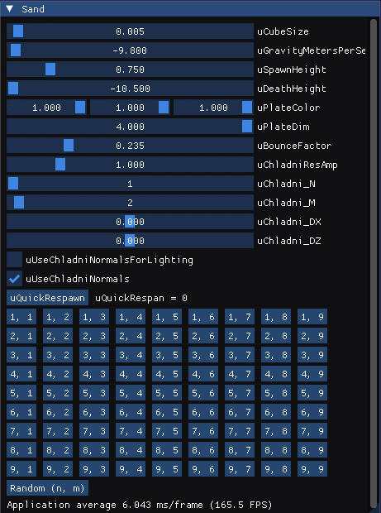
- The Chladni resonance function was modified from this website and this website.
  - cos(n pi x / L) cos(m pi y / L) + cos(m pi x / L) cos(n pi y / L)

Screen Shots:


