Craig Harris
harricra@oregonstate.edu
Final Project Proposal: Chladni Plate Shader

Description: Chladni plates are used to show the modes of vibration on a rigid surface. Activating the resonance was first done by sliding a violin bow across a metal plate, but today it’s typically done by attaching the metal plate to a speaker driver. When sand is covering the top of the plate, and the plate is resonating, the sand falls into the gaps where no movement is occurring (node) as the vibrating part of the plate (antinode) pushes the sand away. When the resonance is changed, the sand flows to the new pattern of nodes/antinodes.

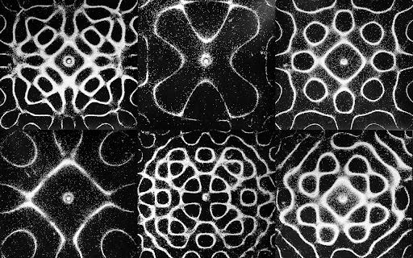
Different patterns created on Chladni plates

Plan: To recreate sand moving in patterns as noted above. There are three main hurtles I see:
- Recreate the pattern in a fragment shader. I have found some equations online that should make this fairly simple. There could be added complexity for adding variability of the shape of the plate (circle, violin, etc) or the point at which the plate is being activated.
- Simulate the depth and imperfections of the system -- the sand groups into piles but is not perfectly within the pattern, some lines are thinner/wider, some sand is still sitting in the antinode area.. This part can likely be done with vertex displacement, noise, and per-frag lighting. I might play with shadows too.
- The trickiest part I would like to implement is the transition between patterns; when one resonance is switched to another, the sand has to move to the new nodes. I’ve purposefully not looked at outside resources yet as I want to attempt this on my own for a bit. I think some sort of motion vector pass could be used. This video shows an example of switching between the resonances.

If that all goes smoothly, I want to look at modifying it for 3 dimensions and adding some sort of color mapping.

