Craig Harris
harricra@oregonstate.edu
Project 6: The Dragon Menagerie Project
Video Link

Description:
- This is a 2-pass process.
  - First Pass
    - Dragon
      - The wing movement is controlled with the timer based on the vertex coordinates (used the find.glib to locate them)
      - The object is lit with a point light really far below to simulate the lava as a light source. I couldn’t get the directional light working so I did it this way.
    - Lava
      - The lava is a quad whose colors are calculated using octave Voronoi noise as the intensity.
    - Cave Walls
      - This is the inside of a sphere with a cave texture applied.
  - Second Pass
    - Heat Waves
      - The first pass render is applied as a texture to a quad after varying the ST lookup coordinates with more octave voronoi noise. The T lookup is animated so that the waves look like they are moving upwards.

Screen Shots:
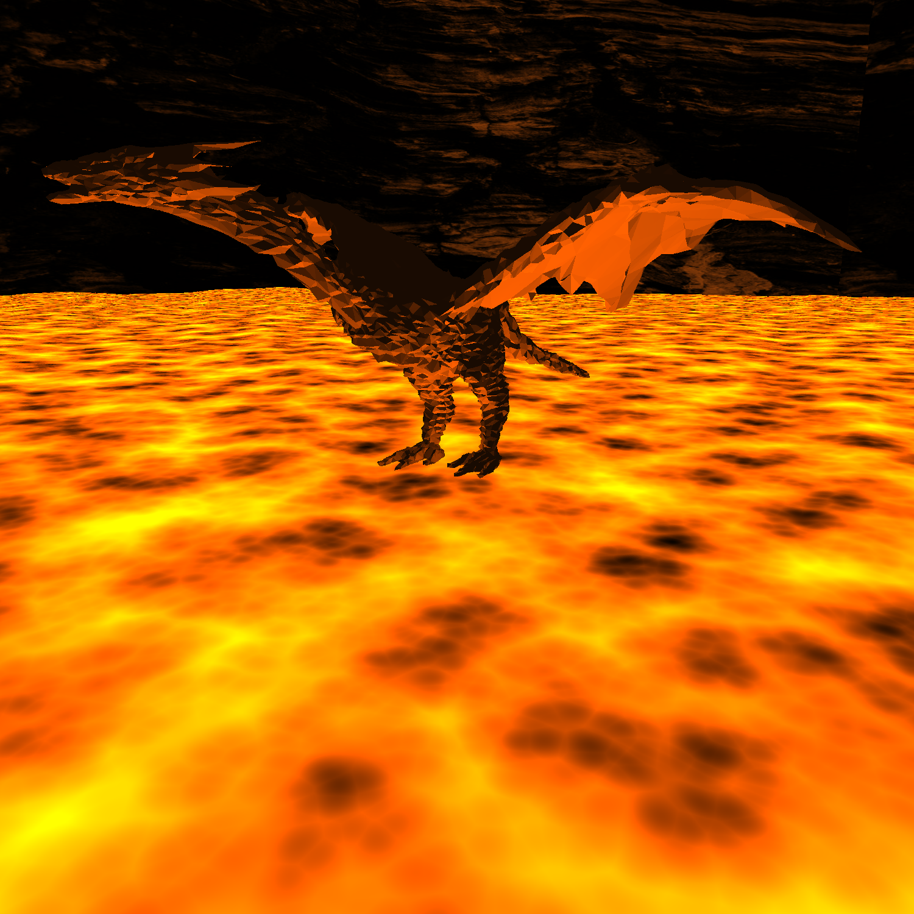
- Note: See the video for heat wave animation.

