Craig Harris
harricra@oregonstate.edu
Project 2: Noisy Elliptical Dots

Video Link

Description: A sphere with elliptical dots on it. The dots can still be turned into ovals with sliders. The edges can be still be softened using a slider. Additionally, noise can be applied to the pattern and the amplitude and frequency of the noise can be modified. You can select whether to use ST or XYZ values for the noise.
It is lit using per-fragment lighting. The ambient, diffuse, and specular lighting variables can be modified with sliders.

Screen Shots:

Amplitude
0.0 0.25 1.0

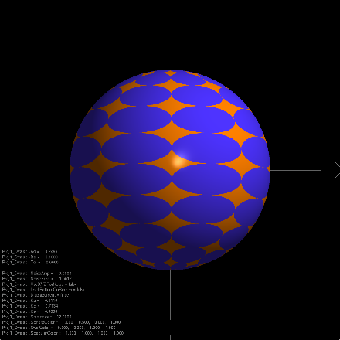 1.0
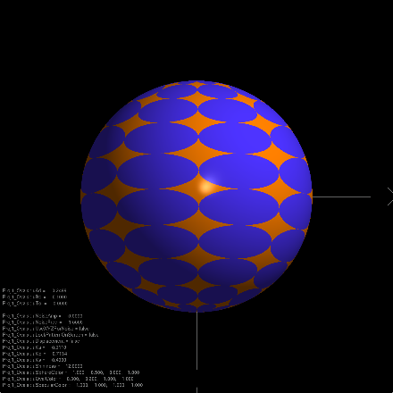 2.5
Fr
equency
10.0
Amplitude increases left->right, Frequency increases top->bottom.
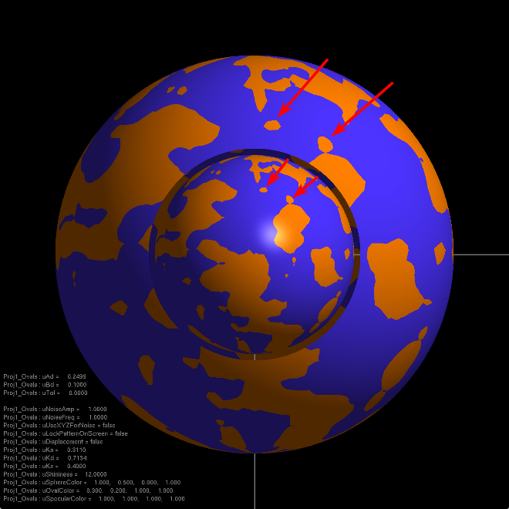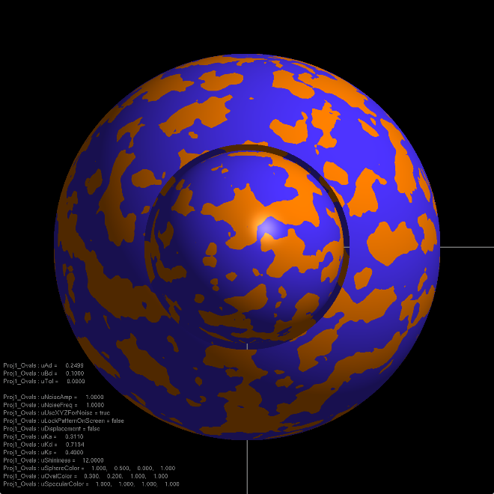
Smaller sphere inside the larger sphere with the large sphere being partially clipped away to reveal the smaller sphere.
Left: S and T are used to generate noise. Both spheres have the same pattern since they have the same S and Ts. Note the two little dots on the top right showing on both spheres, pointed out by red arrows.
Right: X, Y, and Z are used to generate noise. The spheres have different patterns here because the XYZ coordinates generating the noise are different for each sphere.

