Craig Harris
harricra@oregonstate.edu
Project 3: Displacement Mapping, Bump Mapping, and Lighting

Video Link

Description: A quad is generated with a 256 x 256 grid if vertices. The vertex shader displaces these vertices’ z value according to the ripple formula. The normals are adjusted in the vertex shader to account for this change before being passed to the fragment shader. In the fragment shader, A 3D noise texture is used to rotate the normals to create a “crinkled” look to the surface. The fragment shader handles per fragment lighting as is typical after the normal adjustments. Where the screenshots below show no crinkling, the noise amplitude is set to 0.

Screen Shots:

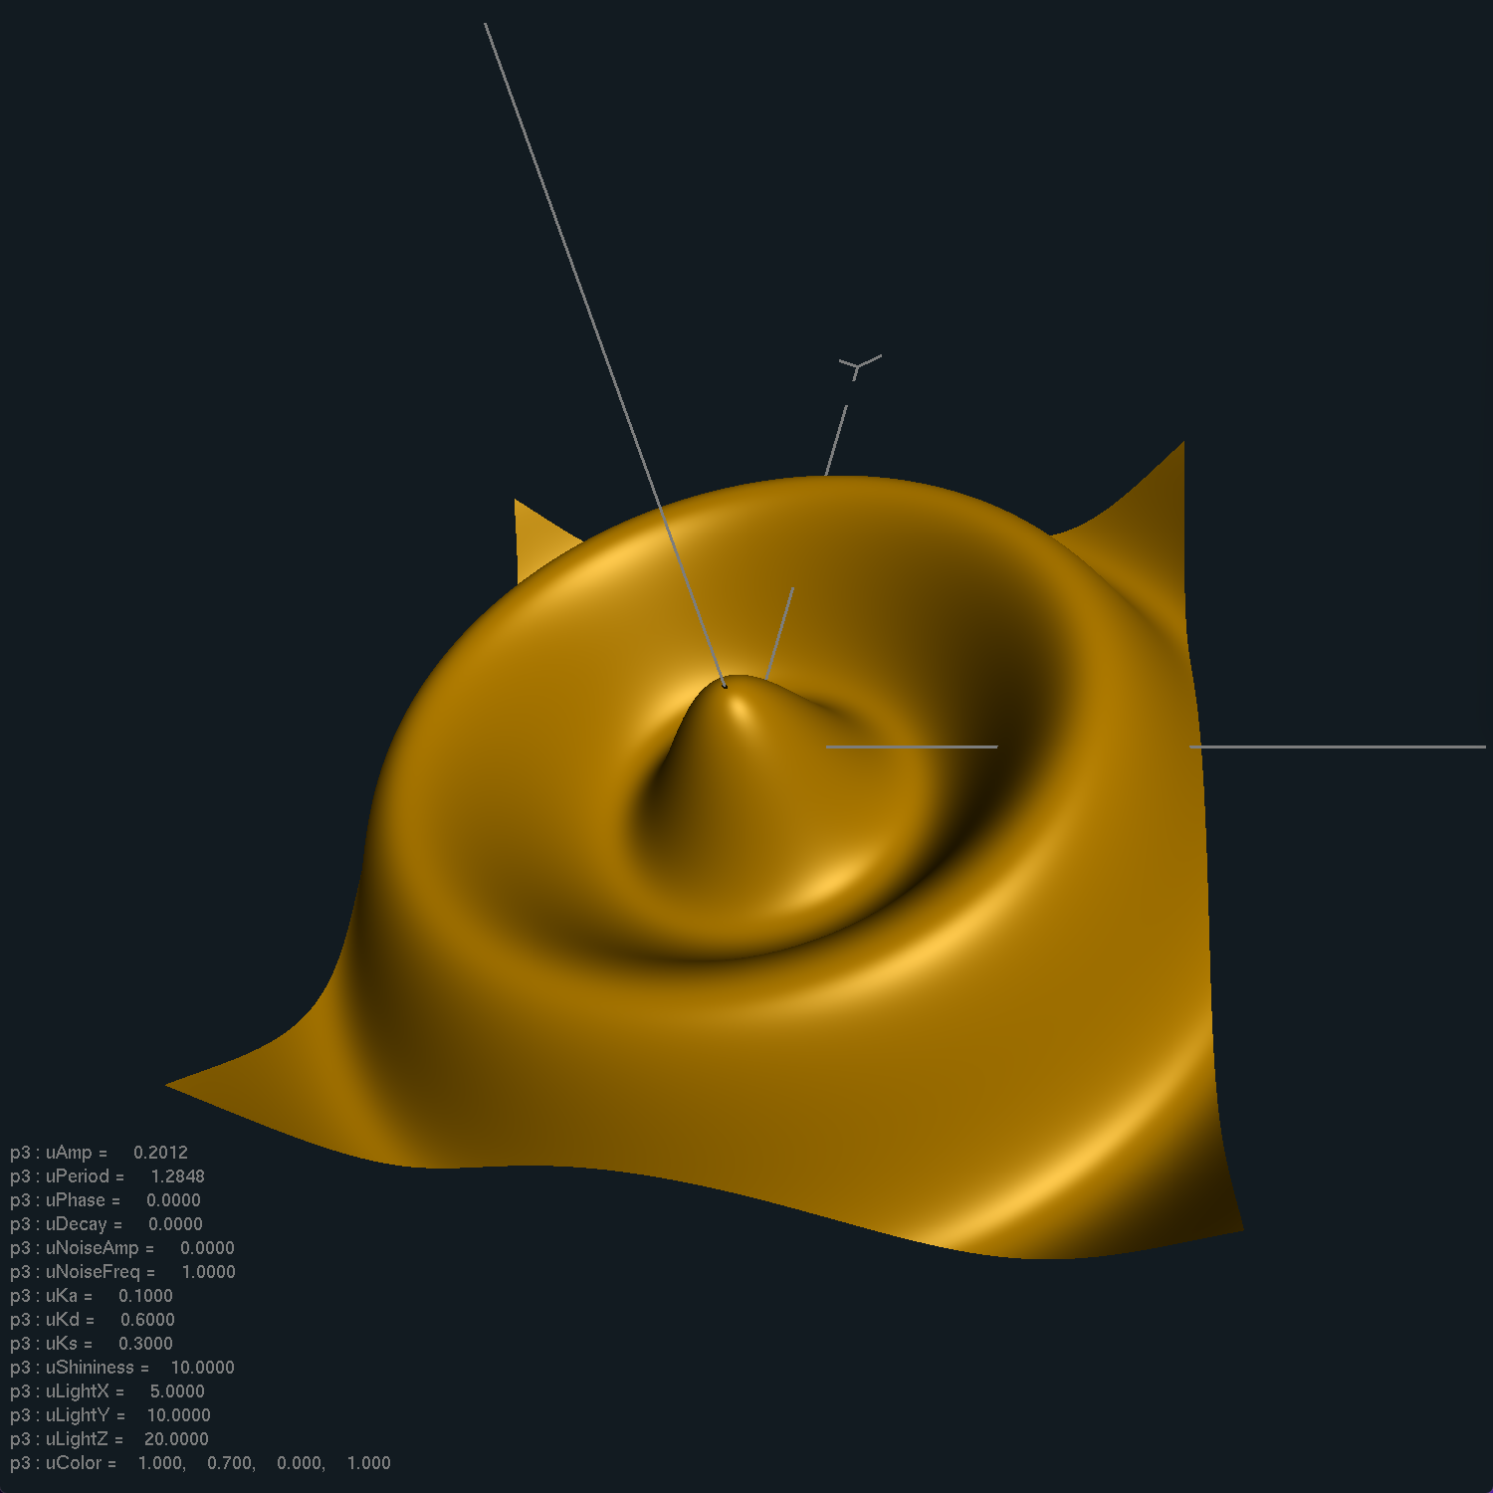
Amplitude changes (A variable)

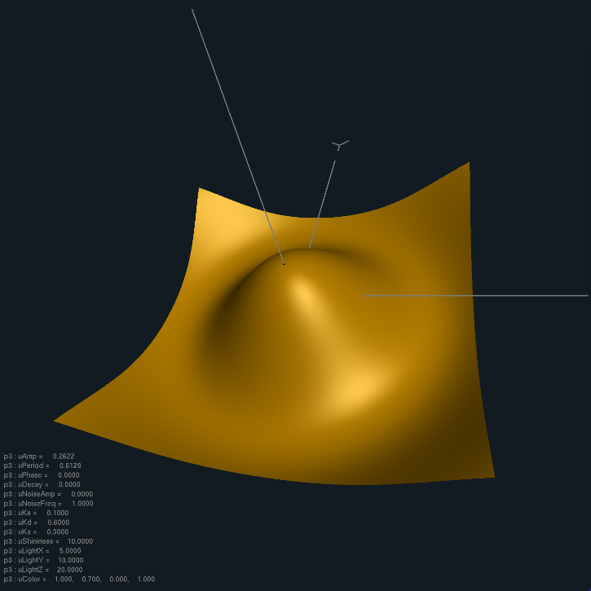
Period changes (B variable)

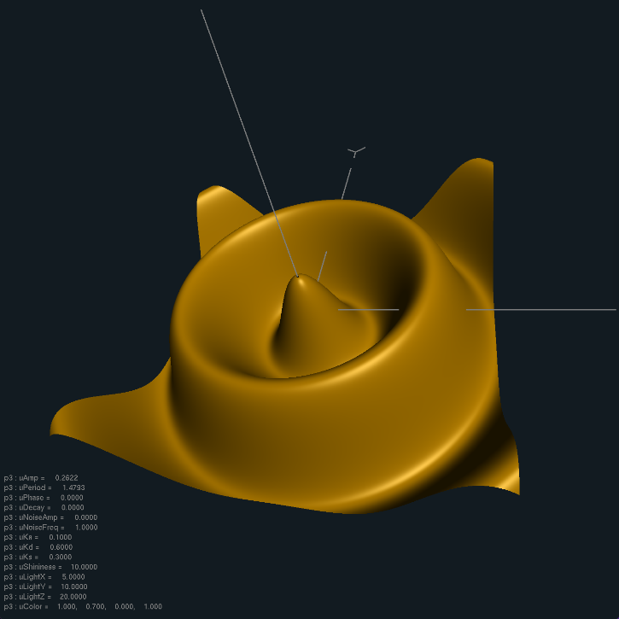
Phase changes (C variable)

Decay changes (D variable)

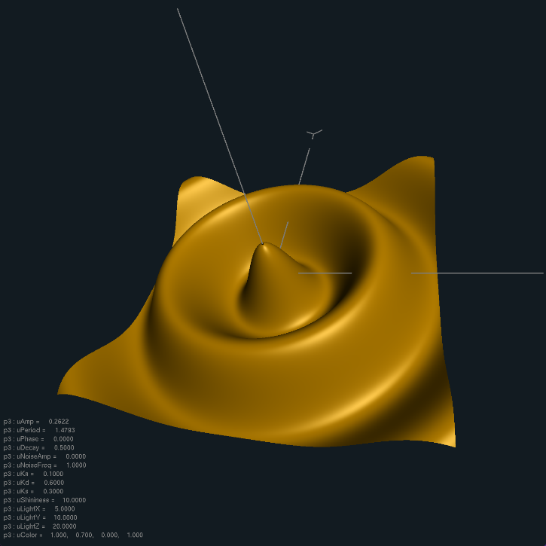
Noise Amplitude changes, per fragment lighting showing displacement-mapped normal are correct and bump-mapped normal are correct

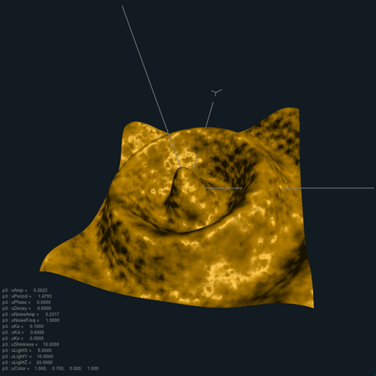
Noise Frequency changes

