Craig Harris
harricra@oregonstate.edu
Project 5: An Image Manipulation "Toolbox"
Video Link

Description: 2 images of the same size are loaded as textures. These textures are applied to a quad. Using the uBlend variable, a mix() function handles how much of each image is applied. The st texture lookup locations are modified to create a fisheye, whirl, and mosaic effect, in addition to blending. In addition to the base functionality specified in the project outline, a brightness slider is added by mixing black with the RGB values, a contrast slider is added utilizing the luminance values shown in the notes, and a checkbox to make the image negative is added by taking vec3(1) - rgb. Another checkbox is added to apply the mosaic before or after the other effects.

For whirl and fisheye, where the texture lookups would be outside the range [0, 1], the pixel is painted black.

Screen Shots:


Image 1 Image 2

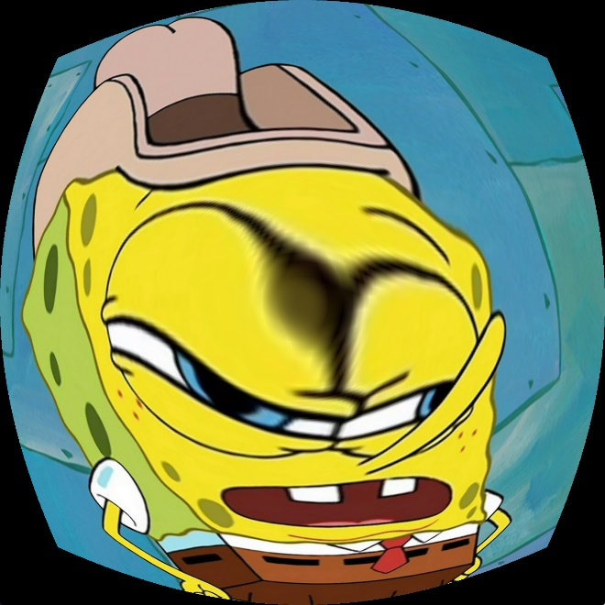
Fisheye Whirl
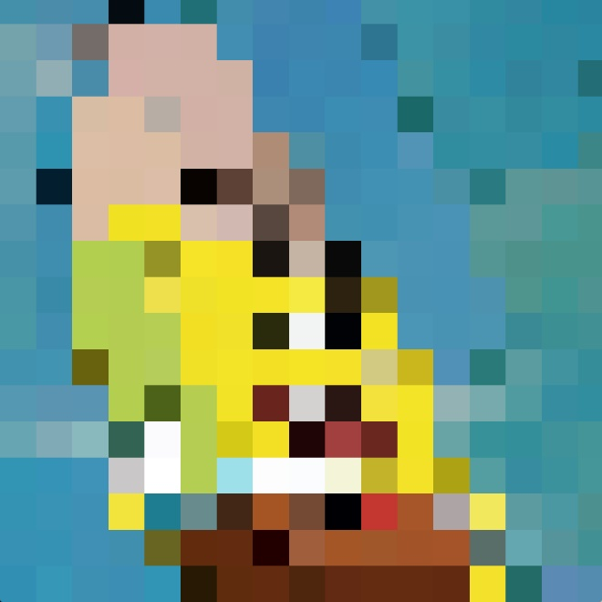
Mosaic Blend

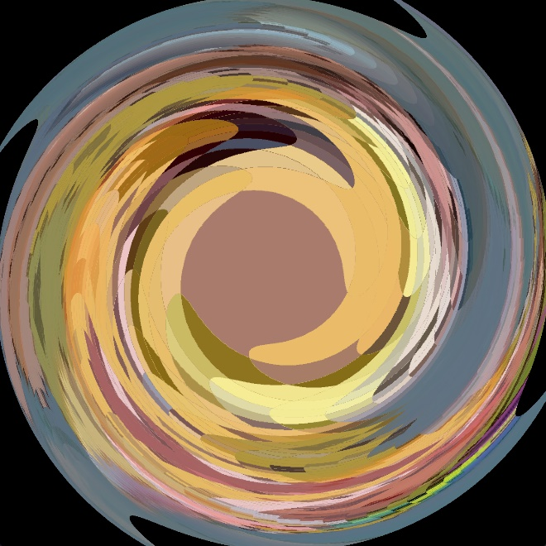
Pre-Mosaic, Blend, Fisheye, Swirl Blend, Fisheye, Swirl, Post-Mosaic

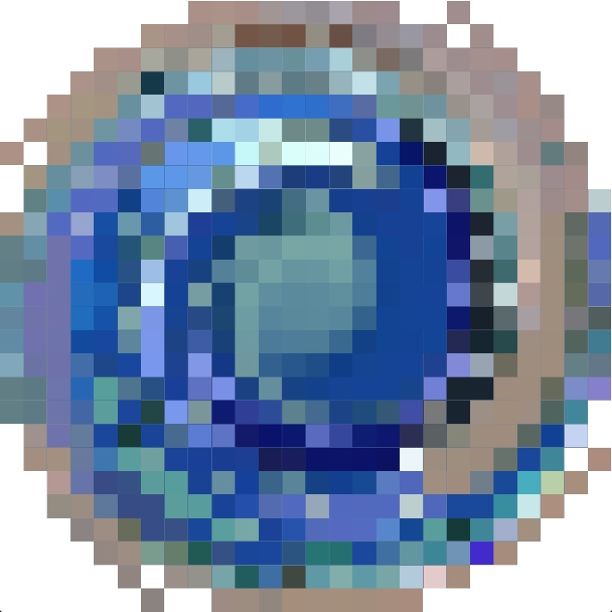
Blend, Fisheye, Swirl, Post-Mosaic, Negative


High brightness High contrast

