**美食论坛——性能测试**

对于美食论坛的性能测试，我们选取了美食论坛最核心的功能——发表帖子这一动作进行测试。

我们用现在常用的性能测试工具loadrunner对这一动作进行测试，具体的测试步骤为：

创建脚本 设置运行脚本的场景 运行场景 分析结果

经过创建发表帖子脚本和设置完场景后，我们点击运行场景，以下是场景运行过程中和结束后的截图，其中我们设置了10个虚拟用户同时进行该动作：

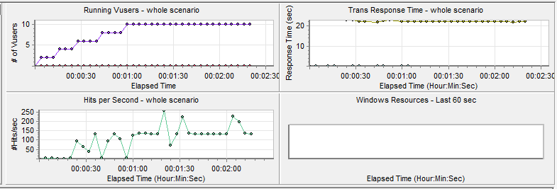

**图一：运行场景时截图**

**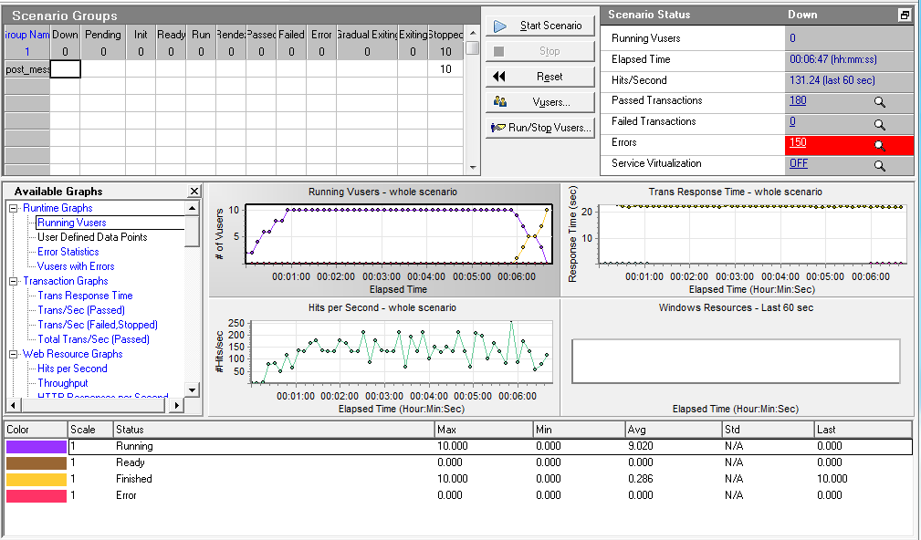图二：运行场景结束后截图**

从图二总我们可以看到，在运行脚本的过程中共发生了150个error，这个数目是比较多的，说明我们的网站性能还有待加强。

而后我们用loadrunner的自动分析工具对该场景进行了分析，得到了如下的分析结果：

|  |  |
| --- | --- |
| Analysis Summary | Period: 2013/6/23 17:56 - 2013/6/23 18:03 |

|  |  |
| --- | --- |
| **Scenario Name:** | Scenario1 |
| **Results in Session:** | C:\Users\think\AppData\Local\Temp\res\res.lrr |
| **Duration:** | 6 minutes and 47 seconds. |

|  |
| --- |
| Statistics Summary |

|  |  |  |
| --- | --- | --- |
| [**Maximum Running Vusers:**](file:///C:\Users\think\AppData\Local\Temp\VuserStateGraph) |  | 10 |
| [**Total Throughput (bytes):**](file:///C:\Users\think\AppData\Local\Temp\Throughput) | [Show SLA Results](slarules:total_throughput) | 267,204,023 |
| [**Average Throughput (bytes/second):**](file:///C:\Users\think\AppData\Local\Temp\Throughput) | [Show SLA Results](slarules:average_throughput) | 654,912 |
| [**Total Hits:**](file:///C:\Users\think\AppData\Local\Temp\HitsperSecond) | [Show SLA Results](slarules:total_hits) | 52,480 |
| [**Average Hits per Second:**](file:///C:\Users\think\AppData\Local\Temp\HitsperSecond) | [Show SLA Results](slarules:average_hits) | 128.627 | [**View HTTP Responses Summary**](file:///C:\Users\think\AppData\Local\Temp\37553627FD.html#1) |
| [**Total Errors:**](file:///C:\Users\think\AppData\Local\Temp\TotalErrorsPerSecond) | [Show SLA Results](slarules:errors_per_second) | 150 |  |

|  |
| --- |
|  |

|  |
| --- |
| 5 Worst Transactions |

|  |
| --- |
| **No valid SLA rules for transactions available** |

|  |
| --- |
|  |
| |  |  | | --- | --- | | **Measurement Name** | **Time Ranges** | | Application Under Test Errors | |  |  |  |  |  |  |  |  |  |  |  |  |  |  |  |  |  |  | | --- | --- | --- | --- | --- | --- | --- | --- | --- | --- | --- | --- | --- | --- | --- | --- | --- | --- | | 0 | 0.1  C:\Users\think\AppData\Local\Temp\ic_fail_bg.gif | 0.3  C:\Users\think\AppData\Local\Temp\ic_fail_bg.gif | 0.4  C:\Users\think\AppData\Local\Temp\ic_fail_bg.gif | 0.5  C:\Users\think\AppData\Local\Temp\ic_fail_bg.gif | 0.4  C:\Users\think\AppData\Local\Temp\ic_fail_bg.gif | 0.4  C:\Users\think\AppData\Local\Temp\ic_fail_bg.gif | 0.4  C:\Users\think\AppData\Local\Temp\ic_fail_bg.gif | 0.4  C:\Users\think\AppData\Local\Temp\ic_fail_bg.gif | 0.4  C:\Users\think\AppData\Local\Temp\ic_fail_bg.gif | 0.4  C:\Users\think\AppData\Local\Temp\ic_fail_bg.gif | 0.4  C:\Users\think\AppData\Local\Temp\ic_fail_bg.gif | 0.4  C:\Users\think\AppData\Local\Temp\ic_fail_bg.gif | 0.4  C:\Users\think\AppData\Local\Temp\ic_fail_bg.gif | 0.4  C:\Users\think\AppData\Local\Temp\ic_fail_bg.gif | 0.5  C:\Users\think\AppData\Local\Temp\ic_fail_bg.gif | 0.2  C:\Users\think\AppData\Local\Temp\ic_fail_bg.gif | 0+  C:\Users\think\AppData\Local\Temp\ic_fail_bg.gif | | |  |  | |  | | | post\_message\_transaction | **SLA data for the specific transaction is not available** | |  | |  |  |  |  |  |  |  |  |  |  |  |  |  |  |  |  |  |  | | --- | --- | --- | --- | --- | --- | --- | --- | --- | --- | --- | --- | --- | --- | --- | --- | --- | --- | | 00:00:00 | 00:00:20 | 00:00:45 | 00:01:05 | 00:01:30 | 00:01:50 | 00:02:15 | 00:02:35 | 00:03:00 | 00:03:25 | 00:03:45 | 00:04:10 | 00:04:30 | 00:04:55 | 00:05:15 | 00:05:40 | 00:06:00 | 00:06:25 | | | C:\Users\think\AppData\Local\Temp\dot_trans.gif | | |

|  |
| --- |
| Transaction Summary |

|  |  |  |  |  |
| --- | --- | --- | --- | --- |
| [**Transactions:**](file:///C:\Users\think\AppData\Local\Temp\TransactionSummary) | Total Passed: 180 | Total Failed: 0 | Total Stopped: 10 | [**Average Response Time**](file:///C:\Users\think\AppData\Local\Temp\ResponseTime) |

|  |  |  |  |  |  |  |  |  |  |
| --- | --- | --- | --- | --- | --- | --- | --- | --- | --- |
| **Transaction Name** | **SLA Status** | **Minimum** | **Average** | **Maximum** | **Std. Deviation** | **90 Percent** | **Pass** | **Fail** | **Stop** |
| [Action\_Transaction](file:///C:\Users\think\AppData\Local\Temp\ResponseTime0000(Action_Transaction)0000) | [Show SLA Results](slarules:transaction_response_time_percentile_Action_Transaction) | 0.908 | 1.221 | 2.031 | 0.172 | 1.397 | 160 | 0 | 0 |
| [post\_message\_transaction](file:///C:\Users\think\AppData\Local\Temp\ResponseTime0000(post_message_transaction)0000) | [Show SLA Results](slarules:transaction_response_time_percentile_post_message_transaction) | 0 | 0 | 0 | 0 | 0 | 0 | 0 | 10 |
| [vuser\_end\_Transaction](file:///C:\Users\think\AppData\Local\Temp\ResponseTime0000(vuser_end_Transaction)0000) | [Show SLA Results](slarules:transaction_response_time_percentile_vuser_end_Transaction) | 0 | 0 | 0 | 0 | 0 | 10 | 0 | 0 |
| [vuser\_init\_Transaction](file:///C:\Users\think\AppData\Local\Temp\ResponseTime0000(vuser_init_Transaction)0000) | [Show SLA Results](slarules:transaction_response_time_percentile_vuser_init_Transaction) | 0 | 0 | 0.001 | 0 | 0.001 | 10 | 0 | 0 |

|  |  |  |  |  |  |  |
| --- | --- | --- | --- | --- | --- | --- |
| **Service Level Agreement Legend:** | C:\Users\think\AppData\Local\Temp\led_ok.gif | Pass | C:\Users\think\AppData\Local\Temp\led_error.gif | Fail | C:\Users\think\AppData\Local\Temp\led_no_data.gif | No Data |

|  |
| --- |
| HTTP Responses Summary |

|  |  |  |
| --- | --- | --- |
| **HTTP Responses** | **Total** | **Per second** |
| [HTTP\_200](file:///C:\Users\think\AppData\Local\Temp\HttpReturnCodes0001(HTTP_200)0001) | 52,480 | 128.627 |

|  |
| --- |
| [**View Retries per Second graph.**](file:///C:\Users\think\AppData\Local\Temp\RetriesPerSecond) |

**图三：测试分析报告**

从图三中我们可以看出，在10个用户同时发帖的情况下，系统的吞吐量达到了要求，但是产生了150个error，有较多数目的错误，说明我们的系统性能不够高，还有待加强。

**附录：其他结果分析图  
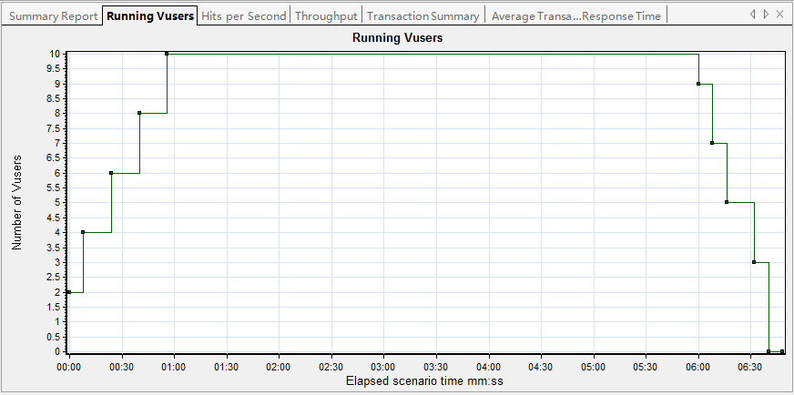**

**图四：Running Vusers**

**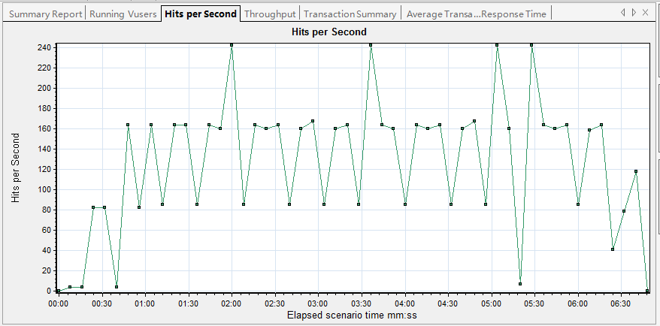**

**图五：Hits per second**

**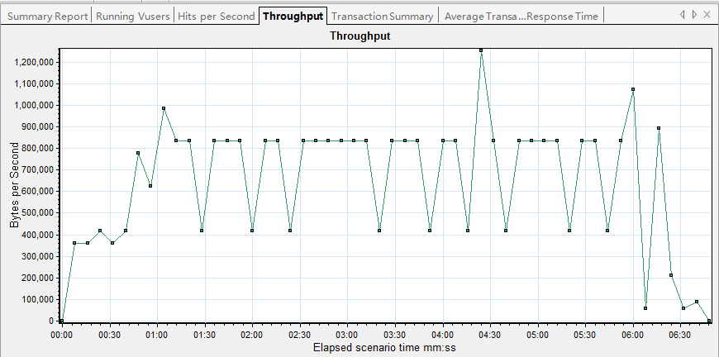**

**图六：Throughput**

**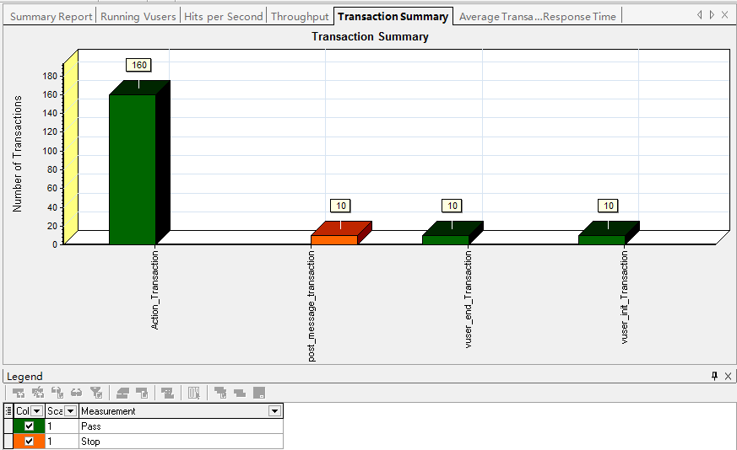**

**图七：Transaction Summary**

**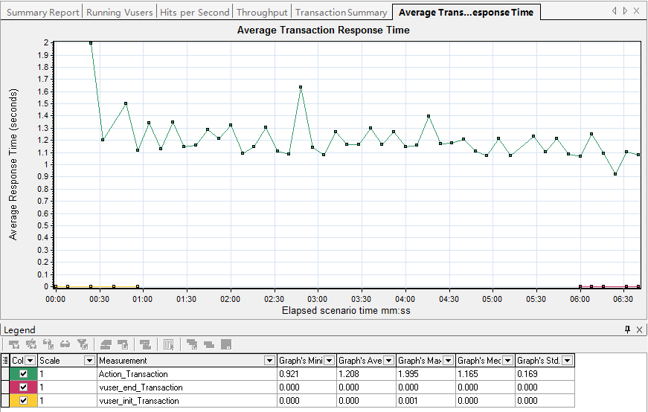**

**图八：Average Transaction Respond Time**