**Things you need if you are using windows**:

1. Software called ‘putty’ to connect to Franklin cluster and type in the commands below. X11 forwarding needs to be enabled to display the Venn diagram. See **Useful commands** and tips.
2. Software called ‘winscp’ to transfer files to Franklin cluster
3. Software called ‘xming’ to display x11 program. This is needed to display Venn diagram.

**There are several different analyses you can run**:

1. Trim low-quality reads and adapter sequences then run quality control (run_trim_qc.sh)
2. Align trimmed reads to hg19 or hg38 or other reference genome and create tracks for visualization (run_align_create_tracks_rna.sh). Although, this can be run independently of #1, it requires all the files to be in the same path as if #1 has already been run.
3. Count reads in each feature and then performed differential analysis (run_differential_analysis_rna.sh). Again, this can be run independently but requires all files to be in their locations as output by the pipeline.
4. Instead of running each of the above steps separately, you can run the full RNA-seq analysis (#1-3) using run_rnaseq_full.sh
5. After running differential analysis, you can view a proportional Venn diagram of differential genes overlap between different groups (run_overlap.sh)

**Notes**:

* This pipeline only accepts fastq.gz files.
* User can run_create_tracks with only 1 replicate but to run full RNA-seq analysis, you need at least two replicates.
* Before running any of these two options, you need to prepare the directory and samples information file called samples.txt is required. More detailed steps are listed below.
* Take a look at /export/apps/opt/rnaseq-pipeline/2.2/scripts/project_ex for examples of input files (i.e., samples.txt and fastq directory). project_ex folder also contains examples of output files upon completion of running RNAseq full analysis.
* You can copy the entire project_ex folder to your own folder, delete outputs folder and all the *.out files then run this as test files.
* Reference files and fastq folder can be symbolic link. See below for how to correctly set the symbolic link.
* In this document, there are also descriptions of output files.

**Preparing directory and samples information**

1. You need to have a project directory. Please avoid spaces in the directory name.
2. Inside the project directory, you must have a directory called “fastq”. All fastq files for all replicates/samples should be in this directory. Inside fastq directory, you can have subdirectories which then contain the fastq.gz files. See “project_ex” directory in /export/apps/opt/rnaseq-pipeline/2.2 for example of a project directory.

Inside the project directory, you must have a “samples.txt” file which contains your samples information. You can copy the “samples.txt” from “project_ex”, open it with excel and change the text inside with your own samples’ information. Do **NOT** save the samples.txt as xlsx file then convert it back to txt. Doing so will add extra invisible characters that are not compatible in Unix. When you’re done, save it back as text file (tab delimited) with the same name and transfer it to your own project directory. Do **NOT** put empty line(s) in your “samples.txt” in between your samples’ information.

**Inside “**samples.txt**”**:

* 1. **First column: “Groupname”** – type in the group name of the samples. Samples with replicates must have the same “Groupname”. This name must be part of the fastq filename. This column cannot be empty.

**Naming Rules:**

1. **Do NOT** use punctuation characters in “Groupname”. Punctuation characters are:

!"#$%&’()*+,-./:;<=>?@[]^_`{|}~

It’s fine for the file name to have punctuation characters. Only part of the file name that is used as “Groupname” that need to have the characters removed (not folder name). Then match “Groupname” to the fastq file names.

1. **Do NOT** use a “Groupname” that starts with a number.
2. Different groups **cannot have** “Groupname” that is a complete part of another group. (i.e., two “Groupname”: “EFKD” and “EF” is not allowed as “EF” is a substring of “EFKD”). See example 3 below.

**Examples of how to pick a “Groupname”:**

* + **Example 1:** if the file name is iLuc-197_rep1_R1.fastq.gz, remove the punctuation character “-“ from the fastq file names so new file name becomes iLuc197_rep1_R1.fastq.gz then set “Groupname” to be iLuc197.
  + **Example 2**: if file names are iEF_714_FLAG_S3_rep1.fastq.gz and iEF-714_FLAG_S3_rep2.fastq.gz which are two biological replicates, both need to have the same name in “Groupname”. For these two files, you need to:
    1. Remove punctuation character “_“ from part of their file names that are going to be used for “Groupname”, so they become iEF714_FLAG_S3_rep1.fastq.gz and iEF714_FLAG_S3_rep2.fastq.gz.

Have 2 lines in the samples.txt with iEF714 as “Groupname” and “rep1” and “rep2” under “Replicatename”. See more information on ‘Third column: “replicatename” ’ below.

* + - * **Example 3:** If file names are iEF_rep1_R1.fastq.gz and iEF714_rep2_R2.fastq.gz, remember that “iEF” and “iEF714” cannot be your “Groupname” as “iEF” is part of “iEF714”. In this case, you can change iEF_rep1_R1.fastq.gz to iEFempty_rep1_R1.fastq.gz. That way, you can then have “iEFempty” and “iEF714” as their “Groupname”. With this change, you no longer have a “Groupname” that is completely part of another group.
    - **Example 4**: if file name is 0647_714R1_S57_L001_R1_001.sub.fastq.gz
      * 1. Change file name to 0647_iEF714R1_S57_L001_R1_001.sub.fastq.gz
        2. Have “Groupname” as iEF714.
  1. **Second column: “Controlname”** - type in the name of the control/ background/reference sample. During differential analysis, the corresponding sample will be compared to its “Controlname”. Fold-change will be calculated with “Controlname” as reference. “Controlname” has to be one of “Groupname”. This name must be part of the fastq filename. This column cannot be empty. For control/background sample, please put NA for “Controlname”.

**The same naming rules for apply:**

1. **Do NOT** use punctuation characters in “Groupname”. Punctuation characters are:

!"#$%&’()*+,-./:;<=>?@[]^_`{|}~

It’s fine for the file name to have punctuation characters. Only part of the file name that is used as “Controlname” that need to have the characters removed (not folder name). Then match “Controlname” to the fastq file names.

1. **Do NOT** use a “Controlname” that starts with a number.

**Examples of how to pick a “Controlname”:**

* **Example 1**: If you have iEF714_rep1_R1.fastq.gz that need to be compared to iEFempty_rep1_R1.fastq.gz as a reference. For these two files you will have two entries in the samples.txt:
  1. one entry with “Groupname” as “iEF714” and “iEFempty” as “Controlname”. This corresponds to your iEF714_rep1_R1.fastq.gz
  2. Another line with “Groupname” as “iEFempty” and “Controlname” as “NA”.
  3. **Third column: “Replicatename”** – type in the name of the replicates. This name must be part of fastq filename. This column cannot be empty. Sometimes the replicates are denoted as R1 or rep1. Make sure the correct replicate notation is typed in the samples.txt. Make sure “**Replicatename**” is not exactly the same as “**string_pair1**” and “**string_pair2**”

**Example of how to pick a “Replicatename”:**

* + - **Example 1:** If you have A8_20-0647_iEF714R1_S57_L001_R1.fastq.gz and A8_20-0647_iEF714R2_S57_L001_R1.fastq.gz then “Replicatename” will be “R1” and “R2”. Make sure when you fill in “string_pair1” it is “_R1” and **not** “R1”
    - **Example 2:** If you have A8_20-0647_iEF714Rep1_S57_L001_R1.sub.fastq.gz and A8_20-0647_iEF714Rep2_S57_L001_R1.sub.fastq.gz then “Replicatename” will be “Rep1” and “Rep2”. It is case sensitive.
  1. **Fourth column: “spikename”** – type in NA for all rows.
  2. **Fifth column: “email”** – type in the email address of the person running the analysis. Slurm job emails will be sent this email address.
  3. **Sixth column**: “**string_to_identify_sample**” – this string will be used to identify files that belong to a particular sample.

**Naming rules**:

* This can have punctuation characters.
* Different sample **cannot have** “string_to_identify_sample” that is a complete part of another “string_to_identify_sample”. (i.e., two “string_to_identify_sample”: “iEF714Rep1” and “iEF714Rep11” are not allowed as “iEF714Rep1” is a substring of “iEF714Rep11”). One workaround is to change your replicatename for Rep11 as Repl11. Remember to change your fastq.gz filename accordingly. In this case, “string_to_identify_sample” is now “iEF714Repl11”. See example 1 below.

**Examples of how to pick a “string_to_identify_sample”:**

* + - **Example 1**: if your file names are:
  + A8_20-0647_iEF714Rep1_S57_L001_R1_001.sub.fastq.gz
  + A8_20-0647_iEF714Rep11_S57_L001_R1_001.sub.fastq.gz
  + C8_20-0649_iEF563Rep1_S59_L001_R1_001.sub.fastq.gz
  + H7_20-0646_iEF197Rep2_S56_L002_R1_001.sub.fastq.gz

With the above file names, you would have iEF714Rep1 as the first **string_to_identify_sample** for the first sample and iEF714Rep11 as the **string_to_identify_sample** for the second sample. However, this would make “iEF714Rep1” a substring of “iEF714Rep11”. So, you need to change the second filename to:

A8_20-0647_iEF714Rep2_S57_L001_R1_001.sub.fastq.gz

And have the string_to_identify_sample for this sample as “iEF714Rep2”

Since we remove iEF714Rep11, we no longer have a string_to_identify_sample that is completely part of another string_to_identify sample.

* 1. **Seventh column**: “**string_pair1**” – each fastq file will be a pair of files that only differs in one string. Usually this string is _R1_ for pair1 reads and _R2_ for pair2 reads.
  2. **Eight column**: “**string_pair2**” – similar to “**string_pair1**” but for pair 2 reads.

**Examples of how to pick “string_pair1” and “string_pair2”:**

* **Example 1**: If your file names are:
  + A9_20-0655_iEF197R2_S65_L001_R1_001.sub.fastq.gz
  + A9_20-0655_iEF197R2_S65_L001_R2_001.sub.fastq.gz

Therefore the “string_pair1” would be “_R1_” and “string_pair2” would be “_R2_”

* **Example 2**: If your file names are:
  + A9_20-0655_iEF197R2_S65_L001_R1.fastq.gz
  + A9_20-0655_iEF197R2_S65_L001_R2.fastq.gz

Therefore the “string_pair1” would be “_R1” and “string_pair2” would be “_R2”

# How to:

* **Trim adapter sequences and low quality reads then run quality control (QC) without running full analysis.**

After preparing the directory and samples information as detailed above, to trim adapter sequences and low quality reads then run QC without running the full analysis:

1. Go into the project directory.
2. For example: if your project directory is called “my_project” then type in:

cd my_project

1. To trim and run QC only, type in:

bash /export/apps/opt/rnaseq-pipeline/scripts/project_ex/scripts/2.2/run_trim_qc.sh &> run_trim_qc.out &

Check “run_trim_qc.out” file for progress and messages. **Do Not** change this output filename.

Type in help to get more information:

bash /export/apps/opt/rnaseq-pipeline/scripts/project_ex/scripts/2.2/run_trim_qc.sh help

* **Align reads to reference genome hg19 (or hg38 or other reference genome) and create normalized tracks for visualization without running the full analysis.**

After preparing the directory and samples information as detailed above, to align and create tracks without running the full analysis:

**Note**: everything needs to be in the same directories as if run_trim_qc.sh had been run.

1. Go into the project directory.

For example: if your project directory is called “my_project” then type in:

cd my_project

1. To align to **hg19** and create tracks only, type in:

bash /export/apps/opt/rnaseq-pipeline/scripts/2.2/run_align_create_tracks_rna.sh &> run_align_create_tracks_rna.out &

Check “run_align_create_tracks_rna.out” file for progress and messages. **Do Not** change this output filename.

1. Or to align to **hg38** and create tracks only, type in:

bash /export/apps/opt/rnaseq-pipeline/scripts/2.2/run_align_create_tracks_rna.sh genome=hg38 &> run_align_create_tracks_rna.out &

Check “run_align_create_tracks_rna.out” file for progress and messages. **Do Not** change this output filename.

1. Or to align to **other reference genome** and create tracks only:

Place reference genome sequence file (.fa or .fasta) and genome annotation (.gtf) inside a directory with the genome name. Place this directory under a directory named “ref”, inside your project directory.

**For example**, to align to genome=mm10, the following would be the file structure:

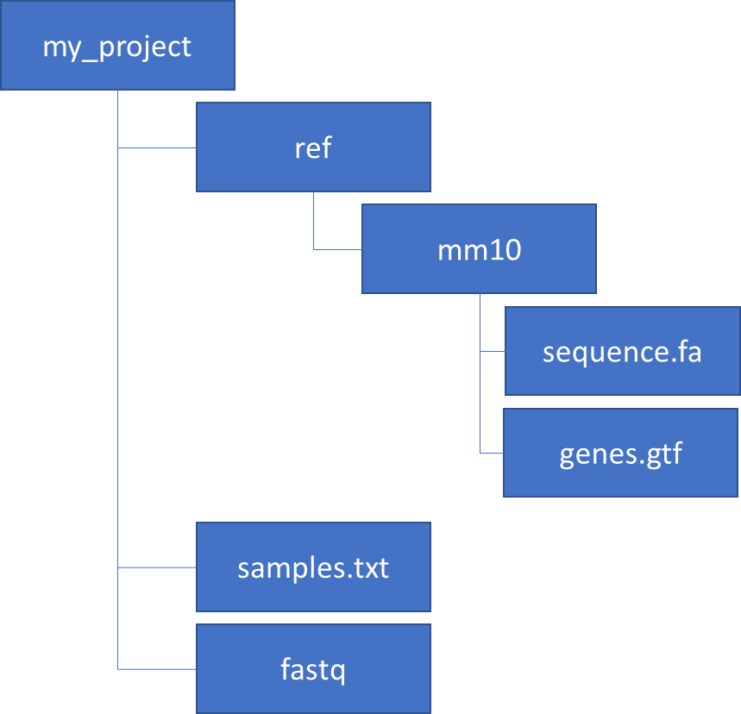

Then type in:

bash /export/apps/opt/rnaseq-pipeline/scripts/2.2/run_align_create_tracks_rna.sh genome=mm10 &> run_align_create_tracks_rna.out &

Check “run_align_create_tracks_rna.out” file for progress and messages. **Do Not** change this output filename.

1. Type in help to get more information:

bash /export/apps/opt/rnaseq-pipeline/scripts/project_ex/2.2/scripts/ run_align_create_tracks_rna.sh help

* **Run feature count and differential analysis without running the full analysis.**

After preparing the directory and samples information as detailed above, to count features and run differential analysis without running the full analysis:

**Note**: everything needs to be in the same directories as if run_align_create_tracks_rna.sh had been run.

1. Go into the project directory.

For example: if your project directory is called “my_project” then type in:

cd my_project

1. To count features and run differential analysis, type in:

bash /export/apps/opt/rnaseq-pipeline/2.2/scripts/run_differential_analysis_rna.sh &> run_differential_analysis_rna.out &

Check “run_differential_analysis_rna.out” file for progress and messages. **Do Not** change this output filename.

1. To get more information, type in:

bash /export/apps/opt/rnaseq-pipeline/2.2/scripts/run_differential_analysis_rna.sh help

* **Run full RNA-seq analysis and obtain lists of differential genes (commonly used)**

After preparing the directory and samples information as detailed above, to run the full analysis which includes trim, qc, alignment, tracks creation, feature counting and differential analysis:

1. Go into the project directory.

For example: if your project directory is called “my_project” then type in:

cd my_project

1. To align to **hg19** and run full RNA-seq analysis, type in:

bash /export/apps/opt/rnaseq-pipeline/scripts/run_rnaseq_full.sh &> run_rnaseq_full.out &

1. Or to align to **hg38** and run full RNA-seq analysis, type in:

bash /export/apps/opt/rnaseq-pipeline/scripts/run_rnaseq_full.sh genome=hg38 &> run_rnaseq_full.out &

1. Or to **align to other reference** genome and run full RNA-seq analysis, place reference genome sequence file (.fa or .fasta) and genome annotation (.gtf) inside a directory with the genome name. Place this directory under a directory named “ref”, inside your project directory.

**For example**, to align to genome=mm10, the following would be the file structure:



Then type in:

bash /export/apps/opt/rnaseq-pipeline/2.2/scripts/run_rnaseq_full.sh genome=mm10 &> run_rnaseq_full.out &

1. Or to specify time limit of 1 day, type in:

bash /export/apps/opt/rnaseq-pipeline/2.2/scripts/run_rnaseq_full.sh time=1-00:00:00 &> run_rnaseq_full.out &

Use this command only if you really need the time limit. Any commands described above, can also be used with the time option. This command is usually used for times when the cluster is scheduled for maintenance within a certain time limit. **Note**: your jobs will be killed if they are not finished within the time limit. The format for time is time=DD-HH:MM:SS

1. Or to get more information, type in:

bash /export/apps/opt/rnaseq-pipeline/2.2/scripts/run_rnaseq_full.sh help

Check “**run_rnaseq_full.out**” file for progress and messages. **Do Not** change this output filename.

* **How to use symbolic link for fastq folder and reference files:**

Reference files and fastq folder can be symbolic link. However, they need to be full path returned by readlink. Do the following to set the symbolic link correctly:

* + Go into the location where fastq directory is. In this case, it is ~/Steve/virtual_server/rnaseq-singularity/project_ex  
    cd ~/Steve/virtual_server/rnaseq-singularity/project_ex
  + Get the full path:

[cxt050@r1pl-hpcf-log01 project_ex]$ readlink -f fastq

/gpfs0/home1/gdlessnicklab/cxt050/Steve/virtual_server/rnaseq-singularity/project_ex/fastq

* + Note the full path returned above, then go into your project directory from where you want to run the pipeline. In this case, it is “my_project5”

cd my_project5

* + Set symbolic link, using the full path returned by “readlink -f” above:

ln -s /gpfs0/home1/gdlessnicklab/cxt050/Steve/virtual_server/rnaseq-singularity/project_ex/fastq fastq

* + Check that the symbolic link is set correctly. There should be an arrow from fastq pointing to the real location of fastq as shown below:

[cxt050@r1pl-hpcf-log01 project_ex5]$ ls -lh

total 27K

lrwxrwxrwx 1 cxt050 gdlessnicklab 90 Feb 11 09:10 fastq -> /gpfs0/home1/gdlessnicklab/cxt050/Steve/virtual_server/rnaseq-singularity/project_ex/fastq

**Output folders:**

In case of errors, you should first read *.out in your project folder. For example, if you are running run_rnaseq_full.sh, run_rnaseq_full.out will contain message about the error and where to look for more information.

After running full RNA-seq analysis, you will have an **outputs** **folder** with all the results of running the analysis. Inside outputs**, diff_analysis_rslt** folder will have the results of differential analysis. **RNA-seq differential_analysis_report.html** which contains detailed report of the entire analysis is a good place to start reading.

**bw_files** will have the normalized tracks for visualization

**fastqc_rslt** will have the quality control reports

**logs** will have logs of programs ran. Details of programs ran will be here

**STAR_2pass** will have the alignment files produced by running two-pass STAR. The **final bam** files are in “**STAR_2pass/Pass2**”. Feature counts used as input for differential analysis are also stored here.

**trim** will have the trimmed fastq files.

**View interactive area-proportional Venn Diagram.**

Once you have run differential analysis, you can run Venn diagram app. The app will allow user to change FDR, fold-change, labels, etc. Run the app using the following steps:

1. Go into the project directory.

For example: if your project directory is called “my_project” then type in:

cd my_project

1. To generate Venn Diagram, type in:

bash /export/apps/opt/rnaseq-pipeline/2.2/scripts/run_overlap.sh

**Note: There is no ‘&’ at the end of the command!!**

This will load shiny app, then it will ask for your Franklin cluster’s password. After you typed in your password, Firefox with interactive Venn diagram will appear. Please wait patiently ☺ as it may take a while for Firefox to appear. After Firefox appears, it may take some time for the page to be loaded. During this time, Firefox will be unresponsive. After loading, if Firefox is slow, simply exit out of Firefox and restart run_overlap.sh.  
  
If it fails with the following error: “connection to … closed by remote host” simply try to re-run the above command.

If a window appears asking you to create new profile, please click on “create new profile”.

**Note**: you will need to have an x11 display server such as Xing running on your computer (see Useful commands and tips).

Screenshots of the Venn diagram app:

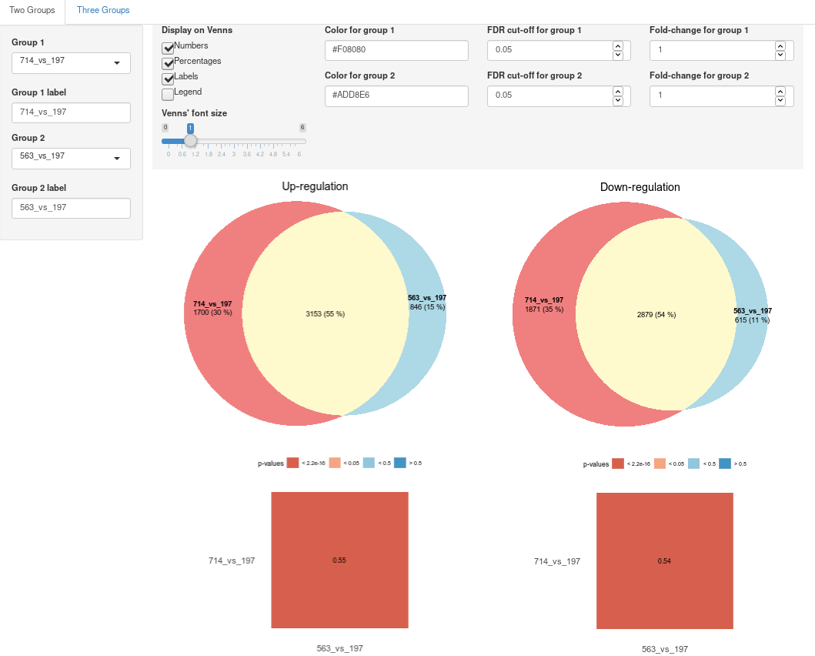

Overlap analysis with more than 3 groups:

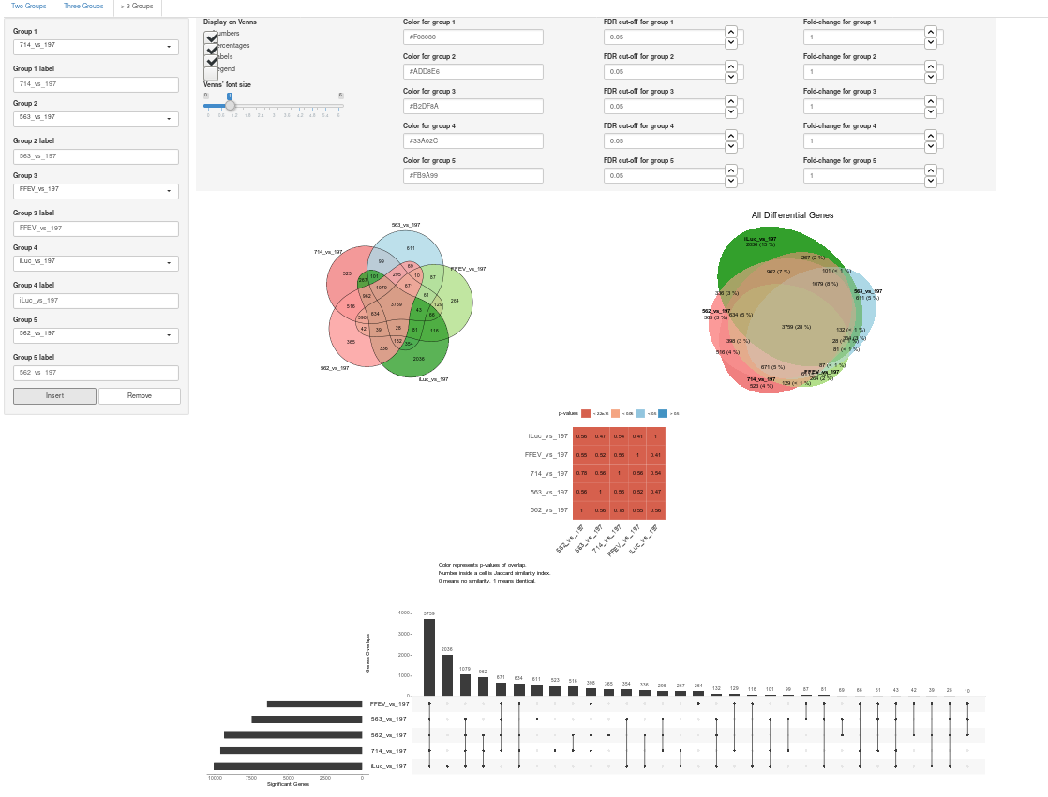

### Useful commands and tips

* To see where you are currently, type:

pwd

* To change directory type:

cd directory_path

**For example:**

|  |
| --- |
| [cxt050@r1pl-hpcf-log01 ~]$ pwd  /gpfs0/home/gdlessnicklab/cxt050 |

Typing ‘pwd’ let me know that I am currently in “/gpfs0/home/gdlessnicklab/cxt050“

To go into ‘/home/gdlessnicklab/share/data/’, type:   
”cd /home/gdlessnicklab/share/data/”

|  |
| --- |
| [cxt050@r1pl-hpcf-log01 ~]$ cd /home/gdlessnicklab/share/data/  [cxt050@r1pl-hpcf-log01 data]$ pwd  /home/gdlessnicklab/share/data |

To be able to display Venn diagram, make sure you have x11 program running:  
In the picture below xming (x11 program) is shown running.  
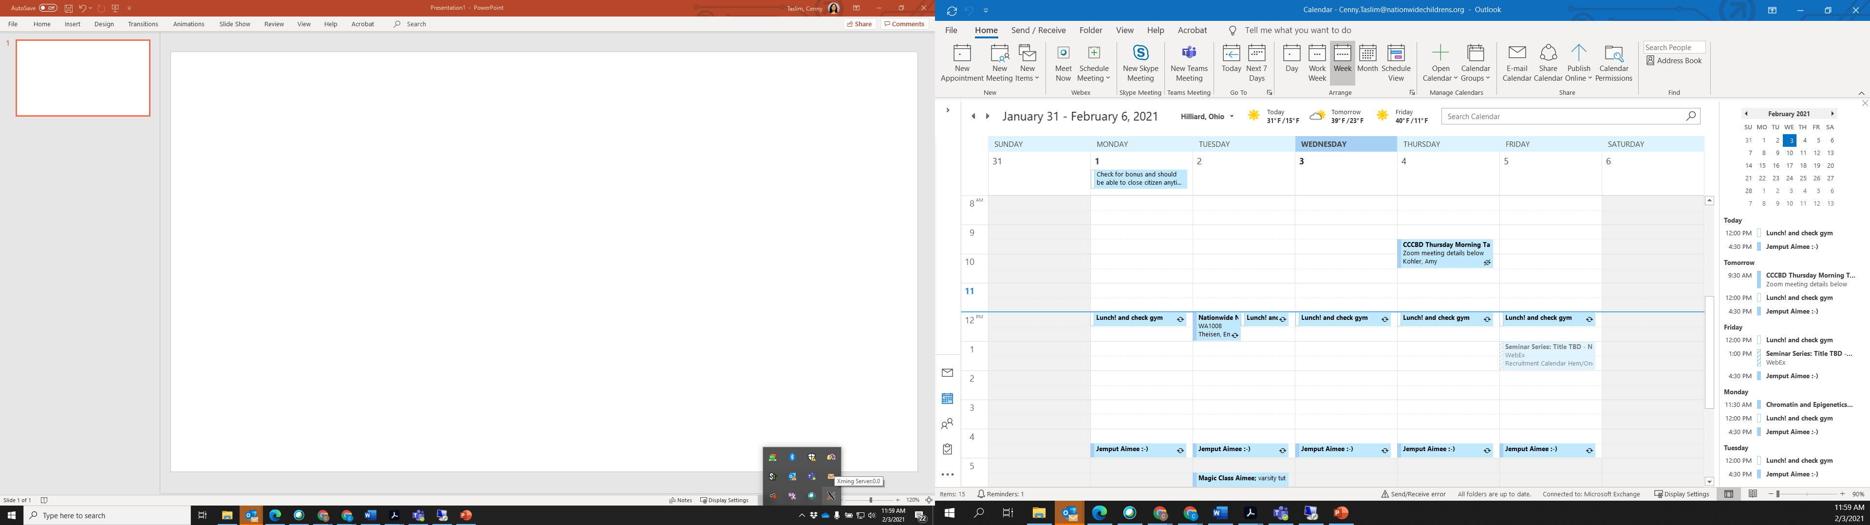

If you are using putty, make sure x11 is also checked (enabled):

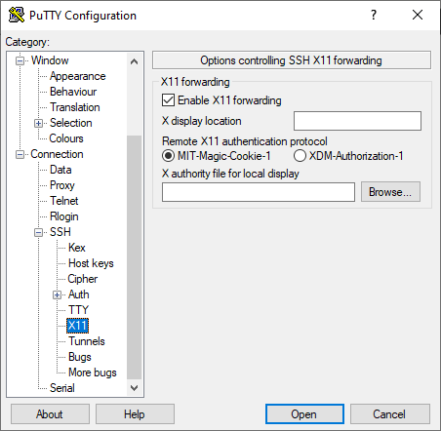

Have questions? Email [cenny.taslim@nationwidechildrens.org](mailto:cenny.taslim@nationwidechildrens.org)