**public** **final** **static** **int** ***ExperimentTimes*** = 10;

**public** **final** **static** **long** ***SubstrateNewtorkRunTimeInterval*** = 50000;// 50000

**public** **final** **static** **long** ***unitTimeInterval*** = 1;

**public** **final** **static** **double** ***requestAppearProbability*** = 1;// 0.1

**public** **final** **static** **long** ***VNRequestsDuration*** = 10;

**public** **final** **static** **long** ***VNRequestsContinueTimeMinimum*** = 1;// 1

**public** **final** **static** **long** ***VNRequestsContinueTimeMaximum*** = 100;// 1000

// ExperimentPicture

**public** **final** **static** **int** ***ExperimentPicturePlotNumber*** = 30;

// service parameter

**public** **final** **static** **int** ***ServiceNumber*** = 5;

**public** **final** **static** **double** ***SerivecProbability*** = 0.5;

// SubStrate Network Parameter

// node parameter

**public** **final** **static** **int** ***SubStrateNodeSize*** = 40;

**public** **final** **static** **int** ***SubStrateNodeComputationMinimum*** = 20;

**public** **final** **static** **int** ***SubStrateNodeComputationMaximum*** = 50;

// edge parameter

**public** **final** **static** **double** ***SubStrateNodenodeProbability*** = 0.4;

**public** **final** **static** **int** ***SubStrateEdgeBandwithMinimum*** = 30;

**public** **final** **static** **int** ***SubStrateEdgeBandwithMaximum*** = 100;

// Virtual Network

// node parameter //2-5 5-8 5-10

**public** **final** **static** **int** ***VirtualNodeSizeMinimum*** =5;

**public** **final** **static** **int** ***VirtualNodeSizeMaximum*** = 5;

**public** **final** **static** **int** ***VirtualNodeComputationMinimum*** = 2;

**public** **final** **static** **int** ***VirtualNodeComputationMaximum*** = 10;

// edge parameter

**public** **final** **static** **double** ***VirtualNodenodeProbability*** = 0.5;

**public** **final** **static** **int** ***VirtualEdgeBandwithMinimum*** = 5;

**public** **final** **static** **int** ***VirtualEdgeBandwithMaximum*** = 10;

**public** **final** **static** **int** ***SubStrateFacilityNodeFailDuration*** = 2000;

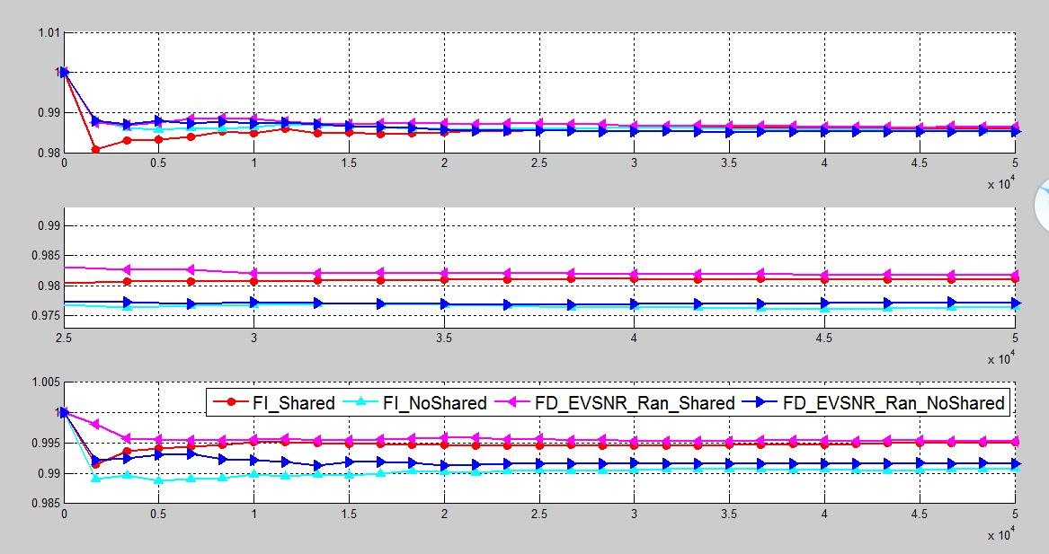

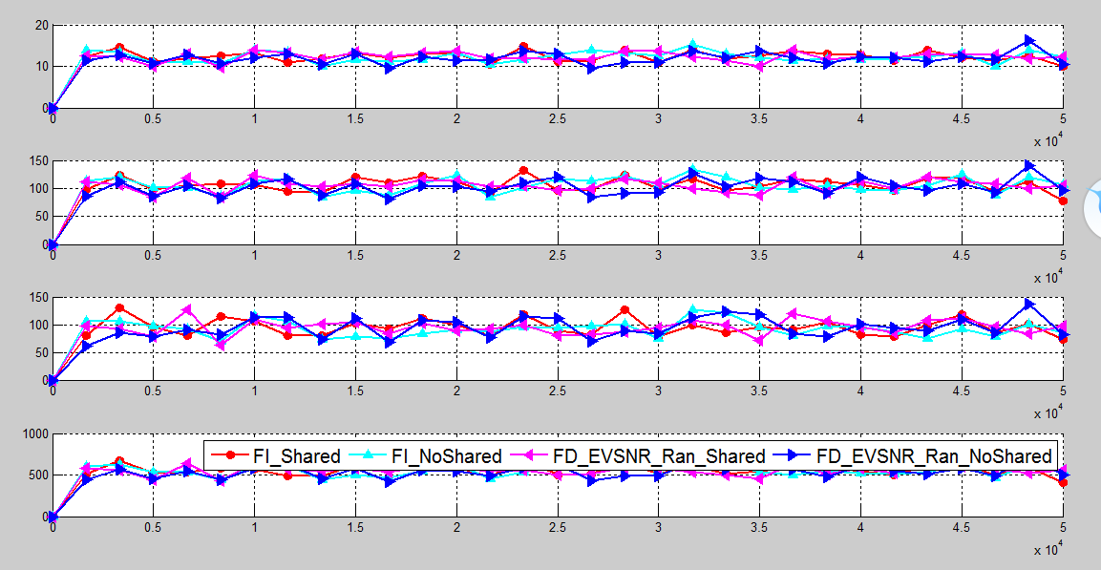

**public** **final** **static** **int** ***ExperimentTimes*** = 10;

**public** **final** **static** **long** ***SubstrateNewtorkRunTimeInterval*** = 50000;// 50000

**public** **final** **static** **long** ***unitTimeInterval*** = 1;

**public** **final** **static** **double** ***requestAppearProbability*** = 1;// 0.1

**public** **final** **static** **long** ***VNRequestsDuration*** = 10;

**public** **final** **static** **long** ***VNRequestsContinueTimeMinimum*** = 1;// 1

**public** **final** **static** **long** ***VNRequestsContinueTimeMaximum*** = 1000;// 1000

// ExperimentPicture

**public** **final** **static** **int** ***ExperimentPicturePlotNumber*** = 30;

// service parameter

**public** **final** **static** **int** ***ServiceNumber*** = 5;

**public** **final** **static** **double** ***SerivecProbability*** = 0.5;

// SubStrate Network Parameter

// node parameter

**public** **final** **static** **int** ***SubStrateNodeSize*** = 50;

**public** **final** **static** **int** ***SubStrateNodeComputationMinimum*** = 25;

**public** **final** **static** **int** ***SubStrateNodeComputationMaximum*** = 50;

// edge parameter

**public** **final** **static** **double** ***SubStrateNodenodeProbability*** = 0.4;

**public** **final** **static** **int** ***SubStrateEdgeBandwithMinimum*** = 50;

**public** **final** **static** **int** ***SubStrateEdgeBandwithMaximum*** = 100;

// Virtual Network

// node parameter //2-5 5-8 5-10

**public** **final** **static** **int** ***VirtualNodeSizeMinimum*** =5;

**public** **final** **static** **int** ***VirtualNodeSizeMaximum*** = 10;

**public** **final** **static** **int** ***VirtualNodeComputationMinimum*** = 2;

**public** **final** **static** **int** ***VirtualNodeComputationMaximum*** = 10;

// edge parameter

**public** **final** **static** **double** ***VirtualNodenodeProbability*** = 0.5;

**public** **final** **static** **int** ***VirtualEdgeBandwithMinimum*** = 5;

**public** **final** **static** **int** ***VirtualEdgeBandwithMaximum*** = 10;

**public** **final** **static** **int** ***SubStrateFacilityNodeFailDuration*** = 2000;

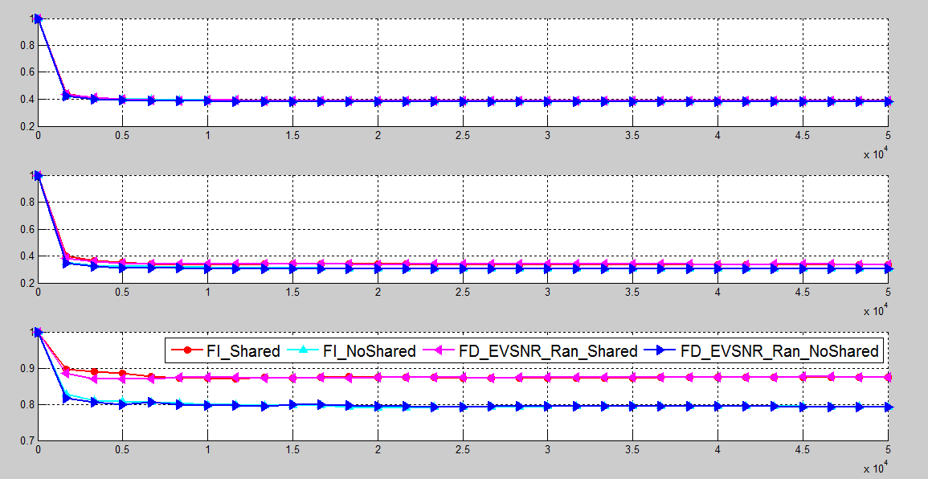

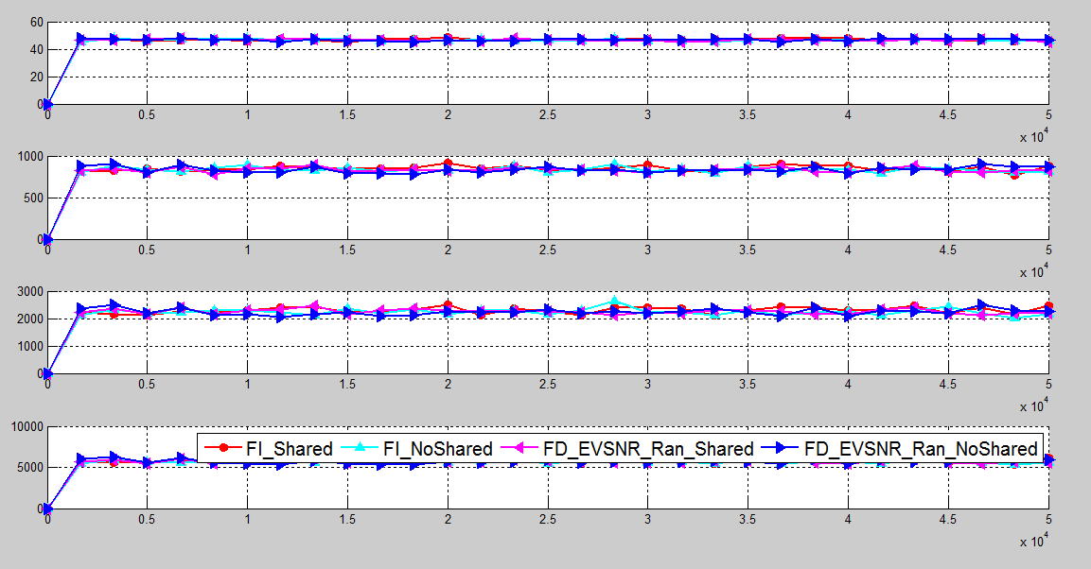

**public** **final** **static** **long** ***SubstrateNewtorkRunTimeInterval*** =10000;// 30000

**public** **final** **static** **long** ***unitTimeInterval*** = 1;

**public** **final** **static** **double** ***requestAppearProbability*** = 1;// 0.1

**public** **final** **static** **long** ***VNRequestsDuration*** = 10;

**public** **final** **static** **long** ***VNRequestsContinueTimeMinimum*** = 1;

**public** **final** **static** **long** ***VNRequestsContinueTimeMaximum*** = 1000;

// ExperimentPicture

**public** **final** **static** **int** ***ExperimentPicturePlotNumber*** = 25;

// service parameter

**public** **final** **static** **int** ***ServiceNumber*** = 1;

**public** **final** **static** **double** ***SerivecProbability*** = 1;

// SubStrate Network Parameter

// node parameter

**public** **final** **static** **int** ***SubStrateNodeSize*** = 100;//100

**public** **final** **static** **int** ***SubStrateNodeComputationMinimum*** = 50;//50

**public** **final** **static** **int** ***SubStrateNodeComputationMaximum*** = ***SubStrateNodeComputationMinimum***\*2;//100

// edge parameter

**public** **final** **static** **double** ***SubStrateNodenodeProbability*** = 0.8;

**public** **final** **static** **int** ***SubStrateEdgeBandwithMinimum*** = 200;

**public** **final** **static** **int** ***SubStrateEdgeBandwithMaximum*** = 300;

// Virtual Network

// node parameter //2-5 5-8 5-10

**public** **final** **static** **int** ***VirtualNodeSizeMinimum*** =2;//2

**public** **final** **static** **int** ***VirtualNodeSizeMaximum*** = 10;//10

**public** **final** **static** **int** ***VirtualNodeComputationMinimum*** = 1;//1

**public** **final** **static** **int** ***VirtualNodeComputationMaximum*** = ***VirtualNodeComputationMinimum***\*5;//5

// edge parameter

**public** **final** **static** **double** ***VirtualNodenodeProbability*** = 0.5;//0.5

**public** **final** **static** **int** ***VirtualEdgeBandwithMinimum*** = 10;//10

**public** **final** **static** **int** ***VirtualEdgeBandwithMaximum*** = ***VirtualEdgeBandwithMinimum***\*2;//20

**public** **final** **static** **int** ***SubStrateFacilityNodeFailDuration*** = 2000;

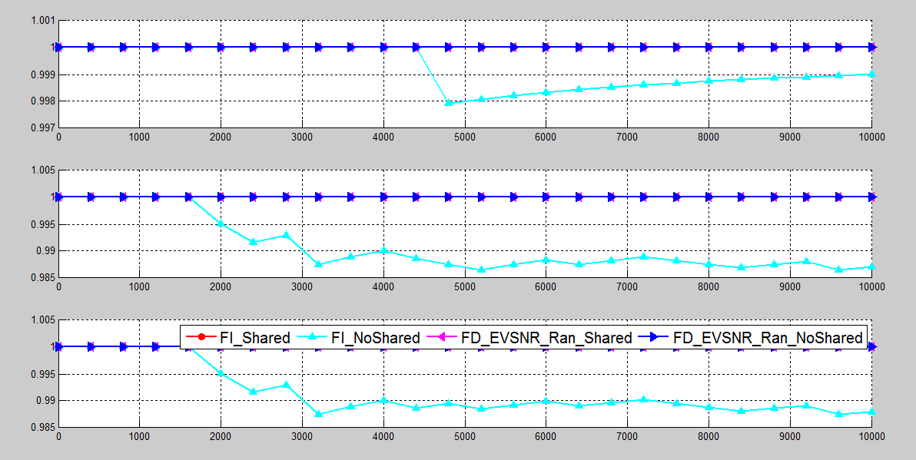

**public** **final** **static** **long** ***SubstrateNewtorkRunTimeInterval*** =10000;// 30000

**public** **final** **static** **long** ***unitTimeInterval*** = 1;

**public** **final** **static** **double** ***requestAppearProbability*** = 1;// 0.1

**public** **final** **static** **long** ***VNRequestsDuration*** = 10;

**public** **final** **static** **long** ***VNRequestsContinueTimeMinimum*** = 1;

**public** **final** **static** **long** ***VNRequestsContinueTimeMaximum*** = 100;

// ExperimentPicture

**public** **final** **static** **int** ***ExperimentPicturePlotNumber*** = 25;

// service parameter

**public** **final** **static** **int** ***ServiceNumber*** = 5;

**public** **final** **static** **double** ***SerivecProbability*** = 0.5;

// SubStrate Network Parameter

// node parameter

**public** **final** **static** **int** ***SubStrateNodeSize*** = 40;//100

**public** **final** **static** **int** ***SubStrateNodeComputationMinimum*** = 20;//50

**public** **final** **static** **int** ***SubStrateNodeComputationMaximum*** = 50;//100

// edge parameter

**public** **final** **static** **double** ***SubStrateNodenodeProbability*** = 0.4;

**public** **final** **static** **int** ***SubStrateEdgeBandwithMinimum*** = 30;

**public** **final** **static** **int** ***SubStrateEdgeBandwithMaximum*** = 100;

// Virtual Network

// node parameter //2-5 5-8 5-10

**public** **final** **static** **int** ***VirtualNodeSizeMinimum*** =5;//2

**public** **final** **static** **int** ***VirtualNodeSizeMaximum*** = 8;//10

**public** **final** **static** **int** ***VirtualNodeComputationMinimum*** = 2;//1

**public** **final** **static** **int** ***VirtualNodeComputationMaximum*** = 10;//5

// edge parameter

**public** **final** **static** **double** ***VirtualNodenodeProbability*** = 0.5;//0.5

**public** **final** **static** **int** ***VirtualEdgeBandwithMinimum*** = 5;//10

**public** **final** **static** **int** ***VirtualEdgeBandwithMaximum*** = 10;//20

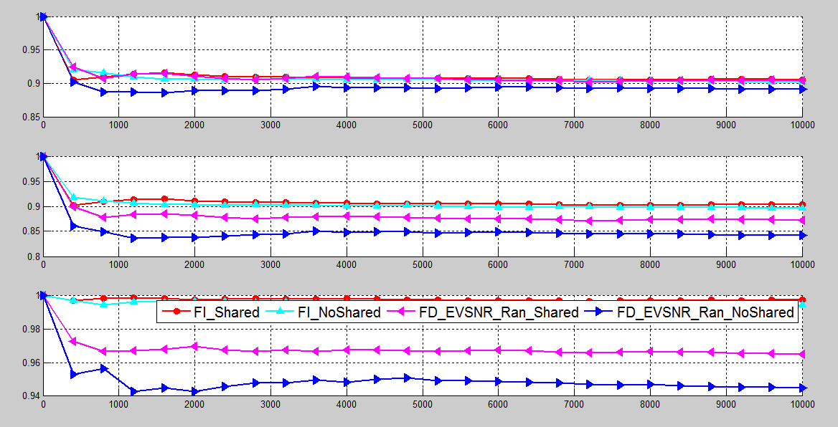

/**

*

*/

package evsnr;

/**

* @author franz

*

*/

public class EVSNR {

// Parameter

public final static int addNewNodeCost = 100000;

public final static int transformExistedNodeCost = 10000;

public final static int addNodeComputaionCost = 300;

public final static int addEdgeBandwithCost = 100;

public final static int RelativeCostbetweenComputingBandwidth = addNodeComputaionCost / addEdgeBandwithCost;

public final static boolean FailureDependent = true;

public final static boolean FailureIndependent = false;

// Algorithm

public final static int AlgorithmFranz = 0;

public final static int AlgorithmMILP = 1;

public final static int MatchMethodILP = 1;

public final static int MatchMethodDP = 2;

public static final int MatchMethod = MatchMethodILP;

public final static int FailureDependentHeuriticAlgorithm = 0;

public final static int FailureIndependentHeuriticAlgorithm = 1;

public final static int IPAlgorithm = 2;

public final static int Ran = 0;

public final static int Min = 1;

// /home/franz/franzDocuments/eclipse4cworkspace/EeVSNR

public final static String FileAbsolutePath = "C:\\Users\\Taoheng\\Desktop\\NFT4VNR";

public final static boolean IsReleaseVNafterEVNFailure=false;

public final static int ExperimentTimes = 3;

public final static long SubstrateNewtorkRunTimeInterval =5000;// 30000

public final static long unitTimeInterval = 1;

public final static double requestAppearProbability = 0.1;// 0.1

public final static long VNRequestsDuration = 1;

public final static long VNRequestsContinueTimeMinimum = 1;

public final static long VNRequestsContinueTimeMaximum = 500;

// ExperimentPicture

public final static int ExperimentPicturePlotNumber = 25;

// service parameter

public final static int ServiceNumber = 20;

public final static double SerivecProbability = 0.3;

// SubStrate Network Parameter

// node parameter

public final static int SubStrateNodeSize = 50;//100

public final static int SubStrateNodeComputationMinimum = 20;//50

public final static int SubStrateNodeComputationMaximum = 50;//100

// edge parameter

public final static double SubStrateNodenodeProbability = 0.8;

public final static int SubStrateEdgeBandwithMinimum = 500;

public final static int SubStrateEdgeBandwithMaximum = 1000;

// Virtual Network

// node parameter //2-5 5-8 5-10

public final static int VirtualNodeSizeMinimum =5;//2

public final static int VirtualNodeSizeMaximum = 10;//10

public final static int VirtualNodeComputationMinimum = 1;//1

public final static int VirtualNodeComputationMaximum = 5;//5

// edge parameter

public final static double VirtualNodenodeProbability = 0.5;//0.5

public final static int VirtualEdgeBandwithMinimum = 5;//10

public final static int VirtualEdgeBandwithMaximum = 25;//20

public final static int SubStrateFacilityNodeFailDuration = 2000;

/**

*

*/

package evsnr;

/**

* @author franz

*

*/

public class EVSNR {

// Parameter

public final static int addNewNodeCost = 100000;

public final static int transformExistedNodeCost = 0;

public final static int addNodeComputaionCost = 300;

public final static int addEdgeBandwithCost = 100;

public final static int RelativeCostbetweenComputingBandwidth = addNodeComputaionCost / addEdgeBandwithCost;

public final static boolean FailureDependent = true;

public final static boolean FailureIndependent = false;

// Algorithm

public final static int AlgorithmFranz = 0;

public final static int AlgorithmMILP = 1;

public final static int MatchMethodILP = 1;

public final static int MatchMethodDP = 2;

public static final int MatchMethod = MatchMethodILP;

public final static int FailureDependentHeuriticAlgorithm = 0;

public final static int FailureIndependentHeuriticAlgorithm = 1;

public final static int IPAlgorithm = 2;

public final static int Ran = 0;

public final static int Min = 1;

// /home/franz/franzDocuments/eclipse4cworkspace/EeVSNR

public final static String FileAbsolutePath = "C:\\Users\\Taoheng\\Desktop\\NFT4VNR";

public final static boolean IsReleaseVNafterEVNFailure=false;

public final static int ExperimentTimes = 10;

public final static long SubstrateNewtorkRunTimeInterval =1000;// 30000

public final static long unitTimeInterval = 1;

public final static double requestAppearProbability = 0.1;// 0.1

public final static long VNRequestsDuration = 1;

public final static long VNRequestsContinueTimeMinimum = 25;

public final static long VNRequestsContinueTimeMaximum = 250;

// ExperimentPicture

public final static int ExperimentPicturePlotNumber = 25;

// service parameter

public final static int ServiceNumber = 50;

public final static double SerivecProbability = 0.1;

// SubStrate Network Parameter

// node parameter

public final static int SubStrateNodeSize = 50;//100

public final static int SubStrateNodeComputationMinimum = 30;//50

public final static int SubStrateNodeComputationMaximum = 50;//100

// edge parameter

public final static double SubStrateNodenodeProbability = 0.5;

public final static int SubStrateEdgeBandwithMinimum = 500;

public final static int SubStrateEdgeBandwithMaximum = 1000;

// Virtual Network

// node parameter //2-5 5-8 5-10

public final static int VirtualNodeSizeMinimum =5;//2

public final static int VirtualNodeSizeMaximum = 10;//10

public final static int VirtualNodeComputationMinimum = 5;//1

public final static int VirtualNodeComputationMaximum = 15;//5

// edge parameter

public final static double VirtualNodenodeProbability = 0.5;//0.5

public final static int VirtualEdgeBandwithMinimum = 5;//10

public final static int VirtualEdgeBandwithMaximum = 25;//20

public final static int SubStrateFacilityNodeFailDuration = 2000;

}

}

// Parameter

**public** **static** **final** **int** ***addNewNodeCost*** = 100000;

**public** **static** **final** **int** ***transformExistedNodeCost*** = 1000;

**public** **static** **final** **int** ***addNodeComputaionCost*** = 3;

**public** **static** **final** **int** ***addEdgeBandwithCost*** = 1;

**public** **static** **final** **int** ***RelativeCostbetweenComputingBandwidth*** = ***addNodeComputaionCost*** / ***addEdgeBandwithCost***;

**public** **static** **final** **boolean** ***FailureDependent*** = **true**;

**public** **static** **final** **boolean** ***FailureIndependent*** = **false**;

// Algorithm

**public** **static** **final** **int** ***AlgorithmFranz*** = 0;

**public** **static** **final** **int** ***AlgorithmMILP*** = 1;

**public** **static** **final** **int** ***MatchMethodILP*** = 1;

**public** **static** **final** **int** ***MatchMethodDP*** = 2;

**public** **static** **final** **int** ***MatchMethod*** = ***MatchMethodILP***;

**public** **static** **final** **int** ***Ran*** = 0;

**public** **static** **final** **int** ***Min*** = 1;

// /home/franz/franzDocuments/eclipse4cworkspace/EeVSNR

**public** **static** **final** String ***FileAbsolutePath*** = "C:\\Users\\Taoheng\\Desktop\\NFT4VNR";

**public** **static** **final** **boolean** ***isSameVNQ4EveryTime*** = **true**;

**public** **static** **final** **boolean** ***IsReleaseVNafterEVNFailure*** = **false**;

**public** **static** **final** **int** ***ExperimentTimes*** = 20;

**public** **static** **final** **long** ***SubstrateNewtorkRunTimeInterval*** = 500;// 30000

**public** **static** **final** **long** ***unitTimeInterval*** = 1;

**public** **static** **final** **double** ***requestAppearProbability*** = 0.1;// 0.1

**public** **static** **final** **long** ***VNRequestsDuration*** = 1;

**public** **static** **final** **long** ***VNRequestsContinueTimeMinimum*** = 25;

**public** **static** **final** **long** ***VNRequestsContinueTimeMaximum*** = 250;

// ExperimentPicture

**public** **static** **final** **int** ***ExperimentPicturePlotNumber*** = 25;

// service parameter

**public** **static** **final** **int** ***ServiceNumber*** = 10;

**public** **static** **final** **double** ***SerivecProbability*** = 0.8;

// SubStrate Network Parameter

// node parameter

**public** **static** **final** **int** ***SubStrateNodeSize*** = 100;// 100

**public** **static** **final** **int** ***SubStrateNodeComputationMinimum*** = 50;// 50

**public** **static** **final** **int** ***SubStrateNodeComputationMaximum*** = 100;// 100

// edge parameter

**public** **static** **final** **double** ***SubStrateNodenodeProbability*** = 0.7;

**public** **static** **final** **int** ***SubStrateEdgeBandwithMinimum*** = 500;

**public** **static** **final** **int** ***SubStrateEdgeBandwithMaximum*** = 1000;

// Virtual Network

// node parameter //2-5 5-8 5-10

**public** **static** **final** **int** ***VirtualNodeSizeMinimum*** = 6;// 2

**public** **static** **final** **int** ***VirtualNodeSizeMaximum*** = 16;// 10

**public** **static** **final** **int** ***VirtualNodeComputationMinimum*** = 10;// 1

**public** **static** **final** **int** ***VirtualNodeComputationMaximum*** = 25;// 5

// edge parameter

**public** **static** **final** **double** ***VirtualNodenodeProbability*** = 0.6;// 0.5

**public** **static** **final** **int** ***VirtualEdgeBandwithMinimum*** = 5;// 10

**public** **static** **final** **int** ***VirtualEdgeBandwithMaximum*** = 25;// 20

**public** **static** **final** **int** ***SubStrateFacilityNodeFailDuration*** = 2000;

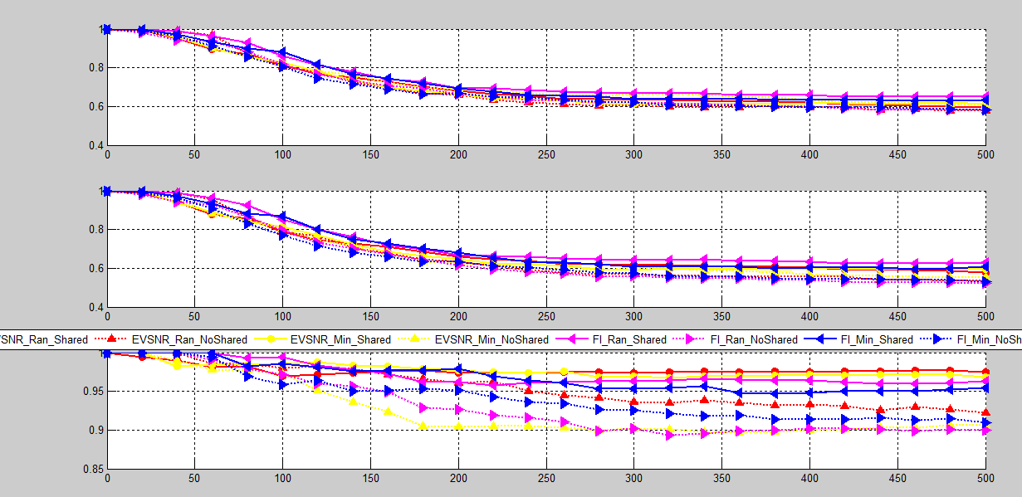

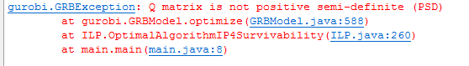

Optimize a model with 9225 rows, 17400 columns and 45749 nonzeros

Model has 90000 quadratic constraints

Coefficient statistics:

Matrix range [1e+00, 2e+01]

Objective range [1e+00, 1e+05]

Bounds range [1e+00, 2e+09]

RHS range [1e+00, 4e+01]

Presolve removed 1340 rows and 880 columns

Presolve time: 0.17s

Barrier solved model in 0 iterations and 0.17 seconds

Model is infeasible

# 调试问题

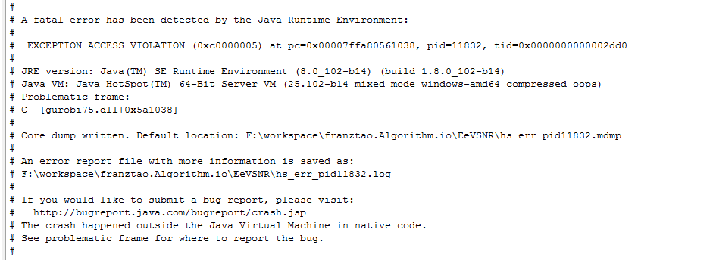

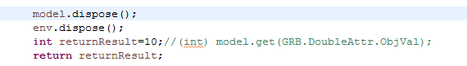

Dispose后再调用模型的问题

# Latex 快捷键

**Alt+C**：在剪贴板原有复制文本后增加新的被选择的文本。   
**Ctrl+Shift+Alt+Right/Left**：对选中文本增加或者删除Comment标记。   
**Ctrl+Enter**：自动完成LaTeX标准命令，cool。   
**Shift+Enter**：对光标所在位置的单词进行英语语法检查   
**Alt+F12**：对选中文本进行LaTeX语法检查（强烈推荐）。   
**查找**：   
**Ctrl+Shift+Backspace/Delete**： Moving Ring Backward/Forward。   
**Ctrl+Shift+F12**：括号匹配。   
**Ctrl+Shift+F1 :** 查找宏包文件   
**Ctrl+F1 :**         查找关键词   
**编译**：   
**Ctrl+Shift+X**：Texify （生成DVI文件）   
**Ctrl+Shift+D**：DVI --> PS   
**Ctrl+Shift+G**：查看PS文件   
**Ctrl+Shift+B**：编译bib文件   
**Ctrl+Shift+C**：编译选中的文本