## Openflow

https://mp.weixin.qq.com/s?__biz=MjM5MTM3MzIzMg==&mid=209584944&idx=1&sn=1558f3bb59f02ff35f2e6d5e14c51a00#rd

## odl-mini-02-symmetric1

## odl-mini-02-symmetric2

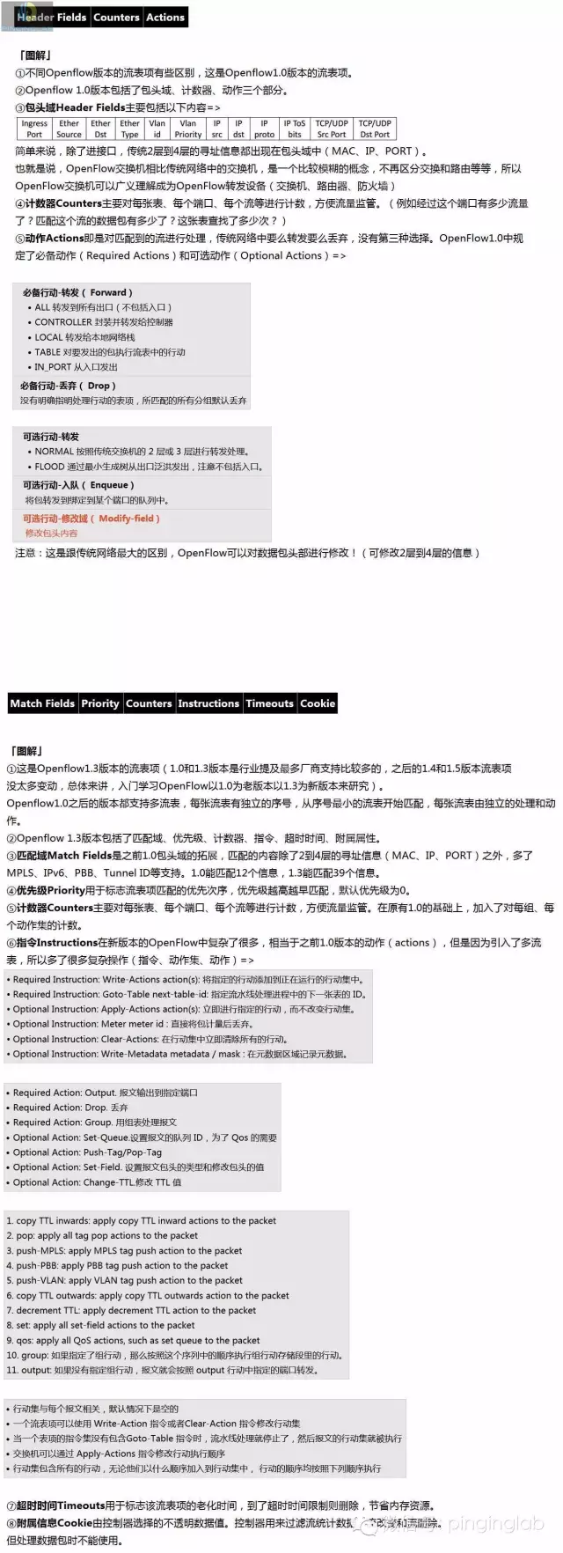

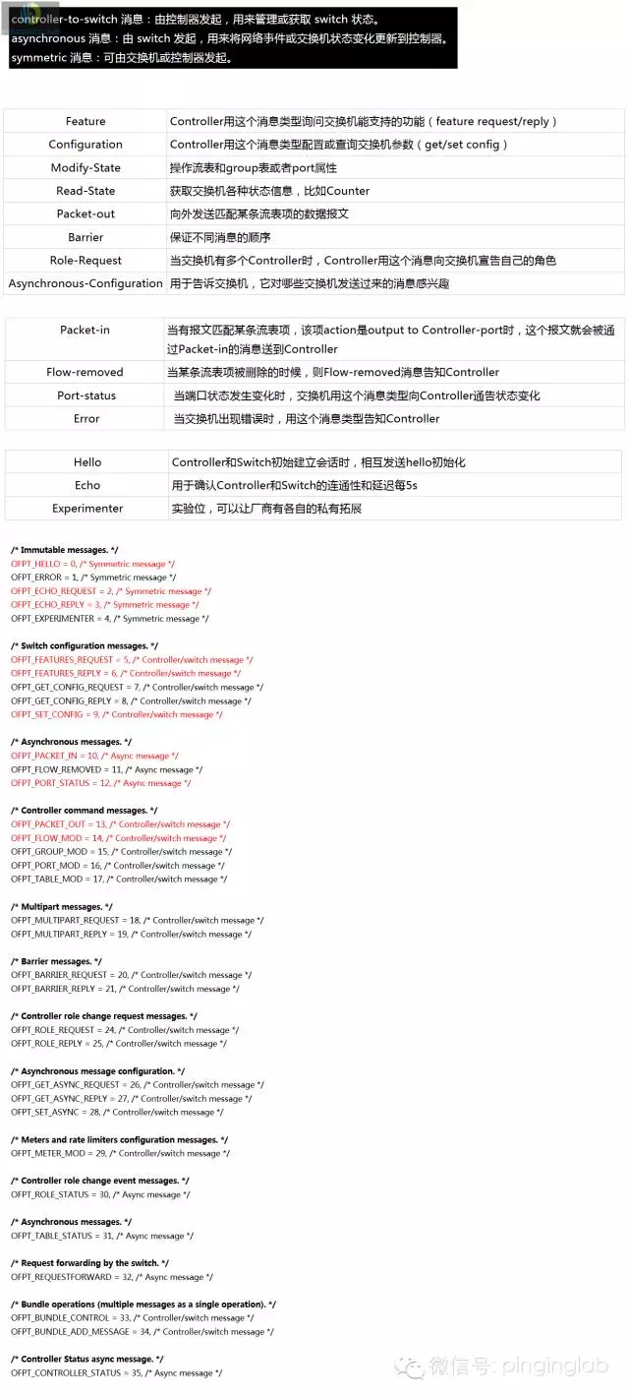



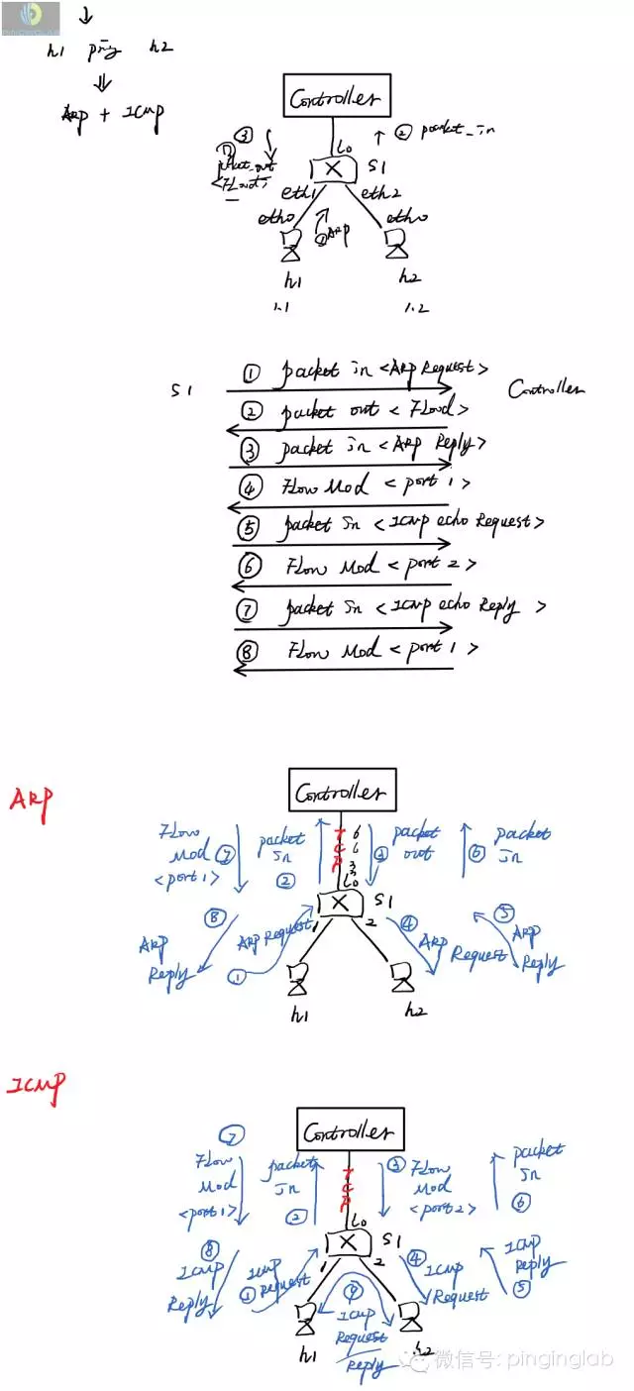



Protocol Decomposition

The OpenFlow protocol can be broken into four components: message layer, state machine, system interface, and configuration. The image and table below illustrate these components, their interaction, and describe their function at a high level.

|  |  |
| --- | --- |
| **Component** | **Description** |
| [Message Layer](http://flowgrammable.org/sdn/openflow/message-layer) | The message layer is the core of the protocol stack. It defines valid structure and semantics for all messages. A typical message layer supports the ability to construct, copy, compare, print, and manipulate messages. |
| [State Machine](http://flowgrammable.org/sdn/openflow/state-machine/) | The state machine defines the core low-level behavior of the protocol. Typically, it is used to describe actions such as: negotiation, capability discover, flow control, delivery, etc. |
| [System Interface](http://flowgrammable.org/sdn/openflow/system-interface) | The system interface defines how the protocol interacts with the outside world. It typically identifies necessary and optional interfaces along with their intended use, such as TLS and TCP as transport channels. |
| [Configuration](http://flowgrammable.org/sdn/openflow/configuration) | Almost all aspects of the protocol have configurations or initial values. Configuration can cover anything from default buffer sizes and reply intervals to X.509 certificates. |
| [Data Model](http://flowgrammable.org/sdn/openflow/data-model) | Another way to consider the OpenFlow protocol is to understand its underlying data model. Each switch maintains a relational data model that contains the attributes for each OpenFlow abstraction. These attributes either describe an abstractions capability, its configuration state, or some set of current statistics. |

### The Flowgrammable SDN Stack is a full-featured stack implementation of the OpenFlow specification,

http://flowgrammable.org/sdn/flowgrammable-stack/