# Introduction

## Objective

## Business Background

# System Architecture

## Architecture Diagram

# Workflow Process

There 3 main business process flow for eTravel system:

1. Travel Application
2. Travel Expense Claims
3. Staff Expense Claims

## Travel Application

### Process Flow Diagram

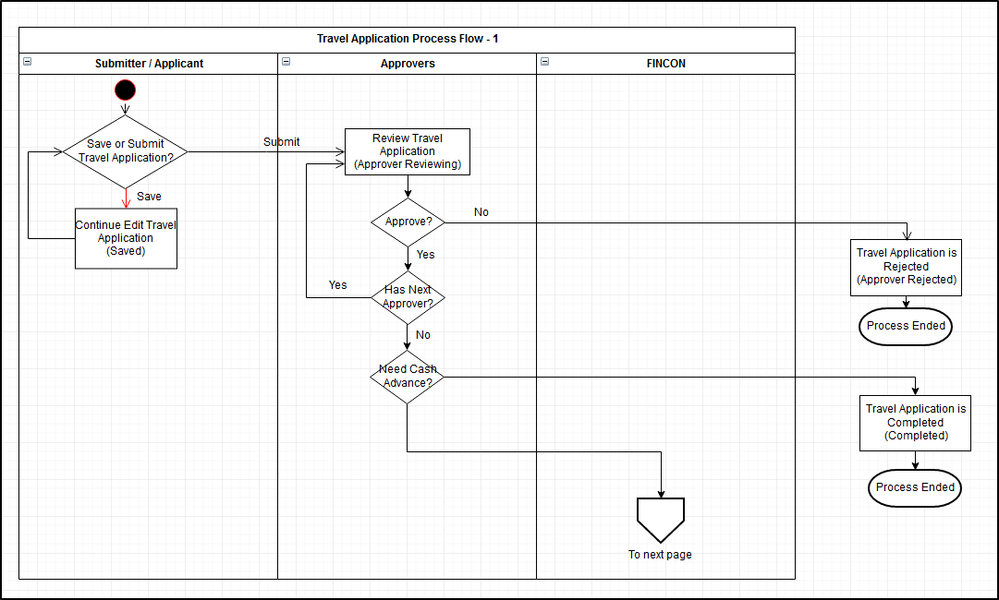

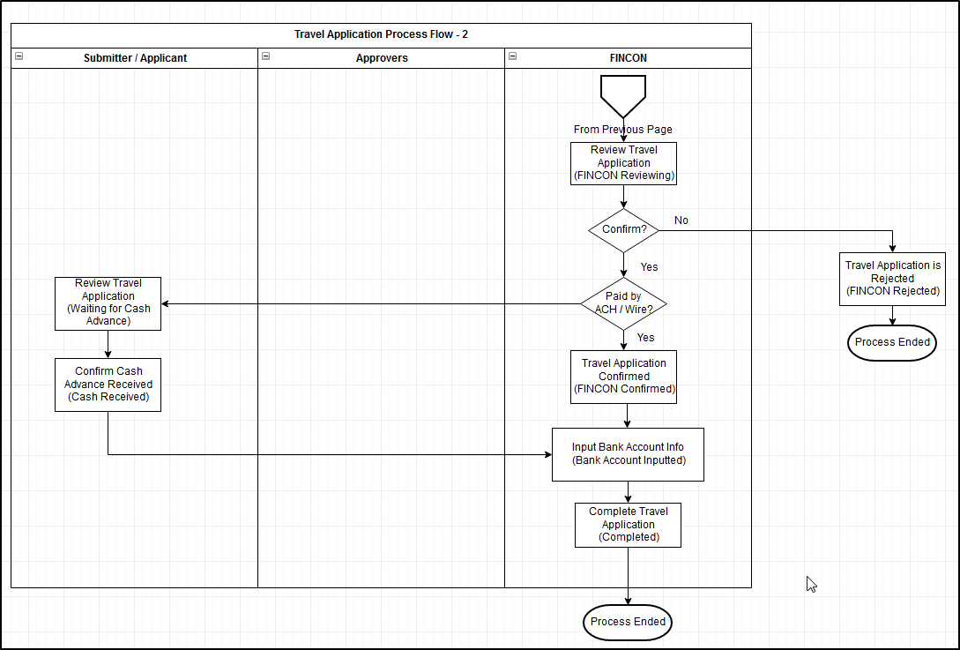

### Process Details

#### Process Status

|  |  |  |  |  |
| --- | --- | --- | --- | --- |
| **Status** | **Previous** | **Next Status** | **Task Owner** | **Conditions for Status Change** |
| Saved | N/A | Approver Reviewing | Applicant/Submitter | To “Approver Reviewing”   * Applicant/Submitter submit the request   To “Cancelled”   * Applicant/Submitter cancel the request |
| Approver Reviewing | N/A or Saved | FINCON Reviewing,  Completed,  Approver Rejected,  Cancelled | Approver | To “FINCON Reviewing”   * All Approver(s) endorsed the request * Cash Advance is necessary   To “Completed”   * All Approver(s) endorsed the request * No Cash Advance   To “Approver Rejected”   * Any one of the Approver reject the request   To “Cancelled”   * Applicant/Submitter cancel the request |
| FINCON Reviewing | Approver Reviewing | Waiting for Cash Advance,  FINCON Confirmed,  FINCON Rejected,  Approver Reviewing,  Cancelled | FINCON | To “Approver Reviewing”   * Applicant/Submitter update the form content except CC list and Remarks   To “Waiting for Cash Advance”   * FINCON approve the request * Cash Advance paid by Cash or Cheque   To “FINCON Confirmed”   * FINCON approve the request * Cash Advance paid by ACH / Wire   To “FINCON Rejected”   * FINCON reject the request   To “Cancelled”   * Applicant/Submitter cancel the request |
| Waiting for Cash Advance | FINCON Reviewing | Cash Received,  Approver Reviewing,  Cancelled | Applicant/Submitter | To “Approver Reviewing”   * Applicant/Submitter update the form content except CC list and Remarks   To “Cash Received”   * Applicant or Record Creator confirmed received Cash Advance by providing authentication   To “Cancelled”   * Applicant/Submitter cancel the request |
| Cash Received | Waiting for Cash Advance | Bank Account Inputted | FINCON | To “Bank Account Inputted”   * FINCON input bank account information |
| FINCON Confirmed | FINCON Reviewing | Bank Account Inputted | FINCON | To “Bank Account Inputted”   * FINCON input bank account information |
| Bank Account Inputted | Cash Received /  FINCON Confirmed | Completed | FINCON | To “Completed”   * FINCON click on Complete button to complete the request |
| Completed | Bank Account Inputted | N/A | N/A |  |
| Approver Rejected | Approver Reviewing | N/A | N/A |  |
| FINCON Rejected | FINCON Reviewing | N/A | N/A |  |
| Cancelled | Saved,  Approver Reviewing,  FINCON Reviewing,  Waiting for Cash Advance | N/A | N/A |  |

#### Process Properties

Task Status vs. User Role’s Access Right:

|  |  |  |  |  |
| --- | --- | --- | --- | --- |
| **Status** | **Applicant/Submitter** | **Approver** | **FINCON** | **CC Staff** |
| Saved | 1. Cancel request 2. Update form content | NIL | NIL | NIL |
| Approver Reviewing | 1. Cancel request 2. Update form content | 1. Approve/Reject 2. Update CC List | NIL | NIL |
| FINCON Reviewing | 1. Cancel request 2. Update form content | NIL | 1. Confirm / Reject 2. Update Account Code and Company columns in Cash Advance table* 3. Update CC List | NIL |
| Waiting for Cash Advance | 1. Cancel request 2. Confirm receive Cash Advance 3. Update form content | NIL | 1. Update CC List | NIL |
| Cash Received | NIL | NIL | 1. Update CC List 2. Input Bank Account Info | NIL |
| FINCON Confirmed | NIL | NIL | 1. Update CC List 2. Input Bank Account Info | NIL |
| Bank Account Inputted | NIL | NIL | 1. Click on Complete button |  |
| Completed | NIL | NIL | NIL | NIL |
| Approver Rejected | NIL | NIL | NIL | NIL |
| FINCON Rejected | NIL | NIL | NIL | NIL |
| Cancelled | NIL | NIL | NIL | NIL |

Remarks*:

1. For FINCON
   * When the status if “FINCON Reviewing”, FINCON can update Account Code and Company columns in Cash Advance table without affecting status of the record.
2. For Submitter or Approver
   * If the Submitter == Approver, system should allow user to update the form content and cancel record as Submitter role, also allow user to Endorse / Reject as Approver role.

User Actions vs. Impacts on task:

|  |  |  |  |
| --- | --- | --- | --- |
| **User Action** | **Actor** | **Task Status Before Action** | **Impacts on Task After Action** |
| Update Form Content (except update Remark and Add Approver/CC) | Applicant/Submitter | Saved,  Approver Reviewing,  FINCON Reviewing,  Waiting for Cash Advance | Task Status would be set to Approver Reviewing, with the approval/endorsement status of all approvers reset. The Approver Approval process needs to be re-run.  Popup the confirmation message for the following cases –  “***Further approval may be required if you have updated the record, are you sure you want to proceed? (Yes/No)***”   1. The request has multiple approvers, and at less one approver approved it, but the status is still Approver Reviewing 2. The request status is FINCON Reviewing or Waiting for Cash Advance |
| Add Approver | Applicant/Submitter | Approver Reviewing | New approver(s) added to the task, no impact on task status. |
| FINCON Reviewing,  Waiting for Cash Advance | Task status change back to Approver Reviewing, but approval/endorsement status of old Approvers would not be affected. |
| Update CC list | Applicant/Submitter | Saved,  Approver Reviewing,  FINCON Reviewing,  Waiting for Cash Advance | CC List of the record would be updated, but no impact on task status. |
| Approver | Approver Reviewing |
| FINCON | FINCON Reviewing,  Waiting for Cash Advance,  Cash Received,  FINCON Confirmed,  Bank Account Inputted |
| Update FINCON Specific Form Fields | FINCON | FINCON Reviewing | FINCON specific Form Fields updated, but no impact on task status |
| Notify Related Parties | Applicant/Submitter | Approver Reviewing,  FINCON Reviewing,  Waiting for Cash Advance,  Cash Received,  FINCON Confirmed,  Bank Account Inputted,  Completed | Email notification would be sent to selected staff, no impact on task status |
| Cancel Record | Applicant/Submitter | Saved,  Approver Reviewing,  FINCON Reviewing,  Waiting for Cash Advance,  Complete (If no cash advance) | Task status change to Cancelled and process ended. |
| Approve/Reject Record | Approver | Approver Reviewing | For “Approve”:   1. If there is/are still approvers not endorsed the task yet, status would not change. 2. If all approver endorsed the task, status would be changed. Please refer to workflow about the status changed.   For “Reject”:  If anyone Approver rejected the record, status would be changed to Approver Rejected, process ended. |
| Confirm/Reject Record | FINCON | FINCON Reviewing | For “Confirm”:   1. Task status would be changed. Please refer to workflow about the status changed.   For “Reject”:  Task status would be changed to FINCON Rejected, process ended. |
| Confirm Receive Cash Advance | Applicant/Submitter | Waiting for Cash Advance | After Applicant or Record Creator received cash advance (offline process), and provided authentication by inputting logon ID and password, task status would be changed to Cash Received. |
| Input Bank Account Info | FINCON | Cash Received,  FINCON Confirmed |  |
| Copy as New | Applicant/Submitter,  Approver,  FINCON | Any status | Copy all data except Attachment on new form |
| Submit Expense Record | Applicant/Submitter | Completed | Open Travel Expense Claims new form with the Travel Application ID selected |

## Travel Expense Claims

### Process Flow Diagram

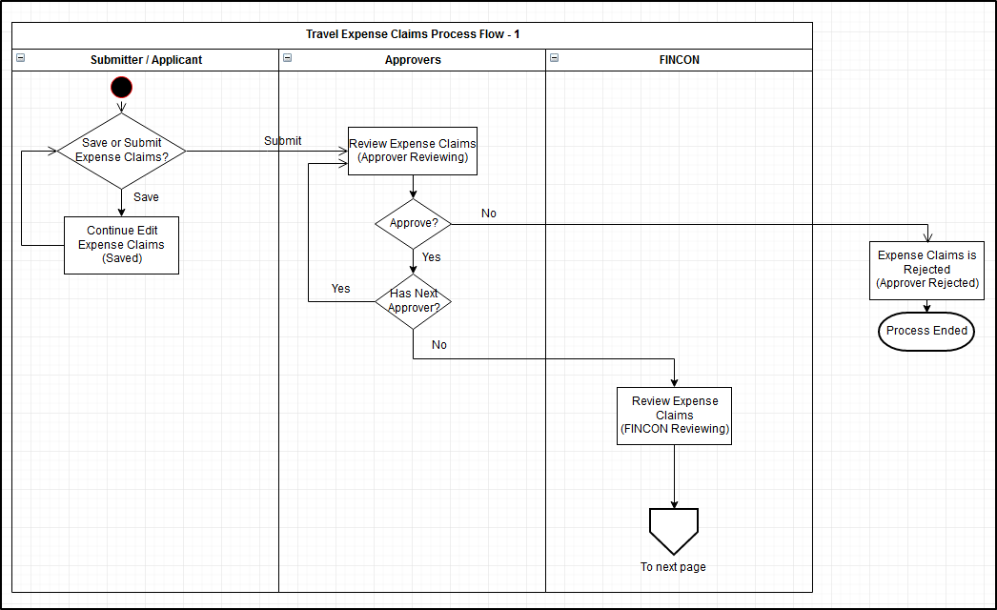

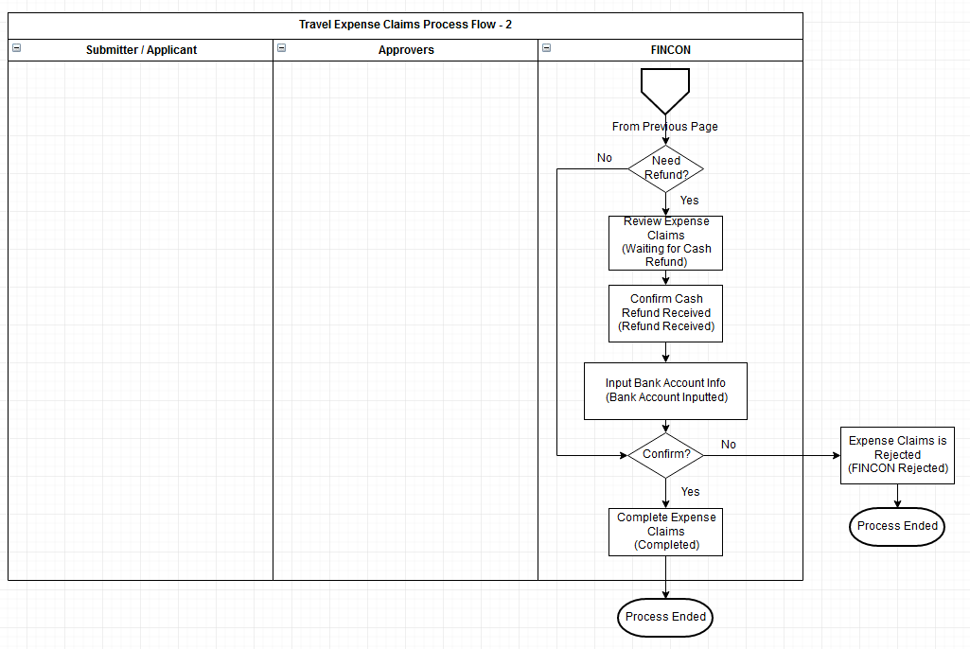

### Process Details

#### Process Status

|  |  |  |  |  |
| --- | --- | --- | --- | --- |
| **Status** | **Previous** | **Next Status** | **Task Owner** | **Conditions for Status Change** |
| Saved | N/A | Approver Reviewing | Applicant/Submitter | To “Approver Reviewing”   * Applicant/Submitter submit the request   To “Cancelled”   * Applicant/Submitter cancel the request |
| Approver Reviewing | N/A or Saved | FINCON Reviewing,  Approver Rejected,  Cancelled | Approver | To “FINCON Reviewing”   * All Approver(s) endorsed the request   To “Approver Rejected”   * Any one of the Approver reject the request   To “Cancelled”   * Applicant/Submitter cancel the request |
| FINCON Reviewing | Approver Reviewing | Completed  Waiting for Cash Refund,  FINCON Rejected,  Approver Reviewing,  Cancelled | FINCON | To “Approver Reviewing”   * Applicant/Submitter update the form content except CC list and Remarks   To “Waiting for Cash Refund”   * FINCON approve the request * Need Cash Refund   To “Completed”   * FINCON confirm the request * No Cash Refund   To “FINCON Rejected”   * FINCON reject the request   To “Cancelled”   * Applicant/Submitter cancel the request |
| Waiting for Cash Refund | FINCON Reviewing | Refund Received,  Cancelled | FINCON | To “Cash Received”   * FINCON confirmed cash refund from Applicant to company by providing authentication   To “Cancelled”   * Applicant/Submitter cancel the request |
| Refund Received | Waiting for Cash Refund | Bank Account Inputted,  FINCON Rejected | FINCON | To “Bank Account Inputted”   * FINCON input bank account information   To “FINCON Rejected”   * FINCON rejected the request |
| Bank Account Inputted | Refund Received | Completed | FINCON | To “Completed”   * FINCON click on Complete button to complete the request |
| Completed | Bank Account Inputted | N/A | N/A |  |
| Approver Rejected | Approver Reviewing | N/A | N/A |  |
| FINCON Rejected | FINCON Reviewing | N/A | N/A |  |
| Cancelled | Saved,  Approver Reviewing,  FINCON Reviewing,  Waiting for Cash Refund | N/A | N/A |  |

#### Process Properties

Task Status vs. User Role’s Access Right

|  |  |  |  |  |
| --- | --- | --- | --- | --- |
| **Status** | **Applicant/Submitter** | **Approver** | **FINCON** | **CC Staff** |
| Saved | 1. Cancel request 2. Update form content | NIL | NIL | NIL |
| Approver Reviewing | 1. Cancel request 2. Update form content | 1. Approve/Reject 2. Update CC List | NIL | NIL |
| FINCON Reviewing | 1. Cancel request 2. Update form content | NIL | 1. Confirm / Reject 2. Update Description, VAT and VAT Code columns in Expense Record table* 3. Update Reimbursement Paying Company 4. Update CC List | NIL |
| Waiting for Cash Refund | 1. Cancel request | NIL | 1. Update CC List 2. Confirm Refund Received 3. Reject | NIL |
| Refund Received | NIL | NIL | 1. Update Reimbursement Paying Company 2. Update CC List 3. Input Bank Account Info 4. Reject | NIL |
| Bank Account Inputted | NIL | NIL | 1. Click on Complete button |  |
| Completed | NIL | NIL | NIL | NIL |
| Approver Rejected | NIL | NIL | NIL | NIL |
| FINCON Rejected | NIL | NIL | NIL | NIL |
| Cancelled | NIL | NIL | NIL | NIL |

Remarks*:

1. For FINCON
   * When the status if “FINCON Reviewing”, FINCON can update Description, VAT and VAT Code columns in Expense Record table, and update Reimbursement Paying Company without affecting status of the record.
2. For Submitter or Approver
   * If the Submitter == Approver, system should allow user to update the form content and cancel record as Submitter role, also allow user to Endorse / Reject as Approver role.

User Actions vs. Impacts on task:

|  |  |  |  |
| --- | --- | --- | --- |
| **User Action** | **Actor** | **Task Status Before Action** | **Impacts on Task After Action** |
| Update Form Content (except update Remark and Add Approver/CC) | Applicant/Submitter | Saved,  Approver Reviewing,  FINCON Reviewing | Task Status would be set to Approver Reviewing, with the approval/endorsement status of all approvers reset. The Approver Approval process needs to be re-run.  Popup the confirmation message for the following cases –  “***Further approval may be required if you have updated the record, are you sure you want to proceed? (Yes/No)***”   1. The request has multiple approvers, and at less one approver approved it, but the status is still Approver Reviewing 2. The request status is FINCON Reviewing |
| Add Approver | Applicant/Submitter | Approver Reviewing | New approver(s) added to the task, no impact on task status. |
| FINCON Reviewing | Task status change back to Approver Reviewing, but approval/endorsement status of old Approvers would not be affected. |
| Update CC list | Applicant/Submitter | Saved,  Approver Reviewing,  FINCON Reviewing | CC List of the record would be updated, but no impact on task status. |
| Approver | Approver Reviewing |
| FINCON | FINCON Reviewing,  Waiting for Cash Refund,  Refund Received,  Bank Account Inputted |
| Update FINCON Specific Form Fields | FINCON | FINCON Reviewing | FINCON specific Form Fields updated, but no impact on task status |
| Cancel Record | Applicant/Submitter | Saved,  Approver Reviewing,  FINCON Reviewing,  Waiting for Cash Refund | Task status change to Cancelled and process ended. |
| Approve/Reject Record | Approver | Approver Reviewing | For “Approve”:   1. If there is/are still approvers not endorsed the task yet, status would not change. 2. If all approver endorsed the task, status would be changed. Please refer to workflow about the status changed.   For “Reject”:  If anyone Approver rejected the record, status would be changed to Approver Rejected, process ended. |
| Confirm/Reject Record | FINCON | FINCON Reviewing | For “Confirm”:   1. Task status would be changed. Please refer to workflow about the status changed.   For “Reject”:  Task status would be changed to FINCON Rejected, process ended. |
| Confirm Receive Cash Refund | FINCON | Waiting for Cash Refund | After FINCON receive refund, and provided authentication by inputting logon ID and password, task status would be changed to Refund Received. |
| Input Bank Account Info | FINCON | Refund Received |  |
| Copy as New | Applicant/Submitter,  Approver,  FINCON | Any status | Copy all data except Attachment on new form |

## Staff Expense Claims

### Process Flow Diagram

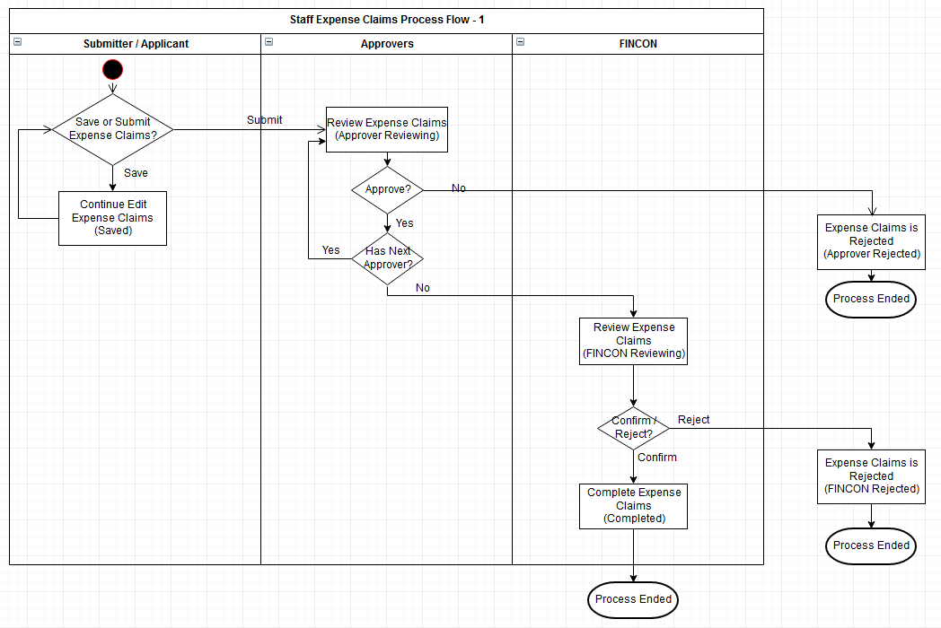

### Process Details

#### Process Status

|  |  |  |  |  |
| --- | --- | --- | --- | --- |
| **Status** | **Previous** | **Next Status** | **Task Owner** | **Conditions for Status Change** |
| Saved | N/A | Approver Reviewing | Applicant/Submitter | To “Approver Reviewing”   * Applicant/Submitter submit the request   To “Cancelled”   * Applicant/Submitter cancel the request |
| Approver Reviewing | N/A or Saved | FINCON Reviewing,  Approver Rejected,  Cancelled | Approver | To “FINCON Reviewing”   * All Approver(s) endorsed the request   To “Approver Rejected”   * Any one of the Approver reject the request   To “Cancelled”   * Applicant/Submitter cancel the request |
| FINCON Reviewing | Approver Reviewing | Completed  FINCON Rejected,  Approver Reviewing,  Cancelled | FINCON | To “Approver Reviewing”   * Applicant/Submitter update the form content except CC list and Remarks   To “Completed”   * FINCON confirm the request * No Cash Refund   To “FINCON Rejected”   * FINCON reject the request   To “Cancelled”   * Applicant/Submitter cancel the request |
| Completed | FINCON Reviewing | N/A | N/A |  |
| Approver Rejected | Approver Reviewing | N/A | N/A |  |
| FINCON Rejected | FINCON Reviewing | N/A | N/A |  |
| Cancelled | Saved,  Approver Reviewing,  FINCON Reviewing | N/A | N/A |  |

#### Process Properties

Task Status vs. User Role’s Access Right

|  |  |  |  |  |
| --- | --- | --- | --- | --- |
| **Status** | **Applicant/Submitter** | **Approver** | **FINCON** | **CC Staff** |
| Saved | 1. Cancel request 2. Update form content | NIL | NIL | NIL |
| Approver Reviewing | 1. Cancel request 2. Update form content | 1. Approve/Reject 2. Update CC List | NIL | NIL |
| FINCON Reviewing | 1. Cancel request 2. Update form content | NIL | 1. Confirm / Reject 2. Update Description, VAT and VAT Code columns in Expense Record table* 3. Update Reimbursement Paying Company 4. Update CC List | NIL |
| Completed | NIL | NIL | NIL | NIL |
| Approver Rejected | NIL | NIL | NIL | NIL |
| FINCON Rejected | NIL | NIL | NIL | NIL |
| Cancelled | NIL | NIL | NIL | NIL |

Remarks*:

1. For FINCON
   * When the status if “FINCON Reviewing”, FINCON can update Description, VAT and VAT Code columns in Expense Record table, and update Reimbursement Paying Company without affecting status of the record.
2. For Submitter or Approver
   * If the Submitter == Approver, system should allow user to update the form content and cancel record as Submitter role, also allow user to Endorse / Reject as Approver role.

User Actions vs. Impacts on task:

|  |  |  |  |
| --- | --- | --- | --- |
| **User Action** | **Actor** | **Task Status Before Action** | **Impacts on Task After Action** |
| Update Form Content (except update Remark and Add Approver/CC) | Applicant/Submitter | Saved,  Approver Reviewing,  FINCON Reviewing | Task Status would be set to Approver Reviewing, with the approval/endorsement status of all approvers reset. The Approver Approval process needs to be re-run.  Popup the confirmation message for the following cases –  “***Further approval may be required if you have updated the record, are you sure you want to proceed? (Yes/No)***”   1. The request has multiple approvers, and at less one approver approved it, but the status is still Approver Reviewing 2. The request status is FINCON Reviewing |
| Add Approver | Applicant/Submitter | Approver Reviewing | New approver(s) added to the task, no impact on task status. |
| FINCON Reviewing | Task status change back to Approver Reviewing, but approval/endorsement status of old Approvers would not be affected. |
| Update CC list | Applicant/Submitter | Saved,  Approver Reviewing,  FINCON Reviewing | CC List of the record would be updated, but no impact on task status. |
| Approver | Approver Reviewing |
| FINCON | FINCON Reviewing |
| Update FINCON Specific Form Fields | FINCON | FINCON Reviewing | FINCON specific Form Fields updated, but no impact on task status |
| Cancel Record | Applicant/Submitter | Saved,  Approver Reviewing,  FINCON Reviewing | Task status change to Cancelled and process ended. |
| Approve/Reject Record | Approver | Approver Reviewing | For “Approve”:   1. If there is/are still approvers not endorsed the task yet, status would not change. 2. If all approver endorsed the task, status would be changed. Please refer to workflow about the status changed.   For “Reject”:  If anyone Approver rejected the record, status would be changed to Approver Rejected, process ended. |
| Confirm/Reject Record | FINCON | FINCON Reviewing | For “Confirm”:   1. Task status would be changed. Please refer to workflow about the status changed.   For “Reject”:  Task status would be changed to FINCON Rejected, process ended. |
| Copy as New | Applicant/Submitter,  Approver,  FINCON | Any status | Copy all data except Attachment on new form |

# Data Schema

**Relation of Travel Application and Travel Expense Claims**

1 Travel Authorization can be associated to multiple Expense Report (no limit on number of Expense Report)

**Time-zone handling for records**

For any Datetime column in Travel Authorization, Expense Report and their associated tables, the Datetime value would be stored in GMT+0.

**Travel Authorization ID**

Travel Authorization ID would be auto-generated by system upon a new Travel Authorization is successfully created, with below format:

TA + <Applicant’s Domain ID> + <System Date in ‘YY’> + 4 digits auto increment number*>

e.g. TAKONGMA100001  
*Remarks*

*\* System would automatically reset 4 digits number to 0001 per year (Jan 1)*

**Travel Expense Report ID**

Generation of Expense Report is same as that of Travel Application ID, just replace the prefix “TA” with “ER“.

e.g. ERKONGMA100001

**Staff Expense Claims ID**

Generation of Staff Expense Claims is same as that of Travel Application ID, just replace the prefix “TA” with “SR“.

e.g. SRKONGMA100001

## Travel Application

TAMain

CMTravelItinerary

TACashAdvance

TAEstimatedExpenses

CMApprover

CMCcStaff

CMCcGroup

CMFA

CMAttachment

TABankInformation

## Travel Expense Claims and

ERMain

CMTravelItinerary

ERExpenseCharge

ERExpenseDetails

ERMileage

ERSummaryExchangeRate

ERSummaryCashAdvanceRefund

CMApprover

CMCcStaff

CMCcGroup

CMFA

CMAttachmentContent

ERBankInformation

## Staff Expense Claims

ERMain

ERExpenseCharge

ERExpenseDetails

ERMileage

CMApprover

CMCcStaff

CMCcGroup

CMFA

CMAttachmentContent

# Code Table Maintenance

# FINCON User Group Maintenance

## Data Schema for FINCON User Group

ACGlobalFnaUserGroup

ACRegionalFnaAddressGroup

ACRegionalFnaUserGroup

## Data Maintenance (Won’t be included in MVP)

## Retrieve Regional FINCON Staff for Travel Application, Travel Expense Claims or Staff Expense Claims

System can get the FINCON Staff list from datatable ACRegionalFnaUserGroup by the selected FINCON company/office in TA/ER/SR

# User Authentication

Authentication of e-Travel system would integrate with the Active Directory of OOCL Domain.

## Authentication in accessing Web UI

Whenever user tries to access records in e-Travel application through:

1. Any web pages in e-Travel application directly
2. The buttons or links in email notifications

System would automatically retrieve user’s authentication information from Windows and authenticate with OOCL Domain Group in Active Directory at the backend. User no need to input login name and password manually.

If authentication failed, system would redirect to a default access deny page.

## Authentication for e-signature

When user perform below actions, they are required to input their login name and password as an e-signature by providing their authentication:

1. Confirm receive cash advance – Applicant / Submitter
2. Confirm receive refund – FINCON

# Access Control

There are totally 4 ways to access Travel Authorization and Expense Record in e-Travel application:

1. To-Do-List
2. My Submission
3. Searching page
4. Email Notification
   1. Buttons to perform action directly
   2. Links to open record

When user opens a record through any one of above way, system would first run authentication logic (refer to section 7) to identify the identify of user. Then determine the access right of user depending on the access control described in this section.

## Create Records

For Travel Application, Travel Expense Claims and Staff Expense Report,

* + Staff can create their own records as applicant
  + Staff can create records for any other staff as record creator

## View and Search Records

For Travel Application, Travel Expense Claims and Staff Expense Report, staff can search out and view the records, if they belong to either one of below group:

* + Record Creator of the record
  + Applicant of the record
  + Approver
  + Included in the CC list of the record
  + Staff in the Regional FINCON User Group of the request, refer to section 6.3 on how to retrieve FINCON users
  + Staff in the Global FINCON User Group

**Exceptional page:**

When create a Travel Expense Claims, in search Travel Application pop-up layer, there is no access control on the searching function. User can search for any records in the pop-up layer, but no able to view the details.

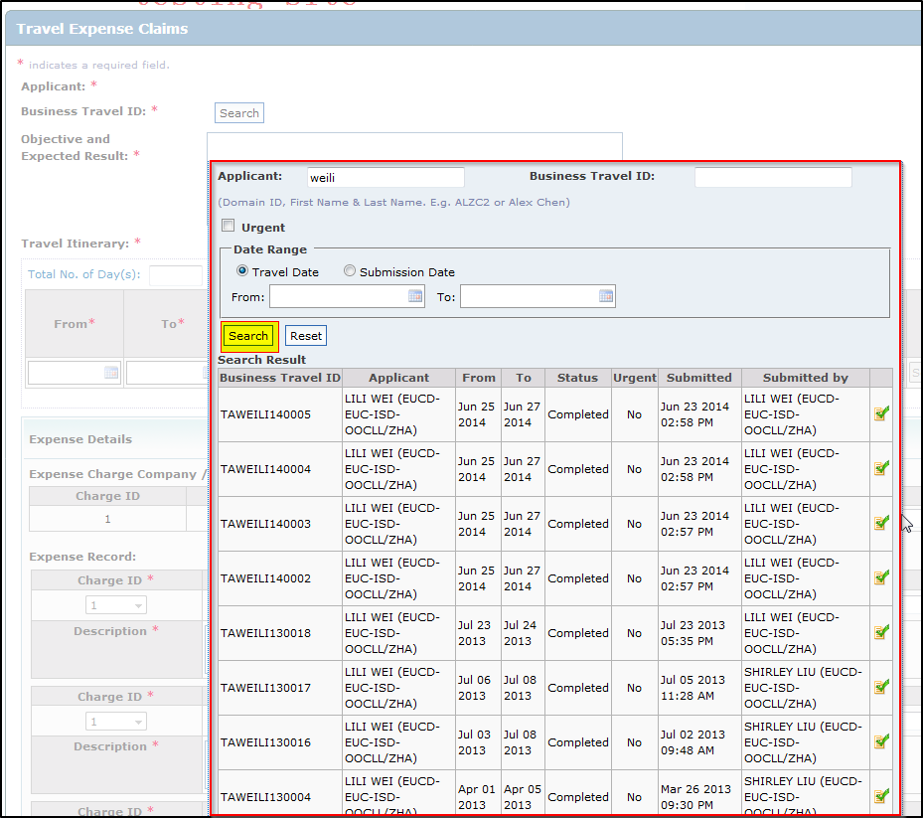

## User Actions in workflow Process

Please refer to section 3.1.2.2, 3.2.2.2 and 3.3.2.2

## Handling on Multiple Roles

It is possible for a staff to have more than one roles in a Travel Authorization or Expense Report record. If this happen, the staff would have access right of both user roles when access the record.

**Applicant and Record Creator**

Conditions: Applicant would be the Creator of the record if he/she create a Travel Authorization or Expense Report for him/herself.

Access Control Logic: If Applicant create the TA/ER/SR record him/herself, there would be no Record Creator role for that record.

**Applicant/Record Creator and FINCON**

Conditions: It is possible for FINCON staff to apply TA, ER and SR for themselves.

Access Control Logic:

The staff would have Applicant/Record Creator and FINCON access rights at all task status. Refer to section 3.1.2.2, 3.2.2.2 and 3.3.2.2.

**Approver and FINCON**

Conditions: It is possible that the staff in Approver list is also belong to FINCON group of the record

Access Control Logic:

The staff would have Approver and FINCON access rights at all task status. Refer to section 3.1.2.2, 3.2.2.2 and 3.3.2.2.

**Record Creator and Approver**

Conditions: It is possible that Record Creator is also included in the Approver List of the TA, ER or SR record.

Access Control Logic:

The staff would have Record Creator and Approver access rights at all task status Refer to section 3.1.2.2, 3.2.2.2 and 3.3.2.2.

**Record Creator and Approver and FINCON**

Conditions: It is possible that Record Creator is also included in the Approver List, and also belongs to FINCON group of the TA, ER or SR record.

Access Control Logic:

The staff would have Record Creator and Approver and FINCON access rights at all task status. Refer to section 3.1.2.2, 3.2.2.2 and 3.3.2.2.

**Applicant and Approver**

Disallowed

## Concurrent Access Handling

A generic checking logic would be implemented to check against the Last Update Datetime of the record at DB whenever update is performed on a Travel Authorization or Expense Report record:

1. When open a record in Update View, system would remember the Last Update Datetime of the record
2. When user click on a button to update the record, system retrieve the latest Last Update Datetime of the record from DB, if the retrieved Datetime did not align with the Datetime retrieved during record open, system would exit the update process and prompt below warning message:

“The record has been updated by others, please close the page and open again to get the most updated version.”

The actions which require concurrent access checking are listed below:

**Travel Application**

|  |  |
| --- | --- |
| **Action** | **Actors** |
| Update Form Content | Applicant, Record Creator |
| Add Approver | Applicant, Record Creator |
| Update CC List | Applicant, Record Creator, Approver, FINCON |
| Approve / Reject | Approver |
| Confirm / Reject | FINCON |
| Update FINCON Specific Form Fields | FINCON |
| Confirm Receive Cash Advance | Applicant, Record Creator, FINCON |
| Cancel Record | Applicant, Record Creator |
| Input Bank Account Info | FINCON |

**Travel Expense Claims**

|  |  |
| --- | --- |
| **Action** | **Actors** |
| Update Form Content | Applicant, Record Creator |
| Add Approver | Applicant, Record Creator |
| Update CC List | Applicant, Record Creator, Approver, FINCON |
| Approve / Reject | Approver |
| Confirm / Reject | FINCON |
| Input Bank Account Info | FINCON |
| Confirm Receive Refund | FINCON |
| Cancel Record | Applicant, Record Creator |

**Staff Expense Claims**

|  |  |
| --- | --- |
| **Action** | **Actors** |
| Update Form Content | Applicant, Record Creator |
| Add Approver | Applicant, Record Creator |
| Update CC List | Applicant, Record Creator, Approver, FINCON |
| Approve / Reject | Approver |
| Confirm / Reject | FINCON |
| Cancel Record | Applicant, Record Creator |

# UI Specifications

## Screen List

## Common UI Control

**Properties of Travel Application**

* Minimum/Maximum Travel Itinerary entries per record: 1/30
* Minimum/Maximum Cash Advance entries per record: 0/10
* Minimum/Maximum Approver/Endorser per record: 1/5
* Minimum/Maximum CC List Staff per record: 0/30
* Minimum/Maximum Attachment File per record: 0/20
* Minimum/Maximum Bank Account info per record: 0/20
* Maximum File size per Attachment File: 2 MB

Applicant is disallowed to be added to Approver/Endorser and CC List

Record Creator is disallowed to be added to CC List

Approver is disallowed to be added to CC List

Field checking would be implemented in Create / Update Travel Authorization Form to prevent user from exceeding/violating above limits/rules.

**Properties of Travel Expense Claims**

* Minimum/Maximum Travel Itinerary entries per record: 1/20
* Minimum/Maximum Expense Charge entries per record: 1/20
* Minimum/Maximum Expense Record entries per record: 0/50
* Minimum/Maximum Approver/Endorser per record: 1/5
* Minimum/Maximum CC List Staff per record: 0/30
* Minimum/Maximum Attachment File per record: 0/20
* Minimum/Maximum Bank Account info per record: 0/20
* Maximum File size per Attachment File: 2 MB

Applicant is disallowed to be added to Approver/Endorser and CC List

Record Creator is disallowed to be added to CC List

Approver is disallowed to be added to CC List

Field checking would be implemented in Create / Update Expense Report Form to prevent user from exceeding/violating above limits/rules.

**Properties of Staff Expense Claims**

* Minimum/Maximum Expense Charge entries per record: 1/20
* Minimum/Maximum Expense Record entries per record: 0/50
* Minimum/Maximum Approver/Endorser per record: 1/5
* Minimum/Maximum CC List Staff per record: 0/30
* Minimum/Maximum Attachment File per record: 0/20
* Maximum File size per Attachment File: 2 MB

Applicant is disallowed to be added to Approver/Endorser and CC List

Record Creator is disallowed to be added to CC List

Approver is disallowed to be added to CC List

Field checking would be implemented in Create / Update Expense Report Form to prevent user from exceeding/violating above limits/rules.

**Summary: If the entries match the Maximum, popup message “You cannot add more than {Maximum} entries in {Table Name}.”.**

**Sorting records by column headers**

Column headers of all record tables in the whole application have sorting feature. When user clicks on the column header, the record would be sorted by that column in ascending (with upward arrow) or descending (with downward arrow) order.

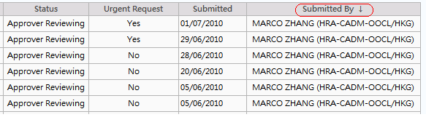

## Home Page (UI-1)

### UI

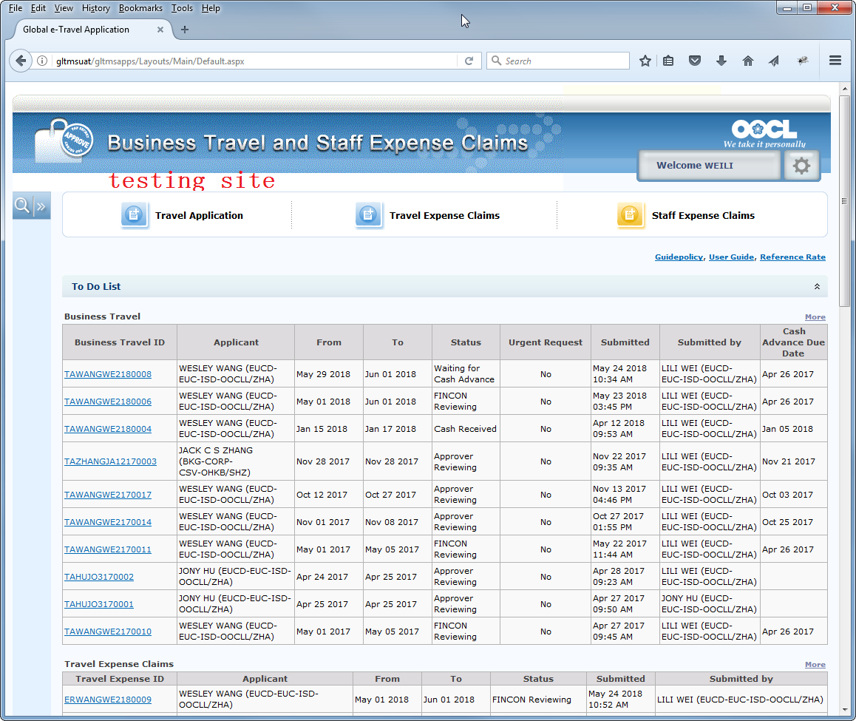

Please refer to <http://gltmsuat/gltmsapps/Layouts/Main/Default.aspx>

**TO-DO-LIST**

Data Retrieval logic

This section would display the records of which logon user is the task owner for Travel Application, Travel Expense Claims and Staff Expense Claims.

For Travel Application, records would be included in To-Do-List if logon user is the task owner at below task status:

|  |  |
| --- | --- |
| **Task Status** | **Task Owner** |
| Approver Reviewing | Approver, which has not approved yet |
| FINCON Reviewing | Regional FINCON Staff (refer to section 6.3), or Global FINCON |
| Waiting for Cash Advance | Applicant and Record Creator |
| Cash Received | Regional FINCON Staff (refer to section 6.3), or Global FINCON |
| FINCON Confirmed | Regional FINCON Staff (refer to section 6.3), or Global FINCON |
| Bank Account Inputted | Regional FINCON Staff (refer to section 6.3), or Global FINCON |

For Travel Expense Claims, records would be included in To-Do-List if logon user is the task owner at below task status:

|  |  |
| --- | --- |
| **Task Status** | **Task Owner** |
| Approver Reviewing | Approver, which has not approved yet |
| FINCON Reviewing | Regional FINCON Staff (refer to section 6.3), or Global FINCON |
| Waiting for Cash Refund | Regional FINCON Staff (refer to section 6.3), or Global FINCON |
| Refund Received | Regional FINCON Staff (refer to section 6.3), or Global FINCON |
| Bank Account Inputted | Regional FINCON Staff (refer to section 6.3), or Global FINCON |

For Staff Expense Claims, records would be included in To-Do-List if logon user is the task owner at below task status:

|  |  |
| --- | --- |
| **Task Status** | **Task Owner** |
| Approver Reviewing | Approver, which has not approved yet |
| FINCON Reviewing | Regional FINCON Staff (refer to section 6.3), or Global FINCON |

Record with any other status not stated above would not be included in To-Do-List.

Default Ordering of Records

Created date descending

Number of Records Display by Default

By default, only the first 10 TA, ER and SR records extracted by above ordering logic would be displayed.

“More” Links

If there are more than 10 records in To-Do-List, system would only display the first 10 records by default, and “More” links would appear above the record tables.

After clicked on the “More” links, the page would be refreshed to list out all outstanding TA, ER or SR records with pagination, 20 records per page.

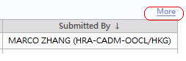

**My Submission**

Data Retrieval logic

This section would display the TA/ER/SR records created by user, i.e. Submitted By = Logon user, or Applicant = Logon user

Default Ordering of Records

Created date descending

Number of Records Display

Only the first 5 TA/ER/SR records extracted by above ordering logic would be displayed.

**Search Criteria**

Search Criteria would appear/hide when click on the arrow button on the left-hand side:

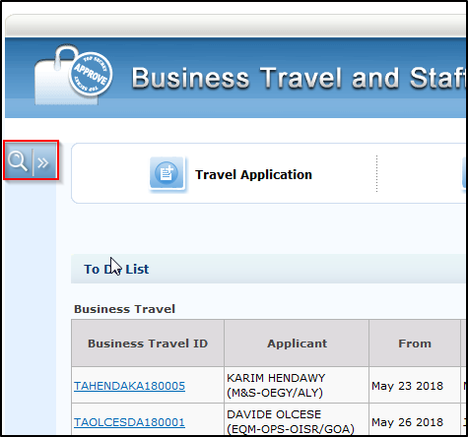

### Form Field Specifications

**Travel Authorization**

| Form Field | Description | Data Type | Multi-lingual | Data Length | Mandatory | Values | Default |
| --- | --- | --- | --- | --- | --- | --- | --- |
| Business Travel ID | ID of the Travel Application Record | Read-only text | No | N/A | N/A | TA_MAIN - TravelAuthorizationID | N/A |
| Applicant | Email Banner of the Applicant | Read-only text | No | N/A | N/A | TA_MAIN - ApplicantEmailBanner | N/A |
| From | Extracted from the earliest From Date in Travel Itinerary | Read-only text | No | N/A | N/A | Earliest value of CMTravelItinerary – FromDate | N/A |
| To | Extracted from the latest To Date in Travel Itinerary | Read-only text | No | N/A | N/A | Latest value of CMTravelItinerary – ToDate | N/A |
| City (only shown on My Submission table) | Combine the City with “/” in Travel Itinerary, etc. Oporto/Barcelona/Hong Kong | Read-only text | No | N/A | N/A | Combine the value of City column in CMTravelItinerary with “/”, etc. Oporto/Barcelona/Hong Kong | N/A |
| Status | Status of the Travel Application Record | Read-only text | No | N/A | N/A | TA_MAIN – Status | N/A |
| Urgent Request | Flag to indicate if the record is urgent request | Read-only text | No | N/A | N/A | TA_MAIN – IsUrgentRequest | N/A |
| Submitted | Date when the record is created | Read-only text | No | N/A | N/A | TA_MAIN – CreatedAt | N/A |
| Submitted By | Email banner of the staff who created this record | Read-only text | No | N/A | N/A | TA_MAIN – CreatedByBanner | N/A |
| [Cash Advance Due Date](javascript:__doPostBack('ucResultLists$gvTA_ToDo','Sort$CashAdvanceDueDate')) | The Due Date of Cash Advance | Read-only text | No | N/A | N/A | TA_MAIN – CashAdvanceDueDate | N/A |

**Expense Report**

| Form Field | Description | Data Type | Multi-lingual | Data Length | Mandatory | Values | Default |
| --- | --- | --- | --- | --- | --- | --- | --- |
| Travel Expense ID | ID of the Expense Report Record | Read-only text | No | N/A | N/A | ER_MAIN – ExpenseReportID | N/A |
| Applicant | Email Banner of the Applicant | Read-only text | No | N/A | N/A | ER_MAIN - ApplicantEmailBanner | N/A |
| From | Extracted from the earliest From Date in Travel Itinerary | Read-only text | No | N/A | N/A | Earliest value of CMTravelItinerary – FromDate | N/A |
| To | Extracted from the latest To Date in Travel Itinerary | Read-only text | No | N/A | N/A | Latest value of CMTravelItinerary – ToDate | N/A |
| Status | Status of the Expense Report Record | Read-only text | No | N/A | N/A | ER_MAIN – Status | N/A |
| Submitted | Date when the record is created | Read-only text | No | N/A | N/A | ER_MAIN – CreatedAt | N/A |
| Submitted By | Email banner of the staff who created this record | Read-only text | No | N/A | N/A | ER_MAIN – CreatedByBanner | N/A |

### Field Actions



* + On click: Open home page (UI-1)



* + On click: Open Travel Application create page



* + On click: Open Travel Expense Claims create page



* + On click: Open Staff Expense Claims create page

## Search Travel Application, Travel Expense Claims and Staff Expense Claims Page (UI-2)

### UI

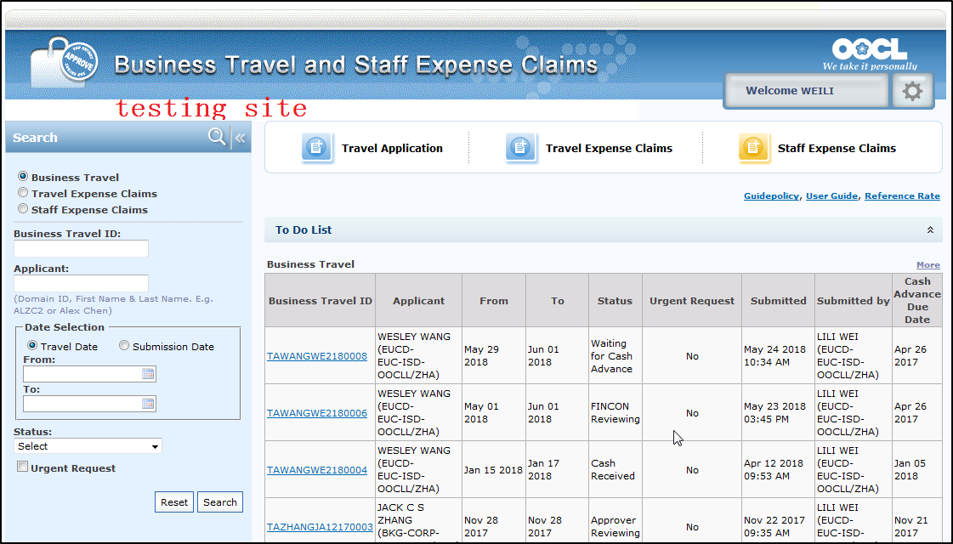

Please refer to <http://gltmsuat/gltmsapps/Layouts/Main/Default.aspx>

**Searching Logic for Travel Application**

|  |  |  |
| --- | --- | --- |
| **Search Criteria Field** | **Target field in DB table** | **Comparison Logic** |
| Business Travel ID | TA_MAIN – TravelAuthorizationID | Case insensitive exact match |
| Applicant | Name prefix of TA_MAIN – ApplicantEmailBanner, or Application Domain ID - TA_MAIN - ApplicantDomainID  E.g. MARCO KONG (HR-CADM-OOCLL/HKG), MARCO KONG is the name prefix, KONGMA | Case insensitive “like” match (i.e. “Like” operator in SQL) |
| Travel Date – From | Extract the earliest date in CMTravelItinerary – From Date | <Inputted Date> >= Earliest value of CMTravelItinerary – FromDate,  by joining TA_MAIN and CMTravelItinerary using TravelAuthorizationID |
| Travel Date – To | Extract the latest date in TravelAuthorizationID – To Date | <Inputted Date> <= latest value of CMTravelItinerary – ToDate,  by joining TA_MAIN and CMTravelItinerary using TravelAuthorizationID |
| Submission Date – From | TA_MAIN – Created Date | <Inputted Date> >= TA_MAIN – CreatedAt |
| Submission Date – To | TA_MAIN – Created Date | <Inputted Date> <= TA_MAIN – CreatedAt |
| Status | TA_MAIN – Status | Exact Match |
| Urgent Request | TA_MAIN – IsUrgentRequest | char(Y/N) matching |

The search criteria fields would be combined together using “AND” logic.

While within Travel/Submission Date, From/To Date are combined using “AND” logic.

**Searching Logic for Travel Expense Report**

|  |  |  |
| --- | --- | --- |
| **Search Criteria Field** | **Target field in DB table** | **Comparison Logic** |
| Travel Expense ID | ER_MAIN – ExpenseReportID | Case insensitive exact match |
| Applicant | Name prefix of TA_MAIN – ApplicantEmailBanner, or Application Domain ID - TA_MAIN - ApplicantDomainID  E.g. MARCO KONG (HR-CADM-OOCLL/HKG), MARCO KONG is the name prefix, KONGMA | Case insensitive “like” match (i.e. “Like” operator in SQL) |
| Travel Date – From | Extract the earliest date in CMTravelItinerary – From Date | <Inputted Date> >= Earliest value of CMTravelItinerary – FromDate,  by joining ER_MAIN and CMTravelItinerary using ExpenseReportID |
| Travel Date – To | Extract the latest date in TravelAuthorizationID – To Date | <Inputted Date> <= latest value of CMTravelItinerary – ToDate,  by joining ER_MAIN and CMTravelItinerary using ExpenseReportID |
| Submission Date – From | ER _MAIN – Created Date | <Inputted Date> >= ER _MAIN – CreatedAt |
| Submission Date – To | ER _MAIN – Created Date | <Inputted Date> <= ER _MAIN – CreatedAt |
| Status | ER _MAIN – Status | Exact Match |

The search criteria fields would be combined together using “AND” logic.

While within Travel/Submission Date, From/To Date are combined using “AND” logic.

**Searching Logic for Staff Expense Report**

|  |  |  |
| --- | --- | --- |
| **Search Criteria Field** | **Target field in DB table** | **Comparison Logic** |
| Staff Expense Claims ID | ER_MAIN – ExpenseReportID | Case insensitive exact match |
| Applicant | Name prefix of TA_MAIN – ApplicantEmailBanner, or Application Domain ID - TA_MAIN - ApplicantDomainID  E.g. MARCO KONG (HR-CADM-OOCLL/HKG), MARCO KONG is the name prefix, KONGMA | Case insensitive “like” match (i.e. “Like” operator in SQL) |
| Submission Date – From | ER _MAIN – Created Date | <Inputted Date> >= ER _MAIN – CreatedAt |
| Submission Date – To | ER _MAIN – Created Date | <Inputted Date> <= ER _MAIN – CreatedAt |
| Status | ER _MAIN – Status | Exact Match |

The search criteria fields would be combined together using “AND” logic.

While within Travel/Submission Date, From/To Date are combined using “AND” logic.

**Ordering of Records**

For both search results of Travel Authorization and Expense Report, the records would be ordered by Submitted descending.

**Paging**

At most 20 records would be displayed per page for both search results of Travel Authorization and Expense Report. If a searching return more than 20 records, paging URL would be available at the bottom of the page.



**Access Control**

Refer to section 8.2 for the access control on searching TA and ER records.

### Form Field Specifications

**Search Criteria**

| Form Field | Description | Data Type | Multi-lingual | Data Length | Mandatory | Values | Default |
| --- | --- | --- | --- | --- | --- | --- | --- |
| Search Option | Define the type of records to be searched | Radio button | No | N/A | Yes | Business Travel,  Travel Expense Claims,  Staff Expense Claims | Business Travel |
| Business Travel ID / Travel Expense ID / Staff Expense Claims ID | ID of the Travel Application, Travel Expense Claims or Staff Expense Claims to be searched | Text | No | 50 | No | User inputted | <Blank> |
| Applicant | Name of the applicant (name prefix in email banner), or applicant domain id | Text | No | 128 | No | User inputted | <Blank> |
| Date Option (For Business Travel and Travel Expense Claims only) | Define the type of date values to be used in search criteria | Radio button | No | N/A | Yes | Travel Date, Submission Date | Travel Date |
| From Date | From Date of Date searching criteria | Date | No | N/A | No | User inputted | <Blank> |
| To Date | To Date of Date searching criteria | Date | No | N/A | No | User inputted | <Blank> |
| Status | Status of Travel Application, Travel Expense Claims or Staff Expense Claims | Pull-down | No | N/A | Yes | From code table? (TBC) | “Any” |
| Urgent Request(For Business Travel only) | A flag for Travel Application to indicate if the record is in urgent | Checkbox | No | N/A | No | User inputted | Unchecked |

**Search Result**

Same as that in Main page, refer to section 9.3.2

### Field Actions

**Reset button**:

* + on click: reset all fields in search criteria and search result table

**Search option radio button**:

* + If selected “Business Travel”, search criteria form should contain

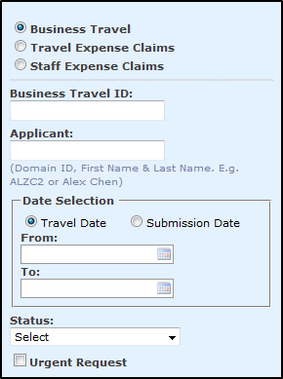

* + If selected “Travel Expense Claims”, search criteria form should contain

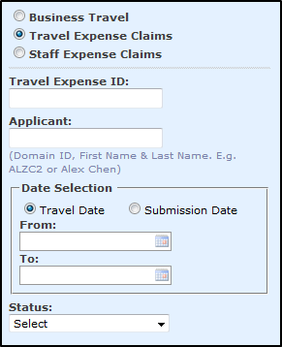

* + If selected “Staff Expense Claims”, search criteria form should contain

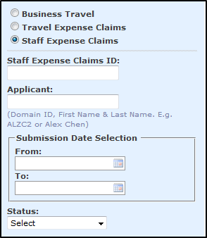

**Search button**:

* + On click:
    - Check if at least one search criteria is inputted
      * If yes, go on below process
      * Otherwise, exist the process with warning message: “Please input search criteria.”
    - Run searching based on input criteria
      * If no records return on searching, display below message in the search result table: “No record found.”
      * Otherwise, refresh the page to display the search result.

## Create Travel Application Page (UI-3)

### UI

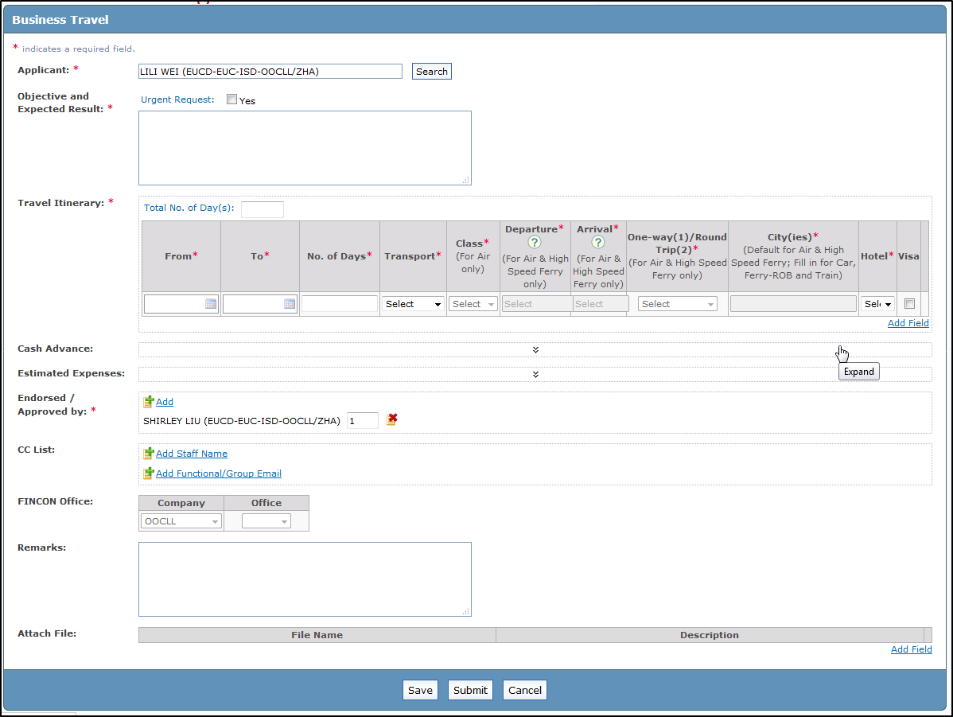

Please refer to <http://gltmsuat/gltmsapps/Layouts/Main/eTravelNew.aspx>

**Page initialization**

Applicant: default email banner of login user

Travel Itinerary: default 1 empty row added

Cash Advance: default collapse, default Company and Account Code columns from the last completed TA record

Estimated Expense: default collapse

Endorsed by: Default approvers from the last completed TA record

CC List: Default CC list from the last completed TA record

FINCON Office: default from the last completed TA record

Attach File: default 0 row

### Form Field Specifications

| Form Field | Description | Data Type | Multi-lingual | Data Length | Mandatory | Values | Default |
| --- | --- | --- | --- | --- | --- | --- | --- |
| Applicant | Email Banner of Applicant | Read-only Text | No | 128 | Yes | Selected from search staff layer | Email Banner of Logon User |
| Urgent Request | Flag to indicate if the record is an urgent request | Checkbox | No | N/A | No | Inputted by user | Unchecked |
| Objective and Expected Result | Free text input field for user to input objective and expected result of travel | Text | No | 1000 | Yes | Inputted by user | <Blank> |

**Travel Itinerary**

| Form Field | Description | Data Type | Multi-lingual | Data Length | Mandatory | Values | Default |
| --- | --- | --- | --- | --- | --- | --- | --- |
| Total Number of Day(s) | Total Number of Travel Days | Number | N/A | [4.1] | Yes | Auto computes (Last Travel Itinerary To Date – First Travel Itinerary From Date). Allow User to change the value | <blank> |
| From Date | Start date of each segment of travel itinerary | Date | N/A | N/A | Yes | User Inputted | <Blank> |
| To Date | End date of each segment of travel itinerary | Date | N/A | N/A | Yes | User Inputted | <Blank> |
| No. of Days | No. of days of the segment of travel itinerary | Number | N/A | [4.1] | Yes | Auto computes (To Date – From Date) Allow User to change the value | <Blank> |
| Transport |  | Pull-down | N/A | N/A | Yes | Code table CT_TRANSPORT Type – Transport Type | <Blank> |
| Class |  | Pull-down | N/A | N/A | Yes/No * | Code table CT_TRANSPORT_CLASS – Class Type | <Blank> |
| Departure |  | Auto-completed | N/A | 200 | Yes/No * | Air: Code table CT_AIR –  If USA - City (StateForUSA), AirportName (IATA), Country  If non-USA - City (StateForUSA), AirportName (IATA), Country  High Speed Ferry: Code table CT_Ferry_Terminal – City, Ferry_Terminal, Location | <Blank> |
| Arrival |  | Auto-completed | N/A | 200 | Yes/No * | Same as above | <Blank> |
| One-way(1)/Round Trip(2) |  | Pull-down | N/A | N/A | Yes/No * | 1 or 2 | 1 |
| City |  | Text | N/A | 100 | Yes | Air or High Speed Ferry: Default from Arrival  Other Transport type: User inputted | <Blank> |
| Hotel |  | Pull-down | N/A | N/A | Yes | Yes, No | <Blank> |
| Visa |  | Pull-down | N/A | N/A | Yes | Yes, No | <Blank> |

Remarks  
* Class would be mandatory if the selected value in Transport (from code table CT_TRANSPORT_TYPE) having “Class Mandatory” column set to “Y”, refer to section 5.3.1 for details of code table schema

* Departure, Arrival, and One-way(1)/Round Trip(2) would be enable only when the Transport is Air or High Speed Ferry

**Cash Advance**

| Form Field | Description | Data Type | Multi-lingual | Data Length | Mandatory | Values | Default |
| --- | --- | --- | --- | --- | --- | --- | --- |
| Due Date | Due date of paying the cash advance to applicant | Date | No | N/A | No | Inputted by user | <Blank> |
| CCY | Currency of cash advance | Pull-down | No | N/A | Yes * | CT_CURRENCY_CODE – Currency Code | <Blank> |
| Amount | Amount of cash advance in a currency | Number | No | [10.2] | Yes * | User inputted | <Blank> |
| By | Paid by type | Pull-down | No | N/A | Yes * | Code table CT_PAID_BY_CASH_ADVANCE – Type | <Blank> |
| Account Code |  | Pull-down | No | N/A | Yes * | Code table CT_COMPANY – CashAdvanceAccountCode, filtered by Company column.  By default select the first Account Code record  Once the value of Company column changed, the pulldown list of Account Code will be changed accordingly. | <Blank> |
| Company |  | Read Only (Except F&A User set to Pull-down) | No | N/A | Yes * | Auto retrieve the value from last completed TA, if no last completed TA, then auto retrieve the Staff Employing Company Code from Staff Profile, allow User to change the Company Code. Code table CT_COMPANY – Company Abbreviation/OfficeCode + “(“ + Company Code + “)”  E.g. “OOCL (2201)”, or “OCHL/ZHA(8071)” | <Blank> |

Remarks

* Cash Advance is not mandatory in Travel Application form, user can leave this section blank. The mandatory fields mentioned above would become mandatory only there is entry added in Cash Advance. System should HIDE Cash Advance section and not allow Applicant to submit Cash Advance request if NO Cash Advance Account Code setup on Applicant’s employing company (The CashAdvanceAccountCode field is empty in CT_Company table).

**Estimated Expenses**

| Form Field | Description | Data Type | Multi-lingual | Data Length | Mandatory | Values | Default |
| --- | --- | --- | --- | --- | --- | --- | --- |
| CCY | Currency of Expense | Pull-down | No | N/A | Yes * | CT_CURRENCY_CODE – Currency Code | <Blank> |
| Total Estimated Expenses | Total Estimated Expenses Amount | Read-only | No | N/A | N/A | Auto Calculate | <Blank> |
| Expense Type | Type of Expense Details | Text | No | 128 | Yes |  | <Blank> |
| Quantity | Quantity of Expense | Text | No | 3 | Yes | Inputted by User | <Blank> |
| $ Rate | Rate of Expense | Text | No | [10.4] | Yes | Inputted by User | <Blank> |
| Total | Expenses Type Total | Text | No | N/A | No | Auto Calculate (Quantity * $ Rate) | <Blank> |
| Remarks | Expense Remarks | Text | No | 1000 | No | Inputted by User | <Blank> |

**Endorsed / Approved By**:

| Form Field | Description | Data Type | Multi-lingual | Data Length | Mandatory | Values | Default |
| --- | --- | --- | --- | --- | --- | --- | --- |
| Name | Email Banner of approver | Read-only Text | No | N/A | Yes | User inputted | <Blank> |
| Sequence | The sequence to send email to approver | Text | No | 10 | Yes | System will auto calculate and display the value, user can amend it. |  |

Remarks:

*Default approvers from the last completed TA record

CC List:

| Form Field | Description | Data Type | Multi-lingual | Data Length | Mandatory | Values | Default |
| --- | --- | --- | --- | --- | --- | --- | --- |
| Name | Email Banner of CC staff | Read-only Text | No | N/A | N/A | User inputted | <Blank> |
| Functional/Group Email | Functional/Group Email Address | Text | No | 128 | N/A | User inputted | <Blank> |

Remarks:

*Default CC List from the last completed TA record

**Remarks**

| Form Field | Description | Data Type | Multi-lingual | Data Length | Mandatory | Values | Default |
| --- | --- | --- | --- | --- | --- | --- | --- |
| Remarks |  | Text | Yes | 1000 | N/A | User inputted | <Blank> |

**Attach File**

| Form Field | Description | Data Type | Multi-lingual | Data Length | Mandatory | Values | Default |
| --- | --- | --- | --- | --- | --- | --- | --- |
| Filename | Location of file to be uploaded | Text | No | 1000 | Yes * | User inputted | <Blank> |
| Description |  | Text | Yes | 1000 | No | User inputted | <Blank> |

Remarks

* Attach file is not mandatory and can be left blank, “File Name” is mandatory only if there is entry in Attach File. The max size of each file is 2 MB.

### Field Actions

**“Search” button for Applicant:**

* On click: pop-up Search Staff layer (UI-9), refer to section 9.11 for details UI specifications

**“Add Field” button for Travel Itinerary:**

* On click: check if there are already 30 entries
  + If yes, prompt warning message and disallow adding: “You cannot add more than 30 entries in Travel Itinerary.”
  + Otherwise, add one empty entry for Travel Itinerary table

**“Delete” buttons for Travel Itinerary:**

* On click: Prompt confirmation message: “Are you sure to remove this Travel Itinerary?”, if user click “Yes”, remove the selected entry, otherwise, do nothing.

**“Add Field” button for Cash Advance:**

* On click: check if there are already 10 entries
  + If yes, prompt warning message and disallow adding: “You cannot add more than 10 entries in Cash Advance.”
  + Otherwise, add one empty entry for Cash Advance table

**“Delete” buttons for Cash Advance:**

* On click: Prompt confirmation message: “Are you sure to remove this Cash Advance?”, if user click “Yes”, remove the selected entry, otherwise, do nothing.

**“Add Field” button for Estimated Expenses:**

* On click: check if there are already 10 entries
  + If yes, prompt warning message and disallow adding: “You cannot add more than 10 entries in Estimated Expenses.”
  + Otherwise, add one empty entry for Estimated Expenses table

**“Delete” buttons for Estimated Expenses:**

* On click: Prompt confirmation message: “Are you sure to remove this Estimated Expenses?”, if user click “Yes”, remove the selected entry, otherwise, do nothing.

**“Add Field” button for Endorsed/Approved By:**

* On click: check if there are already 5 entries:
  + If yes, prompt warning message and disallow adding: “You cannot add more than 5 entries in Endorsed/Approved By”
  + Otherwise, pop-up Search Staff Layer (UI-9)

**“Delete” buttons for Endorsed/Approved By:**

* On click: Prompt confirmation message: “Are you sure to remove this Approver?”, if user click “Yes”, remove the selected entry, otherwise, do nothing.

**“Add” buttons for CC List - Staff:**

* On click: check if there are already 30 entries
  + If yes, prompt warning message and disallow adding: “You cannot add more than 30 entries in CC List”
  + Otherwise, pop-up Search Staff Layer (UI-9)

**“Delete” buttons for CC List - Staff:**

* On click: Prompt confirmation message: “Are you sure to remove this CC Staff?”, if user click “Yes”, remove the selected entry, otherwise, do nothing.

**“Add” buttons for CC List – Functional/Group Email:**

* On click: check if there are already 5 entries
  + If yes, prompt warning message and disallow adding: “You cannot add more than 30 entries Functional/Group Email”
  + Otherwise, add one empty entry for Functional/Group Email

**“Delete” buttons for CC List - Functional/Group Email:**

* On click: Prompt confirmation message: “Are you sure to remove this Functional/Group Email?”, if user click “Yes”, remove the selected entry, otherwise, do nothing.

**“Add Field” button for Attach File**:

* On click: check if there are already 30 entries
  + If yes, prompt warning message and disallow adding: “You cannot add more than 30 entries in Attach File.”
  + Otherwise, add one empty entry for Attach File table

**“Delete” buttons for Attach File**:

* On click: Prompt confirmation message: “Are you sure to remove this Attach File?”, if user click “Yes”, remove the selected entry, otherwise, do nothing.

**Cash Advance – “Company” column:**

* On value change:
  + Refresh the options of Account Code fields in the same entry:
    - Code table: CT_COMPANY
    - Code value to select: CashAdvanceAccountCode
    - Filtered by: The value in Company Column
  + Then reset the Account Code field to <Blank>

**“Save” button**:

* On click: run below checking in order:
  + Check whether user input Applicant
    - If Applicant is empty, popup alert “Please input Applicant.”
    - Otherwise, persist the form content to DB with Saved status, then prompt below information message “Record has been saved successfully.” (OK), and redirect user to home page after user click on OK button.

**“Submit” button:**

* On click: run below checking in order:
  + Pop up confirmation message “Please make sure you have entered the endorser/approver and other data correctly.” (OK/Cancel)
    - If user click “Cancel” button, do nothing
    - If user click “OK” button, go on below logic
  + Check if all mandatory fields/sections are inputted properly
    - If found empty mandatory fields, exit the process and prompt warning message stating the 1st empty field/section in the form, e.g. “Please input Travel Itinerary.”, “Please input Applicant.”. If the TA has Cash Advance, the FINCON Company / Office is mandatory
    - Otherwise, go on below logic
  + Check if Applicant is included in “Endorsed/Approved By”
    - If found any, exit the process and prompt below warning message: “Applicant cannot be included in Approver list.”
    - Otherwise, go on below logic
  + Check if Applicant or Record Creator or Approver is included in “CC List”
    - If found any, exit the process and prompt below warning message: “Applicant / Record Creator / Approver cannot be included in CC List.”
    - Otherwise, go on below logic
  + Check if any file in “Attach File” have size exceeding 2MB
    - If found any, exit the process and prompt warning message stating the 1st file with size > 2MB: “Size of Attach File cannot exceed 2MB: <File Name>.”
    - Otherwise, go on below logic
  + If the application is submitted by other staff, only the applicant or submitter is put in endorser list, and the applicant or submitter is not EXECO members, the following alert message is prompted –

“Applicant / Submitter cannot be the ONLY Endorser, please add Applicant’s supervisor as the 2nd/final Endorser”

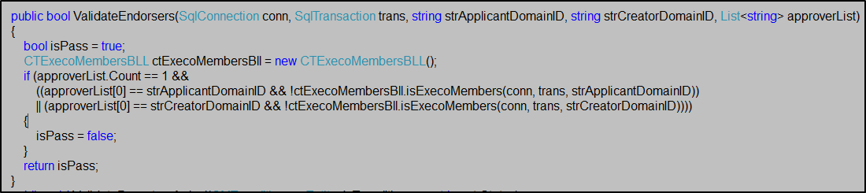

* + System persist the form content to DB, then prompt below information message “Record has been submitted successfully.” (OK), and redirect user to home page after user click on OK button.

**“Cancel” button:**

- On click: prompt confirmation message: “Are you sure to close this page? All the contents you inputted would be lost.”, if user click “OK”, redirect to home page; if user click “Cancel”, do nothing.

### Email Notification

Upon successfully submitted new Travel Application record, send email notification as below:

Subject: Business Travel Request - <Applicant Email Banner> - <TAID>

To: The approver with sequence 1

CC: <Applicant>; <Record Creator>; <CC List Staff>; <CC Functional/Group Email>

Body:

//Quote

This Business Travel Request is MODIFIED. For your review and endorsement please.  
  
Please click on [ENDORSE](http://testwebmail.oocl.com/owa/redir.aspx?C=68bU4_3UDkuoNJByisXxZ9sTuiT0ydVIKFf3kfwIkJgVA2HDkNxZbKsd7Xl0Aom8nAEXFKNbf8E.&URL=http%3a%2f%2fgltmsuat%2fGLTMSAPPS%2flayouts%2femail%2fmApprove.aspx%3fTAID%3dTAWANGWE2180009%26ACTION%3dENDORSE) or [REJECT](http://testwebmail.oocl.com/owa/redir.aspx?C=68bU4_3UDkuoNJByisXxZ9sTuiT0ydVIKFf3kfwIkJgVA2HDkNxZbKsd7Xl0Aom8nAEXFKNbf8E.&URL=http%3a%2f%2fgltmsuat%2fGLTMSAPPS%2flayouts%2femail%2fmApprove.aspx%3fTAID%3dTAWANGWE2180009%26ACTION%3dREJECT) to approve or reject this request   
  
Please [click here](http://testwebmail.oocl.com/owa/redir.aspx?C=68bU4_3UDkuoNJByisXxZ9sTuiT0ydVIKFf3kfwIkJgVA2HDkNxZbKsd7Xl0Aom8nAEXFKNbf8E.&URL=http%3a%2f%2fgltmsuat%2fGLTMSAPPS%2flayouts%2femail%2fmApproveComment.aspx%3fTAID%3dTAWANGWE2180009) if you would like to add any comments or [click here](http://testwebmail.oocl.com/owa/redir.aspx?C=68bU4_3UDkuoNJByisXxZ9sTuiT0ydVIKFf3kfwIkJgVA2HDkNxZbKsd7Xl0Aom8nAEXFKNbf8E.&URL=http%3a%2f%2fgltmsuat%2fGLTMSAPPS%2flayouts%2fmain%2fgltms.aspx%3fTAID%3dTAWANGWE2180009) to open the record.

|  |  |  |  |  |  |  |  |  |  |  |  |  |  |  |  |  |  |  |  |  |  |  |  |  |  |  |  |  |  |  |  |  |  |  |  |  |  |  |  |  |  |  |  |  |  |  |  |  |  |  |  |  |  |  |  |  |  |  |  |  |  |  |  |  |  |  |  |  |  |  |  |  |  |  |  |  |  |  |  |  |  |  |
| --- | --- | --- | --- | --- | --- | --- | --- | --- | --- | --- | --- | --- | --- | --- | --- | --- | --- | --- | --- | --- | --- | --- | --- | --- | --- | --- | --- | --- | --- | --- | --- | --- | --- | --- | --- | --- | --- | --- | --- | --- | --- | --- | --- | --- | --- | --- | --- | --- | --- | --- | --- | --- | --- | --- | --- | --- | --- | --- | --- | --- | --- | --- | --- | --- | --- | --- | --- | --- | --- | --- | --- | --- | --- | --- | --- | --- | --- | --- | --- | --- | --- | --- |
| |  |  |  |  | | --- | --- | --- | --- | | Applicant: | WESLEY WANG (EUCD-EUC-ISD-OOCLL/ZHA) | Business Travel ID: | TAWANGWE2180009 | | Objective and  Expected Result: | |  |  | | --- | --- | | Urgent Request: | No |   testing | | | | Travel Itinerary: | |  |  | | --- | --- | | Total No. of Day(s): | 4.0 |  |  |  |  |  |  |  |  |  |  |  |  | | --- | --- | --- | --- | --- | --- | --- | --- | --- | --- | --- | | From | To | No. of Days | Transport | Class (For Air only) | Departure (For Air & High Speed Ferry only) | Arrival (For Air & High Speed Ferry only) | One-way(1)/Round Trip(2) (For Air & High Speed Ferry only) | City(ies) (Default for Air & High Speed Ferry;  Fill in for Car, Ferry-ROB and Train) | Hotel | Visa | | May 29 2018 | Jun 01 2018 | 4.0 | Train |  |  |  |  | Shenzhen | No | No | | | | | Cash Advance: | |  |  | | --- | --- | | Due Date: | Apr 26 2017 |  |  |  |  |  |  | | --- | --- | --- | --- | --- | | CCY | Amount | By | Account Code | Company | | CNY | 1000 | Cash | 11331848 | OCHL(8071) | | | | | Endorsed / Approved by: * | |  |  |  | | --- | --- | --- | | Name | Endorsed | Comment | | LILI WEI (EUCD-EUC-ISD-OOCLL/ZHA) |  |  | | | | | CC List | |  | | --- | | HENRY LIU (EUCD-EUC-ISD-OOCLL/ZHA) | | | | | CC Group List | |  | | --- | | oocluat@oocl.com | | | | | FINCON Office | |  |  | | --- | --- | | Company | Office | | ABC |  | |  | | |

Please click on [ENDORSE](http://testwebmail.oocl.com/owa/redir.aspx?C=68bU4_3UDkuoNJByisXxZ9sTuiT0ydVIKFf3kfwIkJgVA2HDkNxZbKsd7Xl0Aom8nAEXFKNbf8E.&URL=http%3a%2f%2fgltmsuat%2fGLTMSAPPS%2flayouts%2femail%2fmApprove.aspx%3fTAID%3dTAWANGWE2180009%26ACTION%3dENDORSE) or [REJECT](http://testwebmail.oocl.com/owa/redir.aspx?C=68bU4_3UDkuoNJByisXxZ9sTuiT0ydVIKFf3kfwIkJgVA2HDkNxZbKsd7Xl0Aom8nAEXFKNbf8E.&URL=http%3a%2f%2fgltmsuat%2fGLTMSAPPS%2flayouts%2femail%2fmApprove.aspx%3fTAID%3dTAWANGWE2180009%26ACTION%3dREJECT) to approve or reject this request   
  
Please [click here](http://testwebmail.oocl.com/owa/redir.aspx?C=68bU4_3UDkuoNJByisXxZ9sTuiT0ydVIKFf3kfwIkJgVA2HDkNxZbKsd7Xl0Aom8nAEXFKNbf8E.&URL=http%3a%2f%2fgltmsuat%2fGLTMSAPPS%2flayouts%2femail%2fmApproveComment.aspx%3fTAID%3dTAWANGWE2180009) if you would like to add any comments or [click here](http://testwebmail.oocl.com/owa/redir.aspx?C=68bU4_3UDkuoNJByisXxZ9sTuiT0ydVIKFf3kfwIkJgVA2HDkNxZbKsd7Xl0Aom8nAEXFKNbf8E.&URL=http%3a%2f%2fgltmsuat%2fGLTMSAPPS%2flayouts%2fmain%2fgltms.aspx%3fTAID%3dTAWANGWE2180009) to open the record.  
  
Note:DO NOT reply to this email. For any query, please contact HR department

//Unquote

## Create Travel Expense Claims Page (UI-4)

### UI

Please refer to <http://gltmsuat/gltmsapps/Layouts/Main/eExpenseNew.aspx>

**Page Initialization**

Travel Itinerary:

If submitter has permission to access associated TA, system copy the Travel Itinerary from TA as default, otherwise, default 1 empty row

Expense Charge:

* Company: default from the last completed ER record. If there’s no completed ER, default Staff Company from StaffInfo table
* Department: default from the last completed ER record. If there’s no completed ER, default Staff Department from StaffInfo table
* Biz Area: default from the last completed ER record
* Charge ID: default show “1”

Expense record

* Default 5 rows

Summary Details

* Exchange Rate: default from TA Bank Account Cash Advance Currency
* Cash Advance Refund to Company: default 1 row
  + - * + CCY: Dropdown options copy from TA Bank Account Cash Advance Currency
        + Amount: allow user to input
* Reimbursement in Total Currency: default from the last completed ER

Endorsed by: Default approvers from the last completed ER record

CC List: Default CC list from the last completed ER record

FINCON Office: default from the last completed ER record

Attach File: default 0 row

### Form Field Specifications

| Form Field | Description | Data Type | Multi-lingual | Data Length | Mandatory | Values | Default |
| --- | --- | --- | --- | --- | --- | --- | --- |
| Applicant | Email Banner of Applicant | Read-only Text | No | 128 | Yes | Selected from search Business Travel ID layer | <Blank> |
| Business Travel ID |  | Read-only Text | No | 50 | Yes | Selected from search Business Travel ID layer | <Blank> |

**Travel Itinerary**

| Form Field | Description | Data Type | Multi-lingual | Data Length | Mandatory | Values | Default |
| --- | --- | --- | --- | --- | --- | --- | --- |
| Total Number of Day(s) | Total Number of Travel Days | Number | N/A | [4.1] | Yes | Auto computes (Last Travel Itinerary To Date – First Travel Itinerary From Date). Allow User to change the value | <blank> |
| From Date | Start date of each segment of travel itinerary | Date | N/A | N/A | Yes | User Inputted | <Blank> |
| To Date | End date of each segment of travel itinerary | Date | N/A | N/A | Yes | User Inputted | <Blank> |
| No. of Days | No. of days of the segment of travel itinerary | Number | N/A | [4.1] | Yes | Auto computes (To Date – From Date) Allow User to change the value | <Blank> |
| Transport |  | Pull-down | N/A | N/A | Yes | Code table CT_TRANSPORT Type – Transport Type | <Blank> |
| Class |  | Pull-down | N/A | N/A | Yes/No * | Code table CT_TRANSPORT_CLASS – Class Type | <Blank> |
| Departure |  | Auto-completed | N/A | 200 | Yes/No * | Air: Code table CT_AIR –  If USA - City (StateForUSA), AirportName (IATA), Country  If non-USA - City (StateForUSA), AirportName (IATA), Country  High Speed Ferry: Code table CT_Ferry_Terminal – City, Ferry_Terminal, Location | <Blank> |
| Arrival |  | Auto-completed | N/A | 200 | Yes/No * | Same as above | <Blank> |
| One-way(1)/Round Trip(2) |  | Pull-down | N/A | N/A | Yes/No * | 1 or 2 | 1 |
| City |  | Text | N/A | 100 | Yes | Air or High Speed Ferry: Default from Arrival  Other Transport type: User inputted | <Blank> |
| Hotel |  | Pull-down | N/A | N/A | Yes | Yes, No | <Blank> |

Remarks  
* Class would be mandatory if the selected value in Transport (from code table CT_TRANSPORT_TYPE) having “Class Mandatory” column set to “Y”, refer to section 5.3.1 for details of code table schema

* Departure, Arrival, and One-way(1)/Round Trip(2) would be enable only when the Transport is Air or High Speed Ferry

**Expense Details – Expense Charge Company / Department**

| Form Field | Description | Data Type | Multi-lingual | Data Length | Mandatory | Values | Default |
| --- | --- | --- | --- | --- | --- | --- | --- |
| Charge ID | Expense Charge sequence ID | Read Only Text | No | N/A | No | Sequence ID auto generate by system | <Blank> |
| Company |  | Pull-down | No | N/A | Yes * | Auto retrieve the value from last completed TA, if no last completed TA, then auto retrieve the Staff Employing Company Code from Staff Profile, allow User to change the Company Code. Code table CT_COMPANY – Company Abbreviation/OfficeCode + “(“ + Company Code + “)”  E.g. “OOCL (2201)”, or “OCHL/ZHA(8071)” | <Blank> |
| Department |  | Pull-down | No | N/A | Yes * | Code table CT_DEPARTMENT – Department Abbreviation & Department Code | <Blank> |
| Biz Area |  | Pull-down | No | N/A | Yes * | Code table CT_BIZ_AREA_CODE – Biz Area Code | <Blank> |

**Expense Details – Expense Record**

| Form Field | Description | Data Type | Multi-lingual | Data Length | Mandatory | Values | Default |
| --- | --- | --- | --- | --- | --- | --- | --- |
| Charge ID | Expense Charge sequence ID | Pull-down | No | N/A | Yes | Value from Expense Charge Company / Department. Set field to Read Only if only 1 charge id defined. | 1 |
| Date | Date of Expense | Date | No | N/A | Yes | Inputted by user | <Blank> |
| Type | Type of Expense Details | Pull-down | No | 128 | Yes | Code table CT_EXPENSE_TYPE_AND_ACCOUNT_CODE | System should submit Applicant selected Charge Company Code to search the Expense Type from CT_EXPENSE_TYPE_AND ACCOUNT_CODE Table, when the Charge Company is changed, the expense type list will be refreshed. |
| CCY | Currency of cash advance | Pull-down | No | N/A | Yes * | CT_CURRENCY_CODE – Currency Code | <Blank> |
| Amount | Amount of expense in a currency | Number | No | [10.2] | Yes * | User inputted | <Blank>, disabled as default. Once user select a type, the field will be enabled |
| VAT | VAT Amount | Number | No | [10.2] | Yes * | User inputted | <Blank> |
| Total Amount | Total Amount | Read Only Text | No | [10.2] | No | Amount + VAT | <Blank> |
| VAT Code | VAT Account Code | Pull-down | No | N/A | Set default to “No” However if VAT Amount > 0 then set to “Yes” | Code table CT_VAT_ACCOUNT_CODE | <Blank>* |
| Paid By | Paid by type | Pull-down | No | N/A | Yes * | Code table CT_PAID_BY_EXPENSE_RECORD – Type. | System should not allow Applicant to select “Corp. Card” if No Corp Credit Card Account Code setup for Applicant’s Company Profile.  For example, if Applicant’s employing company (StaffInfo - EmployingCompanyCode) is OCHL, will search for CorpCardAccountCode in CT_Company by OCHL. If CorpCardAccountCode is empty, “Corp. Card” won’t be included in dropdown list. |
| Description | Expense Description | Text | Yes | 1000 | No | Inputted by User | <Blank> |
| Vessel Code |  | Pull-down | No | N/A | No | Code table CT_VESSEL _CODE | <Blank> |
| Project Code |  | Text | No | N/A | No |  | <Blank> |
| Warehouse Code |  | Pull-down | No | N/A | No | Code table CT_WAREHOUSE_CODE | <Blank> |

Remarks: Enables VAT Code field when VAT field’s value > $0. Disable records fields when Mileage Checkbox is clicked. Disable VAT Amount and VAT Code fields if NO VAT Account Code can be searched from CT_VAT_ACCOUNT_CODE by associated Applicant’s Select Company Charge ID

**Expense Details - Mileage**

| Form Field | Description | Data Type | Multi-lingual | Data Length | Mandatory | Values | Default |
| --- | --- | --- | --- | --- | --- | --- | --- |
| CCY | Currency of Mileage | Pull-down | No | N/A | Yes | CT_CURRENCY_CODE | <Blank> |
| Per Mile Allowance | Per Mile Allowance by Company | Number | No | N/A | No | User inputted | <Blank> |
| Date | Date of Mileage | Date | No | N/A | Yes | User inputted | <Blank> |
| Total Miles | Total number of Miles | Number | No | [10.2] | No | User inputted | <Blank> |
| Mileage $ Amount | Mileage Amount | Read Only | No | [10.2] | No | Total Miles x Per Mile Allowance | <Blank> |
| Park / Tolls | Part / Tolls Fee | Number | No | [10.2] | No | User inputted | <Blank> |
| Local Transport | Local Transport Fee | Number | No | [10.2] | No | User inputted | <Blank> |
| VAT | VAT Amount | Number | No | [10.2] | No | User inputted | <Blank> |
| Total Amount | Total Amount | Read Only | No | [10.2] | No | Mileage $ Amount (Total Miles x Per Mile Allowance) + Park / Tolls + Local Transportation + VAT | <Blank> |
| VAT Code | VAT Account Code | Pull-down | No | N/A | No | CT_PAID_BY_CASH_ADVANCE | <Blank>  Set default disable |

Remarks: Enable when Type = “Mileage (6127100) and Clicked Mileage Checkbox. Auto refreshes the Expense Record value as below:

Mileage CCY -> Expense Record -> CCY

Mileage VAT-> Expense Record -> VAT

Mileage Total Amount -> Expense Record -> Total Amount

Mileage Total Amount – VAT -> Expense Report -> Amount

Mileage VAT Code (First Row) -> Expense Record -> VAT Code

If Total Miles <> Null and Per Mile Allowance = NULL then display a message "Please input Per Mile Allowance"

System should able to display below message if Applicant just submit the Mileage - Date field.

“Please input Total Miles, Park/Tolls or Local Transport”

If the Mileage checkbox is checked, default show 1 row in Mileage table. When there’s only 1 row in the table, the remove button will be hidden.

* + One row case

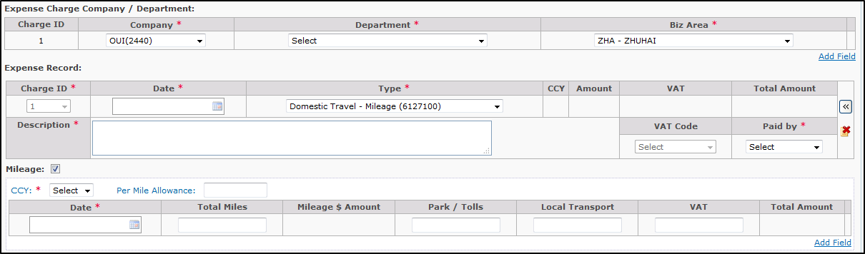

* + Multiple rows case

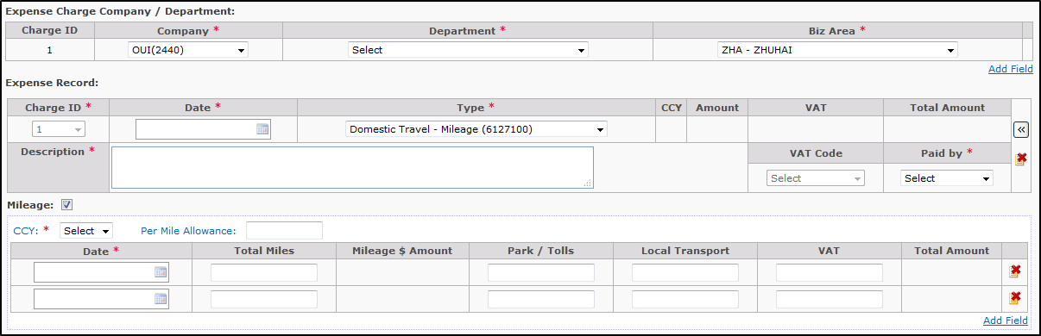

**Summary Details -> Exchange Rate**:

| Form Field | Description | Data Type | Multi-lingual | Data Length | Mandatory | Values | Default |
| --- | --- | --- | --- | --- | --- | --- | --- |
| CCY | Currency of Expense | Label | No | N/A | Yes | Value copy from TA Bank Account Cash Advance Currency, and the selected CCY in Expense Records | <Blank> |
| Exchange Rate | Exchange Rate in local region | Textbox | No | [10.4] | Yes | The exchange rate to Reimbursement Currency | <Blank> |

Summary Details -> Cash Advance Refund to Company:

| Form Field | Description | Data Type | Multi-lingual | Data Length | Mandatory | Values | Default |
| --- | --- | --- | --- | --- | --- | --- | --- |
| CCY | Currency of Expense | Pull-down | No | N/A | Yes | The dropdown option copy from TA Bank Account Cash Advance Currency | <Blank> |
| Amount | The Amount that refund to company | Number | No | [10.2] | Yes |  | <Blank> |

Summary Details -> Reimbursement in Total:

| Form Field | Description | Data Type | Multi-lingual | Data Length | Mandatory | Values | Default |
| --- | --- | --- | --- | --- | --- | --- | --- |
| Currency | Currency of Expense | Pull-down | No | N/A | Yes | Value copy from last completed ER | <Blank> |

**Endorsed / Approved By**:

| Form Field | Description | Data Type | Multi-lingual | Data Length | Mandatory | Values | Default |
| --- | --- | --- | --- | --- | --- | --- | --- |
| Name | Email Banner of approver | Read-only Text | No | N/A | Yes | User inputted | <Blank> |
| Sequence | The sequence to send email to approver | Text | No | 10 | Yes | System will auto calculate and display the value, user can amend it. |  |

Remarks:

*Default approvers from the last completed ER record

**CC List:**

| Form Field | Description | Data Type | Multi-lingual | Data Length | Mandatory | Values | Default |
| --- | --- | --- | --- | --- | --- | --- | --- |
| Name | Email Banner of CC staff | Read-only Text | No | N/A | N/A | User inputted | <Blank> |
| Functional/Group Email | Functional/Group Email Address | Text | No | 128 | N/A | User inputted | <Blank> |

Remarks:

*Default CC List from the last completed ER record

Remarks

| Form Field | Description | Data Type | Multi-lingual | Data Length | Mandatory | Values | Default |
| --- | --- | --- | --- | --- | --- | --- | --- |
| Remarks |  | Text | Yes | 1000 | N/A | User inputted | <Blank> |

**Attach File**

| Form Field | Description | Data Type | Multi-lingual | Data Length | Mandatory | Values | Default |
| --- | --- | --- | --- | --- | --- | --- | --- |
| Filename | Location of file to be uploaded | Text | No | 1000 | Yes * | User inputted | <Blank> |
| Description |  | Text | Yes | 1000 | No | User inputted | <Blank> |

Remarks

* Attach file is not mandatory and can be left blank, “File Name” is mandatory only if there is entry in Attach File. The max size of each file is 2 MB.

**Summary**

| Form Field | Description | Data Type | Multi-lingual | Data Length | Mandatory | Values | Default |
| --- | --- | --- | --- | --- | --- | --- | --- |
| Total Expense | Total Travel Expense | Read-only Text | No | N/A | N/A | Auto Sum Total Expense Details in Different Currency | <Blank> |
| By Company directly to Service Provider | Total Travel Expense Paid by Company | Read-only Text | No | N/A | N/A | Auto Sum Total Expense Paid by Company in Different Currency | <Blank> |
| By Corporate Credit Card | Total Travel Expense Paid by Corp. Card | Read-only Text | No | N/A | N/A | Auto Sum Total Expense Paid by Corp. Card in Different Currency | <Blank> |
| By Cash / Personal Card | Total Travel Expense Paid by Cash / Personal Card | Read-only Text | No | N/A | N/A | Auto Sum Total Expense Paid by Cash / Personal Card in Different Currency | <Blank> |
| Cash Advance | Cash Advance | Read-only Text | No | N/A | N/A | Auto Copy from Travel Authorization Cash Advance Section |  |
| Cash Advance Refund to Company | Cash return from Staff to company | Read-only Text | No | [10.2] | N/A |  | <Blank> |
| Net Cash Advance | Net Cash Advance amount | Read-only Text | No | N/A | N/A | Auto deduct Cash Advance Amount from Cash Refund Amount | <Blank> |
| Reimbursement | Total Reimbursement amount | Read-only Text | No | N/A | N/A | Total Expense – (By Company + By Corp. Card + Net Cash Advance) | <Blank> |
| Exchange Rate | Exchange Rate in local region | Read-only Text | No | [10.4] | N/A |  | <Blank> |
| Reimbursement Currency | Local reimbursement currency | Read-only Text | No | N/A | Yes * |  | <Blank> |
| Reimbursement Amount | Final Reimbursement Amount convert in Local Currency | Read-only Text | No | [10.4] | N/A | Convert Sum (Reimbursement Amount * Exchange Rate) in local currency | <Blank> |

### Field Actions

**“Search” button for Applicant:**

* On click: pop-up Search Travel Application Pop-up layer (UI-10), refer to section 9.12 for details UI specifications

**“Add Field” button for Travel Itinerary:**

* On click: check if there are already 30 entries
  + If yes, prompt warning message and disallow adding: “You cannot add more than 30 entries in Travel Itinerary.”
  + Otherwise, add one empty entry for Travel Itinerary table

**“Delete” buttons for Travel Itinerary:**

* On click: Prompt confirmation message: “Are you sure to remove this Travel Itinerary?”, if user click “Yes”, remove the selected entry, otherwise, do nothing.

**“Add Field” button for Expense Charge Company / Department**

* On click: check if there are already 20 entries
  + If yes, prompt warning message and disallow adding: “You cannot add more than 20 entries in Expense Charge Company / Department.”
* Otherwise, add one empty entry for Expense Charge Company / Department table

**“Delete” buttons for Expense Charge Company / Department:**

* On click:
  + The record that Charge ID is 1 cannot be removed
  + Prompt confirmation message: “Are you sure to remove this Record?”, if user click “Yes”, remove the selected entry, otherwise, do nothing.
  + If the Charge ID of removed record has been selected in Expense Record –
    - If there’s only 1 row in Expense Charge Company / Department table, reset the Charge ID as 1 for the rows that was selected the removed Charge ID in Expense Record table. The Charge ID in Expense record should be disabled.
    - If there’re more than 1 row in Expense Charge Company / Department table, refresh the dropdown list of Charge ID in all rows in Expense Record table, and reset the Charge ID for the rows that was selected the removed Charge ID.

**“Add Field” button for Expense Record:**

* On click: add one empty entry on Expense Record table.

**“Delete” buttons for Expense** **Record**:

* On click: Prompt confirmation message: “Are you sure to remove this Expense Record?”, if user click “Yes”, remove the selected entry, otherwise, do nothing.

**“Add Field” button for Mileage:**

* On click: check if there are already 20 entries
  + If yes, prompt warning message and disallow adding: “You cannot add more than 20 entries in Mileage.”
  + Otherwise, add one empty entry for Mileage table

**“Delete” buttons for Mileage**:

* On click: Prompt confirmation message: “Are you sure to remove this Mileage?”, if user click “Yes”, remove the selected entry, otherwise, do nothing.

**“Add Field” button for Cash Advance Refund to Company:**

* On click: check if there are already 20 entries
  + If yes, prompt warning message and disallow adding: “You cannot add more than 20 entries in Cash Refund to Company.”
* Otherwise, add one empty entry for Cash Refund to Company table

**“Delete” buttons for Cash Advance Refund to Company**:

* On click: Prompt confirmation message: “Are you sure to remove this Cash Refund?”, if user click “Yes”, remove the selected entry, otherwise, do nothing.

**“Add Field” button for Endorsed/Approved By:**

* On click: check if there are already 5 entries:
  + If yes, prompt warning message and disallow adding: “You cannot add more than 5 entries in Endorsed/Approved By”
  + Otherwise, pop-up Search Staff Layer (UI-9)

**“Delete” buttons for Endorsed/Approved By:**

* On click: Prompt confirmation message: “Are you sure to remove this Approver?”, if user click “Yes”, remove the selected entry, otherwise, do nothing.

**“Add” buttons for CC List - Staff:**

* On click: check if there are already 30 entries
  + If yes, prompt warning message and disallow adding: “You cannot add more than 30 entries in CC List”
  + Otherwise, pop-up Search Staff Layer (UI-9)

**“Delete” buttons for CC List - Staff:**

* On click: Prompt confirmation message: “Are you sure to remove this CC Staff?”, if user click “Yes”, remove the selected entry, otherwise, do nothing.

**“Add” buttons for CC List – Functional/Group Email:**

* On click: check if there are already 5 entries
  + If yes, prompt warning message and disallow adding: “You cannot add more than 30 entries Functional/Group Email”
  + Otherwise, add one empty entry for Functional/Group Email

**“Delete” buttons for CC List - Functional/Group Email:**

* On click: Prompt confirmation message: “Are you sure to remove this Functional/Group Email?”, if user click “Yes”, remove the selected entry, otherwise, do nothing.

**“Add Field” button for Attach File**:

* On click: check if there are already 30 entries
  + If yes, prompt warning message and disallow adding: “You cannot add more than 30 entries in Attach File.”
  + Otherwise, add one empty entry for Attach File table

**“Delete” buttons for Attach File**:

* On click: Prompt confirmation message: “Are you sure to remove this Attach File?”, if user click “Yes”, remove the selected entry, otherwise, do nothing.

**“Submit” button:**

* On click: run below checking in order:
  + Pop up confirmation message “Please ensure below are captured and/or uploaded if expenses incurred during your trip:\n\r\n\r1. Any bill that paid and arranged by the Company directly (e.g. air ticket)\n\r2. Any copy of receipt(s) for expense(s) claimed” (OK/Cancel)
    - If user click “Cancel” button, do nothing
    - If user click “OK” button, go on below logic
  + Check if all mandatory fields/sections are inputted properly
    - If found empty mandatory fields, exit the process and prompt warning message stating the 1st empty field/section in the form, e.g. “Please input Travel Itinerary.”, “Please input Applicant.”
    - Otherwise, go on below logic
  + Check if Applicant is included in “Endorsed/Approved By”
    - If found any, exit the process and prompt below warning message: “Applicant cannot be included in Approver list.”
    - Otherwise, go on below logic
  + Check if Applicant or Record Creator or Approver is included in “CC List”
    - If found any, exit the process and prompt below warning message: “Applicant / Record Creator / Approver cannot be included in CC List.”
    - Otherwise, go on below logic
  + Check if any file in “Attach File” have size exceeding 2MB
    - If found any, exit the process and prompt warning message stating the 1st file with size > 2MB: “Size of Attach File cannot exceed 2MB: <File Name>.”
    - Otherwise, go on below logic
  + Check if there’s Air Transport type in Travel Itinerary, if yes, then Check whether there is(are) attachment(s) uploaded
    - If found any, popup confirmation message “Please make sure airport(s) of ARRIVAL & DEPARTURE and CLASS of ticket are provided in the document(s) uploaded” (OK / Cancel). Click OK button to proceed; click Cancel button then do nothing.
    - Otherwise, popup alert message “Please attach ALL air travel supporting documents softcopy, e.g. invoice, flight itinerary, e-tickets, receipts, which have to show i) departure airport; ii) arrival airport; iii) flight class; and iv) one-way or round trip.” and do nothing.
  + If the application is submitted by other staff, only the applicant or submitter is put in endorser list, and the applicant or submitter is not EXECO members, the following alert message is prompted –

“Applicant / Submitter cannot be the ONLY Endorser, please add Applicant’s supervisor as the 2nd/final Endorser”



* + System persist the form content to DB, then prompt below information message “Record has been submitted successfully.” (OK), and redirect user to home page after user click on OK button.

**“Cancel” button**:

- On click: prompt confirmation message: “Are you sure to close this page? All the contents you inputted would be lost.”, if user click “Yes”, close the page, otherwise, do nothing.

**“Save” button**:

* On click: run below checking in order:
  + Check whether user input Applicant
    - If Applicant is empty, popup alert “Please input Applicant.”
    - Otherwise, persist the form content to DB with Saved status, then prompt below information message “Record has been saved successfully.” (OK), and redirect user to home page after user click on OK button.

### Email Notification

Upon successfully submitted new Travel Expense record, send email notification as below:

Subject: Travel Expense Claim - <Applicant Email Banner> - <ERID>

To: The approver with sequence 1

CC: <Applicant>; <Record Creator>; <CC List Staff>; <CC Functional/Group Email>

Body:

//Quote

Dear Approver  
  
This Travel Expense Claim is CREATED. For your review and endorsement please.  
  
Please click on [ENDORSE](http://testwebmail.oocl.com/owa/redir.aspx?C=68bU4_3UDkuoNJByisXxZ9sTuiT0ydVIKFf3kfwIkJgVA2HDkNxZbKsd7Xl0Aom8nAEXFKNbf8E.&URL=http%3a%2f%2fgltmsuat%2fGLTMSAPPS%2flayouts%2femail%2fmApprove.aspx%3fERID%3dERWANGWE2180009%26ACTION%3dENDORSE) or [REJECT](http://testwebmail.oocl.com/owa/redir.aspx?C=68bU4_3UDkuoNJByisXxZ9sTuiT0ydVIKFf3kfwIkJgVA2HDkNxZbKsd7Xl0Aom8nAEXFKNbf8E.&URL=http%3a%2f%2fgltmsuat%2fGLTMSAPPS%2flayouts%2femail%2fmApprove.aspx%3fERID%3dERWANGWE2180009%26ACTION%3dREJECT) to approve or reject this request   
  
Please [click here](http://testwebmail.oocl.com/owa/redir.aspx?C=68bU4_3UDkuoNJByisXxZ9sTuiT0ydVIKFf3kfwIkJgVA2HDkNxZbKsd7Xl0Aom8nAEXFKNbf8E.&URL=http%3a%2f%2fgltmsuat%2fGLTMSAPPS%2flayouts%2femail%2fmApproveComment.aspx%3fERID%3dERWANGWE2180009) if you would like to add any comments or [click here](http://testwebmail.oocl.com/owa/redir.aspx?C=68bU4_3UDkuoNJByisXxZ9sTuiT0ydVIKFf3kfwIkJgVA2HDkNxZbKsd7Xl0Aom8nAEXFKNbf8E.&URL=http%3a%2f%2fgltmsuat%2fGLTMSAPPS%2flayouts%2fmain%2fgltms.aspx%3fERID%3dERWANGWE2180009) to open the record.

|  |  |  |  |  |  |  |  |  |  |  |  |  |  |  |  |  |  |  |  |  |  |  |  |  |  |  |  |  |  |  |  |  |  |  |  |  |  |  |  |  |  |  |  |  |  |  |  |  |  |  |  |  |  |  |  |  |  |  |  |  |  |  |  |  |  |  |  |  |  |  |  |  |  |  |  |  |  |  |  |  |  |  |  |  |  |  |  |  |  |  |  |  |  |  |  |  |  |  |  |  |  |  |  |  |  |  |  |  |  |  |  |  |  |  |  |  |  |  |  |  |  |  |  |  |  |  |  |  |  |  |  |  |  |  |  |  |  |  |  |  |  |  |  |  |  |  |  |  |  |  |  |  |  |  |  |  |  |  |  |  |  |  |  |  |  |  |  |  |  |  |  |  |  |  |  |  |  |  |  |  |  |  |  |  |  |  |  |  |  |  |
| --- | --- | --- | --- | --- | --- | --- | --- | --- | --- | --- | --- | --- | --- | --- | --- | --- | --- | --- | --- | --- | --- | --- | --- | --- | --- | --- | --- | --- | --- | --- | --- | --- | --- | --- | --- | --- | --- | --- | --- | --- | --- | --- | --- | --- | --- | --- | --- | --- | --- | --- | --- | --- | --- | --- | --- | --- | --- | --- | --- | --- | --- | --- | --- | --- | --- | --- | --- | --- | --- | --- | --- | --- | --- | --- | --- | --- | --- | --- | --- | --- | --- | --- | --- | --- | --- | --- | --- | --- | --- | --- | --- | --- | --- | --- | --- | --- | --- | --- | --- | --- | --- | --- | --- | --- | --- | --- | --- | --- | --- | --- | --- | --- | --- | --- | --- | --- | --- | --- | --- | --- | --- | --- | --- | --- | --- | --- | --- | --- | --- | --- | --- | --- | --- | --- | --- | --- | --- | --- | --- | --- | --- | --- | --- | --- | --- | --- | --- | --- | --- | --- | --- | --- | --- | --- | --- | --- | --- | --- | --- | --- | --- | --- | --- | --- | --- | --- | --- | --- | --- | --- | --- | --- | --- | --- | --- | --- | --- | --- | --- | --- | --- | --- | --- | --- | --- | --- | --- | --- | --- | --- |
| |  |  |  |  | | --- | --- | --- | --- | | Applicant: | WESLEY WANG (EUCD-EUC-ISD-OOCLL/ZHA) | Travel Expense Claims ID: | ERWANGWE2180009 | | Business Travel ID: | TAWANGWE2180007 | Attach Cash Advance: | No | | Objective and  Expected Result: | test | | | | Travel Itinerary: | | | | | |  |  | | --- | --- | | Total No. of Day(s): | 32.0 |  |  |  |  |  |  |  |  |  |  |  | | --- | --- | --- | --- | --- | --- | --- | --- | --- | --- | | From | To | No. of Days | Transport | Class (For Air only) | Departure (For Air & High Speed Ferry only) | Arrival (For Air & High Speed Ferry only) | One-way(1)/Round Trip(2) (For Air & High Speed Ferry only) | City(ies) (Default for Air & High Speed Ferry;  Fill in for Car, Ferry-ROB and Train) | Hotel | | May 01 2018 | Jun 01 2018 | 32.0 | Car - Coach |  |  |  |  | Singapore | No | | | | | | Expense Details | | | | | Expense Charge Company / Department: | | | | | |  |  |  |  | | --- | --- | --- | --- | | Charge ID | Company | Department | Biz Area | | 1 | OOCLL(2201) | ISDC(144) | ZHA - ZHUHAI | | | | | | Expense Record: |  |  |  | | |  |  |  |  |  |  |  |  |  |  |  |  | | --- | --- | --- | --- | --- | --- | --- | --- | --- | --- | --- | --- | | Charge ID | Date | Type | CCY | Amount | VAT | Total Amount | VAT Code | Paid by | Vessel Code | Warehouse Code | Project Code | | 1 | May 24 2018 | Overseas Travel - General (6126100) | CNY | 2000 | 0 | 2000 |  | Cash/ P. Card |  |  |  | | Description | test | | | | | | | | | | | | | | | | | Summary | | | |  | | Exchange Rate: |  | Reimbursement in Total: 2000.00CNY | |  | | |  |  | | --- | --- | | CCY | Ex. Rate | | CNY | 1 | |  | Expense in Total: 2000.00CNY | |  | | |  |  | | --- | --- | |  | CNY | | Total Expense | 2,000.00 | |  |  | | Expense Paid |  | | By Company directly to Service Provider | 0.00 | | By Corporate Credit Card | 0.00 | | By Cash / Personal Card | 2,000.00 | |  |  | | Net Cash Advance |  | | Cash Advance | 0.00 | | Cash Advance Refund to Company | 0.00 | | Net Cash Advance | 0.00 | |  |  | | Reimbursement | 2,000.00 | | Exchange Rate | 1 | |  |  | | Total in reimbursement currency | 2,000.00 | | | | |  | | Endorsed / Approved by: * | |  |  |  | | --- | --- | --- | | Name | Endorsed | Comment | | LILI WEI (EUCD-EUC-ISD-OOCLL/ZHA) |  |  | | | |  | | FINCON Office | |  |  | | --- | --- | | Company | Office | | ABC |  | |  | |  | | Remarks: |  | | |  | |

Please click on [ENDORSE](http://testwebmail.oocl.com/owa/redir.aspx?C=68bU4_3UDkuoNJByisXxZ9sTuiT0ydVIKFf3kfwIkJgVA2HDkNxZbKsd7Xl0Aom8nAEXFKNbf8E.&URL=http%3a%2f%2fgltmsuat%2fGLTMSAPPS%2flayouts%2femail%2fmApprove.aspx%3fERID%3dERWANGWE2180009%26ACTION%3dENDORSE) or [REJECT](http://testwebmail.oocl.com/owa/redir.aspx?C=68bU4_3UDkuoNJByisXxZ9sTuiT0ydVIKFf3kfwIkJgVA2HDkNxZbKsd7Xl0Aom8nAEXFKNbf8E.&URL=http%3a%2f%2fgltmsuat%2fGLTMSAPPS%2flayouts%2femail%2fmApprove.aspx%3fERID%3dERWANGWE2180009%26ACTION%3dREJECT) to approve or reject this request   
  
Please [click here](http://testwebmail.oocl.com/owa/redir.aspx?C=68bU4_3UDkuoNJByisXxZ9sTuiT0ydVIKFf3kfwIkJgVA2HDkNxZbKsd7Xl0Aom8nAEXFKNbf8E.&URL=http%3a%2f%2fgltmsuat%2fGLTMSAPPS%2flayouts%2femail%2fmApproveComment.aspx%3fERID%3dERWANGWE2180009) if you would like to add any comments or [click here](http://testwebmail.oocl.com/owa/redir.aspx?C=68bU4_3UDkuoNJByisXxZ9sTuiT0ydVIKFf3kfwIkJgVA2HDkNxZbKsd7Xl0Aom8nAEXFKNbf8E.&URL=http%3a%2f%2fgltmsuat%2fGLTMSAPPS%2flayouts%2fmain%2fgltms.aspx%3fERID%3dERWANGWE2180009) to open the record.  
  
Note:DO NOT reply to this email. For any query, please contact HR department

//Unquote

## Create Staff Expense Claims

### UI

Please refer to <http://gltmsuat/gltmsapps/Layouts/Main/SRNew.aspx>

**Page Initialization**

Expense Charge:

* Company: default from the last completed SR record. If there’s no completed SR, default Staff Company from StaffInfo table
* Department: default from the last completed SR record. If there’s no completed SR, default Staff Department from StaffInfo table
* Biz Area: default from the last completed SR record
* Charge ID: default show “1”

Expense record

* Default 5 rows

Summary Details

* Exchange Rate: default from TA Bank Account Cash Advance Currency
* Cash Advance Refund to Company: default 1 row
  + - * + CCY: Dropdown options copy from TA Bank Account Cash Advance Currency
        + Amount: allow user to input
* Reimbursement in Total Currency: default from the last completed ER

Endorsed by: Default approvers from the last completed SR record

CC List: Default CC list from the last completed SR record

FINCON Office: default from the last completed SR record

Attach File: default 0 row

### Form Field Specifications

| Form Field | Description | Data Type | Multi-lingual | Data Length | Mandatory | Values | Default |
| --- | --- | --- | --- | --- | --- | --- | --- |
| Applicant | Email Banner of Applicant | Read-only Text | No | 128 | Yes | Selected from search Business Travel ID layer | <Blank> |

**Expense Details – Expense Charge Company / Department**

| Form Field | Description | Data Type | Multi-lingual | Data Length | Mandatory | Values | Default |
| --- | --- | --- | --- | --- | --- | --- | --- |
| Charge ID | Expense Charge sequence ID | Read Only Text | No | N/A | No | Sequence ID auto generate by system | <Blank> |
| Company |  | Pull-down | No | N/A | Yes * | Auto retrieve the value from last completed TA, if no last completed TA, then auto retrieve the Staff Employing Company Code from Staff Profile, allow User to change the Company Code. Code table CT_COMPANY – Company Abbreviation/OfficeCode + “(“ + Company Code + “)”  E.g. “OOCL (2201)”, or “OCHL/ZHA(8071)” | <Blank> |
| Department |  | Pull-down | No | N/A | Yes * | Code table CT_DEPARTMENT – Department Abbreviation & Department Code | <Blank> |
| Biz Area |  | Pull-down | No | N/A | Yes * | Code table CT_BIZ_AREA_CODE – Biz Area Code | <Blank> |

**Expense Details – Expense Record**

| Form Field | Description | Data Type | Multi-lingual | Data Length | Mandatory | Values | Default |
| --- | --- | --- | --- | --- | --- | --- | --- |
| Charge ID | Expense Charge sequence ID | Pull-down | No | N/A | Yes | Value from Expense Charge Company / Department. Set field to Read Only if only 1 charge id defined. | 1 |
| Date | Date of Expense | Date | No | N/A | Yes | Inputted by user | <Blank> |
| Type | Type of Expense Details | Pull-down | No | 128 | Yes | Code table CT_EXPENSE_TYPE_AND_ACCOUNT_CODE | System should submit Applicant selected Charge Company Code to search the Expense Type from CT_EXPENSE_TYPE_AND ACCOUNT_CODE Table, when the Charge Company is changed, the expense type list will be refreshed. |
| Amount | Amount of expense in a currency | Number | No | [10.2] | Yes * | User inputted | <Blank>, disabled as default. Once user select a type, the field will be enabled |
| VAT | VAT Amount | Number | No | [10.2] | Yes * | User inputted | <Blank> |
| Total Amount | Total Amount | Read Only Text | No | [10.2] | No | Amount + VAT | <Blank> |
| VAT Code | VAT Account Code | Pull-down | No | N/A | Set default to “No” However if VAT Amount > 0 then set to “Yes” | Code table CT_VAT_ACCOUNT_CODE | <Blank>* |
| Description | Expense Description | Text | Yes | 1000 | No | Inputted by User | <Blank> |
| Vessel Code |  | Pull-down | No | N/A | No | Code table CT_VESSEL _CODE | <Blank> |
| Project Code |  | Text | No | N/A | No |  | <Blank> |
| Warehouse Code |  | Pull-down | No | N/A | No | Code table CT_WAREHOUSE_CODE | <Blank> |

Remarks: Enables VAT Code field when VAT field’s value > $0. Disable records fields when Mileage Checkbox is clicked. Disable VAT Amount and VAT Code fields if NO VAT Account Code can be searched from CT_VAT_ACCOUNT_CODE by associated Applicant’s Select Company Charge ID

**Expense Details - Mileage**

| Form Field | Description | Data Type | Multi-lingual | Data Length | Mandatory | Values | Default |
| --- | --- | --- | --- | --- | --- | --- | --- |
| Per Mile Allowance | Per Mile Allowance by Company | Number | No | N/A | No | User inputted | <Blank> |
| Date | Date of Mileage | Date | No | N/A | Yes | User inputted | <Blank> |
| Total Miles | Total number of Miles | Number | No | [10.2] | No | User inputted | <Blank> |
| Mileage $ Amount | Mileage Amount | Read Only | No | [10.2] | No | Total Miles x Per Mile Allowance | <Blank> |
| Park / Tolls | Part / Tolls Fee | Number | No | [10.2] | No | User inputted | <Blank> |
| Local Transport | Local Transport Fee | Number | No | [10.2] | No | User inputted | <Blank> |
| VAT | VAT Amount | Number | No | [10.2] | No | User inputted | <Blank> |
| Total Amount | Total Amount | Read Only | No | [10.2] | No | Mileage $ Amount (Total Miles x Per Mile Allowance) + Park / Tolls + Local Transportation + VAT | <Blank> |
| VAT Code | VAT Account Code | Pull-down | No | N/A | No | CT_PAID_BY_CASH_ADVANCE | <Blank>  Set default disable |

Remarks: Enable when Type = “Mileage (6127100) and Clicked Mileage Checkbox. Auto refreshes the Expense Record value as below:

Mileage VAT-> Expense Record -> VAT

Mileage Total Amount -> Expense Record -> Total Amount

Mileage Total Amount – VAT -> Expense Report -> Amount

Mileage VAT Code (First Row) -> Expense Record -> VAT Code

If Total Miles <> Null and Per Mile Allowance = NULL then display a message "Please input Per Mile Allowance"

System should able to display below message if Applicant just submit the Mileage - Date field.

“Please input Total Miles, Park/Tolls or Local Transport”

If the Mileage checkbox is checked, default show 1 row in Mileage table. When there’s only 1 row in the table, the remove button will be hidden.

* + One row case

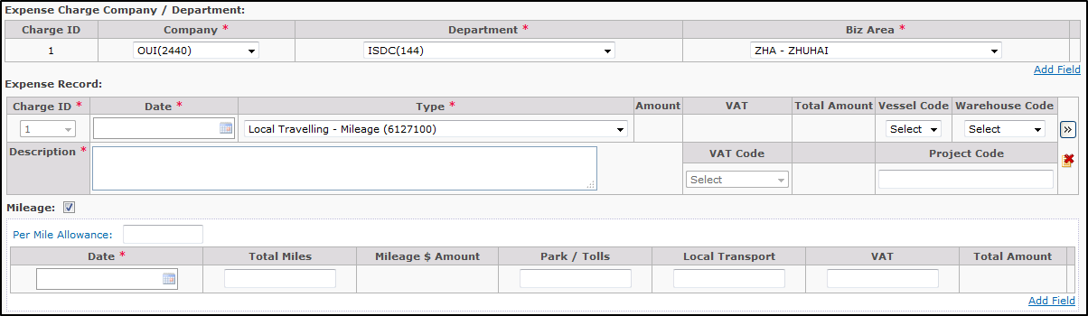

* + Multiple rows case

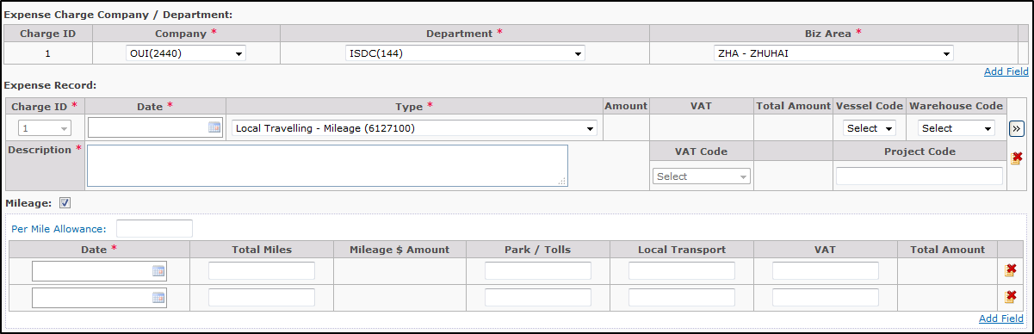

**Summary Details -> Reimbursement in Total**:

| Form Field | Description | Data Type | Multi-lingual | Data Length | Mandatory | Values | Default |
| --- | --- | --- | --- | --- | --- | --- | --- |
| Currency | Currency of Expense | Pull-down | No | N/A | Yes | Value copy from last completed SR | <Blank> |

**Endorsed / Approved By**:

| Form Field | Description | Data Type | Multi-lingual | Data Length | Mandatory | Values | Default |
| --- | --- | --- | --- | --- | --- | --- | --- |
| Name | Email Banner of approver | Read-only Text | No | N/A | Yes | User inputted | <Blank> |
| Sequence | The sequence to send email to approver | Text | No | 10 | Yes | System will auto calculate and display the value, user can amend it. |  |

Remarks:

*Default approvers from the last completed SR record

**CC List:**

| Form Field | Description | Data Type | Multi-lingual | Data Length | Mandatory | Values | Default |
| --- | --- | --- | --- | --- | --- | --- | --- |
| Name | Email Banner of CC staff | Read-only Text | No | N/A | N/A | User inputted | <Blank> |
| Functional/Group Email | Functional/Group Email Address | Text | No | 128 | N/A | User inputted | <Blank> |

Remarks:

*Default CC List from the last completed SR record

Remarks

| Form Field | Description | Data Type | Multi-lingual | Data Length | Mandatory | Values | Default |
| --- | --- | --- | --- | --- | --- | --- | --- |
| Remarks |  | Text | Yes | 1000 | N/A | User inputted | <Blank> |

**Attach File**

| Form Field | Description | Data Type | Multi-lingual | Data Length | Mandatory | Values | Default |
| --- | --- | --- | --- | --- | --- | --- | --- |
| Filename | Location of file to be uploaded | Text | No | 1000 | Yes * | User inputted | <Blank> |
| Description |  | Text | Yes | 1000 | No | User inputted | <Blank> |

Remarks

* Attach file is not mandatory and can be left blank, “File Name” is mandatory only if there is entry in Attach File. The max size of each file is 2 MB.

**Summary**

| Form Field | Description | Data Type | Multi-lingual | Data Length | Mandatory | Values | Default |
| --- | --- | --- | --- | --- | --- | --- | --- |
| Total Expense | Total Expense | Read-only Text | No | N/A | N/A | Auto Sum Total Expense Details in Different Currency | <Blank> |
| Expense Type | Total Expense by Expense type | Read-only Text | No | N/A | N/A | Auto Sum Total Expense by Type | <Blank> |

### Field Actions

**“Add Field” button for Expense Charge Company / Department**

* On click: check if there are already 20 entries
  + If yes, prompt warning message and disallow adding: “You cannot add more than 20 entries in Expense Charge Company / Department.”
* Otherwise, add one empty entry for Expense Charge Company / Department table

**“Delete” buttons for Expense Charge Company / Department:**

* On click:
  + The record that Charge ID is 1 cannot be removed
  + Prompt confirmation message: “Are you sure to remove this Record?”, if user click “Yes”, remove the selected entry, otherwise, do nothing.
  + If the Charge ID of removed record has been selected in Expense Record –
    - If there’s only 1 row in Expense Charge Company / Department table, reset the Charge ID as 1 for the rows that was selected the removed Charge ID in Expense Record table. The Charge ID in Expense record should be disabled.
    - If there’re more than 1 row in Expense Charge Company / Department table, refresh the dropdown list of Charge ID in all rows in Expense Record table, and reset the Charge ID for the rows that was selected the removed Charge ID.

**“Add Field” button for Expense Record:**

* On click: add one empty entry on Expense Record table.

**“Delete” buttons for Expense** **Record**:

* On click: Prompt confirmation message: “Are you sure to remove this Expense Record?”, if user click “Yes”, remove the selected entry, otherwise, do nothing.

**“Add Field” button for Mileage:**

* On click: check if there are already 20 entries
  + If yes, prompt warning message and disallow adding: “You cannot add more than 20 entries in Mileage.”
  + Otherwise, add one empty entry for Mileage table

**“Delete” buttons for Mileage**:

* On click: Prompt confirmation message: “Are you sure to remove this Mileage?”, if user click “Yes”, remove the selected entry, otherwise, do nothing.

**“Add Field” button for Endorsed/Approved By:**

* On click: check if there are already 5 entries:
  + If yes, prompt warning message and disallow adding: “You cannot add more than 5 entries in Endorsed/Approved By”
  + Otherwise, pop-up Search Staff Layer (UI-9)

**“Delete” buttons for Endorsed/Approved By:**

* On click: Prompt confirmation message: “Are you sure to remove this Approver?”, if user click “Yes”, remove the selected entry, otherwise, do nothing.

**“Add” buttons for CC List - Staff:**

* On click: check if there are already 30 entries
  + If yes, prompt warning message and disallow adding: “You cannot add more than 30 entries in CC List”
  + Otherwise, pop-up Search Staff Layer (UI-9)

**“Delete” buttons for CC List - Staff:**

* On click: Prompt confirmation message: “Are you sure to remove this CC Staff?”, if user click “Yes”, remove the selected entry, otherwise, do nothing.

**“Add” buttons for CC List – Functional/Group Email:**

* On click: check if there are already 5 entries
  + If yes, prompt warning message and disallow adding: “You cannot add more than 30 entries Functional/Group Email”
  + Otherwise, add one empty entry for Functional/Group Email

**“Delete” buttons for CC List - Functional/Group Email:**

* On click: Prompt confirmation message: “Are you sure to remove this Functional/Group Email?”, if user click “Yes”, remove the selected entry, otherwise, do nothing.

**“Add Field” button for Attach File**:

* On click: check if there are already 30 entries
  + If yes, prompt warning message and disallow adding: “You cannot add more than 30 entries in Attach File.”
  + Otherwise, add one empty entry for Attach File table

**“Delete” buttons for Attach File**:

* On click: Prompt confirmation message: “Are you sure to remove this Attach File?”, if user click “Yes”, remove the selected entry, otherwise, do nothing.

**“Submit” button:**

* On click: run below checking in order:
  + Check if all mandatory fields/sections are inputted properly
    - If found empty mandatory fields, exit the process and prompt warning message stating the 1st empty field/section in the form, e.g. “Please input Travel Itinerary.”, “Please input Applicant.”
    - Otherwise, go on below logic
  + Check if Applicant is included in “Endorsed/Approved By”
    - If found any, exit the process and prompt below warning message: “Applicant cannot be included in Approver list.”
    - Otherwise, go on below logic
  + Check if Applicant or Record Creator or Approver is included in “CC List”
    - If found any, exit the process and prompt below warning message: “Applicant / Record Creator / Approver cannot be included in CC List.”
    - Otherwise, go on below logic
  + Check if any file in “Attach File” have size exceeding 2MB
    - If found any, exit the process and prompt warning message stating the 1st file with size > 2MB: “Size of Attach File cannot exceed 2MB: <File Name>.”
    - Otherwise, go on below logic
  + If the application is submitted by other staff, only the applicant or submitter is put in endorser list, and the applicant or submitter is not EXECO members, the following alert message is prompted –

“Applicant / Submitter cannot be the ONLY Endorser, please add Applicant’s supervisor as the 2nd/final Endorser”



* + System persist the form content to DB, then prompt below information message “Record has been submitted successfully.” (OK), and redirect user to home page after user click on OK button.

**“Cancel” button**:

- On click: prompt confirmation message: “Are you sure to close this page? All the contents you inputted would be lost.”, if user click “Yes”, close the page, otherwise, do nothing.

**“Save” button**:

* On click: run below checking in order:
  + Check whether user input Applicant
    - If Applicant is empty, popup alert “Please input Applicant.”
    - Otherwise, persist the form content to DB with Saved status, then prompt below information message “Record has been saved successfully.” (OK), and redirect user to home page after user click on OK button.

### Email Notification

Upon successfully submitted new Staff Expense record, send email notification as below:

Subject: Staff Expense Claim - <Applicant Email Banner> - <SRID>

To: The approver with sequence 1

CC: <Applicant>; <Record Creator>; <CC List Staff>; <CC Functional/Group Email>

Body:

//Quote

Dear Approver  
  
This Staff Expense Claim request is CREATED. For your review and endorsement please.  
  
Please click on [ENDORSE](http://testwebmail.oocl.com/owa/redir.aspx?C=68bU4_3UDkuoNJByisXxZ9sTuiT0ydVIKFf3kfwIkJgVA2HDkNxZbKsd7Xl0Aom8nAEXFKNbf8E.&URL=http%3a%2f%2fgltmsuat%2fGLTMSAPPS%2flayouts%2femail%2fmApprove.aspx%3fERID%3dSRWANGWE2180002%26ACTION%3dENDORSE) or [REJECT](http://testwebmail.oocl.com/owa/redir.aspx?C=68bU4_3UDkuoNJByisXxZ9sTuiT0ydVIKFf3kfwIkJgVA2HDkNxZbKsd7Xl0Aom8nAEXFKNbf8E.&URL=http%3a%2f%2fgltmsuat%2fGLTMSAPPS%2flayouts%2femail%2fmApprove.aspx%3fERID%3dSRWANGWE2180002%26ACTION%3dREJECT) to approve or reject this request   
  
Please [click here](http://testwebmail.oocl.com/owa/redir.aspx?C=68bU4_3UDkuoNJByisXxZ9sTuiT0ydVIKFf3kfwIkJgVA2HDkNxZbKsd7Xl0Aom8nAEXFKNbf8E.&URL=http%3a%2f%2fgltmsuat%2fGLTMSAPPS%2flayouts%2femail%2fmApproveComment.aspx%3fERID%3dSRWANGWE2180002) if you would like to add any comments or [click here](http://testwebmail.oocl.com/owa/redir.aspx?C=68bU4_3UDkuoNJByisXxZ9sTuiT0ydVIKFf3kfwIkJgVA2HDkNxZbKsd7Xl0Aom8nAEXFKNbf8E.&URL=http%3a%2f%2fgltmsuat%2fGLTMSAPPS%2flayouts%2fmain%2fgltms.aspx%3fERID%3dSRWANGWE2180002) to open the record.

|  |  |  |  |  |  |  |  |  |  |  |  |  |  |  |  |  |  |  |  |  |  |  |  |  |  |  |  |  |  |  |  |  |  |  |  |  |  |  |  |  |  |  |  |  |  |  |  |  |  |  |  |  |  |  |  |  |  |  |  |  |  |  |  |  |  |  |  |  |  |  |  |  |  |  |  |  |  |  |  |  |  |  |  |  |  |  |  |  |  |  |  |  |  |  |  |  |  |  |  |  |  |  |  |  |  |  |  |  |  |  |  |  |  |  |  |  |  |  |  |  |  |  |  |  |  |  |  |  |  |  |  |  |  |  |  |  |  |  |  |  |  |
| --- | --- | --- | --- | --- | --- | --- | --- | --- | --- | --- | --- | --- | --- | --- | --- | --- | --- | --- | --- | --- | --- | --- | --- | --- | --- | --- | --- | --- | --- | --- | --- | --- | --- | --- | --- | --- | --- | --- | --- | --- | --- | --- | --- | --- | --- | --- | --- | --- | --- | --- | --- | --- | --- | --- | --- | --- | --- | --- | --- | --- | --- | --- | --- | --- | --- | --- | --- | --- | --- | --- | --- | --- | --- | --- | --- | --- | --- | --- | --- | --- | --- | --- | --- | --- | --- | --- | --- | --- | --- | --- | --- | --- | --- | --- | --- | --- | --- | --- | --- | --- | --- | --- | --- | --- | --- | --- | --- | --- | --- | --- | --- | --- | --- | --- | --- | --- | --- | --- | --- | --- | --- | --- | --- | --- | --- | --- | --- | --- | --- | --- | --- | --- | --- | --- | --- | --- | --- | --- | --- | --- | --- |
| |  |  |  |  | | --- | --- | --- | --- | | Created by: | LILI WEI (EUCD-EUC-ISD-OOCLL/ZHA) | Last Action by: | LILI WEI (EUCD-EUC-ISD-OOCLL/ZHA) | | Applicant: | WESLEY WANG (EUCD-EUC-ISD-OOCLL/ZHA) | Staff Expense Claims ID: | SRWANGWE2180002 | | Expense Details | | Status: | Approver Reviewing | | Expense Charge Company / Department: | | | | | |  |  |  |  | | --- | --- | --- | --- | | Charge ID | Company | Department | Biz Area | | 1 | OOCLL(2201) | ISDC(144) | ZHA - ZHUHAI | | | | | | Expense Record: |  |  |  | | |  |  |  |  |  |  |  |  |  |  |  | | --- | --- | --- | --- | --- | --- | --- | --- | --- | --- | --- | | Charge ID | Date | Type | CCY | Amount | VAT | Total Amount | VAT Code | Vessel Code | Warehouse Code | Project Code | | 1 | Oct 30 2017 | Advertising (6121000) | HKD | 80 | 0 | 80 |  |  |  |  | | Description | testing testing testing testing testing testing testing testing testing testing testing testing testing testing testing testing testing testing testing testing testing testing testing testing testing testing testing testing testing testing testing testing testing | | | | | | | | | | | | | | | | Summary | | | |  | | Exchange Rate: | Reimbursement in Total: 80.00HKD | | |  | | |  |  | | --- | --- | | CCY | Ex. Rate | | HKD | 1 | |  | | |  | | |  |  | | --- | --- | |  | HKD | | Expense Item Summary |  | | Advertising (6121000) | 80.00 | |  |  | | Total Expense | 80.00 | | | | |  | | Endorsed / Approved by: * | |  |  |  | | --- | --- | --- | | Name | Endorsed | Comment | | LILI WEI (EUCD-EUC-ISD-OOCLL/ZHA) |  |  | | | |  | | CC List | |  | | --- | | HENRY LIU (EUCD-EUC-ISD-OOCLL/ZHA) | | | |  | | CC Group List | |  | | --- | | oocluat@oocl.com | | | |  | | FINCON Office | |  |  | | --- | --- | | Company | Office | | ABC |  | |  | |  | | Remarks: |  | | |  | |

Please click on [ENDORSE](http://testwebmail.oocl.com/owa/redir.aspx?C=68bU4_3UDkuoNJByisXxZ9sTuiT0ydVIKFf3kfwIkJgVA2HDkNxZbKsd7Xl0Aom8nAEXFKNbf8E.&URL=http%3a%2f%2fgltmsuat%2fGLTMSAPPS%2flayouts%2femail%2fmApprove.aspx%3fERID%3dSRWANGWE2180002%26ACTION%3dENDORSE) or [REJECT](http://testwebmail.oocl.com/owa/redir.aspx?C=68bU4_3UDkuoNJByisXxZ9sTuiT0ydVIKFf3kfwIkJgVA2HDkNxZbKsd7Xl0Aom8nAEXFKNbf8E.&URL=http%3a%2f%2fgltmsuat%2fGLTMSAPPS%2flayouts%2femail%2fmApprove.aspx%3fERID%3dSRWANGWE2180002%26ACTION%3dREJECT) to approve or reject this request   
  
Please [click here](http://testwebmail.oocl.com/owa/redir.aspx?C=68bU4_3UDkuoNJByisXxZ9sTuiT0ydVIKFf3kfwIkJgVA2HDkNxZbKsd7Xl0Aom8nAEXFKNbf8E.&URL=http%3a%2f%2fgltmsuat%2fGLTMSAPPS%2flayouts%2femail%2fmApproveComment.aspx%3fERID%3dSRWANGWE2180002) if you would like to add any comments or [click here](http://testwebmail.oocl.com/owa/redir.aspx?C=68bU4_3UDkuoNJByisXxZ9sTuiT0ydVIKFf3kfwIkJgVA2HDkNxZbKsd7Xl0Aom8nAEXFKNbf8E.&URL=http%3a%2f%2fgltmsuat%2fGLTMSAPPS%2flayouts%2fmain%2fgltms.aspx%3fERID%3dSRWANGWE2180002) to open the record.  
  
Note:DO NOT reply to this email. For any query, please contact HR department

//Unquote

## View/Update Travel Application

## View/Update Expense Claims

## View/Update Staff Expense Claims

# Appendix

Validation:

1. If the application is submitted by other staff, only the applicant or submitter is put in endorser list, and the applicant or submitter is not EXECO members, the following alert message is prompted -

“Applicant / Submitter cannot be the ONLY Endorser, please add Applicant’s supervisor as the 2nd/final Endorser”

1. 