**[Tutorial 2](https://www.myefrei.fr/moodle/mod/resource/view.php?id=38589)**

**NI HE**

**BI2**

**Artificial Intelligence for Knowledge Discovery**

rules.append("[rule1: (?x mcf:PartOf ?y), (?y mcf:PartOf ?z) -> (?x mcf:PartOf ?z)] ");

rules.append("[rule2: (?x rdfs:subClassOf ?y), (?y rdfs:subClassOf ?z) -> (?x rdfs:subClassOf ?z)] ");

rules.append("[rule3: (?a, rdfs:subClassOf, ?c), (?c, mcf:InsertOn, ?b) -> (?a, mcf:InsertOn, ?b)]");

rules.append("[rule4: (?a, mcf:IsInvolvedIn, ?c), (?c, rdfs:subClassOf, ?b) -> (?a, mcf:IsInvolvedIn, ?b)]");

rules.append("[rule5: (?a, mcf:LeftSubClassOf, ?b) -> (?a, rdfs:subClassOf, ?b)]");

rules.append("[rule6: (?a, mcf:RightSubClassOf, ?b) -> (?a, rdfs:subClassOf, ?b)]");

rules.append("[rule7: (?a, mcf:HasFunction, ?b) -> (?a, mcf:ContributesTo, ?b)]");

rules.append("[rule8: (?a, mcf:ContributesTo, ?c), (?c, mcf:IsInvolvedIn, ?b) -> (?a, mcf:ContributesTo, ?b)]");

rules.append("[rule9: (?a, mcf:ContributesTo, ?c), (?c, rdfs:subClassOf, ?b) -> (?a, mcf:ContributesTo, ?b)]");

rules.append("[rule10: (?a, mcf:InsertOn, ?c), (?c, mcf:PartOf, ?b) -> (?a, mcf:InsertOn, ?b)]");

rules.append("[rule11: (?a, mcf:IsInvolvedIn, ?c), (?c, mcf:IsInvolvedIn, ?b) -> (?a, mcf:IsInvolvedIn, ?b)]");

rules.append("[rule12: (?a, mcf:ContributesTo, ?b), (?b, mcf:Flexion_of_knee_joint, ?c) -> (?a, ContributesTo, ?c)]");

1. What is the size (number of triplets) of each knowledge base before and after saturation?

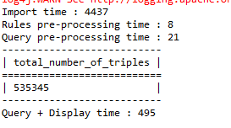

MyCF2

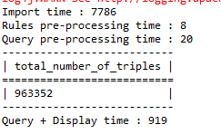

MyCF2Sat

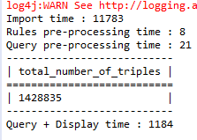

go

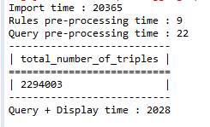

go-plus

1. Consider rdfs: subClassOf, part of and 3 other properties specific to each ontology of your choice. For each property, how many triplets are there before and after saturation?

-------------------------------- ---subClassOf----------------------------------

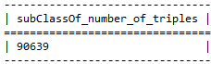

Go

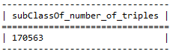

Go-plus

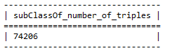

MyCF2

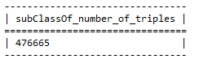

MyCF2Sat

------------------------------------Part Of-------------------------------------

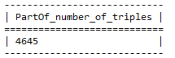

MyCF2

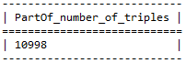

MyCF2Sat

--------------------------------Right Sub Class Of-------------------------------

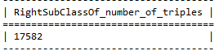

MyCF2



MyCF2Sat

---------------------------------Left Sub Class Of-------------------------------

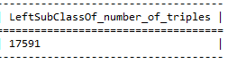

MyCF2

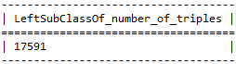

MyCF2Sat

1. Choose three rules for each ontology. How many triplets are inferred for each rule?

I don’t get the rules of Go, so I don’t know how to figure out this .

* rules.append("[rule1: (?x mcf:PartOf ?y), (?y mcf:PartOf ?z) -> (?x mcf:PartOf ?z)] ");

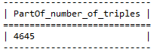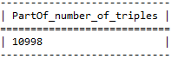

MyCF2

* rules.append("[rule8: (?a, mcf:ContributesTo, ?c), (?c, mcf:IsInvolvedIn, ?b) -> (?a, mcf:ContributesTo, ?b)]");

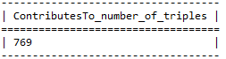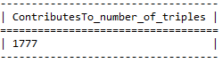

MyCF2

* rules.append("[rule10: (?a, mcf:InsertOn, ?c), (?c, mcf:PartOf, ?b) -> (?a, mcf:InsertOn, ?b)]");

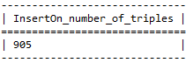 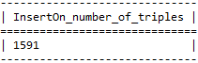

MyCF2

1. What is the inference time of the set of rules for each knowledge base? P.S. You should measure the execution time for the same machine.

Same problem with question 3,can’t get GO rules

MyCF2 execution time is 12

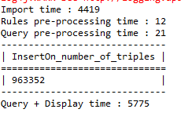

1. Choose two classes of MyCF, one of which is subclass of mcf: Anatomical_entity and the other is subclass of mcf: Functional_entity, and calculate the number of respective subclasses. Measure time response to the query, using the three different reasoning engines (Hybrid, Forward, and Backward) implemented by Jena.

The number of Anatomical_entity: 7

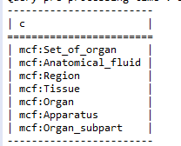 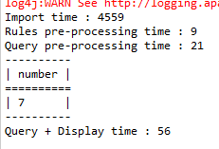

The number of Functional_entity: 7

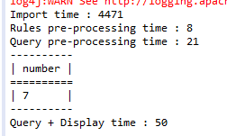 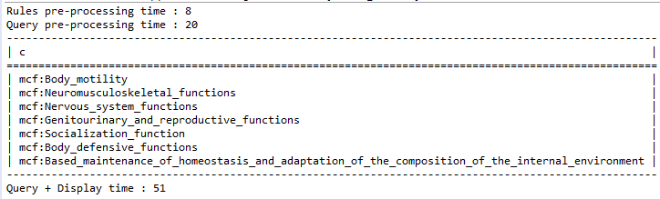

Hybrid for Anatomical_entity : 22

Hybrid for Functional_entity : 20

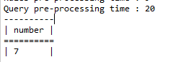 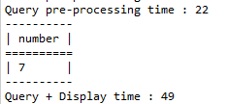

forward for Anatomical_entity : 22

forward for Functional_entity:16

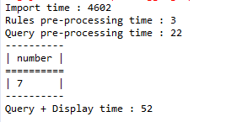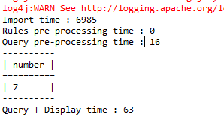

backward for Anatomical_entity : 20

backward for Functional_entity : 20

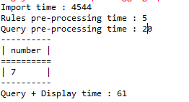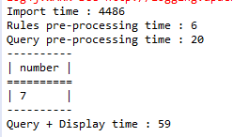

Qustion6: The question want me to choose two GO classes,

I try to find the classes of go, but I don’t find it.

