Sample: Framed Image annotation

H1 About the image

The sample image is generated by copilot.microsoft.com on 2026-01-02
with prompt:
generate a clean dining room with apples, bananas, guavas on the table, each group of fruits distributed sparsely on the dining table, warm and cozy, breeze comes in from the window
Table 1: Prompt of the sample image

H1 The annotated framed image
arrow 3
3. dining room
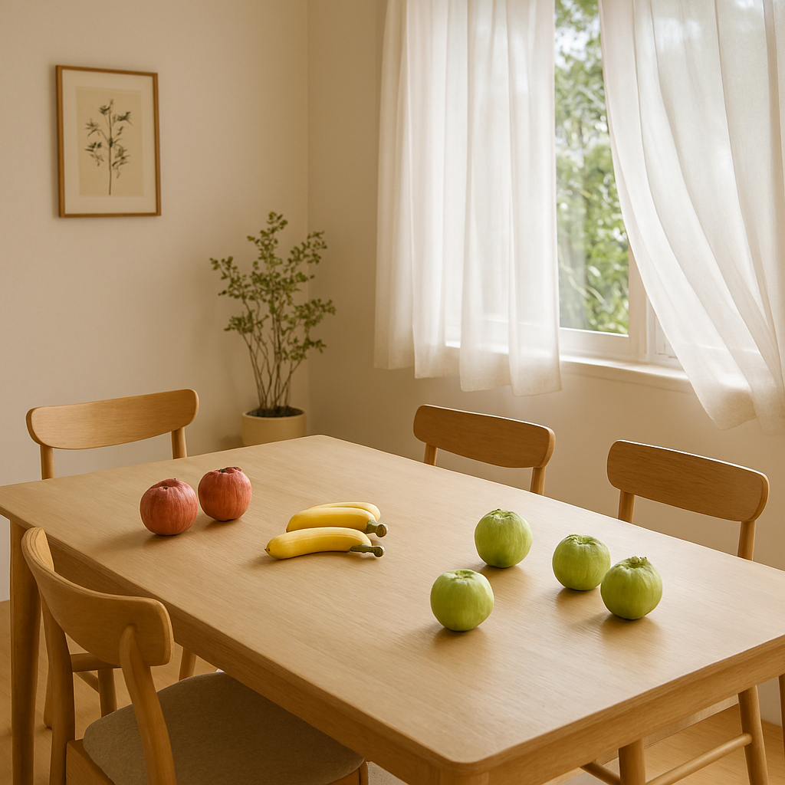Figure 1: Image with annotation text and drawing objects
arrow 1
arrow 2
1. picture on the wall
2. banana

H2 Annotated text
1. picture on the wall: red bounding box, with solid line line color red, align right, center vertically
2. banana: black bound box, with dotted line color red, align center, align bottom, italic
3. dining room: bounding box with green background color, no bounding line, align right, align top

