

Technical Safety Concept Lane Assistance

**Document Version: [Version]**

**Template Version 1.0, Released on 2017-06-21**



# Document history

|  |  |  |  |
| --- | --- | --- | --- |
| Date | Version | Editor | Description |
| 10/23/2018 | 1.0 | Yan Cui | First draft |
| 11/01/2018 | 1.1 | Yan Cui | Revision for submission |
|  |  |  |  |
|  |  |  |  |
|  |  |  |  |

# 

# Table of Contents

Document history

Table of Contents

Purpose of the Technical Safety Concept

Inputs to the Technical Safety Concept

Functional Safety Requirements

Refined System Architecture from Functional Safety Concept

Functional overview of architecture elements

Technical Safety Concept

Technical Safety Requirements

Refinement of the System Architecture

Allocation of Technical Safety Requirements to Architecture Elements

Warning and Degradation Concept

# Purpose of the Technical Safety Concept

In this document, new requirements are assigned to the system architecture. The technical safety concept covered in this document is more concrete and gets into the details of the item's technology.

# Inputs to the Technical Safety Concept

## Functional Safety Requirements

|  |  |  |  |  |
| --- | --- | --- | --- | --- |
| **ID** | **Functional Safety Requirement** | **ASIL** | **Fault Tolerant Time Interval** | **Safe State** |
| Functional  Safety  Requirement  01-01 | Lane Departure Warning (LDW) function needs to ensure the oscillating torque amplitude is always below Max_Torque_Amplitude. | C | 50ms | Oscillating torque amplitude below Max_Torque_Amplitude |
| Functional  Safety  Requirement  01-02 | Lane Departure Warning (LDW) function needs to ensure the oscillating torque frequency is always below Max_Torque_Frequency. | C | 50ms | Oscillating torque frequency below Max_Torque_Frequency |
| Functional  Safety  Requirement  01-03 | Lane Departure Warning (LDW) function shall be deactivated the time when camera sensor stops working | C | 10ms | LDW is deactivated |
| Functional  Safety  Requirement  02-01 | The electronic power steering ECU needs to ensure that Lane Keeping Assistance torque is applied only Max_Duration | B | 500ms | Lane Keeping Assistance torque is zero |
| Functional  Safety  Requirement  02-02 | The Lane Keeping Assistance (LKA) shall be deactivated the time when camera sensor stops working | D | 10ms | Function is deactivated |

## Refined System Architecture from Functional Safety Concept

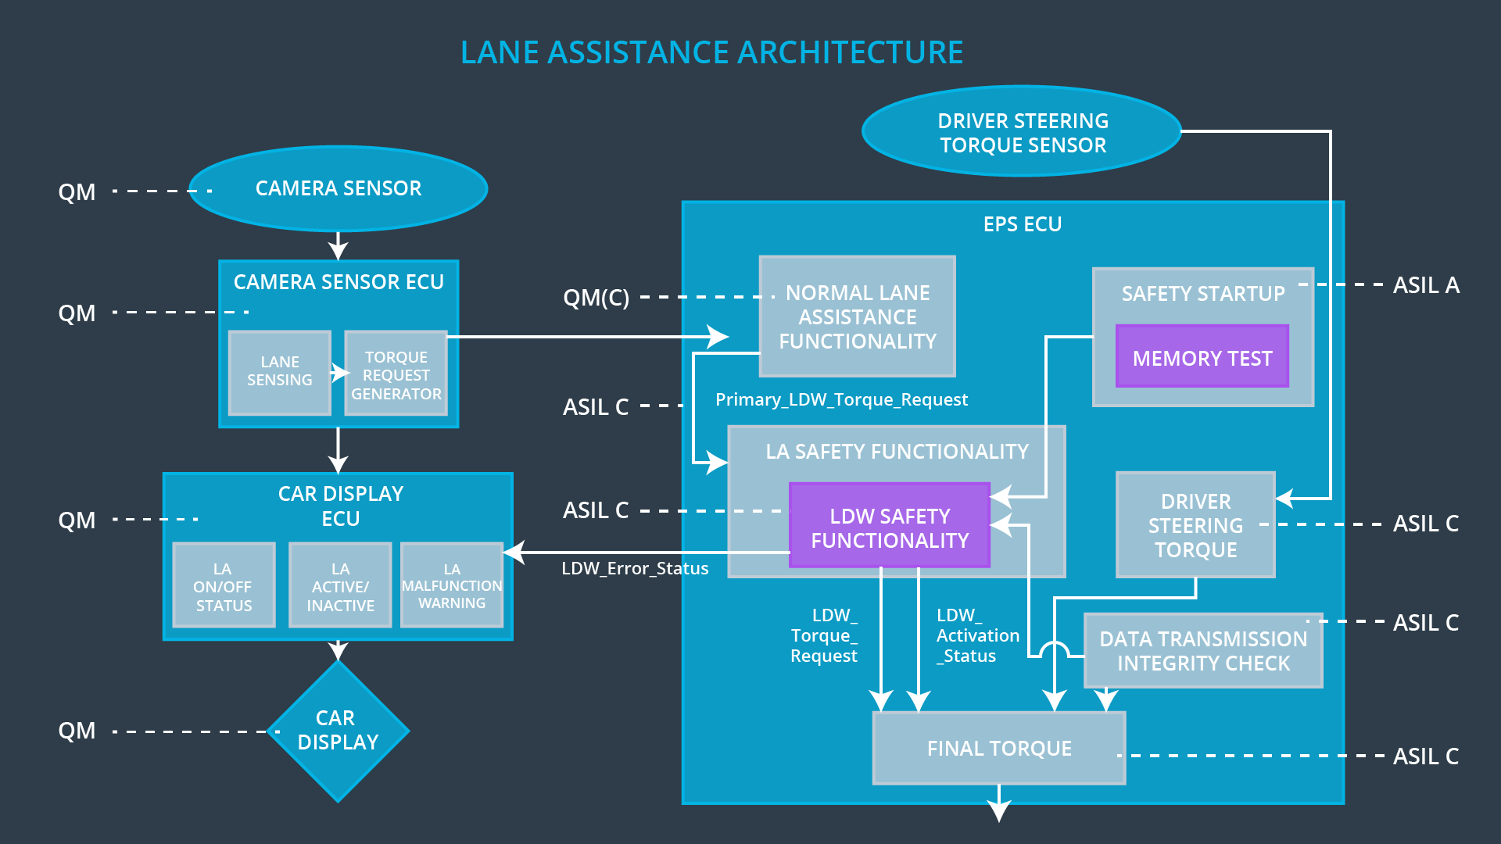

### Functional overview of architecture elements

|  |  |
| --- | --- |
| **Element** | **Description** |
| Camera Sensor | Capture road images and feed them to Camera Sensor ECU. |
| Camera Sensor ECU - Lane Sensing | Software module, detect the lane line position from images captured by Camera Sensor. |
| Camera Sensor ECU - Torque request generator | Software module, calculate the torque to be requested to Electronic Power Steering ECU. |
| Car Display | Display warnings to driver. |
| Car Display ECU - Lane Assistance On/Off Status | Indicate status of the Lane Assistance function On/Off. |
| Car Display ECU - Lane Assistant Active/Inactive | Indicate function status of Lane Assistant, Active/Inactive. |
| Car Display ECU - Lane Assistance malfunction warning | Indicate malfunction on the Lane Assistance function. |
| Driver Steering Torque Sensor | Measure the torque applied to steering wheel by the driver. |
| Electronic Power Steering (EPS) ECU - Driver Steering Torque | Software module, receive driver’s steering torque request from the steering wheel. |
| EPS ECU - Normal Lane Assistance Functionality | Software module, receive Camera Sensor ECU torque request. |
| EPS ECU - Lane Departure Warning Safety Functionality | Software module, make sure the torque applied having amplitude within the limited range. |
| EPS ECU - Lane Keeping Assistant Safety Functionality | Software module, make sure the LKA function is not active more than Max_Duration time. |
| EPS ECU - Final Torque | Combine the torque request from LKA and LDW functions, and send torque to Motor. |
| Motor | Physically applies torque to steering wheels. |

# Technical Safety Concept

## Technical Safety Requirements

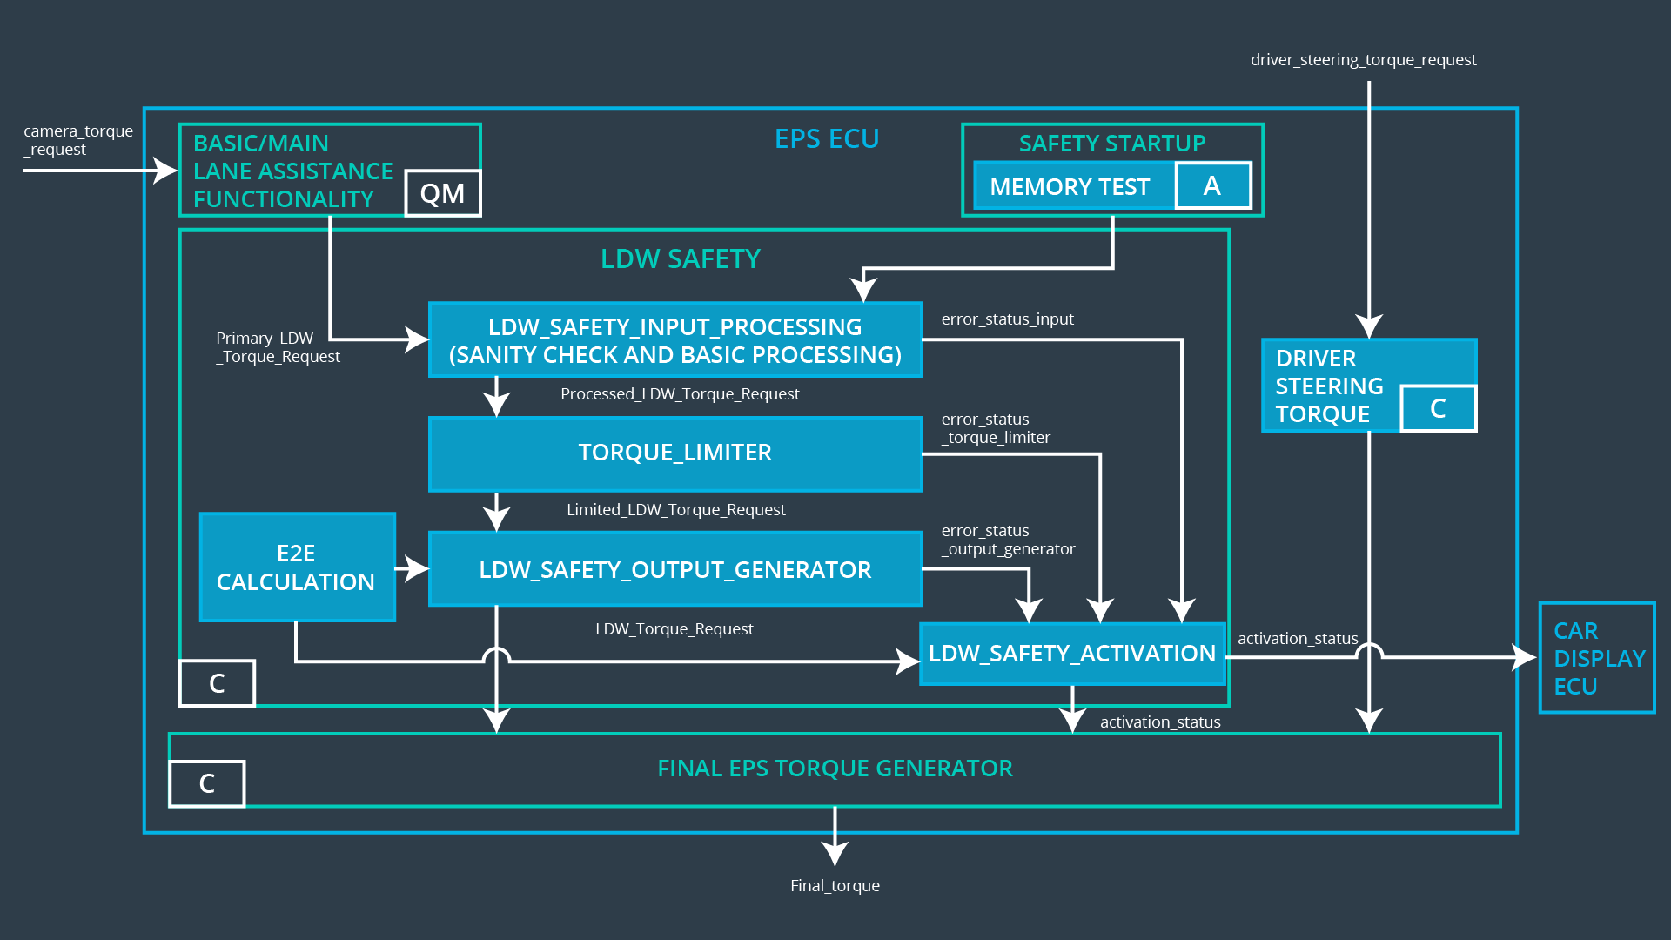

**Lane Departure Warning (LDW) Requirements:**

Functional Safety Requirement 01-01 with its associated system elements

(derived in the functional safety concept)

|  |  |  |  |  |
| --- | --- | --- | --- | --- |
| **ID** | **Functional Safety Requirement** | **Electronic Power Steering ECU** | **Camera ECU** | **Car Display ECU** |
| Functional  Safety  Requirement  01-01 | The lane keeping item shall ensure that the lane departure oscillating torque amplitude is below Max_Torque_Amplitude | X |  |  |

Technical Safety Requirements related to Functional Safety Requirement 01-01 are:

|  |  |  |  |  |  |
| --- | --- | --- | --- | --- | --- |
| **ID** | **Technical Safety Requirement** | **ASIL** | **Fault Tolerant Time Interval** | **Architecture Allocation** | **Safe State** |
| Technical  Safety  Requirement  01 | The Lane Departure Warning safety component needs to ensure the amplitude of the LDW torque request being sent to Electronic Power Steering torque is below Max_Torque_Amplitude. | C | 50ms | LDW Safety | LDW torque at zero |
| Technical  Safety  Requirement  02 | When the Lane Departure Warning is deactivated, the LDW Safety module must send a signal message to Car Display ECU indicating the warning. | C | 50ms | LDW Safety | LDW torque at zero |
| Technical  Safety  Requirement  03 | When failure of Lane Departure Warning function is detected, it must deactivate the LDW feature and reset torque request to zero. | C | 50ms | LDW Safety | LDW torque at zero |
| Technical  Safety  Requirement  04 | The validity and integrity of data transmission of LDW torque request needs to be ensured. | C | 50ms | LDW Safety | LDW torque at zero |
| Technical  Safety  Requirement  05 | Memory test needs to be conducted at starting of EPS ECU to check any memory issue. | A | Ignition cycle | Data transmission integrity check | LDW torque at zero |

Functional Safety Requirement 01-2 with its associated system elements

(derived in the functional safety concept)

|  |  |  |  |  |
| --- | --- | --- | --- | --- |
| **ID** | **Functional Safety Requirement** | **Electronic Power Steering ECU** | **Camera ECU** | **Car Display ECU** |
| Functional  Safety  Requirement  01-02 | The lane keeping item shall ensure that the lane departure oscillating torque frequency is below Max_Torque_Frequency | X | LDW Safety | LDW torque at zero |

Technical Safety Requirements related to Functional Safety Requirement 01-02 are:

|  |  |  |  |  |  |
| --- | --- | --- | --- | --- | --- |
| **ID** | **Technical Safety Requirement** | **ASIL** | **Fault Tolerant Time Interval** | **Architecture Allocation** | **Safe State** |
| Technical  Safety  Requirement  01 | The Lane Departure Warning safety component must ensure the torque frequency sent to Electronic Power Steering Torque is below Max_Torque_Frequency. | C | 50ms |  |  |

**Lane Keeping Assistance (LKA) Requirements:**

Functional Safety Requirement 02-1 with its associated system elements

(derived in the functional safety concept)

|  |  |  |  |  |
| --- | --- | --- | --- | --- |
| **ID** | **Functional Safety Requirement** | **Electronic Power Steering ECU** | **Camera ECU** | **Car Display ECU** |
| Functional  Safety  Requirement  02-01 | The lane keeping item shall ensure that the lane keeping assistance torque is applied for only Max_Duration | X |  |  |

Technical Safety Requirements related to Functional Safety Requirement 02-01 are:

|  |  |  |  |  |  |
| --- | --- | --- | --- | --- | --- |
| **ID** | **Technical Safety Requirement** | **ASIL** | **Fault Tolerant Time Interval** | **Allocation to Architecture** | **Safe State** |
| Technical  Safety  Requirement  01 | The Lane Keeping Assistance safety component must make sure the duration of the LKA torque is activated within time of Max_Duration. | C | 500ms | LKA Safety | LKA torque at zero. |
| Technical  Safety  Requirement  02 | When Lane Keeping Assistance function is deactivated, the LKA safety component must send a signal message to Car Display ECU, indicating a warning. | C | 500ms | LKA Safety | LKA torque at zero. |
| Technical  Safety  Requirement  03 | When failure is detected, the Lane Keeping Assistance function must be deactivated and the corresponding torque request must be reset to zero. | C | 500ms | LKA Safety | LKA torque at zero. |
| Technical  Safety  Requirement  04 | The validity and integrity of the data transmission for LKA torque request must be ensured. | C | 500ms | LKA Safety | LKA torque at zero. |
| Technical  Safety  Requirement  05 | Memory test must be conducted at starting of EPS ECU to check any memory issue. | A | Ignition cycle | Data transmission integrity check | LKA torque at zero. |

## Refinement of the System Architecture



## Allocation of Technical Safety Requirements to Architecture Elements

|  |  |  |  |  |
| --- | --- | --- | --- | --- |
| **ID** | **Technical Safety Requirement** | **Electronic Power Steering ECU** | **Camera ECU** | **Car Display ECU** |
| Technical  Safety  Requirement  01-01-01 | The Lane Departure Warning safety component needs to ensure the amplitude of the LDW torque request being sent to Electronic Power Steering torque is below Max_Torque_Amplitude. | X |  |  |
| Technical  Safety  Requirement  01-01-02 | When the Lane Departure Warning is deactivated, the LDW Safety module must send a signal message to Car Display ECU indicating the warning. | X |  |  |
| Technical  Safety  Requirement  01-01-03 | When failure of Lane Departure Warning function is detected, it must deactivate the LDW feature and reset torque request to zero. | X |  |  |
| Technical  Safety  Requirement  01-01-04 | The validity and integrity of data transmission of LDW torque request needs to be ensured. | X |  |  |
| Technical  Safety  Requirement  01-01-05 | Memory test needs to be conducted at starting of EPS ECU to check any memory issue. | X |  |  |
| Technical  Safety  Requirement  02-01-01 | The Lane Keeping Assistance safety component must make sure the duration of the LKA torque is activated within time of Max_Duration. | X |  |  |
| Technical  Safety  Requirement  02-01-02 | When Lane Keeping Assistance function is deactivated, the LKA safety component must send a signal message to Car Display ECU, indicating a warning. | X |  |  |
| Technical  Safety  Requirement  02-01-03 | When failure is detected, the Lane Keeping Assistance function must be deactivated and the corresponding torque request must be reset to zero. | X |  |  |
| Technical  Safety  Requirement  02-01-04 | The validity and integrity of the data transmission for LKA torque request must be ensured. | X |  |  |
| Technical  Safety  Requirement  02-01-05 | Memory test must be conducted at starting of EPS ECU to check any memory issue. | X |  |  |

## Warning and Degradation Concept

|  |  |  |  |  |
| --- | --- | --- | --- | --- |
| **ID** | **Degradation Mode** | **Trigger for Degradation Mode** | **Safe State invoked?** | **Driver Warning** |
| WDC-01 | Turn off Lane Departure Warning (LDW) function | Malfunction_01,  Malfunction_02,Malfunction_04 | Yes | Lane Departure Warning (LDW) malfunction warning on Car Display |
| WDC-02 | Turn off Lane Keeping Assistance (LKA) function | Malfunction_03,Malfunction_05 | Yes | Lane Keeping Assistance (LKA) malfunction warning on Car Display |