

Software Safety Requirements and Architecture

Lane Assistance

**Document Version: [Version]**

**Template Version 1.0, Released on 2017-06-21**



# Document history

|  |  |  |  |
| --- | --- | --- | --- |
| Date | Version | Editor | Description |
| 10/28/2018 | v-1.0 | Yan Cui | First draft. |
| 11/01/2018 | v-1.1 | Yan Cui | Revision for submission |
|  |  |  |  |
|  |  |  |  |
|  |  |  |  |

# 

# Table of Contents

Document history

Table of Contents

Purpose

Inputs to the Software Requirements and Architecture Document

Technical safety requirements

Refined Architecture Diagram from the Technical Safety Concept

Software Requirements

Refined Architecture Diagram

# Purpose

This document includes new requirements for software components at component level, to identify potential problems on software design and architecture. These requirements are more detailled than technical safety concept requirement.

# Inputs to the Software Requirements and Architecture Document

## Technical safety requirements

Technical Safety Requirements related to Functional Safety Requirement 01-01 are:

|  |  |  |  |  |  |
| --- | --- | --- | --- | --- | --- |
| **ID** | **Technical Safety Requirement** | **ASIL** | **Fault Tolerant Time Interval** | **Architecture Allocation** | **Safe State** |
| Technical  Safety  Requirement  01-01-01 | The Lane Departure Warning safety component needs to ensure the amplitude of the LDW torque request being sent to Electronic Power Steering torque is below Max_Torque_Amplitude. | C | 50ms | LDW Safety | LDW torque at zero |
| Technical  Safety  Requirement  01-01-02 | When the Lane Departure Warning is deactivated, the LDW Safety module must send a signal message to Car Display ECU indicating the warning. | C | 50ms | LDW Safety | LDW torque at zero |
| Technical  Safety  Requirement  01-01-03 | When failure of Lane Departure Warning function is detected, it must deactivate the LDW feature and reset torque request to zero. | C | 50ms | LDW Safety | LDW torque at zero |
| Technical  Safety  Requirement  01-01-04 | The validity and integrity of data transmission of LDW torque request needs to be ensured. | C | 50ms | Data transmission integrity check | LDW torque at zero |
| Technical  Safety  Requirement  01-01-05 | Memory test needs to be conducted at starting of EPS ECU to check any memory issue. | A | Ignition cycle | Safety startup - Memory test | LDW torque at zero |

## Refined Architecture Diagram from the Technical Safety Concept

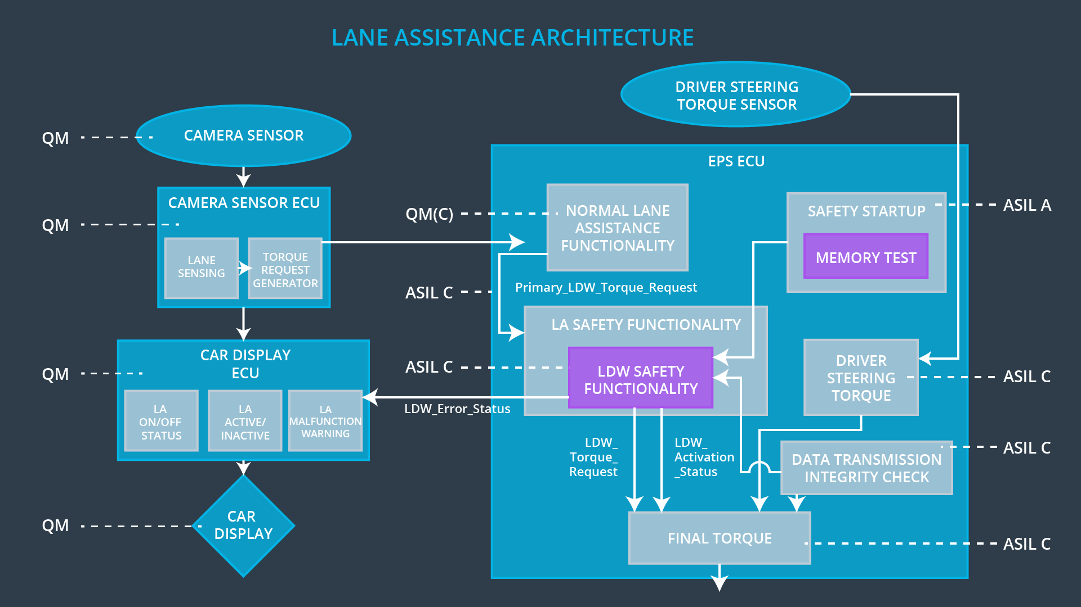

# Software Requirements

**Lane Departure Warning (LDW) Amplitude Malfunction Software Requirements:**

|  |  |  |  |  |  |
| --- | --- | --- | --- | --- | --- |
| **ID** | **Technical Safety Requirement** | **ASIL** | **Fault Tolerant Time Interval** | **Allocation to Architecture** | **Safe State** |
| Technical  Safety  Requirement  01 | The LDW safety component shall ensure that the amplitude of the LDW_Torque_Request sent to the Final Electronic Power Steering Torque component is below Max_Torque_Amplitude | C | 50ms | LDW Safety | Lane Departure Warning torque at zero |

|  |  |  |  |  |
| --- | --- | --- | --- | --- |
| ID | Software Safety Requirement | ASIL | Allocation Software Elements | Safe State |
| Software  Safety  Requirement  01-01 | The input signal, Primary_LDW_Torque_Request must be read and processed to determing the torque request from the Normal Lane Assistance Functionality. | C | LDW_SAFETY_INPUT_PROCESSING | N/A |
| Software Safety Requirement 01-02 | If the processed LDW_Torque_Request is greater than Max_Torque_Amplitude_LDW, the signal limited_LDW_Torque_Request must be reset to zero. Otherwise, limited_LDW_Torque_Request takes value of processed LDW_Torque_Request. | C | TORQUE_LIMITER | Limited_LDW_Torque_Request set to zero |
| Software Safety Requirement 01-03 | The limited_LDW_Torque_Request must be transformed to LDW_Torque_Request, which must be then transmitted out of LDW Safety Component to Final Torque EPS. | C | LDW_SAFETY_OUTPUT_GENERATOR | LDW_Torq_Request set to zero |

|  |  |  |  |  |  |
| --- | --- | --- | --- | --- | --- |
| **ID** | **Technical Safety Requirement** | **ASIL** | **Fault Tolerant Time Interval** | **Allocation to Architecture** | **Safe State** |
| Technical  Safety  Requirement  02 | The validity and integrity of the data transmission for LDW_Torque_Request signal shall be ensured | C | 50ms | LDW Safety | Lane Departure Warning torque at zero |

|  |  |  |  |  |
| --- | --- | --- | --- | --- |
| **ID** | **Software Safety Requirement** | **ASIL** | **Allocation Software Elements** | **Safe State** |
| Software Safety Requirement 02-01 | Data transmitted out, LDW_Torque_Request and Activation_status must be protected by an End-2-End protection mechanism | C | E2C Calc | LDW_Torque_Request at zero |
| Software Safety Requirement 02-02 | The End-2-End protection protocol must contain and attach the control data (SQC, CRC) to data that being transmitted | C | E2E Calc | LDW_Torque_Request at zero |

|  |  |  |  |  |  |
| --- | --- | --- | --- | --- | --- |
| **ID** | **Technical Safety Requirement** | **ASIL** | **Fault Tolerant Time Interval** | **Allocation to Architecture** | **Safe State** |
| Technical  Safety  Requirement  03 | As soon as a failure is detected by the LDW function, it shall deactivate the LDW feature and the LDW_Torque_Request shall be set to zero | C | 50ms | LDW Safety | Lane Departure Warning torque at zero |

|  |  |  |  |  |
| --- | --- | --- | --- | --- |
| **ID** | **Software Safety Requirement** | **ASIL** | **Allocation Software Elements** | **Safe State** |
| Software Safety Requirement03-01 | Each software element must output a signal to indicate corresponding error | C | ALL | N/A |
| Software Safety Requirement03-02 | A software element shall evaluate the error status from other elements. If any of them shows error, this element shall deactivate the Lane Departure Warning, reset activation_status to zero | C | LDW_SAFETY_ACTIVATION | Activation_status = 0 |
| Software Safety Requirement03-03 | While no error from software elements, the Lane Departure Warning function shall be activated, activation_status to 1 | C | LDW_SAFETY_ACTIVATION | N/A |
| Software Safety Requirement03-04 | If any error is detected by software elements, this shall reset the LDW_Torque_Request to zero | C | ALL | LDW_Torque_Request = 0 |
| Software Safety Requirement03-05 | Once the Lane Departure Warning functionality is deactivated, it shall remain at that status until the next ignition switched on | C | LDW_SAFETY_ACTIVATION | Activation_status = 0 |

|  |  |  |  |  |  |
| --- | --- | --- | --- | --- | --- |
| **ID** | **Technical Safety Requirement** | **ASIL** | **Fault Tolerant Time Interval** | **Allocation to Architecture** | **Safe State** |
| Technical  Safety  Requirement  04 | As soon as the LDW function deactivates the LDW feature, the LDW Safety software block shall send a signal to the car display ECU to turn on a warning light | C | 50ms | LDW Safety | Lane Departure Warning torque at zero |

|  |  |  |  |  |
| --- | --- | --- | --- | --- |
| **ID** | **Software Safety Requirement** | **ASIL** | **Allocation Software Elements** | **Safe State** |
| Software Safety Requirement 04-01 | When the Lane Departure Warning is deactivated the activation_status shall be sent to Car Display ECU | C | LDW_SAFETY_ACTIVATION, Car Display ECU | N/A |

|  |  |  |  |  |  |
| --- | --- | --- | --- | --- | --- |
| **ID** | **Technical Safety Requirement** | **ASIL** | **Fault Tolerant Time Interval** | **Allocation to Architecture** | **Safe State** |
| Technical  Safety  Requirement  05 | Memory test shall be conducted at start up of the EPS ECU to check for any faults in memory | A | Ignition cycle | Data Transmission Integrity Check | Lane Departure Warning torque at zero |

|  |  |  |  |  |
| --- | --- | --- | --- | --- |
| **ID** | **Software Safety Requirement** | **ASIL** | **Allocation Software Elements** | **Safe State** |
| Software Safety Requirement 05-01 | CRC checksum over the software in Flash memory must be done everytime ignition is switched on | A | MEMORYTEST | Activation_status = 0 |
| Software Safety Requirement 05-02 | Standard RAM test to check the data bus, address bus and device integrity must be done everytime ignition is switched on | A | MEMORYTEST | Activation_status = 0 |
| Software Safety Requirement 05-03 | The test result of RAM or Flash memory shall be indicated to LDW_Safety component through test_status signal | A | MEMORYTEST | Activation_status = 0 |
| Software Safety Requirement 05-04 | If any error is indicated through test_status signal, the INPUT_LDW_PROCESSING shall raise error flag and set error_status_input = 1, and consequently, LDW_Torque_Request reset to zero | A | LDW_SAFETY_INPUT_PROCESSING | Activation_status = 0 |

# 

# Refined Architecture Diagram

