Bulletin Board for VIT University

**CHANDAN YADAV (14BCE0082)**

**Prepared project for IWP:**

**Bulletin Board For Vit University**

**CSE326 –Internet web programming**

**Instructor: Prof. Manoov R**

**ABSTRACT:**

In recent years, the Internet and especially the Web has enabled a communication revolution, the ability to send and retrieve information everywhere has changed the way we work and live. Internet based access to information and internet communication means shave become ubiquitous. A bulletin board is a surface intended for the posting of public messages, for example, to advertise items wanted for sale, announce events, or provide information. Bulletin boards can also be entirely in the digital domain and placed on computer networks so people can leave and erase messages for other people to read and see, as in a Bulletin Board System.

Table of Contents

1. Introduction: 3

2. Comparative analysis: 3

3. GAP ANALYSIS: 3

4. PROBLEM STATEMENT: 4

5. OBJECTIVE: 4

6. MOTIVATION: 5

7. WORK BREAK DOWN STRUCTURE: 5

7.1. PROCESS BREAK DOWN STRUCTURE: 6

8. NON-FUNCTIONAL REQUIREMENTS: 7

9. SYSTEM REQUIRMENTS: 7

10. ARCHITECTURE DESIGN: 9

11. DATA FLOW DIAGRAM: 10

12. ENTITY RELATION DIAGRAM: 11

13. STATE MACHINE DIAGRAM: 12

14. USE CASE DIAGRAM: 12

15. SEQUENCE DIAGRAM: 13

16. CLASS DIAGRAM: 14

17. ACTIVITY DIAGRAM: 15

18. IMPLIMENTATION AND TESTING: 16

20. Testing 18

21. REFERENCES 19

# **1. Introduction:**

1. Introduction

In recent years, the Internet and especially the Web has enabled a communication revolution, the ability to send and retrieve information everywhere has changed the way we work and live. Internet based access to information and internet communication means shave become ubiquitous.

A bulletin board is a surface intended for the posting of public messages, for example, to advertise items wanted for sale, announce events, or provide information. Bulletin boards can also be entirely in the digital domain and placed on computer networks so people can leave and erase messages for other people to read and see, as in a Bulletin Board System.

* 1. Purpose

In a university a lot of information needs to be conveyed to the students regarding events, announcements etc. Reaching every student is a daunting task. Naturally E-mail provides a solution but not every student checks his/her E-mail account every day. Online Bulletin Board will serve as an online notice board to combat this problem. Any important announcement from the university, information about any upcoming event by a club or chapter can be put up on the board which can be easily viewed by any students having a computer or a smartphone which will save them from the hassle of going through their E-mail account.

* 1. Scope

A student can display interest in any upcoming event by agreeing to attend it. This data can be used to keep track of the number of people attending a particular event which can be thought of as the popularity of an event. Events can be sorted based on date, the club/chapter conducting it, popularity etc. Any information from the university will get maximum attention and will be displayed on the top.

* 1. References

# <https://en.wikipedia.org/wiki/Bulletin_board>

The perspective of this system varies from user to user and more specifically between students and clubs/chapters

**Student’s Individual Perspective:**

Student may see this portal as an opportunity to connect to their peers for resource sharing and as well to connect to the other students for any queries.

**Clubs’/Chapters’ Perspective:**

Clubs/chapters may see this portal to connect to students and can pass any important information at once to all.

* 1. Product Functions

The students can register on the website by providing following information

* User ID
* Name
* Registration Number
* E-Mail Address
* Year of Joining
* Branch

The faculties can register to the website by providing following information

* User ID
* Name
* Faculty ID
* E-Mail Address
  1. Operating Environment

OE-1 : The VIT Bulletin Baord will operate with the following browsers

* Google Chrome version 55 and above
* Mozilla Firefox version 46 and above
* Microsoft Edge version 36 and above

OE-2 : The VIT Bulletin Board shall operate on a server running the current corporate approved Apache web server.

* 1. Design and Implementation Constraints

The places where internet connectivity is not constant or available this system may not be useful to those institutions.

* 1. Assumptions

If anyone wishes to undergo the payment services provided by the clubs/chapters or any other individuals, they would have to contact the concerned person in private and that the VIT Bulletin Board does not provide these payment related services.

* 1. External Interface Requirements
     1. User Interfaces
* The system will provide GUI for the users.
* The users will be able to access the system using their web browsers
  + 1. Hardware Interfaces
* The system will have an interface with their unique login id and password
* They can access the portal through their smart phones as well
  + 1. Software Interfaces
* Concepts of Internet and web programming are used in this project taking use of the programming languages HTML, CSS, JavaScript, PHP, JQuery, Ajax, MySQL and Smarty.
* The softwares used in the development of the project are WampServer 3.0.6, Apache 2.4.23, PHP 5.6.25 :- MySQL 5.7.14, phpMyAdmin 4.6.4, Adminer 4.2.5, PHPSysInfo 3.2.5
* Also the tool used for the development is Firebug

# **2. Comparative analysis:**

In a university a lot of information needs to be conveyed to the students regarding events, announcements etc. Reaching every student is a daunting task. Naturally E-mail provides a solution but not every student checks his/her E-mail account every day. Online Bulletin Board will serve as an online notice board to combat this problem. Any important announcement from the university, information about any upcoming event by a club or chapter can be put up on the board which can be easily viewed by any students having a computer or a smartphone which will save them from the hassle of going through their E-mail account.

# **3. GAP ANALYSIS:**

**Pros**

* system will more effective
* Intended for the development of the student
* Best way to control on the resources
* Redemption from heavy load of academics
* user friendly
* use of generic search algorithms
* system will be more flexible
* support by all college

**Cons**

* system will become more complex than it was earlier
* Totally dependent on the student and faculty behavior
* use of extra time by the faculty
* some student will not accept this
* People will not simply trust other student

# **4. PROBLEM STATEMENT:**

In our three years at VIT, we have come to observe that whenever an event or function is going to take place, the students that are a part of the organizing society are made to go around to different classes and make the announcements.

This has a few negative outcomes:

•Firstly, those students sometimes end up missing their classes to do so. As a result, they fall behind in studies.

•Second, even the classroom environment is disturbed. The students go to classrooms to make announcements and interrupt the teacher mid-lecture to do so. This effects both the students that are a part of the class as well as the teacher as it breaks his/her flow.

•Lastly, another major drawback of this method is that this information does not reach all the students and as a result, many of those interested are not notified about the events and subsequently miss them.

Another thing we have noticed is that during student life, almost everyone is short on money. As a result, people usually have to make do without a lot of resources they would have otherwise wanted. Be it books, stationery, software, etc., all these are equally important and due to lack of money, everyone has to make choices and they always end up having to miss out on one or more of these things.

# **5. OBJECTIVE:**

Our objective is to create a portal with an aim to establish a dedicated information sharing environment with an air of professionalism about it. This, we believe, is the best way to get rid of the various problems caused by students going from room-to-room to make announcements along with making it very easy to share resources, thereby enabling students to gain access to sources of material they would otherwise not have had. A social networking web portal is project that intends to connect students in a particular college to those of their peers and faculties. This networking can help students in numerous ways like sharing and receiving resources related to their curriculum or field of interest. Students can keep themselves updated regarding the different activities going on in the campus and other activities or workshops to be held in future.

# **6. MOTIVATION:**

Having observed the various negative effects of making room-to-room announcements we decided to make use of technology to come up with a more viable solution. Considering that we live in the age of digital technology, we believe that having digital notice boards cum resource sharing platform for universities is the best way forward and will have quite a few positive effects.

# **7. WORK BREAK DOWN STRUCTURE:**

|  |  |  |  |
| --- | --- | --- | --- |
| LEVEL 1  **Social Web Portal** | LEVEL 2  **1.Initiate Project** | LEVEL 3  1.1Develop project charter | LEVEL 4  1.1.1team Development |
| 1.1.2Define scope |
| 1.2Develop project plan | 1.2.1Survey related system |
| 1.2.2Define Requirements |
| **2.Designing** | 2.1Design the Project | 2.1.1Define WBS |
| 2.1.2schedule project |
| 2.2Design project outline | 2.2.1Develop database design |
| 2.2.2 Design constraints |
| **3.Implementation** | 3.1Front-end Work | 3.1.1Portal for registration |
| 3.1.2Portal for |
| searching posts  3.1.3Portal for confirm.. |
| 3.2Back-end Work | 3.2.1Design database |
| 3.2.1Store all user details  3.2.1handle all user |
| requests |
| **4.Testing** | 4.1Testing Procedure | 4.1.1Checking with static testing |
| 4.1.2Evaluation with dynamic testing |
| **5.Maintenance** | 5.1Quality assurance | 5.1.1Corrective Maintenance |
| 5.1.2Adaptive Maintenance |
| 5.2Quality development | 5.2.1Perfective maintenance |

# **7.1. PROCESS BREAK DOWN STRUCTURE:**

# **8. NON-FUNCTIONAL REQUIREMENTS:**

As we know that non-functional requirements describe how the system works. The definition for a non-functional requirement is that it essentially specifies how the system should behave and that it is a constraint upon the systems behaviour. One could also think of non-functional requirements as quality attributes for of a system. How can we manage our system in any type of failure? How our system can handle with the situation, there we are going to describe the non-functional requirement of the system.

1. **Performance:** The user who has 8Mbits internet connection speed, shall be able to enter a page of the system in less than 1 second. The system shall be able to respond more than one thousand users simultaneously. The system shall be able to keep user information of more than one hundred thousand users.
2. **Reliability:** Backing Up of the required, important databases.
3. **Availability:** Since a lot of information about the trips and check in are available in the application, it has to be highly available and guarantees a good server up-time. The server should allow only 1 hour down time per year which is 99.99% up-time.
4. **Security:** The application should ensure the privacy of the users including the trips they take part in and their accounts. The login system should also be robust where only authorized users can post and edit their own information.
5. **Maintenance:** Since the application may be developed in the future by adding other features, it should be easily maintainable.
6. **Portability:** Portability is a characteristic attributed to a computer program if it can be used in an operating systems other than the one in which it was created without requiring major rework. Porting is the task of doing any work necessary to make the computer program run in the new environment.
7. **Scalability:** The application should respond properly to a high increase of users. It should be able to handle from 10 000 users to 100 000 users. And also from 100 000 to one millions users.

# **9. SYSTEM REQUIRMENTS:**

This section gives background information about specific requirements of the web based. Although we will not describe every requirement in detail, this section will describe the factors that affect the final product.

**Product Perspective:**

Bulletin Board for VIT University is independent and self-contained. The constraints which describe how the software operates are listed below:

* + 1. **System Interfaces:** The system has search API as a subsystem. Search subsystem has their own web based interface which is a list of student in a desired college and user can easily intersect with this system.
    2. **User Interfaces:** This software product is developed for student and their need. Product will be deployed to web site and all users of the system will access the system through the web interface which includes multiple pages according to the system functionality for example for login functionality there will be login page. To access the system, every user has unique user name and password. In addition, there will be a database who stores and manipulate all the data about the users. Website will only be the interface for all the user data which stored by database and the execution of provided functionalities.
    3. **Hardware Interfaces:** Because social web system is web based, it is compatible with all the browsers and can be run on any operating system and processor.
    4. **Software Interfaces:** Database management system is required software product for social web system because all data about system for example user and resource information must be stored in database for later use and system functionality. MySQL database management system is used for that purpose and it has nice open source user interface which displays table and rows in well formatted form for developers to create and manage the whole database.
    5. **Communication Interfaces:** The system shall send automatic verification e-mail to the user who wants to register in case of loss of a previously saved registered password.
    6. **Memory:** 64-bit, 4 cores processor. 8 GB RAM. 80 GB for system drive.

|  |  |
| --- | --- |
| **CPU** | 3.0 GHz Intel® Pentium® 4 class or AMD Athlon™ 64 3500+ or equivalent processor |
| **CPU SPEED** | 3.0 GHz Intel® Pentium® 4 class or AMD Athlon™ 64 3500+ or equivalent processor |
| **RAM** | 800MB |
| **OS** | Microsoft® Windows® 7 /8/10 XP® SP3,Linex Mac |
| **MEMORY** | 8 GB for system drive |
| **GRAPHICS CARD** | 1 GB for better visualization |

# 10. **ARCHITECTURE DESIGN:**

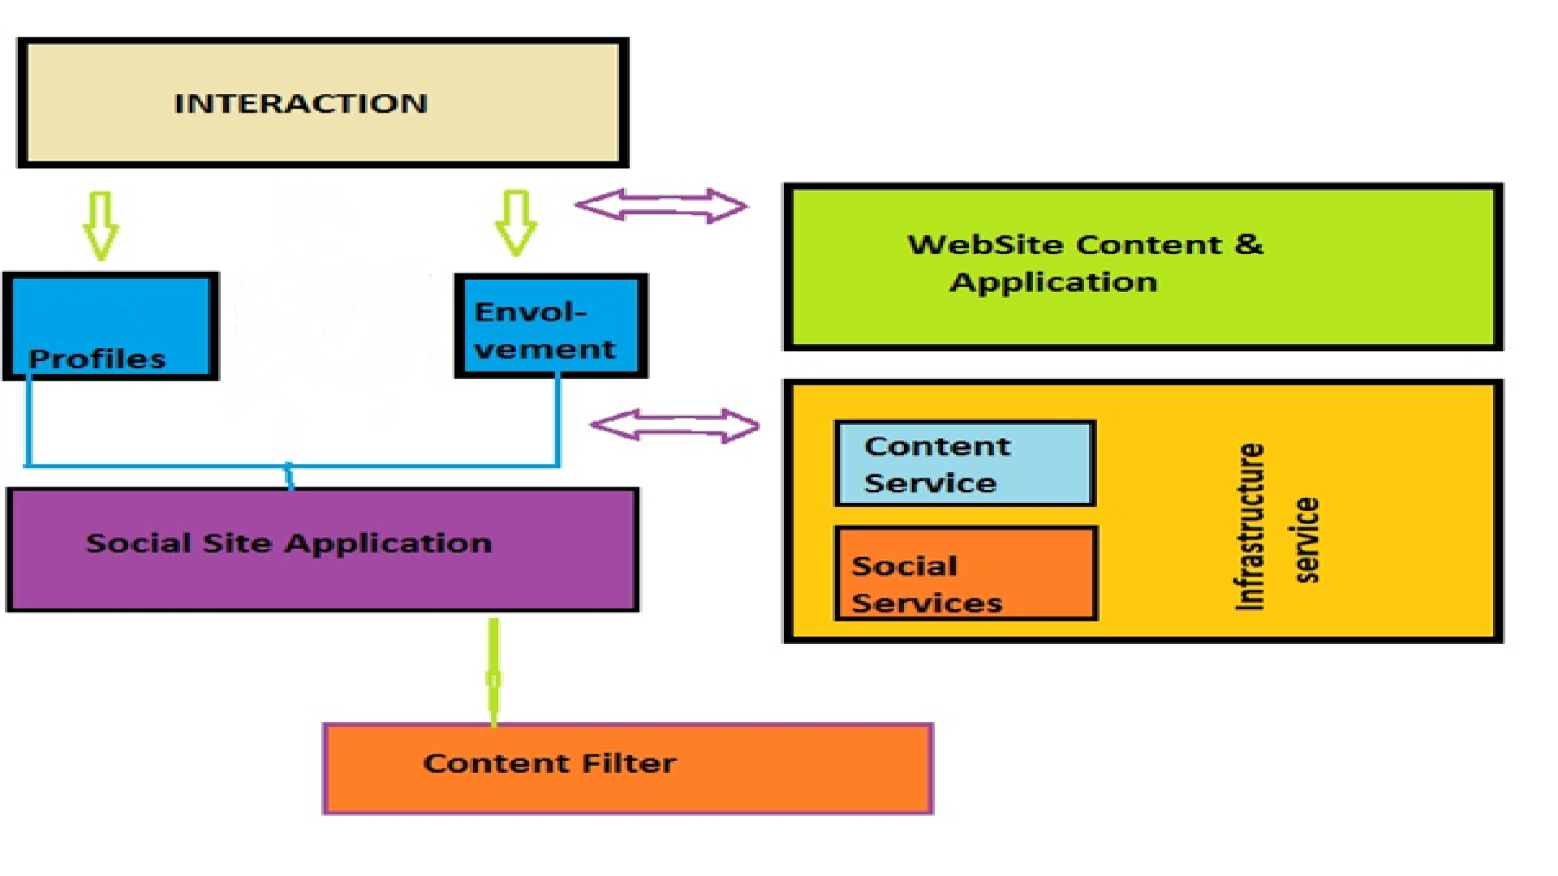

# 11. **DATA FLOW DIAGRAM:**

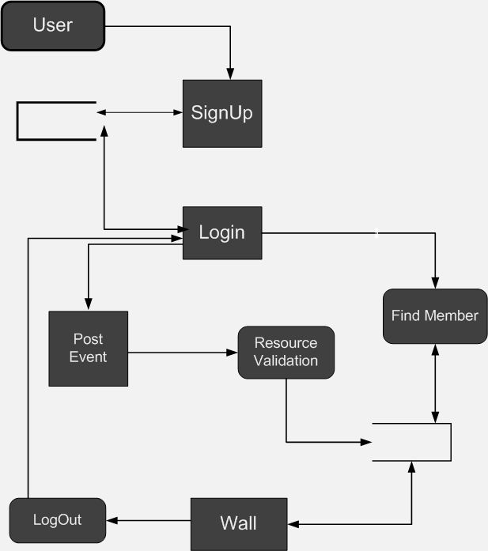

# 12. **ENTITY RELATION and Database Connection DIAGRAM:**

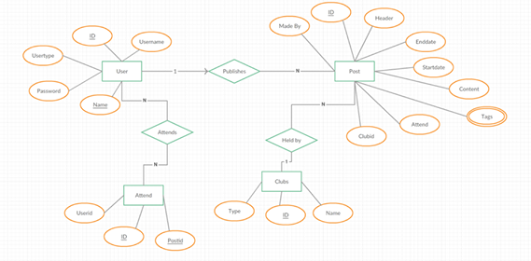

# 13. **STATE MACHINE DIAGRAM:**

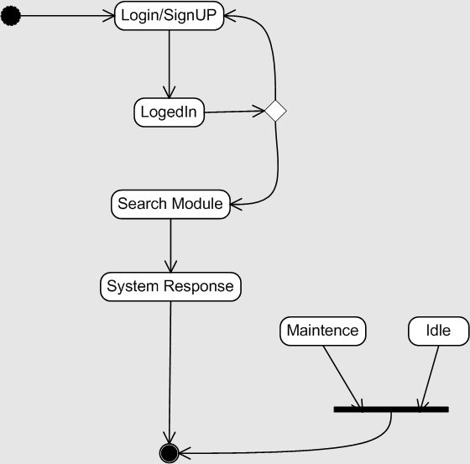

# 14. **USE CASE DIAGRAM:**

**15.1. User Interaction:**

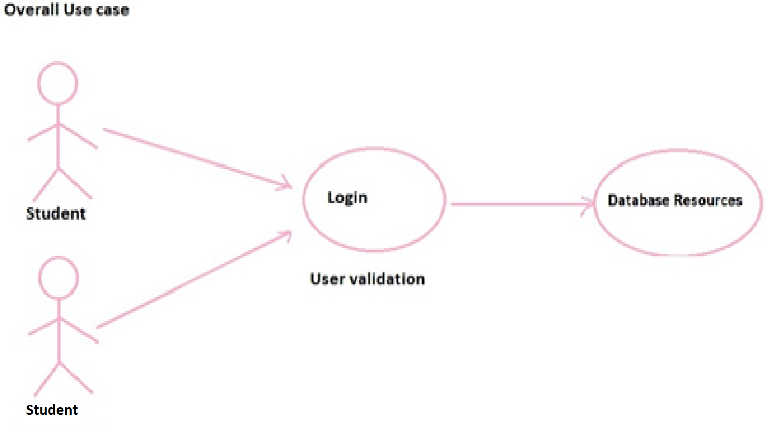

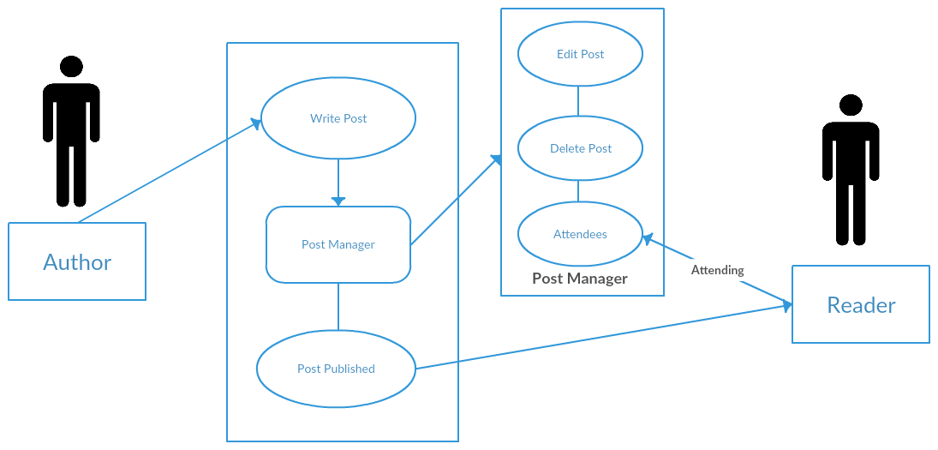

# 16. **CLASS DIAGRAM:**

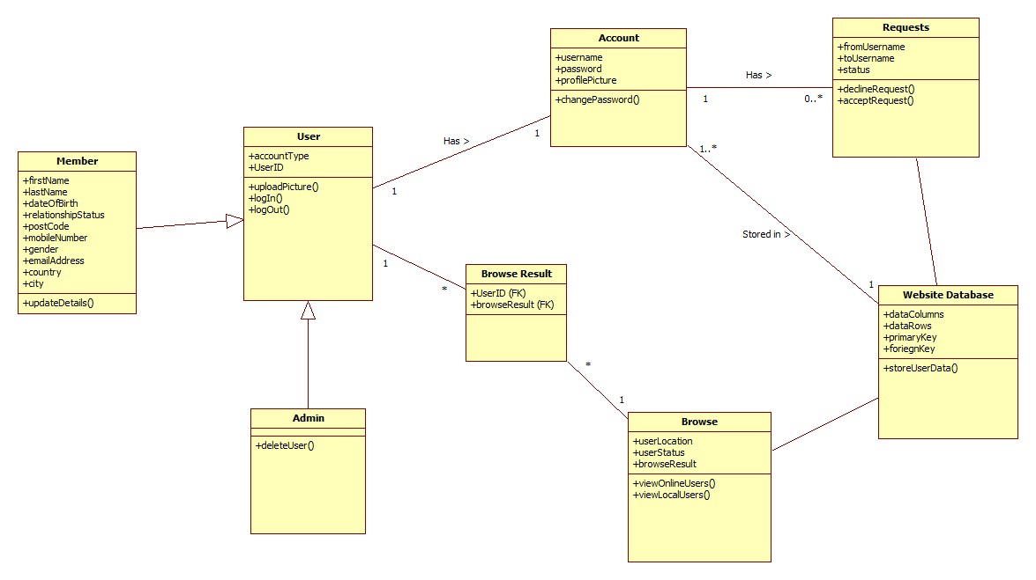

# 17. **ACTIVITY DIAGRAM:**

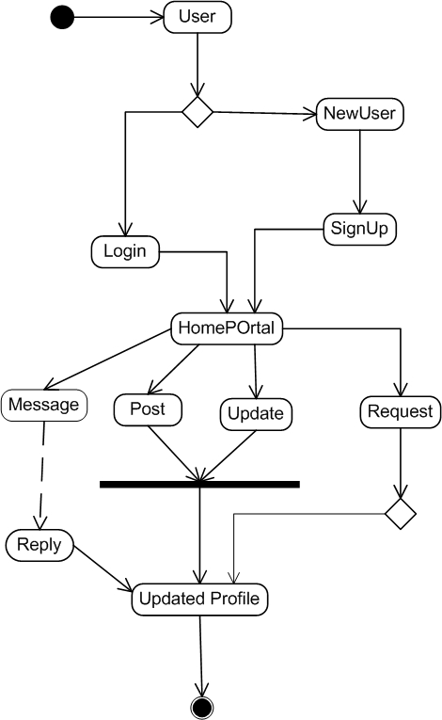

# 18. **IMPLIMENTATION:**

**USER INTERFACE DESIGN:**

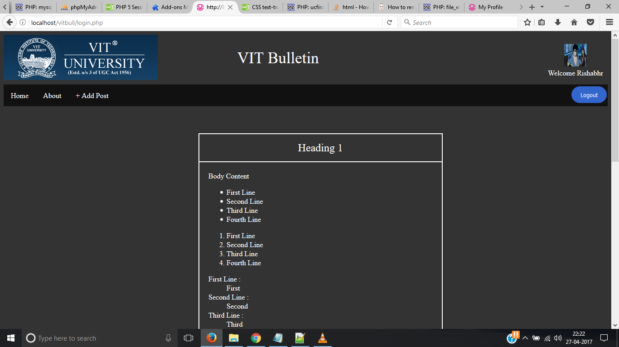

USER INTERFCE DESCRPTION:

The user interface can be accessed by running the index file on the web browser. By clicking on the signup tab and then logging into the account, regestrations can be done.

**USER REGISTRATION MODULE**

**User Registration**

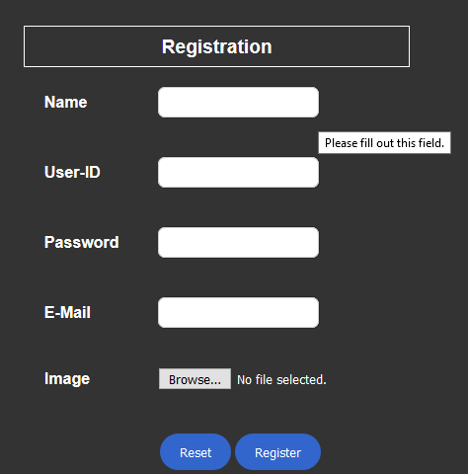

**User Login:**

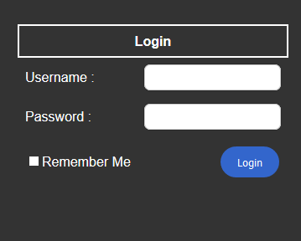

**Message Page**

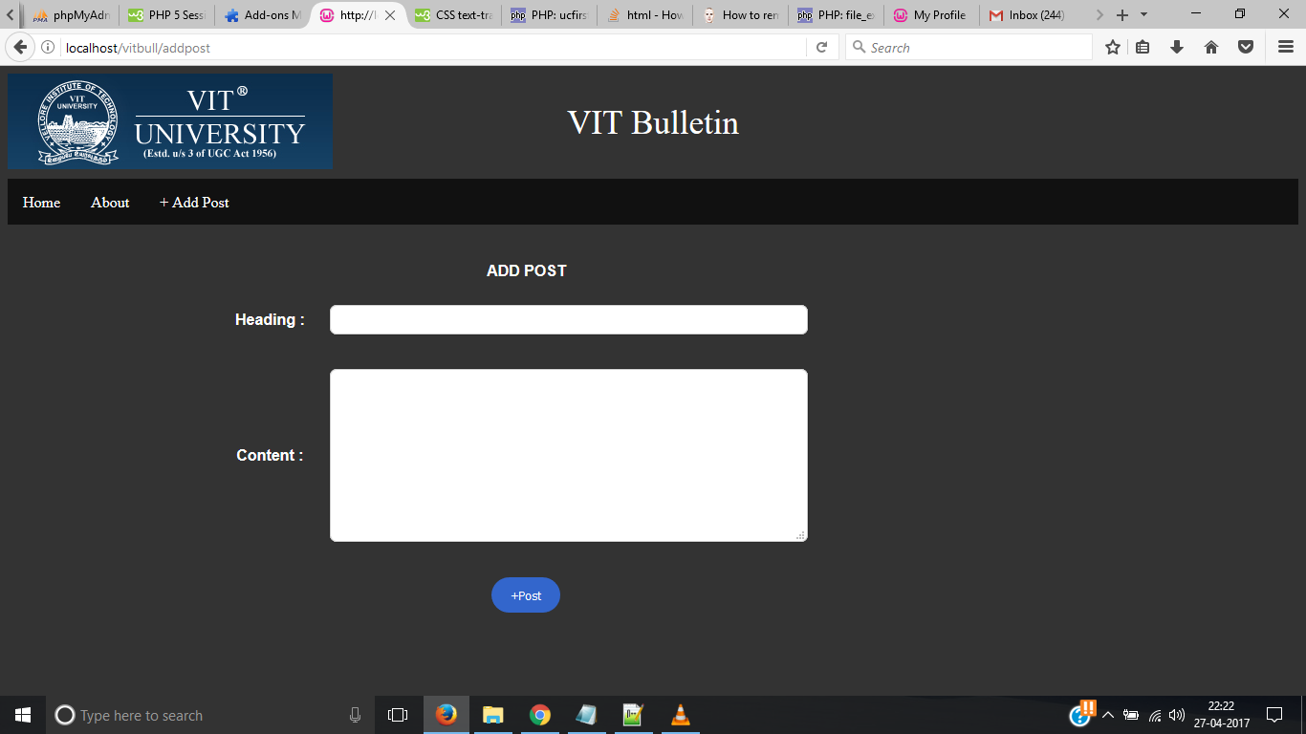

# Testing

|  |  |  |  |  |  |
| --- | --- | --- | --- | --- | --- |
| Test Case Id | S.No | Action | Expected Outcome | Actual Outcome | Result |
| 1.1 | 1 | New user try to login without registration | Redirected to signup form | Message displayed user doesn’t exist and redirected to sign up page | Passed |
|  | 2 | Registered user try to login with wrong password or email id | Message displayed Wrong email-id or password | Message displayed | Passed |
| 2.1 | 1 | New user register by filling form | Data from the form will be sent to database and user will be registered | Message displayed user registered | Passed |
|  | 2 | User try to register by filling incomplete information | Alert message should be displayed | Alert message displayed | Passed |
| 3.1 | 1 | After logging in user try to add other members in his friend list by clicking add friend button | Request approval message should be sent to the other user | Message sent successfully | Passed |
|  | 2 | After adding send message to the other user | Message should be received by other user | Message received on the other side | Passed |
|  | 3 | Posting status on the wall | Should be visible to all other users in the friend list | Status visible to the other users | Passed |
| 4.1 | 1 | User click the logout button | Should be logged out and bring to the guest page | User logged out successfully and brought to guest page | Passed |

# REFERENCES

1. https://en.wikipedia.org/wiki/SocialNetwork
2. [IEEE] The applicable IEEE standards are published in “IEEE Standards Collection,” 2001 edition.
3. [Bruade] The principal source of textbook material is “Software Engineering: An Object-Oriented Perspective” by Eric J. Bruade (Wiley 2001).
4. Hanneman, Robert A. and Mark Riddle. 2005. Introduction to social network methods. Riverside, CA: University of California, Riverside ( published in digital form at http://faculty.ucr.edu/~hanneman/ )
5. [Journal] 830-1984, IEEE Guide to Software Requirements Specifications
6. Kadushin, Charles, 2004. Introduction to Social Network Theory.
7. Daly & Haahr., 2007. Social Network Analysis for Routing in Disconnected Delay-Tolerant, MANETs ACM 978-1- 59593-684-/07/0009.
8. http://ecomputernotes.com/mis/system-design/discuss-the-different-steps-of-the-detailed-system-design
9. http://images.slideplayer.com/17/5267676/slides/slide_2.jpg
10. https://www.google.co.in/url?sa=t&rct=j&q=&esrc=s&source=web&cd=2&cad=rja&uact=8&ved=0ahUKEwjK7vvr8rbMAhUFuo4KHc6DDMoQjBAIIjAB&url=http%3A%2F%2Fwww.tutorialspoint.com%2Fsoftware_engineering%2Fsoftware_engineering_pdf_