Mexico E-Commerce Market
Deep Research Report
Mercado Libre vs Amazon Mexico
User Profiles | Consumer Behavior | Payment Preferences | Platform Strategy

June 2026 | Data through Q4 2025-Q1 2026
Sources: AMVO, MELI Investor Relations, Sensor Tower, Start.io,
Marketing4eCommerce, ResearchAndMarkets, PPRO, CommerceGate, Cofece
Auto-generated by Claude Code AI Research

Table of Contents
I. Mexico E-Commerce Market Overview
II. Platform Landscape: Duopoly + New Entrants
III. Deep User Profile Comparison
IV. Consumer Behavior Differences
V. Payment Preferences: Core Competitive Barrier
VI. Logistics & Delivery Experience
VII. Core Data Quick-Reference Table
VIII. Key Insights & Strategic Recommendations
IX. Data Sources & References

I. Mexico E-Commerce Market Overview
Mexico is Latin America's second-largest e-commerce market (after Brazil) and one of the world's fastest-growing emerging markets. In 2025, the market reached MXN 9.41 trillion (~USD 47 billion), growing 19.2% YoY — the sixth consecutive year of double-digit growth. With 77.2 million online shoppers (>60% of the population), Mexico represents a massive opportunity for cross-border sellers.
Core thesis: Mexico's e-commerce market is transitioning from "traffic-driven" to "fulfillment-driven." Logistics speed, payment convenience, and localized trust are becoming the new competitive battleground.
Metric | 2025 Data | Trend
Market Size | MXN 9.41T (~USD 47B) | +19.2% YoY, 6th consecutive year double-digit
E-Commerce Penetration | 17.7% of total retail | Projected 19% by 2028
Online Shoppers | 77.2 million | >60% of national population
Mobile Share | 75-84% of transactions | LatAm mobile-first benchmark
Global Ranking | #8 in retail online penetration | Growing faster than global average
Internet Penetration | >80% | Continuing to rise
Cross-Border Share | ~25% of transactions | Increasing YoY

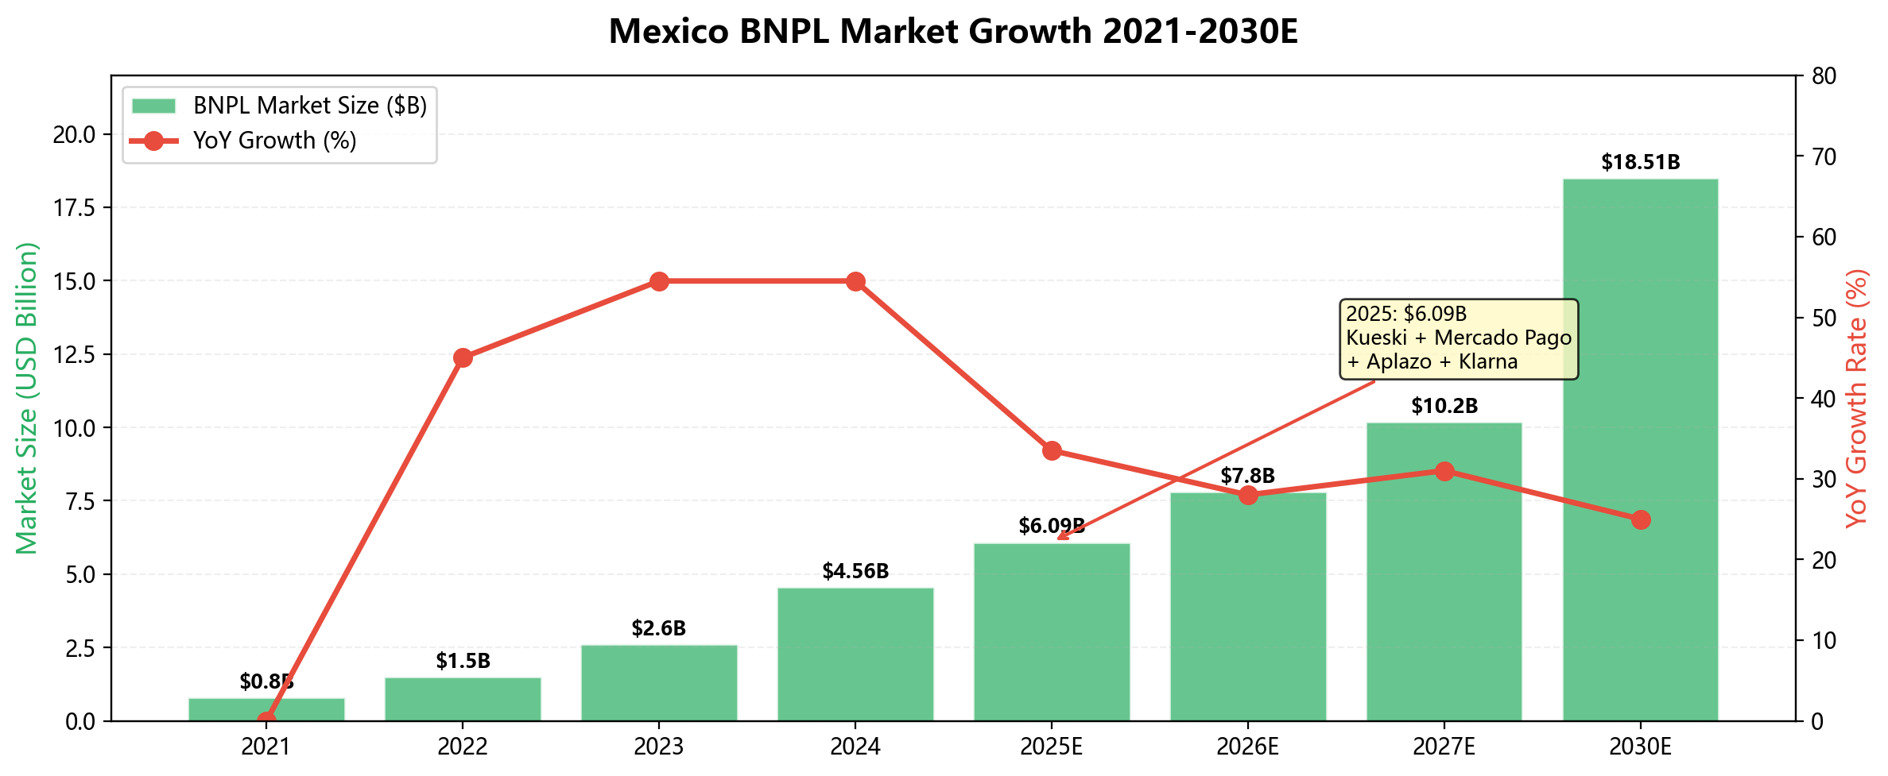
Figure 1: Mexico BNPL Market Growth 2021-2030E

II. Platform Landscape: Duopoly + New Entrants
Mexico's e-commerce landscape is a "duopoly + disruptors" model: Mercado Libre and Amazon together command >85% of market share. Temu, SHEIN, and TikTok Shop are rapidly penetrating the 18-35 demographic from China.
In December 2025, Mexico's antitrust authority Cofece found both major platforms create competition barriers (unclear product ranking logic, favoritism toward sellers using their own logistics), but no fines were imposed due to lack of consensus.
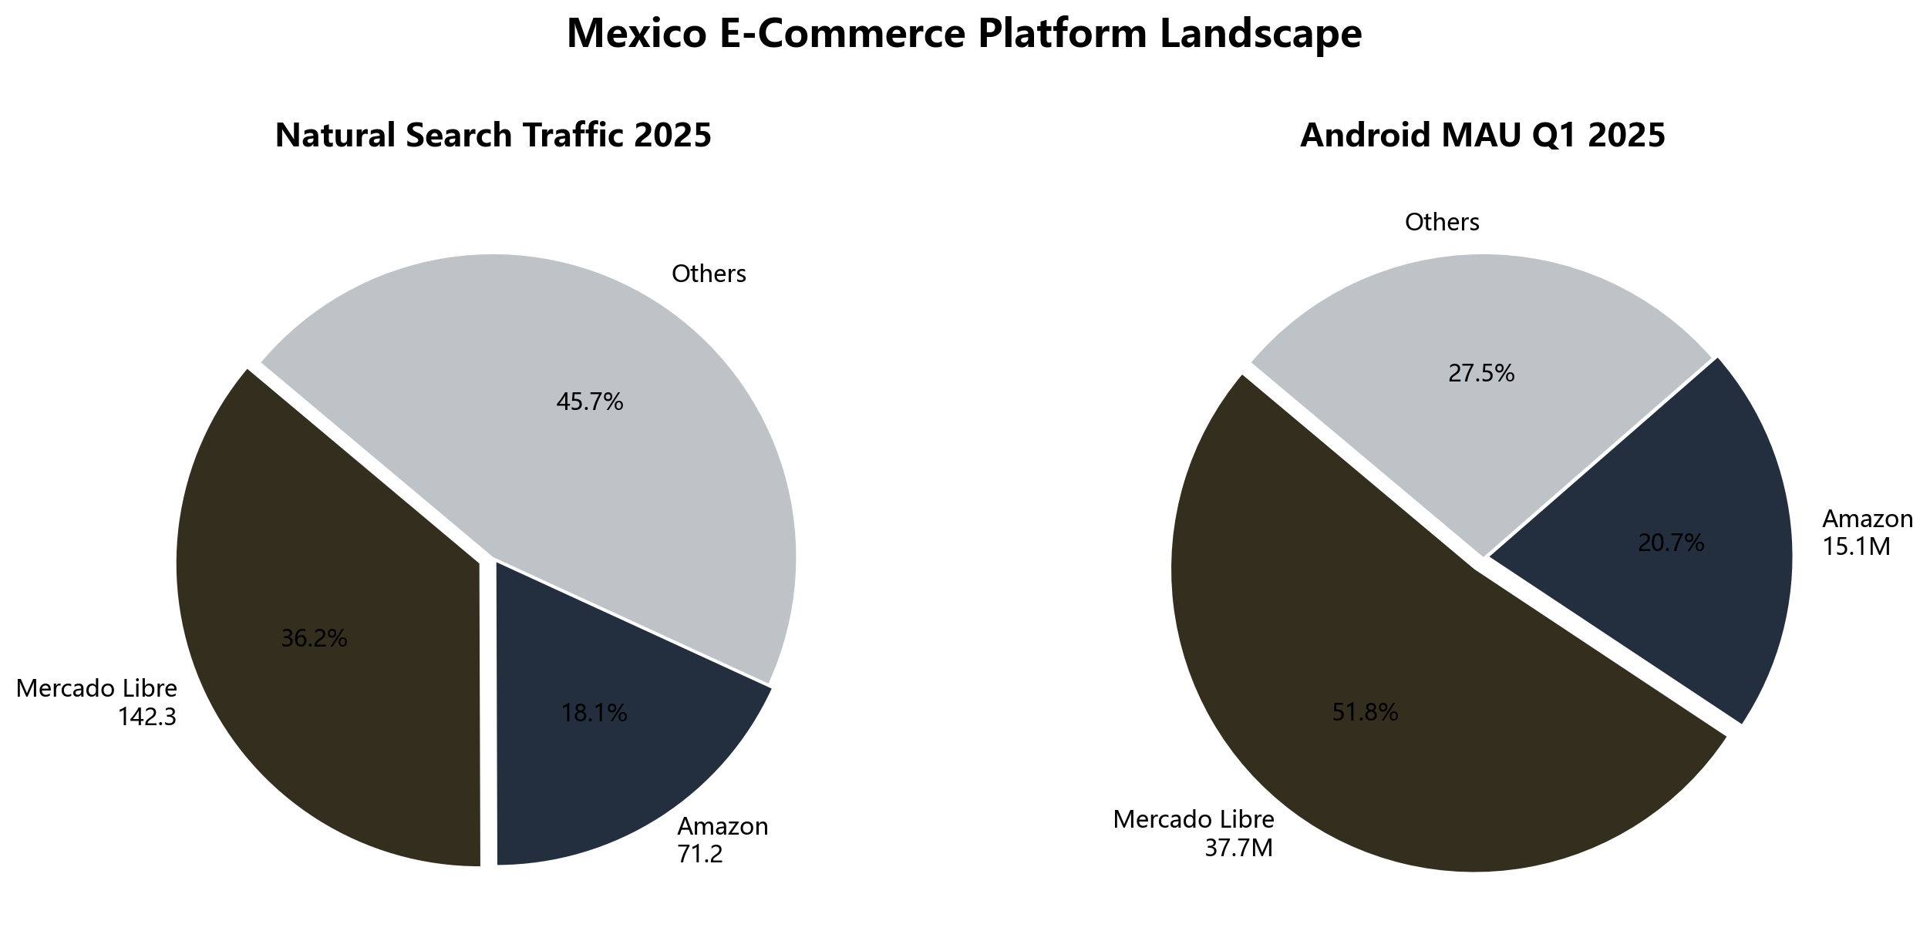
Figure 2: Platform Market Share (Traffic & MAU)
Dimension | Mercado Libre | Amazon Mexico
Natural Search Traffic (2025) | 14.23B visits | 7.12B visits
Android MAU (Q1 2025) | 37.7M | 15.1M
Market Share | 50-68% | ~33%
Consumer 1st Choice | 77% | 73%
Global Active Buyers | 83.2M (+23.6% YoY) | Not separately disclosed
Mexico Revenue (Q4 2025) | $2.1B (23.9% of global) | Key global growth market
Platform Positioning | Local native, all income tiers | International brand, mid-high tier
Years Operating | 25+ years (LatAm native) | ~10 years (entered 2015)

Mercado Libre's organic search traffic is 2x Amazon's; mobile MAU is 2.5x. But Amazon retains differentiated advantages in brand authenticity assurance and premium 3C categories.

III. Deep User Profile Comparison

3.1 Mercado Libre User Profile
Dimension | Data
Core Age | 25-44 (Millennials), dominant purchasing cohort
Youth Segment | 18-24 ~24% (active in fashion & trends)
Gender (Major Sales) | 67% Male / 33% Female
Income Tiers | Full coverage; mid-low income notably higher than Amazon
Purchase Frequency | 16% of middle class shop daily; MELI+ members 2.3x frequency
Top 5 Regions | EdoMex > CDMX > Jalisco > Puebla > Nuevo Leon
Device | Mid-range Android phones

3.2 Amazon Mexico User Profile
Dimension | Data
Core Age | 18-44; app ad audience 73.8% aged 18-24
Gender | 55.6% Male / 44.4% Female (more balanced)
Income Tiers | Mid-to-high income, banked urban consumers primarily
Devices | Huawei Y9 Prime, P30 Lite, Y9 2019 (mid-range Android)
Carriers | Telcel > AT&T > Movistar
Prime Membership | Growing fast (global Prime: 13B+ items delivered 2025)

3.3 User Overlap
Mexican consumers are highly dual-platform — most use both simultaneously. Estimated overlap: 60-70%.
Usage pattern: Mercado Libre = daily high-frequency purchases (home goods, auto parts, affordable fashion); Amazon Mexico = planned high-value purchases (brand electronics, imports, books).
79% of consumers compare prices across platforms before purchasing. Brand loyalty is low.
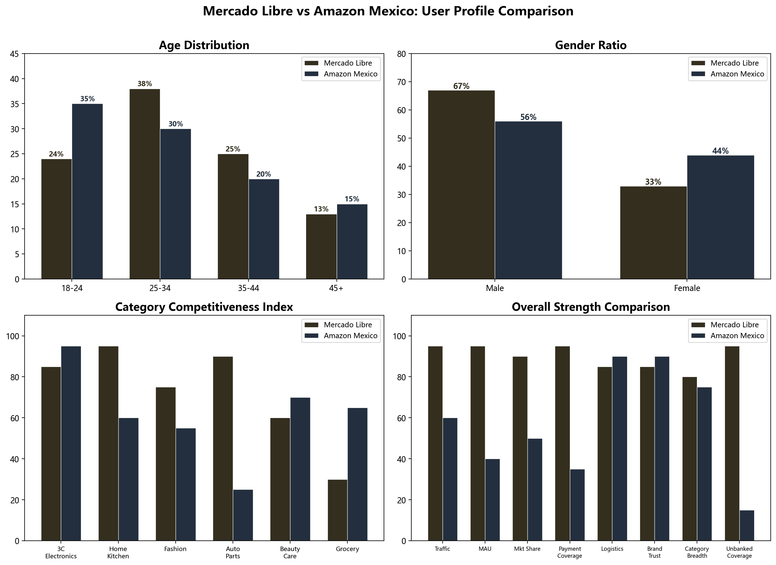
Figure 3: Multi-Dimensional User Profile Comparison

IV. Consumer Behavior Differences

4.1 Average Order Value & Purchase Frequency
Dimension | Mercado Libre | Amazon Mexico
Typical AOV | Low-Mid ($10-50 USD) | Mid-High (>$20 USD)
Purchase Frequency | High (daily replenishment) | Mid-Low (planned purchases)
Shopping Cadence | Bi-weekly/monthly salary cycles | Promo-driven (Hot Sale/Buen Fin/Prime Day)
Browsing Style | Family browsing (Sunday together) | Purpose-driven search
Family Basket | 2.3x average cart value | —

4.2 Category Preference Matrix
Category | Mercado Libre | Amazon Mexico | Notes
3C Electronics | ★★★ | ★★★★★ | Amazon strongest category
Home & Kitchen | ★★★★★ | ★★★ | MELI absolute advantage
Fashion | ★★★★ | ★★★ | Plus-size MELI 30-60% margin
Auto Parts | ★★★★★ | ★★ | MELI traditional strength
Beauty & Care | ★★★ | ★★★★ | Amazon brand trust advantage
Books | ★★ | ★★★★★ | Amazon traditional strength
Pet Supplies | ★★★ | ★★★★ | Emerging high-growth
Grocery | ★★ | ★★★★ | Amazon Now + Rappi 15-min delivery

4.3 Mobile vs Desktop
- Mobile share: 75-84% of transactions (LatAm overall)
- Mercado Libre App Android MAU: 37.7M (Q1 2025, Sensor Tower)
- Amazon Shopping App Android MAU: 15.1M (Q1 2025, Sensor Tower)
- MELI mobile users: 2.5x Amazon
- Mobile UX: WhatsApp product sharing -> short video discovery -> in-app one-click payment
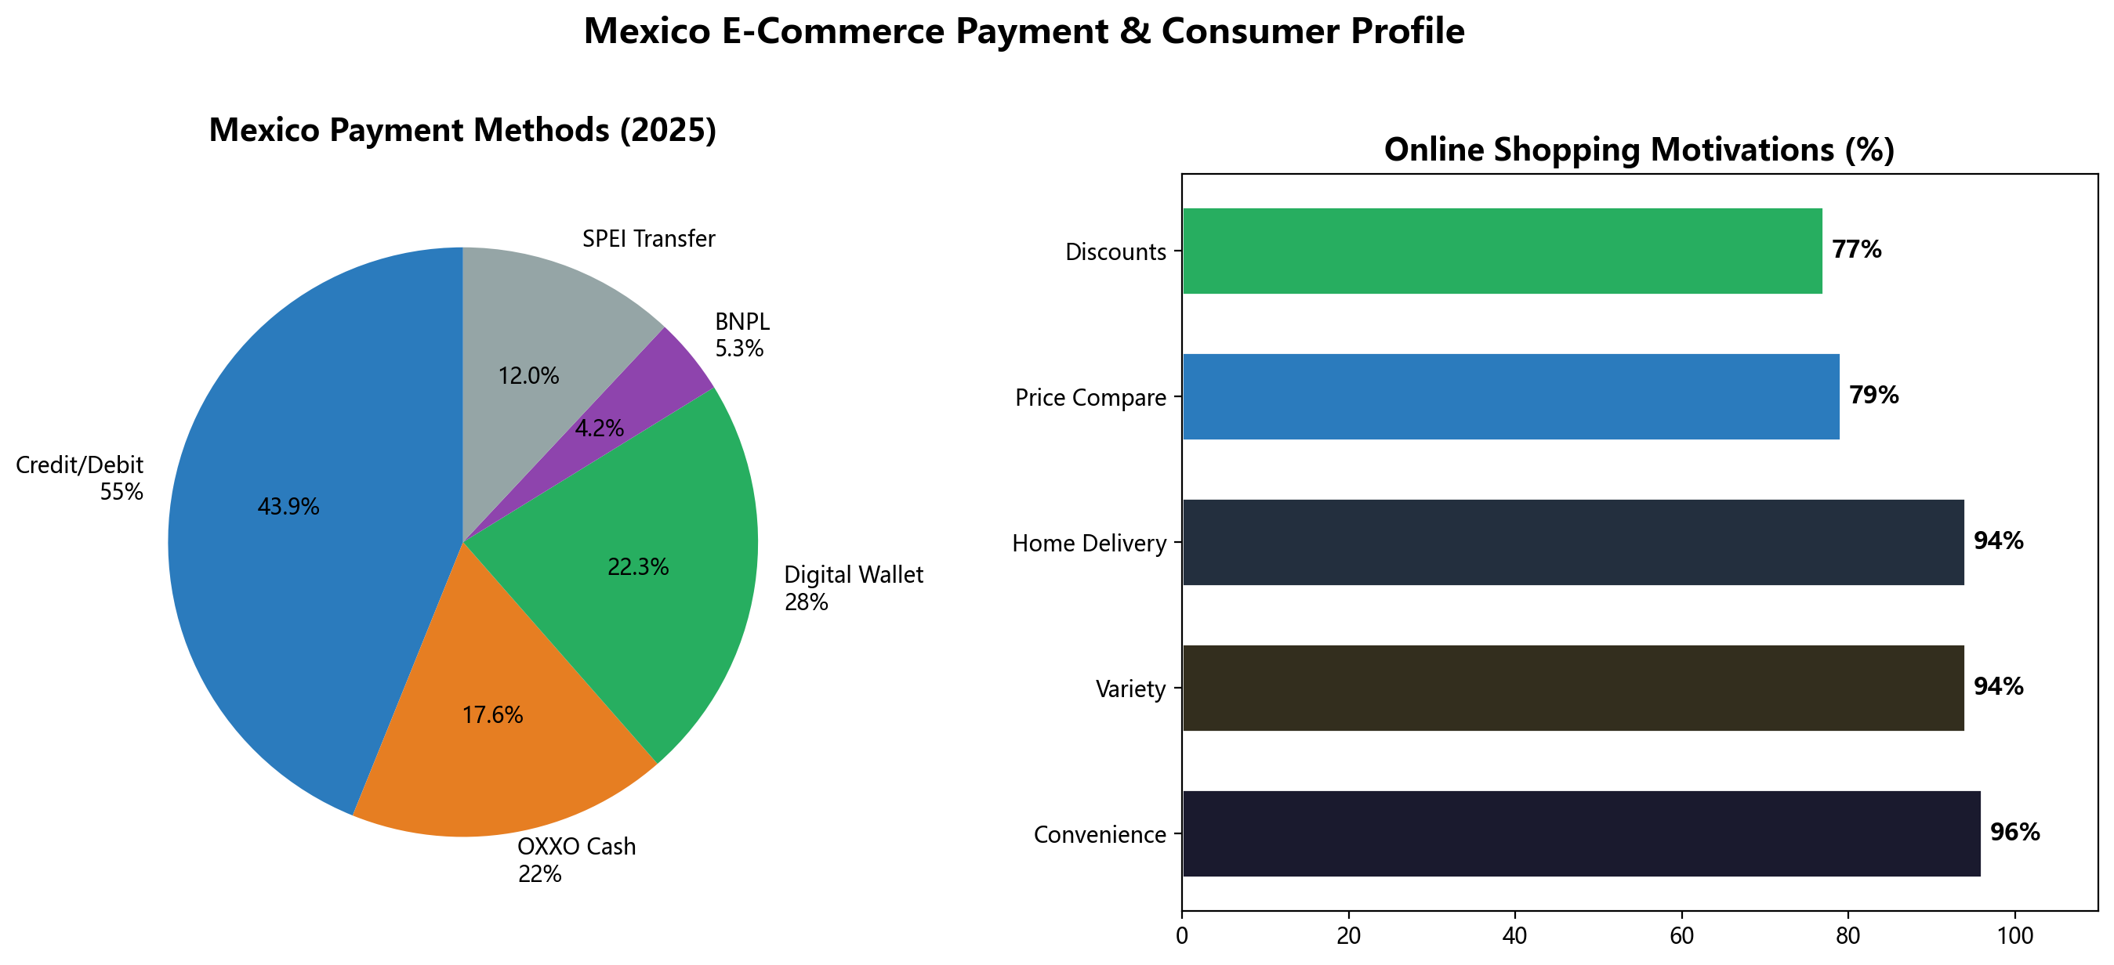
Figure 4: Payment Methods & Consumer Motivations

V. Payment Preferences: MELI's Core Competitive Barrier
Payment is the single largest structural difference between the two platforms. Through Mercado Pago + OXXO cash payments, Mercado Libre reaches 40M+ unbanked Mexican consumers that Amazon cannot access.

5.1 Mexico Payment Landscape
Payment Method | Online Transaction Share | Characteristics
Credit/Debit Cards | 55% | Mainstream but only 30-35% of population holds a credit card
OXXO Cash Payment | 22-30% | 22,000+ stores nationwide, serves 42% unbanked population
Digital Wallets | 28%+ | Mercado Pago: 120M+ users across Latin America
BNPL | 5.3% (fastest growing) | 2025 market: $6.09B (+33.5% YoY)
SPEI Bank Transfer | Rapid growth | Transaction volume +37% in 2024

5.2 Platform Payment Comparison
Payment Method | Mercado Libre | Amazon Mexico
Credit/Debit Cards | Yes | Yes
OXXO Cash Payment | Yes (core advantage) | No
Interest-Free Installments (MSI) | Yes (Mercado Pago) | Yes (partner banks)
BNPL | Yes (Mercado Credito) | 3rd-party (Kueski Pay)
Proprietary Digital Wallet | Mercado Pago (120M users) | None
Unbanked Coverage | 40M+ people | Almost none

Key findings:
- Mercado Pago is applying for a banking license (filed Sep 2024) — if approved, will further widen the payment gap
- OXXO accepts cash payments at 22,000+ stores covering all cities and rural towns
- MSI (interest-free installments) is a critical conversion driver — 67% of searches include "meses sin intereses"
- BNPL is exploding: Kueski, Mercado Credito, and Aplazo dominate, covering 10M+ users
- Amazon relies on traditional banking infrastructure — almost invisible to Mexico's 42% unbanked population
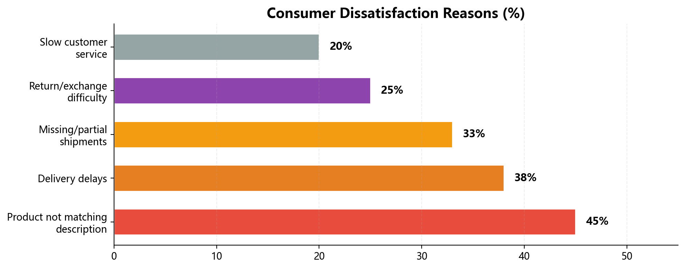
Figure 5: Consumer Dissatisfaction Drivers

VI. Logistics & Delivery Experience
Logistics has become an arms race between the two platforms. MELI's FULL warehouse system and Amazon's FBA network are both expanding aggressively in Mexico. For sellers, "can you deliver within 3 days" is no longer a differentiator — it's the entry ticket.
Dimension | Mercado Libre | Amazon Mexico
Warehouse Network | 12+ new regional fulfillment centers | FBA fulfillment network
Delivery Speed | 50% orders <= 24h (FULL) | Same-day in hundreds of cities
Consumer Expectation | 71% expect delivery within 5 days | Same expectation
Innovation | 2-hr delivery windows (Colombia) | Weekend delivery + nighttime convenience store pickup
Local Warehouse Advantage | Conversion +20-30% | FBA also boosts search ranking
Global Investment | LatAm $34B logistics infra | Global Prime: 13B items delivered (2025)
Ultra-fast | — | Amazon Now + Rappi: 12.93 min avg delivery

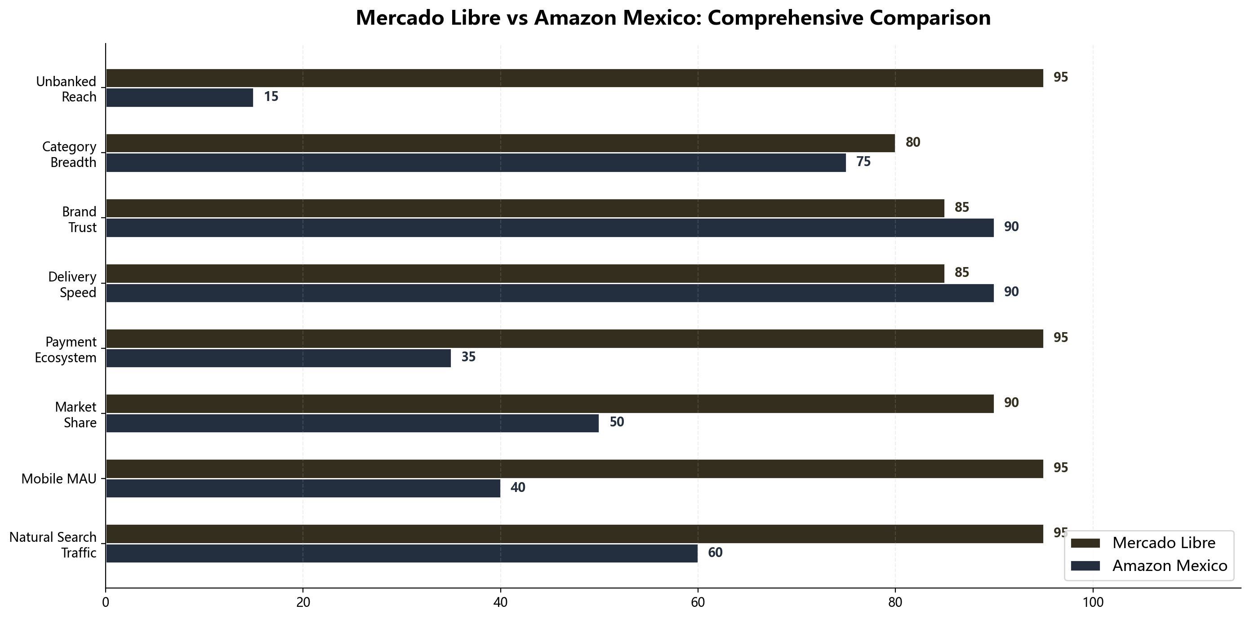
Figure 6: Comprehensive Radar Comparison

VII. Core Data Quick-Reference Table
Below: A direct comparison of 15 core dimensions between the two platforms.
Metric | Mercado Libre | Amazon Mexico | Winner
Annual Natural Traffic | 14.23B | 7.12B | MELI
Mobile MAU (Android) | 37.7M | 15.1M | MELI
Market Share | 50-68% | ~33% | MELI
Consumer 1st Choice | 77% | 73% | MELI
Global Active Buyers | 83.2M | Not disclosed | MELI
Core Age | 25-44 | 18-44 | Different focus
Gender Ratio (M:F) | 67:33 | 56:44 | Amazon more balanced
Income Coverage | All tiers | Mid-high tier | MELI
Mobile Share | ~80% | ~80% | Tie
24h Delivery Rate | 50% of orders | Hundreds of cities | Different advantages
OXXO Cash Payment | Yes | No | MELI
Proprietary Payment Ecosystem | Mercado Pago | None | MELI
Unbanked Coverage | 40M+ people | Almost none | MELI
Authenticity Guarantee | Seller-dependent | Strict (A-to-Z) | Amazon
Membership Program | MELI+ (2.3x frequency) | Prime (13B items/yr) | Amazon

VIII. Key Insights & Strategic Recommendations

8.1 Six Core Insights
1. Platforms are complementary, not substitute
Mexican consumers use MELI as their "daily supermarket" and Amazon as their "brand boutique." The same user buys a blender on MELI in the morning and Sony headphones on Amazon in the afternoon.

2. Payment is the deepest competitive moat
Mercado Pago + OXXO gives MELI access to 40M+ unbanked consumers that Amazon structurally cannot reach. This is not something Amazon can replicate quickly — it requires physical infrastructure across 22,000+ stores.

3. Mobile experience = market share
84% of transactions happen on phones. MELI's 2.5x mobile MAU advantage directly maps to its market share lead. Any platform wanting to win in Mexico must be mobile-first.

4. Amazon's path is "upward"
Amazon's irreplaceable advantages are in brand authenticity, imported goods, and premium Prime experience. Amazon Now (15-min delivery with Rappi) and Amazon Day (weekly consolidated delivery) are key differentiators.

5. New entrants are exploiting the seams
Temu, SHEIN, and TikTok Shop are rapidly penetrating the 18-35 demographic. Social commerce share is projected to grow from 18% to 32% by 2026. Chinese sellers should pursue multi-platform strategies.

6. User loyalty is a myth
79% of consumers compare prices across platforms before purchasing. Platform stickiness comes from logistics speed + payment convenience + price transparency — not brand loyalty.

8.2 Seven Strategy Recommendations for Chinese Cross-Border Sellers
Strategy | Specific Recommendation
Platform Priority | MELI first (max traffic + broadest coverage) -> Amazon (brand premium + high AOV) -> Temu/SHEIN (youth traffic)
Localization Compliance | RFC tax registration is mandatory — non-RFC sellers face 36% withholding tax from 2026 (20% income + 16% VAT)
Payment Integration | Accept cards + OXXO + Mercado Pago simultaneously, covering 95%+ consumers
Logistics Strategy | Use MELI FULL or Amazon FBA; compress delivery to <=3 days — conversion increases 20-30% directly
Pricing Strategy | Design prices suitable for MSI (interest-free installments) — MXN $200-500/month is the optimal conversion sweet spot
Category Selection | 3C electronics accessories > small home appliances > plus-size fashion > auto parts > pet supplies
Marketing Calendar | Follow Mexico's promo calendar: Hot Sale (mid-year) -> Buen Fin (Nov) -> Christmas season -> bi-weekly paydays

IX. Data Sources & References
[1] Marketing4eCommerce 2025 Mexico E-Commerce Traffic Top 100
https://www.amz123.com/kx/G1tJfiLm
[2] Sensor Tower Q1 2025 Mexico Shopping App MAU Data
https://sensortower.com/blog/2025-q1-android-top-5-shopping-units-mx-6571f22de1714cfff1c79b4a
[3] Mercado Libre Q4 2025 Shareholder Letter / Investor Report
https://investor.mercadolibre.com/sites/mercadolibre/files/2025-10/MELI-Shareholder-Letter-Q3-25.pdf
[4] Captide Mercado Libre Q1 2025 Earnings Analysis
https://www.captide.ai/insights/mercado-libre-q1-2025
[5] Start.io Amazon Shoppers in Mexico Audience Profile
https://www.start.io/audience/amazon-shoppers-in-mexico
[6] Mexico BNPL Business Report 2025 (ResearchAndMarkets)
https://www.businesswire.com/news/home/20251201561044/en/Mexico-Buy-Now-Pay-Later-Business-Report-2025
[7] PPRO Mexico E-Commerce & Digital Payments Insights
https://www.ppro.com/insights/mexicos-e-commerce-and-digital-payments-growth-era/
[8] CommerceGate Mexico Online Payment Trends 2025
https://www.commercegate.com/online-payment-trends-for-mexico-in-2025/
[9] Elogia 2025 Mexico Consumer Platform Preference Survey
https://www.ikjzd.com/articles/1810625995694947741
[10] 2025 Mexico E-Commerce Logistics & Delivery Expectation Report
https://www.amz123.com/t/zsOgHLwy
[11] Cofece Dec 2025 Antitrust Investigation Announcement
https://uk.investing.com/news/stock-market-news/mexicos-ecommerce-giants-face-competition-barriers-no-fines-93CH-4261824
[12] Mercado Libre Mexico Unboxing Days 2025 Results
https://www.amz123.com/kx/QStNDVkE
[13] 2026 Mexico Cross-Border E-Commerce Development Trends Report
https://www.renrendoc.com/paper/521521960.html
[14] Latin America E-Commerce $215.3B 2026 Forecast (Endeavor/MELI)
https://www.xingjunyi.net/4691.html
[15] Mercado Libre Mexico Site 2026 Deep Dive
https://erp.91miaoshou.com/blog/article_2725.html

----------------------------------------
This report was auto-researched and auto-generated by Claude Code (Anthropic Claude Opus 4.8)
Research date: June 2, 2026 | Data type: Publicly aggregated information | Not investment advice
Report includes 6 data charts + 15 cited sources with links

