Experiment- 4

Aim:
Implement CYCLIC REDUNDANCY CHECK technique for error detection in data sent in form of bits.

Language Used:

Python

Theory:

CRC stands for Cyclic Redundancy Check. It is an error-detecting code used to determine if a block of data has been corrupted. CRCs are ubiquitous. They are present in many of the link layers that TCP/IP is used over. For instance, Ethernet and Wi-Fi packets both contain CRCs.

In the cyclic redundancy check, a fixed number of check bits, often called a checksum, are appended to the message that needs to be transmitted. The data receivers receive the data, and inspect the check bits for any errors.

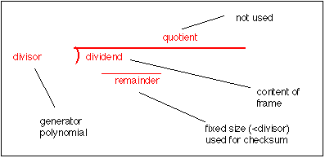

Code:

def xor(a, b):
result = []
for i in range(1, len(a)):
if a[i] == b[i]:
result.append('0')
else:
result.append('1')
return ''.join(result)

def mod2div(dvd, dvs):
covered = len(dvs)
picked = dvd[0 : covered]
while covered < len(dvd):
if picked[0] == '1': picked = xor(picked,dvs) + dvd[covered]
else: picked = xor(picked,'0'*covered) + dvd[covered]
covered += 1
# For the last bit, done manually so that index does not go out of bounds
if picked[0] == '1': picked = xor(picked,dvs)
else: picked = xor(picked,'0'*covered)
#print("Remainder: ", picked)
return picked

def crc(data, gen):
appended = data + '0'*(len(gen)-1)
remainder = mod2div(appended, gen)
encoded = data + remainder
print("Encoded Data: ",encoded)

data = input("Enter the Data")
gen = input("Enter the Generator")
crc(data, gen)

receive = input("Enter the Received message : ")

if int(mod2div(receive, gen)) == 0:
print("Correct Received, Original Message is: ", receive[:-(len(gen)-1)])
else:
print("Wrong Data")

Output:

