# Background

## Moore-Penrose Pseudoinverse

The Moore-Penrose pseudoinverse, denoted as A+, is defined for any matrix and is unique. It can act as a partial replacement for the matrix inverse in cases where it does not exist. This matrix is frequently used to solve a system of linear equations when the system does not have a unique solution or has many solutions.

For any matrix A, the pseudoinverse B exists, is unique, and has the same dimensions as A'. If A is square and not singular, then pinv(A), MATLAB command, is simply an expensive way to compute inv(A). However, if A is not square, or is square and singular, then inv(A) does not exist.

# Design approach

## Force Sensor Array Design

### First Design

The first 8 by 8 array design is shown below.

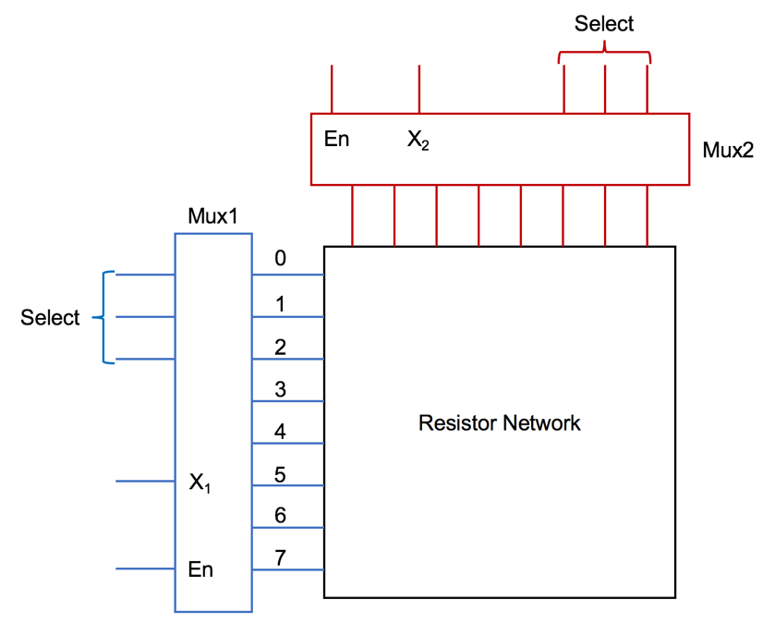

### Second Design

### Third Design

## Creep Experiment Design

# Experiment & Simulation

## Multiplexer Experiment

### First Design

#### Purpose

This experiment is to use the time-domain-based measurement method to achieve the measurement for force sensing array. The main purpose to use the sensor array is to increase the resolution and to locate the highest pressure location point more accurately.

Matrix Integration

