需求文档

一、需求描述

1. 业务需求：物联网领域的快速发展带动了前景和目标
2. 用户需求（可略去）：用例（流程图和状态图）、场景描述、事件响应表（输入输出）
3. 功能需求：信息结构图、产品结构图、功能流程图

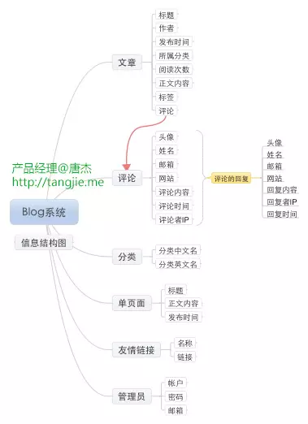

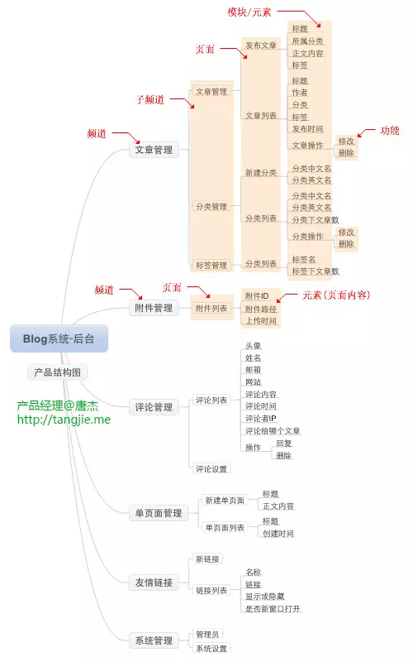

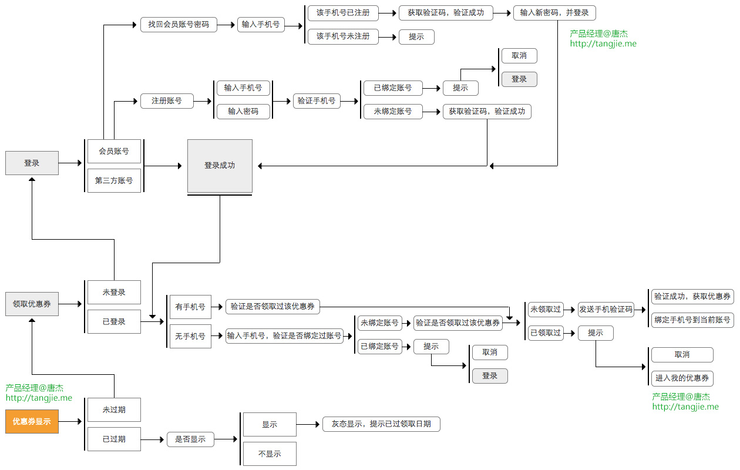

* 1. 技术实现

1. 技术选型
2. 架构设计
3. 排期

|  |  |  |  |
| --- | --- | --- | --- |
| 日期 | 任务 | 具体内容 | 完成情况 |
| 7.21 | 了解项目的模块和结构 |  |  |
| 7.21 | 了解各种技术选型及应用、版本 |  |  |
| 7.22 | 学习基础知识 |  |  |
| 7.22 | 确定选题、画设计思维导图和流程图 |  |  |
| 7.23~8.25  （待细分） | 正式开始项目、记录遇到的重点和难点 |  |  |
| 学习专项知识 |  |  |
| 8.26~8.31 | 测试 |  |  |
|  |  |  |  |

每晚抽时间做算法和数据结构题3~5道。

1. 每日项目记录（争分夺秒！）

|  |  |  |  |
| --- | --- | --- | --- |
| 日期 | 任务 | 完成情况 | 花费时间 |
| 7.22 |  |  |  |
|  |  |  |  |
|  |  |  |  |
|  |  |  |  |
|  |  |  |  |
|  |  |  |  |
|  |  |  |  |

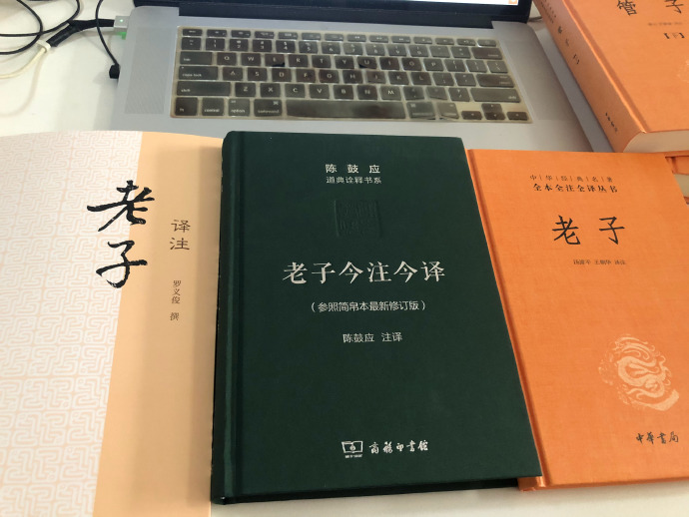

网站汇总

练习<https://github.com/Yixiaohan/show-me-the-code>

项目<http://aosabook.org/blog/>

项目<https://zhuanlan.zhihu.com/p/34870899>

教程<https://flyouting.gitbooks.io/learn-python-the-hard-way-cn/content/>

指南<https://zhuanlan.zhihu.com/p/25824007>

练习<https://www.hackerrank.com/domains/python?filters%5Bsubdomains%5D%5B%5D=py-introduction>

<https://www.zhihu.com/question/28966220>

代码规范<https://pep8.org/>

教程<https://code.ziqiangxuetang.com/django/django-tutorial.html>

项目<https://blog.csdn.net/han_xiaoyang/article/details/49797143>

指南<https://python-web-guide.readthedocs.io/zh/latest/>

教程<https://github.com/jackfrued/Python-100-Days/blob/master/Day76-90/80.k%E6%9C%80%E8%BF%91%E9%82%BB%E5%88%86%E7%B1%BB.md>

库<https://zhuanlan.zhihu.com/p/21563130>

库<https://awesome-python.com/>

项目<https://www.shiyanlou.com/>

项目<https://www.oschina.net/>

爬虫<https://cuiqingcai.com/>

实战<https://www.liaoxuefeng.com/wiki/1016959663602400/1018138095494592>

练习<https://leetcode-cn.com/problemset/algorithms/>

<https://cyanchen.coding.net/user/projects/managed?sortKey=VISIT&sortValue=desc>

练习<https://zhuanlan.zhihu.com/p/38005681>

项目<https://docs.djangoproject.com/en/2.1/intro/tutorial01/>

安装<https://www.runoob.com/mysql/mysql-install.html>

<https://www.cnblogs.com/flyfox1982/p/12986024.html>

<https://www.jianshu.com/p/a633925728fa>

项目<https://github.com/hualuoo/dormitory_menage_system>

<https://www.cnblogs.com/feifeifeisir/p/12870211.html>

技术面<https://www.udacity.com/course/data-structures-and-algorithms-in-python--ud513>

数据结构<https://ishare.iask.sina.com.cn/f/35867630.html>

<https://www.cnblogs.com/kangjianwei101/p/5221816.html>

思维导图<https://www.processon.com/mindmap/5f127cf11e08537d50b1bfd9>

<https://blog.csdn.net/qdx411324962/article/details/47610681>

<https://blog.csdn.net/qq_39820671/article/details/102546444>

<https://blog.csdn.net/qq_39820671/article/details/101521789>

宝塔<http://122.51.125.253:8888/>

迁户<http://122.51.125.253:8888/>

<https://www.qixin.com/company/bbf8fcce-398f-48a9-bdb7-257a002d1875>

<http://hrss.sz.gov.cn/>

<https://www.sohu.com/a/390163430_711451>