1.​Class & Object: A weather station logs city name and temperature readings. Create a WeatherReport class to input and display this data.​

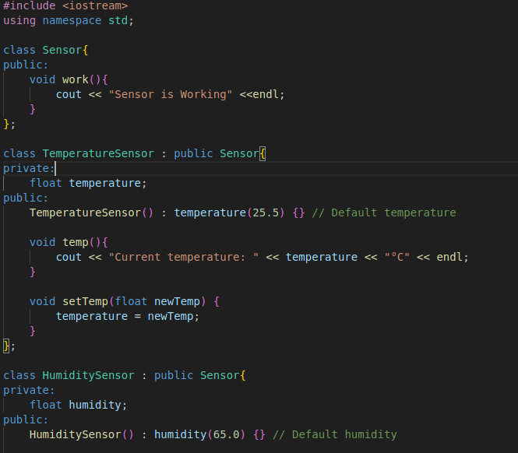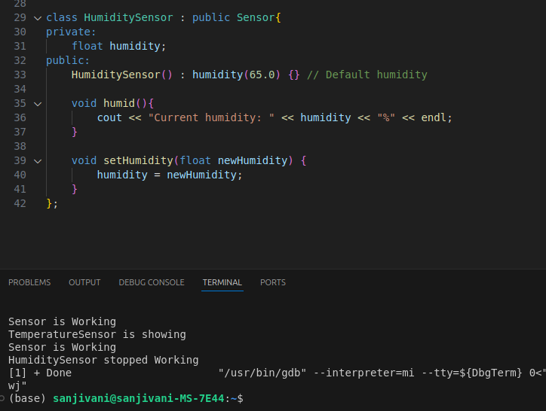

2.​Hierarchical Inheritance: Define a base class Sensor and derive TemperatureSensor and HumiditySensor from it.Show their readings.​

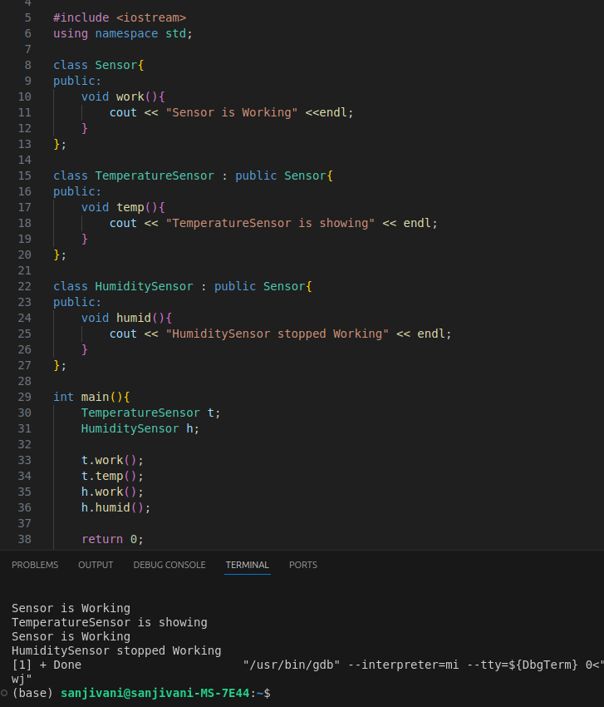

3.​Overloading: Overload report() to provide daily, weekly, and monthly temperature reports.​

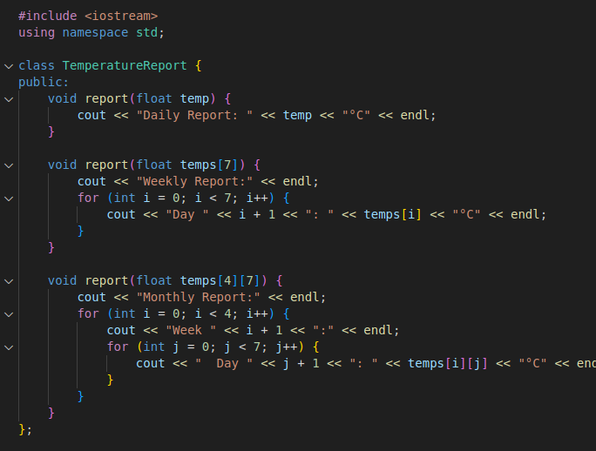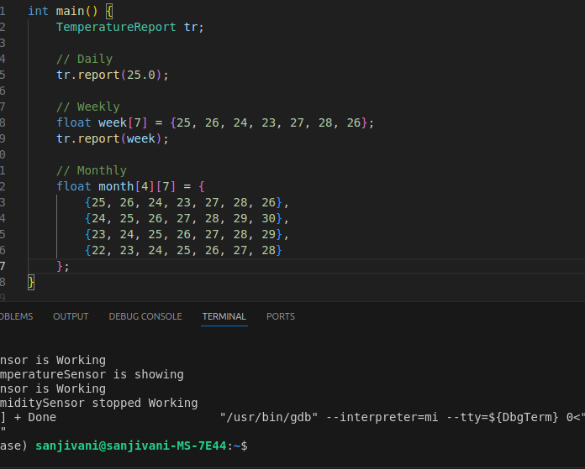

1. ​Exception Handling: If temperature is less than -100°C or more than 100°C, throw "Sensor error".​
2. 