**IST722 Group Project Milestone#3 Document - Deliverable 6**

Team 1 - Xuehan Chen, Yue Wang, Yimin Xiao, Chiau Yin Yang

**Business Intelligence**

1. SSAS cubes on Analysis Services Server
   1. Shipment Analysis

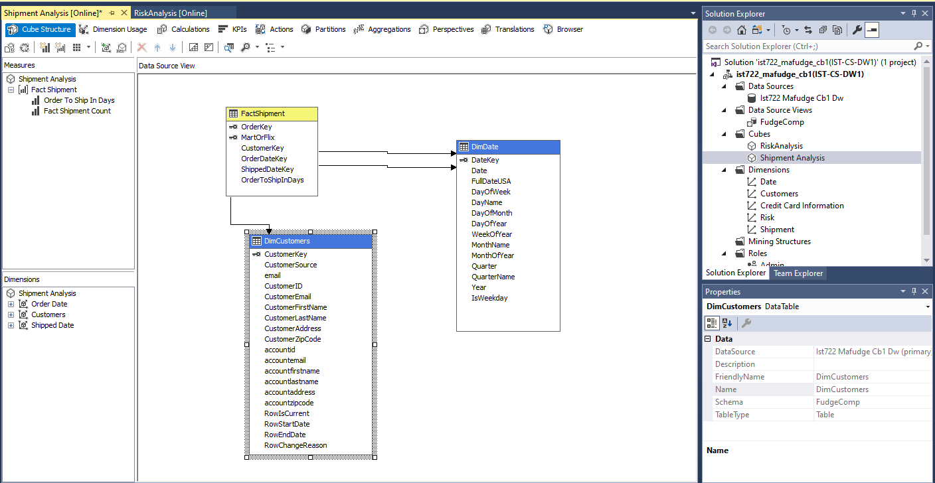

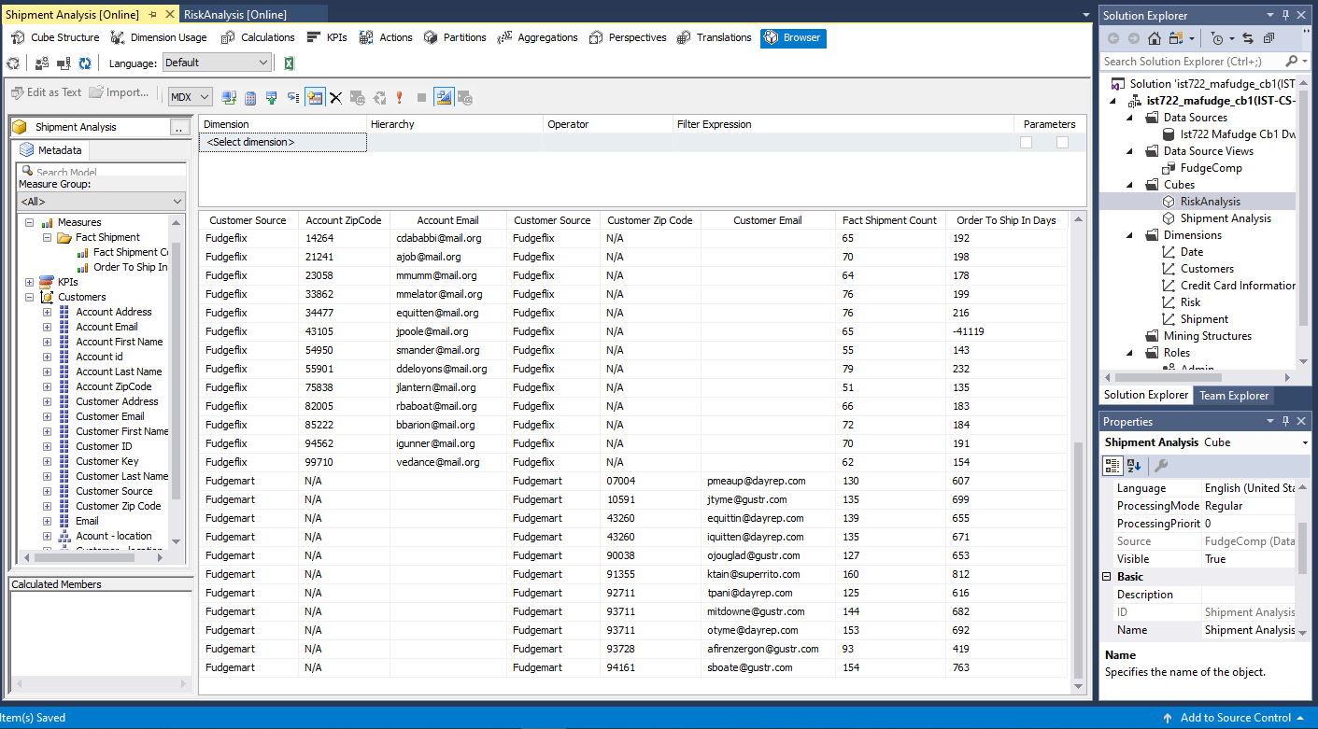

* 1. Risk Analysis

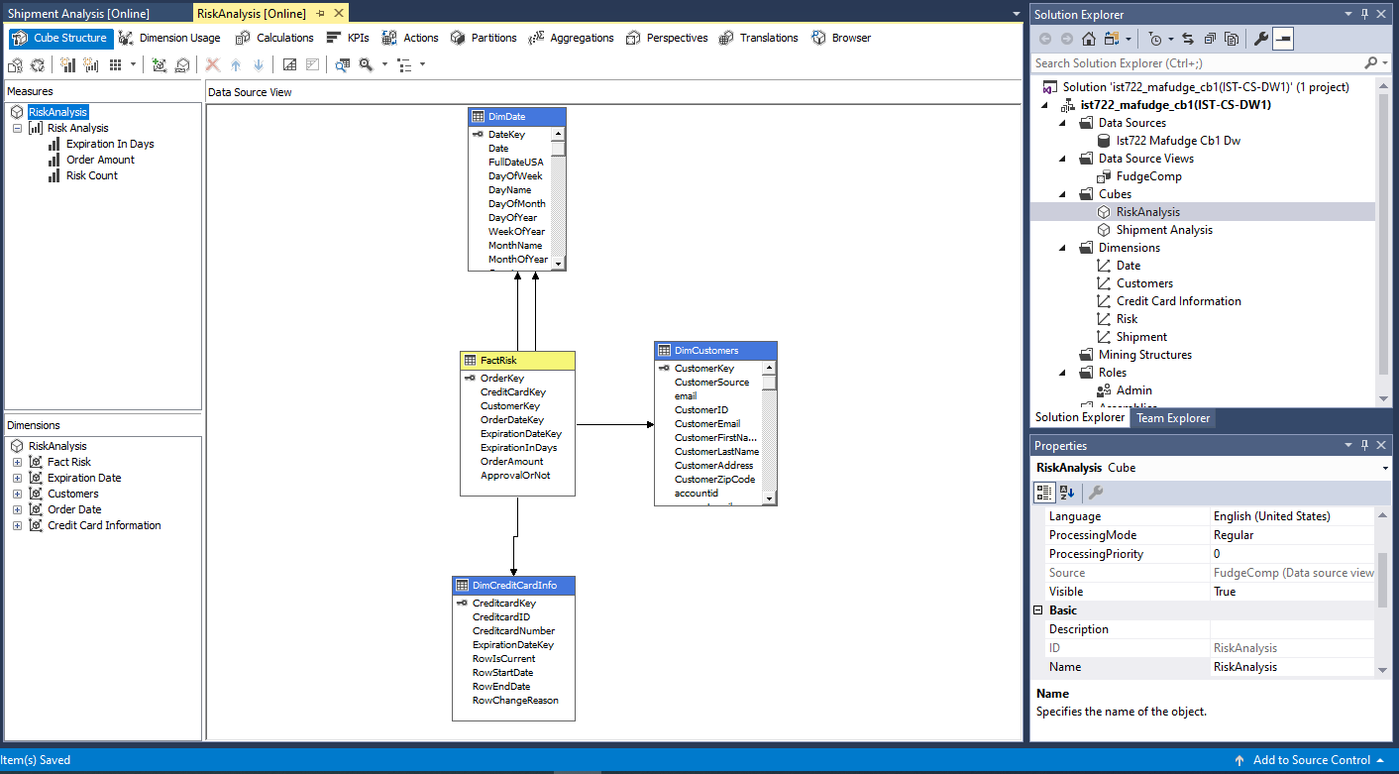

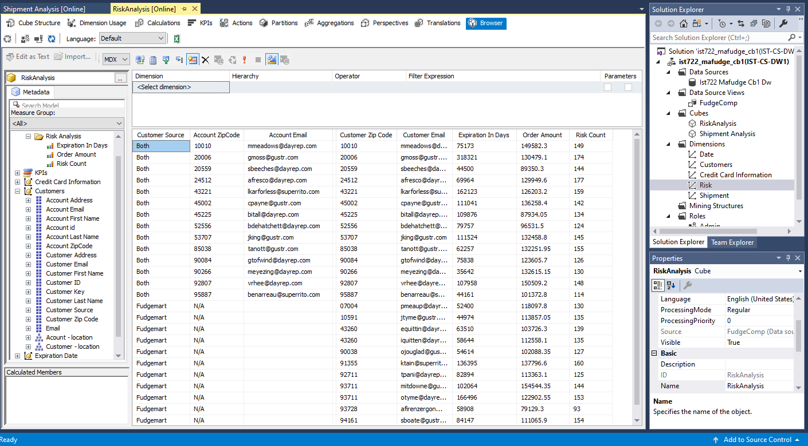

1. BI Dashboard or Application in Power BI and/or Excel.
   1. Risk Analysis(Cube KPI)

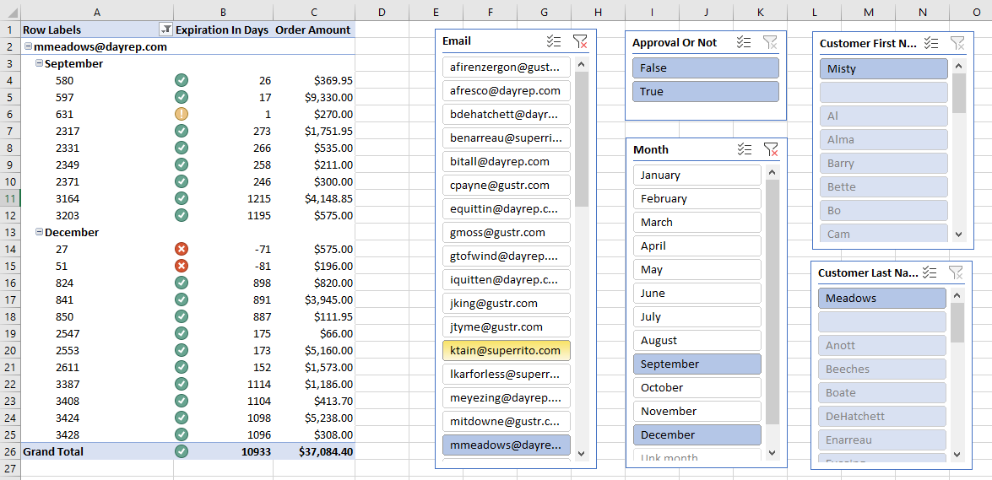

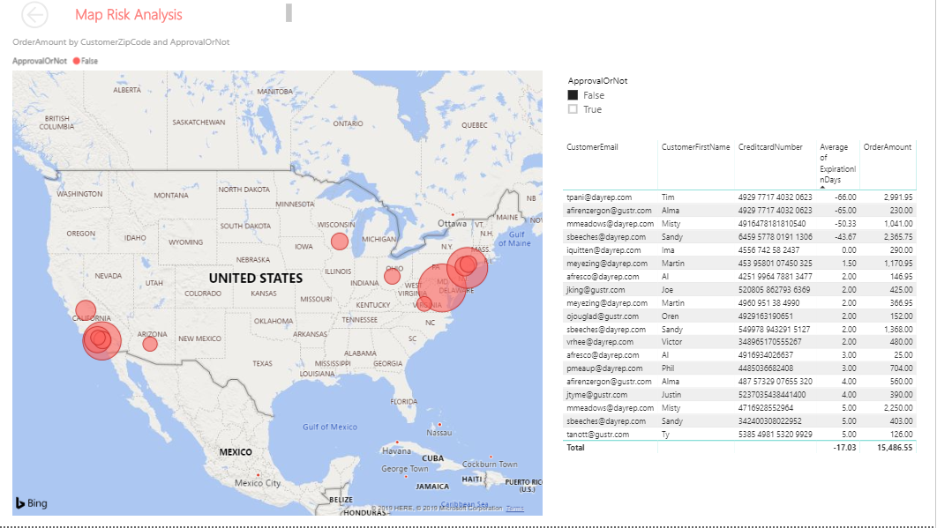

* 1. Shipment analysis

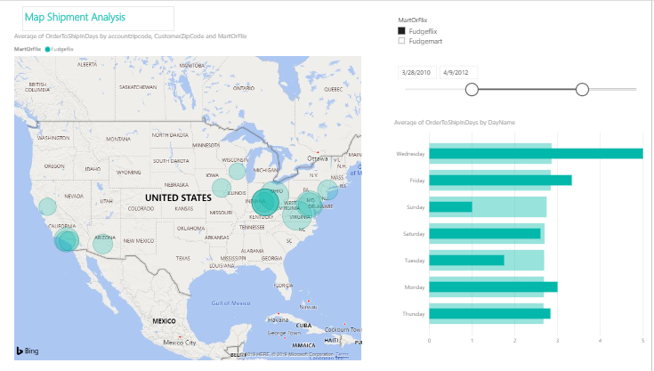

1. BI Documentation: Briefly explain the goal of your analytics and what type of BI it is.

We build business intelligence using Power BI on both cubes we created - risk analysis and shipment analysis. In the BI dashboard of risk analysis, we use zip code to represent the total order amount in map. The larger the circle, the greater the order amount by location. You can also filter the order amount by whether the order is approved or not, so you can tell how much money the company has lost by shipping orders that have no valid credit card number. There is a list of customers where their average expiration days (order date minus credit card expiration date) is lower than 5 days.

In the BI dashboard of shipment analysis, we combined the order information from both database - fudgeflix and fudgemart. In the analysis, we also use customer and account zip code to identify the location, and use the size of the bubble to represent the average order-to-ship in days. The larger the bubble, the greater average order-to-ship in-days of the specific location. On the right hand side, you can compare the average order-to-ship in-days by the day of the week and when you select specific location, you can compare that to the overall average days. We include filters of the customer sources (Mart of Flix) and order date.

All in all, both BI applications are interactive and can show much more meaningful information for both analysis.