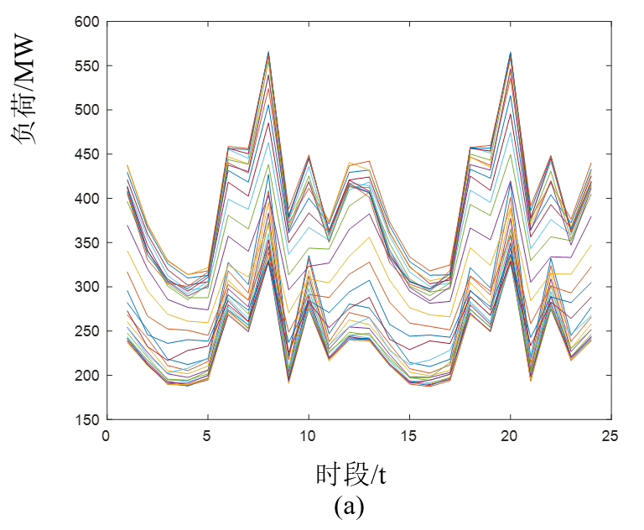

1. The load curve that clustered in 30 typical days

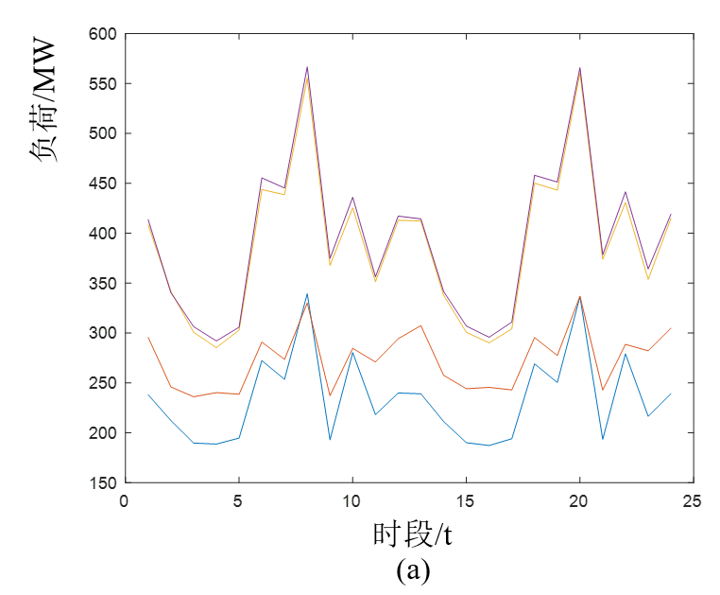

1. The load curve that clustered in 4 typical days