Activity

Class Project: Find the infoBase Behind the Web Site

filename: findTheInfoBaseBehindTheWebSite.docx:

# Introduction

In this activity you will deconstruct the web site of your choice to find the key elements of the infoBase behind the site.

# Choose an Info Type

Think of one kind of information that:

* You are really interested in.
* Comes in reasonably small chunks
* Has at least a few sites dedicated to it

|  |  |
| --- | --- |
| Good choices | Poor choices |
| Pets  Off-Road Cars  Horses  Horror Movies  Indie Songs  Chinese Recipes  Children’s Books  State Parks  Good Cities to visit | Types that are too general: soccer, science, countries, all movies.  Types that are too complicated: Films with actors, staff and studio (that is three types all tied together), basketball leagues, teams and players (again, this is 3 not one type of information) |

### Question 1:

|  |  |
| --- | --- |
| What is your info type? | Motorcycle |

# Choose two sites that represent your type now

Find two site on the Web that showcase your info type.

|  |  |
| --- | --- |
| Good choices | Poor choices |
| Sites that focus entirely on your type  Sites that have clear navigation of all 4 types  Sites that are not clogged with a lot of ads and other distractions | General commerce sites like Amazon.  Sites that don’t fully represent your type  Sites that don’t navigate well between items of your type |

### Question 2: What are your two sites?

|  |  |
| --- | --- |
| Name | URL |
| ZigWheels | <https://www.zigwheels.com> |
| Zero Motorcycles | <http://www.zeromotorcycles.com/> |

# Presentation: Screens and areas

Take a screen-shot of the full page that shows one item of the type you chose. Mark-up the areas on the picture to show header, nav and content areas. If the whole page does not fit on one screen, take as much as will fit. But try to show the most significant parts of the page in the screenshot you take.

**Header**

## Site 1:

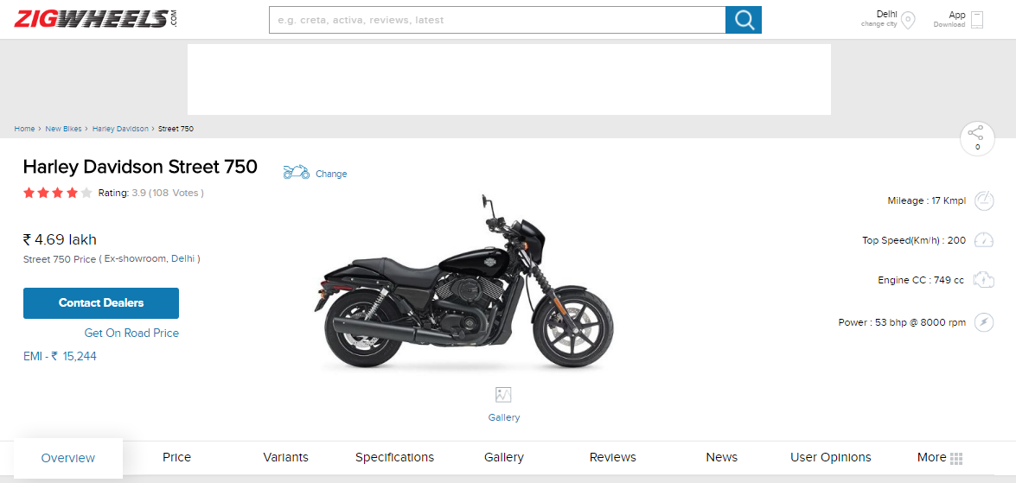

**Content Area**

**Navigation**

## Site 2:

**Header**

# Presentation: Full-views

**Content Area**

**Navigation**

|  |  |
| --- | --- |
| *In general*, what is a full-view? | A full view is the display of an info item or org item that shows all or most attributes of the item. |

For each of your two sites, make a screen capture of one full view of type you chose. Include in the image only the part of the screen with the full-view, no headers, links or navigation that is not part of the full-view. Mark-up (that is draw circles and label them) the illustrations with arrows and labels to point to all the attributes you can find.

## Site 1:

## 

**Range in city**

**Max Capacity**

**Drivetrain**

**Charger type**

**Acceleration**

**Model**

* **Torque**
* **Top Speed**
* **Range**
* **Cost**

## Site 2:

**Rating**

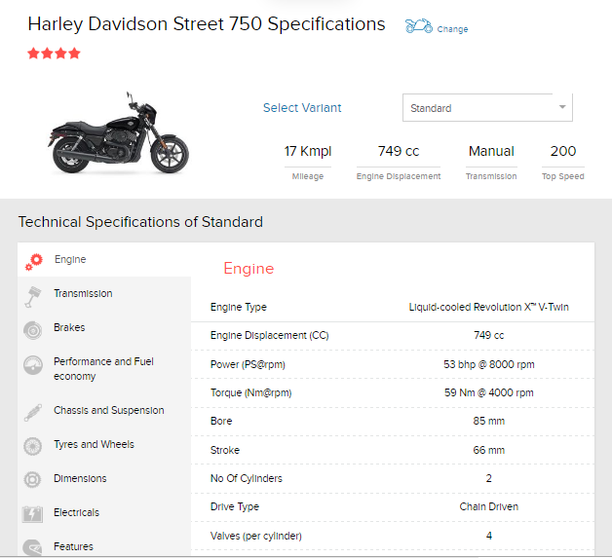

**No of cylinders**

**Eng Displacement**

**Drive Type**

**Stroke**

**Bore**

**Torque**

**Power**

**Eng Type**

**Top Speed**

**Transmission**

**Engine**

**Mileage**

**Bike Name**

**Price**

# Presentation: Partial-views

**Valves**

|  |  |
| --- | --- |
| What is a partial-view? |  |

For each of your two sites, make a screen capture of partial views of your info type. Include in the image only the part of the screen with the partial-views, no headers, links or navigation that is not part of the partial-views. Mark up one of the partial views to label the attributes that are shown.

## Site 1:

**Nickname**

**Model Name**

## Site 2:

**Range**

**Power**

**Weight**

# 

# Representation: Gather the attributes from the screens

Fill out the table below to aggregate all the attributes shown in the two screens

|  |  |
| --- | --- |
| Site 1 attributes | Site 2 attributes |
| * id * Model * Range * Max torque * Max Power * Top speed * Acceleration * Type * Controller * Power pack * Max capacity * Nominal capacity * Charger type * Transmission * Final Drive * Front suspension * Rear suspension * Front brakes * Rear brakes * Front tire * Rear tire * Front wheel * Rear wheel * Wheelbase * Seat Hight * Rake * Trail * Frame * Curb weight * Carrying capacity * Fuel economy * Cost to recharge * Price * Warranty | * id * Variant * Engine type * Engine displacement * Power * Torque * Bore * Stroke * No of cylinders * Drive type * Valves * Fuel system * Fuel type * Ignition * Transmission type * No of gears * Brakes front * Brakes rear * Overall fuel economy * 0-60(km/h) * Top speed(km/h) * Chassis type * Suspension-Front * Suspension-Rear9 * Tyre size(Front) * Tyre Size (Rear) * Wheel Size * Tubeless Tyres * Wheels Type (Pressed Steel) * Lendth*Width*Height * Wheelbase * Ground Clearance * Fuel Capacity * Kerb Weight * Head lamp * Battery * Projector hear light * Pilot lamps * LED tail lights * ABS * Body Graphics * Self Start * Kick Start * Pass switch * Digital Speedometer * Tachometer * Trip meter * Average fuel economy * Standard Warranty (years) * Standard Warranty (kilometers) |
|  |  |

I have pre-populated the table with two attributes we can safely assume any info type will have:

* An id which is the way the system will identify each item.
* A title (or name) which is the way people will identify each item.

For example, if your info type is “pet,” you can be sure that the pet type will have an id (for finding them) and a name (so people have something to call them).

Don’t worry if you don’t entirely understand this concept for now, we will come back to it many times.

# Organization: Find org types

Find examples of each of the four types of organization (hierarchy, index, association and sequence). If you can’t find an example on the site, look more widely on the internet or invent your own by making a sketch of how a site *could have* included that type of organization.

## Site 1

### Org Type: Hierarchy

Show an example here of items of your type in an outline, tree or other parent/child relationship.

Org Item:

Bike

Honda BMW Suzuki Hyosung Aprilla Harley Davidson Yahama KTM Ducati

Gixxer Hayabusa Swish FZ Fazer Ray Z

155 SP 150 Rear disc Petrol

### Org Type: Index

Show an example here of items of your type in an alphabetical list. There was no alphabetical list on the sites I choose. Here is an unordered list by brand.

Org Item:

### 

If converted to alphabetical list it would be like this:

* Bajaj
* Harley Davidson
* Hero Moto Corp
* Honda
* Kawasaki
* KTM
* Piaggio
* Roya Enfield
* Suzuki
* Triumph
* TVS
* Yahama

### Org Type: Association

Show an example here of links between one item and other that are, in some way, like it.

Org Item:

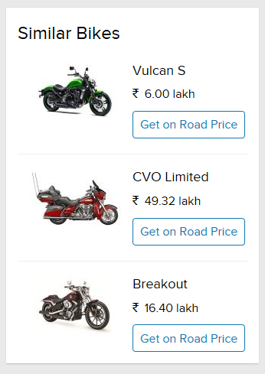

### Org Type: Sequence

Show an example here of where you are expected to go through a list of items of your type in a particular order.

Org Item:

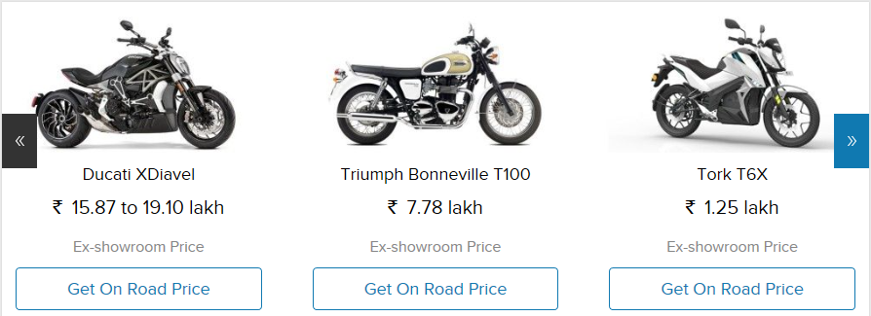

## Site 2

### Hierarchy

Bike

Zero S Zero SR Zero DS Zero DSR Zero FX Zero FXS

### Index

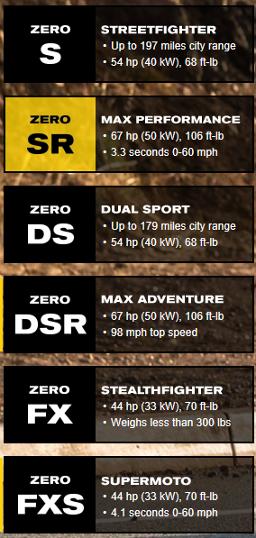

### Association

NO Association

### Sequence

