Background: Even for now, the classification of bicycles is still uncertain and unsafe. Bicycles are not cataloged as a vehicle, for sure. It is neither cataloged as a passenger since it still uses the motorway. In other words, anyone can ride a bicycle onto the motorway without system training of traffic law and ethics. This is dangerous because we cannot track all the bicycles and their riders through license plates, which makes it impossible to punish all the violators. Thus, we would like to build an automatic system that would stop the bicycles when a STOP sign is detected to prevent the violation of STOP signs. Because the violation of STOP signs is the most common and dangerous behavior that could happen to bicycle riders.

High-level requirements list:

The project must be able to detect a STOP sign within proper distance.

The wireless connection must be built successfully so that the speaker on helmet rings properly.

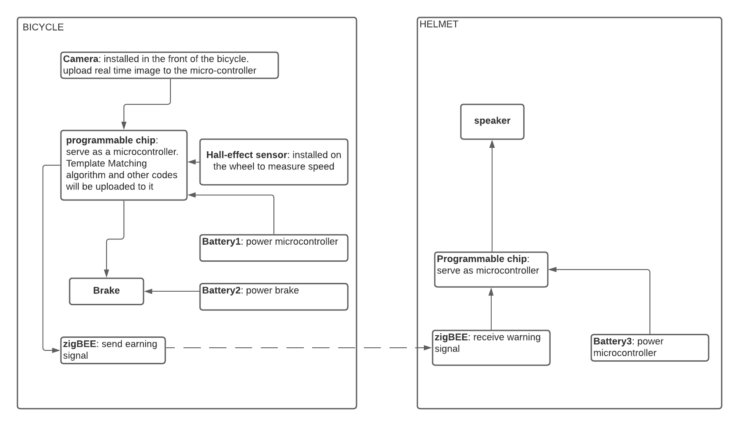Based on the speed, the brake must be activated properly within a threshold distance.

The microcontroller on the bicycle will be able to process the real-time from the camera and detects if a STOP sign is captured. It will also be able to compute speed from data given by the hall-effect sensor and triggers the brake properly.