High-level requirements list:

The project must be able to detect a STOP sign within proper distance.

The wireless connection must be built successfully so that the speaker on helmet rings properly.

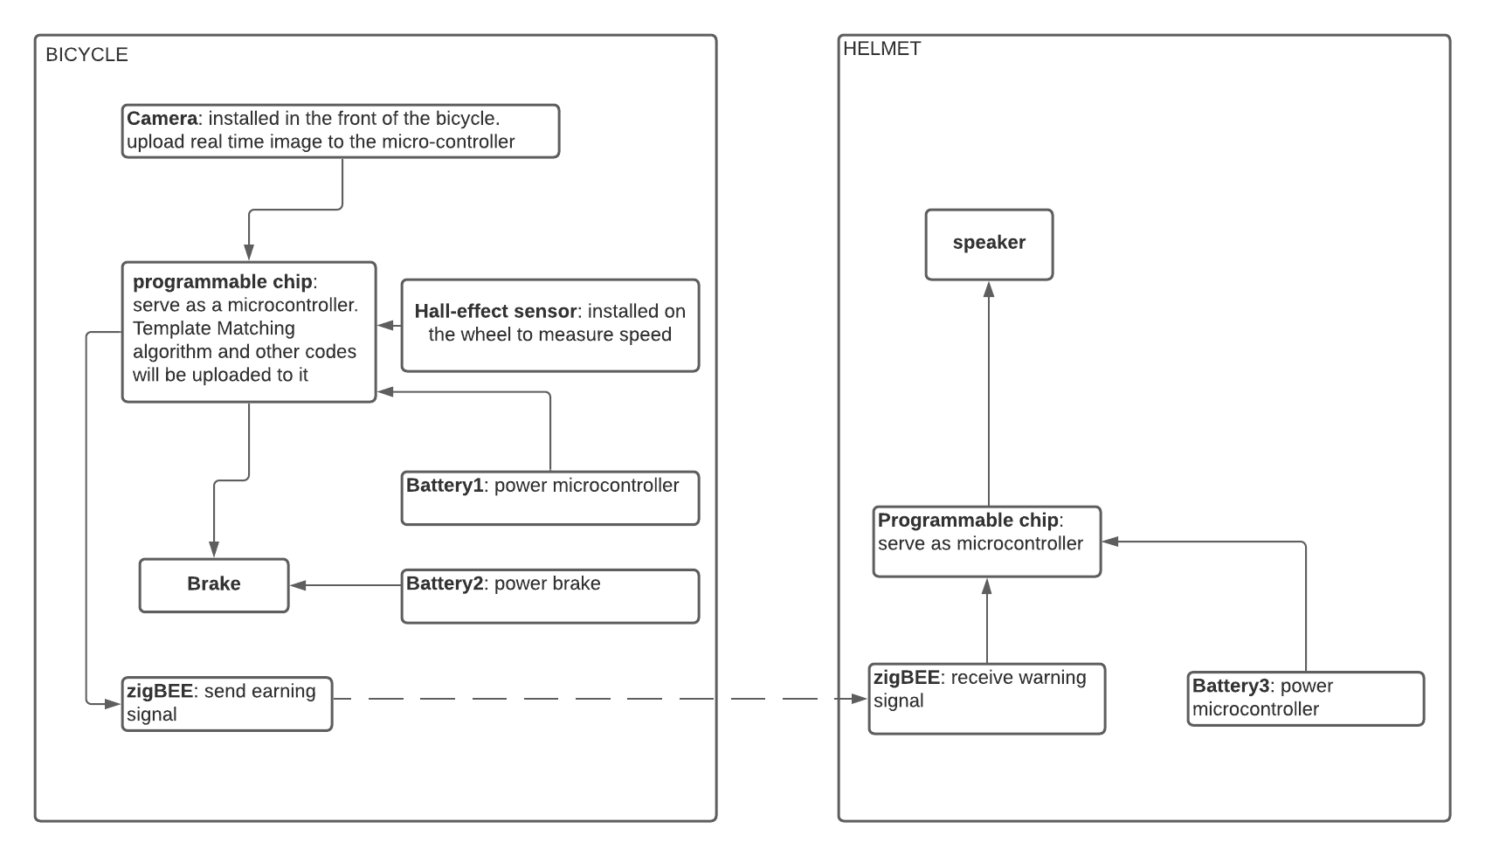Based on the speed, the brake must be activated properly within a threshold distance.

The microcontroller on the bicycle will be able to process the real-time from the camera and detects if a STOP sign is captured. It will also be able to compute speed from data given by the hall-effect sensor and triggers the brake properly.