电子科技大学
实
验
报
告

学生姓名：张志豪
学号：2019270103014
课程名称：计算机网络基础
指导教师：杨宁
日期： 2021 年 4 月 7 日

实验项目名称：实验3-1
报告评分： 教师签字：
- 实验概要
- Capturing a bulk TCP transfer from your computer to a remote server
- A first look at the captured trace
- TCP Basics
- TCP congestion control in action
- 实验步骤、数据及分析结果
- Capturing a bulk TCP transfer from your computer to a remote server
Start up your web browser. Go the http://gaia.cs.umass.edu/wireshark-labs/alice.txt and retrieve an ASCII copy of Alice in Wonderland. Store this file somewhere on your computer. 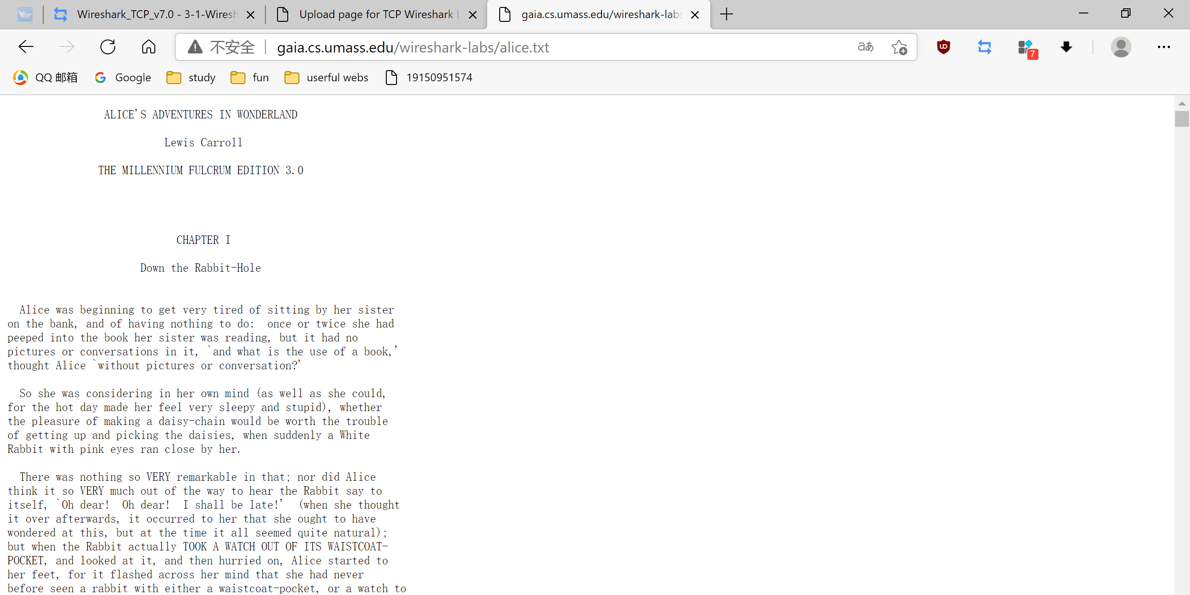
Next go to http://gaia.cs.umass.edu/wireshark-labs/TCP-wireshark-file1.html

Use the Browse button in this form to enter the name of the file (full path name) on your computer containing Alice in Wonderland (or do so manually). Don’t yet press the “Upload alice.txt file” button.
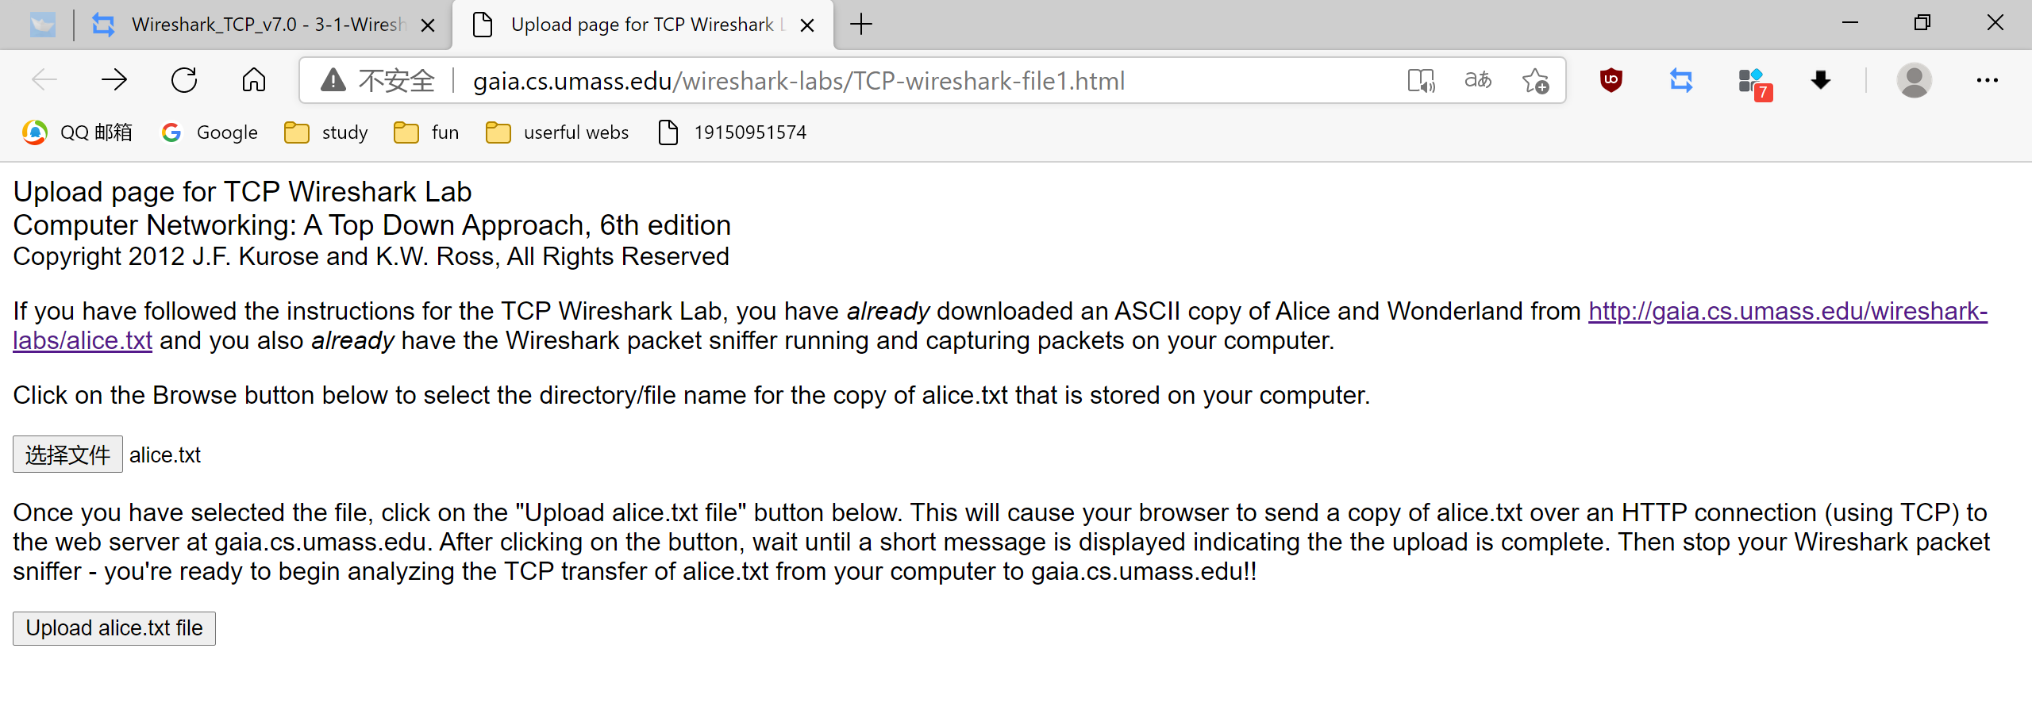
Now start up Wireshark and begin packet capture (Capture->Start) and then press OK on the Wireshark Packet Capture Options screen (we’ll not need to select any options here)
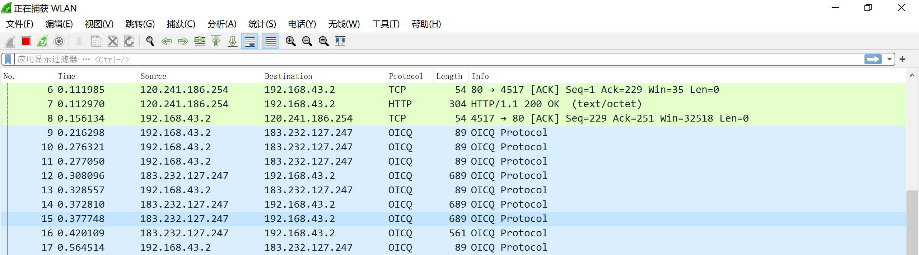
Returning to your browser, press the “Upload alice.txt file” button to upload the file to the gaia.cs.umass.edu server. Once the file has been uploaded, a short congratulations message will be displayed in your browser window.
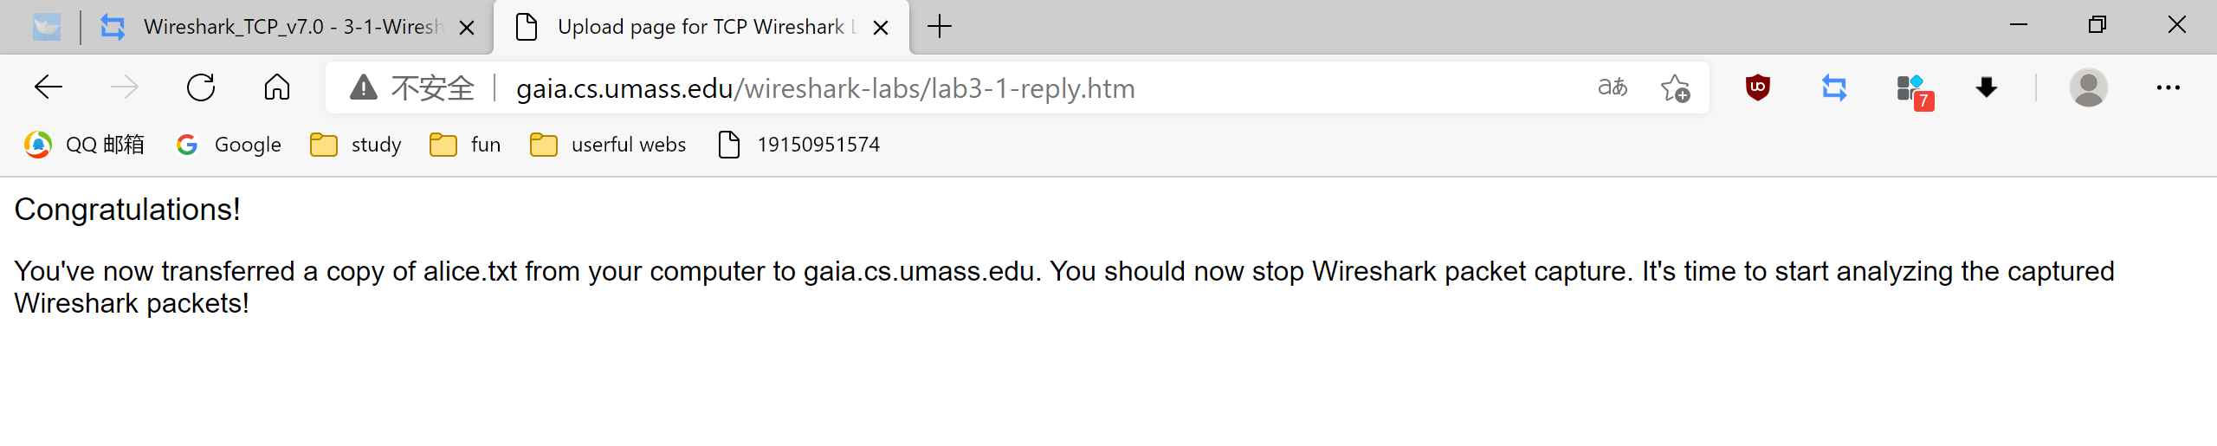
Stop Wireshark packet capture. Your Wireshark window should look similar to the window shown below.

- A first look at the captured trace
First, filter the packets displayed in the Wireshark window by entering “tcp” (lowercase, no quotes, and don’t forget to press return after entering!) into the display filter specification window towards the top of the Wireshark window.
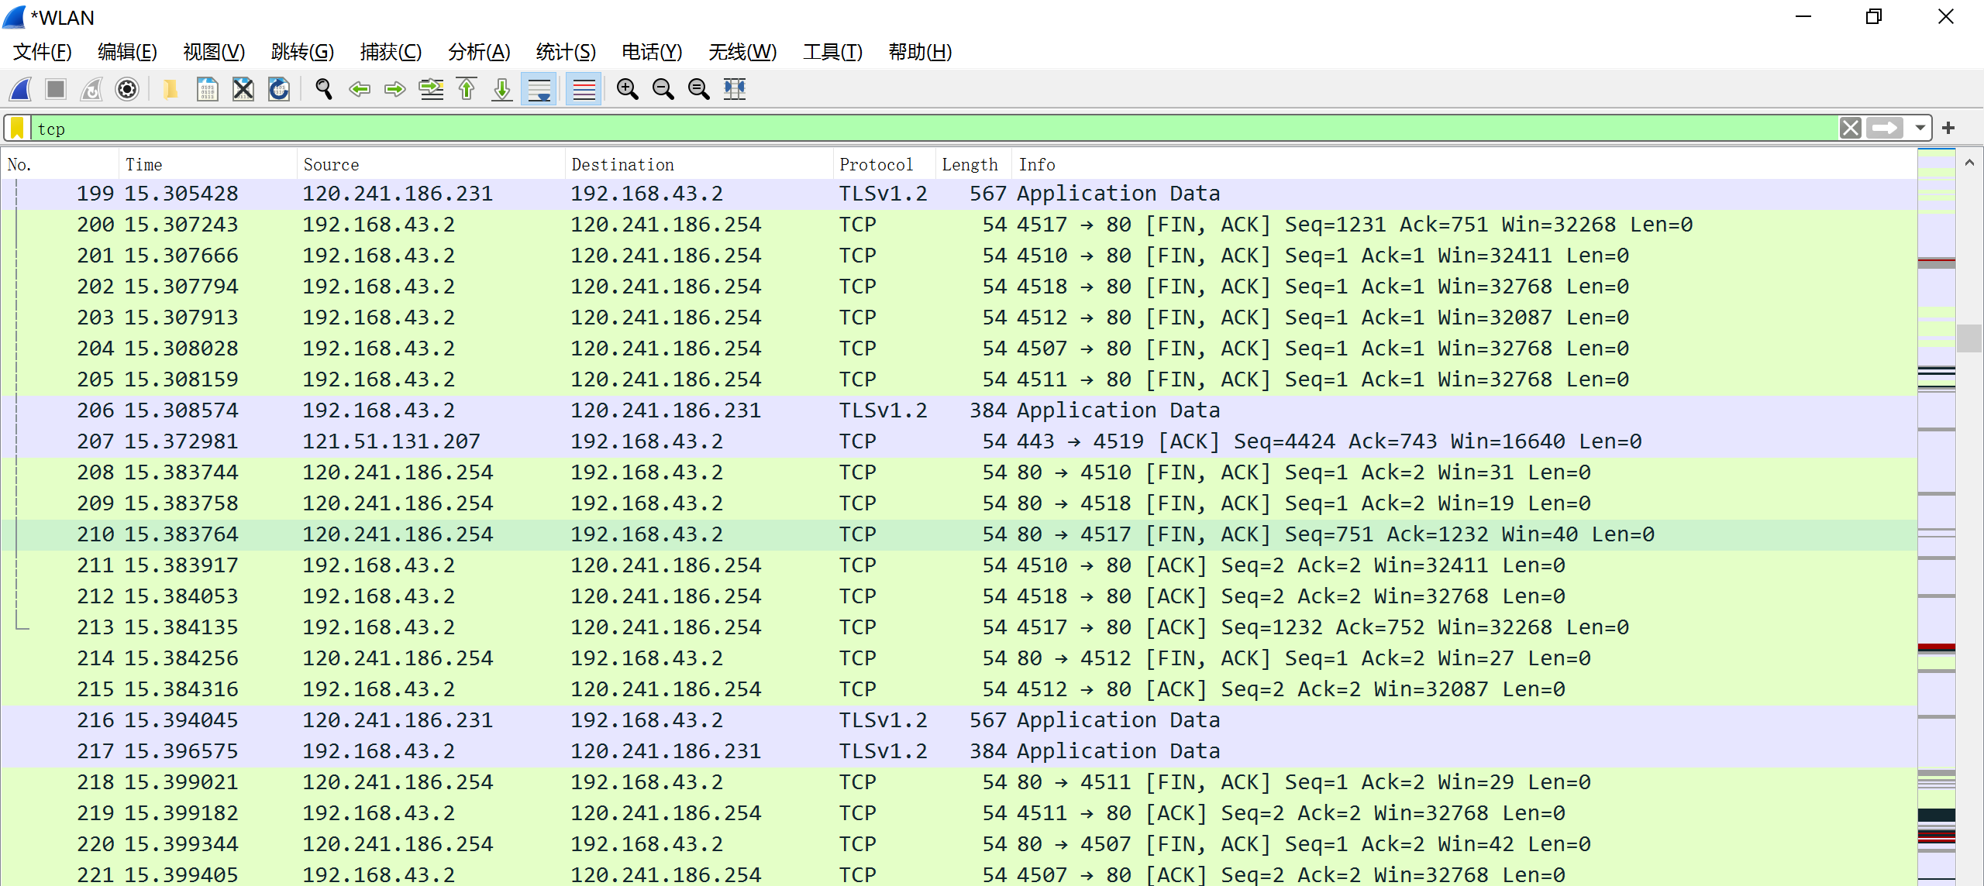
- TCP Basics
- TCP congestion control in action
Select a TCP segment in the Wireshark’s “listing of captured-packets” window. Then select the menu : Statistics->TCP Stream Graph-> Time-Sequence-Graph(Stevens). You should see a plot that looks similar to the following plot, which was created from the captured packets in the packet trace tcp-ethereal-trace-1 in http://gaia.cs.umass.edu/wireshark-labs/wireshark-traces.zip (see earlier footnote ):
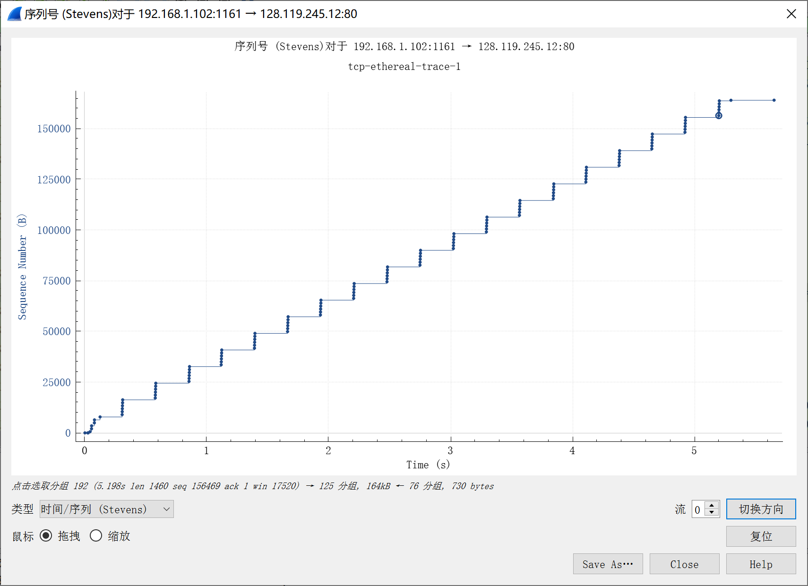
- What is the IP address and TCP port number used by the client computer (source) that is transferring the file to gaia.cs.umass.edu? To answer this question, it’s probably easiest to select an HTTP message and explore the details of the TCP packet used to carry this HTTP message, using the “details of the selected packet header window” (refer to Figure 2 in the “Getting Started with Wireshark” Lab if you’re uncertain about the Wireshark windows.
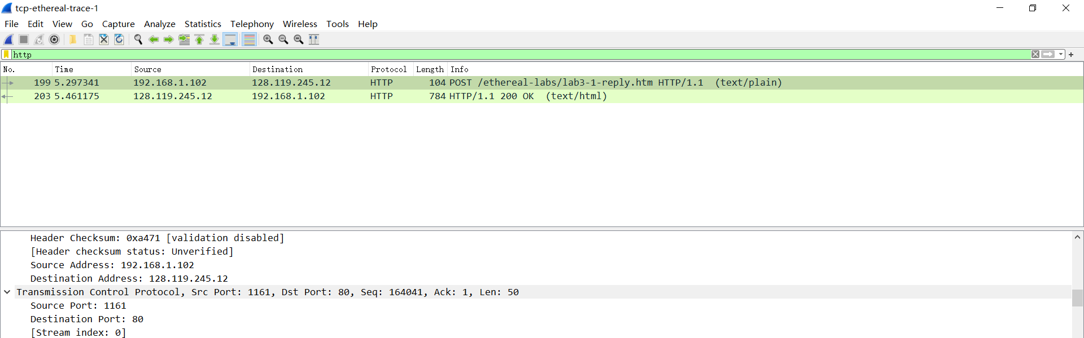
IP：192.168.1.102
Port number：1161
- What is the IP address of gaia.cs.umass.edu? On what port number is it sending and receiving TCP segments for this connection?
IP:128.119.245.12
PORT NUMBER:80
- What is the IP address and TCP port number used by your client computer (source) to transfer the file to gaia.cs.umass.edu?
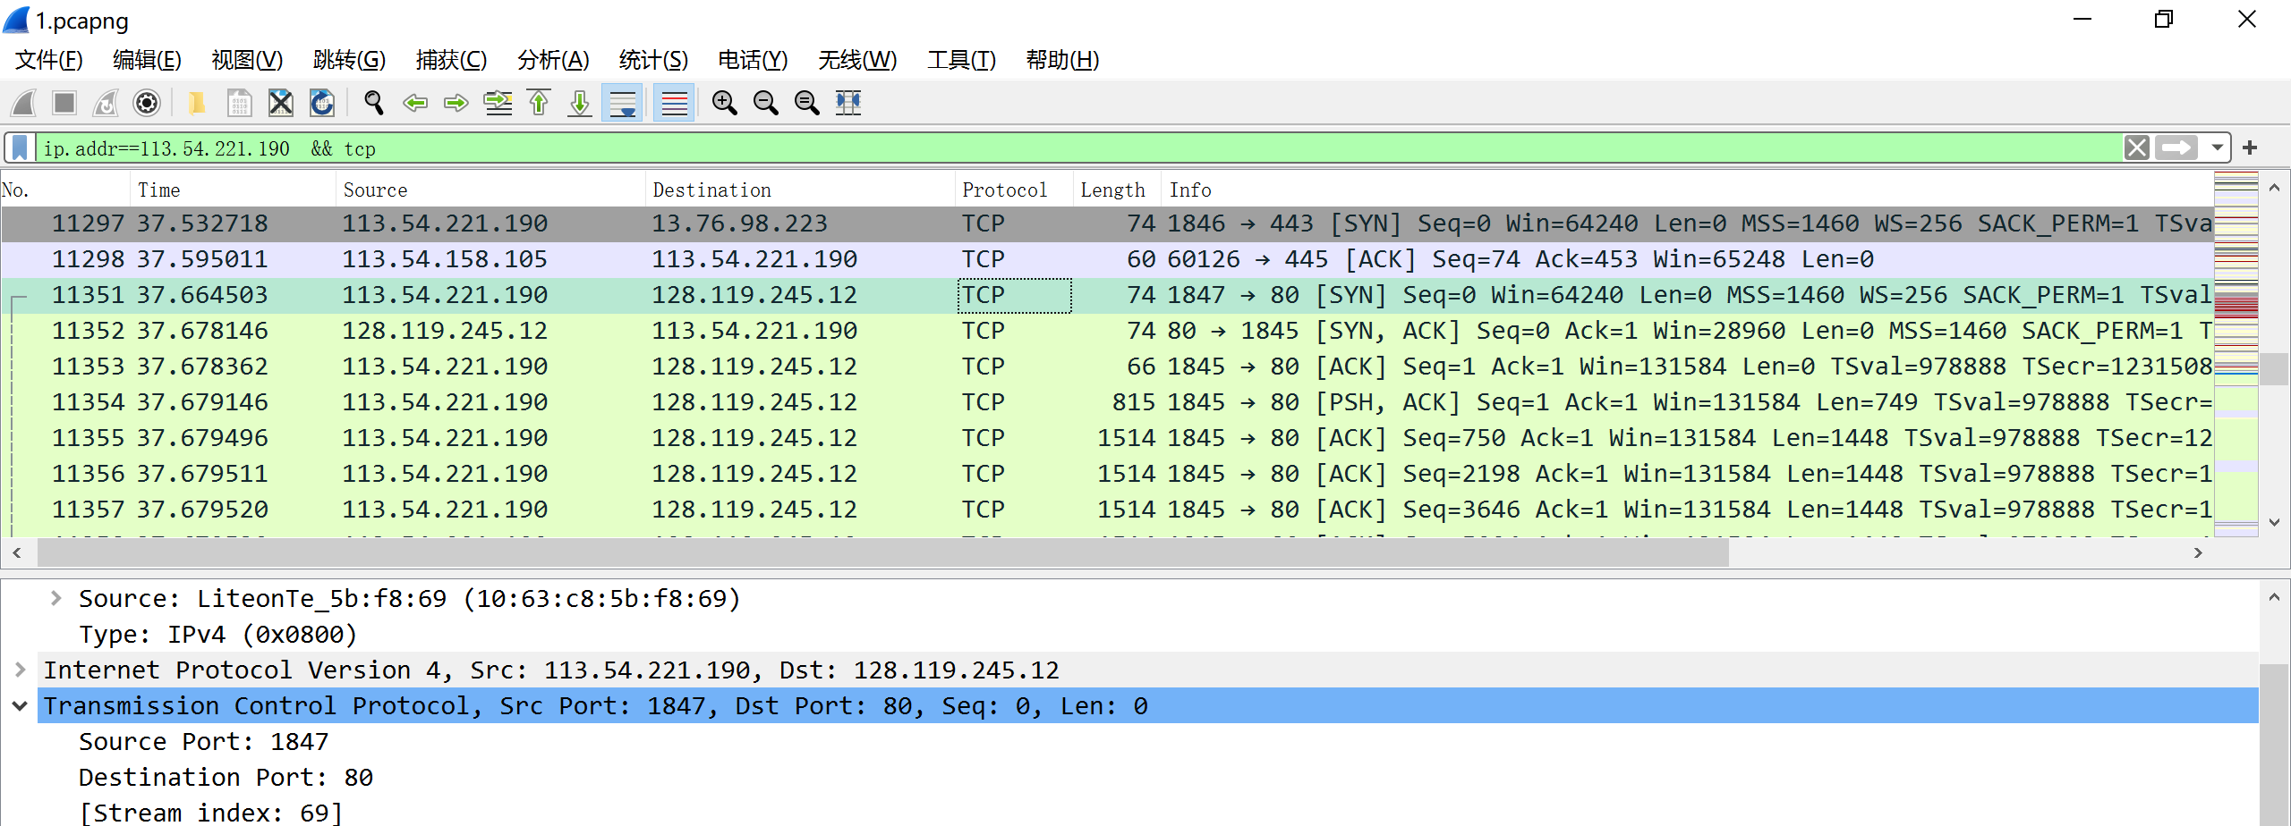
IP:113.54.221.190
PORT NUMBER:1847
- What is the sequence number of the TCP SYN segment that is used to initiate the TCP connection between the client computer and gaia.cs.umass.edu? What is it in the segment that identifies the segment as a SYN segment?
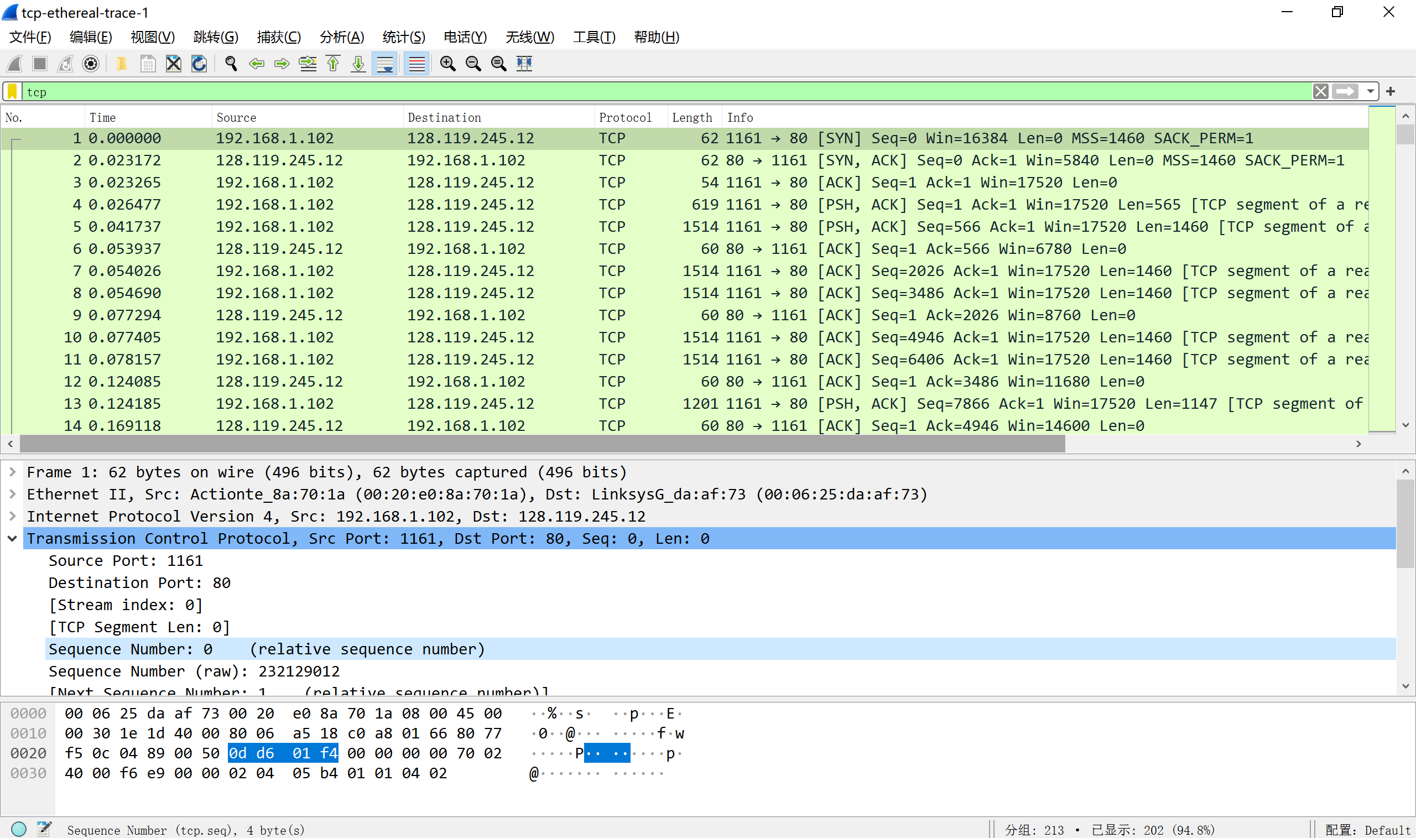
Sequence number:0d d6 01 f4

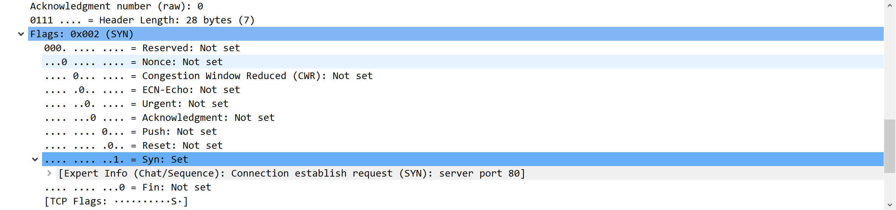
将SYN设为0x002来表示SYN报文
- What is the sequence number of the SYNACK segment sent by gaia.cs.umass.edu to the client computer in reply to the SYN? What is the value of the Acknowledgement field in the SYNACK segment? How did gaia.cs.umass.edu determine that value? What is it in the segment that identifies the segment as a SYNACK segment?
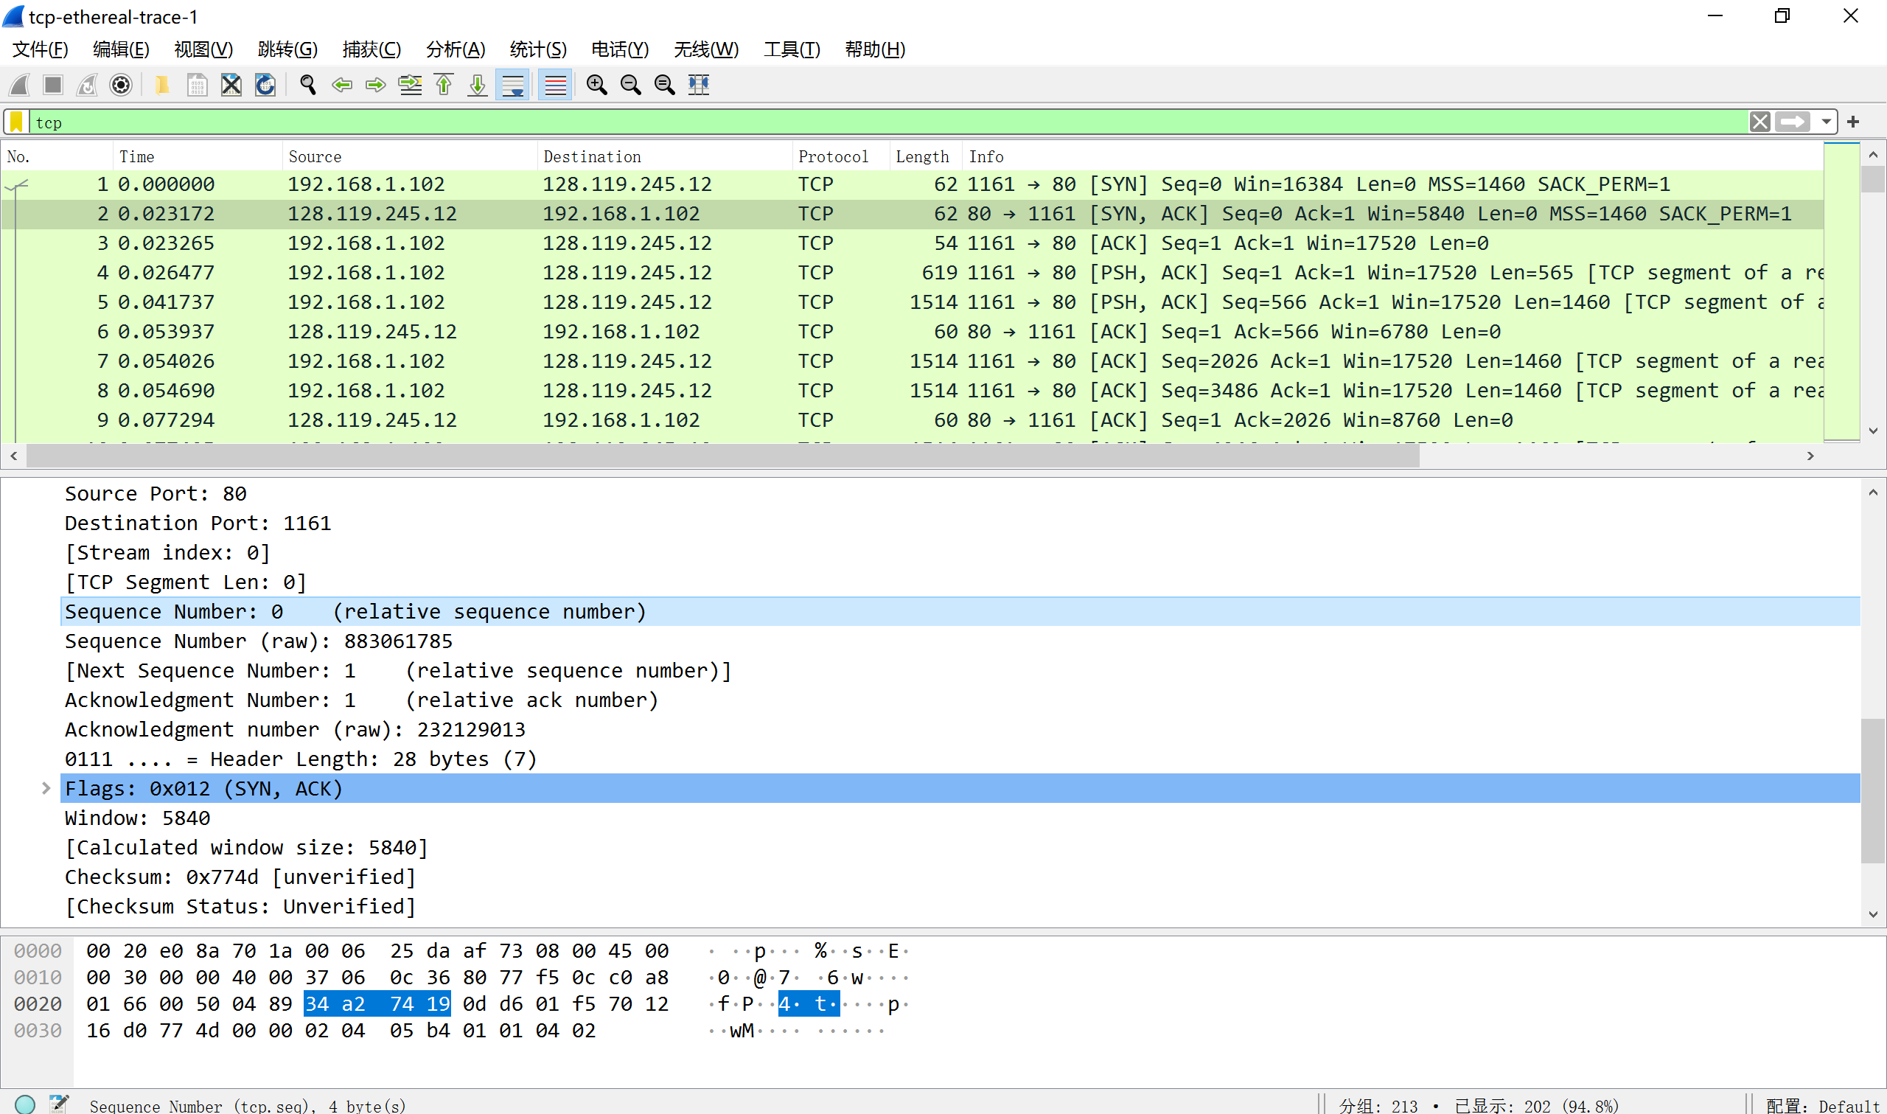
Sequence number:34 a2 74 19
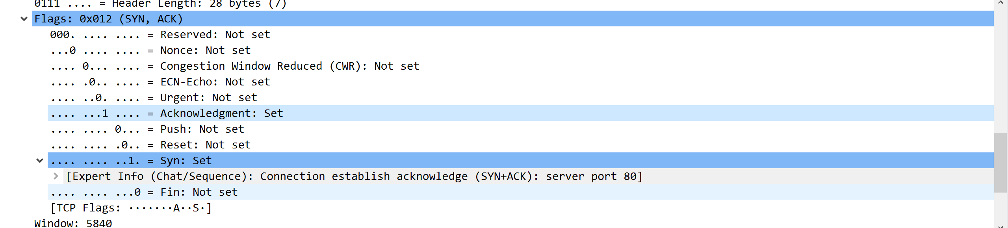
Acknowledgment:1
client发来的SYN报文sequence number为0，对应+1后得到Acknowledgment
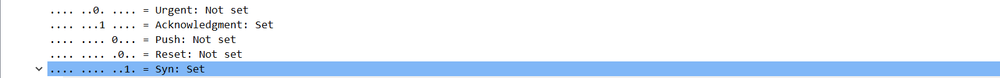
将SYN和acknowledgement设为1可识别为SYNACK
- What is the sequence number of the TCP segment containing the HTTP POST command? Note that in order to find the POST command, you’ll need to dig into the packet content field at the bottom of the Wireshark window, looking for a segment with a “POST” within its DATA field.
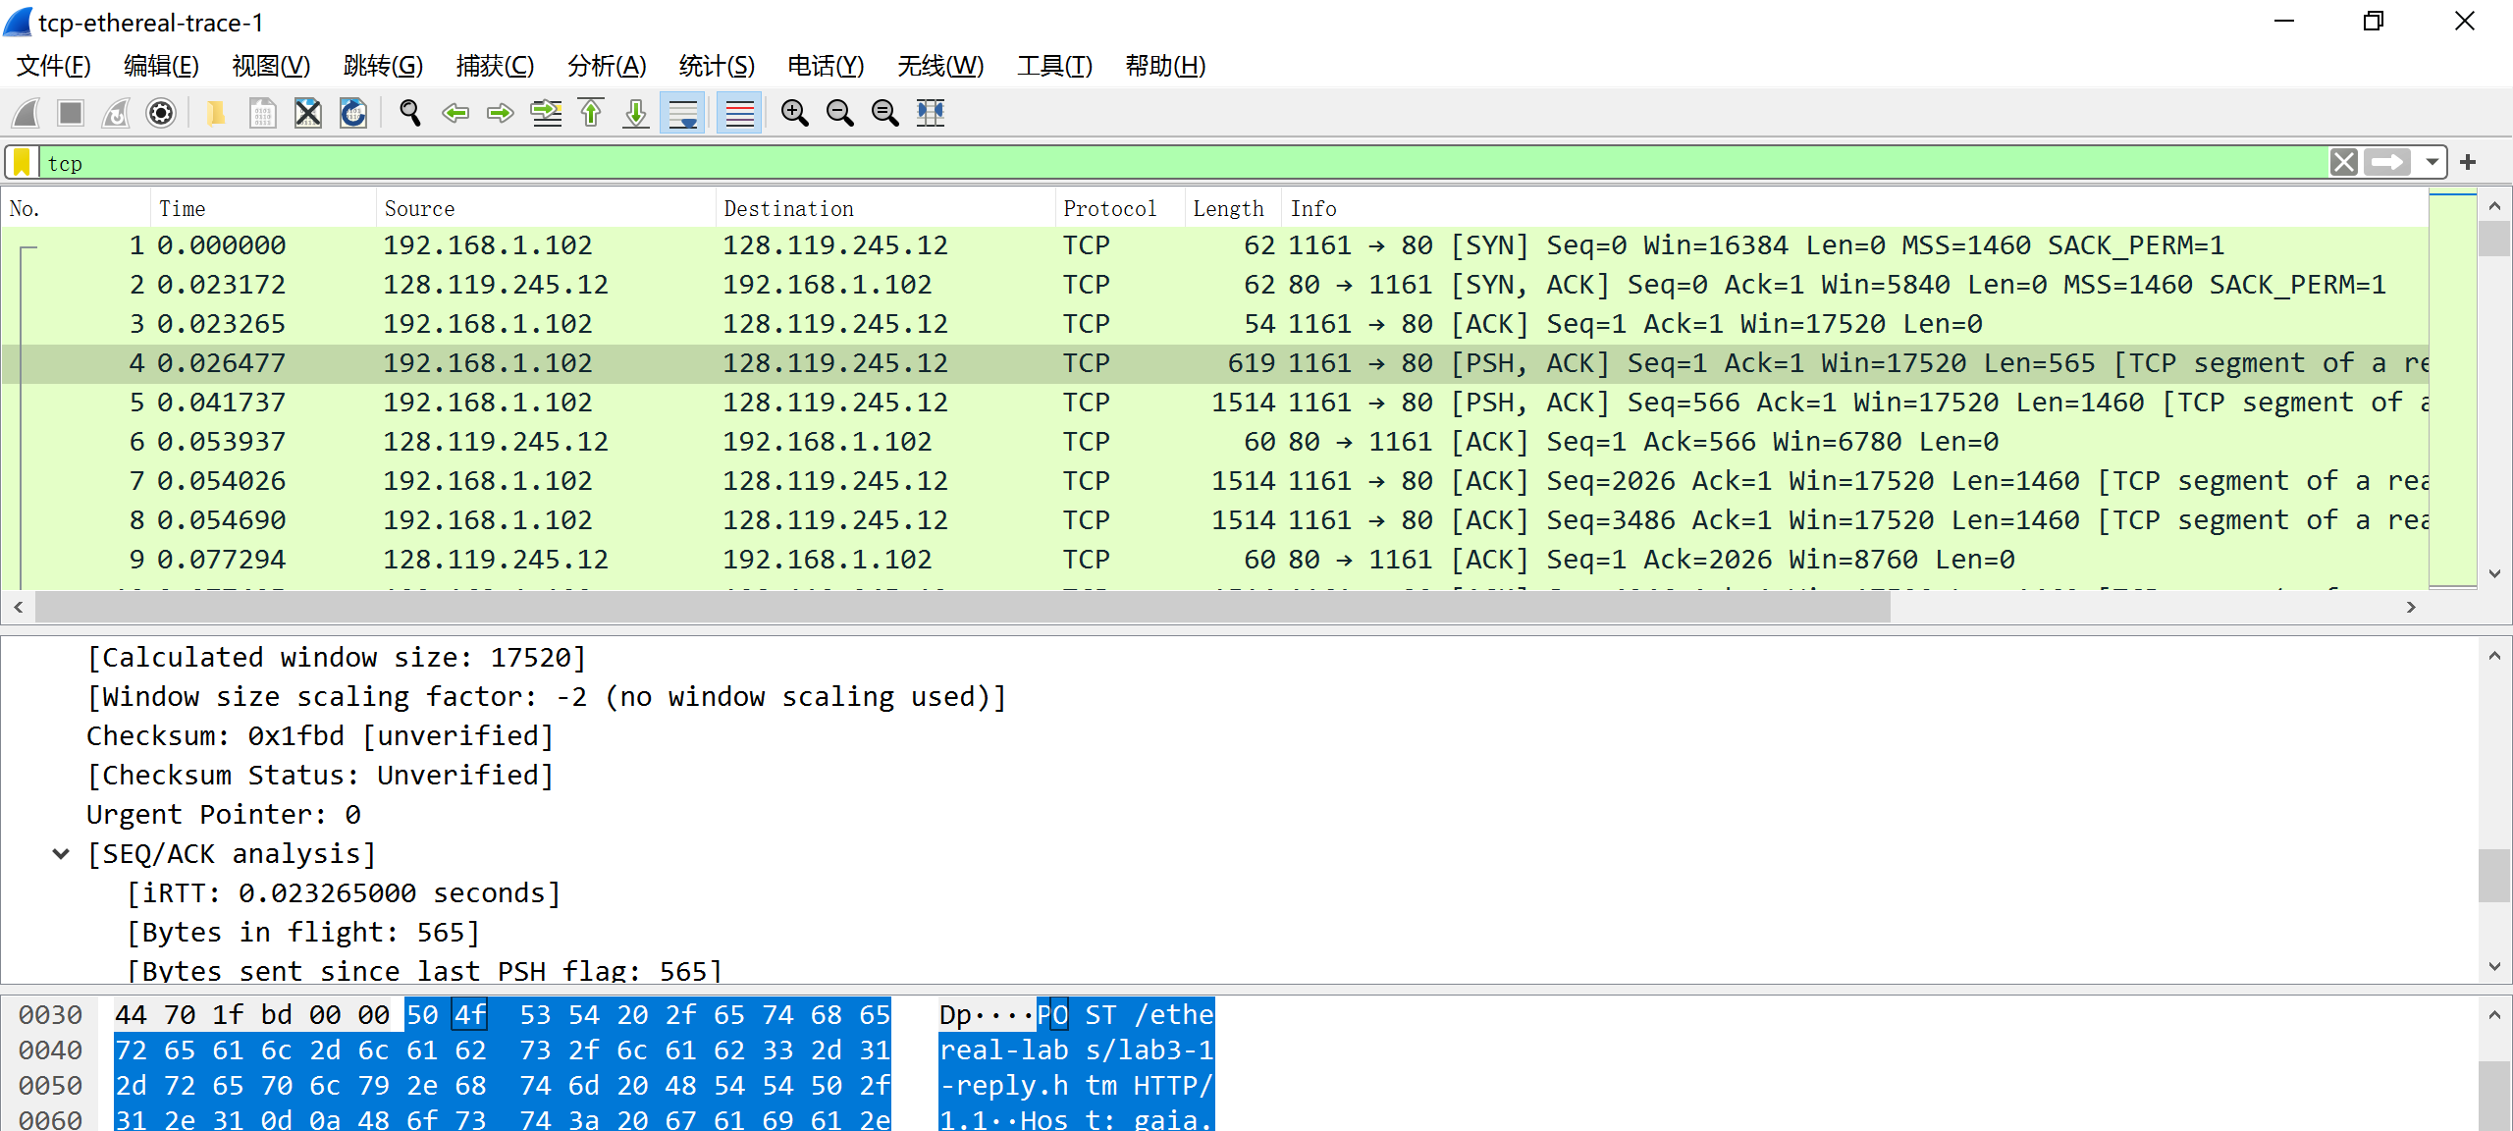
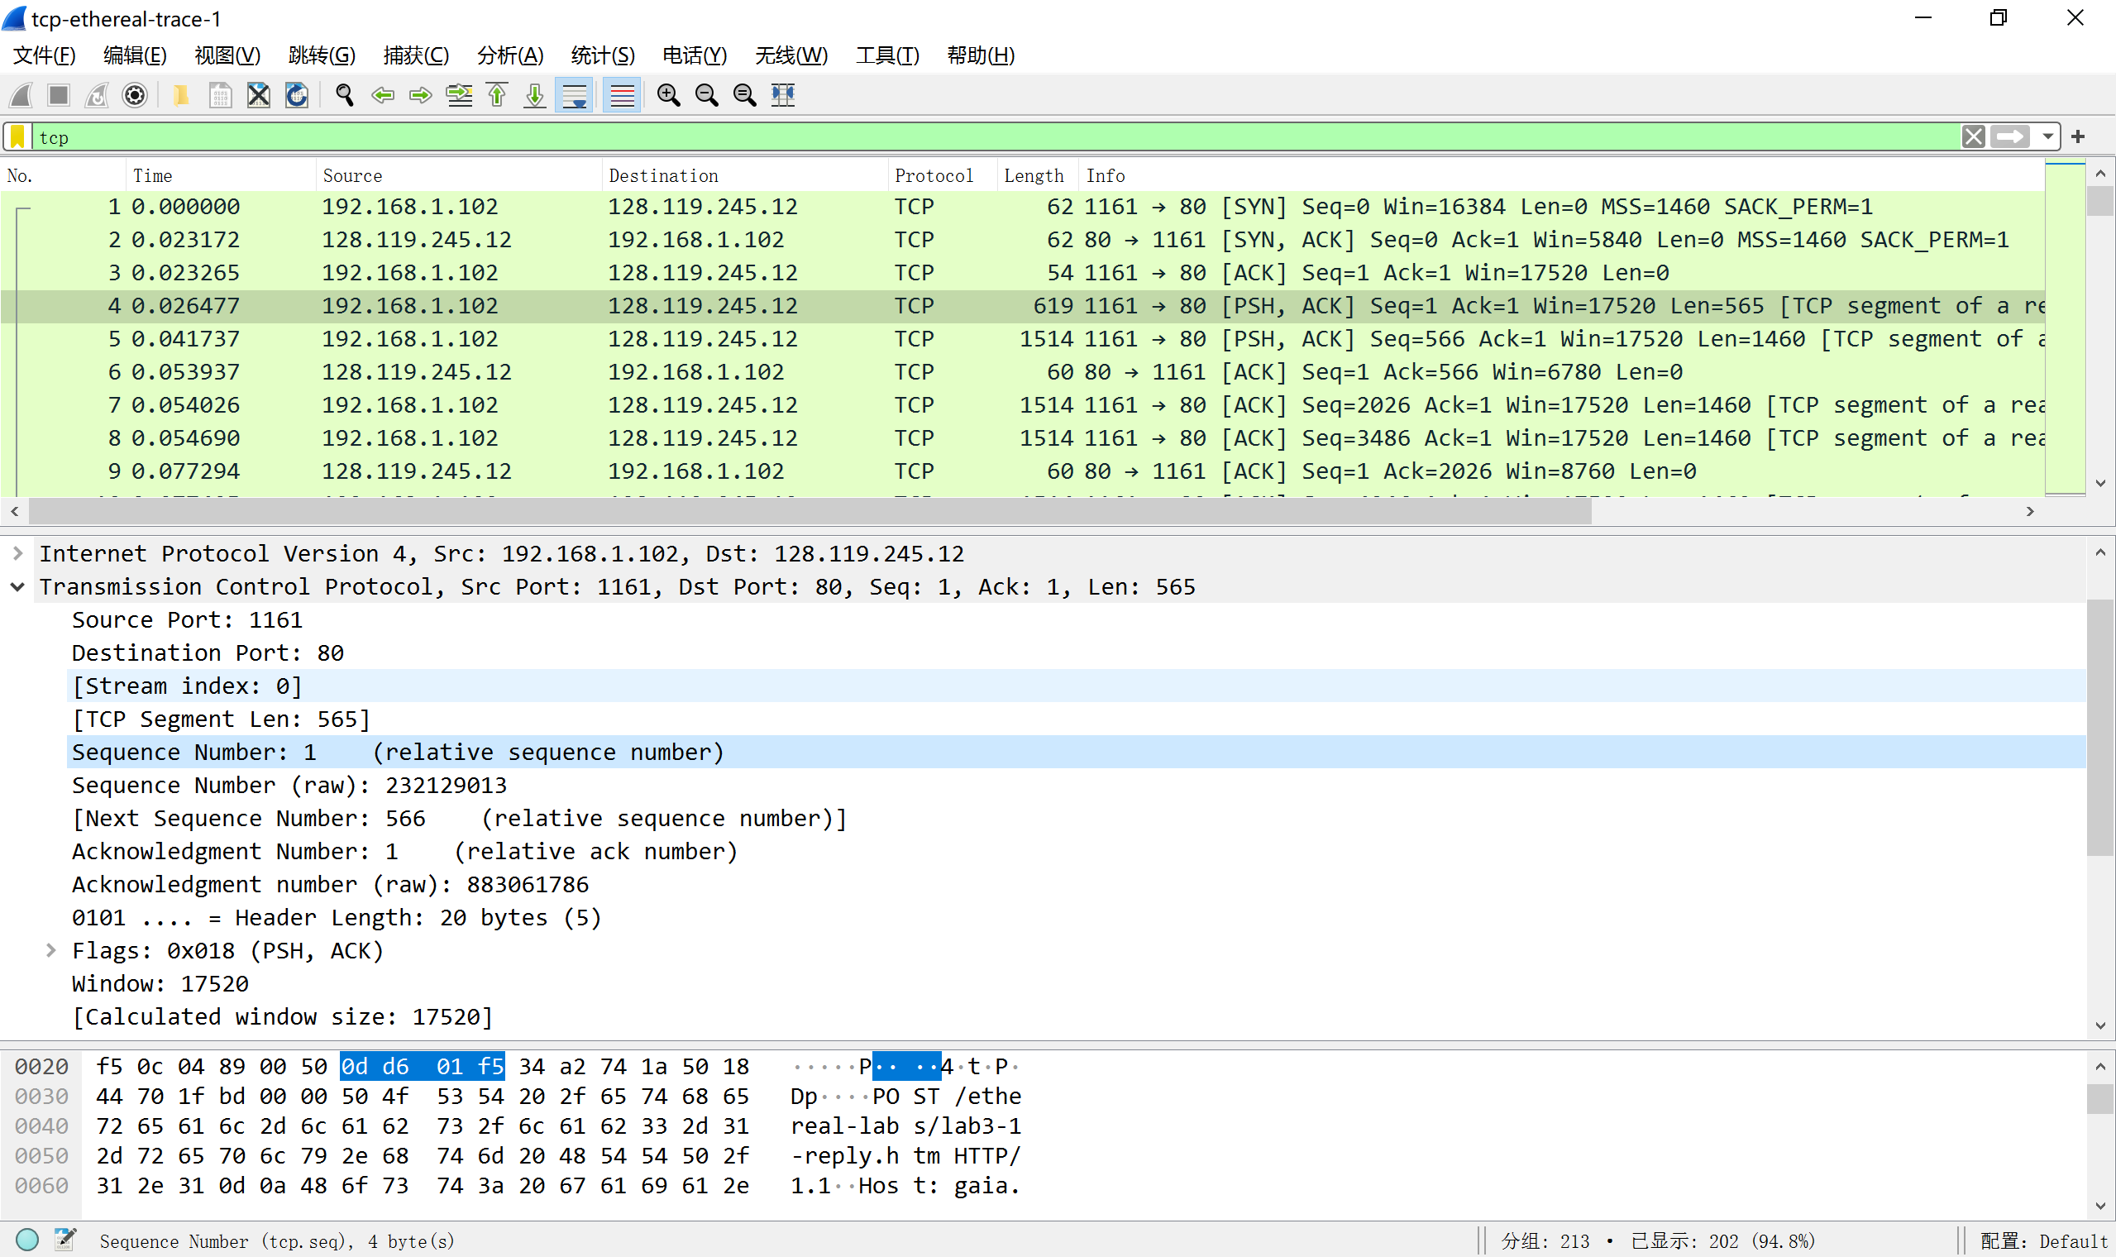
Sequence number：0d d6 01 f5
- Consider the TCP segment containing the HTTP POST as the first segment in the TCP connection. What are the sequence numbers of the first six segments in the TCP connection (including the segment containing the HTTP POST)? At what time was each segment sent? When was the ACK for each segment received? Given the difference between when each TCP segment was sent, and when its acknowledgement was received, what is the RTT value for each of the six segments? What is the EstimatedRTT value (see Section 3.5.3, page 242 in text) after the receipt of each ACK? Assume that the value of the EstimatedRTT is equal to the measured RTT for the first segment, and then is computed using the EstimatedRTT equation on page 242 for all subsequent segments. Note: Wireshark has a nice feature that allows you to plot the RTT for each of the TCP segments sent. Select a TCP segment in the “listing of captured packets” window that is being sent from the client to the gaia.cs.umass.edu server. Then select: Statistics->TCP Stream Graph- >Round Trip Time Graph.
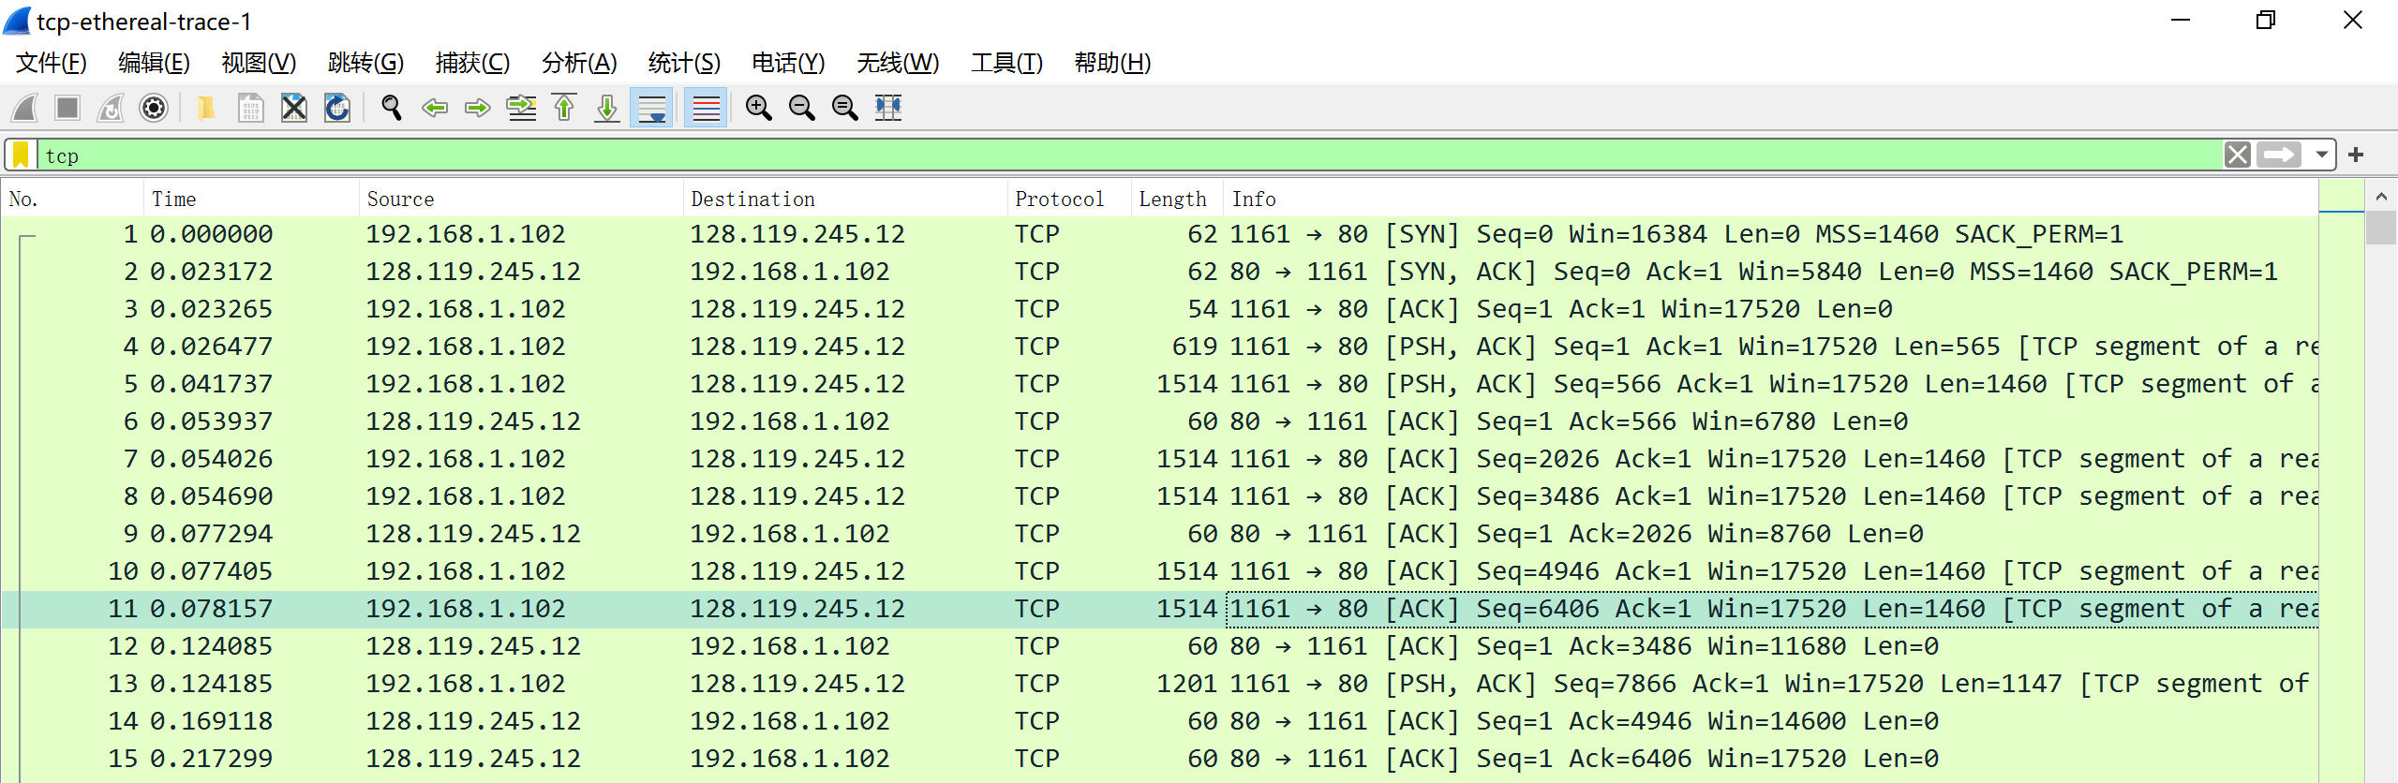
Sequence number：1，566，2026，3486，4946，6406
发送时间:0.023265 0.041737 0.054026 0.054690 0.077405 0.078157
接受时间:0.026477 0.053937 0.077294 0.124085 0.169118 0.217299
RTT(s): 0.000093 0.0122 0.023268 0.069395 0.091713 0.0139142
EstimatedRTT(s):
0.000093 0.001606375 0.0310345 0.029033875 0.07218475 0.08198815
- What is the length of each of the first six TCP segments?
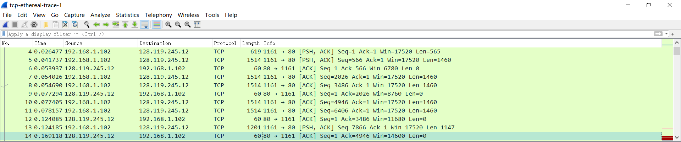
565 1460 1460 1460 1460 1460
- What is the minimum amount of available buffer space advertised at the received for the entire trace? Does the lack of receiver buffer space ever throttle the sender?
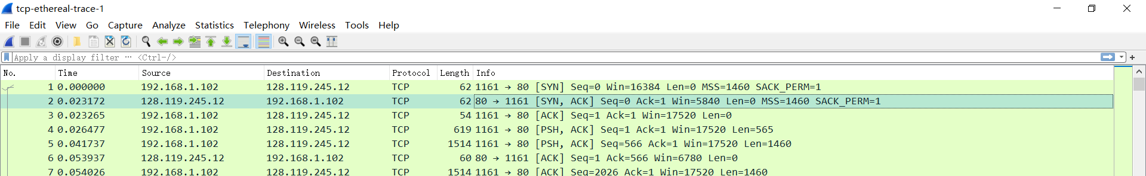
最小20BIT。不会限制

- Are there any retransmitted segments in the trace file? What did you check for (in the trace) in order to answer this question?
没有发生重传。因为序列号递增，而且从抓包文件看，没有重复的信息。
- How much data does the receiver typically acknowledge in an ACK? Can you identify cases where the receiver is ACKing every other received segment (see Table 3.2 on page 250 in the text).
观察传输的报文，1460频繁出现。
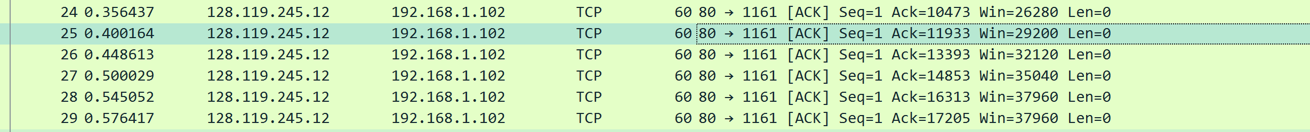
从这一段看，任意两份报文的ack之差都为2920，即传输两份1460长的报文确认的结果。
- What is the throughput (bytes transferred per unit time) for the TCP connection? Explain how you calculated this value
throughput =（61085-9013）/(2.029069-0.304807)=30199（b/s）
用某段时间内传输的数据总量除以这段时间，就能得到throughput
- Use the Time-Sequence-Graph(Stevens) plotting tool to view the sequence number versus time plot of segments being sent from the client to the gaia.cs.umass.edu server. Can you identify where TCP’s slowstart phase begins and ends, and where congestion avoidance takes over? Comment on ways in which the measured data differs from the idealized behavior of TCP that we’ve studied in the text.
根据图可以发现，报文最初就处于慢启动状态，到报文的sequencenumber等于6406时，速度得到提升
根据图像并没有看出拥塞避免状态线性增长的过程，与理想化的TCP行为不同。
- Answer each of two questions above for the trace that you have gathered when you transferred a file from your computer to gaia.cs.umass.edu
选取两条报文：
Throughput=（163712-13782）/(38.453543-3.241086)=4258(b/s)
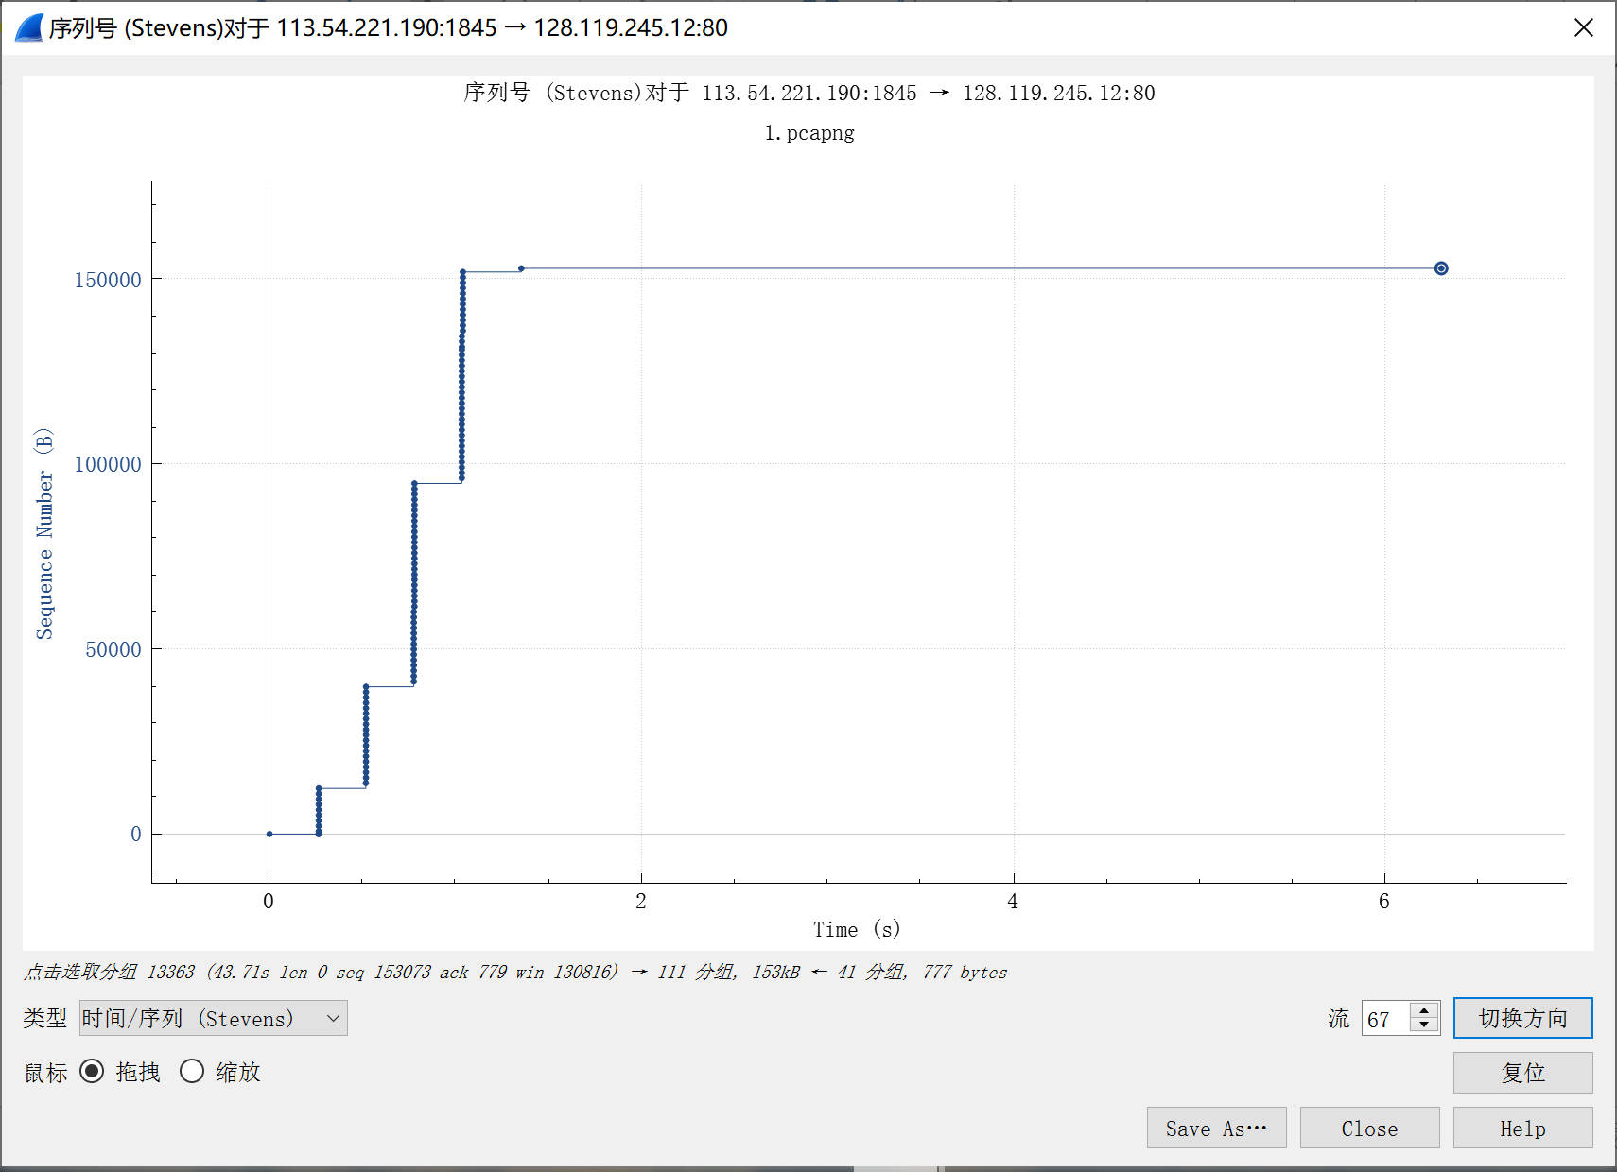
图中TCP传输情况与实例中相似

三、总结及心得体会
通过本次的wireshark抓包实验，我对于TCP协议有了进一步的理解，通过对比实例文件与自己的抓包文件，对TCP协议有了全面、普遍的了解，能够分析每一条报文的具体意义，并结合对应的上下文对整个传输过程进行分析。通过回答问题，也了解了一些相关的重要概念，以及他们的具体应用。
四、对本实验过程及方法、手段的改进建议
部分题目存在语义不好理解的问题，有时候不能很好地体会题目的用意，建议可能理解出现偏差的题目给出相应的中文对照。

