电子科技大学
实
验
报
告

学生姓名：张志豪
学号：2019270103014
课程名称：计算机网络基础
指导教师：杨宁
日期： 2021 年 4 月8 日

实验项目名称：实验4-2
报告评分： 教师签字：
- 实验概要
NAT Measurement Scenario

- 实验步骤、数据及分析结果
1.打开NAT_home_side
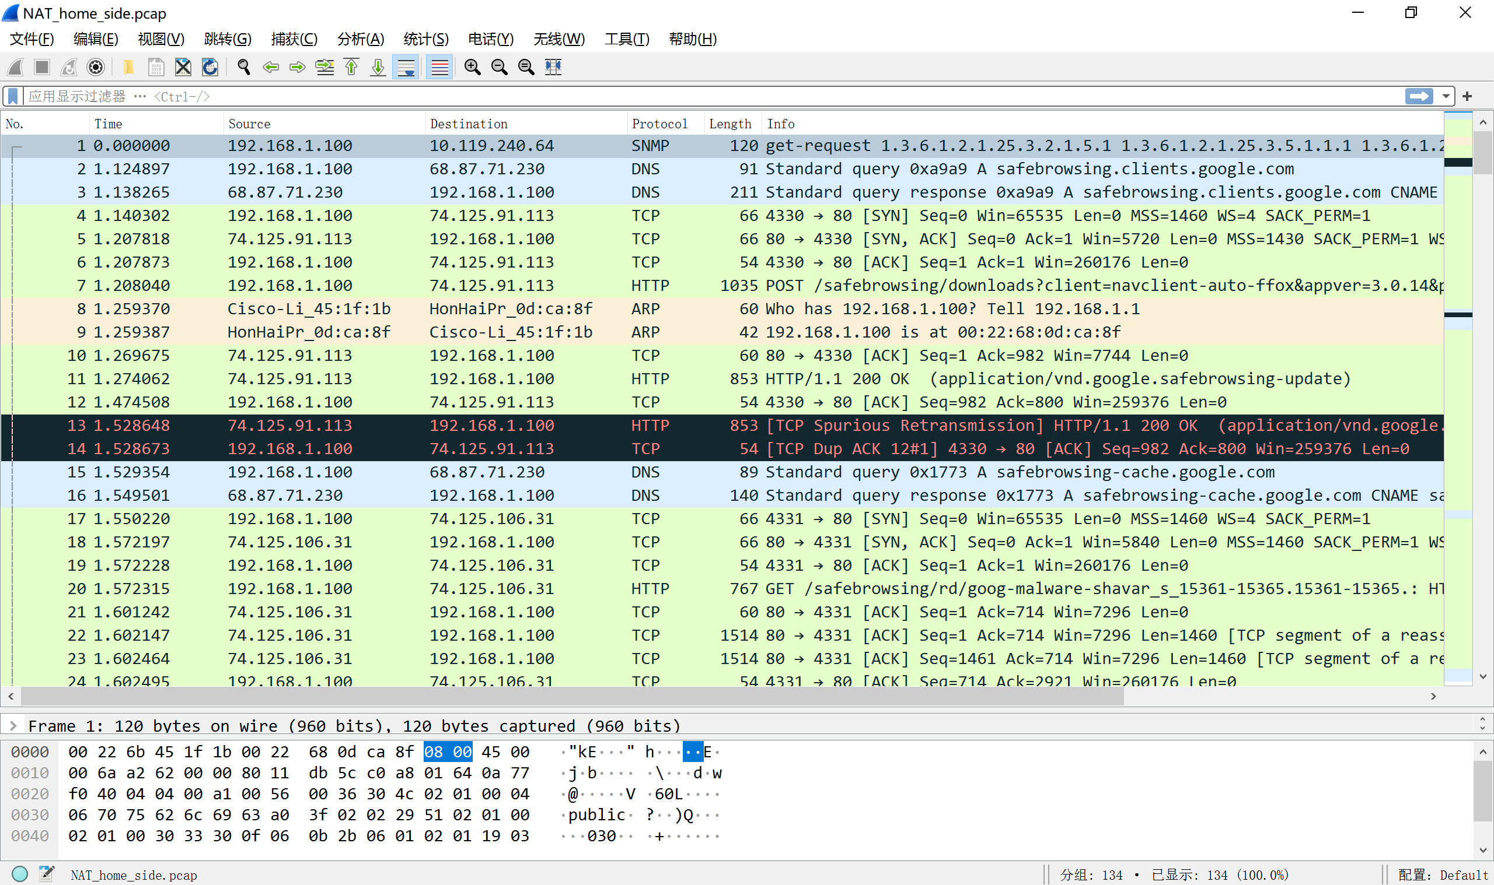
2.启用过滤器ip.addr==64.233.169.104 && http
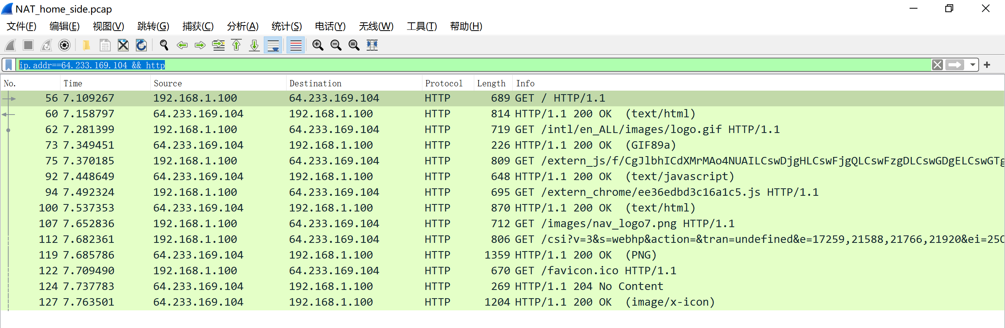
3.启用tcp过滤器
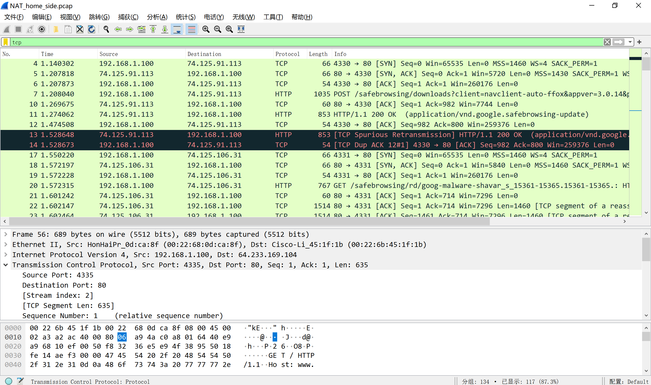
打开NAT_ISP_side
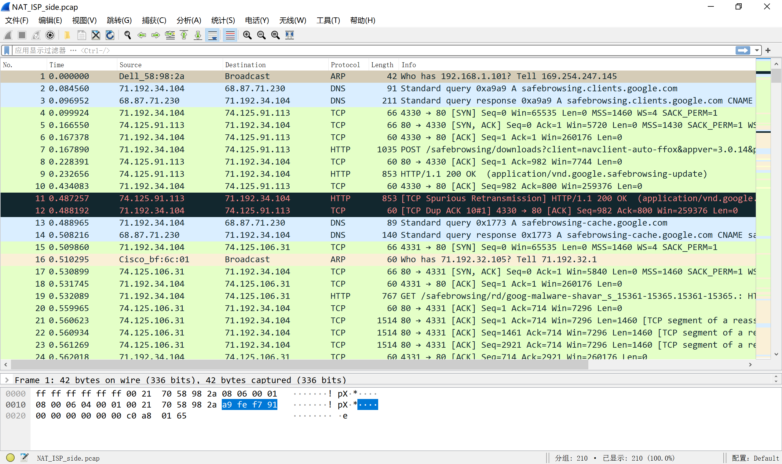

- What is the IP address of the client?
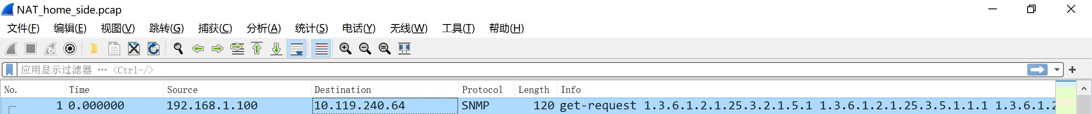
192.168.1.100
- The client actually communicates with several different Google serversin order to implement “safe browsing.” (See extra credit section at the end of this lab).The main Google server that will serve up the main Google web page has IP address64.233.169.104. In order to display only those frames containing HTTP messages that are sent to/from this Google, server, enter the expression “http && ip.addr == 64.233.169.104” (without quotes) into the Filter: field in Wireshark .
- Consider now the HTTP GET sent from the client to the Google server (whose IP address isIP address64.233.169.104)at time 7.109267. What are the source and destination IP addresses and TCP source and destination ports on the IP datagram carrying this HTTP GET?
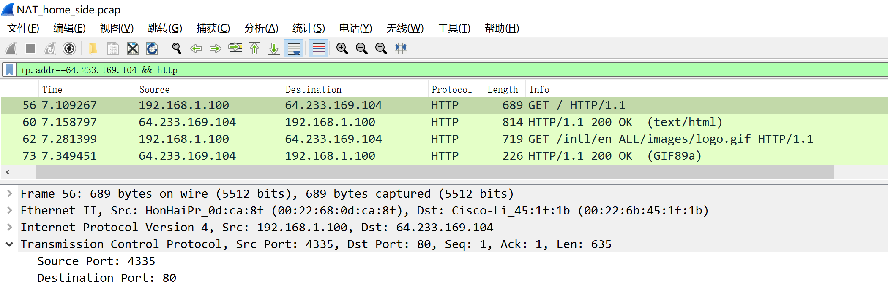
Source: 192.168.0.100 port:4335
Destination: 64.233.169.104 port:80
- At what time is the corresponding 200 OK HTTP message received from the Google server? What are the source and destination IP addresses and TCP source and destination ports on the IP datagram carrying this HTTP 200 OK message?
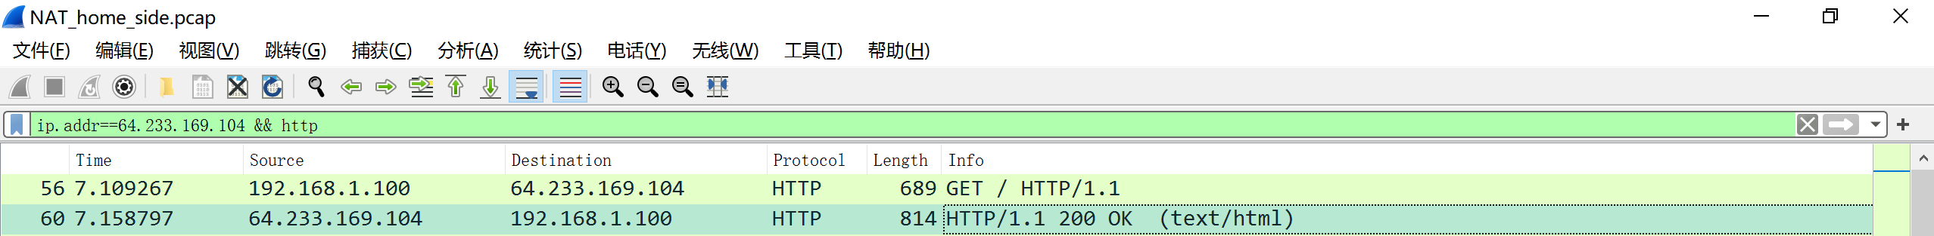
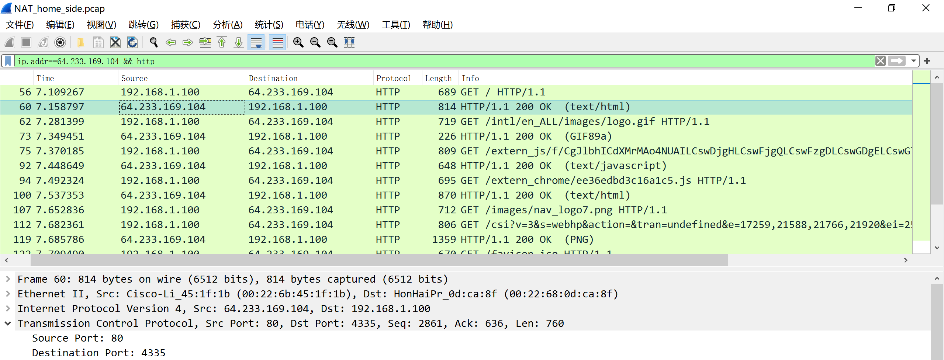
Time:7.158797
Source :64.233.169.104 port：60
Destination:192.168.0.100 port:4335

- Recall that before a GET command can be sent to an HTTP server, TCP must first set up a connection using the three-way SYN/ACK handshake. At what time is the client-to-server TCP SYN segment sent that sets up the connectionused by the GET sent at time 7.109267? What are the source and destination IP addresses and source and destination ports for the TCP SYN segment? What are the source and destination IP addresses and source and destination ports of the ACK sent in response to the SYN. At what time is this ACK received at the client?(Note: to find these segments you will need to clear the Filter expression you entered above in step 2. If you enter the filter “tcp”, only TCP segments will be displayedby Wireshark).
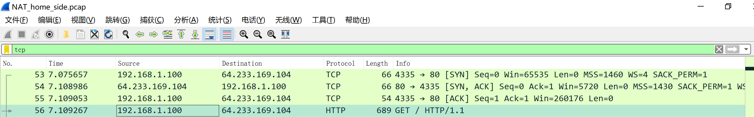

SYN: Time:7.075657 Source：192.168.0.100 port：4335
Destination：64.233.169.104 port：80
SYN,ACK: Time:7.108986 Source: 64.233.169.104 port：80
Destination：192.168.0.100 port：4335
ACK: Time:7.109053 Source：192.168.0.100 port：4335
Destination：64.233.169.104 port：80
- In the NAT_ISP_sidetrace file, find the HTTP GET message was sent from the client to the Google server at time 7.109267 (where t=7.109267 is time at which this was sent as recorded in theNAT_home_side trace file). At what time does this message appear in the NAT_ISP_sidetrace file? What are the source and destination IP addresses and TCP source and destination ports on the IP datagram carrying this HTTP GET (as recording in the NAT_ISP_sidetrace file)? Which of these fields are the same, and which are different,than in your answer to question 3 above?
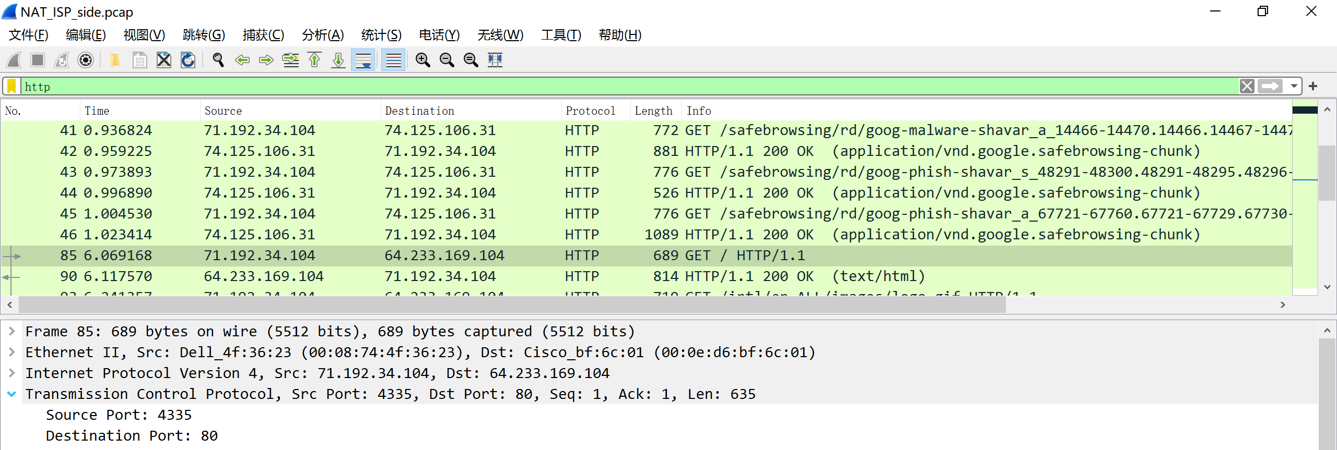

Time：6.069168 Source：71.192.34.104 port：4335
Destination：64.233.169.104 port：80
source端口不同

- Are any fields in the HTTP GET message changed? Which of the following fields in the IP datagram carrying the HTTP GET are changed: Version, Header Length, Flags, Checksum. If any of these fields have changed, give a reason (in one sentence) stating why this field needed to change.
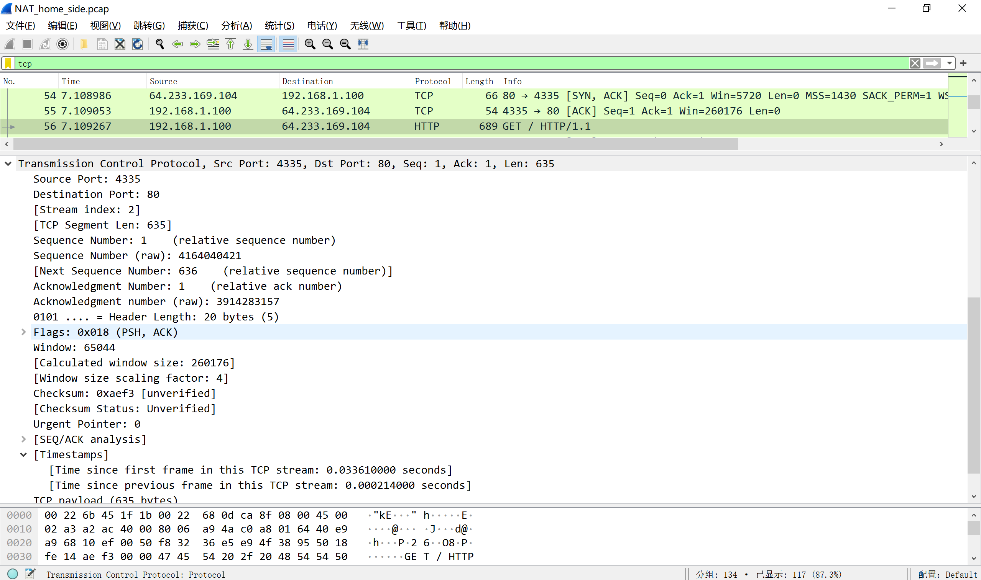
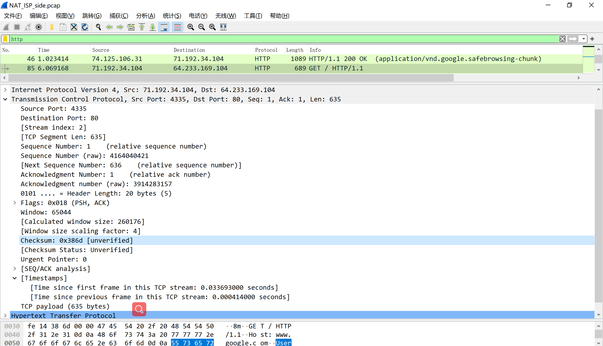
Header length都为20 bytes
Flags都为0x018
Checksum为0xaef3和0x386d发生了改变
改变的原因是NAT路由会重新计算校验和并将自己的地址为源重新发送
- In the NAT_ISP_sidetrace file, at what time is the first 200 OK HTTP message received from the Google server? What are the source and destination IP addresses and TCP source and destination ports on the IP datagram carrying this HTTP 200 OK message? Which of these fields are the same, and which are different than your answer to question 4 above?
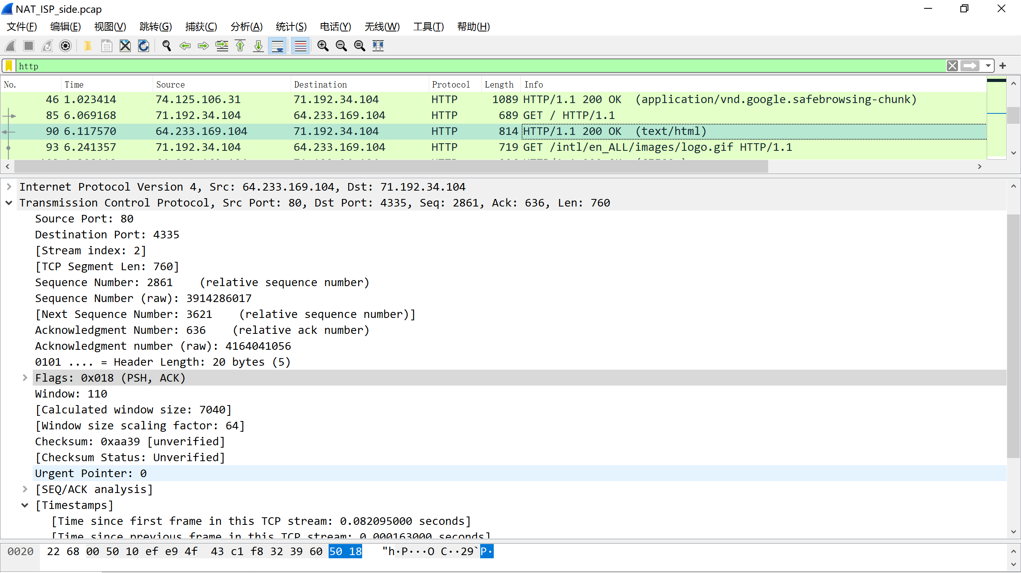
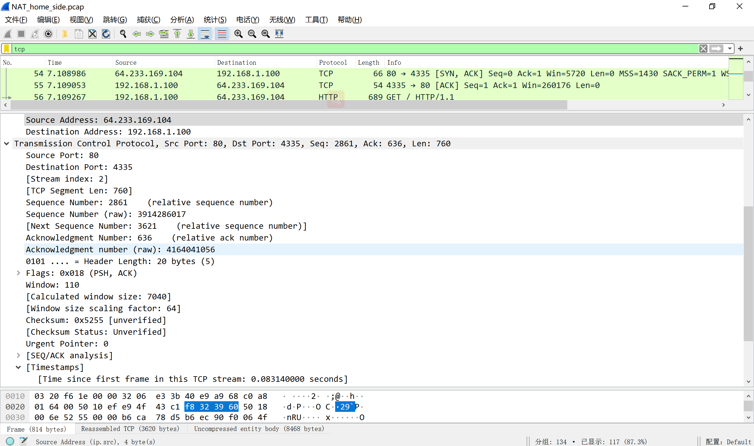
Time：117570 source：64.233.169.104 port:80
Destination:71.192.34.104 port:4335
不同的部分与上一题一致
- In the NAT_ISP_sidetracefile, at what time were the client-to-server TCP SYN segment and the server-to-client TCP ACK segment corresponding to the segments in question 5 above captured?What are the source and destination IP addresses and source and destination ports for these two segments?Which of these fields are the same, and which are different than your answer to question 5 above?
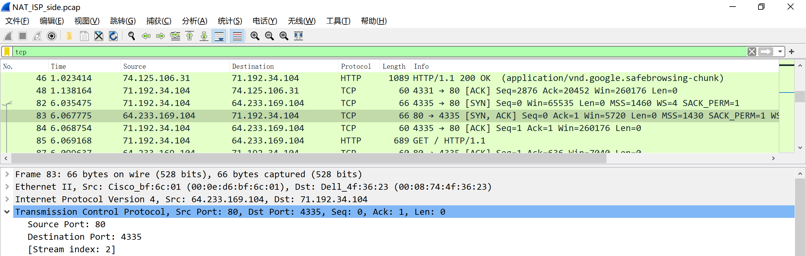
SYN: Time:6.035475 Source：71.192.34.104 port：4335
Destination：64.233.169.104 port：80
SYN,ACK: Time:6.067775 Source: 64.233.169.104 port：80
Destination：71.192.34.104 port：4335
ACK: Time:6.068754 Source：71.192.34.104 port：4335
Destination：64.233.169.104 port：80
不同处与前两题一致
10. Using your answers to 1-8 above, fill in the NAT translation table entries for HTTP connection considered in questions 1-8 above

 |  | Home | ISP
Recive | Source | 64.233.169.104：80 | 71.192.34.104：4335
Recive | Destination | 192.168.0.100：4335 | 64.233.169.104：80
Send | Source | 192.168.0.100：4335 | 64.233.169.104：80
Send | Destination | 64.233.169.104：80 | 71.192.34.104：4335
NAT:192.168.0.100：4335 → 71.192.34.103：4335
11. The trace files investigated above have additional connections to Google servers above and beyond the HTTP GET, 200OK request/response studied above. For example, in the NAT_home_side trace file, consider the client-to-server GET at time 1.572315, and the GET at time 7.573305. Research the use of these two HTTP messages and write a half page explanation of the purpose of each of these messages.
观察报文中含有safebrowing字样，为谷歌提供的对于不安全网站的安全访问机制，相关github：https://github.com/google/safebrowsing

三、总结及心得体会
通过本次的wireshark抓包实验，我对于NAT路由有了进一步的理解，通过对比实例文件与自己的抓包文件，对NAT路由有了更全面、普遍的了解，能够分析每一条报文的具体意义，并结合对应的上下文对整个传输过程进行分析。通过回答问题，也了解了一些相关的重要概念，以及他们的具体应用。
四、对本实验过程及方法、手段的改进建议
除了分析已有文件外，可以增设在学生自己电脑上完成的抓包文件与分析任务，让学生迁移应用这一部分知识。

