**Hypothesis:**

Countries that are difficult to do business usually consist of countries with low GDP levels.

**Variables:**

Dataset: wbdata

Target Variable: Doing business score, higher best

Explanatory Variable: GDPPC

Causality Control Variable. Education level, higher best

**Regression Table**

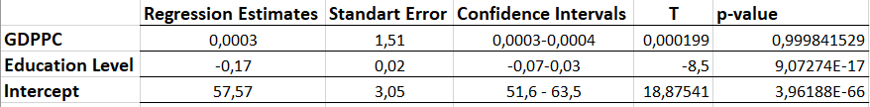

**Result:**

I look at GDPPC effects on doing business score while controlling education level. Since P value higher than 0.05 there is no relationship was found between GDPPC and doing business. So accept, null. Education level is also find out the causality.