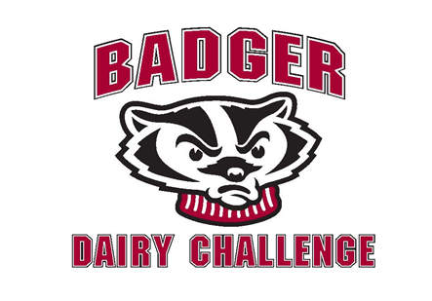

|  |
| --- |
| **2015 BADGER DAIRY CHALLENGE**  **“Minnesota/Wisconsin”**  ***October 23 & 24, 2015***  **RULES, REGULATIONS and SCHEDULE** |

**MISSION**

To allow students a hands-on opportunity to apply their dairy management skills in an applied practical setting. Give students a networking opportunity with each other and with industry professionals, enhancing career development and overall educational experience.

**ENTRIES**

**An entry and skill assessment form must be completed and emailed to Ted Halbach, the contest superintendent, at** [**tjhalbach@wisc.edu**](mailto:tjhalbach@wisc.edu) **on or before Thursday, October 15, 2015.**

**MEALS**

The participants will be provided snacks and refreshments during the farm visit on October 23th. There will be a mixer and pizza party following the farm visits. On October 24th, a dinner and awards program will follow the final presentations.

**CONTEST WAIVER**

Each contestant will be required to sign a liability waiver and turn it in alongside their registration.

**TEAMS**

The **Legends Division** will be made up of students with senior standing or any students who have successfully completed an introductory dairy management course at one of the participating universities. The **Leaders Division** is open for undergraduate students who are currently enrolled in an introductory dairy science course. In order to be eligible to participate in the Badger Dairy Challenge, a student must be a full-time undergraduate student. All students will be placed by contest management on aggregate teams of four to six members. Students from the two schools will be assigned to a team with the use of a student skills’ assessment.

**JUDGING SYSTEM**

A panel of five judges will hear all presentations in a division. There will be two sets of judges; one for each division. The judging panel will contain five individuals who have extensive dairy knowledge in the fields of production, nutrition, reproduction, genetics, housing, finance, nutrient management, milking procedures and on farm consulting.

The judging panel will follow the Dairy Challenge scorecard to arrive at the final rankings. The judging panel will provide oral feedback for each team after the conclusion of their presentation. However, final ratings are decided at the end of the contest.

**METHOD OF CONDUCT OF THE CONTEST**

**GENERAL RULES**

Each team will work independently. On Friday evening and Saturday morning a staffed resource room will be available. Students in the Leaders Division may receive guidance from the staff. In the Legends Division there should be no aid from instructors or other individuals not on their team. No cell phones will be allowed during the farm visits out of respect for the hosts. Contestants are permitted to access the Internet to obtain resources to aid in preparation of their presentations.

**COMPUTERS**

Personal computers will be used during the competition. Software and herd information will be made available on a website, hereinafter referred to as ContestLearn@UW, by noon on October 22. For UW-Madison students, laptop computers are available for use from the CALS Computer Lab.

**MATERIALS AND DATA**

Each division will analyze separate farms. For the farm visit, the teams will be allowed to bring a digital camera, calculator, measuring tape, watch and pens. Contest notepads will be provided. No other equipment will be allowed. The ContestLearn@UW website will contain DairyComp 305 and Bovisync dairy management programs. Each team will also receive the necessary data to analyze the results of operations and their herd management practices. This data may be provided in print or electronic form, using standard industry formats. The data will be the real on-farm data, or when not available from the farm, will be simulated data provided by contest management.

The data shall consist of farm goals, financial statistics, standard operating procedures, cost details or estimates, ration formulations for all feeding groups, Penn State particle separator analysis of feed, feed inventories, housing dimensions and characteristics, manure or nutrient management, milking procedures and equipment specifications, reproductive data, ancestry identification if available, production records, and herd summaries with a history of production characteristics for the last 2-3 years.

**STRUCTURE OF VISITS**

Each division will analyze separate farms. By analyzing the data provided at the start of the contest, each team will have already prioritized the farm areas needing a detailed examination. The farm visit will consist of 150 minutes. In the Legends Division, each team must decide how to allocate their members and time to cover all areas of the farm. In the Leaders Division, team members will rotate in a timed sequence to each area of the farm. A member of the officials’ team will be in each area to mentor students and answer questions. Students in both divisions are not allowed to ask employees any questions while on the visit, as employees can give different answers to different team members or misleading answers. Students will be allowed to examine most areas of the dairy but for bio-security reasons may not have access to all areas. In the last 60 minutes of the farm visit, each team will be given a 10 minute period to ask questions to the herd owner/manager. Questions can pertain to the herd goals, student observations, and information in the data set provided.

**TIME MANAGEMENT**

One of the objectives of the contest is to mirror what happens to consultants in the real world of on-farm consulting. Therefore, strict time allocations are followed, which are similar to what consultants would be given by a real farm manager. Time management and prioritization of questions are very important throughout the contest.

Each team must deposit their final presentation into the ContestLearn@UW dropbox by 11:45 AM on Saturday, October 24.

**PRESENTATIONS**

Each team will be asked to provide a presentation to a panel of five judges that recommends improvements to the operation of the dairy and/or its finances. Only presentations submitted in the ContestLearn@UW dropbox can be accessed.

The contest management will make photocopies of the presentations for the judges’ panels and load the presentations on computer projectors in presentation order for each team. Dress code for the presentations is professional. The gentlemen are expected to wear shirt, tie, dress pants, and dress shoes. The ladies are expected to wear a professional equivalent. No hats, sweatshirts, or jeans. Dress as if going to an interview.

Each team will be assigned to an afternoon presentation session. Presentation order of the 7 teams will be by random draw. Each team will follow in order at approximately 45 minute intervals until all teams have given their presentations.

The presentations should be designed as if the team was making a presentation to the farm owner or manager. It is not necessary to describe the farm to the person who owns the farm as an introduction. Begin discussing benchmarks or important outcomes of your evaluation as soon as possible.

EACH TEAM SHOULD USE ACTUAL STUDENT NAMES, and should provide a team photo in their presentation slides.

Each team will be allowed 20 minutes for their presentation with notices from a timer when 5 minutes and 2 minutes are left in their 20 minute time limit. Time limits are strictly enforced and teams will be stopped even if the presentation is not complete. An additional 10 minutes will follow for questions from the judges’ panel. After the Q & A period, the judges will provide 10 minutes of feedback. A five minute transition time is allotted between group presentations. All four of the team members must speak during some part of the presentation and during the question session. Teams may briefly confer on a question or may choose not to, as each team member should have a specialty area in questioning that they are responsible for.

Every team will have to formulate their presentations in PowerPoint. The contest will provide a laser pointer, projector, and computer. No spectators will be allowed to enter or leave a room until the entire presentation is complete. Students can view presentations AFTER they have given theirs.

After every presentation the judges’ panel will privately rate each team against the scorecard. After all presentations are complete, a final ranking will be given for each team. A summary of the judges’ evaluation for each farm visit will also be provided. Teams will receive these materials at the awards ceremony.

**BIO-SECURITY**

All contest members are required to wear plastic boots (provided) for each farm visit and should be wearing clean, protective clothing. Contestants should dress appropriately for the weather. Keep in mind that the host farms are freestall operations.

**AWARDS**

Teams will be ranked in each division as either “Gold”, “Silver” or “Bronze” with each “Gold” team member receiving a gift certificate of $50 for their respective university’s bookstore.

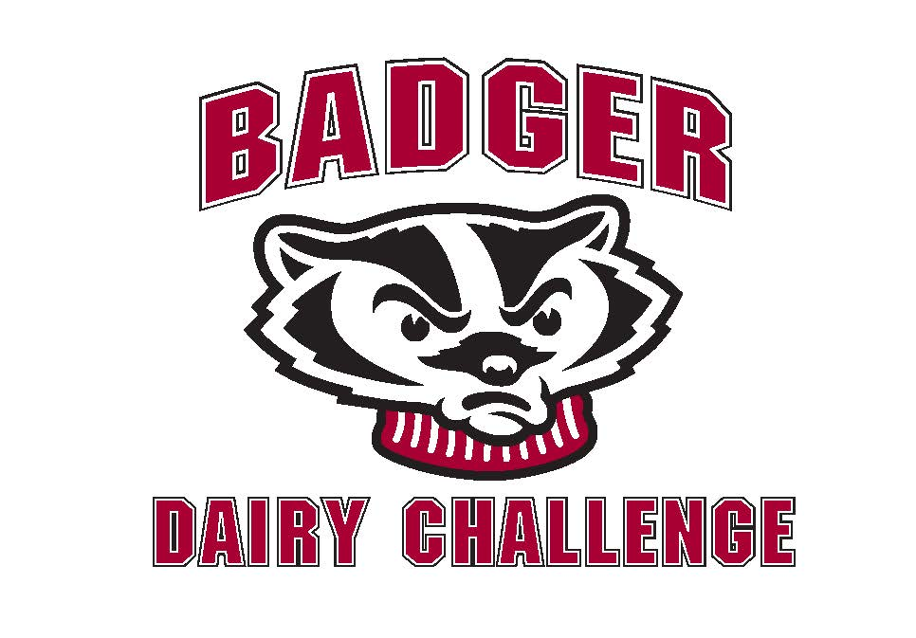

*Friday, October 23*

**Farm Visits**

Location: Leave from the Dairy Cattle Center promptly at 1:00 PM

* Students arrive at dairies at 1:45PM
* Students depart dairies at 4:15PM
* Students arrive back to campus at 5:00PM
* Pizza Dinner at 5:30 PM
* Resource room open from 6:00PM to 9:00PM – Animal Sciences 204 for work on presentations
* Student mixer at 9:30PM

*Saturday, October 24*

Resource room open from 9:00AM to noon – Animal Sciences 204 for work on presentations

**Presentation Schedule**

* Legends division presentations in Animal Sciences 236 (Please arrive no later than 10 minutes before your scheduled time.)
* Leaders division presentations in Animal Sciences 274 (Please arrive no later than 10 minutes before your scheduled time.)

|  |  |
| --- | --- |
| 12:00-12:50PM |  |
| 12:55-1:45PM |  |
| Judges Break |  |
| 2:00-2:50PM |  |
| 2:55 - 3:45PM |  |
| Judges Break |  |
| 4:00 - 4:50PM |  |
| 5:30 – 6:30PM | Awards Dinner and Judges Evaluations |