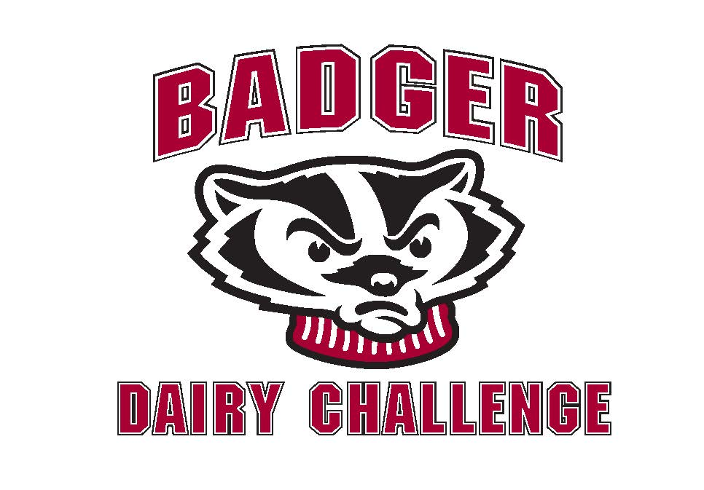

**2013 Badger Dairy Challenge: University of Wisconsin-Madison**

First Name Last Name

Year in School

Major

E-mail

Phone

What division are you in? Please circle one.

Leaders Legends

Team Name**

Team Members**

Do you have any food allergies or food restrictions? Please circle one.

Yes No

If so, please list below.

* **A maximum of seven teams can participate in either of the contest’s two divisions.** The **Legends Division** will be made up of students with senior standing or any students who have successfully completed Dairy Science 433, Dairy Herd Management. The **Leaders Division** is open for all other undergraduates or second year Farm and Industry Short Course students. In order to be eligible to participate in the Badger Dairy Challenge, a student must be a full-time undergraduate student or in their second year of Farm and Industry Short Course. Teams will consist of four members. Students can select the members of their team, or if a student does not have a team preference, the contest coordinator can randomly place the student. The Dairy Challenge staff reserves the right to compose teams of five if the limit of participants is exceeded in either division.

**If you need to be placed on a team, please indicate here with the word “placement.”

Entry due date: Wednesday, November 13 at noon. Send or leave entries at the Dairy Science office, 266 Animal Sciences.