public class NewJFrame extends javax.swing.JFrame {

public NewJFrame() {

initComponents();

}

@SuppressWarnings("unchecked")

// <editor-fold defaultstate="collapsed" desc="Generated Code">

private void initComponents() {

buttonGroup1 = new javax.swing.ButtonGroup();

a = new javax.swing.JTextField();

b = new javax.swing.JTextField();

jButton1 = new javax.swing.JButton();

c = new javax.swing.JLabel();

jLabel1 = new javax.swing.JLabel();

panlabel = new javax.swing.JLabel();

jLabel3 = new javax.swing.JLabel();

jLabel4 = new javax.swing.JLabel();

jRadioButton1 = new javax.swing.JRadioButton();

jRadioButton2 = new javax.swing.JRadioButton();

jLabel5 = new javax.swing.JLabel();

jLabel6 = new javax.swing.JLabel();

blabel = new javax.swing.JLabel();

btxt = new javax.swing.JTextField();

pantxt = new javax.swing.JTextField();

name = new javax.swing.JTextField();

x = new javax.swing.JLabel();

y = new javax.swing.JLabel();

setDefaultCloseOperation(javax.swing.WindowConstants.EXIT_ON_CLOSE);

jButton1.setText("Calculate Tax");

jButton1.addActionListener(new java.awt.event.ActionListener() {

public void actionPerformed(java.awt.event.ActionEvent evt) {

jButton1ActionPerformed(evt);

}

});

c.setText("Click the button below!");

jLabel1.setText("NAME:");

panlabel.setText("PAN No.");

jLabel3.setText("CALCULATE TAX AMOUNT");

jLabel4.setText("Account type:");

buttonGroup1.add(jRadioButton1);

jRadioButton1.setText("Private");

jRadioButton1.addActionListener(new java.awt.event.ActionListener() {

public void actionPerformed(java.awt.event.ActionEvent evt) {

jRadioButton1ActionPerformed(evt);

}

});

buttonGroup1.add(jRadioButton2);

jRadioButton2.setText("Business");

jRadioButton2.addActionListener(new java.awt.event.ActionListener() {

public void actionPerformed(java.awt.event.ActionEvent evt) {

jRadioButton2ActionPerformed(evt);

}

});

jLabel5.setText("Gross income:");

jLabel6.setText("Insurance amount:");

blabel.setText("Business id:");

btxt.addActionListener(new java.awt.event.ActionListener() {

public void actionPerformed(java.awt.event.ActionEvent evt) {

btxtActionPerformed(evt);

}

});

javax.swing.GroupLayout layout = new javax.swing.GroupLayout(getContentPane());

getContentPane().setLayout(layout);

layout.setHorizontalGroup(

layout.createParallelGroup(javax.swing.GroupLayout.Alignment.LEADING)

.addGroup(layout.createSequentialGroup()

.addGap(69, 69, 69)

.addGroup(layout.createParallelGroup(javax.swing.GroupLayout.Alignment.LEADING)

.addComponent(jLabel4)

.addComponent(jLabel1)

.addComponent(blabel)

.addComponent(panlabel)

.addComponent(jLabel5)

.addComponent(jLabel6))

.addGap(21, 21, 21)

.addGroup(layout.createParallelGroup(javax.swing.GroupLayout.Alignment.LEADING)

.addGroup(layout.createSequentialGroup()

.addComponent(y)

.addGap(0, 0, Short.MAX_VALUE))

.addGroup(layout.createSequentialGroup()

.addComponent(x)

.addContainerGap(javax.swing.GroupLayout.DEFAULT_SIZE, Short.MAX_VALUE))

.addGroup(layout.createSequentialGroup()

.addGroup(layout.createParallelGroup(javax.swing.GroupLayout.Alignment.LEADING)

.addComponent(c, javax.swing.GroupLayout.DEFAULT_SIZE, javax.swing.GroupLayout.DEFAULT_SIZE, Short.MAX_VALUE)

.addComponent(name)

.addGroup(layout.createSequentialGroup()

.addGroup(layout.createParallelGroup(javax.swing.GroupLayout.Alignment.LEADING)

.addGroup(layout.createParallelGroup(javax.swing.GroupLayout.Alignment.LEADING, false)

.addComponent(b, javax.swing.GroupLayout.DEFAULT_SIZE, 82, Short.MAX_VALUE)

.addComponent(a))

.addComponent(jButton1)

.addComponent(jLabel3)

.addGroup(layout.createSequentialGroup()

.addComponent(jRadioButton1)

.addGap(18, 18, 18)

.addComponent(jRadioButton2))

.addGroup(layout.createParallelGroup(javax.swing.GroupLayout.Alignment.TRAILING, false)

.addComponent(btxt, javax.swing.GroupLayout.Alignment.LEADING, javax.swing.GroupLayout.DEFAULT_SIZE, 82, Short.MAX_VALUE)

.addComponent(pantxt, javax.swing.GroupLayout.Alignment.LEADING)))

.addGap(0, 16, Short.MAX_VALUE)))

.addGap(118, 118, 118))))

);

layout.setVerticalGroup(

layout.createParallelGroup(javax.swing.GroupLayout.Alignment.LEADING)

.addGroup(layout.createSequentialGroup()

.addContainerGap()

.addComponent(jLabel3)

.addGap(42, 42, 42)

.addGroup(layout.createParallelGroup(javax.swing.GroupLayout.Alignment.BASELINE)

.addComponent(jLabel1)

.addComponent(name, javax.swing.GroupLayout.PREFERRED_SIZE, javax.swing.GroupLayout.DEFAULT_SIZE, javax.swing.GroupLayout.PREFERRED_SIZE))

.addGap(18, 18, 18)

.addGroup(layout.createParallelGroup(javax.swing.GroupLayout.Alignment.BASELINE)

.addComponent(jLabel4)

.addComponent(jRadioButton1)

.addComponent(jRadioButton2))

.addGap(6, 6, 6)

.addGroup(layout.createParallelGroup(javax.swing.GroupLayout.Alignment.BASELINE)

.addComponent(blabel)

.addComponent(btxt, javax.swing.GroupLayout.PREFERRED_SIZE, javax.swing.GroupLayout.DEFAULT_SIZE, javax.swing.GroupLayout.PREFERRED_SIZE))

.addPreferredGap(javax.swing.LayoutStyle.ComponentPlacement.UNRELATED)

.addGroup(layout.createParallelGroup(javax.swing.GroupLayout.Alignment.BASELINE)

.addComponent(panlabel)

.addComponent(pantxt, javax.swing.GroupLayout.PREFERRED_SIZE, javax.swing.GroupLayout.DEFAULT_SIZE, javax.swing.GroupLayout.PREFERRED_SIZE))

.addPreferredGap(javax.swing.LayoutStyle.ComponentPlacement.RELATED, 30, Short.MAX_VALUE)

.addGroup(layout.createParallelGroup(javax.swing.GroupLayout.Alignment.BASELINE)

.addComponent(a, javax.swing.GroupLayout.PREFERRED_SIZE, javax.swing.GroupLayout.DEFAULT_SIZE, javax.swing.GroupLayout.PREFERRED_SIZE)

.addComponent(jLabel5))

.addPreferredGap(javax.swing.LayoutStyle.ComponentPlacement.UNRELATED)

.addGroup(layout.createParallelGroup(javax.swing.GroupLayout.Alignment.BASELINE)

.addComponent(b, javax.swing.GroupLayout.PREFERRED_SIZE, javax.swing.GroupLayout.DEFAULT_SIZE, javax.swing.GroupLayout.PREFERRED_SIZE)

.addComponent(jLabel6))

.addPreferredGap(javax.swing.LayoutStyle.ComponentPlacement.UNRELATED)

.addComponent(x)

.addGap(12, 12, 12)

.addComponent(y)

.addGap(22, 22, 22)

.addComponent(c)

.addPreferredGap(javax.swing.LayoutStyle.ComponentPlacement.RELATED)

.addComponent(jButton1))

);

pack();

}// </editor-fold>

private void jButton1ActionPerformed(java.awt.event.ActionEvent evt) {

// TODO add your handling code here:

int d=Integer.parseInt(a.getText());

int e=Integer.parseInt(b.getText());

int f=(d-e)*9;

int g=f/100;

x.setText("Hello,"+ name.getText());

y.setText("For your Private account ");

c.setText("your tax due amount is Rs."+g+"");

}

private void jRadioButton1ActionPerformed(java.awt.event.ActionEvent evt) {

// TODO add your handling code here:

blabel.setVisible(false);

btxt.setEnabled(false);

}

private void btxtActionPerformed(java.awt.event.ActionEvent evt) {

// TODO add your handling code here:

}

private void jRadioButton2ActionPerformed(java.awt.event.ActionEvent evt) {

// TODO add your handling code here:

panlabel.setVisible(false);

pantxt.setEnabled(false);

}

/**

* @param args the command line arguments

*/

public static void main(String args[]) {

/* Set the Nimbus look and feel */

//<editor-fold defaultstate="collapsed" desc=" Look and feel setting code (optional) ">

/* If Nimbus (introduced in Java SE 6) is not available, stay with the default look and feel.

* For details see http://download.oracle.com/javase/tutorial/uiswing/lookandfeel/plaf.html

*/

try {

for (javax.swing.UIManager.LookAndFeelInfo info : javax.swing.UIManager.getInstalledLookAndFeels()) {

if ("Nimbus".equals(info.getName())) {

javax.swing.UIManager.setLookAndFeel(info.getClassName());

break;

}

}

} catch (ClassNotFoundException ex) {

java.util.logging.Logger.getLogger(NewJFrame.class.getName()).log(java.util.logging.Level.SEVERE, null, ex);

} catch (InstantiationException ex) {

java.util.logging.Logger.getLogger(NewJFrame.class.getName()).log(java.util.logging.Level.SEVERE, null, ex);

} catch (IllegalAccessException ex) {

java.util.logging.Logger.getLogger(NewJFrame.class.getName()).log(java.util.logging.Level.SEVERE, null, ex);

} catch (javax.swing.UnsupportedLookAndFeelException ex) {

java.util.logging.Logger.getLogger(NewJFrame.class.getName()).log(java.util.logging.Level.SEVERE, null, ex);

}

//</editor-fold>

/* Create and display the form */

java.awt.EventQueue.invokeLater(new Runnable() {

public void run() {

new NewJFrame().setVisible(true);

}

});

}

// Variables declaration - do not modify

private javax.swing.JTextField a;

private javax.swing.JTextField b;

private javax.swing.JLabel blabel;

private javax.swing.JTextField btxt;

private javax.swing.ButtonGroup buttonGroup1;

private javax.swing.JLabel c;

private javax.swing.JButton jButton1;

private javax.swing.JLabel jLabel1;

private javax.swing.JLabel jLabel3;

private javax.swing.JLabel jLabel4;

private javax.swing.JLabel jLabel5;

private javax.swing.JLabel jLabel6;

private javax.swing.JRadioButton jRadioButton1;

private javax.swing.JRadioButton jRadioButton2;

private javax.swing.JTextField name;

private javax.swing.JLabel panlabel;

private javax.swing.JTextField pantxt;

private javax.swing.JLabel x;

private javax.swing.JLabel y;

// End of variables declaration

}

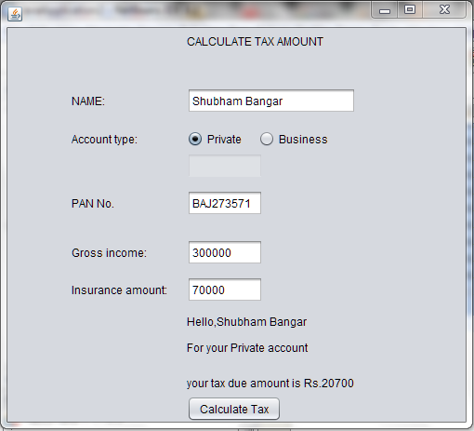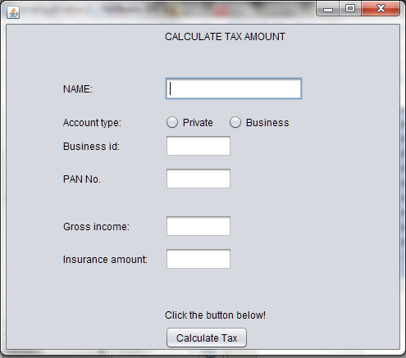

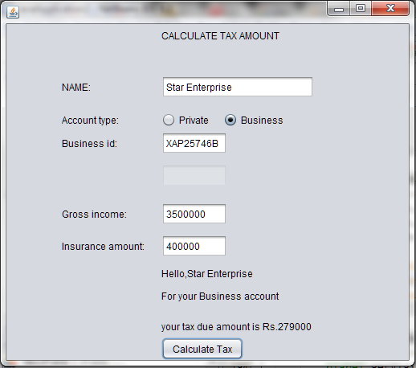

TAXT CALCULATION MODULE