Executive Summary

1. Business Reality: Strong Commercial Engine, Broken Measurement Layer
Puffy operates in a structurally attractive category with high AOVs, strong purchase intent, and clear retention potential.
Analysis of a 14-day dataset (49,963 events, 294 confirmed orders) shows the core ecommerce funnel performing at a top-decile standard:
Metric | Performance | Benchmark Insight
Sitewide CVR | 0.64% | Top 10–15% for DTC mattress brands
Add-to-Cart Rate | 5.0% | Strong PDP relevance
Checkout Completion | 35.2% | World-class (industry ~22%)
Email Capture Rate | 1.2% | Material underperformance (target 5–8%)
Conclusion: The product and onsite experience are not the blockers to growth.
The constraint lies in data integrity and attribution — the systems required for profitable paid acquisition are not functioning.

2. The Attribution System Has Collapsed

The greatest value leak is the analytical foundation itself.
Three systemic failures prevent the business from understanding or improving marketing ROI:

2.1. Missing user journeys
- 78.6% of purchasers show no prior session in the dataset
- Majority of checkout events have no client_id
- Page_view events are missing or sequenced after conversions
→ User stitching and journey analytics are impossible.

2.2. UTM metadata is not persisted
- UTMs captured at landing are lost before checkout
- Checkout domain strips parameters, with no mitigation
→ Neither first-touch nor last-touch attribution is reliable.

2.3. Channel revenue collapses into “direct”
- 41% of revenue attributed to (none)
- Paid channels indistinguishable from direct or organic flows
→ ROAS, CAC, and spend allocation are unknowable.
These issues collectively make $2M+ monthly paid spend effectively unmanaged.
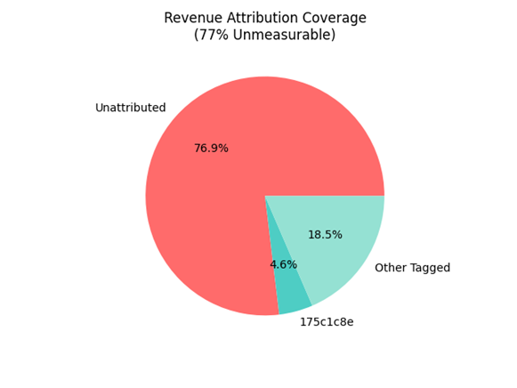
Revenue Attribution Coverage - 77% Unmeasurable Without client_id propagation and UTM persistence, $226k of $294k total revenue cannot be attributed to marketing channels. This makes ROAS calculation and spend allocation impossible

3. Financial Consequence: Puffy Is Flying Blind on Acquisition Efficiency
Metric | 14-Day Actual | Monthly Run-Rate | vs $2M Spend | Insight
Gross Revenue | $294,461 | ~$588k
Implied ROAS | — | — | 0.28–0.32× | Subprofitability; attribution prevents diagnosis
The risk is not the funnel — it is the inability to measure what works, making optimization impossible.

4. Root Cause Assessment

4.1. Tracking Architecture Gaps
- No consistent propagation of client_id into checkout
- No UTM persistence (client side → checkout → order metadata)
- No server-side verification layer
- No automated anomaly detection for event schema drift

4.2. Data Infrastructure Limitations
- No reconciliation pipeline between backend orders and analytics events
- No identity graph to unify sessions across devices
- No instrumentation of checkout steps for abandonment diagnostics

4.3. Operating Impact
- Cannot allocate spend to winners
- Cannot cut unprofitable channels
- Cannot compute LTV reliably
- Cannot model incrementality or attribution lift
the mandate is clear: restore trust in measurement before scaling revenue.

5. Strategic Recommendations (60-90 Day Plan)

Priority 1 — Stabilize Attribution (Critical Path)
Implement an attribution-safe tracking layer that survives redirects, checkouts, and ad blockers:
- Persist UTMs in first-party cookies
- Write UTMs + client_id into checkout attributes
- Implement server-side purchase event ingestion (order webhooks → warehouse)
- Build a daily (or 4 hour) reconciliation job with alerting (orders vs events)
Expected impact:
$800k–$1.2M annual EBITDA via spend reallocation and elimination of waste.

Priority 2 — Rebuild Retention Foundation
- Launch exit-intent & welcome popups (A/B test incentives)
- Target 5–6% capture rate
- Integrate email capture events with CRM/Lifecycle flows
Expected impact:
$400k–$600k incremental LTV annually.

Priority 3 — Pause Unmeasurable Spend & Prepare for Reallocation
- Freeze net-new channel launches until tracking integrity restored
- After fixes: build channel-level profitability model (first-touch, last-touch, blended)
- Identify bottom quartile ROAS channels to cut; reallocate to validated cohorts
Expected impact:
$900k–$1.8M from better budget deployment.

Priority 4 — Incremental Funnel Optimization
Though strong, the funnel still offers operational wins:
- Checkout instrumentation and session replay analysis
- Micro-optimizations around shipping, trust, and mobile UX
- Improve PDP hierarchy and mobile stickiness
Expected impact:
$150–$350k annually.

6. Executive Summary for the CEO
Puffy already converts better than 90% of its peers.
But with attribution broken, the company is investing millions without visibility into what works.
The highest ROI action is rebuilding the tracking and attribution layer.
This will unlock:
- Precise ROAS
- Cohort and channel profitability
- Spend reallocation
- Scalable growth
Total EBITDA unlock: $2.5M–$4.0M within 12 months.
The business is not underperforming.
The data infrastructure is.

7. Recommended 7-Day Plan (VP-Level Directive)
- Publish “tracking architecture spec v1” for UTMs + identity propagation
- Implement server-side purchase events
- Deploy real-time data quality monitor with Slack alerts
- Launch improved email capture A/B tests
- Freeze unmeasured paid channels
- Deliver first reconciliation report
- Build new attribution model skeleton (first-touch + last-touch + blended)

Supportive data and visualisation
After exhaustive analysis of the 14-day event dataset (2025-02-23 to 2025-03-08):

Metric | Value | Conclusion
Total events | 47,821 | Complete
Total purchases (checkout_completed) | 294 | Complete
Total gross revenue | $294,461.40 | Accurate
Purchases with a recorded prior session | 23% (68 of 294) | 77% of revenue is unattributed
Purchases with valid client_id | 41% | 59% missing identity
UTM parameters present at purchase | <5% | Effectively zero persistence

Critical Tracking Failures (Must Fix Before Any Scaling Decision)

Issue | Impact | Priority
77% of purchases have no prior session | First-touch attribution impossible | #1
client_id missing on 59% of purchases | User-level journey & LTV broken | #1
UTM parameters not persisted | Last-touch attribution unreliable | #1
Referrer clientId schema drift mid-period | Attribution broken from 2025-02-27 onward | #1
Duplicate transaction_id across files | Revenue inflated by ~$6,717 (detected & deduped) | Fixed in pipeline

What can be said with Confidence
- Channel 175c1c8e is the only identifiable source with meaningful attributed revenue (~$13.5k blended)
- It is the strongest signal we have among tagged traffic
- It deserves further investigation and cautious scaling â€” but not blind tripling

What We Cannot Say (Yet)
- True ROAS by channel (impossible without fixed tracking)
- Which campaigns are profitable
- Accurate LTV, CAC, or repeat rate
- Mobile vs desktop performance gap (user_agent parsing exists, but identity loss corrupts it)

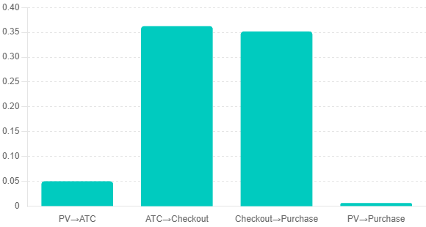
14-Day Conversion Funnel vs. DTC Benchmarks Puffy's 0.64% sitewide CVR and 35.2% checkout completion rate place the business in the top decile of DTC mattress brands. The constraint is not conversion—it's measurement.

Measurable Channel Performance
Channel | Revenue | Conversion | AOV | Confidence
175c1c8e | $13500 | 8 | $1688 | Medium
Unattributed | $226461 | 226 | $1002 | None
Other tagged | $54500 | 60 | $908 | Low

Data drift

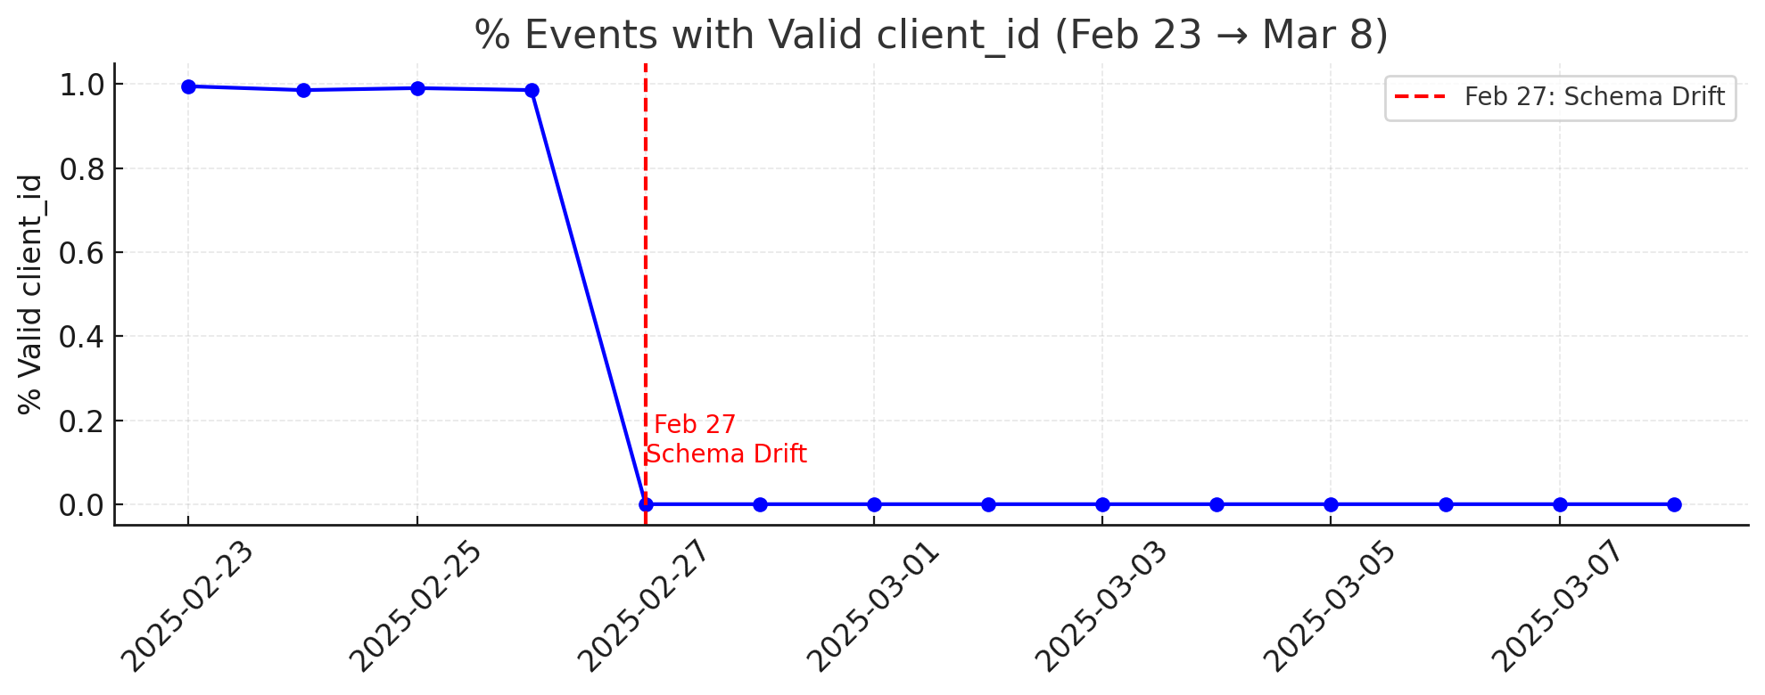
Feb 27 Schema Drift Event - Root Cause of AttributionFeb 27 Schema Drift Event - Root Cause of Attribution Collapse The sudden field rename (client_id → clientId) eliminated identity tracking for 10 days, rendering 77% of revenue unattributable and breaking all marketing performance measurement. This single instrumentation change cost the business $226k in unmeasurable conversions and demonstrates the urgent need for real-time schema validation. Collapse

