

**REPUBLIQUE DU CAMEROON**

**PAIX-Travail-Patrie**

**MINISTRE DE L’ENSEIGNEMENT SUPERIEUR**

**FACULTE D’INGINERIE**

**ET TECHGNOLOGIE**

**REPUBLIC OF CAMEROON**

**Peace-Work-Fatherland**

**MINISTER OF HIGHER EDUCATION**

**FACULTY OF ENGINEERING**

**AND TECHNOLOGY**

**CEF440: INTERNET AND MOBILE PROGRAMMING**

**DESIGN OF A FOOD**

**WASTAGE APPLICATION**

**Presented by:**

**BITO’O BI HIEGA II DYLAN FLORENT FE20A024**

**CHEZEM DONGMEZA MIGUEL FE20A026**

**DJIOTSA DJOUAKE CHRISTIAN DARYN FE20A029**

**DJOUKENG NOUGNING YANNICK IVAN FE20A030**

**MADADJO KUITCHE MONICK CYBELLE FE20A060**

**INSTRUCTOR**: **Dr. NKEMENI VALERY**

**April 2023**



**REPUBLIQUE DU CAMEROON**

**PAIX-Travail-Patrie**

**MINISTRE DE L’ENSEIGNEMENT SUPERIEUR**

**FACULTE D’INGINERIE**

**ET TECHGNOLOGIE**

**REPUBLIC OF CAMEROON**

**Peace-Work-Fatherland**

**MINISTER OF HIGHER EDUCATION**

**FACULTY OF ENGINEERING**

**AND TECHNOLOGY**

**CEF440: INTERNET AND MOBILE PROGRAMMING**

**DESIGN OF A FOOD**

**WASTAGE APPLICATION**

**Presented by:**

**BITO’O BI HIEGA II DYLAN FLORENT FE20A024**

**CHEZEM DONGMEZA MIGUEL FE20A026**

**DJIOTSA DJOUAKE CHRISTIAN DARYN FE20A029**

**DJOUKENG NOUGNING YANNICK IVAN FE20A030**

**MADADJO KUITCHE MONICK CYBELLE FE20A060**

**INSTRUCTOR**: **Dr. NKEMENI VALERY**

**April 2023**



**REPUBLIQUE DU CAMEROON**

**PAIX-Travail-Patrie**

**MINISTRE DE L’ENSEIGNEMENT SUPERIEUR**

**FACULTE D’INGINERIE**

**ET TECHGNOLOGIE**

**REPUBLIC OF CAMEROON**

**Peace-Work-Fatherland**

**MINISTER OF HIGHER EDUCATION**

**FACULTY OF ENGINEERING**

**AND TECHNOLOGY**

**CEF440: INTERNET AND MOBILE PROGRAMMING**

**DESIGN OF A FOOD**

**WASTAGE APPLICATION**

**Presented by:**

**BITO’O BI HIEGA II DYLAN FLORENT FE20A024**

**CHEZEM DONGMEZA MIGUEL FE20A026**

**DJIOTSA DJOUAKE CHRISTIAN DARYN FE20A029**

**DJOUKENG NOUGNING YANNICK IVAN FE20A030**

**MADADJO KUITCHE MONICK CYBELLE FE20A060**

**INSTRUCTOR**: **Dr. NKEMENI VALERY**

**April 2023**



**REPUBLIQUE DU CAMEROON**

**PAIX-Travail-Patrie**

**MINISTRE DE L’ENSEIGNEMENT SUPERIEUR**

**FACULTE D’INGINERIE**

**ET TECHGNOLOGIE**

**REPUBLIC OF CAMEROON**

**Peace-Work-Fatherland**

**MINISTER OF HIGHER EDUCATION**

**FACULTY OF ENGINEERING**

**AND TECHNOLOGY**

**CEF440: INTERNET AND MOBILE PROGRAMMING**

**DESIGN OF A FOOD**

**WASTAGE APPLICATION**

**Presented by:**

**BITO’O BI HIEGA II DYLAN FLORENT FE20A024**

**CHEZEM DONGMEZA MIGUEL FE20A026**

**DJIOTSA DJOUAKE CHRISTIAN DARYN FE20A029**

**DJOUKENG NOUGNING YANNICK IVAN FE20A030**

**MADADJO KUITCHE MONICK CYBELLE FE20A060**

**INSTRUCTOR**: **Dr. NKEMENI VALERY**

**April 2023**

Contents

INTRODUCTION: 6

**I.** **UNIFIED MODELING LANGUAGE MODEL (UML model)** 7

**1.** **CLASS DIAGRAM** 7

2.1. **User Log in** 8

2.2. **Discussion threads** 9

2.3. **Notifications** 10

**3.** **Sequence Diagram** 14

3.1. **User registration** 14

3.2. **User log in** 15

4. **Activity diagram** 20

II. **DATA FLOW MODEL** 21

1. **Level 0: Context Diagram** 21

**2.** **Data Flow Diagram** 22

# INTRODUCTION:

Food wastage is very imminent in our society. To solve this issue we proposed the Food Waste Management Software. After the collection and the analysis of the requirements we dive right into the **design phase.** Here we will use UML diagrams to model our software and plan its development.

1. **UNIFIED MODELING LANGUAGE MODEL (UML model)**
2. **CLASS DIAGRAM**

Class Diagram describes the static structure of the system rather than how it behaves. Below is the Class Diagram of our food management software.

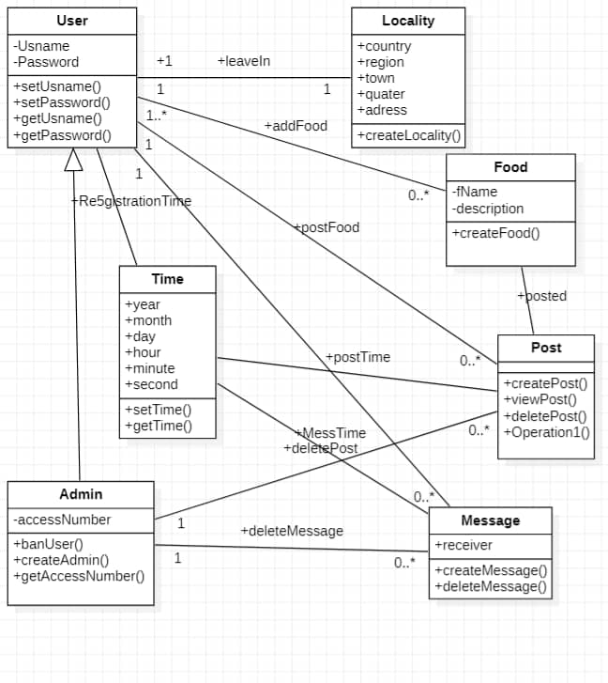

1. **USE CASE DIAGRAM**

Use Case Diagram describes the functionality of a system including users and other system. For our system, we broke the use case diagram into smaller use cases.

* 1. **User Log in**

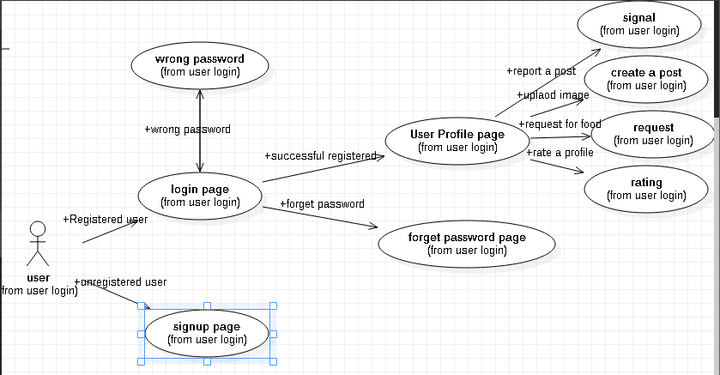

**Description:**

|  |  |
| --- | --- |
| **Purpose** | User logs in to system using existing profile. |
| **User** | A user with an existing profile. |
| **Input Data** | Profile username and password. |
| **Output Data** | Corresponding page data. |
| **Invariants** | Profile table data and user information. |
| **Pre-Conditions** | User is not logged in to a profile, input  profile exists in data base, user  password matches profile |
| **Post-conditions** | User's computer has been supplied  with appropriate cookie, page data is  appropriate for selected profile |
| **Basic Flow:** | Webpage looks up profile data and returns the matching cookie. Webpage is updated to match new user data. |
| **Alternative Flow(s):** | Invalid password, invalid username,  Or mismatched username and password redirect to error message and previous page. |
| **Business Rules:** | This allows users to log in to their profile from anywhere. |

* 1. **Discussion threads**

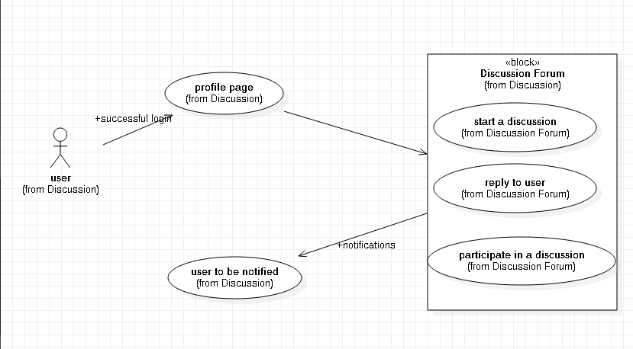

**Description:**

|  |  |
| --- | --- |
| **Purpose** | User Discuss with other users of the system, takes rendezvous with food donors and sellers, comment posts and also rate their quality of Service |
| **User** | A user that is logged into the system |
| **Input Data** | Message to be send |
| **Output Data** | Message send to targeted user or set of users |
| **Invariants** | The message sent cannot be modified but can be deleted |
| **Pre-Conditions** | User is Logged into the system |
| **Post-conditions** | The person(s) to who the message is destined to should be the only ones to be able to view its content |
| **Basic Flow:** | A user sends a message to another user on his profile page or sends a message in the main forum for all users to see or even comments a post or rate a user on the quality of service he received from a previous donation, this messages are stored on the server and send specifically to the target |

* 1. **Notifications**

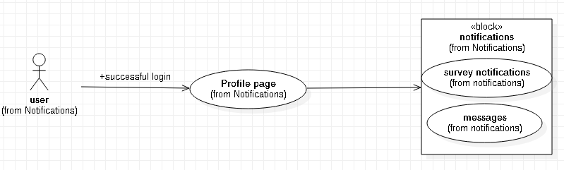

**Description:**

|  |  |
| --- | --- |
| **Purpose** | To get Notifications of posts of foods you like the most, and permanent notifications for post monitoring |
| **User** | Any User of the system |
| **Input Data** | User enable notifications from his device settings |
| **Output Data** | The Notification |
| **Invariants** | Notification Content |
| **Pre-Conditions** | User has an account in the system and have granted notification permission to the app |
| **Post-conditions** | User receives only desired notifications |
| **Basic Flow:** | User enables notifications, and receives notification anytime food is published in his town  Notifications are also send to posters for them to monitor their posts without necessarily opening the app to indicate that the food they posted is finished for example |

* 1. **Make a post**

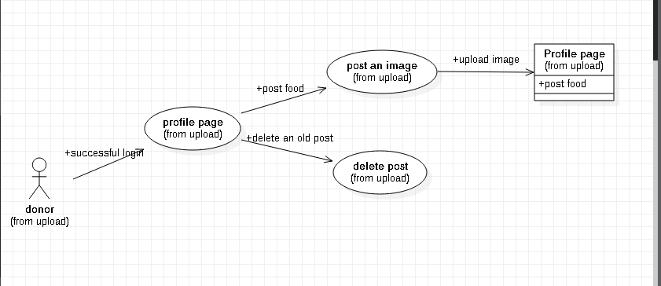

**Description:**

|  |  |
| --- | --- |
| **Purpose** | To get Notifications of posts of foods you like the most, and permanent notifications for post monitoring |
| **User** | Any User of the system |
| **Input Data** | User enable notifications from his device settings |
| **Output Data** | The Notification |
| **Invariants** | Notification Content |
| **Pre-Conditions** | User has an account in the system and have granted notification permission to the app |
| **Post-conditions** | User receives only desired notifications |
| **Basic Flow:** | User enables notifications, and receives notification anytime food is published in his town  Notifications are also send to posters for them to monitor their posts without necessarily opening the app to indicate that the food they posted is finished for example |

* 1. **Make a research**

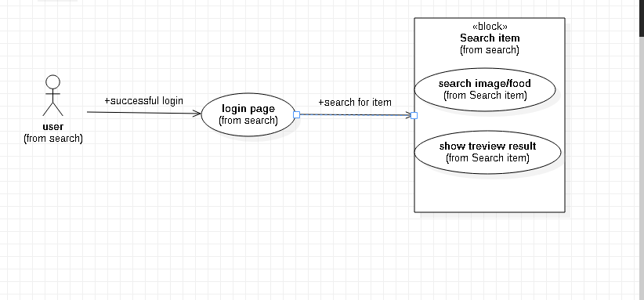

**Description:**

|  |  |
| --- | --- |
| **Purpose** | User wants to search for a particular meal |
| **User** | Any logged in user |
| **Input Data** | Name of meal, Filter by Category or Location |
| **Output Data** | All the corresponding posts |
| **Invariants** | The user and the search result |
| **Pre-Conditions** | User is Logged in |
| **Post-conditions** | Search result should be precise, explicit and usable |
| **Basic Flow:** | User logs in, Enters the name of the meal in the search box, clicks the search button and gets the search results. He can also filter the results by Category and by Location |

* 1. **Location**

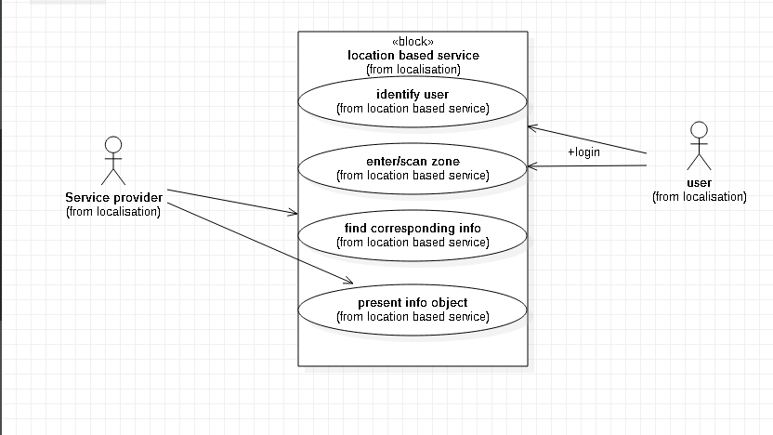

1. **Sequence Diagram**

Sequence Diagram typically shows the flow of functionality through a use case. Below are the sequence diagrams for each of our Use Case Scenarios.

* 1. **User registration**

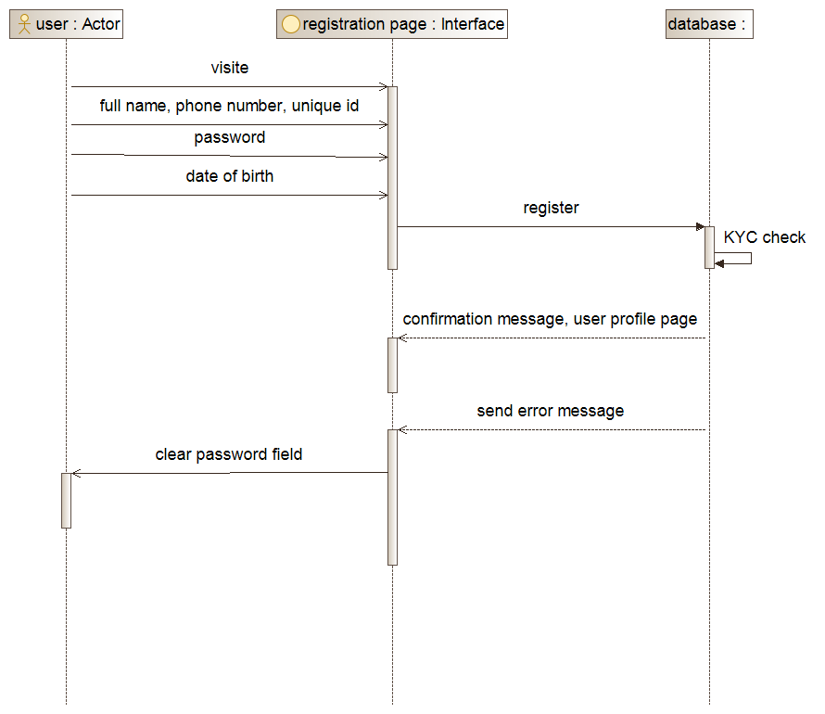

* 1. **User log in**

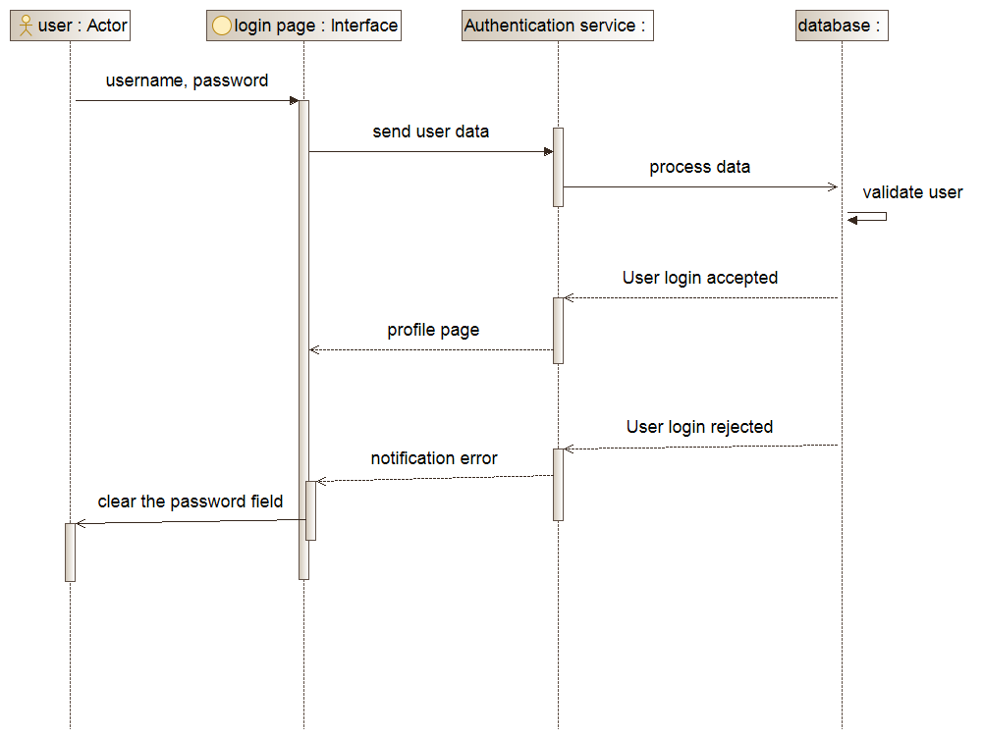

* 1. **Food posting**

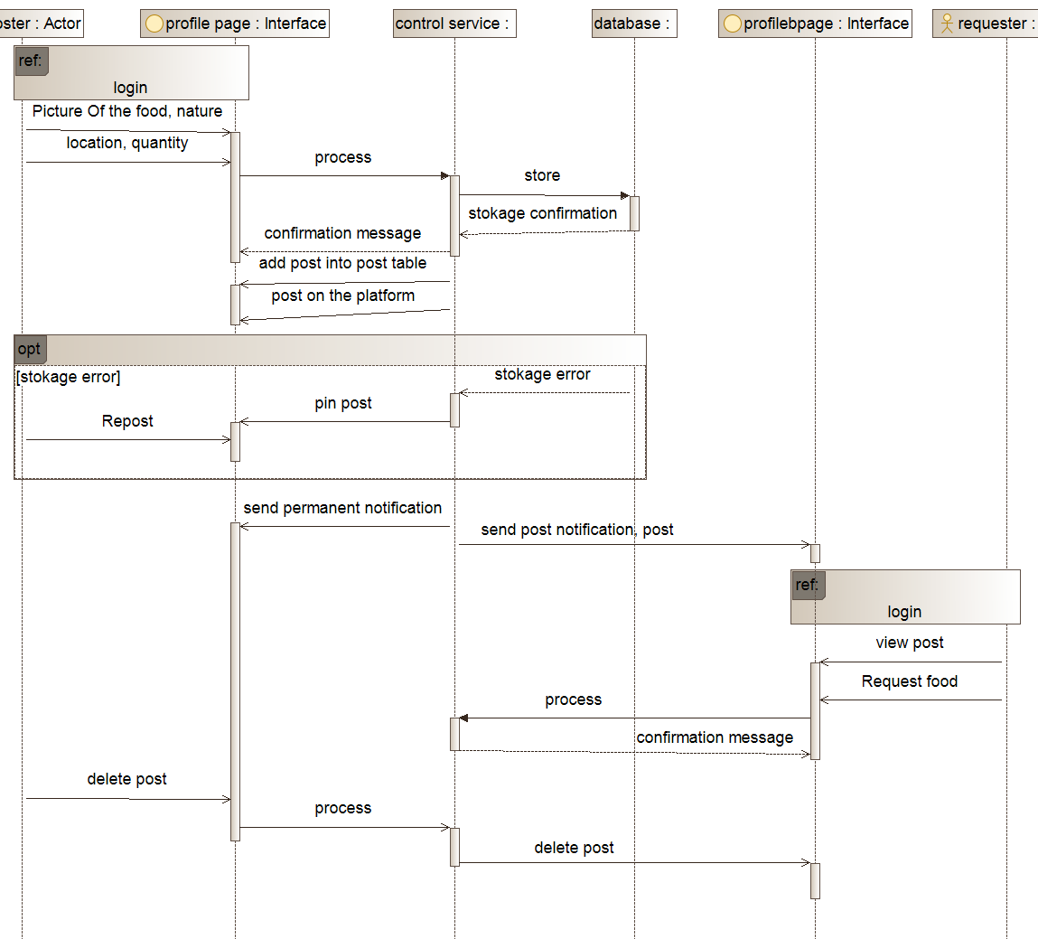

* 1. **Discussions ratings and comments**

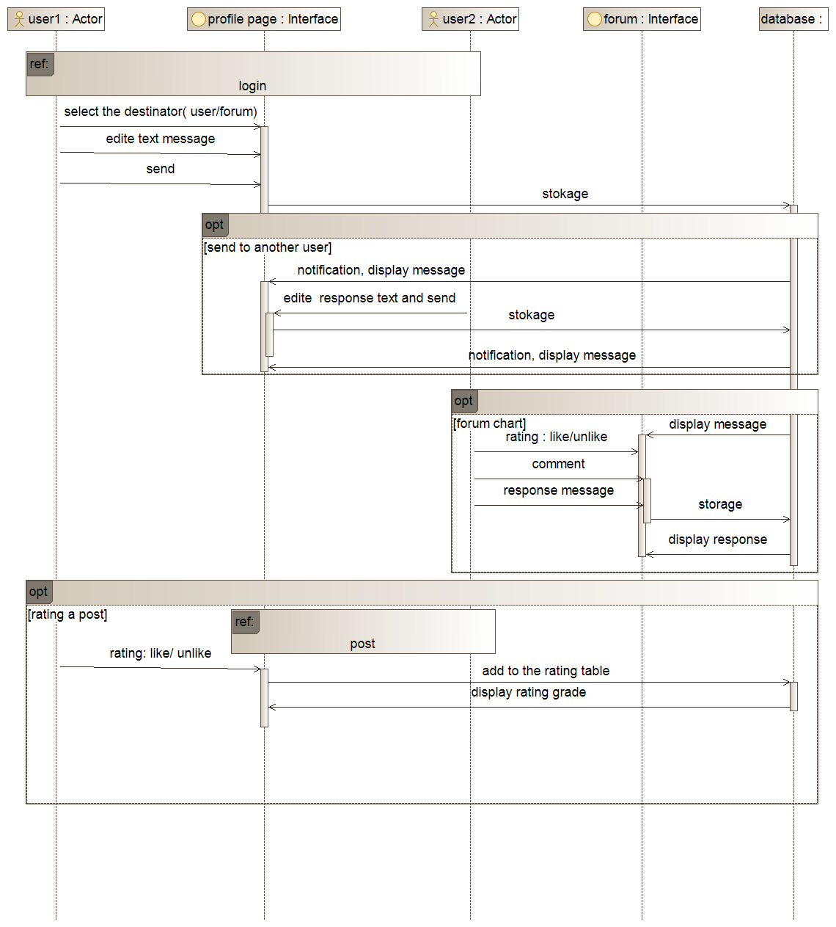

* 1. **Search**

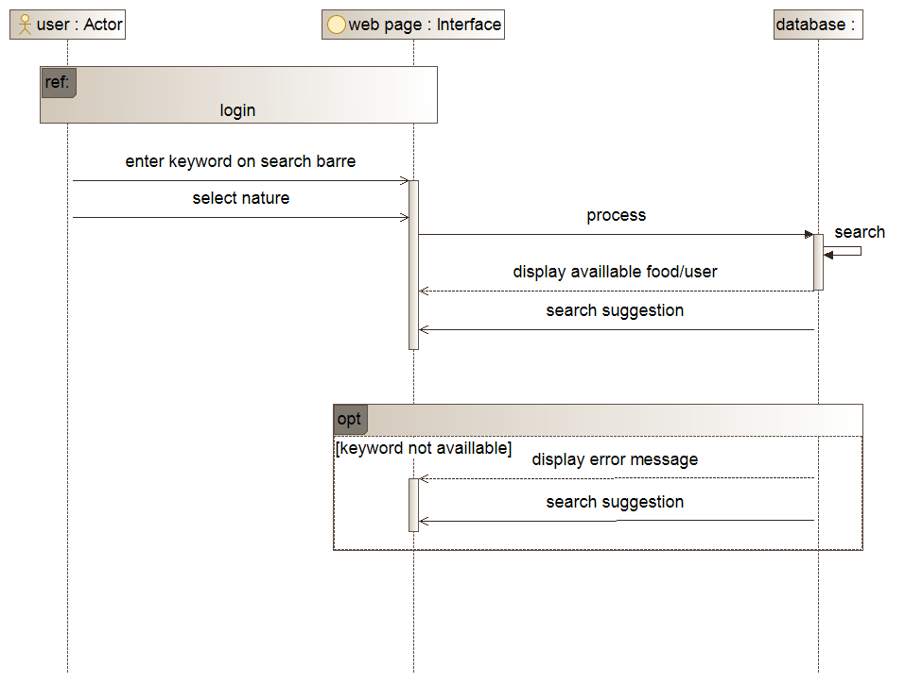

* 1. **Notifications**

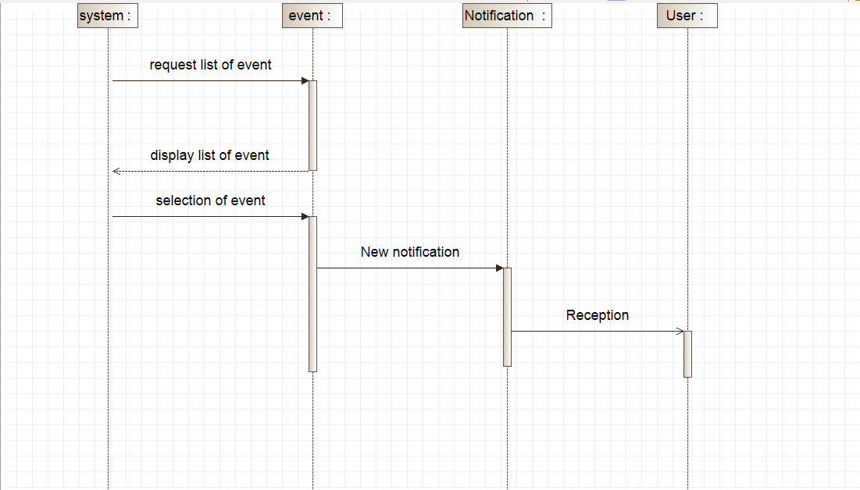

1. **Activity diagram**

Activity Diagram shows the flow from one activity to the other in a system or process.

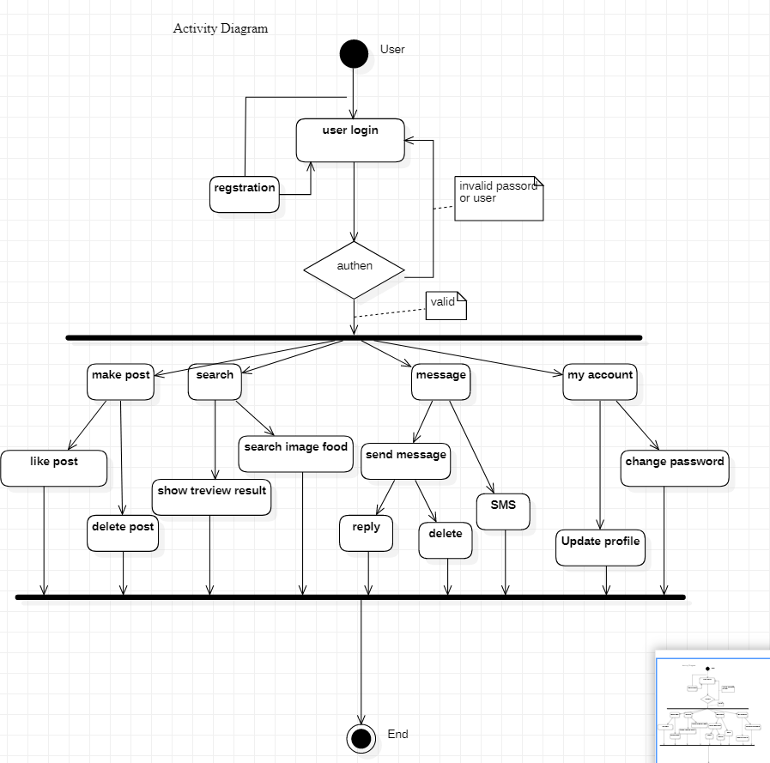

1. **DATA FLOW MODEL**

A data flow diagram shows the way information flows through a process or system. It includes data inputs and outputs, data stores, and the various sub processes the data moves through.

1. **Level 0: Context Diagram**

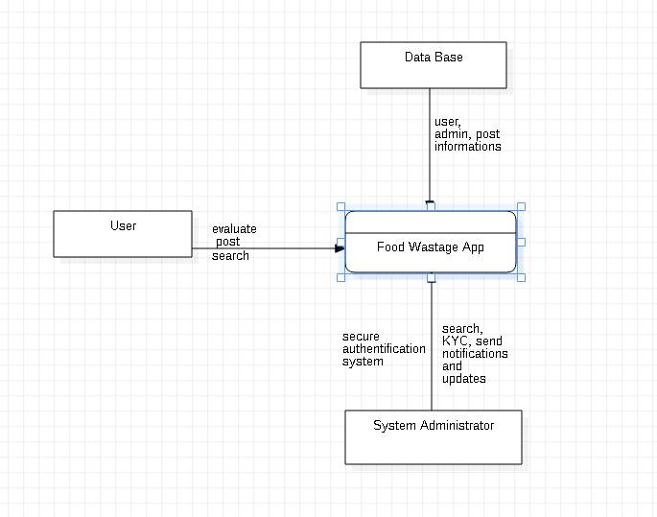

1. **Data Flow Diagram**

