**REPUBLIC OF CAMEROON**

**Peace-Work-Fatherland**

**MINISTER OF HIGHER EDUCATION**

**FACULTY OF ENGINEERING**

**AND TECHNOLOGY**



**REPUBLIQUE DU CAMEROON**

**PAIX-Travail-Patrie**

**MINISTRE DE L’ENSEIGNEMENT SUPERIEUR**

**FACULTE D’INGINERIE**

**ET TECHGNOLOGIE**

**Presented by:**

**BITO’O BI HIEGA II DYLAN FLORENT FE20A024**

**CHEZEM DONGMEZA MIGUEL FE20A026**

**DJIOTSA DJOUAKE CHRISTIAN DARYN FE20A029**

**DJOUKENG NOUGNING YANNICK IVAN FE20A030**

**MADADJO KUITCHE MONICK CYBELLE FE20A060**

**INSTRUCTOR**: **Dr. NKEMENI VALERY**

**26 MAI 2023**

**Introduction**

**UI design**, short for **User Interface design**, is the process of designing the interface through which users interact with digital products such as websites, applications, and software. The goal of UI design is to create an intuitive and visually appealing interface that enables users to accomplish their tasks as efficiently and effectively as possible. **UI designers consider factors such as *usability, accessibility*, and user experience when creating designs**. Their designs typically include elements such as buttons, menus, icons, typography, and color schemes, all of which work together to create a cohesive and user-friendly interface.

**UI Design**

For the Food Wast Management System to meet the user need, a good UI Design is required and the selection of the UI design tool as well.

Following are the different interfaces of the food wast management system designed using Adobe Xd.

1. **Sign Up**

The sign-up page offers an interface where users can join the community. The sign-up process is quick and easy, and ensure the security and privacy of every user.

The user can create an ancount in two ways, first by filling the form or using an existing acount on platform as facebook, google

or twiter.

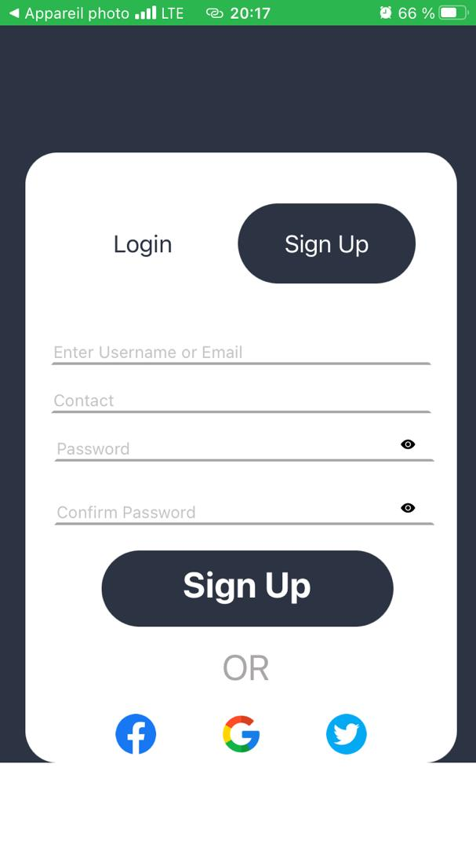

**2. Login**

To insure that only registered users can asccess the platform by entry their User name an password.

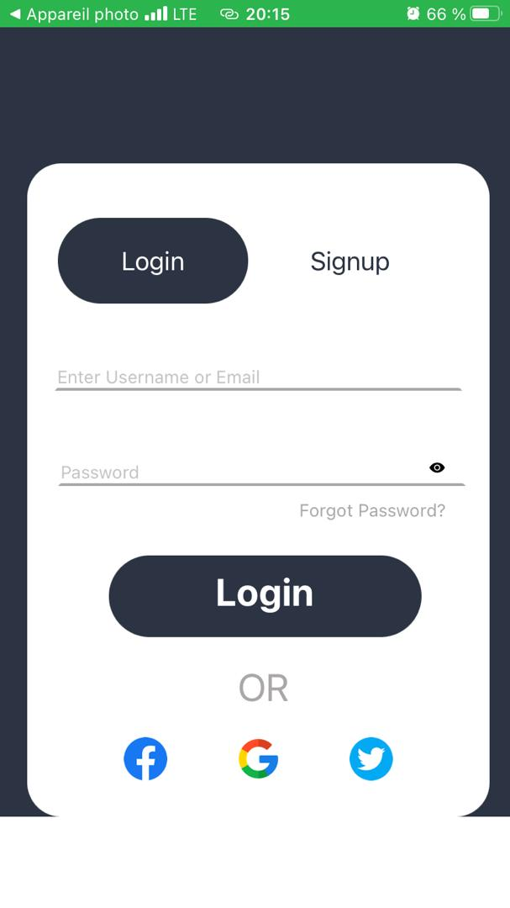

**3. Profile page**

this is page loaded after the login process where user can view post , request and post food.

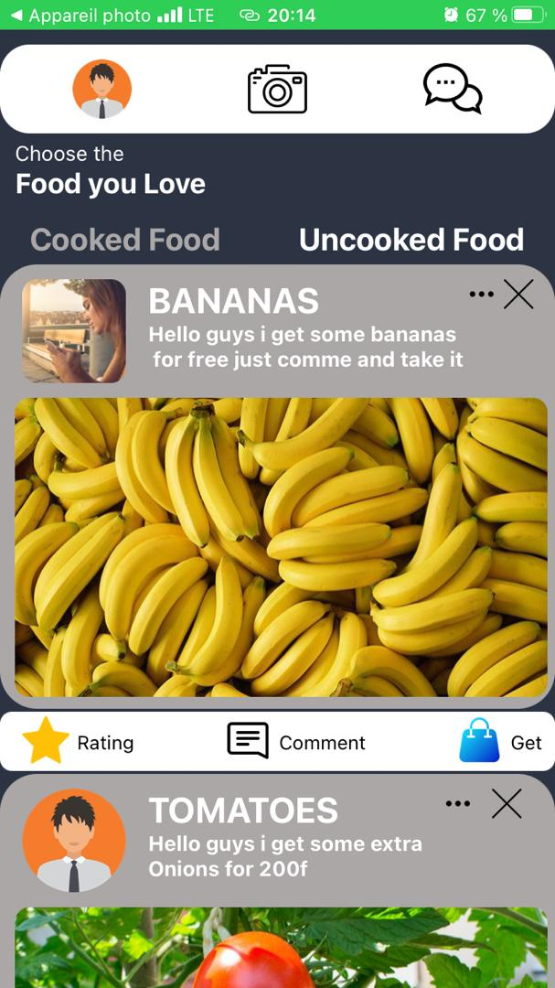

**4. Request**

Here, user can apply for food that they are interested on by clicking on the get button.

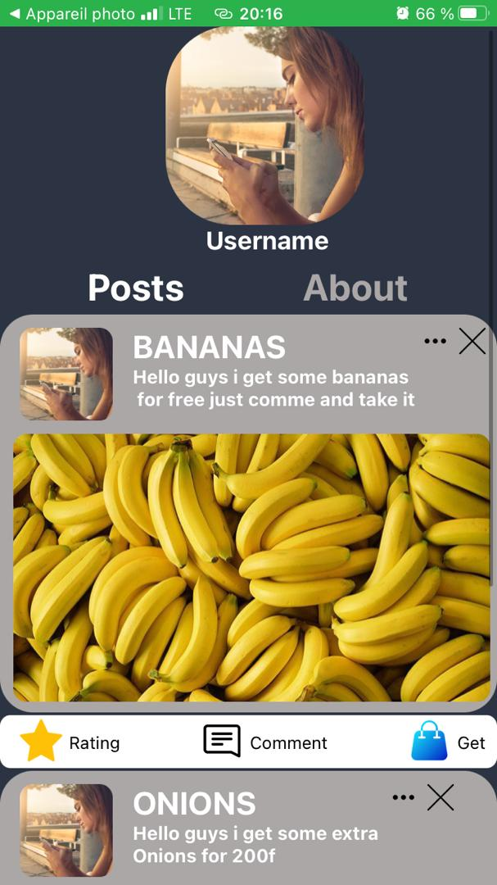

**5. Forum**

This interface offer a public forum where all users of the platform can communicate, discuss about the platform, expose their experience in the platform.

