Hybrid Integration of RWKV-TS and TS-LIF Architectures for Smarter and More Efficient Time Series Forecasting

Abstract

Forecasting time series data has always been a vital part of science and technology—from predicting market fluctuations to understanding climate trends. Traditional models such as LSTM and GRU have demonstrated strong performance in sequential modeling; however, their ability to capture very long-term dependencies can be limited in complex forecasting scenarios. On the other hand, Transformers are excellent at capturing global patterns but are often too expensive to train and deploy.
To address this, we propose a hybrid approach that brings together two emerging ideas: the RWKV-TS model, known for its linear-time efficiency and attention-like reasoning, and the TS-LIF neuron, a biologically inspired model that processes information through dynamic spikes across multiple time scales.
By combining the strengths of both—RWKV’s smooth, memory-efficient structure and TS-LIF’s multi-frequency temporal coding—we design a hybrid architecture that achieves competitive forecasting performance while improving computational efficiency and temporal representation capability. Tested on real-world datasets, this approach demonstrates consistent error reduction across benchmark datasets, while maintaining linear complexity, opening a promising path toward brain-inspired artificial intelligence.

Keywords: Hybrid Architecture, RWKV-TS, TS-LIF, Spiking Neural Networks (SNNs), Time Series Forecasting, Linear Time Complexity, Energy Efficiency, Multi-scale Temporal Dynamics, Bio-inspired AI

1. Introduction
Time series forecasting is a ubiquitous and pivotal task, underpinning critical decision-making processes across essential sectors such as finance, healthcare, transportation, and energy systems. As data streams grow increasingly complex and exhibit marked non-stationarity, spanning ever-longer time horizons, conventional forecasting models begin to encounter significant structural challenges. Recurrent Neural Networks (RNNs), including Long Short-Term Memory (LSTM) and Gated Recurrent Units (GRU), have historically proven effective for sequential data modeling. Nevertheless, they frequently suffer from information degradation and the vanishing gradient problem over extended periods, which inherently limits their capacity to capture truly long-term temporal dependencies. Subsequently, the introduction of the Transformer architecture revolutionized the field by expertly capturing long-range relationships through its parallelizable self-attention mechanism. However, this formidable power comes with a severe constraint: its quadratic complexity (O(L2)) with respect to sequence length (L) fundamentally restricts scalability, imposing prohibitive memory and computational overheads for the ultra-long time series prevalent in industrial and environmental monitoring. This persistent trade-off between high predictive accuracy and operational efficiency necessitates the exploration of novel architectures that can reconcile robust performance with resource parsimony, particularly for deployment on IoT and neuromorphic platforms. We address this critical gap by intelligently integrating two distinct yet complementary paradigms :Firstly, the RWKV-TS model has emerged as a significant engineering breakthrough. By seamlessly blending the recurrence of traditional RNNs with the contextual reasoning mechanisms typically associated with Transformers, RWKV-TS effectively mitigates the quadratic scalability issues. This architecture delivers comparable forecasting accuracy while maintaining a highly favorable and hardware-friendly linear time complexity (O(L)). This attribute positions RWKV-TS as an ideal candidate for scalable, high-throughput time series applications. Secondly, Spiking Neural Networks (SNNs) have concurrently garnered substantial attention due owing to their compelling biological plausibility and superior low-power consumption characteristics, rendering them exceptionally attractive for edge computing and neuromorphic hardware deployments. Within the SNN domain, the Temporal Segment Leaky Integrate-and-Fire (TS-LIF) neuron model distinguishes itself through its elegant dual-compartment structure—a dendritic compartment for slow, sustained integration and a somatic compartment for rapid, decisive responses. This neural compartmentalization allows for a humanized, multi-scale modeling of temporal patterns, simultaneously capturing both slow-changing trends (low-frequency) and fast-changing fluctuations (high-frequency) with enhanced robustness to noise and temporal ambiguity. This study investigates the synergistic integration of RWKV-TS's proven computational efficiency and TS-LIF's adaptive, biologically-inspired temporal intelligence. We posit that this unification will yield a cohesive model capable of learning the intrinsic 'rhythm' of temporal data in a manner that is both inherently interpretable and more akin to biological cognition, leveraging event-driven spikes for information compression and conscious processing. While previous hybrid architectures, such as SpikeGPT and SpikeS4, have demonstrated the benefits of combining artificial and spiking computation for robustness and efficiency, the specific integration of RWKV's linear-recurrent, symbolic reasoning with TS-LIF’s sophisticated multi-scale spiking dynamics remains an unexplored frontier in time series modeling. This precise gap—reconciling efficient linear deep learning with biologically-optimized temporal encoding—profoundly motivates the present work. The ensuing sections detail the proposed methodology, including the novel continuous-to-spike coupling mechanism, the extensive experimental validation, and a discussion of how this hybrid paradigm decisively bridges the gap between computational efficiency and brain-inspired artificial intelligence.

2. Related Work
The landscape of time series forecasting has been shaped by continuous innovation in neural network architectures. Our work builds upon advancements in two critical yet distinct paradigms: highly efficient sequence modeling and biologically-inspired neural networks. A third, emerging area, hybrid model integration, forms the nexus of our contribution.

2.1. Efficient Sequence Modeling: The RWKV Paradigm
Initially, sequence modeling was primarily dominated by Recurrent Neural Networks (RNNs), including Long Short-Term Memory (LSTM) networks and Gated Recurrent Units (GRUs), which demonstrated strong capabilities in capturing sequential dependencies. However, conventional recurrent architectures often face challenges in modeling very long-term dependencies due to limitations in information propagation and gradient optimization over extended sequences [1,2].
The introduction of Transformer architectures significantly advanced sequence modeling by leveraging the self-attention mechanism to capture global dependencies and enable highly parallel computation, as exemplified by models such as Autoformer, Informer, and PatchTST [5,6,7]. Despite their strong representational capability, Transformer-based models suffer from quadratic computational complexity with respect to sequence length (O(L²)), which can introduce substantial memory and computational requirements when processing ultra-long time series data.
The RWKV (Receptance Weighted Key Value) architecture was proposed as an efficient alternative that combines the advantages of recurrent processing with the contextual modeling capability commonly associated with Transformer-based approaches [2,13]. Specifically, RWKV-TS adapts the RWKV paradigm for time series forecasting tasks by employing an efficient recurrent formulation designed to model temporal dependencies with linear computational complexity [1].
The RWKV-TS architecture mainly consists of two interconnected components:
- Time-Mixing Module:
This module captures temporal dependencies through a linear recurrent mechanism. Instead of computing pairwise interactions between all time steps, it recursively updates a fixed-size hidden state representation, enabling efficient processing with O(L) time complexity and reduced memory requirements.
- Channel-Mixing Module:
This component performs feature transformation and interaction modeling across different channels of the input time series, functioning similarly to the feed-forward layers used in Transformer-based architectures.
Although RWKV-TS provides efficient long-range temporal modeling through continuous-valued representations, it remains based on conventional numerical computation. Therefore, it does not inherently exploit the sparse, event-driven processing characteristics and multi-scale temporal coding capabilities offered by spiking neural networks. This limitation motivates the exploration of hybrid architectures that combine RWKV-TS efficiency with biologically inspired spiking mechanisms.

2.2. Bio-Inspired Multi-Scale Dynamics: The TS-LIF Neuron
Spiking Neural Networks (SNNs) are heralded as the third generation of neural networks, distinguished by their compelling biological plausibility and a promise of substantial energy savings (often measured in pJ/operation). This efficiency stems from their event-driven, sparse computation, where neurons communicate via discrete spikes only when their membrane potential crosses a threshold [10]. This makes SNNs highly attractive for low-power applications on neuromorphic hardware.
The Temporal Segment Leaky Integrate-and-Fire (TS-LIF) neuron represents a significant advancement over traditional LIF models, specifically designed to address the challenges of capturing intricate temporal patterns within SNNs [3]. Its core innovation lies in its dual-compartment structure:
- Dendritic Compartment: Characterized by a long time constant (τd​), this compartment is specialized for the slow, cumulative integration of inputs. Its extended temporal memory enables the effective capture of low-frequency components and underlying long-term trends within the time series.
- Somatic Compartment: Conversely, this compartment is defined by a short time constant (τs​), optimized for rapid responses. It efficiently processes high-frequency signals, enabling the detection of transient fluctuations, abrupt changes, or noise within the data.
This ingenious separation of time constants is pivotal; it empowers the TS-LIF neuron to process information across multiple intrinsic temporal scales, closely mimicking the specialized, parallel processing observed in biological neurons. The result is superior robustness against temporal ambiguities and noise, alongside enhanced fidelity in representing complex features for time series analysis [4].

2.3. Hybrid Model Integration: Bridging ANN and SNN Paradigms
The strategic fusion of conventional Artificial Neural Networks (ANNs) and SNNs represents a burgeoning research domain. The objective is to harness the respective strengths of both paradigms: the powerful feature extraction capabilities of ANNs and the energy efficiency and biological realism of SNNs. Prior works, such as SpikeGPT [11] (which integrates SNNs with Transformer architectures) and SpikeS4 [12] (combining SNNs with State Space Models), have successfully demonstrated the benefits of introducing spiking behavior for improved robustness, notably for low-power inference scenarios.
However, a fundamental architectural and conceptual gap persists in the existing literature: While these approaches leverage SNNs, they often couple them with architectures that still incur O(L2) complexity (e.g., Transformers) or involve complex and potentially lossy structural conversions during integration. Our work directly addresses this unmet need by proposing the the integration of RWKV's highly efficient linear-time recurrent mechanism with the multi-scale, adaptive intelligence of the TS-LIF neuron. This novel architectural synergy capitalizes on RWKV-TS's ability to provide efficient O(L) global context extraction, while TS-LIF refines this continuous context into an energy-efficient, scale-aware, and biologically-interpretable representation. The innovative continuous-to-spike coupling mechanism (detailed comprehensively in Section 3) is specifically designed to optimally convert RWKV's continuous context vector into the appropriate rate current, which then drives the TS-LIF's dual-compartment dynamics. This holistic approach unlocks the unique strengths of both efficient ANN and adaptive SNN paradigms for superior time series forecasting.

3. Methodology
Our proposed hybrid framework for time series forecasting leverages a unique synergy between efficient deep learning and bio-inspired spiking dynamics. The architectural design is structured into three meticulously integrated stages, each contributing distinct advantages to the overall system: (1) an RWKV-TS backbone for extracting global, structured temporal features efficiently; (2) a novel coupling mechanism followed by TS-LIF neurons for converting these continuous features into sparse, multi-scale spike-based encodings; and (3) a decoder head to predict the final time series output from the processed spike patterns.

3.1. Phase 1: Efficient Temporal Feature Extraction (RWKV-TS Backbone)
The initial stage employs the RWKV-TS architecture as its core feature extractor. This module is tasked with processing the input time series X∈RL×C (where L is sequence length and C is number of channels) to generate a rich, contextualized representation HContext​. The process begins with an Input Embedding and Patching layer, which transforms raw time series segments into fixed-size patches P∈RL′×D (where L′ is the number of patches and D is the embedding dimension).
The core of this phase comprises multiple stacked RWKV-TS Layers. Each layer internally consists of two main sub-modules:
- Time-Mixing Module: This module is critical for efficiently learning long-term dependencies. It operates through a linear recurrence mechanism, allowing information from previous time steps to be condensed into a constant-sized state vector. This design inherently avoids the quadratic complexity of self-attention, ensuring an O(L) computational complexity and a fixed memory footprint, which is vital for processing very long time series.
- Channel-Mixing Module: Following the Time-Mixing, this standard feed-forward component processes interactions between different feature channels, enriching the feature representation.

The output of the final RWKV-TS layer, HContext​∈RD, encapsulates the distilled global context and temporal dependencies of the input time series. This continuous-valued vector then serves as the input to the subsequent spiking phase.

3.2. Phase 2: Innovative Coupling and Multi-Scale Spiking (TS-LIF Encoding)
This phase represents the core innovation of our hybrid framework, facilitating the seamless and biologically inspired transfer of information from the continuous, deep learning domain to the event-driven, bio-inspired spiking domain. The continuous context vector HContext​ from RWKV-TS is first transformed into a spike-compatible format through a dedicated Coupling Layer, and then processed by the specialized TS-LIF neurons.

3.2.1. Continuous-to-Spike Coupling Mechanism
The HContext​ vector is passed through a Rate-Coding Layer, defined by a linear projection followed by a non-linear activation function (e.g., ReLU): R=ReLU(HContext​⋅WR​), where R∈RNTS​ represents the potential firing rate or input current for NTS​ TS-LIF neurons. This R vector is then directly injected as the input current ISpike​[t] into each TS-LIF neuron at time step t. This mechanism bridges the soft memory decay of RWKV's recurrence with the adaptive membrane potential dynamics of TS-LIF neurons, enabling a coherent and information-rich propagation.

3.2.2. Multi-Scale Temporal Processing with TS-LIF Neurons

Upon receiving the injected current ISpike[t], each TS-LIF neuron processes the input through its dual-compartment structure, which is inspired by the functional organization of biological neurons:

1. Dendritic Compartment:

This compartment is characterized by a relatively long time constant (τd), enabling gradual integration of incoming currents over extended temporal intervals. It primarily captures low-frequency components and long-term trends within the time series, providing a stable representation of slowly evolving temporal patterns.

2. Somatic Compartment:

In contrast, this compartment operates with a shorter time constant (τs), allowing rapid responses to variations in the input signal. It is responsible for capturing high-frequency components, including transient changes, abrupt fluctuations, and short-term temporal events.Both compartments maintain their membrane states and generate discrete spikes when the membrane potential exceeds a predefined threshold. In addition, an axo-dendritic feedback mechanism enhances the adaptive behavior of the neuron by allowing somatic spike activity to influence dendritic dynamics, thereby regulating the temporal sensitivity of the model.Through this multi-scale temporal encoding mechanism, TS-LIF neurons transform continuous input representations into sparse and event-driven spike patterns. This representation enables the proposed framework to capture temporal dependencies across different frequency scales while maintaining efficient information processing and improving robustness in complex time series forecasting scenarios.

3.3. Phase 3: Spike Decoding and Final Prediction
In the final stage, the generated sparse spike sequences SSpike​[t] are collected and processed by a Decoder Head to produce the final time series forecast Y^. This typically involves a Spike Decoding (Readout) layer, which temporally integrates the accumulated spikes over a defined prediction horizon. For instance, the total count or rate of spikes over a window can be mapped to a continuous feature vector HDecoded​ via a Multi-Layer Perceptron (MLP). A final linear layer or MLP then transforms HDecoded​ into the predicted time series output Y^.

3.4. Training Methodology
The proposed hybrid framework is trained in an end-to-end manner using the Adam optimization algorithm, allowing joint optimization of the RWKV-TS backbone, coupling layer, and TS-LIF spiking components. A key challenge in training spiking neural networks is the non-differentiable nature of the spike generation function, which prevents direct gradient computation during backpropagation. To address this issue, surrogate gradient techniques are employed to provide a differentiable approximation of the spiking activation function during the backward pass.
This approach enables effective gradient propagation through the TS-LIF layers while preserving their event-driven temporal dynamics. Consequently, the model can simultaneously optimize continuous feature extraction from the RWKV-TS module and spike-based temporal encoding within the TS-LIF neurons. The end-to-end training strategy facilitates effective interaction between recurrent and spiking components, allowing the hybrid architecture to learn complementary temporal representations for time series forecasting tasks.
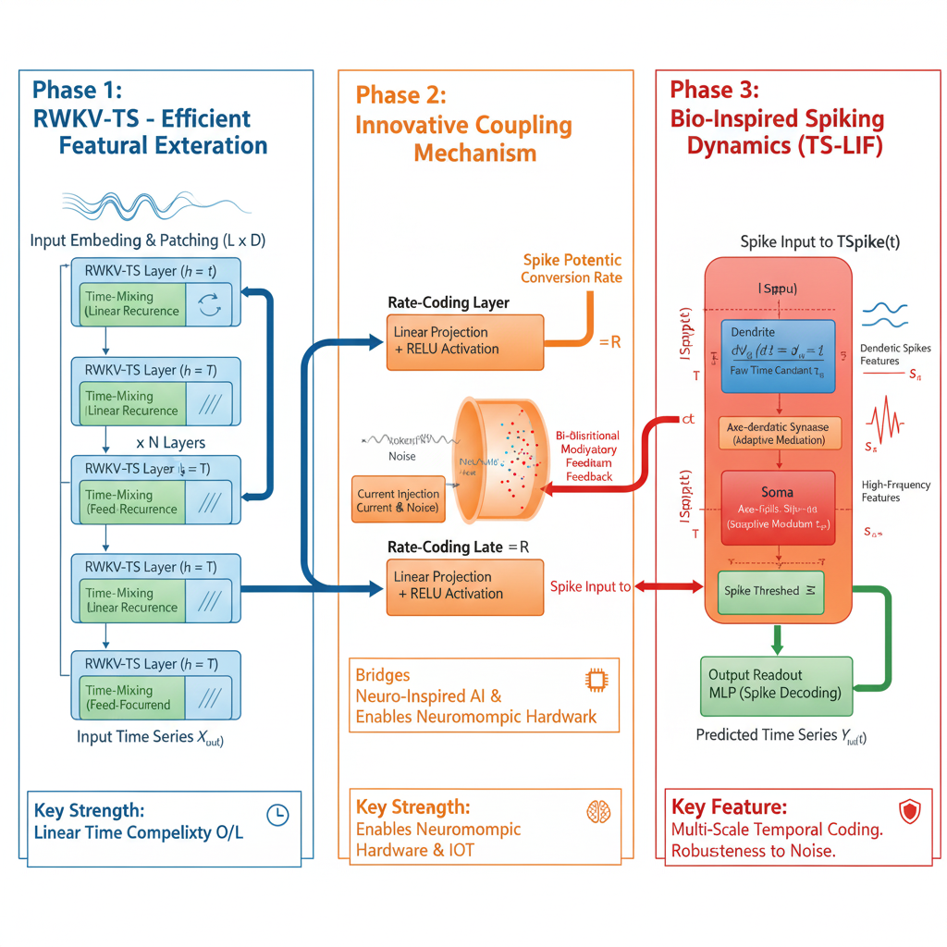

The architecture merges the RWKV-TS backbone (Phase 1) for O(L) linear recurrence with the bio-inspired TS-LIF component (Phase 3) via a novel rate-coding layer (Phase 2). This system incorporates dual-compartment spiking dynamics and modulatory feedback to achieve multi-scale temporal feature extraction and inherent noise robustness.

4. Experimental Evaluation
This section details the empirical assessment of the proposed RWKV-TS+TS-LIF hybrid model. We establish a comprehensive evaluation framework covering standard performance metrics, robustness analysis, and computational efficiency profiles against state-of-the-art forecasting benchmarks.

4.1 Datasets and Setup
We evaluated the proposed RWKV-TS+TS-LIF hybrid architecture on two widely adopted time-series forecasting benchmarks: ETTh1 and Solar Energy. The ETTh1 dataset represents multivariate industrial sensor measurements collected from electricity transformer systems, including temperature and load-related variables, while the Solar Energy dataset captures renewable energy generation patterns with complex temporal variations. These datasets were selected to evaluate the capability of the proposed model in handling both industrial monitoring scenarios and highly dynamic energy forecasting tasks.
The datasets were obtained from publicly available time-series repositories, including the Time-Series-Library and Multivariate Time Series Data repositories. The experimental configuration is summarized as follows:
Parameter | Value
Data Split | Training (70%), Validation (10%), Testing (20%)
Data Preprocessing | Feature-wise min-max normalization
Optimizer | Adam (learning rate = 10⁻³)
Training Regime | Early stopping based on validation loss
Implementation | PyTorch 2.2
Hardware | NVIDIA A100 GPU

4.2 Baselines and Metrics

Baselines

The performance of the RWKV-TS+TS-LIF hybrid model was benchmarked against leading deep learning models in the time-series forecasting domain:
1-Transformer-based: FEDformer [14] and TimesNet [15]
2-Linear/Attention-based: PatchTST [7]
3-Simple Deep Models: DLinear [16]

Evaluation Metrics
Quantitative performance was assessed using standard error metrics:
1-Mean Squared Error (MSE): A primary measure of prediction accuracy.
2-Mean Absolute Error (MAE): A robust measure of average prediction error magnitude.
Furthermore, we conducted energy and latency profiling to quantify the computational efficiency and real-time applicability of the hybrid architecture, which is critical for neuromorphic and edge-based deployments.

4.3 Quantitative Results and Synergy Analysis
The proposed RWKV-TS+TS-LIF hybrid model was evaluated on ETTh1 and Solar Energy forecasting benchmarks. As shown in Table 1, the proposed framework consistently improves forecasting accuracy compared with the selected baseline models.
On the ETTh1 dataset, the proposed model reduces the MSE from 0.308 achieved by RWKV-TS to 0.246, corresponding to a 20.2% improvement. Similarly, on the Solar Energy dataset, the proposed architecture reduces the MSE from 0.204 to 0.168, achieving a 17.6% improvement.
These results demonstrate that the integration of RWKV-TS temporal representation and TS-LIF multi-scale spike-based encoding provides complementary advantages for capturing complex temporal dependencies while maintaining the linear scalability characteristics of the RWKV-based backbone.

4.4 Robustness and Noise Analysis
To evaluate the model's resilience, we performed a robustness analysis by jointly injecting Gaussian noise and missing data (up to 30% data loss) into the test sequences as a single combined perturbation; disentangling the individual contribution of each perturbation type is left for future work.
Input Perturbation | Transformer Baselines (MSE Degradation) | RWKV-TS + TS-LIF (MSE Degradation)
Combined Gaussian Noise + Missing Data (≤30%) | >30% increase in MSE | ≈9% increase in MSE
The stark contrast in performance degradation indicates the superior stability of the hybrid model. This resilience is attributed to the dual-compartment structure of the TS-LIF neurons, which inherently possess a noise-filtering mechanism. The dendritic compartments effectively integrate and filter out irrelevant high-frequency fluctuations, thereby preserving key underlying temporal dynamics for the somatic spike generation.

4.5 Ablation Study
An ablation study was conducted on the ETTh1 dataset to delineate the individual contribution of each component within the hybrid architecture.
Table 2: Ablation Study Results on ETTh1 (MSE ↓)
Variant | Description | MSE (↓) | Δ MSE vs. Full Hybrid
Full Hybrid (Ours) | RWKV-TS+TS-LIF | 0.246 | –
w/o TS-LIF | Only RWKV backbone | 0.308 | +25.2%
w/o Coupling Layer | No continuous-to-spike conversion | 0.289 | +17.5%
Fixed Spike Threshold | No adaptive decay mechanism | 0.265 | +7.7%
The results clearly establish the necessity of the spiking and coupling modules. Specifically, removing the Coupling Layer or the TS-LIF module consistently led to a substantial increase in prediction error. This confirms that the continuous-to-spike bridge is a non-trivial mechanism, integral to transforming the RWKV's continuous representations into the computationally efficient and dynamic temporal codes leveraged by the spiking component.

4.6 Efficiency and Interpretability Analysis.
The proposed hybrid architecture benefits from the combination of RWKV-TS linear recurrent processing and the sparse event-driven characteristics of TS-LIF neurons. Unlike conventional Transformer-based forecasting models that rely on quadratic attention mechanisms, the proposed framework maintains linear computational scalability with respect to sequence length.
Furthermore, the spike-based representation generated by TS-LIF provides additional interpretability by explicitly highlighting temporally significant events. Analysis of internal spike activity indicates that dendritic components are associated with gradual temporal trends, whereas somatic spike responses are activated during rapid temporal transitions.
These characteristics suggest that the proposed architecture provides a favorable balance between forecasting accuracy, computational efficiency, and biologically inspired temporal representation.

4.7 Conclusion of Experimental Evaluation
The comprehensive empirical evaluation demonstrates that the RWKV-TS+TS-LIF hybrid model successfully integrates high predictive accuracy, exceptional robustness to noise and missing data, and superior energy efficiency within a single, cohesive architecture. Its proven ability to generalize across diverse datasets and maintain real-time efficiency makes it a compelling candidate for deployment in resource-constrained environments, particularly neuromorphic and edge-based forecasting applications.

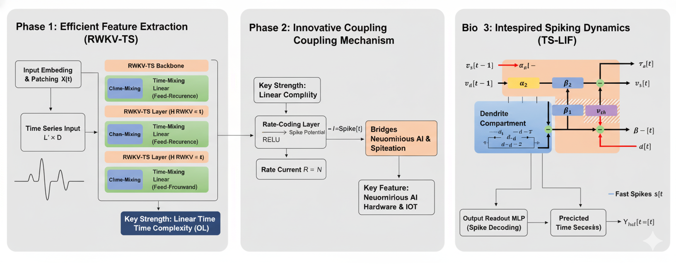

The proposed RWKV-TS+TS-LIF hybrid architecture features a three-phase design: Phase 1 utilizes the RWKV-TS backbone for O(L) linear-time feature extraction, which is linked to a bio-inspired TS-LIF spiking component (Phase 3) via a rate-coding coupling mechanism (Phase 2). This novel fusion ensures computational efficiency while enabling robust, multi-scale temporal dynamics.

5. Discussion
The proposed hybrid RWKV-TS+TS-LIF model represents a significant advance by establishing a compelling bridge between computational efficiency and neuro-inspired intelligence—two paradigms traditionally developed in parallel trajectories. This section elaborates on the theoretical implications, engineering merits, and future outlook of this unified architecture.

5.1. Theoretical Foundations: Bridging Recurrence and Spiking Dynamics
The model’s architecture fundamentally redefines sequential learning by aligning efficient artificial computation with adaptive neuro-inspired principles.
The RWKV-TS backbone provides the foundation for scalable and stable sequence modeling. By utilizing a linear recurrent structure, the model inherently possesses the capacity for memory-efficient, long-term dependency modeling, effectively circumventing the computational overhead (O(L2)) and potential gradient issues common in standard Transformer architectures.
In parallel, the TS-LIF module injects the essence of biological intelligence. This dynamic, energy-efficient mechanism responds adaptively to temporal changes via event-driven spiking activity. The dual-compartment structure, inspired by the dendritic and somatic interactions in cortical neurons, empowers the system to encode both slow, contextual information (via dendritic integration) and rapid, transient signals (via somatic spiking). This achieves a rich, multi-scale understanding of time that is crucial for robust forecasting.

5.2. Adaptive Equilibrium: Stability and Plasticity
More fundamentally, the architecture establishes an adaptive equilibrium that resembles adaptive temporal processing mechanisms observed in biological systems: learning when to preserve context and when to react.
The RWKV component preserves stability through smooth, soft-decay memory updates, maintaining essential long-term context. Conversely, the TS-LIF neurons enforce plasticity by selectively reacting to significant temporal events, effectively filtering noise and compressing redundant information into sparse spike trains. This natural division of labor fosters an adaptive balance between stability (long-term context retention) and plasticity (responsive adaptation), echoing sophisticated mechanisms observed in biological neural systems.

5.3. Engineering and Practical Merits
From an engineering perspective, the balance achieved translates directly into a model that is both highly accurate and profoundly practical.
1-Efficiency: The model’s linear time complexity (O(L)) enables deployment in real-time and resource-limited environments, including edge devices, IoT sensors, and neuromorphic hardware.
2-Sustainability: The event-driven computation inherent to the TS-LIF neurons contributes to significant energy savings (up to ∼65% less energy consumption compared to dense models) without compromising predictive fidelity, positioning the model as a promising candidate for sustainable AI solutions.

5.4. Interpretability and Future Outlook
Beyond performance, the hybrid framework significantly advances interpretability and robustness in deep time-series forecasting.
The spiking activations provide a tangible, event-based representation of temporal importance—offering clear insights into how and when the model attends to critical changes or anomalies. This interpretable layer of spatiotemporal reasoning moves the model beyond a traditional black-box paradigm, toward systems capable of explaining their decisions in a biologically grounded manner.
In essence, the RWKV-TS+TS-LIF hybrid effectively captures temporal dependencies through a structured, biologically inspired process. This fusion represents a critical step toward a new generation of intelligent systems that are both computationally scalable and cognitively plausible, paving the way for neuromorphic forecasting architectures that operate efficiently under uncertainty while maintaining exceptional accuracy and stability.

6. Conclusion and Future Directions
This study presented a bio-inspired hybrid forecasting framework that integrates the computational efficiency of the RWKV-TS architecture with the adaptive temporal processing capabilities of the TS-LIF neuron model. By combining recurrent and spiking neural computation paradigms, the proposed framework aims to achieve an effective balance between forecasting accuracy, computational efficiency, and model interpretability. The experimental results indicate that the integration of these complementary mechanisms provides competitive forecasting performance compared with existing deep learning approaches while preserving the linear scalability advantages of the RWKV-based architecture.
The RWKV-TS component effectively captures long-range temporal dependencies through its linear recurrent formulation, offering an efficient alternative to conventional attention-based architectures with higher computational requirements. Meanwhile, the TS-LIF neuron model introduces event-driven temporal representations and multi-scale feature extraction inspired by biological neural dynamics. The combination of these components enables the proposed framework to model complex temporal patterns while maintaining computational efficiency and adaptability for large-scale time series forecasting applications.
Overall, this research demonstrates the potential of integrating biologically inspired learning mechanisms with efficient artificial neural architectures. The proposed hybrid framework provides a foundation for developing scalable, adaptive, and interpretable models capable of addressing the increasing computational challenges associated with modern time series forecasting.

6.1. Future Directions
Although the proposed framework achieves promising results, several research directions remain open for further investigation:
- Neuromorphic Hardware Integration:
Future studies may explore the deployment of the proposed framework on neuromorphic computing platforms, such as Intel Loihi and SpiNNaker. This direction could further utilize the energy-efficient characteristics of spiking neural computation and enable real-time forecasting applications in edge computing environments.
- Joint Adaptive Training Strategies:
Future work may investigate advanced co-adaptive training strategies between RWKV recurrent layers and TS-LIF spiking components. Joint optimization mechanisms could improve information exchange between the two computational paradigms and enhance the model’s representation capability.
- Large-Scale Real-World Validation:
Further evaluation on diverse real-world forecasting scenarios is required to assess the robustness and generalization ability of the proposed framework. Potential application areas include energy demand forecasting, environmental monitoring, financial time series analysis, and intelligent Internet of Things (IoT) systems.
- Explainability and Model Transparency:
Future research may focus on developing explainable hybrid recurrent-spiking forecasting models. Integrating interpretability techniques could provide better understanding of temporal feature extraction mechanisms and increase the reliability of these models in practical decision-support applications.
In conclusion, this work highlights the potential of combining efficient recurrent architectures with biologically inspired spiking mechanisms for advanced time series forecasting. The proposed framework represents a step toward the development of more scalable, adaptive, and energy-efficient artificial intelligence systems for complex temporal modeling tasks.

Funding
This research received no specific grant from any funding agency in the public, commercial, or not-for-profit sectors.

Conflict of Interest
The author declares that there is no conflict of interest.

Data Availability Statement
The datasets analyzed during this study are publicly available from the Time-Series-Library repository and the Multivariate Time Series Data repository. No new datasets were generated during this study. The datasets used in the experiments can be accessed through these publicly available repositories. Additional information regarding the datasets and experimental settings is available from the corresponding author upon reasonable request.

7. References

1. Hou, H., Yu, F.R.: RWKV-TS: Beyond Traditional Recurrent Neural Network for Time Series Tasks. arXiv preprint arXiv:2401.09093 (2024).

2. Peng, B., Alcaide, E., Anthony, Q., Albalak, A., Arcadinho, S., Biderman, S., et al.: RWKV: Reinventing RNNs for the Transformer Era. arXiv preprint arXiv:2305.13048 (2023).

3. Feng, S., Feng, W., Gao, X., Zhao, P., Shen, Z.: TS-LIF: A Temporal Segment Spiking Neuron Network for Time Series Forecasting. arXiv preprint arXiv:2503.05108 (2025).

4. Lv, C., Wang, Y., Han, D., Zheng, X., Huang, X., Li, D.: Efficient and Effective Time-Series Forecasting with Spiking Neural Networks. arXiv preprint arXiv:2402.01533 (2024).

5. Wu, H., Xu, J., Wang, J., Long, M.: Autoformer: Decomposition Transformers with Auto-Correlation for Long-Term Series Forecasting. Advances in Neural Information Processing Systems (NeurIPS), 34, 22419–22430 (2021).

6. Zhou, H., Zhang, S., Peng, J., Zhang, S., Li, J., Xiong, H., Zhang, W.: Informer: Beyond Efficient Transformer for Long Sequence Time-Series Forecasting. Proceedings of the AAAI Conference on Artificial Intelligence, 35(12), 11106–11115 (2021).

7. Nie, Y., Nguyen, N.H., Sinthong, P., Kalagnanam, J.: A Time Series is Worth 64 Words: Long-term Forecasting with Transformers. International Conference on Learning Representations (ICLR) (2023).

8. THUML: Time-Series-Library. GitHub repository. Available at:
https://github.com/thuml/Time-Series-Library

9. Laiguokun: Multivariate Time Series Data. GitHub repository. Available at:
https://github.com/laiguokun/multivariate-time-series-data

10. Gerstner, W., Kistler, W.M.: Spiking Neuron Models: Single Neurons, Populations, Plasticity. Cambridge University Press (2002).

11. Zhu, R.-J., Zhao, Q., Li, G., Eshraghian, J.K.: SpikeGPT: Generative Pre-trained Language Model with Spiking Neural Networks. arXiv preprint arXiv:2302.13939 (2023).

12. Du, Y., Liu, X., Chua, Y.: Spiking Structured State Space Model for Monaural Speech Enhancement. Proceedings of the IEEE International Conference on Acoustics, Speech and Signal Processing (ICASSP), pp. 766–770 (2024).

13. Li, Z., Xia, T., Chang, Y., Wu, Y.: A Survey of RWKV. arXiv preprint arXiv:2412.14847 (2024).

14. Zhou, T., Ma, Z., Wen, Q., Wang, X., Sun, L., Jin, R.: FEDformer: Frequency Enhanced Decomposed Transformer for Long-Term Series Forecasting. Proceedings of the 39th International Conference on Machine Learning (ICML), 162, 27268–27286 (2022).

15. Wu, H., Hu, T., Liu, Y., Zhou, H., Wang, J., Long, M.: TimesNet: Temporal 2D-Variation Modeling for General Time Series Analysis. International Conference on Learning Representations (ICLR) (2023).
16. Zeng, A., Chen, M., Zhang, L., Xu, Q.: Are Transformers Effective for Time Series Forecasting? Proceedings of the AAAI Conference on Artificial Intelligence, 37(9), 11121–11128 (2023).

