NAVIOTEC H SOLUT ION S PV T. LTD . • CYB ER SEC U R IT Y AS SES SM EN T
PHISHING AWARENESS SIMULATION REPORT
Empirical Vulnerability Assessment, Behavioral Telemetry & Technical Defense Roadmap
Prepared By
Entity
Atharv Hogade & Uzair Shaikh Naviotech Solutions Pvt. Ltd.
Target Sample
19 Internal Personnel
Date / Status
June 2026 / Completed
100%
ETHICAL & ZERO DATA STORED
41.7%
NEAR CREDENTIAL ENTRY
91.7%
CLICK-THROUGH RATE (11/12)
63.2%
EMAIL OPEN RATE (12/19)

Executive Summary & Overview

This assessment documents a controlled, ethical phishing awareness simulation orchestrated and executed by Atharv Hogade and Uzair Shaikh at Naviotech Solutions Pvt. Ltd. in June 2026. The engagement was engineered to evaluate real-world susceptibility to modern social engineering tactics, measure the efficacy of existing security heuristics among personnel, and establish quantitative metrics to drive targeted awareness training and defensive controls.
A cohort of nineteen (19) participants received a simulated spear-phishing payload mimicking a critical Google Account security password reset. Telemetry tracked the full attack chain progression—from delivery and inbox open to link clicks and form interactions. Crucially, the simulation proved that cognitive stressors (such as artificial urgency) routinely override standard visual inspection, reinforcing the need for multi-layered technical controls.

Attack Mechanics & Threat Taxonomy

Phishing attacks bypass perimeter technical controls by exploiting human trust, routine habits, and emotional urgency. Modern campaigns employ sophisticated taxonomies:
- Spear Phishing: Highly contextualized, targeted lures tailored to specific organizational roles using Open Source Intelligence (OSINT).
- Adversary-in-the-Middle (AiTM): Transparent reverse-proxy frameworks (e.g., Evilginx) capable of intercepting live session cookies, bypassing traditional MFA.
- Business Email Compromise (BEC): High-trust impersonation of executive leadership or vendors to redirect wire transfers or sensitive IP.
- Omnichannel Vectors: Phishing expanded across Smishing (SMS), Vishing (Voice), and Quishing (QR Code phishing).

Ethical Simulation Methodology

To ensure absolute compliance with ethical penetration testing standards and privacy frameworks, the simulation adhered to a strict 6-stage lifecycle:

Stage | Phase Name | Operational Execution | Data Captured
Stage 1 | Design & Weaponization | Engineered credential harvesting page and spoofed security email with urgency cues. | Artifact Integrity
Stage 2 | Deployment | Dispatched emails from personal Gmail vector to 19 targeted accounts on June 11, 2026. | Open / Ignore Logs
Stage 3 | Informed Consent | Mandatory MailSecure Training Portal consent screen displayed prior to payload. | Consent Confirmed
Stage 4 | Active Simulation | Annotated Google authentication clone rendered with decoy hint credentials. | Form Interaction Telemetry
Stage 5 | Real-Time Education | Debrief screen highlighting 5 immediate red-flag indicators upon completion. | Completion Status
Stage 6 | Feedback & Diagnostic | Distributed structured diagnostic survey to capture qualitative behavioral insights. | 12 Survey Responses
Ethical Guardrails Maintained: All input form action endpoints routed user inputs to localized non-persisting memory. Zero live user passwords or corporate secrets were captured, logged, or transmitted across external networks.

Campaign Telemetry & Empirical Findings
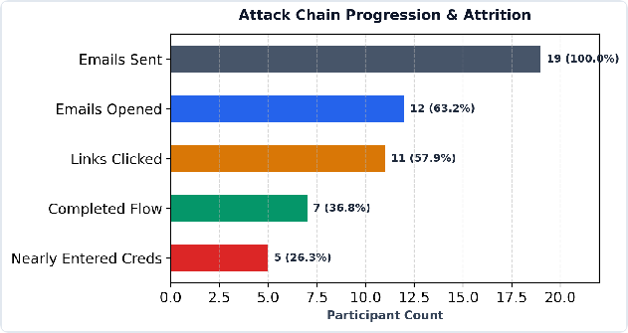

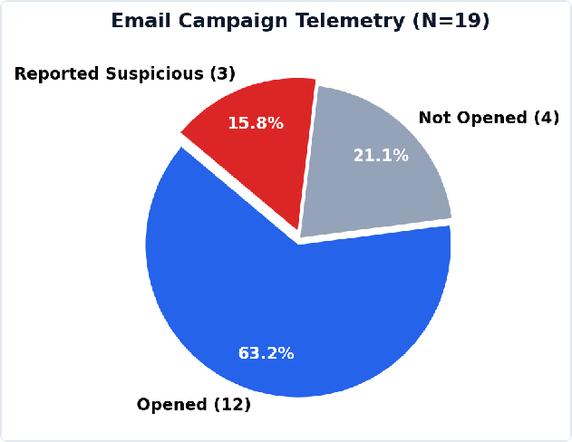
Figure 1: Email Campaign Telemetry (N=19)
Figure 2: Attack Chain Conversion Funnel

Telemetry Breakdown

Campaign Milestone | Count | Cohort Rate (%) | Industry Benchmark | Risk Classification
Total Emails Sent | 19 | 100.0% | — | Baseline
Emails Opened | 12 | 63.2% | 20.0% – 35.0% | Elevated Ingress
Phishing Links Clicked | 11 | 91.7% (of openers) | 10.0% – 18.0% | Critical Vulnerability
Full Flow Completed | 7 | 58.3% (of openers) | — | Full Engagement
Mid-Flow Dropouts | 5 | 41.7% (of openers) | — | Early Detection

Campaign Milestone | Count | Cohort Rate (%) | Industry Benchmark | Risk Classification
Near Credential Submission | 5 | 41.7% (of survey respondents) | 5.0% – 12.0% | Severe Exposure
Proactively Reported to Admin | 3 | 15.8% (of total cohort) | < 5.0% | Positive Reflex
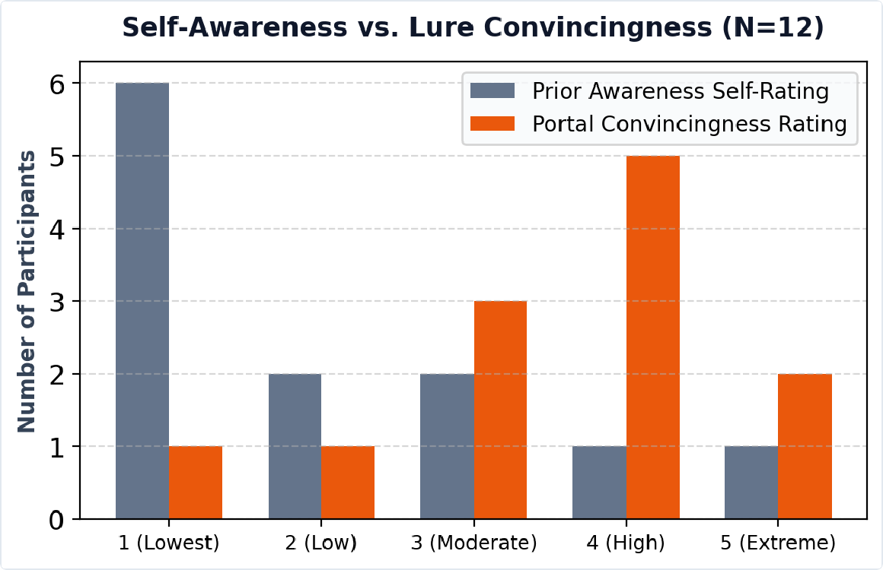
Figure 3: Disconnect between Baseline Awareness & Interface Deception Rating

Deep Behavioral Analysis & Core Findings
Finding 1: High Ingress Driven by Familiarity Bias
The 63.2% open rate significantly outpaced the standard industry cold baseline (20-35%). Utilizing a recognized peer sender identity suppressed natural scrutiny. Personnel evaluated the message based on who it appeared to come from rather than inspecting the underlying cryptographic transport headers.
Finding 2: Artificial Urgency Disables Critical Thinking
11 out of 12 openers clicked the embedded link (91.7%). The 30-minute expiration countdown forced an immediate task-completion reflex, bypassing deliberate analytical steps such as sender address verification and link hovering.
Finding 3: UI Fidelity Overcomes Passive Warning Banners
Despite a bright red warning banner and explicit simulation disclaimers, 41.7% of respondents nearly entered authentic credentials. Under time pressure, users hyper-focus on input fields (Email/Password) and ignore peripheral warnings and page banners.

Finding 4: The Awareness-Action Dissonance
While 66.7% of participants rated their prior phishing knowledge as low (1-2/5), even those claiming high awareness fell prey to link clicks. Self-assessed awareness does not reliably translate to secure behavioral reflexes during live social engineering attempts.

Technical Artifact Comparisons

Simulated Email vs. Authentic Google Security Alert

Vector Attribute | Simulated Phishing Email | Legitimate Google Security Alert
Sender Address | himanshusoni86549@gmail.com (Personal Mail) | no-reply@accounts.google.com
Salutation | Generic: "Dear User" | Personalized: "Dear [Full Name]"
Target Domain | stunning-beijinho-0c3b48.netlify.app | https://myaccount.google.com/security
Urgency Cue | Hostile: "Account link will expire in 30 mins" | Calm, informative notification; no punitive timer
Sign-off Structure | "Support Team, Google Organization" | "The Google Accounts Team"
Legal Footers | Absent | Mandatory Privacy Policy & Terms links present
6.2 Simulated Harvesting Portal vs. Legitimate Google Sign-in
Interface Component | Simulated Spoofed Portal | Legitimate Google Authentication
Address Bar URL | *.netlify.app (Unverified Subdomain) | accounts.google.com
Domain In-Page Label | accounts.google-secure-login.com | Cryptographically matched to address bar
Form Pre-fills | Test credentials provided (testuser/demo123) | Never displays hints or pre-filled passwords
Password Input | Revealed dummy placeholder strings | Strictly masked (••••••••)
SSO / Aux Options | Omitted ("Forgot email?", "Create account") | Full recovery ecosystem & Passkey support

Defense-in-Depth Mitigation Framework

To systematically eliminate the attack vectors identified by Atharv Hogade and Uzair Shaikh, Naviotech Solutions must implement a multi-layered security architecture:
Layer
Technical Control
Mapped
Finding
Implementation
Priority

Identity FIDO2 / WebAuthn Hardware Keys: Cryptographically binds logins to exact FQDNs, neutralizing credential theft.
Priority 2 (High)
Finding 3 & 4

Gateway
Strict SPF, DKIM & DMARC Enforcement: Policy set to p=reject to eliminate external domain spoofing.
Finding 1
Priority 1 (Critical)

Endpoint EDR & DNS Sinkholing: Automated web-reputation filtering to block newly registered domains and Netlify lures.
Priority 1 (Critical)
Finding 2

Priority 2 (High)
Finding 4
Adaptive Simulation Training: Quarterly micro-simulations to convert
analytical checks into automatic reflexes.
Human
Implementation
Priority
Mapped
Finding
Technical Control
Layer

Process One-Click MUA Reporting Plugin: Direct pipeline from email client to Security Operations Center (SOC) sandbox.
Finding 1 & 2

Strategic Lessons Learned & Roadmap
Priority 3 (Medium)

- Lesson 1: Display Names Are Not Identity: Peer-based familiarity is weaponized easily. Training must reinforce looking at the complete RFC-5322 header and address domain.
- Lesson 2: Urgency Demands Mandatory Pauses: Establish standard operating procedures where any time-sensitive credential alert requires out-of-band verification.
- Lesson 3: Technical Safeguards Must Backstop Human Fallibility: Because 41.7% nearly surrendered credentials despite visible warnings, human awareness alone cannot be the sole perimeter. FIDO2 MFA provides essential structural defense.

Conclusion

The simulation conducted by Atharv Hogade and Uzair Shaikh validates that technical defenses and human behavioral training must operate in unison. By implementing phishing-resistant MFA, rigorous email gateway filtering, and continuous simulation exercises, Naviotech Solutions Pvt. Ltd. can significantly harden its defenses against advanced social engineering and credential harvesting attacks.

References

- Verizon Communications. 2026 Data Breach Investigations Report (DBIR).
- Anti-Phishing Working Group (APWG). Phishing Activity Trends Report, Q1 2026.
- National Institute of Standards and Technology (NIST). Special Publication 800-63B: Digital Identity Guidelines.
- Cybersecurity & Infrastructure Security Agency (CISA). Phishing Simulation and Security Awareness Manual.
- OWASP Foundation. Automated Threats to Web Applications & Social Engineering Defense.

